List Fragment

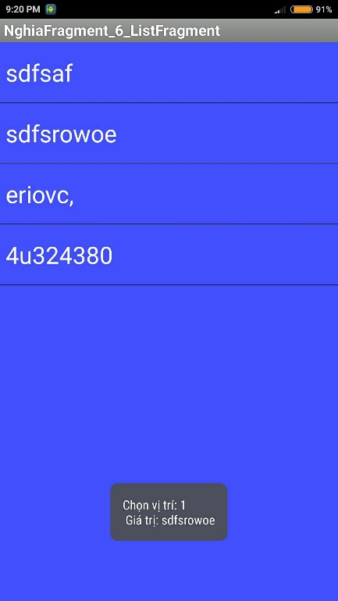

**File: fragment_list_a.xml**

<LinearLayout…>

<ListView… android:id="@android:id/list"/>

</LinearLayout>

**File: FragmentListA.java**

public class FragmentListA extends ListFragment{

@Override

public View onCreateView(LayoutInflater inflater, ViewGroup container, Bundle savedInstanceState) {

return inflater.inflate(R.layout.fragment_list_a, container, false);

}

@Override

public void onActivityCreated(Bundle savedInstanceState) {

super.onActivityCreated(savedInstanceState);

// init views & event

ArrayAdapter adapter = ArrayAdapter.createFromResource(getActivity(),

R.array.array_nghia_random,

android.R.layout.simple_list_item_1);

setListAdapter(adapter);

// init event

getListView().setOnItemClickListener(new AdapterView.OnItemClickListener() {

@Override

public void onItemClick(AdapterView<?> parent, View view, int position, long id) {

onItemClickListener(parent, view, position, id);

}

});

}

private void onItemClickListener(AdapterView<?> parent, View view, int position, long id) {

String value = getResources().getStringArray(R.array.array_nghia_random)[position];

String message = String.format("Chọn vị trí: %s \n Giá trị: %s", position, value);

Toast.makeText(getActivity(), message, Toast.LENGTH_LONG).show();

}

}

**Sử dụng trong: activity_main.xml**

<RelativeLayout… tools:context=".MainActivity">

<fragment…

android:name="com.imark.nghia.nghiafragment_6_listfragment.FragmentListA"

android:id="@+id/fragment"

tools:layout="@layout/fragment_list_a"/>

</RelativeLayout>