**SPINER**

Danh sách sổ xuống.

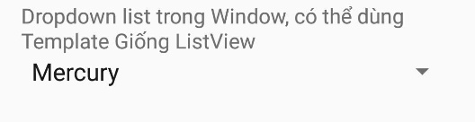Khởi tạo giống ListView. Có thể khởi tạo Custom Adapter.

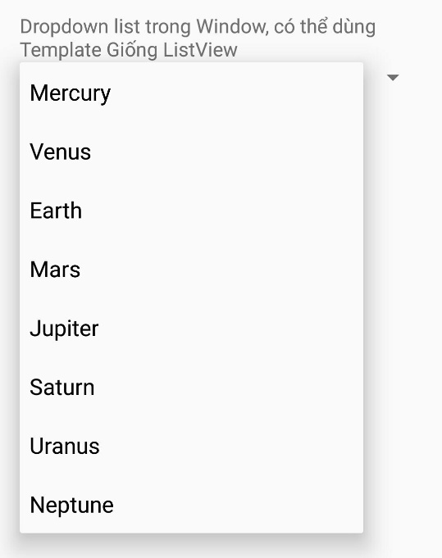

Layout XML tag:

<Spinner …

android:id="@+id/planets_spinner" />

Cài đặt trong Activity:

//Find in Layout

Spinner spinner = (Spinner) findViewById(R.id.planets_spinner);

// Create an ArrayAdapter using the string array and a default spinner layout

ArrayAdapter<CharSequence> adapter = ArrayAdapter.createFromResource(this,

R.array.nghia_planets_array, android.R.layout.simple_spinner_item);

// Specify the layout to use when the list of choices appears

adapter.setDropDownViewResource(android.R.layout.simple_spinner_dropdown_item);

// Apply the adapter to the spinner

spinner.setAdapter(adapter);

//---- Even----chọn mới

spinner.setOnItemSelectedListener(new AdapterView.OnItemSelectedListener() {

@Override

public void onItemSelected(AdapterView<?> parent, View view, int position, long id) {

Toast.makeText(getBaseContext(), position + "", Toast.LENGTH_SHORT).show();

}

@Override

public void onNothingSelected(AdapterView<?> parent) {

}

});

Với danh sách string: value/strings.xml

…

<string-array name="nghia_planets_array">

<item>Mercury</item>

<item>Venus</item>

<item>Earth</item>

<item>Mars</item>

<item>Jupiter</item>

<item>Saturn</item>

<item>Uranus</item>

<item>Neptune</item>

</string-array>

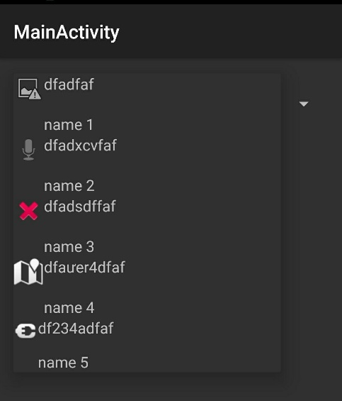**Custom Spiner**

Tự tạo giao diện cho spiner

Xem listview Adapter