**SECTION HEADER LISTVIEW**

Listview Chia theo phần.

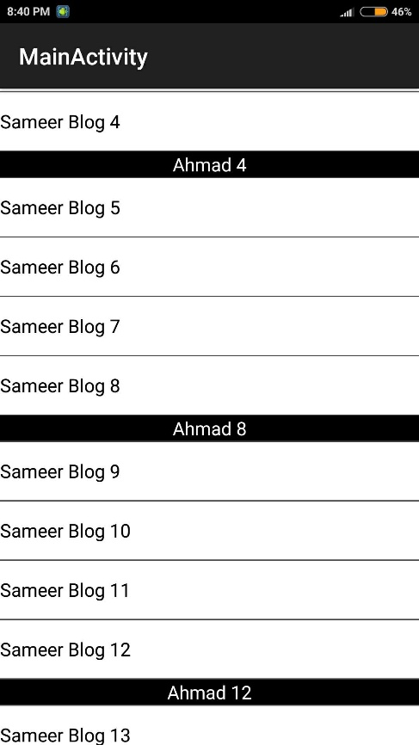Header có 2 kiểu Item.

Bước 1: Tạo giao diện 2 Item:

Layout hiểu thị Item: layout/item1.xml

<LinearLayout

xmlns:android="http://schemas.android.com/apk/res/android"

android:layout_height="wrap_content"

android:layout_width="fill_parent">

<TextView

android:id="@+id/text"

android:layout_height="50dp"

android:gravity="center_vertical"

android:text="text"

android:visibility="visible"

android:layout_width="fill_parent"

android:textColor="#FF000000"

android:background="#FFFFFFFF" />

</LinearLayout>

Layout hiển thị Header: layout/item2.xml

<LinearLayout

xmlns:android="http://schemas.android.com/apk/res/android"

android:layout_height="wrap_content"

android:layout_width="fill_parent">

<TextView

android:id="@+id/textSeparator"

android:layout_height="wrap_content"

android:gravity="center"

android:text="text"

android:visibility="visible"

android:layout_width="fill_parent"

android:textColor="#FFFFFFFF"

android:background="#000" />

</LinearLayout>

Bước 2: Tạo Adapter: MyCustomAdapter.java

class MyCustomAdapter extends BaseAdapter {

private static final int TYPE_ITEM = 0;

private static final int TYPE_SEPARATOR = 1;

private static final int TYPE_MAX_COUNT = TYPE_SEPARATOR + 1;

private ArrayList<String> mData = new ArrayList<String>();

private LayoutInflater mInflater;

private TreeSet<Integer> mSeparatorsSet = new TreeSet<Integer>();

public MyCustomAdapter() {

mInflater = (LayoutInflater)getSystemService(Context.LAYOUT_INFLATER_SERVICE);

}

//Thêm Item

public void addItem(final String item) {

mData.add(item);

notifyDataSetChanged();

}

//Thêm Header

public void addSeparatorItem(final String item) {

mData.add(item);

mSeparatorsSet.add(mData.size() - 1); //Lưu vị trí SectionHeader

notifyDataSetChanged();

}

@Override

public int getItemViewType(int position) {

return mSeparatorsSet.contains(position) ? TYPE_SEPARATOR : TYPE_ITEM;

}

@Override

public int getViewTypeCount() {

return TYPE_MAX_COUNT;

}

public int getCount() {

return mData.size();

}

public String getItem(int position) {

return mData.get(position);

}

public long getItemId(int position) {

return position;

}

public View getView(int position, View convertView, ViewGroup parent) {

ViewHolder holder = null;

int type = getItemViewType(position);

System.out.println("getView " + position + " " + convertView + " type = " + type);

if (convertView == null) {

holder = new ViewHolder();

switch (type) {

case TYPE_ITEM:

convertView = mInflater.inflate(R.layout.item1, null);

holder.textView = (TextView)convertView.findViewById(R.id.text);

break;

case TYPE_SEPARATOR:

convertView = mInflater.inflate(R.layout.item2, null);

holder.textView = (TextView)convertView.findViewById(R.id.textSeparator);

break;

}

convertView.setTag(holder);

} else {

holder = (ViewHolder)convertView.getTag();

}

holder.textView.setText(mData.get(position));

return convertView;

}

class ViewHolder {

public TextView textView; //Id textView Hiển thị

}

}

Bước 3: Sử dụng trong List Activity

public class MainActivity extends ListActivity{

private MyCustomAdapter mAdapter;

@Override

public void onCreate(Bundle savedInstanceState) {

...

mAdapter = new MyCustomAdapter();

for (int i = 1; i < 50; i++) {

mAdapter.addItem("Sameer Blog " + i);

if (i % 4 == 0) {

//Section Header, cứ 4 item có 1 header

mAdapter.addSeparatorItem("Ahmad " + i);

}

}

setListAdapter(mAdapter);

}

}