**RECYCLE VIEW**

Hiển thị danh sách lên giao diện như ListView.

Hiển thị đa dạng hơn.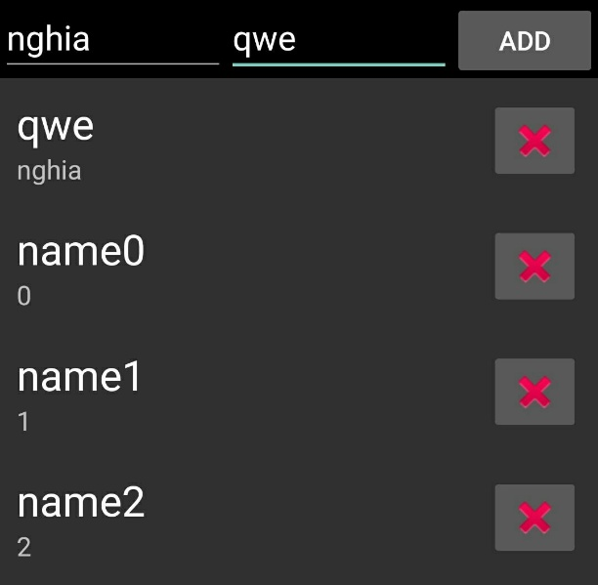

Bước 1: Thêm RecycleView trong: **build.gradle**

dependencies {

// RecyclerView

implementation 'com.android.support:recyclerview-v7:26.1.0'

}

Bước 2: Tạo trên giao diện activity layout:

<LinearLayout xmlns:android="http://schemas.android.com/apk/res/android"

xmlns:tools="http://schemas.android.com/tools"

android:layout_width="match_parent"

android:layout_height="match_parent"

android:orientation="vertical"

tools:context="com.imark.nghia.nghiacontainer_recyclerview_likelistview.MainActivity">

//Thêm mới

<LinearLayout

android:layout_width="match_parent"

android:layout_height="wrap_content"

android:orientation="horizontal"

android:background="#000000">

<EditText

android:id="@+id/main_edit_text_code"

android:layout_width="0dp"

android:layout_height="wrap_content"

android:layout_weight="1"

android:hint="Name"/>

<EditText

android:id="@+id/main_edit_text_name"

android:layout_width="0dp"

android:layout_height="wrap_content"

android:layout_weight="1"

android:hint="Code"/>

<Button

android:id="@+id/main_button_add"

android:layout_width="wrap_content"

android:layout_height="wrap_content"

android:text="Add"/>

</LinearLayout>

//Hiển thị danh sách

<android.support.v7.widget.RecyclerView

android:id="@+id/main_recycler_view"

android:layout_width="match_parent"

android:layout_height="match_parent"

android:scrollbars="vertical"/>

</LinearLayout>

Tạo giao diện Item: layout/item_recyclerview.xml

<RelativeLayout xmlns:android="http://schemas.android.com/apk/res/android"

android:layout_width="match_parent"

android:layout_height="wrap_content"

android:gravity="center_vertical"

android:padding="10dp">

<ImageButton

android:id="@+id/button_delete"

android:layout_width="wrap_content"

android:layout_height="match_parent"

android:src="@android:drawable/ic_delete"

android:layout_alignParentRight="true"

android:layout_alignParentEnd="true"

android:layout_centerInParent="true"/>

<TextView

android:id="@+id/text_view_name"

android:layout_width="match_parent"

android:layout_height="wrap_content"

android:textAppearance="?android:textAppearanceLarge"

android:layout_toLeftOf="@+id/button_delete"

android:layout_toStartOf="@+id/button_delete"/>

<TextView

android:id="@+id/text_view_code"

android:layout_width="match_parent"

android:layout_height="wrap_content"

android:layout_below="@+id/text_view_name"

android:layout_alignParentLeft="true"

android:layout_alignParentStart="true"

android:layout_toLeftOf="@+id/button_delete"

android:layout_toStartOf="@+id/button_delete"/>

</RelativeLayout>

Bước 2: Tạo ItemModel để lưu trữ Item: ItemModel.java

public class ItemModel {

public String Code;

public String Name;

public ItemModel(String code, String name) {

this.Code = code;

this.Name = name;

}

}

Khởi tạo Adapter kết nối Item: CustomRecyclerAdapter.java

public class CustomRecyclerAdapter extends RecyclerView.Adapter<CustomRecyclerAdapter.RecyclerViewHolder> {

private List<ItemModel> mListItem;

public CustomRecyclerAdapter(List<ItemModel> listItem) {

this.mListItem = listItem;

}

@Override

public RecyclerViewHolder onCreateViewHolder(ViewGroup viewGroup, int position) {

// Khởi tạo giao diện

LayoutInflater inflater = LayoutInflater.from(viewGroup.getContext());

View itemView = inflater.inflate(R.layout.item_recyclerview, viewGroup, false);

return new RecyclerViewHolder(itemView);

}

@Override

public void onBindViewHolder(RecyclerViewHolder recyclerViewHolder, int position) {

// Hiển thị giá trị lên giai diện

ItemModel itemModel = mListItem.get(position);

recyclerViewHolder.mTextView_Name.setText(itemModel.Name);

recyclerViewHolder.mTextView_Code.setText(itemModel.Code);

}

@Override

public int getItemCount() {

return mListItem.size();

}

/**ViewHolder for item view of list*/

public class RecyclerViewHolder extends RecyclerView.ViewHolder {

TextView mTextView_Code, mTextView_Name;

ImageButton mButton_Delete;

public RecyclerViewHolder(View itemView){

super(itemView);

// ----- Find View ----

mTextView_Code = (TextView) itemView.findViewById(R.id.text_view_code);

mTextView_Name = (TextView) itemView.findViewById(R.id.text_view_name);

mButton_Delete = (ImageButton) itemView.findViewById(R.id.button_delete);

// ----- Init ----- Nút xoá Item

mButton_Delete.setOnClickListener(new View.OnClickListener() {

@Override

public void onClick(View v) {

mListItem.remove(getAdapterPosition());

notifyItemRemoved(getAdapterPosition());

}

});

}

}

}

Bước 3: Sử dụng trong Activity

EditText mEditText_Name, mEditText_Code;

Button mButton_Add;

private RecyclerView mRecyclerView;

List<ItemModel> mListItem;

CustomRecyclerAdapter mAdapter;

@Override

protected void onCreate(Bundle savedInstanceState) {

//...

findViews();

initVars();

}

private void findViews() {

mEditText_Code = (EditText) findViewById(R.id.main_edit_text_code);

mEditText_Name = (EditText) findViewById(R.id.main_edit_text_name);

mButton_Add = (Button) findViewById(R.id.main_button_add);

mRecyclerView = (RecyclerView) findViewById(R.id.main_recycler_view);

}

private void initVars() {

//Tao Danh Sach

mListItem = new ArrayList<ItemModel>(){{

for(int i=0; i<100; i++){

add(new ItemModel(""+i, "name"+i));

}

}};

// If the size of views will not change as the data changes.

mRecyclerView.setHasFixedSize(true);

// Setting the LayoutManager.

LinearLayoutManager layoutManager = new LinearLayoutManager(this);

mRecyclerView.setLayoutManager(layoutManager);

mAdapter = new CustomRecyclerAdapter(mListItem);

mRecyclerView.setAdapter(mAdapter);

//Thêm Item tại Vị trí đầu tiên

mButton_Add.setOnClickListener(new View.OnClickListener() {

@Override

public void onClick(View v) {

mListItem.add(0, new ItemModel(

mEditText_Code.getText()+"",

mEditText_Name.getText()+""));

mAdapter.notifyDataSetChanged();

}

});

}