**EXPLANDABLE LISTVIEW**

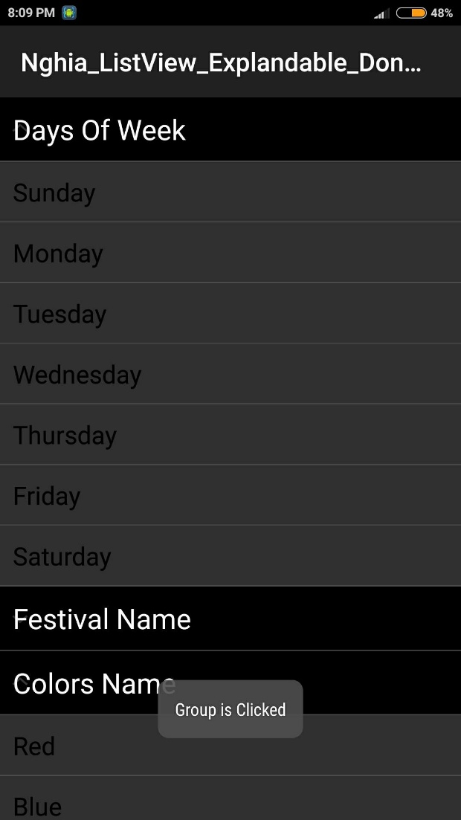Listview theo nhóm.

Bước 1: Tạo trong Activity layout

<ExpandableListView ... android:id="@+id/expListView"/ >

Thuộc tính:

Tạo giao diện cho Item: layout/list_item.xml

<LinearLayout xmlns:android="http://schemas.android.com/apk/res/android"

android:layout_width="match_parent"

android:layout_height="wrap_content"

android:padding="10dp"

android:orientation="horizontal" >

<TextView

android:id="@+id/textViewChild"

android:layout_width="fill_parent"

android:layout_height="wrap_content"

android:textColor="@android:color/black"

android:textSize="17sp" />

</LinearLayout>

Tạo giao diện Header: layout/list_header.xml

<LinearLayout xmlns:android="http://schemas.android.com/apk/res/android"

android:layout_width="fill_parent"

android:layout_height="wrap_content"

android:background="@android:color/black"

android:orientation="horizontal"

android:padding="10dp" >

<TextView

android:id="@+id/textViewHeader"

android:layout_width="fill_parent"

android:layout_height="wrap_content"

android:textColor="@android:color/white"

android:textSize="19sp" />

</LinearLayout>

Bước 2: tạo Explandable Adapter: ListAdapterExpandable.java

public class ListAdapterExpandable extends BaseExpandableListAdapter {

private Context context;

private List<String> headerArray;

private HashMap<String, ArrayList<String>> childArray;

private LayoutInflater infalInflater;

// Initialize constructor for array list

public ListAdapterExpandable(Context context, ArrayList<String> headerArray,

HashMap<String, ArrayList<String>> listChildData) {

this.context = context;

this.headerArray = headerArray;

this.childArray = listChildData;

infalInflater = (LayoutInflater) this.context

.getSystemService(Context.LAYOUT_INFLATER_SERVICE);

}

@Override

public Object getChild(int groupPosition, int childPosititon) {

return this.childArray.get(this.headerArray.get(groupPosition))

.get(childPosititon);

}

@Override

public long getChildId(int groupPosition, int childPosition) {

return childPosition;

}

@Override

public int getChildrenCount(int groupPosition) {

return this.childArray.get(this.headerArray.get(groupPosition))

.size();

}

@Override

public Object getGroup(int groupPosition) {

return this.headerArray.get(groupPosition);

}

@Override

public int getGroupCount() {

return this.headerArray.size();

}

@Override

public long getGroupId(int groupPosition) {

return groupPosition;

}

@Override

public boolean hasStableIds() {

return false;

}

@Override

public boolean isChildSelectable(int groupPosition, int childPosition) {

return true;

}

@Override

public View getGroupView(int groupPosition, boolean isExpanded,

View convertView, ViewGroup parent) {

//Khởi tạo Header qua Inflater

String headerTitle = (String) getGroup(groupPosition);

if (convertView == null) {

convertView = infalInflater.inflate(R.layout.list_header, null);

}

TextView textViewHeader = (TextView) convertView.findViewById(R.id.textViewHeader);

textViewHeader.setText(headerTitle);

return convertView;

}

@Override

public View getChildView(int groupPosition, final int childPosition,

boolean isLastChild, View convertView, ViewGroup parent) {

//Khởi tạo Item qua Inflater

final String childText = (String) getChild(groupPosition, childPosition);

if (convertView == null) {

convertView = infalInflater.inflate(R.layout.list_item, null);

}

TextView textViewChild = (TextView) convertView.findViewById(R.id.textViewChild);

textViewChild.setText(childText);

return convertView;

}

}

Bước 3: Sử dụng trong Activity

private ExpandableListView expListView;

private ListAdapterExpandable adapter;

// List Header

ArrayList<String> headersArrayList = new ArrayList<String>();

// List Header + Item

HashMap<String, ArrayList<String>> childArrayList = new HashMap<String, ArrayList<String>>();

@Override

protected void onCreate(Bundle savedInstanceState) {

...

//--- Khởi tạo dữ liệu ---

// add headers values

headersArrayList.add("Days Of Week");

headersArrayList.add("Festival Name");

headersArrayList.add("Colors Name");

// add add child content

ArrayList<String> daysOfWeekArrayList = new ArrayList<String>();

daysOfWeekArrayList.add("Sunday");

daysOfWeekArrayList.add("Monday");

daysOfWeekArrayList.add("Tuesday");

daysOfWeekArrayList.add("Wednesday");

daysOfWeekArrayList.add("Thursday");

daysOfWeekArrayList.add("Friday");

daysOfWeekArrayList.add("Saturday");

childArrayList.put("Days Of Week", daysOfWeekArrayList);

ArrayList<String> festivalArrayList = new ArrayList<String>();

festivalArrayList.add("Diwali");

festivalArrayList.add("Holi");

festivalArrayList.add("Christmas");

festivalArrayList.add("Vijay Dashmi");

childArrayList.put("Festival Name", festivalArrayList);

ArrayList<String> colorsArrayList = new ArrayList<String>();

colorsArrayList.add("Red");

colorsArrayList.add("Blue");

colorsArrayList.add("Green");

childArrayList.put("Colors Name", colorsArrayList);

//--- khởi tạo ListView ---

expListView = (ExpandableListView) findViewById(R.id.expListView);

adapter = new ListAdapterExpandable(this, headersArrayList, childArrayList);

expListView.setAdapter(adapter);

//--- Event ---

expListView.setOnChildClickListener(new ExpandableListView.OnChildClickListener() {

@Override

public boolean onChildClick(ExpandableListView parent, View v,

int groupPosition, int childPosition, long id) {

Toast.makeText(getApplicationContext(), "Child is clicked", Toast.LENGTH_LONG).show();

return false;

}

});

expListView.setOnGroupClickListener(new ExpandableListView.OnGroupClickListener() {

@Override

public boolean onGroupClick(ExpandableListView parent, View v,

int groupPosition, long id) {

Toast.makeText(getApplicationContext(), "Group is Clicked", Toast.LENGTH_LONG).show();

return false;

}

});

expListView.setOnGroupCollapseListener(new ExpandableListView.OnGroupCollapseListener() {

@Override

public void onGroupCollapse(int groupPosition) {

Toast.makeText(getApplicationContext(), "Child is Collapsed", Toast.LENGTH_SHORT).show();

}

});

expListView.setOnGroupExpandListener(new ExpandableListView.OnGroupExpandListener() {

@Override

public void onGroupExpand(int groupPosition) {

Toast.makeText(getApplicationContext(), "Child is Expanded", Toast.LENGTH_SHORT).show();

}

});

}