**NOTIFICATION Custom Layout XML**

Tạo giao diện notification qua XML layout file.

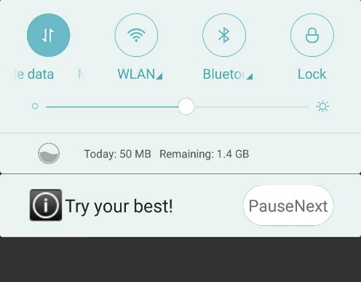

Bước 1: Tạo giao diện Notification: layout/custom_notification.xml

...

<ImageView android:id="@+id/imageView" .../>

<TextView android:id="@+id/textView" .../>

<Button android:id="@+id/button_pause"

android:text="Pause" .../>

<Button android:id="@+id/button_next"

android:text="Next" .../>

Tạo giao diện notification khi mở rộng: layout/custom_notification_expanded.xml (Tạo sao cũng được ))

Bước 2: hiện Notification trong Activity

/** Show Custom XML Notification */

private void showNotification() {

//---- Build Notification interface ----

Notification.Builder builder = new Notification.Builder(this);

builder.setSmallIcon(R.drawable.ic_stat_custom);

builder.setAutoCancel(true); //Đóng khi chạm

//---Notification Click => Use Intent => Open Activity---

Intent i = new Intent(this, MainActivity.class);

i.setFlags(Intent.FLAG_ACTIVITY_SINGLE_TOP);

PendingIntent pi = PendingIntent.getActivity(this, 0, i, PendingIntent.FLAG_UPDATE_CURRENT);

builder.setContentIntent(pi);

//---Set XML Layout for Notification

Notification notification = builder.build();

RemoteViews contentView1 = new RemoteViews(getPackageName(),

R.layout.custom_notification); //Nomal Interface

RemoteViews contentView2 = new RemoteViews(getPackageName(),

R.layout.custom_notification_expanded); //Expanded Interface

notification.contentView = contentView1; // replace with builder.setCustomContentView

notification.bigContentView = contentView2;

//--- Setup View inside XML Layout ---

contentView1.setTextViewText(R.id.textView, "Try your best!");

contentView1.setOnClickPendingIntent(R.id.button_next, pi); //Set Intent for button_next

// Show Notification

NotificationManager manager = (NotificationManager) getSystemService(NOTIFICATION_SERVICE);

manager.notify(0, notification);

}