**Preference Screen**

Màn hình cài đặt.

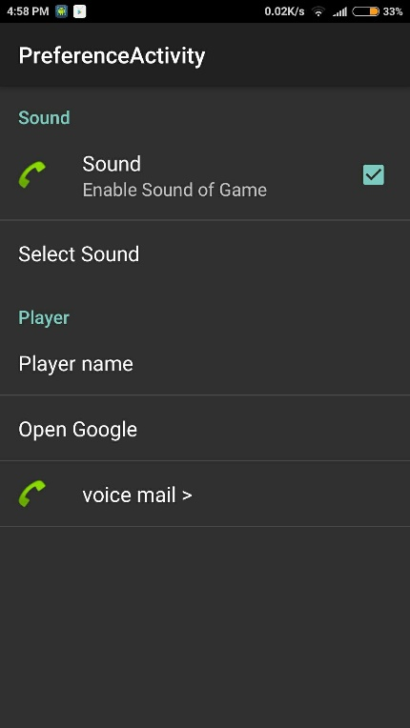

Bước 1: tạo file Setting: res/xml/app_preference.xml

<PreferenceScreen xmlns:android="http://schemas.android.com/apk/res/android">

<!--Nhóm-->

<PreferenceCategory android:title="Sound">

<!--Check box-->

<!--key: key lưu trữ, like Id-->

<CheckBoxPreference

android:key="has_sound"

android:defaultValue="true"

android:title="Sound"

android:summary="Enable Sound of Game"

android:icon="@android:drawable/sym_action_call"/>

<!--List chọn-->

<ListPreference

android:key="sound_index"

android:title="Select Sound"

android:defaultValue="1"

android:entries="@array/soundArray"

android:entryValues="@array/soundValues" />

</PreferenceCategory>

<PreferenceCategory android:title="Player">

<!--Mở nhập văn bản-->

<EditTextPreference

android:key="player_name"

android:title="Player name"

android:dialogTitle="Enter your name" />

<!--Mở Intent-->

<Preference android:title="Open Google" >

<intent android:action="android.intent.action.VIEW"

android:data="http://www.google.com.vn" />

<!--android:mimeType

android:targetClass

android:targetPackage-->

</Preference>

</PreferenceCategory>

<!--Mở màn hình phụ-->

<PreferenceScreen

android:key="button_voicemail_category_key"

android:title="voice mail >"

android:persistent="false">

<!--Mở chọn Ringtone-->

<RingtonePreference

android:key="button_voicemail_ringtone_key"

android:title="Select Sound"

android:ringtoneType="notification" />

</PreferenceScreen>

</PreferenceScreen>

Thuộc tính:

* android:key="has_sound": giá trị lưu trong Preference
* android:title="Sound"
* android:summary="Enable Sound of Game"
* android:icon="@android:drawable/sym_action_call"
* android:defaultValue="true"
* android:entries="@array/soundArray": Danh sách hiện chọn
* android:entryValues="@array/soundValues": Danh sách giá trị chọn, lưu giá trị trong list này.
* android:dialogTitle="Enter your name"

Bước 2: tạo fragment load file từ Resource: PrefsFragment.java

public class PrefsFragment extends PreferenceFragment {

@Override

public void onCreate(Bundle savedInstanceState) {

// TODO Auto-generated method stub

super.onCreate(savedInstanceState);

// Tải preferences từ XML

addPreferencesFromResource(R.xml.app_preference);

}

}

Bước 3: Activity Setting load fragment: PreferenceActivity.java

@Override

protected void onCreate(Bundle savedInstanceState) {

super.onCreate(savedInstanceState);

getFragmentManager().beginTransaction().replace(android.R.id.content,

new PrefsFragment(), "frag_tag").commit();

}

Bước 4: Tải dữ liệu đã lưu:

/** Lấy Pref */

private void loadPref(){

SharedPreferences sp = PreferenceManager.getDefaultSharedPreferences(this);

//get from Check Box

boolean sound = sp.getBoolean("has_sound", false);

CheckBox prefCheckBox = (CheckBox)findViewById(R.id.prefCheckBox);

prefCheckBox.setChecked(sound);

//get from List Array

String soundName = sp.getString("sound_index", "1");

TextView vSoundName = (TextView)findViewById(R.id.textview_sound);

vSoundName.setText(soundName);

//get from Edit text

String playerName = sp.getString("player_name", "empty");

TextView vPlayerName = (TextView)findViewById(R.id.textview_player_name);

vPlayerName.setText(playerName);

}