**TOAST CUSTOM LAYOUT**

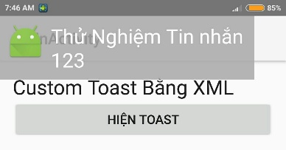

Lưu ý: ko sử dụng Input Control cho Toast được, chỉ hiện ko dùng được.

Tạo file layout cho Toast: layout/toast_layout.xml

<LinearLayout android:id="@+id/toast_layout_root"

xmlns:android="http://schemas.android.com/apk/res/android"

android:orientation="horizontal"

android:layout_width="fill_parent"

android:layout_height="fill_parent"

android:padding="8dp"

android:background="#DAAA" >

<ImageView android:src="@mipmap/ic_launcher"

android:layout_width="wrap_content"

android:layout_height="wrap_content"

android:layout_marginRight="8dp" />

<TextView android:id="@+id/text"

android:textAppearance="?android:textAppearanceLarge"

android:layout_width="wrap_content"

android:layout_height="wrap_content"

android:textColor="#FFF" />

</LinearLayout>

Hiển thị Toast trong Activity:

public void showToast(View view) {

CharSequence text_message = "Thử Nghiệm Tin nhắn 123";

Toast toast = Toast.makeText(getBaseContext(), text_message, Toast.LENGTH_SHORT);

// Vị trí TOP | LEFT (Trên cùng, tay trái)

toast.setGravity(Gravity.TOP|Gravity.LEFT, 0, 0);

//----- Set Toast Layout -----

LayoutInflater inflater = getLayoutInflater();

View layout = inflater.inflate(R.layout.toast_layout, (ViewGroup) findViewById(R.id.toast_layout_root));

TextView textView = (TextView) layout.findViewById(R.id.text);

textView.setText(text_message);

toast.setView(layout);

toast.show();

}

}