**ListView Custom Layout**

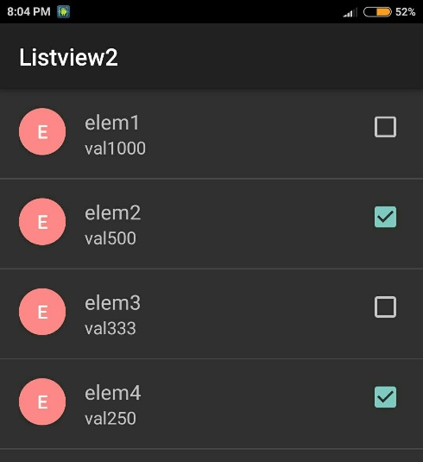

Bước 1: Tạo List trong XML: layout/activity.xml

… <ListView ... android:id="@+id/listview"/>

Tạo giao diện mỗi Item: layout/list_item.xml

<RelativeLayout xmlns:android="http://schemas.android.com/apk/res/android"

android:layout_width="match_parent"

android:layout_height="match_parent"

android:padding="16dp">

<LinearLayout

android:id="@+id/linearlayout1"

android:orientation="vertical"

android:layout_width="40dp"

android:layout_height="wrap_content"

android:gravity="center_vertical">

<Button

android:text="A"

android:textSize="14sp"

android:layout_width="40dp"

android:layout_height="40dp"

android:id="@+id/button_round"

android:background="@drawable/round_button"/>

</LinearLayout>

<LinearLayout

android:id="@+id/linearlayout_right"

android:orientation="vertical"

android:layout_width="wrap_content"

android:layout_height="wrap_content"

android:layout_alignParentRight="true" >

<CheckBox

android:id="@+id/checkbox_selected"

android:layout_width="wrap_content"

android:layout_height="wrap_content"/>

</LinearLayout>

<LinearLayout

android:orientation="vertical"

android:layout_width="match_parent"

android:layout_height="wrap_content"

android:layout_toLeftOf="@+id/linearlayout_right"

android:layout_toRightOf="@+id/linearlayout1"

android:layout_toEndOf="@+id/linearlayout1"

android:paddingLeft="16dp">

<TextView

android:layout_width="match_parent"

android:layout_height="wrap_content"

android:textSize="15sp"

android:text="empty"

android:id="@+id/textView_Display" />

<TextView

android:layout_width="match_parent"

android:layout_height="wrap_content"

android:textSize="13sp"

android:text="empty"

android:id="@+id/textView_Value" />

</LinearLayout>

</RelativeLayout>

Tạo hình nền tròn: drawable/round_button.xml

<selector xmlns:android="http://schemas.android.com/apk/res/android">

<item>

<shape android:shape="oval">

<solid android:color="#ff8888"/>

</shape>

</item>

</selector>

Bước 2: khởi tạo List trong Activity:

ListView listview = (ListView)findViewById(R.id.listview);

// make array list

list = new ArrayList<SimpleType>();

for (int i=1; i<=100; i++) {

list.add(new SimpleType("elem"+i, "val"+1000/i));

}

//init ListView

final Custom1Adapter adapter = new Custom1Adapter(this,

R.layout.list_item, list);

listview.setAdapter(adapter);

//--- Even ---

//Remove item when Item click

listview.setOnItemClickListener(new AdapterView.OnItemClickListener() {

@Override

public void onItemClick(AdapterView<?> parent, final View view, int position, long id) {

final SimpleType item = (SimpleType) parent.getItemAtPosition(position);

//Sử lý item được chọn...

}

});

Bước 3: tạo 1 lớp SimpleType lưu giá trị, có chọn.

public class SimpleType

{

public String Display;

public String Value;

public boolean Selected = false;

public SimpleType(String display, String value) {

this.Display = display;

this.Value = value;

}

}

Bước 4: Tạo 1 lớp kế thừa ArrayAdapter để kết nối Item vào List: Custom1Adapter.java

public class Custom1Adapter extends ArrayAdapter<SimpleType> {

public static final long ACTION_ID_ADD = -1;

private final Context mContext;

private final int mLayoutResourceId;

private final List<SimpleType> mList;

//Khởi tạo Adapter

public Custom1Adapter(Context context, int layoutResourceId, List<SimpleType> listAssign) {

super(context, layoutResourceId, listAssign);

this.mContext = context;

this.mLayoutResourceId = layoutResourceId;

this.mList = listAssign;

}

@Override

public int getCount() {

// tránh bị lỗi Out of Size

return mList.size();

}

@Override

public View getDropDownView(int position, View convertView, ViewGroup parent) {

//Hien thi DropDownList, spinner

return getView(position, convertView, parent);

}

@Override

public View getView(final int position, View convertView, ViewGroup parent) {

//kết nối Item vào List

final SimpleType item = mList.get(position);

// ----- Init View -----

final AssignViewHolder viewHolder;

if (convertView == null){

convertView = ((Activity)mContext)

.getLayoutInflater().inflate(this.mLayoutResourceId, parent, false);

viewHolder = new AssignViewHolder();

viewHolder.textView_Display =

(TextView) convertView.findViewById(R.id.textView_Display);

viewHolder.textView_Value =

(TextView) convertView.findViewById(R.id.textView_Value);

viewHolder.button_Round =

(Button) convertView.findViewById(R.id.button_round);

viewHolder.checkbox_selected =

(CheckBox) convertView.findViewById(R.id.checkbox_selected);

//---Event--- đổi trạng thái CheckBox

viewHolder.checkbox_selected.setOnClickListener( new View.OnClickListener() {

public void onClick(View v) {

CheckBox cb = (CheckBox) v ;

SimpleType st = (SimpleType)viewHolder.checkbox_selected.getTag();

st.Selected = cb.isChecked();

}

});

convertView.setTag(viewHolder); //Lưu viewHolder vào tag

} else {

//Lấy lại ViewHolder đã lưu trong tag

viewHolder = (AssignViewHolder) convertView.getTag();

}

//Lưu giá trị Item vào Checbox tag, để gọi lại trong sự kiện

viewHolder.checkbox_selected.setTag(item);

// ----- Set value - Display Giao diện ------

viewHolder.textView_Display.setText(item.Display);

viewHolder.textView_Value.setText(item.Value);

viewHolder.button_Round.setText(item.Display.substring(0,1));

viewHolder.checkbox_selected.setChecked(item.Selected);

return convertView;

}

/**TÁc dụng: Hiệu suất */

private class AssignViewHolder {

TextView textView_Display;

TextView textView_Value;

Button button_Round; //text image

CheckBox checkbox_selected;

}

}