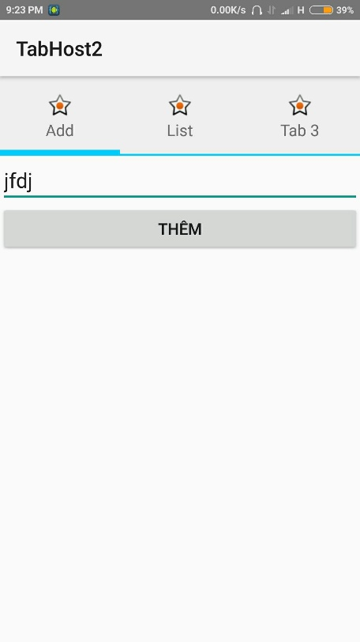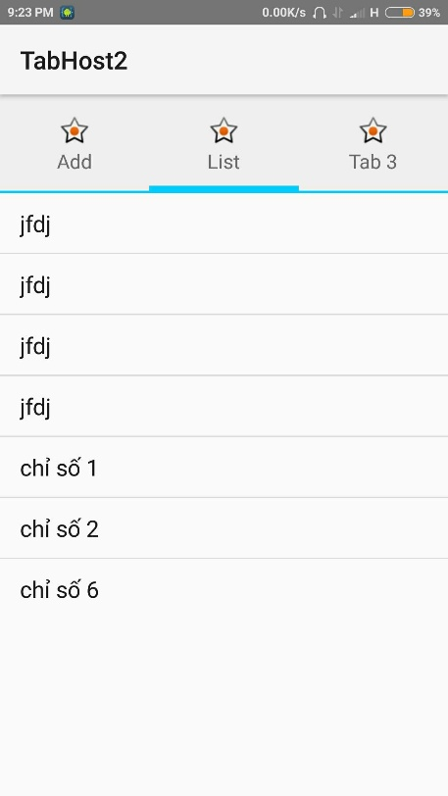**TABHOST**

**Giao diện:**

File hiển thị tabhost: layout/main.xml

<!--khởi tạo tabhost layout -->

<TabHost xmlns:android="http://schemas.android.com/apk/res/android"

android:id="@+id/my_tabhost"

android:layout_width="match_parent"

android:layout_height="match_parent" >

<LinearLayout

android:layout_width="match_parent"

android:layout_height="match_parent"

android:orientation="vertical" >

<!-- Giao diện Tab header -->

<TabWidget

android:id="@android:id/tabs"

android:layout_width="match_parent"

android:layout_height="wrap_content" >

</TabWidget>

<!-- Giao diện các tab -->

<FrameLayout

android:id="@android:id/tabcontent"

android:layout_width="match_parent"

android:layout_height="match_parent" >

<!--Nội dung tab1 -->

<LinearLayout

android:id="@+id/tab1"

android:layout_width="match_parent"

android:layout_height="match_parent" >

<!--gọi giao diện Tab1 vào-->

<include

android:layout_width="match_parent"

android:layout_height="wrap_content"

layout="@layout/tab1_layout" />

</LinearLayout>

<!-- Nội dung tab 2 -->

<LinearLayout

android:id="@+id/tab2"

android:layout_width="match_parent"

android:layout_height="match_parent" >

<!--Gọi Tab 2 vào-->

<include

android:layout_width="wrap_content"

android:layout_height="wrap_content"

layout="@layout/tab2_layout" />

</LinearLayout>

<!-- nội dung tab 3-->

<LinearLayout

android:id="@+id/tab3"

android:layout_width="match_parent"

android:layout_height="match_parent" >

<TextView

android:id="@+id/textView3"

android:layout_width="wrap_content"

android:layout_height="wrap_content"

android:text="Tab 3 Content" />

</LinearLayout>

</FrameLayout>

</LinearLayout>

</TabHost>

File hiển thị tab header: layout/tab_header_layout.xml

<!--Giao diện Tiêu đề của Tab-->

<LinearLayout xmlns:android="http://schemas.android.com/apk/res/android"

android:layout_width="fill_parent"

android:layout_height="fill_parent"

android:background="@drawable/tab_indicator"

android:orientation="vertical" >

<ImageView android:id="@+id/imageView"

android:layout_width="wrap_content"

android:layout_height="wrap_content"

android:layout_centerHorizontal="true"

android:layout_gravity="center_horizontal" />

<TextView

android:id="@+id/textView"

android:layout_width="wrap_content"

android:layout_height="wrap_content"

android:layout_gravity="center_vertical|center_horizontal" />

</LinearLayout>

File giao diện tab 1: layout/tab1_layout.xml

<?xml version="1.0" encoding="utf-8"?>

<!--Giao diện tab 1 - thêm text-->

<LinearLayout xmlns:android="http://schemas.android.com/apk/res/android"

android:layout_width="match_parent"

android:layout_height="match_parent"

android:orientation="vertical">

<EditText android:id="@+id/edtValue"

android:layout_width="match_parent"

android:layout_height="wrap_content"

android:hint="Any Text"/>

<Button android:id="@+id/btnAdd"

android:layout_width="match_parent"

android:layout_height="wrap_content"

android:text="Thêm"/>

</LinearLayout>

File giao diện tab 2: layout/tab2_layout.xml

<?xml version="1.0" encoding="utf-8"?>

<!--Giao diện Tab 2 - danh sách -->

<LinearLayout xmlns:android="http://schemas.android.com/apk/res/android"

android:orientation="vertical" android:layout_width="match_parent"

android:layout_height="match_parent">

<ListView android:id="@+id/livItem"

android:layout_width="match_parent"

android:layout_height="wrap_content">

</ListView>

</LinearLayout>

File background, trạng thái nhấn của tab header: drawable/ tab_indicator.xml

<!-- Trạng thái nhấn Của Tab Header-->

<selector xmlns:android="http://schemas.android.com/apk/res/android">

<!-- Non focused states -->

<item android:state_focused="false" android:state_selected="false" android:state_pressed="false" android:drawable="@drawable/tab_unselected" />

<item android:state_focused="false" android:state_selected="true" android:state_pressed="false" android:drawable="@drawable/tab_selected" />

<!-- Focused states -->

<item android:state_focused="true" android:state_selected="false" android:state_pressed="false" android:drawable="@drawable/tab_focused" />

<item android:state_focused="true" android:state_selected="true" android:state_pressed="false" android:drawable="@drawable/tab_focused" />

<!-- Pressed -->

<item android:state_selected="true" android:state_pressed="true" android:drawable="@drawable/tab_pressed" />

<item android:state_pressed="true" android:drawable="@drawable/tab_pressed" />

</selector>

File drawble/tab_focused.xml

<shape xmlns:android="http://schemas.android.com/apk/res/android"

android:shape="rectangle"

android:padding="10dp">

<gradient android:startColor="#ffcc00"

android:endColor="#ffcc00"

android:angle="-90" />

</shape>

File: drawable/tab_pressed.xml

<layer-list xmlns:android="http://schemas.android.com/apk/res/android" >

<item>

<shape android:shape="rectangle">

<solid android:color="#FFcccccc" />

</shape>

</item>

<item android:top="-3dp" android:bottom="0dp" android:left="-3dp" android:right="-3dp">

<shape

android:shape="rectangle">

<padding android:left="10dp"

android:top="15dp"

android:right="10dp"

android:bottom="15dp" />

<stroke android:width="2dp" android:color="#FF00ccff" />

<solid android:color="#00000000" />

</shape>

</item>

</layer-list>

File drawable/tab_selected.xml

<layer-list xmlns:android="http://schemas.android.com/apk/res/android" >

<item>

<shape android:shape="rectangle">

<solid android:color="#FFefefef" />

</shape>

</item>

<item android:top="-7dp" android:bottom="0dp" android:left="-7dp" android:right="-7dp">

<shape

android:shape="rectangle">

<padding android:left="10dp"

android:top="15dp"

android:right="10dp"

android:bottom="15dp" />

<stroke android:width="6dp" android:color="#FF00ccff" />

<solid android:color="#00000000" />

</shape>

</item>

</layer-list>

File drawable/tab_unselected.xml

<layer-list xmlns:android="http://schemas.android.com/apk/res/android" >

<item>

<shape android:shape="rectangle">

<solid android:color="#FFefefef" />

</shape>

</item>

<item android:top="-3dp" android:bottom="0dp" android:left="-3dp" android:right="-3dp">

<shape android:shape="rectangle">

<padding android:left="10dp"

android:top="15dp"

android:right="10dp"

android:bottom="15dp" />

<stroke android:width="2dp" android:color="#FF00ccff" />

<solid android:color="#00000000" />

</shape>

</item>

</layer-list>

**File activity java**

File: MainActivity.java

public class MainActivity extends Activity {

private EditText mEdtValue;

private Button mBtnAdd;

private ListView mLivItem;

private ArrayList<String> mLstLivItem;

private ArrayAdapter<String> mAdtLivItem;

@Override

public void onCreate(Bundle savedInstanceState) {

super.onCreate(savedInstanceState);

setContentView(R.layout.main);

loadMyTab();

//Sử lý các View trong tab

findViews();

initVariables();

}

//Khởi tạo TabHost

void loadMyTab(){

final TabHost tabHost = (TabHost)findViewById(R.id.my_tabhost);

this.setNewTab(this, tabHost, "tab1", R.string.tab_title1, android.R.drawable.star_on, R.id.tab1);

this.setNewTab(this, tabHost, "tab2", R.string.tab_title2, android.R.drawable.star_on, R.id.tab2);

this.setNewTab(this, tabHost, "tab3", R.string.tab_title3, android.R.drawable.star_on, R.id.tab3);

//Sự kiện chuyển Tab

tabHost.setOnTabChangedListener(new TabHost.OnTabChangeListener() {

@Override

public void onTabChanged(String arg0) {

String message = String.format("TabTag=%s, index=%s",

arg0, tabHost.getCurrentTab());

Toast.makeText(getApplicationContext(), message, Toast.LENGTH_SHORT).show();

}

});

}

//Thêm Tab vào TabHost

private void setNewTab(Context context, TabHost tabHost, String tag, int title, int icon, int contentID ){

tabHost.setup();

TabHost.TabSpec tabSpec = tabHost.newTabSpec(tag);

//Đặt giao diện tab Header

tabSpec.setIndicator(getTabIndicator(tabHost.getContext(), title, icon));

tabSpec.setContent(contentID); //Đặt layoutId hiển thị tab

tabHost.addTab(tabSpec); //thêm tab vào tabhost

}

//Đặt giá trị Cho giao diện tab header

private View getTabIndicator(Context context, int title, int icon) {

//Lấy View từ file xml layout, đặt giá trị.

View view = LayoutInflater.from(context).inflate(R.layout.tab_header_layout, null);

ImageView iv = (ImageView) view.findViewById(R.id.imageView);

iv.setImageResource(icon);

TextView tv = (TextView) view.findViewById(R.id.textView);

tv.setText(title);

return view;

}

void findViews(){

mEdtValue = (EditText)findViewById(R.id.edtValue);

mBtnAdd = (Button)findViewById(R.id.btnAdd);

mLivItem = (ListView)findViewById(R.id.livItem);

}

void initVariables(){

mLstLivItem = new ArrayList<String>();

mAdtLivItem = new ArrayAdapter<String>(this, android.R.layout.simple_list_item_1, mLstLivItem);

mLivItem.setAdapter(mAdtLivItem);

mBtnAdd.setOnClickListener(new View.OnClickListener() {

@Override

public void onClick(View v) {

String value = mEdtValue.getText() + "";

mLstLivItem.add(value);

mAdtLivItem.notifyDataSetChanged();

}

});

}

}