Object Oriented Programming 2800ICT: Assignment Milestone
Phoenix Asange-Harper

Section 1: UML

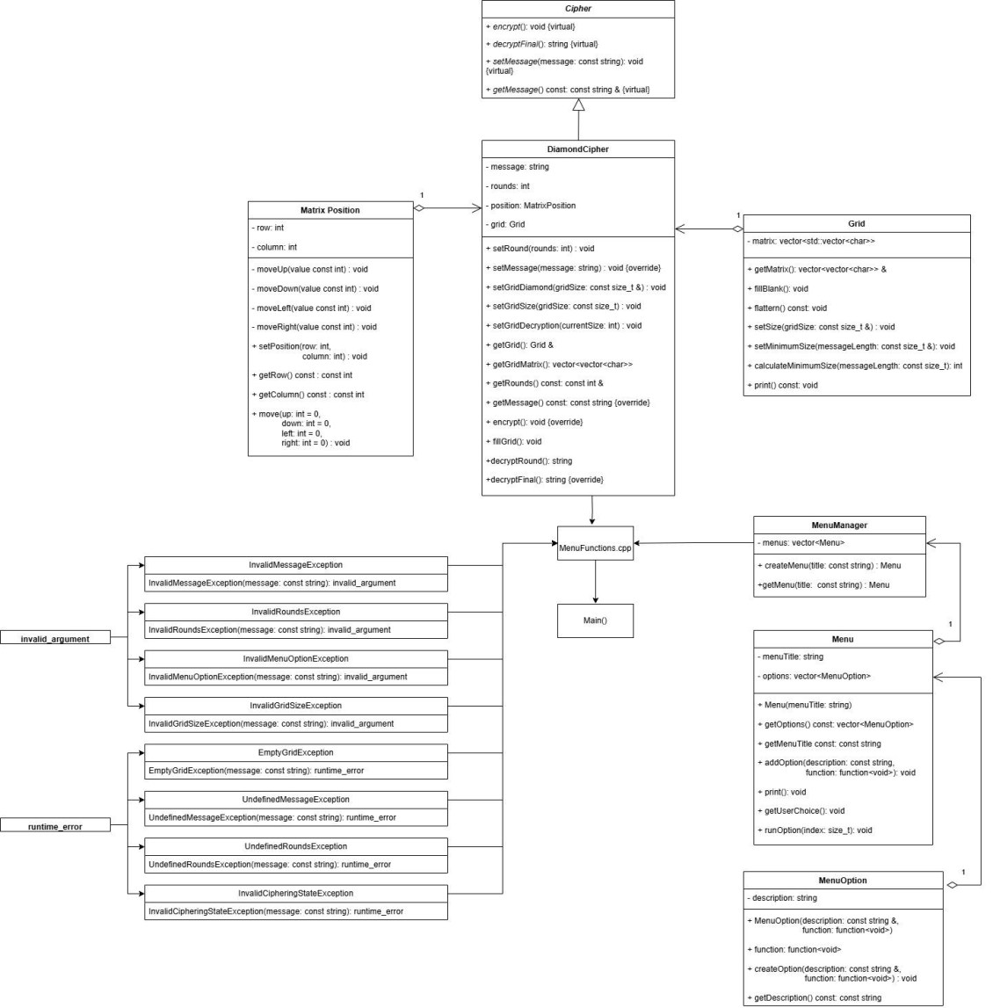
MenuFunctions.hpp
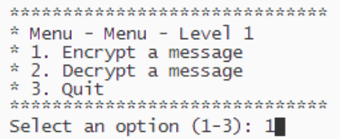
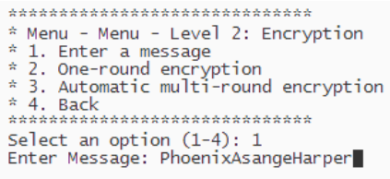
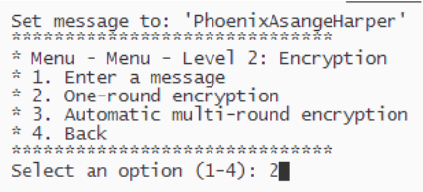
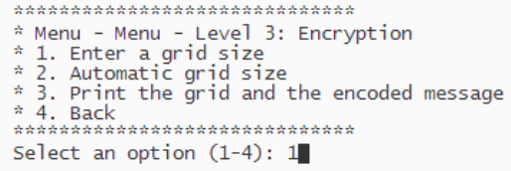
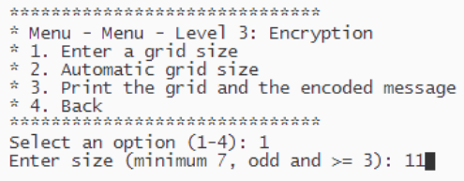
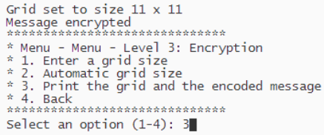
Section 2: Normal Execution

Scenario 1:

Encryption menu / Enter a message

One-round encryption menu

Enter a grid size

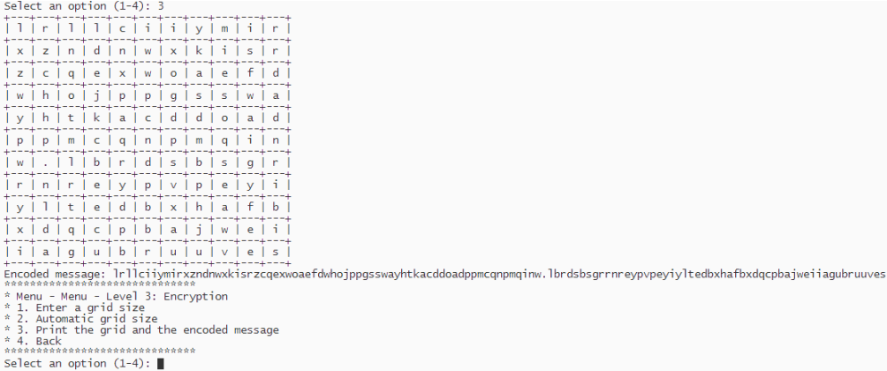
Print the grid and encoded message
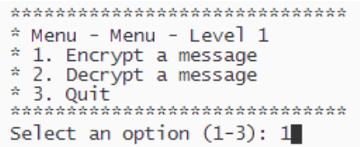

Scenario 2:

Encryption menu

Enter a message


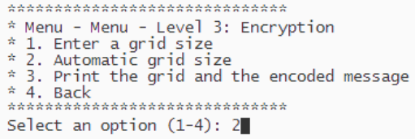
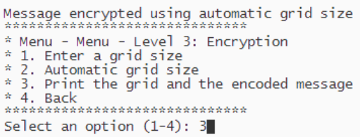
One-round encryption menu
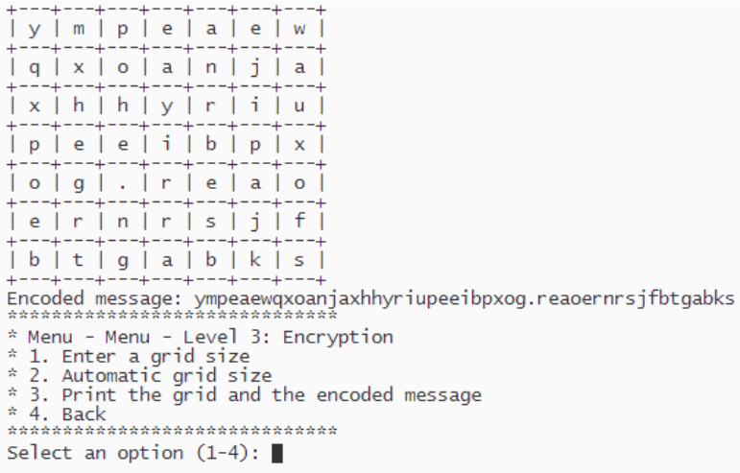
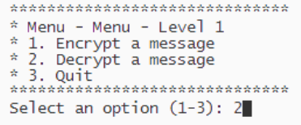
Print the grid and the encoded message

Decryption menu

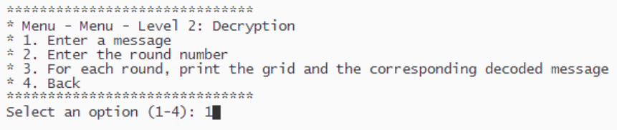
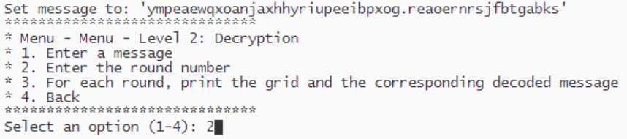
Enter a message
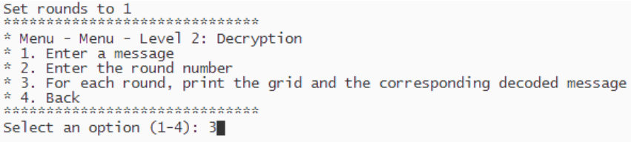
Set rounds

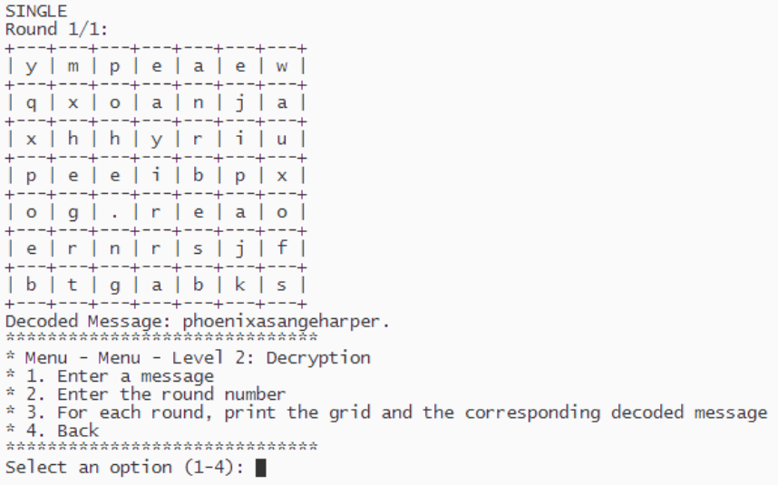
For each round, print the grid and the corresponding decoded message

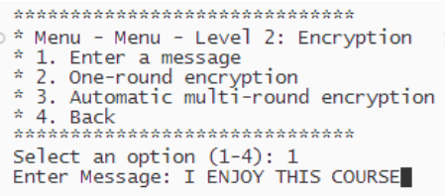
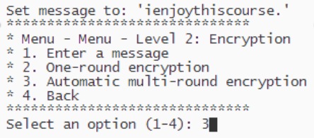
Scenario 3:

Encryption menu

Enter a message

Set message

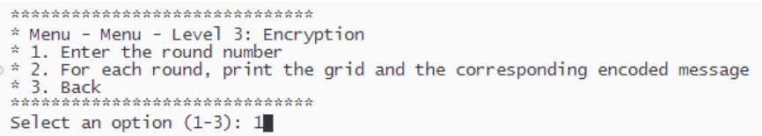
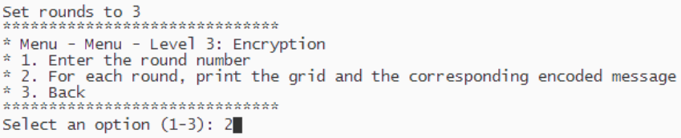
Set rounds
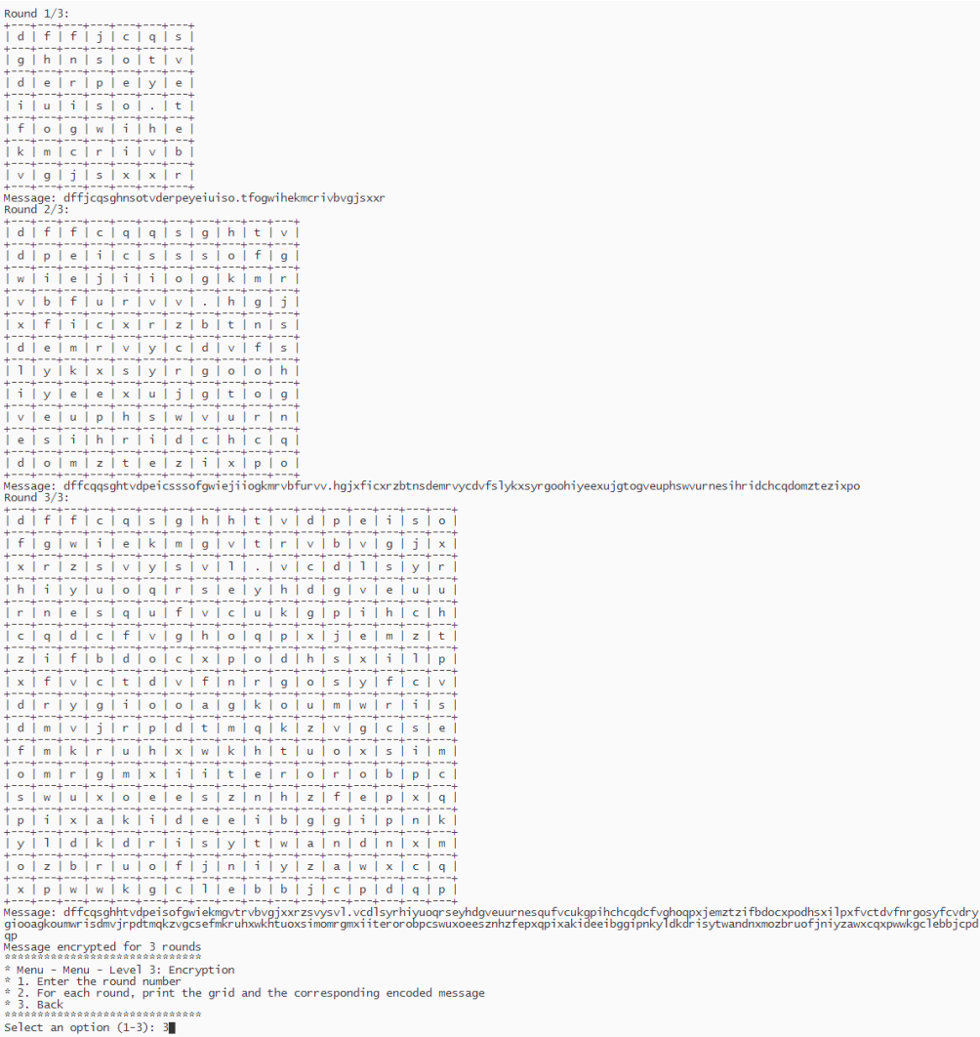
For each round, print the grid and the corresponding encoded message


Decryption menu
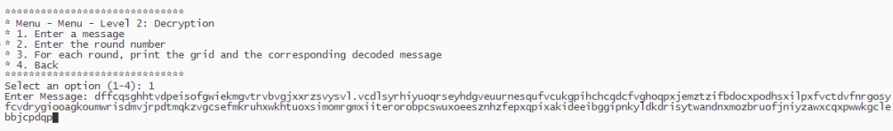
Enter a message

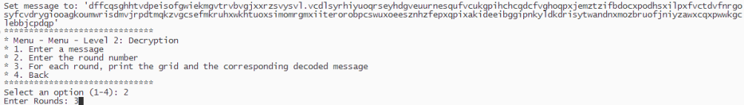
Set rounds
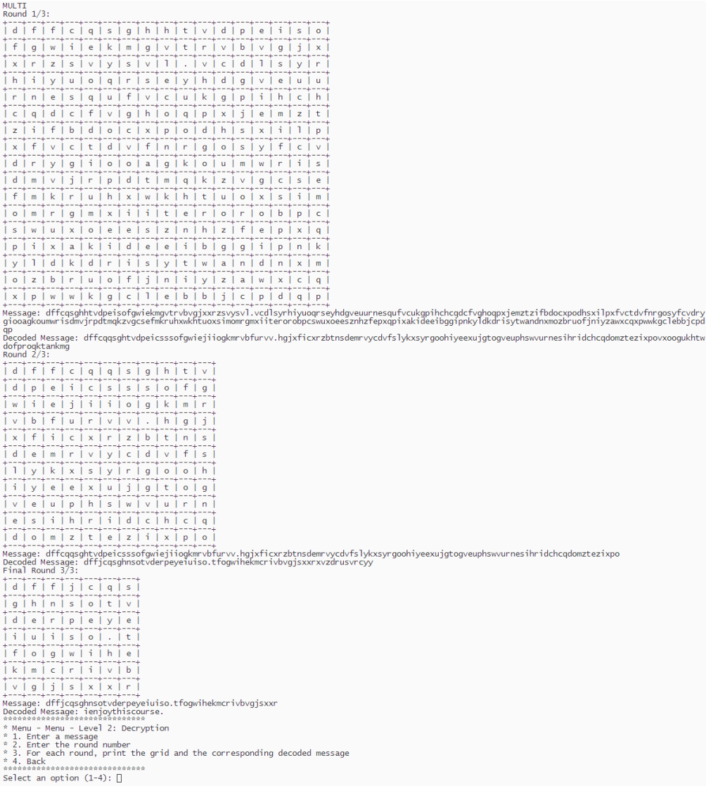
For each round, print the grid and the corresponding decoded message
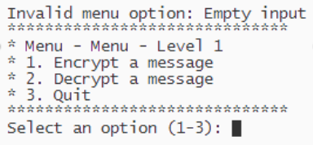
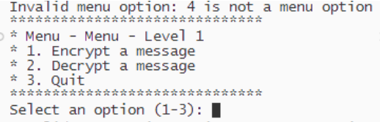
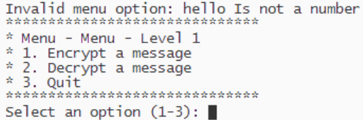
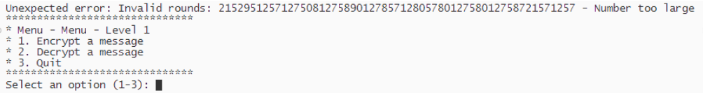
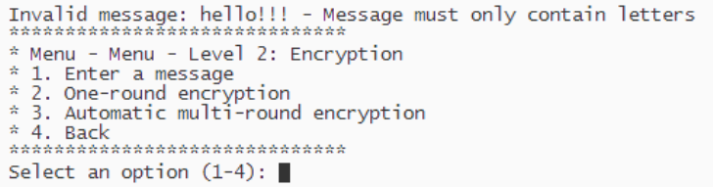
Section 3: Abnormal Execution

Menu navigation:

• Empty input (‘ ‘ or pressing enter)

• Option out of range

• Character input

• Extremely large number

Message input:

• Message has characters that aren’t letters

• Empty input (‘ ‘ or pressing enter)
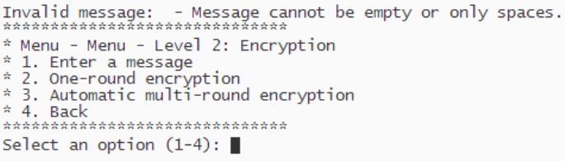
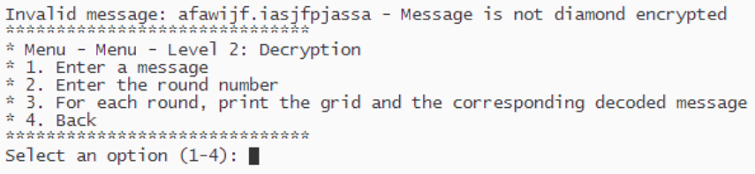
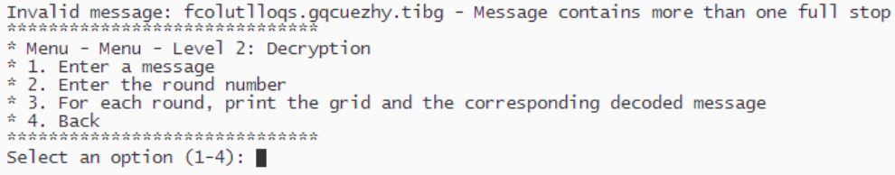
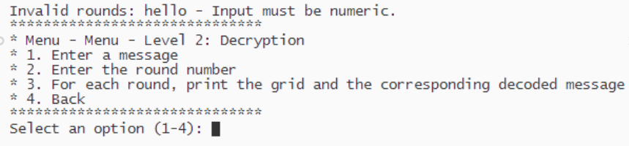
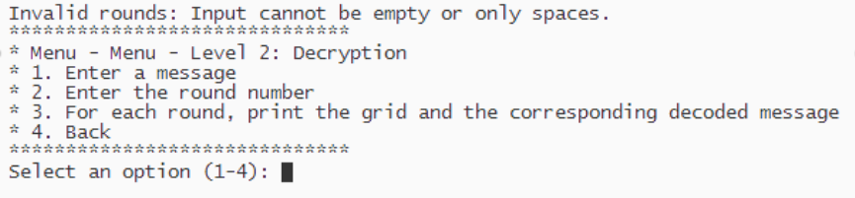

• Not a valid encrypted message (during decryption)

• Encrypted message has multiple full stops

Round input:

• Character input

• Empty input

• Extremely large input
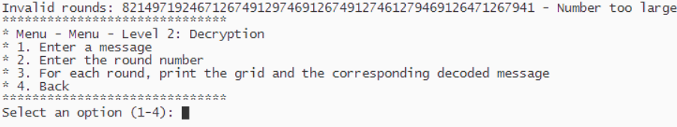
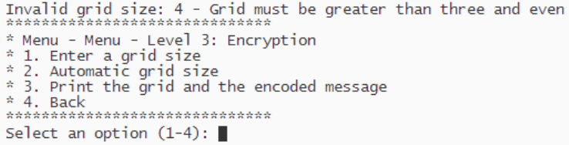
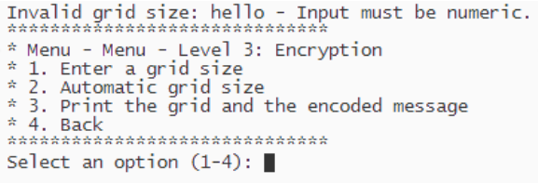
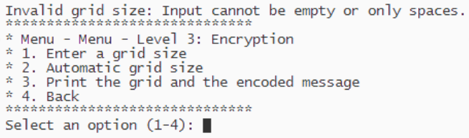

Grid size input:

• Unusable grid size

• Character input

• Empty input

Encryption/Decryption:

• Attempting to single and multi-round encrypt or decrypt a message more than once
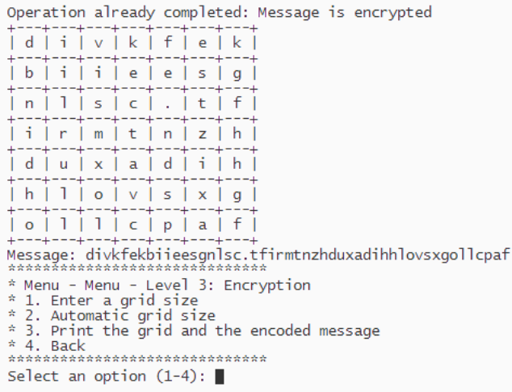
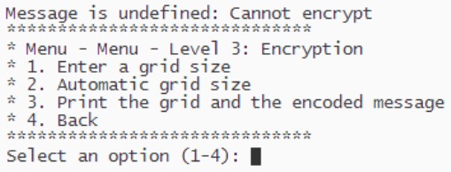

• Attempting to encrypt/decrypt with undefined message

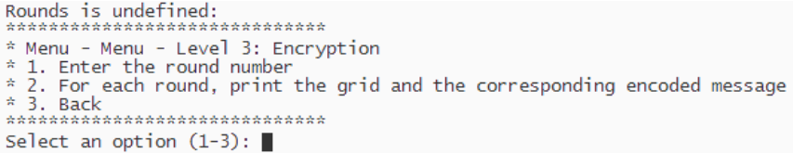
• Attempting to multi-round encrypt/decrypt with undefined rounds
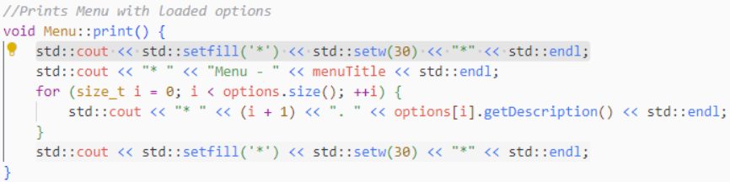
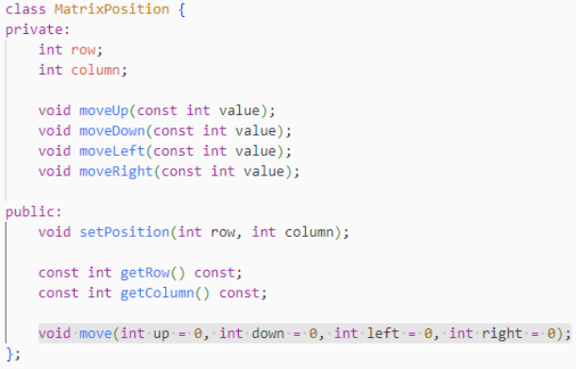
Section 4: Application of Course Concepts

(Some examples of implementation have been shown)

Week 1: Iostream, variables, auto, data types (int, bool, size_t, char, bool), logical operators, conditionals, for, while, ranged loops, std::string, std::vector, functions, reference variables

setfill(), setw()

default arguments

Week 2: container methods (emplace_back, clear, resize, at, size), 2D vector matrix (std::vector<std::vector<char>>)
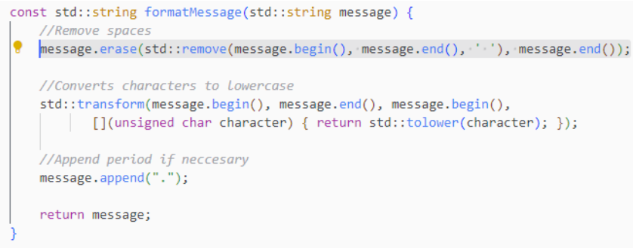
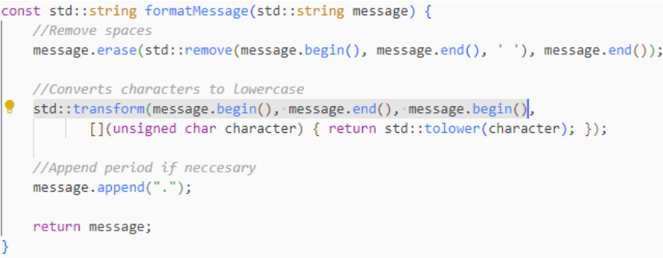
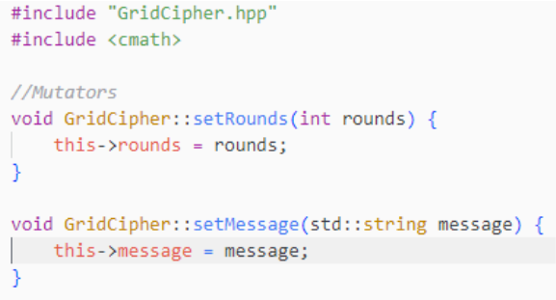
iterators, .begin(), .end(),

Week 3: transform(), erase()

Week 4: Classes, Methods, Attributes, access specifiers (public, private), accessors, const, scope resolution operator, Mutators,Accessors, header files, Separating Specification from Implementation, defining and accessing object instances, inline member functions, constructors, constructor initialisation lists, this->

Week 5: Member-wise assignment, Aggregation, pass-by-reference, implementation matches UML

Week 6: Inheritance, abstract base classes, pure virtual functions, overriding
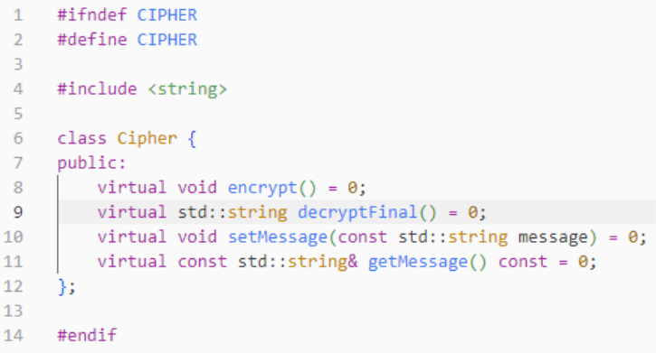
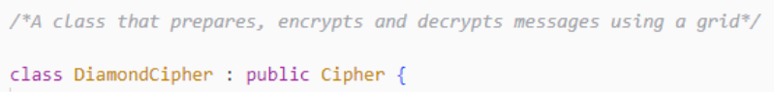

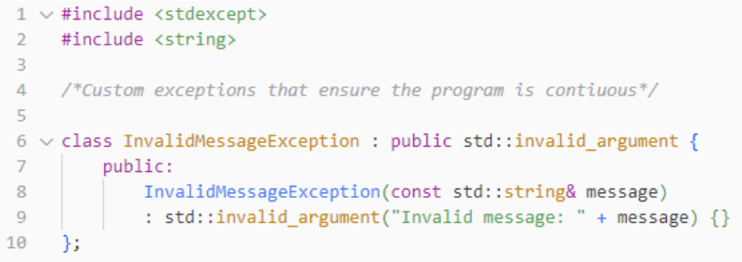
Week 7: try, catch, throw, standard exceptions, custom exceptions, what() override, multiple exception types, program continuation

