Bon Laundry Station — User Guide & Standard Operating Procedures
Role-by-Role Practical Guide & Step-by-Step Workflows
Urban Deca Homes Ortigas Branch

Quick Navigation Index
1. Customer User Guide & Step-by-Step Instructions
• 1.1 How to Sign In via Google Single Sign-On (SSO)
• 1.2 How to Book a Laundry Service Online (4-Step Wizard)
• 1.3 How to Track Live Orders & Lifecycle Milestones
• 1.4 How to View Service Rates & Official Price Tariffs
• 1.5 How to Inspect Live Machine Fleet Availability
• 1.6 How to Cancel a Pending Order with OTP Verification
2. Staff Operations Guide & Step-by-Step Instructions
• 2.1 Front-Desk Operations Console Overview
• 2.2 How to Verify and Check In Customer Orders at the Counter
• 2.3 How to Process Walk-In POS Job Orders
• 2.4 How to Manage Online Bookings & Condo Doorstep Pickups
• 2.5 How to Advance Orders on the Live Queue Board
• 2.6 How to Operate Machine Timers & Maintenance Mode
• 2.7 How to Handle Late Garment Retrieval Penalties
3. Manager Supervisory Guide & Step-by-Step Instructions
• 3.1 Supervisory Console Overview
• 3.2 How to Interpret Machine Learning Peak Hour Demand Forecasts
• 3.3 How to Allocate Habitual VIP "Ghost Slots"
• 3.4 How to Reconcile the Daily Sales Ledger, Tally Cash & Export CSV
• 3.5 How to Review the Chronological Security Audit Trail
4. Super Admin Administration Guide & Step-by-Step Instructions
• 4.1 How to Use the Dynamic Role Perspective Switcher
• 4.2 How to Pre-Register Staff & Manager Accounts for Google SSO
• 4.3 How to Promote, Demote, or Reassign User Roles
• 4.4 How to Configure Store Tariffs, Grace Periods & Late Multa Penalties
• 4.5 How to Configure the Machine Hardware Fleet Matrix
5. Role Navigation & Route Reference Table

1. Customer User Guide & Step-by-Step Instructions
The Customer Portal provides self-service laundry booking, live order tracking, transparent rate cards, and machine fleet telemetry for Urban Deca Homes Ortigas residents.

1.1 How to Sign In via Google Single Sign-On (SSO)
1. Open your web browser and go to /login.
2. Click Continue with Google.
3. Select your Google account.
4. You will be automatically redirected to your personal customer portal at /customer/dashboard.
[NOTE] No manual password creation is required. Your name, email, and Google profile picture are automatically synced to your account.

1.2 How to Book a Laundry Service Online (4-Step Wizard)

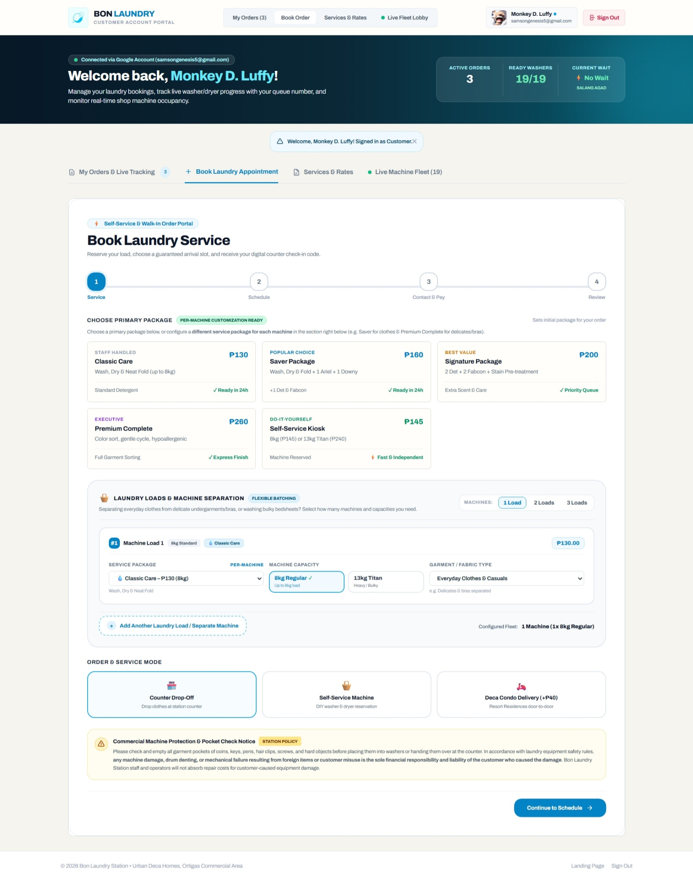
Figure 1: Customer Online Booking Wizard
Step-by-Step Procedure:
1. From the portal header or top navigation bar, click the Book Appointment tab (#tab-content-book or /book).
2. Step 1 — Service Tier, Loads & Mode:
• Select your desired service tier:
• Wash, Dry & Fold: Complete full-service package.
• Wash Only: Self-drying or line-drying.
• Dry Only: For pre-washed garments.
• Bulky Comforter / Blanket: Specialized large-drum cycle.
• Select the number of loads: click 1 Load (up to 8.0 kg), 2 Loads (up to 16.0 kg), or 3 Loads.
• Choose your service mode:
• Drop-Off at Station: Personal counter drop-off.
• Self-Service: On-site assisted machine use.
• Condo Doorstep Pickup & Delivery: Station staff collects and returns laundry to your condo unit.
• Click Next Step: Schedule.
3. Step 2 — Schedule & Time Slot:
• Pick your preferred date using the calendar input.
• Select an available 2-hour window (e.g., 08:00 AM - 10:00 AM, 10:00 AM - 12:00 PM, or 02:00 PM - 04:00 PM).
• If Condo Pickup is selected: Enter your Building Number (e.g., Bldg 12) and Unit Number (e.g., Unit 304).
• Click Next Step: Contact & Pay.
4. Step 3 — Contact Details & Payment Method:
• Confirm your contact details (Full Name and Mobile Phone Number).
• Select your payment channel:
• Cash on Drop-Off / COD: Pay upon physical handover.
• Pay Online Now via PayMongo: Direct digital payment via GCash, Maya, GrabPay, or Credit/Debit Card.
• Click Next Step: Review.
5. Step 4 — Review, Liability Waiver & Confirmation:
• Review the itemized cost breakdown (base loads, detergent add-ons, and delivery fees).
• Check the Customer Equipment Liability Policy checkbox, certifying that all pockets have been emptied of coins, pens, and sharp objects.
• Click Confirm Booking.
• Your unique Order Reference Code (e.g., ORD-84920) is issued, and an SMS confirmation is sent to your phone.

1.3 How to Track Live Orders & Lifecycle Milestones

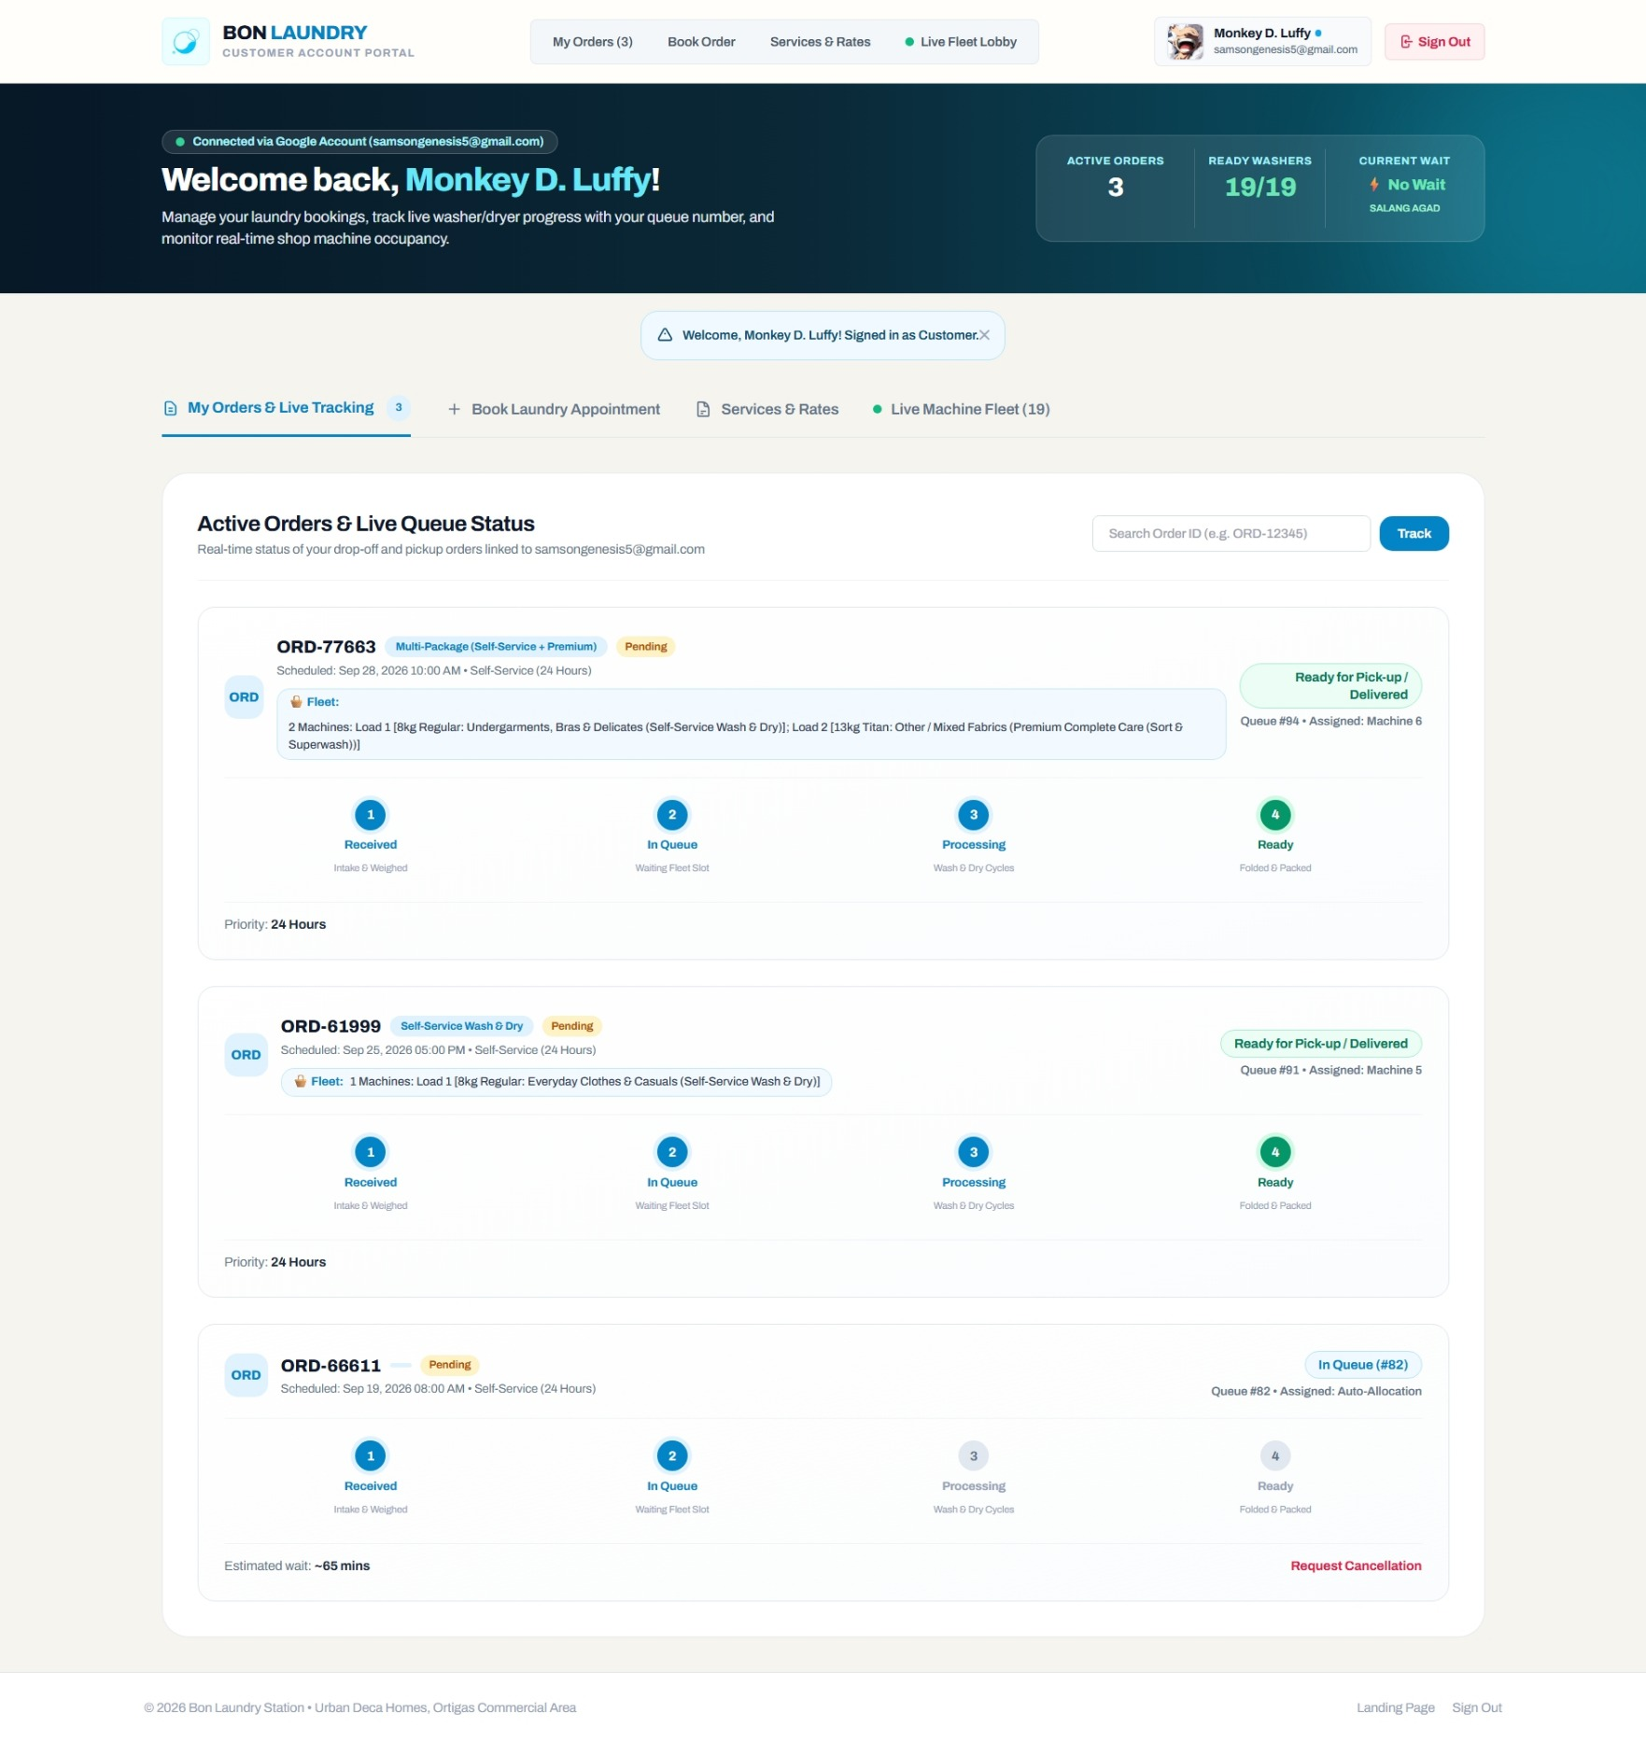
Figure 2: Customer Live Order Tracking & Queue Status
Step-by-Step Procedure:
1. In the customer portal, click the My Orders tab (#tab-content-orders).
2. Locate your active order card, or enter your Order Reference Code (e.g., ORD-84920) in the search box.
3. Observe the live 4-step progress tracker:
• Step 1: Order Received: Booking registered in the system; awaiting drop-off or doorstep pickup.
• Step 2: In Queue: Staff verified your laundry at the counter; weight entered; ticket Q-XXX issued.
• Step 3: In Progress: Garments loaded into the washer or dryer; active cycle running with a live timer.
• Step 4: Ready for Pick-Up: Cycle complete; laundry folded and bagged; ready for collection or delivery.
4. Check the Assigned Machine badge (e.g., Washer 04) and estimated turnaround time to know when your laundry will be finished.

1.4 How to View Service Rates & Official Price Tariffs

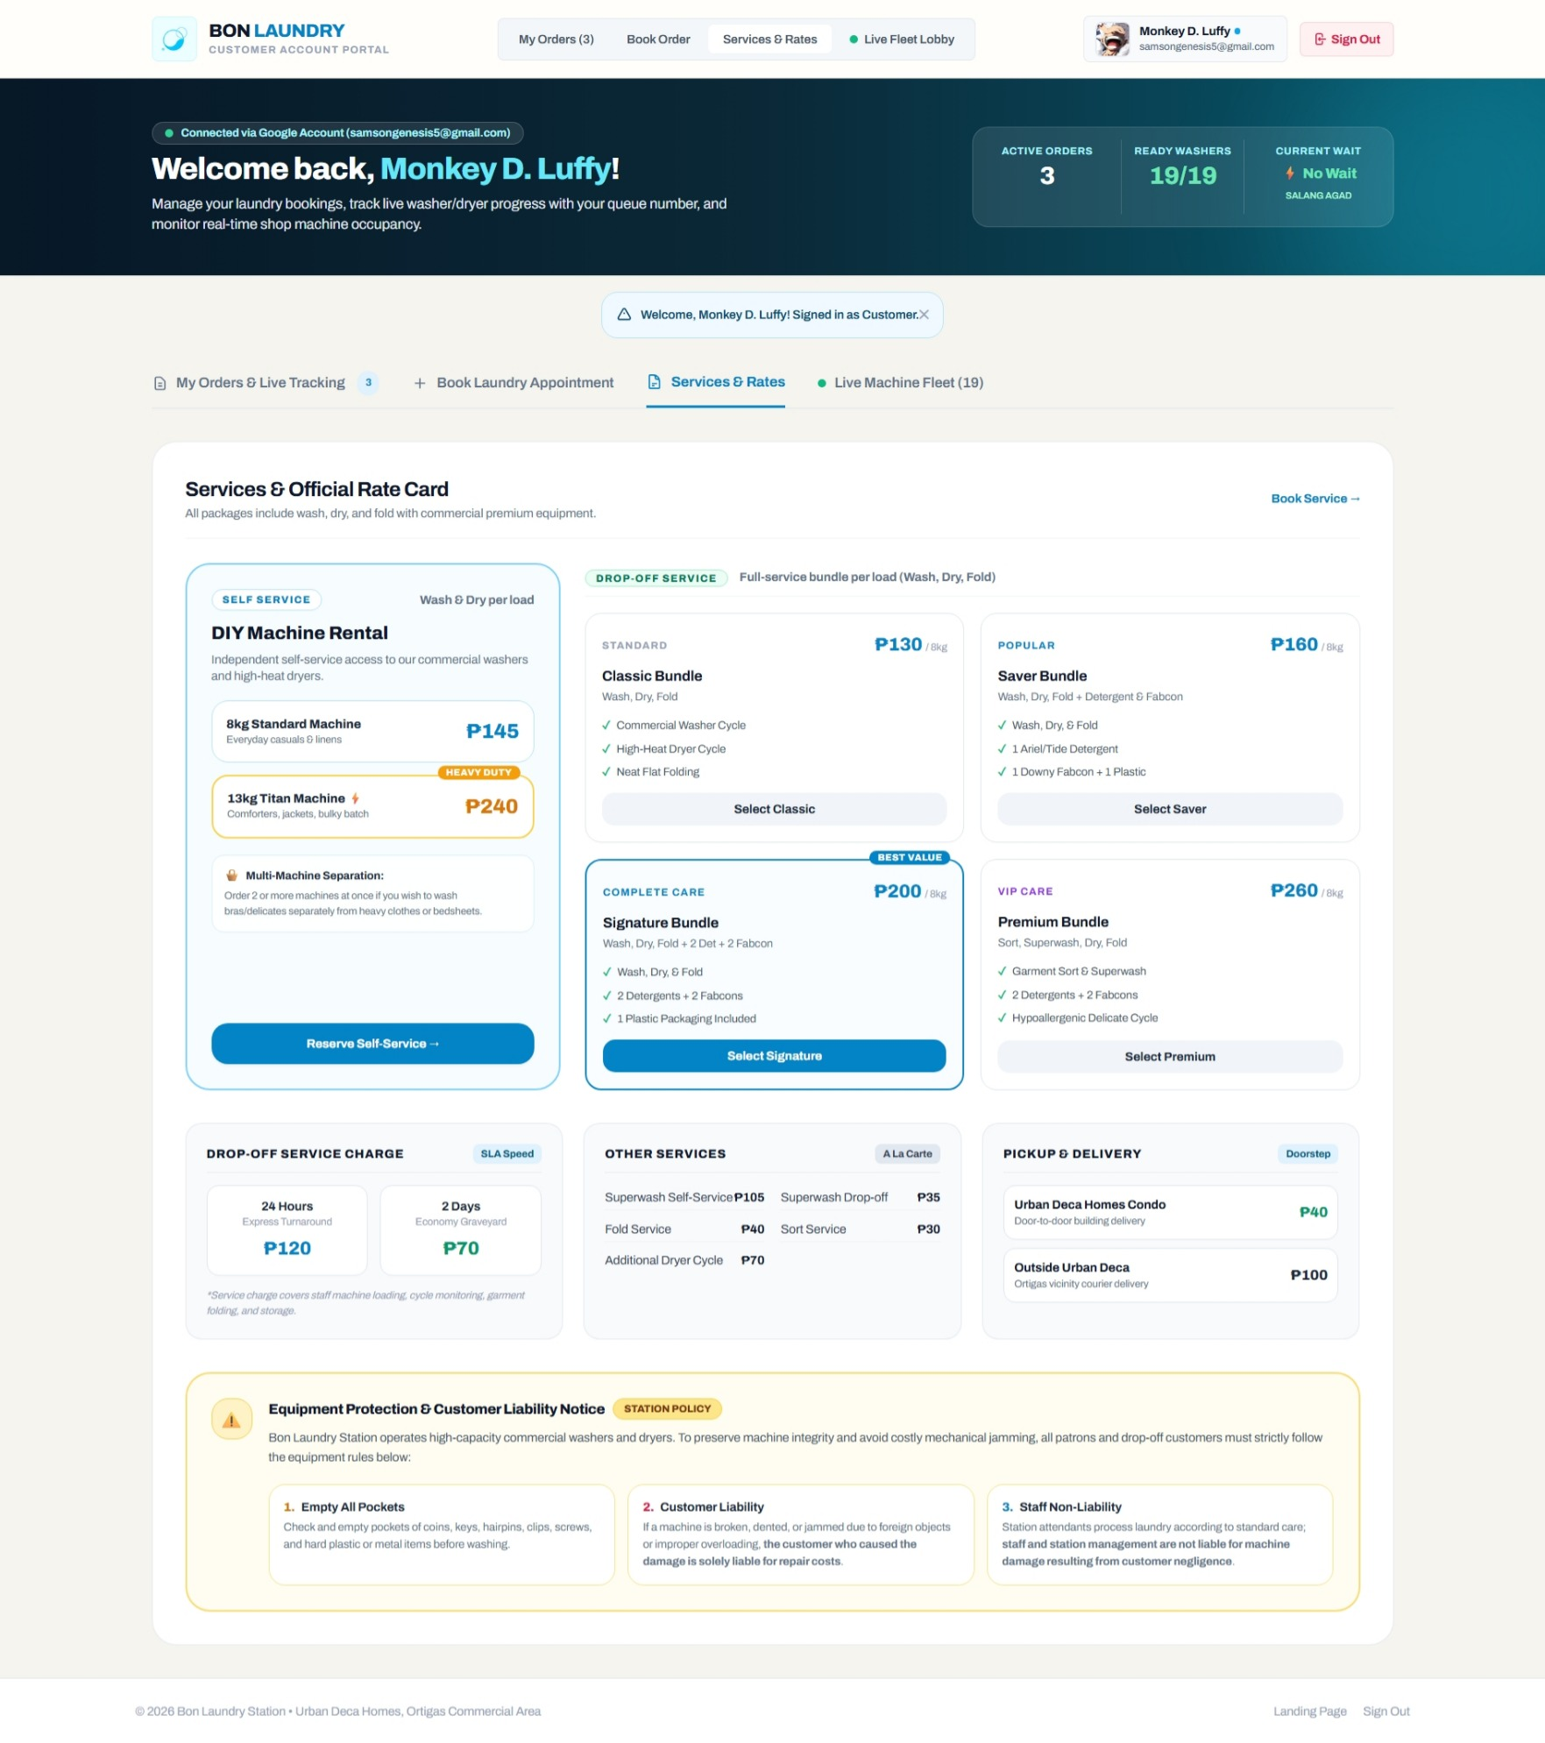
Figure 3: Services & Official Store Rate Card
Step-by-Step Procedure:
1. Click the Services & Rates tab (#tab-content-services).
2. Review the transparent store rate card:
• Regular Wash (Washer): Up to 8.0 kg — ₱145.00 flat cycle fee (₱65.00/kg base tariff).
• Titan Dry (Dryer): Up to 13.0 kg — ₱145.00 flat cycle fee.
• Wash, Dry & Fold Bundle: 1 Load (8.0 kg) — ₱290.00 (24-hour turnaround SLA).
• Express Same-Day Rush: +₱100.00 surcharge (4–6 hour turnaround SLA).
• Bulky Comforter / Heavy Blanket: ₱200.00 flat fee.
• Detergent & Fabric Softener Add-ons: Ariel/Tide (₱20.00/sachet), Downy (₱15.00/sachet).
• Condo Delivery: Free or ₱30.00 promotional rate for Urban Deca Homes Ortigas residents.

1.5 How to Inspect Live Machine Fleet Availability

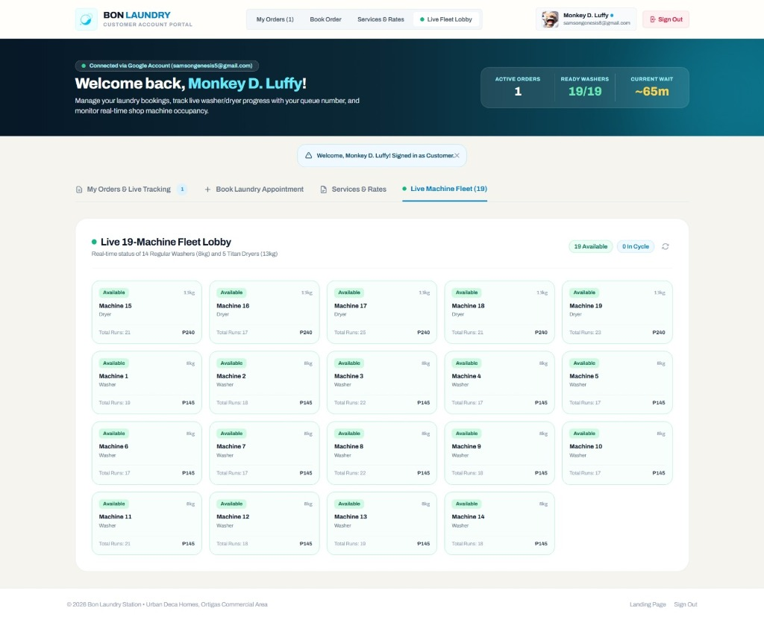
Figure 4: Live Machine Fleet Lobby Telemetry
Step-by-Step Procedure:
1. Click the Live Lobby tab (#tab-content-lobby).
2. Inspect the telemetry grid of all 19 shop machines (14 Washers and 5 Dryers).
3. Review the status indicators:
• 🟢 Available: Ready for immediate assignment.
• 🟡 In-Use (Walk-In): Active walk-in cycle running with live countdown timer.
• 🔵 In-Use (Online Order): Active cycle assigned to a scheduled online customer.
• 🔴 Maintenance: Offline for servicing or drum sanitation.
4. Check the Estimated Waiting Time (EWT) banner to plan your visit during low-traffic periods.

1.6 How to Cancel a Pending Order with OTP Verification
1. Navigate to My Orders (#tab-content-orders).
2. Locate the active order card (must be in Pending or In Queue status).
3. Click the Cancel Order button.
4. The system sends a 6-digit One-Time Password (OTP) to your registered email and mobile phone.
5. In the cancellation dialog, enter the 6-digit OTP and select your reason for cancellation.
6. Click Confirm Cancellation. The order is cancelled, your reserved slot is released, and confirmation is displayed.
[WARNING] Orders that have already entered the active washing or drying cycle (`In Progress`) cannot be cancelled online. Please contact the front desk directly.

2. Staff Operations Guide & Step-by-Step Instructions
The Staff Console is designed for countertop operators handling physical intake, digital scale weighing, machine allocation, queue progression, and customer handovers.

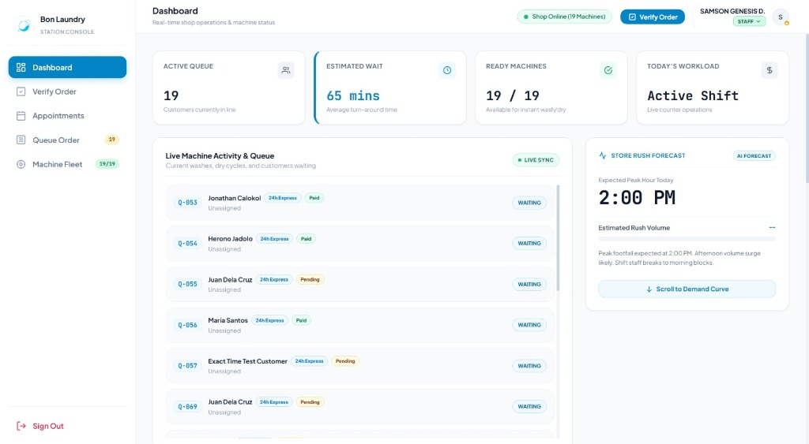
Figure 5: Staff Front-Desk Operations Dashboard

2.1 Front-Desk Operations Console Overview
• Sign In: Navigate to /login and sign in with your pre-registered Google account. You will automatically land on /staff/dashboard.
• Sidebar Navigation:
• Dashboard: High-level telemetry, active queue counts, and live activity feed.
• Verify Order: Counter intake and digital scale weighing terminal.
• Appointments: Incoming online bookings and condo pickup requests.
• Queue Order: Live queue board with cycle progression controls.
• Machine Fleet: Status controls and manual timer overrides for all 19 machines.

2.2 How to Verify and Check In Customer Orders at the Counter

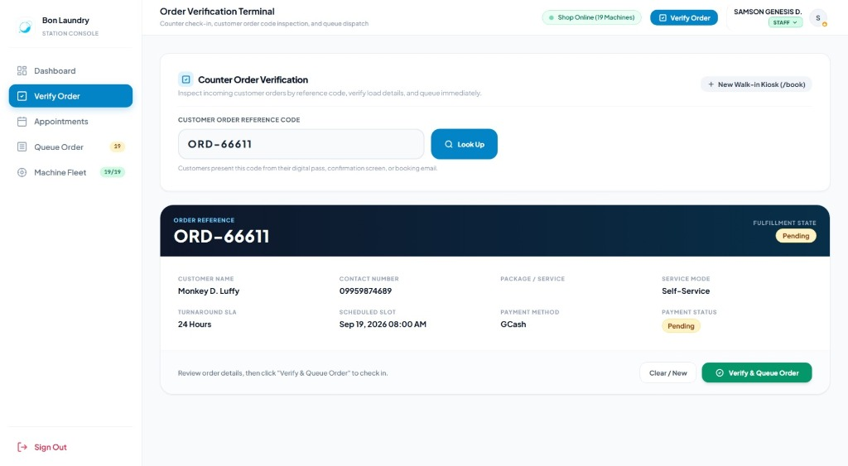
Figure 6: Counter Order Verification & Digital Scale Terminal
Step-by-Step Procedure:
1. Click the Verify Order tab on the sidebar (or open /staff/verify-order).
2. Order Lookup:
• Request the customer's Order Code (e.g., ORD-84920) or mobile phone number.
• Enter the code in the search field and press Enter (or click Look Up).
• Verify customer name, service package, and delivery preference.
3. Physical Scale Weighing:
• Place the laundry bag on the digital countertop scale.
• Enter the exact scale weight in kilograms (e.g., 7.4 kg) in the Physical Scale Weight field.
• If the weight exceeds the 8.0 kg limit: The system alerts you to split the laundry into two loads.
4. Machine Recommendation:
• Review the machine unit recommended by the system (e.g., Regular Washer 03).
• Accept the recommended machine or select an alternate available unit.
5. Equipment Liability Verification:
• Ask the customer: "Have you checked all pockets for coins, pens, or metal objects?"
• Verify the liability check displayed on screen.
6. Payment Collection:
• If payment status is Pending, collect cash or confirm PayMongo online payment.
• Click Mark as Paid.
7. Confirm Check-In:
• Click Confirm & Dispatch to Queue.
• The system assigns a physical queue ticket (e.g., Q-014), updates the order to In Queue, and dispatches an arrival confirmation SMS to the customer.

2.3 How to Process Walk-In POS Job Orders
1. On the operations header or sidebar, click Walk-in Booking (or visit /book).
2. Select the customer's requested service tier (e.g., Wash, Dry & Fold).
3. Set the load count based on laundry volume.
4. Enter the customer's Name and Mobile Phone Number.
5. Click Submit Walk-In Order to generate an instant Order Code.
6. Return to the Verify Order terminal (/staff/verify-order) and follow the check-in steps in Section 2.2 to weigh, assign a machine, collect payment, and issue a queue ticket.

2.4 How to Manage Online Bookings & Condo Doorstep Pickups

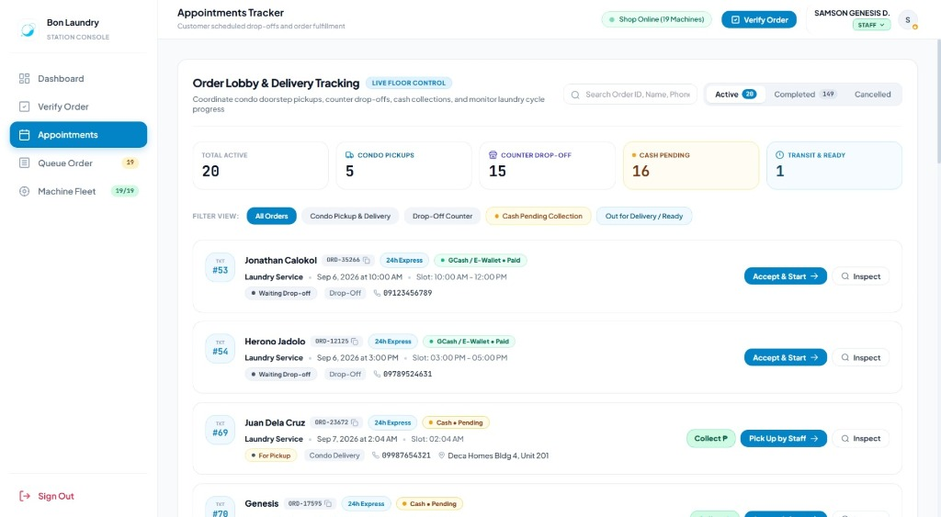
Figure 7: Online Appointments & Condo Pickup Intake
Step-by-Step Procedure:
1. Click the Appointments tab (#view-appointment).
2. Filter the table by clicking Pending or Confirmed.
3. For Condo Doorstep Pickups:
• Review the scheduled time window, customer name, and Building/Unit number (e.g., Bldg 14, Unit 512).
• Dispatch floor staff to collect the laundry bag from the resident's door.
4. When the laundry arrives at the counter, click the Check-In button on the table row.
5. The order loads directly into the Verification Terminal for weighing and queue assignment.

2.5 How to Advance Orders on the Live Queue Board

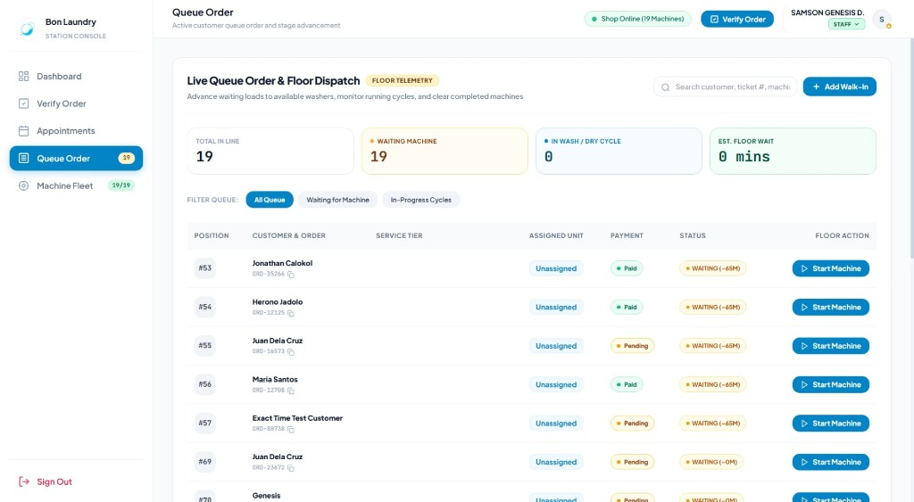
Figure 8: Live Queue Order Board & Floor Dispatch
Step-by-Step Procedure:
1. Click the Queue Order tab (#view-queue).
2. Review the sequence of tickets arranged by priority and ticket number (Q-001, Q-002, etc.).
3. To Start a Wash or Dry Cycle:
• Carry the laundry bag to the assigned machine (e.g., Washer 04).
• Load the garments, add detergent/softener, close the door, and start the physical machine.
• On the Queue Board card, click Start Wash (or Start Dry).
• Status transitions from Waiting to Processing. The synchronized 39m or 40m countdown timer begins.
4. To Complete a Cycle:
• When the timer reaches 00:00, unload the drum immediately.
• Transport garments to the folding table; fold, pack, and attach the order tag.
• On the Queue Board card, click Complete Cycle.
• Status transitions to Done. An automated SMS notifies the resident that their laundry is ready for pickup.
• The 10-minute retrieval grace period begins.
5. To Release Garments to Customer:
• When the customer arrives, verify their ticket number or order code.
• Hand over the clean, bagged laundry.
• Click Release Garments. The ticket is archived, and the machine returns to Available.

2.6 How to Operate Machine Timers & Maintenance Mode

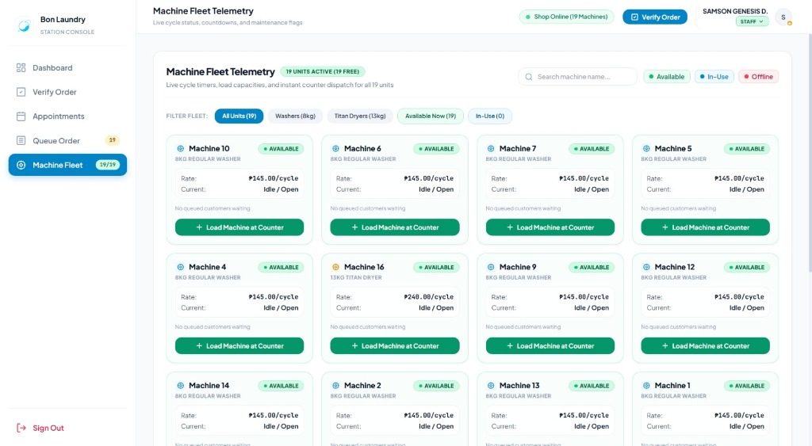
Figure 9: Machine Fleet Status & Cycle Timers
Step-by-Step Procedure:
1. Click the Machine Fleet tab (#view-machines).
2. View all 19 machines (Washers 01–14, Dryers 01–05).
3. Manual Cycle Start (Walk-In Self-Service):
• Click Start Cycle on the target machine card.
• Select cycle duration (39 mins Wash or 40 mins Dry).
• The unit locks and begins counting down.
4. Toggle Maintenance Mode:
• If a machine requires drum cleaning, filter clearing, or servicing, click Toggle Maintenance.
• The machine is immediately marked offline (red badge), preventing the booking wizard and recommendation engine from assigning jobs to it.
• Once servicing is complete, click Toggle Maintenance again to return it to Available.

2.7 How to Handle Late Garment Retrieval Penalties
1. When a cycle is completed, the system begins a 10-minute grace period.
2. If the customer does not retrieve their laundry within 10 minutes:
• The Queue Board displays an amber alert: Grace Period Expired — Penalty Applicable.
3. When the customer arrives to collect their laundry:
• The terminal displays the standard ₱100.00 Late Multa surcharge.
• Explain the policy to the customer and collect the ₱100 penalty fee.
• Record the penalty collection in the drawer and click Release Garments.

3. Manager Supervisory Guide & Step-by-Step Instructions
The Manager Console provides oversight of store operations, demand forecasting, financial drawer reconciliation, and security audit logs.

3.1 Supervisory Console Overview
• Sign In: Navigate to /login with your pre-registered Manager Google account. You will automatically land on /manager/dashboard.
• Supervisory Features:
• Inherits all Staff floor operations tabs.
• Unlocks the Machine Learning Demand Forecast engine.
• Unlocks the Sales Ledger & Tally tab.
• Unlocks the Audit Trail & Prediction Logs tab.

3.2 How to Interpret Machine Learning Peak Hour Demand Forecasts
1. On the Dashboard overview tab (#view-dashboard), locate the Predictive Operations & Rush Forecast card.
2. Review the core metrics:
• Predicted Peak Rush: Identifies projected high-volume hours (e.g., Peak Rush Expected: 3:00 PM – 6:00 PM with 18+ incoming loads).
• MAPE Accuracy Score: Displays model accuracy (e.g., MAPE: 8.4%, indicating high statistical reliability).
• Staffing Recommendation: Advises whether to deploy an additional floor operator or clear folding tables in advance.
3. Use this forecast during morning briefings to schedule shift handovers and plan machine availability.

3.3 How to Allocate Habitual VIP "Ghost Slots"
1. In the Dashboard tab, locate the Habitual Ghost Slots Matrix card.
2. The engine identifies residents who regularly wash on specific days/times (3+ previous visits).
3. Review the identified habitual customer slots for the day.
4. When a regular resident contacts the shop, click Assign Ghost Slot next to their profile.
5. The system pre-reserves their preferred machine and turnaround tier, ensuring fast service without double-booking walk-in clients.

3.4 How to Reconcile the Daily Sales Ledger, Tally Cash & Export CSV

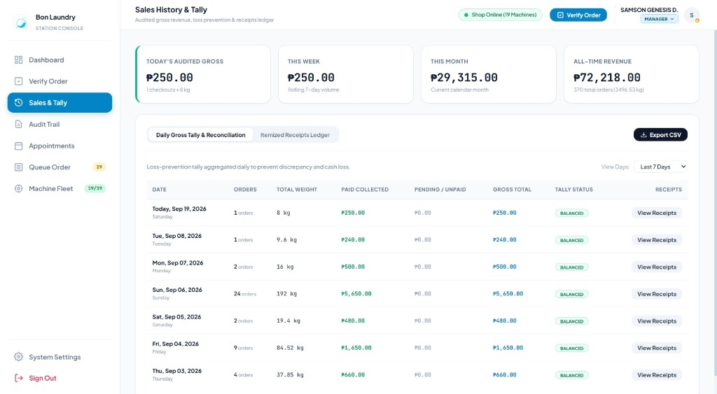
Figure 10: Sales Ledger, Cash Tally & Revenue Reconciliation
Step-by-Step Procedure:
1. Click the Sales & Tally tab (#view-sales).
2. Select Date Filter: Click Today, Yesterday, Last 7 Days, This Month, or specify a custom date range.
3. Reconcile Financial Cards:
• Gross Revenue: Total collected sales.
• Cash Drawer Tally: Verify that physical cash in the counter register matches this figure.
• Digital PayMongo Tally: Confirms funds deposited via GCash, Maya, and cards.
• Pending Receivables: Review orders currently in progress that have not yet been settled.
4. Audit Transactions: Review individual records in the transaction table (Order Code, Customer, Weight, Machine ID, Amount, Payment Method).
5. Export Financial Records:
• Click the Export CSV button in the top right corner.
• The system downloads a complete .csv spreadsheet (/sales/export) for store accounting, Excel reconciliation, or tax filings.

3.5 How to Review the Chronological Security Audit Trail

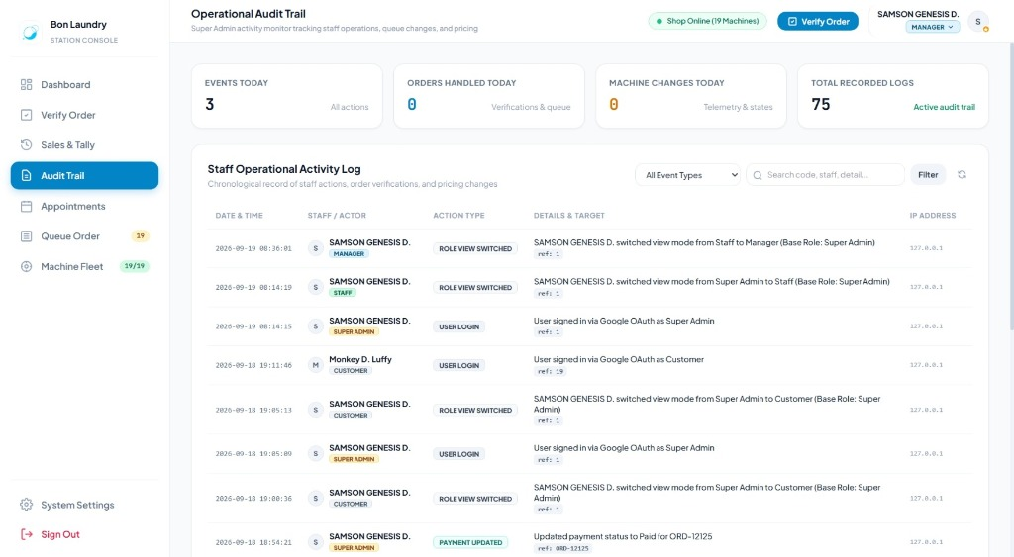
Figure 11: Operational Security Audit Trail & ML Logs
Step-by-Step Procedure:
1. Click the Audit Trail tab (#view-audit).
2. Review chronological system activity:
• User sign-ins and session role switches.
• Order counter check-ins and manual price overrides.
• Machine maintenance toggles.
• Appointment cancellations and OTP submissions.
• Account provisioning and role adjustments.
3. Check the Actor, Action, IP Address, and Timestamp columns to investigate operational discrepancies.
4. Scroll to the Prediction Logs section to review historical forecast accuracy against actual customer traffic.

4. Super Admin Administration Guide & Step-by-Step Instructions
The Super Admin possesses executive control over store policies, pricing structures, hardware settings, and employee system access.

4.1 How to Use the Dynamic Role Perspective Switcher

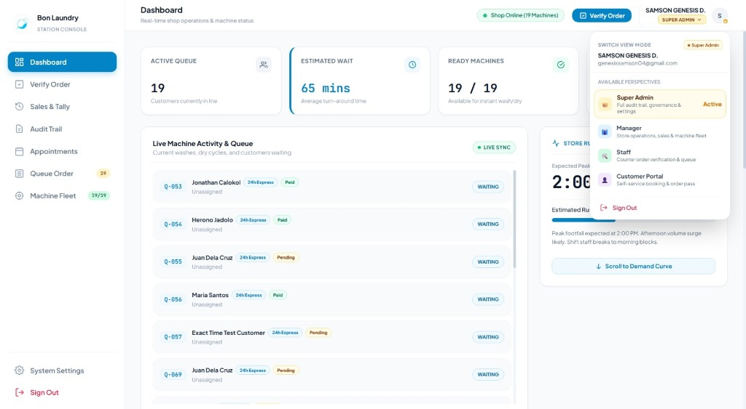
Figure 12: Dynamic Role Perspective Switcher
Step-by-Step Procedure:
1. Click the user profile button in the top-right header (marked with a gold star ★ Super Admin).
2. The Switch View Mode dropdown opens, displaying all four system perspectives:
• 👑 Super Admin: Master governance, audit trail, user provisioning, and tariffs.
• 👔 Manager: Operations overview, sales ledger, ML forecasts, and ghost slots.
• 🛠️ Staff: Counter verification terminal, live queue board, and machine controls.
• 👤 Customer Portal: End-user booking wizard, live orders, and fleet lobby.
3. Click your target perspective.
4. The workspace re-renders immediately under that role's interface rules without requiring you to log out.
5. To return to administrative mode, open the dropdown and select Super Admin.

4.2 How to Pre-Register Staff & Manager Accounts for Google SSO

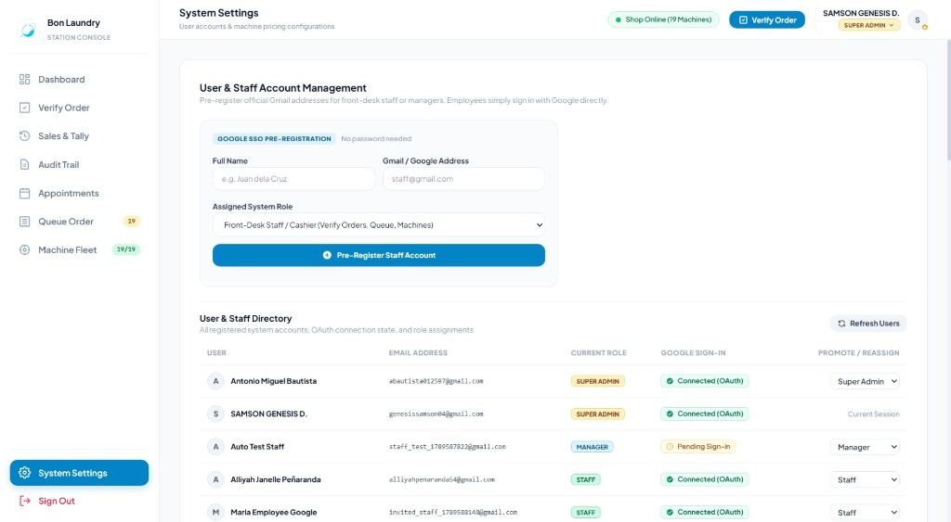
Figure 13: Staff Google SSO Account Provisioning & Role Management
Step-by-Step Procedure:
1. Click the System Settings tab (#view-settings or switchTab('settings')).
2. Scroll to the Account Provisioning & Staff Onboarding card.
3. Fill in the employee onboarding fields:
• Full Name: e.g., Maria Santos.
• Gmail Address: e.g., maria.santos@gmail.com (must be their official Google account).
• Assigned Role: Select Staff (or Manager).
4. Click Pre-Register Account.
5. Inform the employee to open /login on their workstation and click Continue with Google.
6. The system links their Google identity and routes them directly to their assigned operational workspace.

4.3 How to Promote, Demote, or Reassign User Roles
1. In the System Settings tab, scroll to the Registered Users Directory table.
2. Locate the user you wish to modify.
3. Click the Role Selector dropdown in their row.
4. Select the updated role: Customer, Staff, Manager, or Super Admin.
5. The permission change takes effect immediately.
[NOTE] Only a Super Admin can promote a user to the Super Admin role or modify existing Super Admin accounts.

4.4 How to Configure Store Tariffs, Grace Periods & Late Multa Penalties
1. In the System Settings tab, locate the Store Operating Rules & Pricing Parameters card.
2. Update the master store values:
• Base Price per Kilogram: e.g., ₱65.00 per kg.
• Maximum Weight Limit per Regular Load: e.g., 8.0 kg.
• Standard Washer Cycle Duration: e.g., 39 minutes.
• Standard Dryer Cycle Duration: e.g., 40 minutes.
• Late Retrieval Grace Period: e.g., 10 minutes.
• Late Retrieval Penalty Surcharge (Multa): e.g., ₱100.00.
3. Click Save Settings. The updated rules apply immediately across the booking wizard, verification terminal, and queue timers.

4.5 How to Configure the Machine Hardware Fleet Matrix
1. In the System Settings tab, locate the Machine Hardware Matrix table.
2. For each of the 19 fleet machines (Washers 01–14, Dryers 01–05), you can customize:
• Machine Name: e.g., Titan Dryer 01.
• Capacity (kg): e.g., 8 kg for Washers, 13 kg for Dryers.
• Per-Cycle Fee (₱): e.g., ₱145.00.
• Operational Status: Toggle between Available and Maintenance.
3. Click Save Hardware Configuration. Updated cycle fees reflect immediately across counter POS calculations and customer online bookings.

5. Role Navigation & Route Reference Table
Workspace / Module | Permitted Roles | Direct URL / Selector | Primary Purpose
Public Landing Page | Public | / | Store amenities, machine preview, community info, and chatbot.
Google Sign-In | Public | /login | Secure OAuth 2.0 authentication entry point.
Customer Portal | Customer | /customer/dashboard | Central customer portal for bookings, live orders, rates, and lobby.
Online Booking Wizard | Customer | /book | 4-step self-service appointment booking wizard.
Live Machine Lobby | Customer | #tab-content-lobby | Telemetry grid showing real-time status of all 19 machines.
Staff Dashboard | Staff, Mgr, Admin | /staff/dashboard | Real-time queue counters, ready units, and recent jobs feed.
Order Verification Terminal | Staff, Mgr, Admin | /staff/verify-order | Counter check-in: digital scale weight entry, liability, and machine dispatch.
Online Appointments Queue | Staff, Mgr, Admin | #view-appointment | Scheduled bookings and condo doorstep pickup management.
Live Queue Order Board | Staff, Mgr, Admin | #view-queue | Cycle progression board: Start Wash/Dry, Complete Cycle, Release Garments.
Machine Fleet Control | Staff, Mgr, Admin | #view-machines | Individual countdown timers, walk-in cycle start, and maintenance toggles.
Manager Dashboard | Manager, Admin | /manager/dashboard | Supervisory console with ML rush forecasts and ghost slot optimization.
Sales Ledger & Tally | Manager, Admin | #view-sales | Financial reconciliation: Cash drawer, PayMongo digital sales, CSV export.
CSV Sales Data Export | Manager, Admin | /sales/export | One-click spreadsheet download of all store transactions.
Audit Trail & Prediction Logs | Manager, Admin | #view-audit | Chronological security activity log and ML model validation records.
Role Perspective Switcher | Super Admin | Top Bar Dropdown | Dynamic switching between Admin, Manager, Staff, and Customer viewports.
User Account Provisioning | Super Admin | #view-settings | Pre-registering Staff/Manager Gmail accounts and reassigning roles.
Master Tariffs & Rules | Super Admin | #view-settings | Master pricing per kg, cycle durations, grace periods, and late penalty fees.
Hardware Fleet Matrix | Super Admin | #view-settings | Per-machine capacity (8kg/13kg) and cycle tariff configurations.

Bon Laundry Station User Guide & Standard Operating Procedures — Document End

