Bon Laundry Station — Comprehensive System User Manual
Operating System, Cashier Terminal, Customer Portal & Supervisory Console
Urban Deca Homes Ortigas Branch

Document Control & System Information
Parameter | Specification
System Name | Bon Laundry Station Operating System with Predictive Analytics
Platform Target | Web (Desktop Countertop POS, Tablet Terminal & Mobile Customer Portal)
Supported Roles | Customer (Resident), Staff (Cashier/Operator), Manager (Supervisor), Super Admin (Owner)
Fleet Capacity | 19 Commercial Units (14 Regular 8kg Washers, 5 Titan 13kg Dryers)
Document Version | 2.5.0 (Production Release)
Target Codebase | Flask, SQLAlchemy, MySQL, Tailwind CSS, Chart.js, PayMongo & PhilSMS

Table of Contents
1. Executive Summary & System Architecture
2. Role Hierarchy & Access Matrix
3. System Access, Authentication & Navigation
• 3.1 Public Landing Page Navigation (/)
• 3.2 Google Single Sign-On (SSO) Authentication (/login)
• 3.3 Dynamic Role Switcher (Super Admin Exclusive)
4. Customer Portal User Guide
• 4.1 Portal Header & Real-Time Shop Telemetry
• 4.2 Module 1: My Orders & Live Lifecycle Tracking (#tab-content-orders)
• 4.3 Module 2: 4-Step Booking Wizard (#tab-content-book)
• 4.4 Module 3: Service Menu, Rates & Turnaround SLAs (#tab-content-services)
• 4.5 Module 4: Live Machine Lobby & Traffic Telemetry (#tab-content-lobby)
• 4.6 Self-Service Order Cancellation with OTP Verification
5. Staff Operations & Cashier Terminal Guide
• 5.1 Staff Ledger Navigation & Layout
• 5.2 Operations Dashboard & Live Queue Readout (#view-dashboard)
• 5.3 Counter Order Verification & Check-in Terminal (#view-verify & /staff/verify-order)
• 5.4 Online Appointments & Condo Pickup Intake (#view-appointment)
• 5.5 Live Queue Board & Stage Progression (#view-queue)
• 5.6 Machine Fleet Telemetry & Cycle Timers (#view-machines)
6. Manager Supervisory & Analytics Console Guide
• 6.1 Supervisory Operational Readout
• 6.2 Machine Learning Demand & Rush Hour Forecasting
• 6.3 Habitual Predictive Slots ("Ghost Slots") Allocation
• 6.4 Sales Ledger, Daily Tally & CSV Export (#view-sales)
• 6.5 Chronological Audit Trail & Prediction Logs (#view-audit)
7. Super Admin Governance & Administration Guide
• 7.1 Executive System Overview
• 7.2 Dynamic View Mode Perspective Switcher (toggleRoleDropdown)
• 7.3 User & Staff Account Management (#view-settings)
• 7.4 Master Pricing Tariffs, Grace Periods & Late Penalties Configuration
• 7.5 Machine Hardware Configuration Matrix
8. Standard Operating Procedures (Step-by-Step Workflows)
• SOP-01: Online Booking to Counter Intake
• SOP-02: Walk-In POS Order Processing
• SOP-03: Machine Cycle Execution & Countdown Monitoring
• SOP-04: Order Completion, Pick-Up & Late Retrieval Penalty Assessment
• SOP-05: Provisioning a New Staff Member
9. Operational Edge Cases & Troubleshooting Guide
10. Complete System Navigation Map & URL Reference Table

1. Executive Summary & System Architecture
Bon Laundry Station operates an end-to-end commercial laundromat ecosystem servicing the residential community of Urban Deca Homes Ortigas. The platform unifies:
• Customer Self-Service: Transparent online appointment booking, live 19-machine fleet lobby tracking, real-time order milestones, and PayMongo digital payments.
• Front-Desk POS & Fleet Operations: High-speed counter order check-in, physical scale weight recording, machine allocation, synchronized wash/dry countdown timers, and customer cycle completion alerts.
• Managerial Oversight & Predictive Analytics: Automated peak-hour demand forecasting powered by 2nd-degree polynomial regression (evaluated via Mean Absolute Percentage Error, MAPE), habitual reservation slot optimization, sales ledger reconciliation, and chronological audit trails.
• Super Admin Governance: Master store configuration, pricing tariff adjustment, employee provisioning, and perspective switching.
flowchart TD
subgraph Public_Customer[Customer Space]
Landing[Landing Page /] --> Book[Booking Wizard /book]
Landing --> Track[Public Tracker /api/order/track]
Landing --> Auth[Google Sign-In /login]
Auth --> CustPortal[Customer Portal /customer/dashboard]
end
subgraph Staff_Console[Staff Space]
Auth --> StaffDash[Staff Dashboard /staff/dashboard]
StaffDash --> Verify[Verify Terminal /staff/verify-order]
StaffDash --> QueueBoard[Live Queue Board]
StaffDash --> FleetCtrl[Machine Fleet Control]
end
subgraph Manager_Console[Manager Space]
Auth --> MgrDash[Manager Dashboard /manager/dashboard]
MgrDash --> MLForecast[ML Rush Hour Forecast]
MgrDash --> GhostSlots[Habitual Ghost Slots]
MgrDash --> SalesLedger[Sales Ledger & Tally]
MgrDash --> AuditTrail[System Audit Trail]
end
subgraph SuperAdmin_Console[Super Admin Space]
MgrDash --> RoleSwitch[Perspective Switcher]
MgrDash --> UserMgmt[User & Staff Account Mgmt]
MgrDash --> SysConfig[Store Tariffs & Fleet Config]
end
CustPortal -.->|Creates Order ORD-XXXXX| Verify
Verify -.->|Dispatches Ticket Q-XXX| QueueBoard
QueueBoard -.->|Occupies Machine| FleetCtrl
FleetCtrl -.->|Logs Transaction & Cycle| SalesLedger
SalesLedger -.->|Historical Data Feed| MLForecast

2. Role Hierarchy & Access Matrix
The system implements Role-Based Access Control (RBAC) with strict hierarchical inheritance:
Super Admin ──▶ (inherits) ──▶ Manager ──▶ (inherits) ──▶ Staff
This guarantees that supervisory and executive personnel maintain full operational capabilities over all frontline counter and floor terminals without requiring account reassignment.
Table 1: Complete Feature & Page Access Matrix
Feature / Workspace View | Customer | Staff | Manager | Super Admin | Route / View ID
Public Landing Page | Yes | Yes | Yes | Yes | /
Google Sign-In / SSO | Yes | Yes | Yes | Yes | /login
Customer Portal & Orders | Yes | Perspective | Perspective | Perspective | /customer/dashboard
Self-Service Booking Wizard | Yes | Yes | Yes | Yes | /book or #tab-content-book
Order Cancellation with OTP | Yes | No | No | No | /api/order/cancel
Staff/Manager Dashboard Tab | No | Yes | Yes | Yes | #view-dashboard
Counter Order Verification | No | Yes | Yes | Yes | #view-verify & /staff/verify-order
Appointments Management Tab | No | Yes | Yes | Yes | #view-appointment
Live Queue Order Board | No | Yes | Yes | Yes | #view-queue
Machine Fleet Telemetry | No | Yes | Yes | Yes | #view-machines
Machine Maintenance Toggle | No | Yes | Yes | Yes | #view-machines
Sales Ledger & Tally | No | No | Yes | Yes | #view-sales
CSV Sales Data Export | No | No | Yes | Yes | /sales/export
ML Peak Hour Demand Forecast | No | No | Yes | Yes | #view-dashboard (ML Module)
Habitual Ghost Slots Matrix | No | Yes (Assign) | Yes | Yes | /api/manager/ghost-slots
Audit Logs & Prediction Logs | No | No | Yes | Yes | #view-audit
Dynamic Role Perspective Switcher | No | No | No | Yes | Top Bar Dropdown
Staff Account Provisioning | No | No | No | Yes | #view-settings
Role Promotion & Demotion | No | No | No | Yes | #view-settings
Store Tariffs & Fee Settings | No | No | No | Yes | #view-settings

3. System Access, Authentication & Navigation
3.1 Public Landing Page Navigation (`/`)
The landing page serves as the entry point for residents, walk-in clients, and station staff.
• URL: Landing Page (/)
• Primary Navigation Bar:
• Brand Identity: Bon Laundry Station logo and home anchor.
• Navigation Links:
• Machines: Anchors to #machines detailing the 19-unit commercial fleet.
• Environment: Anchors to #environment highlighting shop amenities (air-conditioned lounge, charging ports, high-speed Wi-Fi).
• Community: Anchors to #community explaining free doorstep pickup/delivery for Urban Deca Homes residents.
• Track Order Button: Opens the quick optical order tracking modal where users enter their ORD-XXXXX code to view progress.
• Book Laundry (CTA): Directs to the self-service booking wizard (/book).
• Sign In / Portal: Directs to /login. If already signed in, automatically redirects the user to their designated role home.
• Interactive AI Chatbot: Located at the bottom right corner of the landing page. Powered by the automated bot service (/api/bot/chat), enabling residents to ask pricing questions, check machine availability, and trace live orders conversationally.

3.2 Google Single Sign-On (SSO) Authentication (`/login`)
Bon Laundry Station enforces Google OAuth 2.0 authentication to eliminate password-related security vulnerabilities.
sequenceDiagram
autonumber
actor User as User (Customer / Staff / Admin)
participant Browser as Web Browser
participant App as Bon Laundry (/login)
participant Google as Google Identity Provider
participant DB as MySQL Database
User->>Browser: Navigates to /login
Browser->>App: GET /login
App-->>Browser: Renders Google Sign-In Portal
User->>Browser: Clicks "Continue with Google"
Browser->>App: GET /auth/google/login
App-->>Browser: Redirects to accounts.google.com with OAuth Scope
User->>Google: Authenticates & grants profile permissions
Google-->>Browser: Redirects to /auth/google/callback?code=...
Browser->>App: GET /auth/google/callback
App->>Google: Exchanges Code for Access Token & User Profile
Google-->>App: Returns Email, Name, Avatar URL & Google Sub ID
App->>DB: Queries tbl_users by google_id or email
alt User exists in database
DB-->>App: Existing record (Role: Staff / Manager / Super Admin / Customer)
App->>DB: Updates Google Sub, Avatar & resets failed attempts
else User does not exist
App->>DB: Auto-provisions new User record with Role = 'Customer'
end
App->>App: Sets encrypted session (user_id, role, base_user_role)
App-->>Browser: Redirects to designated Role Home View

How to Authenticate:
1. Open the browser and visit /login.
2. Click the Continue with Google button.
3. Select your registered Google account in the Google OAuth prompt.
4. Upon successful validation, the system resolves your profile:
• New Users: Automatically registered as Customer and redirected to /customer/dashboard.
• Pre-registered Staff: Automatically redirected to /staff/dashboard.
• Pre-registered Manager / Super Admin: Automatically redirected to /manager/dashboard.
[NOTE] Staff and Managers must be pre-registered by the Super Admin in the System Settings panel using their official Gmail address prior to their first login.

3.3 Dynamic Role Switcher (Super Admin Exclusive)
The Super Admin possesses an executive perspective switcher allowing instant viewport changes across Super Admin, Manager, Staff, and Customer without logging out.
• Location: Top right profile banner in the operations top bar.
• Visual Cue: Gold badge with a star icon (★ Super Admin).
• Procedure:
1. Click on the profile button in the top right header.
2. The Switch View Mode dropdown reveals available perspectives:
• 👑 Super Admin: Master governance, audit trail, account provisioning, and system tariffs.
• 👔 Manager: Operations overview, sales tally, machine learning forecasts, and ghost slots.
• 🛠️ Staff: Counter verification terminal, live queue board, and floor machine controls.
• 👤 Customer Portal: End-user self-service booking, tracking, and live lobby view.
3. Select the desired perspective. The session updates dynamically and routes to the selected role's home view.
4. Every perspective change is automatically recorded in the system audit log (tbl_audit_logs).

4. Customer Portal User Guide
The Customer Portal provides a mobile-responsive, zero-friction interface designed specifically for Urban Deca Homes Ortigas residents.

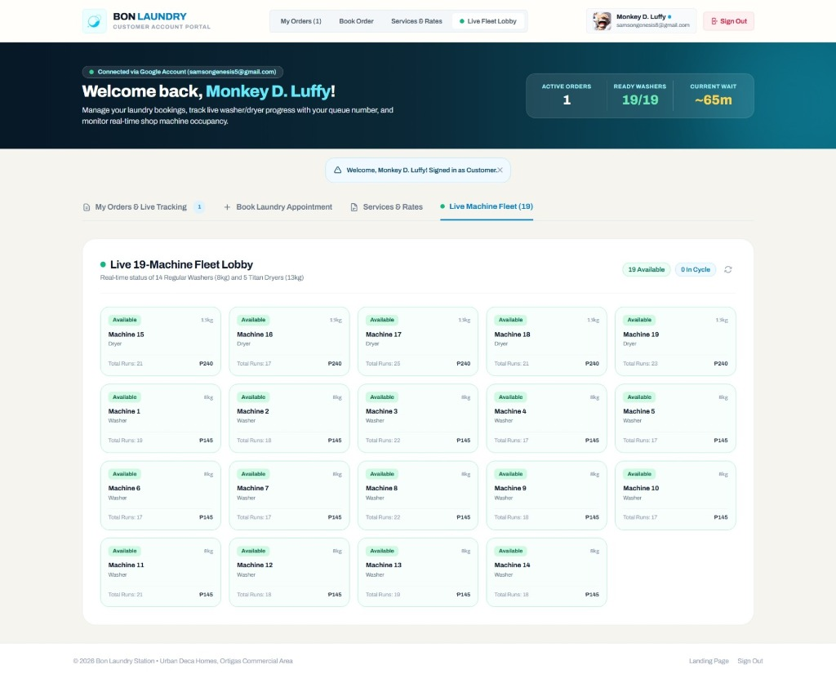
Figure 1: Customer Portal Overview
4.1 Portal Header & Real-Time Shop Telemetry
Located at the top of /customer/dashboard:
• Welcome Banner: Displays the customer's display name and synced Google profile photo.
• Live Operational Pulse: Real-time status cards showing:
• Shop Status: Online indicator and total fleet count (19 Machines).
• Active Queue: Current number of laundry orders awaiting processing.
• Ready Machines: Count of instantly available washers and dryers.
• Estimated Wait Time (EWT): Algorithmic wait duration in minutes.

4.2 Module 1: My Orders & Live Lifecycle Tracking (`#tab-content-orders`)

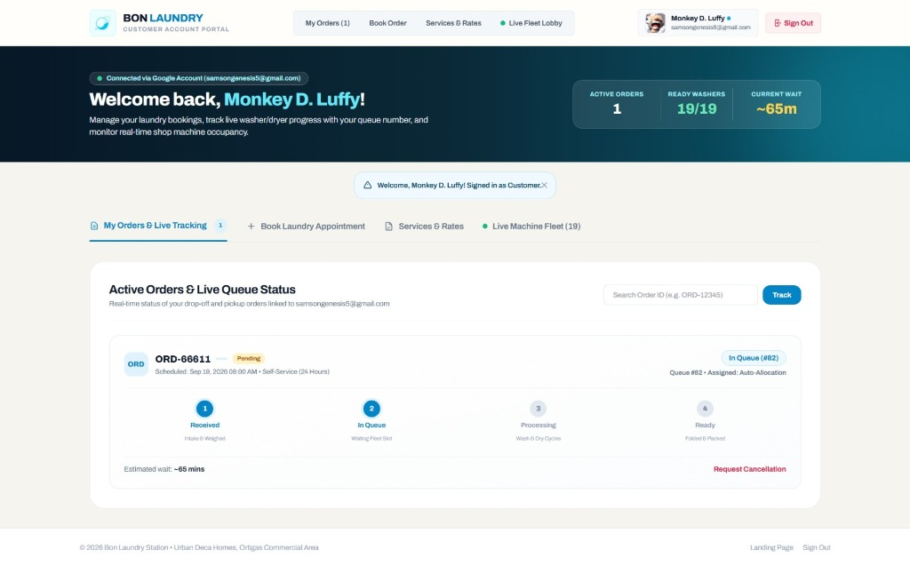
Figure 4: Customer Order Tracking
Page Layout:
• Search / Quick Tracker Bar: Enter any ORD-XXXXX tracking number to instantly highlight or locate an order.
• Active Order Cards: Each card details:
• Order Reference Code (e.g., ORD-84920) with a 1-click copy button.
• Service Tier (e.g., Classic Wash, Dry & Fold).
• Service Mode (Drop-Off at Station, Self-Service, or Doorstep Condo Delivery).
• Turnaround SLA (Standard 24h or Express Rush).
• Payment Status Badge (Pending in Amber, Paid in Emerald).
• Assigned Machine (e.g., Washer 04 or Auto-Allocation).
Visual 4-Step Lifecycle Progress Tracker:
Every order progresses through four synchronized milestones:
stateDiagram-v2
direction LR
[*] --> Step1: Resident Submits Booking
Step1: 1. Order Received
note right of Step1: Booking registered; awaiting drop-off or pickup.
Step1 --> Step2: Staff Verifies at Counter
Step2: 2. In Queue
note right of Step2: Weight validated; ticket Q-XXX assigned.
Step2 --> Step3: Machine Started
Step3: 3. In Progress
note right of Step3: Active wash/dry cycle running with live timer.
Step3 --> Step4: Cycle Complete & Bagged
Step4: 4. Ready for Pick-Up
note right of Step4: SMS notification sent; ready for release or delivery.
Step4 --> [*]

How to Track an Order:
1. Navigate to the My Orders tab on the navigation bar.
2. View your active orders displayed at the top.
3. Observe the highlighted step in the progress bar.
4. Check the Assigned Machine badge and countdown timer to anticipate when your laundry will be finished.

4.3 Module 2: 4-Step Booking Wizard (`#tab-content-book`)

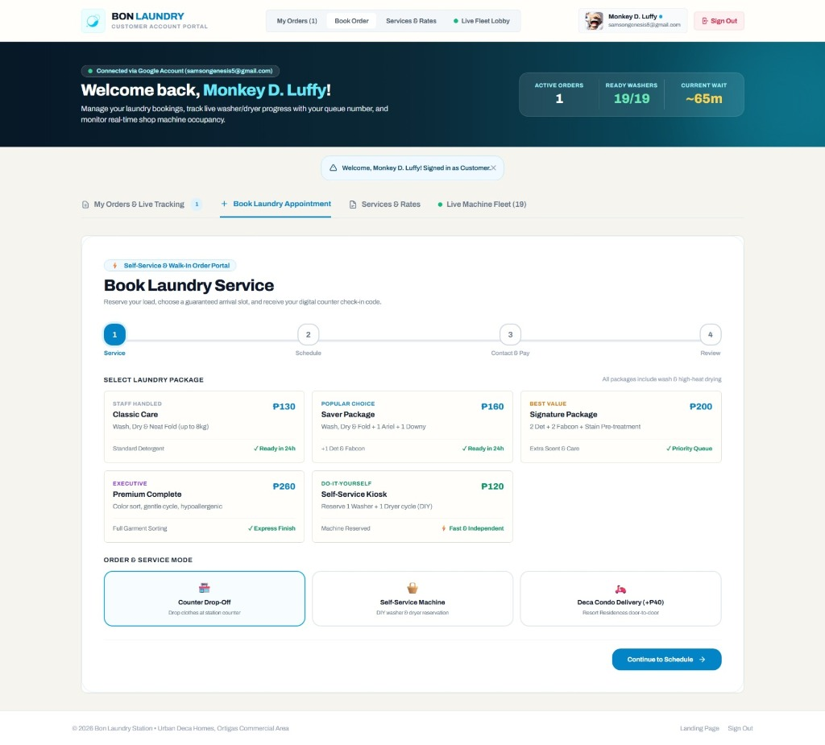
Figure 3: Booking Wizard
The booking engine guides users through an intuitive four-step sequence:
flowchart LR
S1[Step 1: Service & Loads] --> S2[Step 2: Schedule & Slot]
S2 --> S3[Step 3: Contact & Payment]
S3 --> S4[Step 4: Review & Confirm]

Step 1: Service Type, Loads & Mode Configuration
• Service Tier: Select between Wash, Dry & Fold, Wash Only, Dry Only, or Premium Comforter / Delicate.
• Load Count: Click 1 Load, 2 Loads, 3 Loads, or use custom increment buttons.
• 1 Load = up to 8kg (Regular Washer).
• 2 Loads = up to 16kg (allocated across 2 machines).
• Service Mode:
• Drop-Off at Station: Customer personally brings laundry to the counter.
• Self-Service: Customer operates machines on-site with token assistance.
• Condo Doorstep Pickup & Delivery: Dedicated for Urban Deca Homes Ortigas residents.
Step 2: Schedule & Time Slot Selection
• Booking Date: Select pickup or drop-off date using the calendar input.
• Time Slot: Select from available 2-hour windows (e.g., 08:00 AM - 10:00 AM, 10:00 AM - 12:00 PM, 02:00 PM - 04:00 PM).
• Condo Address Fields (if Condo Delivery selected): Enter Building Number (e.g., Building 14) and Unit Number (e.g., Unit 512).
Step 3: Contact & Payment Selection
• Customer Information: Automatically filled from your Google Profile (Name, Email, Mobile Phone Number).
• Payment Method:
• Cash on Counter / COD: Pay upon physical garment drop-off or doorstep delivery handover.
• Pay Online Now (PayMongo): Direct digital settlement via GCash, Maya, GrabPay, or Debit/Credit Card.
Step 4: Review, Policy Acknowledgment & Confirmation
• Itemized Price Breakdown: Displays base load tariffs, add-on supplies, delivery surcharges, and estimated turnaround.
• Customer Equipment Liability Policy: Check the mandatory liability box certifying:
1. All garment pockets have been emptied (no pens, lighters, coins, or sharp objects).
2. Acceptance of store equipment damage liability policies.
• Submit Booking: Click Confirm Booking. The system generates a unique Order Code (ORD-XXXXX), records the booking, sends an SMS confirmation, and routes to PayMongo checkout if online payment was selected.

4.4 Module 3: Service Menu, Rates & Turnaround SLAs (`#tab-content-services`)

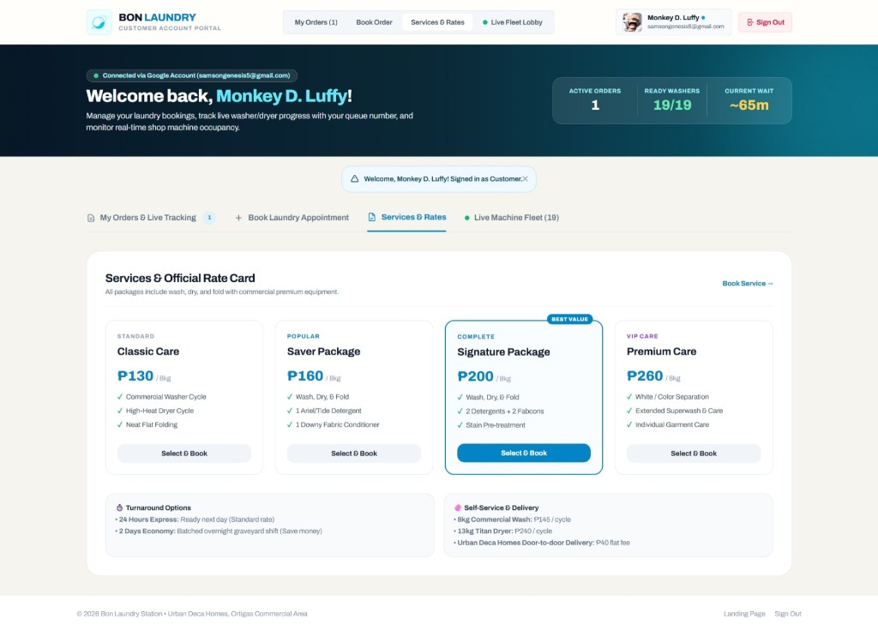
Figure 2: Services & Rates
This section provides transparent pricing disclosure for all customers:
Table 2: Standard Store Pricing Tariffs
Service Category | Capacity Bracket | Cycle Fee | Per-Kg Equivalent | Standard Turnaround
Regular Wash (Washer) | Up to 8.0 kg | ₱145.00 flat | ₱65.00 / kg | 39 minutes cycle
Titan Dry (Dryer) | Up to 13.0 kg | ₱145.00 flat | Included in bundle | 40 minutes cycle
Full Wash, Dry & Fold Bundle | 1 Load (8.0 kg) | ₱290.00 | ₱65.00 / kg base | 24 Hours SLA
Express Same-Day Rush | 1 Load (8.0 kg) | +₱100.00 surcharge | — | 4 – 6 Hours SLA
Bulky Comforter / Blanket | 1 Unit | ₱200.00 flat | Flat item rate | 24 Hours SLA
Ariel / Tide Powder Sachet | 1 Sachet | ₱20.00 | Add-on supply | —
Downy Fabric Softener | 1 Sachet | ₱15.00 | Add-on supply | —
Urban Deca Doorstep Delivery | Per trip | Free / ₱30.00 | Surcharge waived on promo | Doorstep handover

4.5 Module 4: Live Machine Lobby & Traffic Telemetry (`#tab-content-lobby`)
Displays real-time hardware status across the store’s 19 machines:
• Machine Inventory:
• 14 Regular Washers (8kg capacity, labeled Washer 01 through Washer 14).
• 5 Titan Dryers (13kg capacity, labeled Dryer 01 through Dryer 05).
• Live Status Indicators:
• 🟢 Available: Ready for immediate assignment.
• 🟡 In-Use (Walk-In): Running a walk-in counter cycle with live countdown timer.
• 🔵 In-Use (Online Order): Processing an online scheduled order.
• 🔴 Maintenance: Offline for servicing or drum sanitation.
• Traffic Rush Indicator: Displays current shop traffic density (Low, Moderate, High Rush) based on active machine usage.

4.6 Self-Service Order Cancellation with OTP Verification
To prevent accidental or unauthorized cancellations while preserving customer flexibility, orders in the Pending or In Queue state can be cancelled using an automated One-Time Password (OTP) verification mechanism.
sequenceDiagram
autonumber
actor Customer
participant Portal as Customer Portal
participant API as Backend API
participant SMS as PhilSMS / Email Service
participant DB as MySQL Database
Customer->>Portal: Clicks "Cancel Order" on active order card
Portal->>API: POST /api/order/cancel/request-otp {order_code}
API->>DB: Validates status is 'Pending' or 'In Queue' (not yet washing)
API->>API: Generates 6-digit numeric OTP (valid 10 mins)
API->>DB: Stores cancellation_otp and expiration timestamp
API->>SMS: Dispatches OTP via SMS / Email
API-->>Portal: Returns {status: 'success', message: 'OTP sent'}
Portal-->>Customer: Displays OTP input modal
Customer->>Portal: Enters 6-digit OTP & cancellation reason
Portal->>API: POST /api/order/cancel {order_code, otp, reason}
API->>DB: Validates OTP and timestamp
API->>DB: Transitions status to 'Cancelled', releases queue & machines
API-->>Portal: Returns cancellation confirmation
Portal-->>Customer: Displays success banner; order card moves to Past Orders

5. Staff Operations & Cashier Terminal Guide
The Staff workspace is engineered for countertop operations in fast-paced laundromat environments, optimizing intake speed, scale weight entry, and machine timer dispatching.

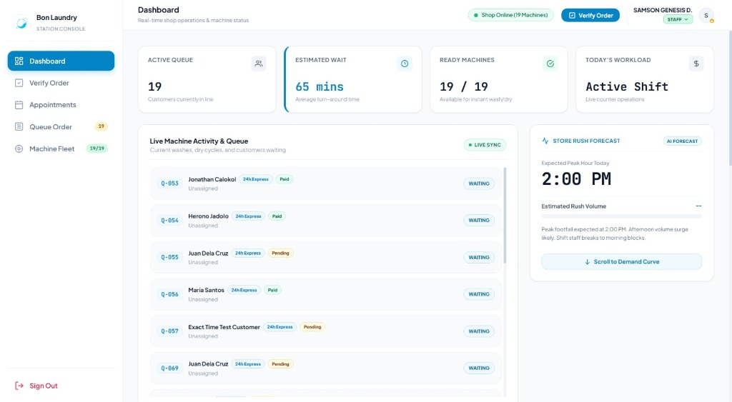
Figure 21: Staff Dashboard Overview
5.1 Staff Ledger Navigation & Layout
The desktop operations console uses a clean ledger design:
• Service Ink Sidebar: Fixed navigation column featuring primary operational tabs:
• Dashboard: Fleet telemetry, queue counts, and real-time activity feed.
• Verify Order: Primary counter check-in terminal for arriving orders.
• Appointments: Incoming online appointment queue.
• Queue Order: Live queue board with stage advancement controls.
• Machine Fleet: Status monitoring and manual timer overrides for all 19 machines.
• Top Header:
• Shop Online Live Pulse indicator.
• 1-Click Verify Order quick action button.
• Staff profile identity badge and Sign Out button.

5.2 Operations Dashboard & Live Queue Readout (`#view-dashboard`)
Provides an immediate operational overview:
• Metric Cards:
• Active Queue: Total customers waiting or currently washing.
• Est. Wait Time: Current system Estimated Waiting Time (minutes).
• Machines Ready: Number of available units ready for immediate intake.
• Machines Running: Active units currently in wash or dry cycles.
• Live Activity Tracker Table: Real-time table of the 15 most recent jobs, displaying Queue ID, Order Code, Customer Name, Contact Number, Service Tier, Current Stage, and Assigned Machine.

5.3 Counter Order Verification & Check-in Terminal (`#view-verify` & `/staff/verify-order`)

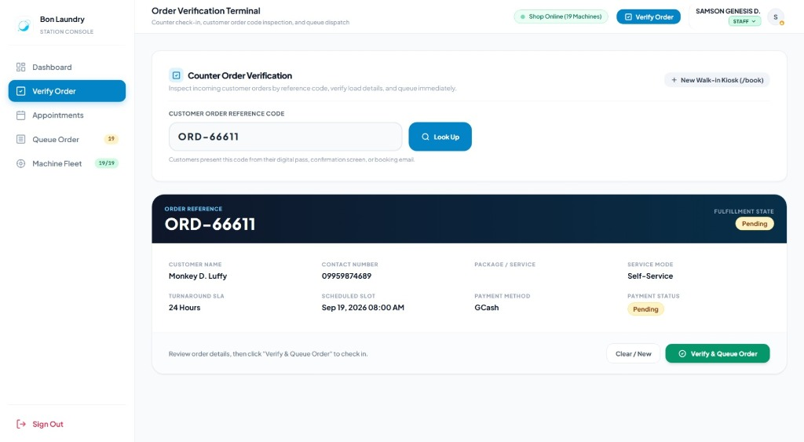
Figure 22: Order Verification Terminal
The verification terminal is the primary work tool for counter cashiers when customers arrive at the shop.
Operational Procedure for Counter Intake:
1. Look Up Order:
• Request the customer's Order Code (e.g., ORD-84920) or mobile phone number.
• Input the code into the Customer Order Code search box and press Enter (or click Look Up).
• The terminal displays the order details, customer name, service package, and delivery preference.
2. Weigh Garments on Digital Scale:
• Place the customer's laundry bag on the counter scale.
• Enter the verified weight in kilograms in the Physical Scale Weight (kg) field.
• The terminal automatically verifies if the weight fits within the selected machine bracket (8.0 kg regular limit) and calculates any overweight charges.
3. Review Recommended Machine Assignment:
• The terminal's allocation algorithm recommends the optimal available machine (e.g., Regular Washer 03) to minimize wait times and balance fleet wear.
• Staff may override and manually select an alternate machine if necessary.
4. Confirm Equipment Liability Waiver:
• Confirm that the customer has removed all coins, pens, and metal items from garments.
• Verify the liability acknowledgment displayed on the screen.
5. Collect Payment:
• If payment status is Pending, collect counter cash or confirm PayMongo digital settlement.
• Click Mark as Paid to record payment in the drawer.
6. Confirm Check-In:
• Click Confirm & Dispatch to Queue.
• The terminal assigns an official queue ticket (e.g., Q-014), updates the order to In Queue, prints or sends the customer queue slip via SMS, and advances the job to the Queue Board.

5.4 Online Appointments & Condo Pickup Intake (`#view-appointment`)

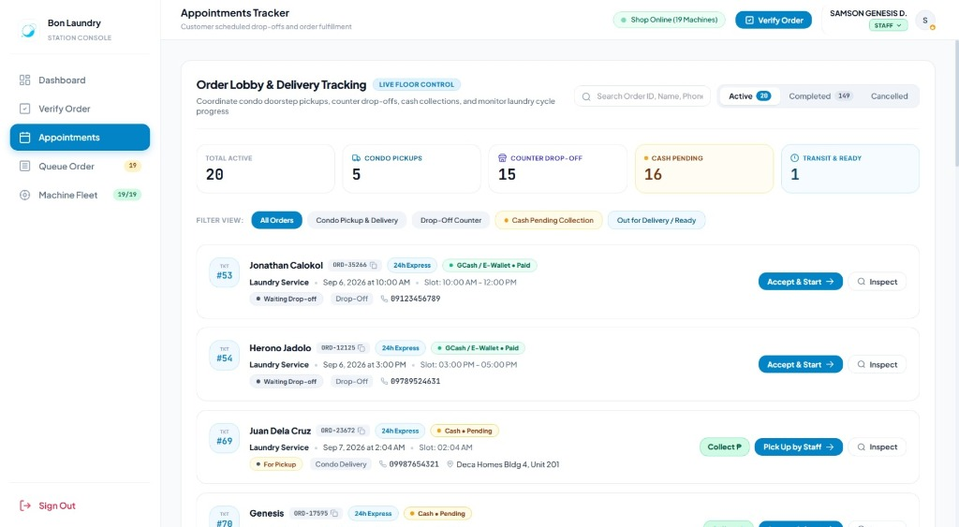
Figure 23: Appointments Management Tab
Manages all scheduled bookings submitted through the online customer portal.
• Filter Tabs: View orders by status: All, Pending, Confirmed, Completed, Cancelled.
• Appointment Row Details:
• Scheduled Date and Time Slot.
• Customer Name and Condo Unit Address (for doorstep pickup).
• Load Count and Machine Allocation.
• Payment Status (Cash Pending vs Online Paid).
• Row Actions:
• Inspect (Eye Icon): Opens the full-detail inspection drawer.
• Check-In (Check Icon): Immediately transfers the appointment into the Verification Terminal when the customer arrives or when staff collects the laundry from the condo.
• Cancel (Cross Icon): Allows staff to cancel no-show orders with an audit-logged reason.

5.5 Live Queue Board & Stage Progression (`#view-queue`)

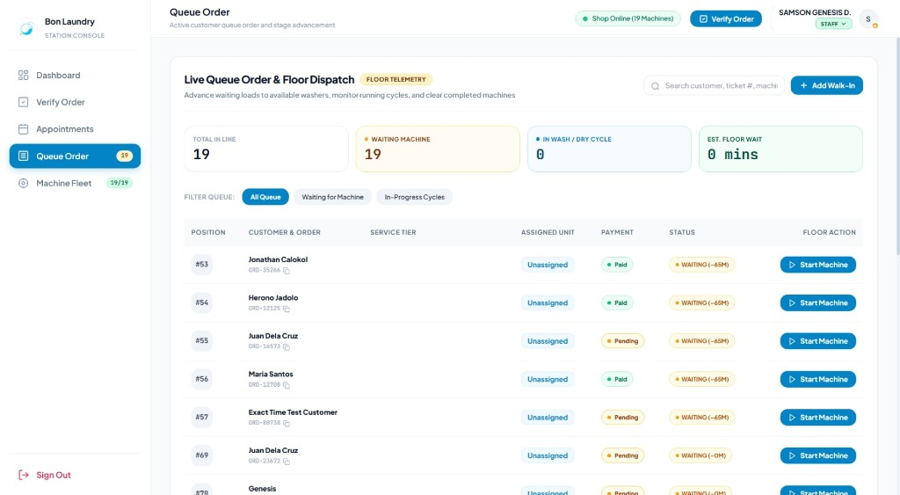
Figure 24: Live Queue Management
The Queue Board controls floor operations, machine loading, and order release.
Queue Card Attributes:
• Queue Number: Distinct alphanumeric ticket (e.g., Q-008).
• Order Reference: Linked customer order code (ORD-XXXXX).
• Customer Name: Resident name and phone link.
• Assigned Machine: Machine badge (e.g., W-02 for Washer 2, D-04 for Dryer 4).
• Stage Status: Waiting, Processing (Washing/Drying), or Done.
• Live Timer: Remaining cycle countdown.
How to Advance Order Stages:
flowchart TD
A["Ticket in 'Waiting' Status"] -->|Staff loads machine & clicks 'Start Wash'| B["Status becomes 'Processing' (39m timer starts)"]
B -->|Cycle timer reaches 00:00| C["Staff unloads, folds, & clicks 'Complete Cycle'"]
C -->|Status becomes 'Done' (Ready for Pickup)| D["Customer arrives & presents ticket"]
D -->|Staff clicks 'Release Garments'| E["Order Archived & Machine Released to 'Available'"]

1. Starting a Cycle: Click Start Wash / Dry. The order transitions to Processing, the assigned machine is locked to In-Use, and the synchronized 39m or 40m countdown timer begins.
2. Completing a Cycle: When the cycle timer finishes, staff remove garments, fold, and pack them into the designated clean laundry basket. Click Complete Cycle.
• Status updates to Done / Ready for Pick-up.
• An automated SMS notification is dispatched to the customer.
3. Releasing to Customer: When the customer arrives at the counter:
• Verify ticket number.
• If pickup exceeds the 10-minute grace period, the system prompts for a ₱100 late penalty fee.
• Click Release Garments. The ticket is archived and the machine returns to Available.

5.6 Machine Fleet Telemetry & Cycle Timers (`#view-machines`)

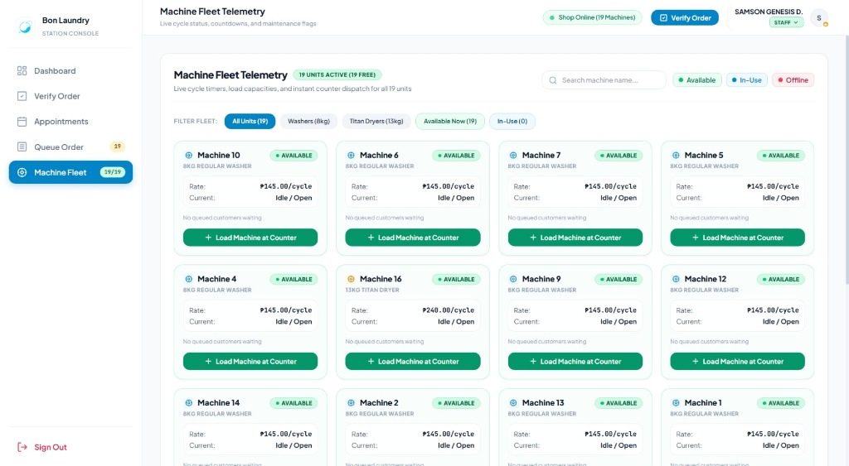
Figure 25: Machine Fleet Telemetry
Provides centralized monitoring and floor control over all 19 commercial units:
• Machine Telemetry Card Elements:
• Unit Name (e.g., Regular Washer 07, Titan Dryer 02).
• Capacity Badge (8kg for Washers, 13kg for Dryers).
• Operational State (Available, In-Use (Walk-In), In-Use (Online), Maintenance).
• Live Circular Timer Progress Bar.
• Lifetime Cycle Counter (monitors machine wear and service schedules).
• Manual Walk-In Cycle Start:
• For walk-in self-service customers, click Start Cycle. Select cycle type (Washing 39m or Drying 40m) to lock the machine and start the hardware countdown timer.
• Maintenance Toggle:
• If a machine requires drum cleaning, filter clearing, or maintenance, click Toggle Maintenance. The unit is immediately flagged as unavailable, preventing the recommendation engine and booking wizard from assigning new jobs to it.

6. Manager Supervisory & Analytics Console Guide
The Manager Console builds upon all staff capabilities by adding business intelligence, demand forecasting, financial drawer reconciliation, and security auditing.

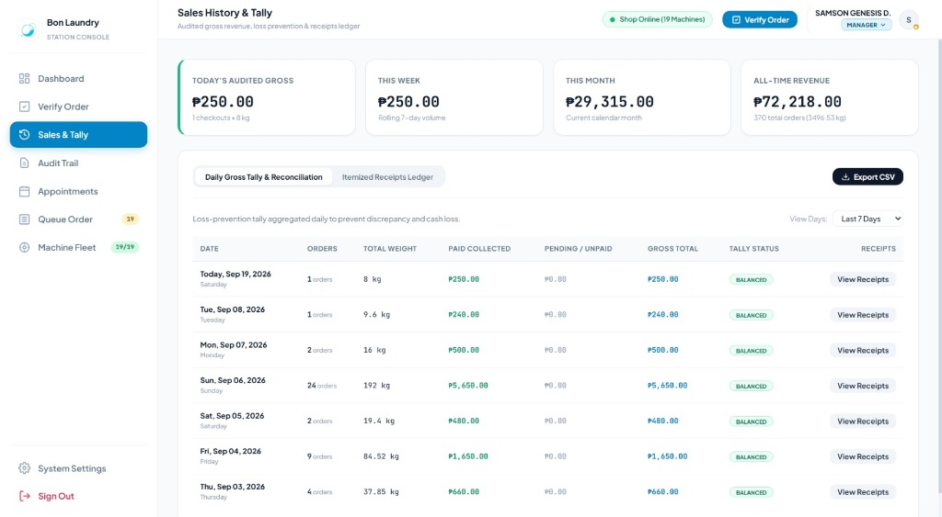
Figure 27: Manager Sales Ledger
6.1 Supervisory Operational Readout
The Manager dashboard (/manager/dashboard) includes high-level executive cards:
• Total Store Revenue (₱): Cumulative gross receipts.
• Total Processed Loads: All-time completed wash and dry cycles.
• Fleet Utilization Rate (%): Proportion of machines currently generating revenue.
• Maintenance Alert Counter: Number of machines currently offline.

6.2 Machine Learning Demand & Rush Hour Forecasting
To prevent counter bottlenecks and optimize staff scheduling, Bon Laundry Station integrates a predictive demand analytics engine.
graph LR
A[Historical Transaction Database] -->|Hourly Load Frequencies| B[Analytics Engine]
B -->|2nd-Degree Polynomial Regression| C[Rush Hour Prediction Model]
C --> D[Predicted Peak Rush: 3:00 PM - 6:00 PM]
C --> E[Model Accuracy: MAPE 8.4%]
C --> F[Staffing Recommendation: Add Floor Operator]

• Predictive Model: 2nd-Degree Polynomial Regression evaluating historical load times and day-of-week demand patterns.
• Predicted Peak Hour: Highlights anticipated daily rush periods (e.g., Predicted Peak Rush: 3:00 PM – 6:00 PM with 18+ incoming loads).
• Model Validation Metric: Displays the real-time Mean Absolute Percentage Error (MAPE) score (e.g., MAPE: 8.4%), confirming model reliability against actual store transactions.
• Managerial Action: Use forecast outputs to schedule additional floor staff and prepare folding stations ahead of peak hours.

6.3 Habitual Predictive Slots ("Ghost Slots") Allocation
Urban Deca Homes residents frequently follow habitual laundry routines (e.g., washing every Tuesday morning or Saturday afternoon).
• Algorithm: The engine identifies recurring visit patterns among registered residents who have completed three or more orders.
• Provisional Buffer Allocation: Proactively reserves machine buffer slots for habitual clients, preventing walk-in crowds from completely booking out returning residents.
• 1-Click Slot Assignment: When an identified resident contacts the shop, the manager clicks Assign Ghost Slot to instantly book their regular machine and turnaround tier without manual form entry.

6.4 Sales Ledger, Daily Tally & CSV Export (`#view-sales`)
The financial ledger consolidates all shop transactions across both cash and digital channels.
• Financial KPI Cards:
• Gross Revenue: Total collected funds for the selected date filter.
• Cash Drawer Tally: Physical cash collected at the counter.
• Digital PayMongo Tally: Online funds settled via GCash, Maya, and cards.
• Pending Receivables: Unpaid orders currently in processing.
• Date Range Filters: 1-click filters for Today, Yesterday, Last 7 Days, This Month, or custom date picker.
• Transaction Table Columns: Transaction ID, Date & Time, Order Code, Customer Name, Garment Weight (kg), Assigned Machine, Cycle Type, Total Amount (₱), Payment Status.
• CSV Export (`/sales/export`): Click Export CSV to download a clean, audit-ready spreadsheet for bookkeeping, Excel financial models, or tax accounting.

6.5 Chronological Audit Trail & Prediction Logs (`#view-audit`)

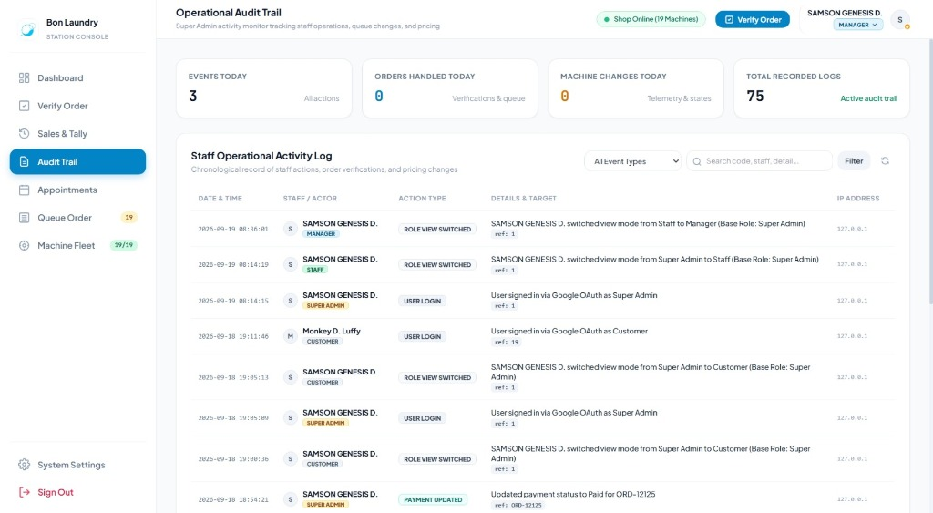
Figure 26: Manager Audit Trail
Maintains full compliance and data integrity across all operational actions.
• Audit Trail Table: Records chronological system events:
• User Logins and Role Switches.
• Order Check-ins and Manual Price Overrides.
• Machine Maintenance Toggles.
• Appointment Cancellations and OTP Verifications.
• User Account Creation and Role Changes.
• Log Record Attributes: Timestamp, Actor Name, User Role, Action Description, Target Entity ID, Client IP Address.
• Prediction Log Auditing: Compares historical machine learning predictions against actual counter traffic, validating accuracy and tracking model performance over time.

7. Super Admin Governance & Administration Guide
The Super Admin tier provides executive control over store policies, pricing structures, hardware settings, and employee system access.

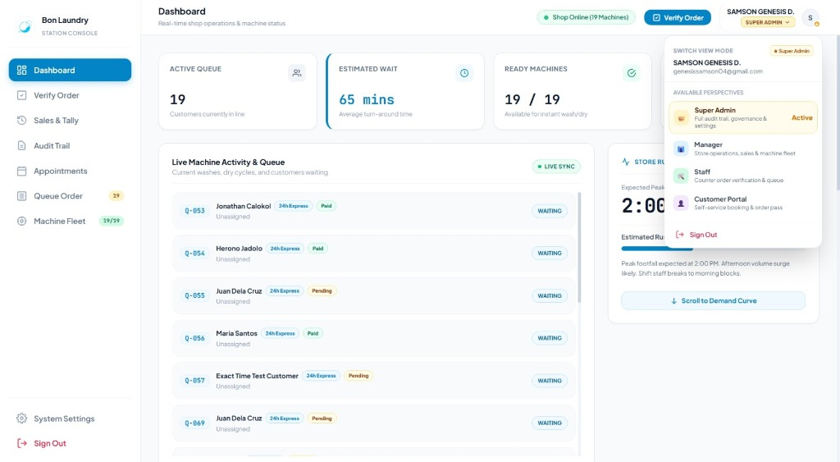
Figure 28: Super Admin Role Switcher
7.1 Executive System Overview
The Super Admin inherits all Manager and Staff capabilities while retaining exclusive access to:
1. Dynamic Role Switcher.
2. User and Staff Account Provisioning.
3. Master System Settings and Pricing Tariffs.
4. Machine Hardware Fleet Configuration.

7.2 Dynamic View Mode Perspective Switcher (`toggleRoleDropdown`)
Enables immediate perspective shifts without logging out:
1. Click the top-right user profile dropdown.
2. Select any role perspective (Super Admin, Manager, Staff, or Customer Portal).
3. The interface re-renders under the selected role's view rules, allowing the administrator to test the counter terminal, verify booking flows, or inspect customer experiences firsthand.
4. Return to executive mode at any time by selecting Super Admin.

7.3 User & Staff Account Management (`#view-settings`)

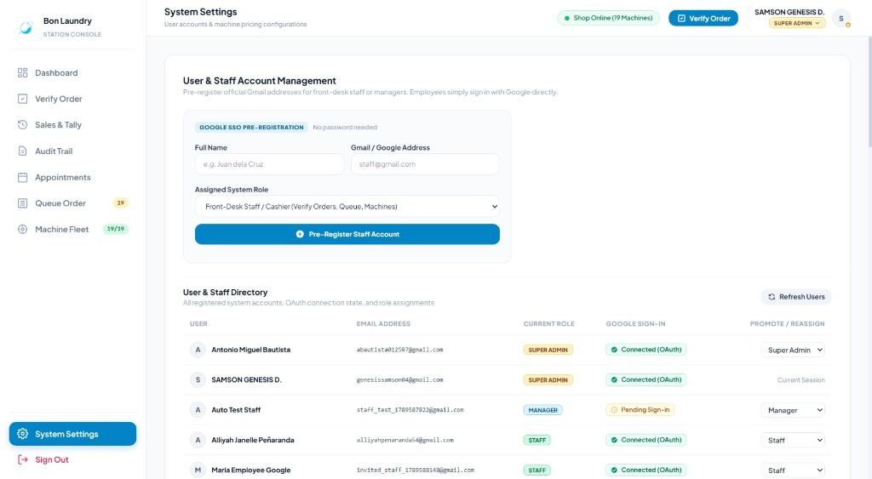
Figure 29: Super Admin Account Management
Controls user provisioning and role assignments across the platform.
How to Provision a New Staff Member:
1. Navigate to the System Settings tab (switchTab('settings')).
2. Locate the Account Provisioning & Staff Onboarding card.
3. Enter the employee's details:
• Full Name: e.g., Juan Dela Cruz.
• Gmail Address: e.g., juan.delacruz@gmail.com (must be a valid Google account).
• Assigned Role: Select Staff (or Manager).
4. Click Pre-Register Account.
5. The account is created with Google SSO authorization. When the employee navigates to /login and clicks Continue with Google, the system recognizes their email and grants access to their assigned operational workspace.
How to Promote, Demote, or Reassign Roles:
1. In the Registered Users Directory table, locate the target user.
2. Click the Role Selector dropdown in the user's table row.
3. Choose the updated role (Customer, Staff, Manager, or Super Admin).
4. The role change takes effect immediately. The target user will operate under their updated permissions upon their next page load or session refresh.
[WARNING] Only a Super Admin can promote another user to the Super Admin role or modify existing Super Admin accounts. Managers cannot alter administrative permissions.

7.4 Master Pricing Tariffs, Grace Periods & Late Penalties Configuration
Located in the System Settings panel:
• Base Price per Kilogram: Default ₱65.00 / kg. Used for counter scale weight calculations.
• Maximum Weight Limit per Regular Load: Default 8 kg. Flags orders requiring multi-machine splitting.
• Standard Washer Cycle Duration: Default 39 minutes.
• Standard Dryer Cycle Duration: Default 40 minutes.
• Late Garment Retrieval Grace Period: Default 10 minutes. Permitted window between cycle completion and penalty application.
• Late Retrieval Penalty Surcharge: Default ₱100.00. Applied when customers leave finished laundry in machines past the grace period, preventing drum bottlenecks.

7.5 Machine Hardware Configuration Matrix
Allows custom per-unit cycle pricing and capacity specifications across all 19 fleet machines:
1. In System Settings, locate the Machine Hardware Matrix.
2. For any machine (e.g., Titan Dryer 01), adjust:
• Cycle Fee (₱): e.g., ₱145.00.
• Capacity (kg): e.g., 13 kg.
• Operational Status: Available vs Maintenance.
3. Click Save Machine Configuration. Updated tariffs apply immediately across the booking wizard and counter POS calculations.

8. Standard Operating Procedures (Step-by-Step Workflows)
SOP-01: Online Booking to Counter Intake
sequenceDiagram
actor Resident as Customer (Resident)
actor Staff as Counter Staff
participant Sys as Bon Laundry System
Resident->>Sys: Completes 4-Step Booking Wizard online
Sys-->>Resident: Issues Order Code ORD-84920 & QR Code
Resident->>Staff: Arrives at station & presents ORD-84920
Staff->>Sys: Enters ORD-84920 into Verify Terminal (/staff/verify-order)
Staff->>Staff: Places laundry bag on digital scale
Staff->>Sys: Inputs scale weight (e.g. 7.4 kg)
Sys->>Sys: Recommends Washer 05 (Available, 39m cycle)
Staff->>Sys: Confirms liability waiver & collects cash (or verifies PayMongo)
Staff->>Sys: Clicks "Confirm & Dispatch to Queue"
Sys-->>Staff: Prints / assigns Queue Ticket Q-012
Sys-->>Resident: Sends SMS confirmation with live tracking link

SOP-02: Walk-In POS Order Processing
For walk-in customers arriving without an existing online appointment:
1. Open the operations console and click Verify Order (#view-verify).
2. Click the Walk-in Booking button in the header (or open /book in a dedicated tab).
3. Select service package (e.g., Wash, Dry & Fold), set load count, and enter customer name and phone number.
4. Submit the form to generate an instant walk-in order reference code.
5. In the Verification Terminal, enter the weight from the digital scale.
6. Collect cash payment at the register. Click Mark as Paid.
7. Click Confirm & Dispatch to Queue. Provide the customer with their queue ticket number.

SOP-03: Machine Cycle Execution & Countdown Monitoring
1. In the Queue Order tab (#view-queue), locate the next ticket in Waiting status.
2. Escort the customer laundry bag to the designated washer or dryer (e.g., Washer 04).
3. Load the drum, add the customer's selected detergent/softener, close the door, and set the machine program.
4. On the Queue Board, click Start Wash (or Start Dry).
5. The system initiates the 39-minute (wash) or 40-minute (dry) synchronized countdown timer.
6. The machine's status indicator automatically updates to In-Use across the Customer Lobby and Staff Telemetry screens.

SOP-04: Order Completion, Pick-Up & Late Retrieval Penalty Assessment
1. When a machine cycle timer reaches 00:00, remove garments from the drum immediately.
2. Transport garments to the folding counter; fold, pack, and tag with the order code.
3. On the Queue Board, click Complete Cycle.
• Status transitions to Done.
• An automated SMS alert notifies the customer that their laundry is ready for pickup.
• The 10-minute retrieval grace period timer begins.
4. When the customer arrives at the counter:
• Request their Queue Ticket or Order Code.
• If arrival exceeds the 10-minute grace window:
• The system alerts: Late retrieval: ₱100 penalty fee applies.
• Explain the policy to the customer and collect the ₱100 penalty fee.
• Hand over the clean, packaged laundry.
• Click Release Garments to close the ticket and return the machine to Available.

SOP-05: Provisioning a New Staff Member
1. Log in with a Super Admin account.
2. Navigate to System Settings (switchTab('settings')).
3. In the Account Provisioning form, enter the employee's full name, official Gmail address, and select the Staff role.
4. Click Pre-Register Account.
5. Inform the employee to open /login on their workstation and click Continue with Google.
6. The employee is automatically authenticated and routed to /staff/dashboard.

9. Operational Edge Cases & Troubleshooting Guide
Table 3: Operational Troubleshooting Matrix
Issue / Scenario | Root Cause | Standard Resolution Procedure
Customer cannot sign in with Google | Popup blocker active or browser cookies blocked. | Advise the user to allow popups for accounts.google.com or open the portal in an incognito window. Ensure the account matches the pre-registered Gmail for staff.
Scale weight exceeds 8.0 kg limit | Customer brought an overloaded bag (e.g., 11.5 kg). | Split laundry into two separate loads in the Verification Terminal. Assign across two washers (e.g., 6.0 kg and 5.5 kg) to prevent machine damage and ensure thorough washing.
Machine trips / error code mid-cycle | Hardware malfunction, water inlet stoppage, or power trip. | 1. Open #view-machines and click Toggle Maintenance to lock the unit.<br>2. Transfer garments to an available secondary unit.<br>3. In #view-queue, reassign the order to the new machine and restart the cycle timer.<br>4. Log a service ticket for technician inspection.
Customer requests cancellation after arriving | Customer changes mind before washing begins. | Open the Appointments tab, locate the order, and click Cancel Booking. Input the reason. If garments were already weighed, cancel the pending queue slot to release the machine.
Customer attempts cancellation while machine is running | Garments currently in active wash/dry cycle. | The self-service cancellation option is automatically disabled once status enters Processing. Inform the customer that the cycle is running and garments cannot be safely extracted until completion.
Customer loses their Order Code | Misplaced confirmation slip or lost SMS. | Ask for the customer's mobile phone number or full name. Search using the global search bar in #view-appointment or #view-verify to retrieve the order code.
PayMongo payment status shows Pending after user paid | Webhook delay or network interruption during checkout. | Check the PayMongo merchant dashboard or click Re-verify Payment on the order modal. If the customer presents a digital receipt showing a successful charge, click Mark as Paid to update the record manually.

10. Complete System Navigation Map & URL Reference Table
Table 4: Complete System Route Map
URL Route | Blueprint | Supported Methods | Permitted Roles | Functional Description
/ | Core | GET | Public | Public landing page, shop features, lobby preview, FAQ, and chatbot.
/login | auth | GET | Public | Unified sign-in entry point with Google OAuth 2.0.
/register | auth | GET | Public | Alias to /login for customer account onboarding.
/auth/google/login | auth | GET | Public | Initiates Google OAuth2 authorization code flow.
/auth/google/callback | auth | GET | Public | Handles OAuth callback, resolves user identity, sets session, and routes to role home.
/auth/logout | auth | GET | Authenticated | Clears active session and redirects to /login.
/customer/dashboard | dashboard | GET | Customer | Self-service customer portal: orders, booking wizard, rates, and live lobby.
/customer/portal | dashboard | GET | Customer | Alias to /customer/dashboard.
/book | dashboard | GET | Public / Customer | Direct booking wizard and walk-in reservation terminal.
/walk-in | dashboard | GET | Public / Staff | Direct walk-in order placement portal.
/staff/dashboard | dashboard | GET | Staff, Manager, Admin | Front-desk operations ledger: queue counts, active activity, and floor controls.
/staff/verify-order | dashboard | GET | Staff, Manager, Admin | Full-screen counter check-in terminal for order verification and scale entry.
/manager/dashboard | dashboard | GET | Manager, Admin | Supervisory operations console: ML forecasting, ghost slots, sales ledger, and audit logs.
/sales/export | dashboard | GET | Manager, Admin | Downloads complete transaction ledger as a CSV file.
/api/order/create | appointments | POST | Public / Customer | Submits a new laundry order from the booking wizard.
/api/order/track | appointments | GET | Public / Customer | Returns live status and lifecycle progress for a given order code.
/api/order/cancel/request-otp | appointments | POST | Customer | Generates and sends a 6-digit cancellation OTP.
/api/order/cancel | appointments | POST | Customer | Verifies OTP and cancels a pending appointment.
/api/staff/verify-order | dashboard | GET | Staff, Manager, Admin | Looks up order details for counter verification.
/api/staff/confirm-order | dashboard | POST | Staff, Manager, Admin | Confirms check-in, validates weight, assigns machine, and creates queue ticket.
/api/queue/<id>/advance | dashboard | POST | Staff, Manager, Admin | Advances queue ticket status (Waiting \rightarrow Processing \rightarrow Done).
/api/machines/<id> | machines | PUT | Staff, Manager, Admin | Updates machine operational status (Available / Maintenance).
/api/manager/live-forecast | dashboard | GET | Manager, Admin | Returns real-time 2nd-degree polynomial regression demand predictions.
/api/manager/ghost-slots | dashboard | GET | Manager, Admin | Returns habitual customer recurring routine slots.
/api/auth/switch-role | auth | POST | Super Admin | Switches active perspective mode (Admin, Manager, Staff, Customer).
/manager/accounts | auth | POST | Super Admin | Pre-registers staff/manager accounts with Google SSO linking.
/api/manager/users/<id>/role | auth | POST | Super Admin | Promotes or demotes user account roles.
/api/bot/chat | bot | POST | Public / Customer | Conversational AI endpoint for inquiries, rates, and order tracking.

Bon Laundry Station Operations Manual — Document End

