PROJECT: RANKARO GAME



Programmer:

* Nguyen Hoang Phuong (design and coding)

Genre: Puzzle

Platform: IOS, Android, Windows

Target Market: Casual, everyone

Time-frame: May 5, 2013 – May 25, 2013



1. Requirements specification

* This is a simple multiplayer online game which uses client-server model and run on multiplatform: IOS, Android , Windows
* This game is turn-based game (sequential)
* Core action: The game allows up to two to four players to play simultaneously. Each players is provided a board 9x9. People play in turn, each turn player receivers a block number 3x1 include 3 numbers generated on server. Player touches in the board to put it down abide by block slot
* Rules: The goal for the players is put the block number so that rows, columns and crosses have the same number of consecutive. The score is calculated by the total number of that if it has least three numbers. The player who has the heighest score in the end (27 turn) will be the winner.
* Each two minutes if player not sends anything to server, it will be disconnected

1. Analysis design

* Use client-server model
* Client: send name, send state, send position to server

Server: broadcast it to rest clients

* Details

Sequence diagram:

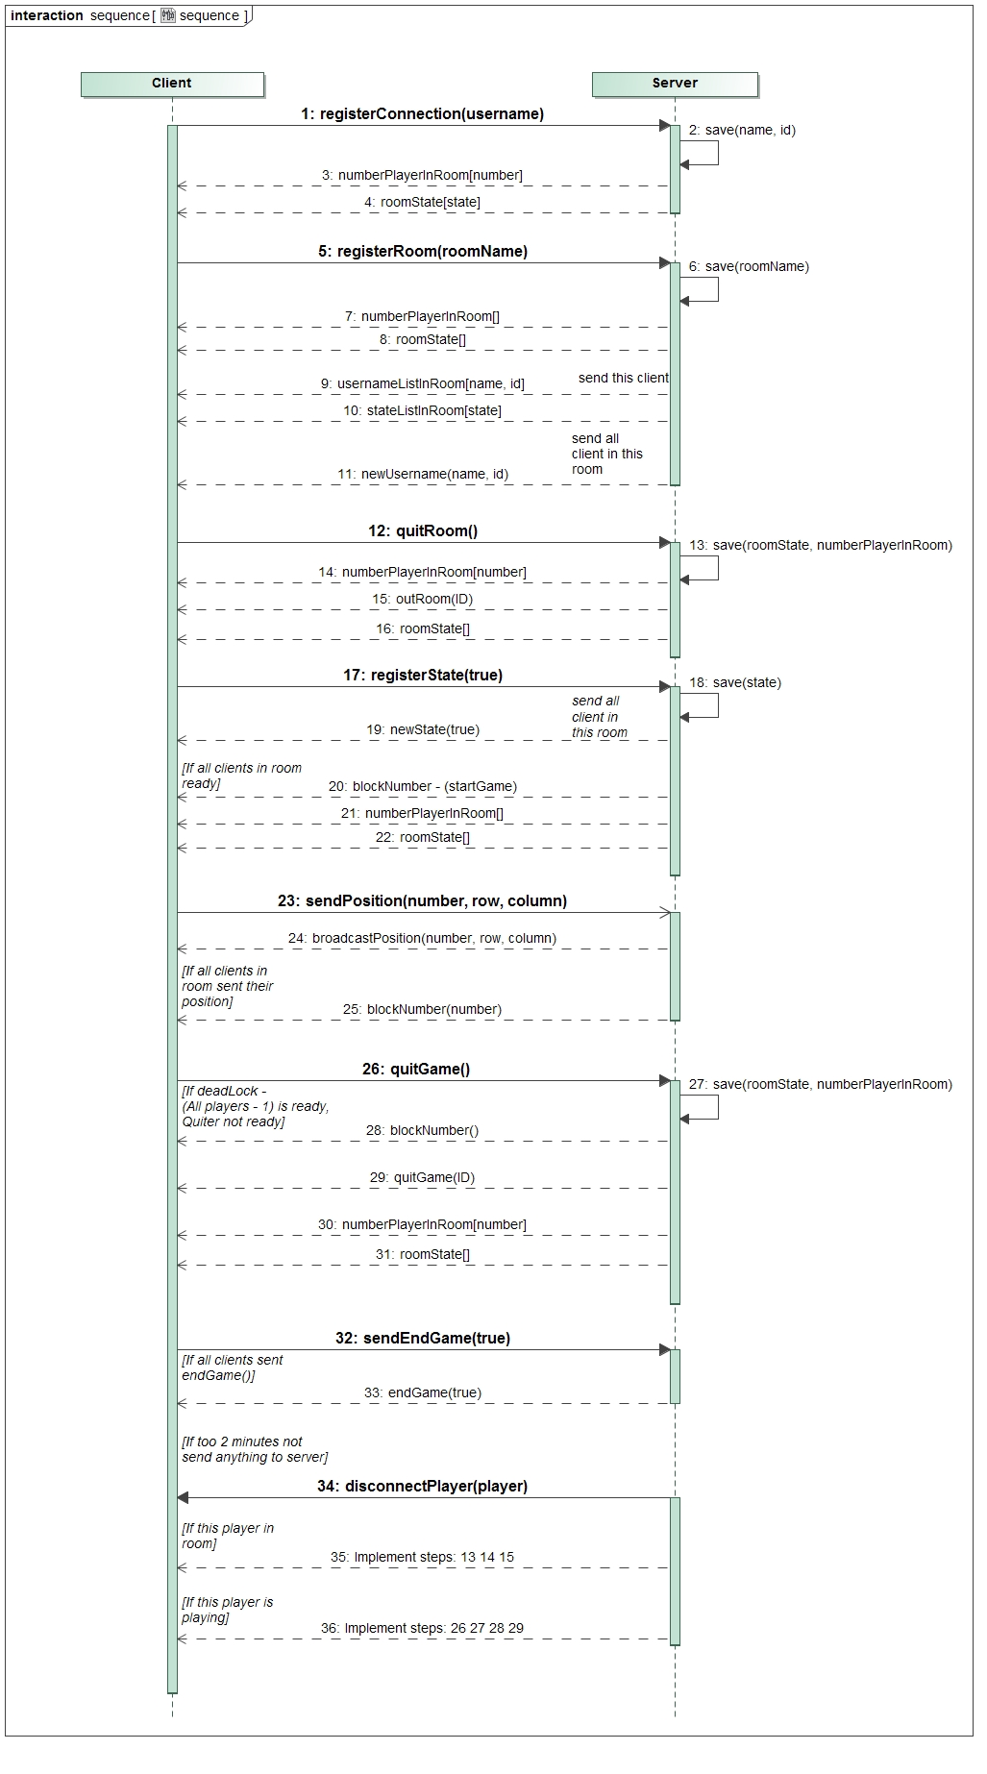

1. Technology used

* C++ and Cocos2d-x framework
* Cocos2d-x is a cross platform open source 2D game engine for mobile gamedev (C++, IOS, Android).

1. Demo program

This video demo game: <http://youtu.be/z_QkKSz9wAU>

Following is some screenshots of the game:

1. Start screen

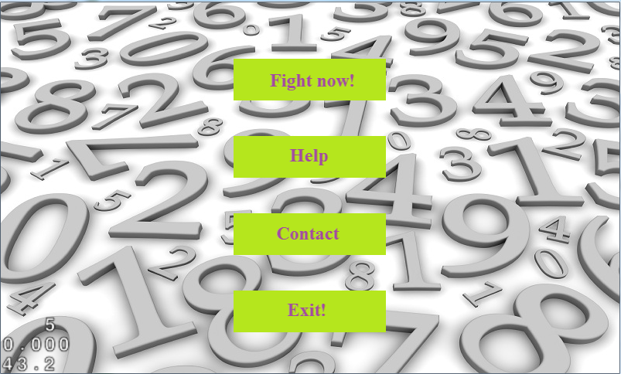

1. Register username

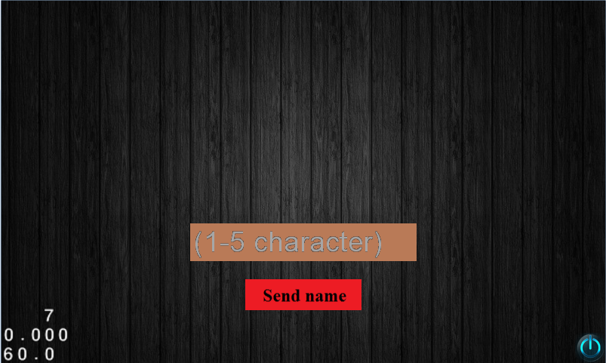

1. Choose a room

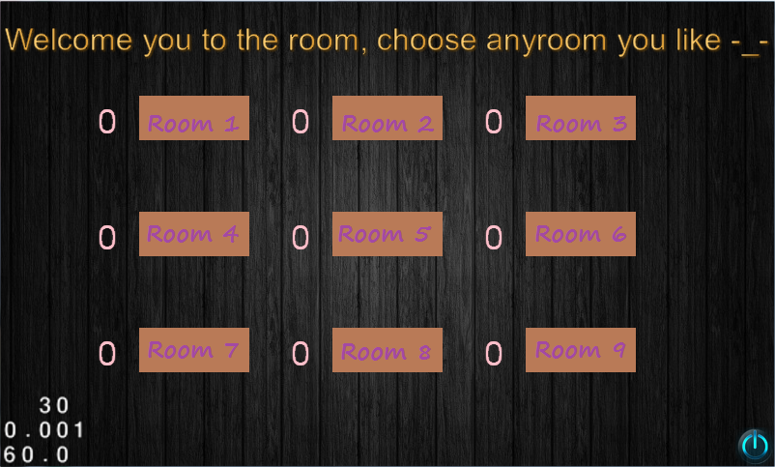

1. Room screen

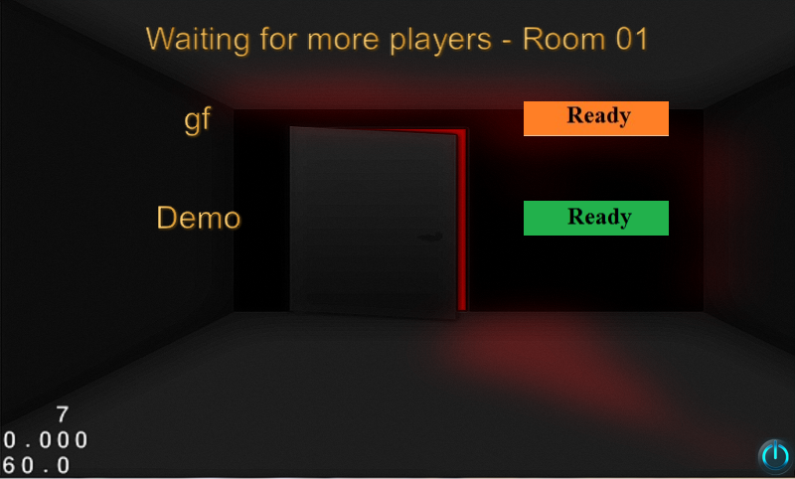

1. Play screen:

