**Marketing Research for Health Care Business**

**Introduction**

“Health care” means a set of actions to maintain or improve the health condition, whereas the term “healthcare” indicates a system, industry, or field that facilitates the logistics and delivery of health care. Therefore, we could say “a health care business in healthcare industry”, but not vice versa.



Additionally, “healthcare” itself is an ambiguous term which has various interpretations in different contexts. Therefore, it is necessary to define the scope of this term beforehand to avert confusion. The meaning of the term healthcare used in this article is cited from the Organization for Economic Co-operation and Development’s (OECD). The meaning of the term covers very specific fields which include services of curative and rehabilitative care, services of long-term nursing care, ancillary services to healthcare, medical goods, prevention and public health service, and health administration and health insurance. These services might come from various providers, including but not limit to: hospitals, nursing and residential care facilities, providers of ambulatory healthcare, retail sales and other providers of medical goods, provision and administration of public health programs, and general health administration and insurance. The scope should be broad enough to cover everything companies need to consider when they try to evaluate a new market.

Most of the countries, including our four primary research targets – U.S., Japan, China, and Australia – are spending increasingly in healthcare industry. Here we invoke Purchasing Power Parity (PPP) to ensure the accuracy and integrity of the data. As presented in Table 1, the expenditure per capita keeps increasing over the last decades, indicating that each individual in these countries receives more health care resources each year.

Table 1. Trend of Health Expenditure per Capita (0)

Health expenditure tends to raise as national income increases. In other words, countries with strong economy and high GDP per capita tend to spend more on healthcare. This trend can be demonstrated by the latest official statistics from OECD. As we can observe from Table 2, healthcare expenditure accounted for a significant 16% of the nation’s GDP in the United States. Similarly, Japan and Australia as developed countries also invested heavily in healthcare. Nonetheless, China, which is a developing country, spent only 5.4% in healthcare, slightly more than a half of the average percentage.

Table 2. Health Expenditure as Percentage of National GDP (0)

We would see an even greater difference when we look at the total health expenditure (Table 3) and health expenditure per capita (Table 4). U.S. still leads the chart as it spends $3.2 trillion ($2.7 trillion, PPP) on healthcare in 2014, which means $8,713 on every citizen, exceeding the second place ($6,325) for almost 40%. The total amount is six times as much as that of Japan or China. It is safe to conclude that U.S. is the largest market for healthcare related businesses. Though both Japan and Australia spend around $3,800 on each citizen this year, which is few hundreds above the OECD average, the market size of Australia is much smaller, due to the small population size of the nation. On the other hand, though China invest similar amount in healthcare to Japan, given the population China owns, the resource that each individual can receive becomes rare. Therefore, there might be a huge gap between what people desire and what the society offers.

Table 3. Total Health Expenditure in $ million, PPP (0)

Table 4. Health Expenditure per Capita (0)

Consider these four countries in a larger scope (Table 5), we can observe the position of each nation (marked with brown color). While U.S. has a mature market where private spending accounts for more than 50%, Japan and Australia assign more responsibilities to government expenditure. As for China, the market is inferior and there is a large room for future development when we consider its population.

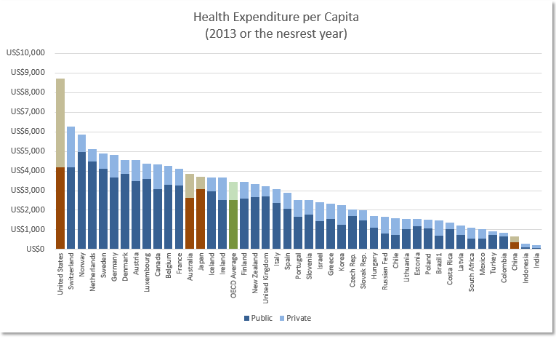

Table 5. Health Expenditure per Capita (Worldwide, 2013 or the nearest year) (0)

**PEST Analysis**

**The United States of America**

**Political Analysis**

Though more than half of the healthcare expenditure is from the private sector, the U.S. government still plays an indispensable role in the nation’s healthcare market, as it guides the market and invests heavily in it (Table 6). There are several federal programs that can reflect the government’s steadfast support for the healthcare industry.

Table 6. Health expenditure per capita, U.S.

According to the statistics of the U.S. Congressional Budget Office, the government plans to invest totally $1,024 billion in healthcare programs during fiscal year 2016. $591 billion out the total amount goes to MEDICARE, a federal program that provides health coverage for elders whose age are 65 or beyond. $371 billion has been assigned to MEDICAID, a state and federal program that provide health coverage for the unprivileged groups. Another $49 billion goes to health insurance subsidies and relevant spending, while the remaining $13 billion is used for children’s health insurance program (Table 7).

Table 7. U.S. Healthcare Programs Expenditure 2016 (in $ billion) (5)

The government investment in healthcare is heavier than before since President Obama signed the Patient Protection and Affordable Care Act (ACA) in March, 2010. This legislation is an expansion of MEDICAID that aims to provide insurance coverage to millions of Americans who have no insurances and also to regulate insurance companies to provide a uniform price to each client regardless of their previous status. In addition, the law also introduces an individual mandate, which forces every citizen to purchase insurance. Apparently, this act would increase the number of people enrolled in an insurance and therefore increase the expenditure in healthcare industry. In fact, the year of 2014 witnessed a 5.3% growth rate in health expenditure, compared with the 3.7% average for the last five year (3).

Despite enhances national welfare and increases insurance premium, the U.S. government also reacts swiftly to emerging health threats. For instance, during the deadly Ebola outbreak in 2014, U.S. Congress has appropriated $5.4 billion to fight the virus ([1](http://kff.org/global-health-policy/issue-brief/the-u-s-response-to-ebola-status-of-the-fy2015-emergency-ebola-appropriation/)). In the case of Zika virus, which threatened the nation in the mid of 2016, the government redirected $622 million to fight the virus while the Congress is processing the $1.9 billion funding (2).

Overall, though there are imperfections, the government of the States played a very active role in the field of healthcare and showed its steadfast support for the future development of its healthcare system.

**Economic Analysis**

According to the most recent data in 2013, the United States spent about $2.7 trillion on healthcare, comprising 16.4% of the nation’s Gross Domestic Product (GDP), which was $16.66 trillion. Such a significant share of the world’s largest economy is an unignorable market for any business who intended to stand strong in healthcare industry.

Furthermore, the growth rate of health expenditure remains higher than the growth rate in the past decade. As we can see from Table 7, though the trend is similar, the health expenditure was more stable, as it was not cut to alleviate the economic impact even during the worst year of the crisis. In the post-crisis years of 2014 and 2015, the growth rate of healthcare expenditure exceeded 5%. Considering the size of the economy, such an increasing speed will certainly bring abundant opportunities.

Unlike that of highly risky European countries, the economy of U.S. is recovering swiftly from the recession and is unlikely to suffer another crisis. Therefore, the economy of the nation can and will bolster and fund the development of its healthcare industry, making this nation a relatively safe and stable market for investors.

Table 7. U.S. GDP and Health Expenditure Growth Rate Comparison (4)

**Social Analysis**

An inevitable problem that Americans are facing is the aging population, as an increasing number of Baby Boomers enter retirement age. Baby boomers refer to a portion of the population who was born between 1946 and 1964, when the birth rate was high. This group represents 76 million people which account for about 20% of the U.S. population (6). When compared with their previous generations, Baby Boomers are more proactive and are expected to live longer. Therefore, it is guaranteed that healthcare spending will keep raising as Boomers start to take advantage of the nation’s welfare system. Not only because of the raising number of elderly individuals, but also because of the raising medical cost as one grows old.

Additionally, the healthcare system is not yet prepared for its aging population. According to a research done by U.S. Department of Health and Human Service, there will be a projected shortage of 20,400 primary care physicians in 2020 (7). Therefore, private service and facilities will thrive, as Boomers have strong consumer power to seek additional medical resources, including home care, adult day care, nursing home, and assisted living (8).

Another eye-catching issue in U.S. is the nation’s unemployment rate. As showed in Table 8, the unemployment rate falls dramatically while the nation is recovering from the economic crisis. On one hand, the public healthcare expenditure decreases. The descending unemployment rate means that more people are hired and therefore have stable income, reducing the nation’s healthcare investment in low-income group and eventually decreasing healthcare expenditure for the government. On the other hand, healthcare expenditure from private sector should increase. Although the hired individuals are no longer covered by government healthcare plan, they still need to buy their own insurance. In addition, insurance beneficiaries still need to pay about 20% of the medical cost out of their own pocket (10). As the consumer power increases, more and more people may pursue higher quality medical resources. Therefore, it is complicated to judge the eventual result of the dropping unemployment rate for now, however, it should be beneficial for the healthcare industry in the long run, as the nation suffers less and the life quality of its citizens gets higher.

Table 8. U.S Unemployment Rate (2006-2015) (9)

**Technological Analysis**

The United States is a leading entity in IT technology as well as medical science and equipment. According to PwC’s Global 100 Software Leaders, among these leading IT companies, 66 of them are U.S.-based. For the top ten companies who gained the highest revenue, nine of them are U.S.-based. The data may differ slightly in different reports, but it is undoubtable that the United States attracts the most edge-cutting talents and companies in IT industry. The thriving of IT industry provides the healthcare industry opportunities to introduce new technologies help patients, such as mobile applications and comprehensive data analysis.

Table 9. Top 100 Software Leaders Distribution (11)

As for medical science, U.S. has some of the world’s finest universities which have strong edge in this field, contributing directly to the nation’s medical science. According to a world ranking from TopUniversities.com, six of the top ten medical schools are in U.S., which are Harvard University, Stanford University, Johns Hopkins University, University of California, Los Angeles (UCLA), University of California, San Francisco (UCSF), and Yale University (12). There are also plenty of other world-famous institutions, such as Columbia University and Massachusetts Institution of Technology (MIT), that have strong expertise in medical science. The talents from these institutions are indispensable for the development of the healthcare industry in the long run.

**Japan**

**Political Analysis**

In Japan, the government has strong control over the nation’s medical resources and health insurance through law enforcement and price regulation. The public fund bears 82% of the nation’s healthcare costs (13). Though the government put strict limit on the market, the derivatives, such as mobile application and healthcare instruments are not that restrained and still has their potential to thrive.

Figure . Health expenditure per capita, Japan

For public healthcare, the nation has a unique insurance system, called *kaihoken*, which provides its citizens cheap and universal health insurance. For the general public, the *kaihoken* system means a great deal. Unlike like in Western countries where patients have to wait for weeks even months for an appointment, whereas in Japan people can see the doctor in the same day. Though the waiting time could be long, it is worthwhile compared with waiting for weeks. In addition, the insurance also controls the cost of treatment, the maximum copayment required is 30% and the rates are lower for the young and the elderly. Therefore, even a critical disease, such as cancer, will not bankrupt a family. However, the *kaihoken* system established in the1960s is struggling to serve its people nowadays, as the number of patients grows and that of doctors in short. Some doctors commented that they work more than a hundred hours a day and therefore has no time to do anything else. As a result, many doctors choose small client instead of hospitals, because doing such will grant them a better work-life balance and higher pay. Currently, the government is investing more in healthcare industry to release the intensity (14), but there is no sign that the government will change the role it plays or will fundamentally change the nation’s healthcare system.

Additionally, the Japanese government also reduced regulations for developing new medicines in 2014, encouraging universities and hospitals to accelerate the research progress for new medicine. This release will hopefully allow Japan to compete with U.S. and European Union regarding drug development (18).

**Economic Analysis**

According to the research of International Monetary Fund (IMF), World Bank, and United Nations, Japanese economy is third largest in the world based on GDP. Based on the figures in Table 10, the nation’s economy did not suffer too much during the economic crisis since 2008. Although the GDP growth rate is relatively low compared with other leading economies, considering the size of its economy, Japan is able to bear its increasing healthcare expenditure and keep investing heavily in its healthcare system while incur no excessive financial burden for the government (15).

Table 10. Japan GDP Growth Rate (10)

Japanese government also realized that there is no major changes in the nation’s economy and the nation needs momentum in private demand such as private consumption and business fixed investment (16). To resolve this issue, the government is pushing companies to invest within the nation and to raise wages to stimulation consumption (17). The nation’s government will also keep pushing the Integrated Economic and Fiscal Reforms to reach its goal which is achieving the target GDP of ¥600 trillion in 2020. This is a trustworthy goal as the annual growth in healthcare surges in Japan (Table 11).

Japan is already the second largest pharmaceutical market, considering its steady national economy and the expanding medical expenditure, it will continue to be a fertile land for health care businesses.

Table 11. Annual Average Growth in Expenditure on Health

**Social Analysis**

Japan has the highest life expectancy among all countries in the world, yet the country spent about 9% of its GDP to achieve it (0). On one hand, high life expectancy represents the nation’s exceptional healthcare level. On the other hand, it also puts a chain on the nation’s healthcare system. According to the statistics of Japan Cabinet Office, in 2010, among the 126.96 million citizens, people who aged beyond 65 account for 23% of the nation’s population. This number is expected to reach 32% in 2030 and to a staggering 40% in 2050 (17). Therefore, Japan is facing a more severe aging issue than any other country in the world. The proportion of the population receiving treatment for lifestyle diseases generally increases after the age of 50 and peaks after 75 (19). Furthermore, citizens aged over 65 account for 49% of the nation’ medical costs. Accordingly, the size of the healthcare market is expected to grow dramatically as the number of the elderly surges.

The longevity is not only the contribution of the nation’s comprehensive welfare system, but also the habits of healthy eating and lifestyle. Many diseases plant their seeds in their victims’ childhood, but Japanese kids are winning the “World Health Olympics” (20). People in Japan pay more attention to their health condition throughout the lifetime, making therapies more effective and efficient. Healthcare products are therefore more likely to generate positive outcomes. This is a result that health care businesses are willing to see.

Additionally, poverty is also an exacerbating issue in Japan. The threshold of poverty, calculated by MHLW based on OECD standards, in 2012 was defined as ¥1.22 million (21). From Table 12, we could learn that the proportion of population that lived in poverty is 16.1%, which is about 2 million people. Among these people, 65.1% are aged over 50, 50.9% are over 60, and 28% are over 70. Only about 20% of these elders are currently covered. If the nation continues its endeavors to cover all its citizens, the healthcare expenditure will have to balloon to cover the people living in poverty.

Table 12. Poverty Rate in Japan 1985 - 2012

**Technical Analysis**

A research done by Japan Association for the Advancement of Medical Equipment indicates that the total healthcare expenditure and the expenditure on medical technology is linearly dependent in Japanese market. Medical technology accounted for 6.3% of the nation’s healthcare expenditure, compared with 6.3% of European Union average and 5.5% of the United States (15). It is safe to conclude that Japan’s healthcare industry pays enough attention to technology. As the healthcare expenditure grows, the demand for medical apparatus and instruments will increase as well.

According to a research conducted by American Medical Devices and Diagnostics Manufacturers' Association (AMDD), which evaluate the market environment for medical devices on a scale of 1 to 7, Japan ranked the highest among Asian countries with a score of 6.2 (17). It concludes that the aging society and high revenue adumbrate a sophisticated and growing market.

**China**

**Political Analysis**

China is known for its one-party political domination, which makes its public sector overwhelmingly strong in many fields, healthcare industry is not an exception. Public hospitals in China account for 89% of total beds and 92% of hospital admissions (44). As for expenditure, the public accounted for 44% of the spending in 2015.

Figure . Health expenditure per capita, China

The collaborative power of public sector can help the nation to complete reforms in a very short time. The Chinese government raised the insurance coverage rate from 45% to 90% in merely three years from 2006 to 2009 (23). Afterwards, China has published its healthcare reform plan in April, 2009, aiming to provide affordable healthcare plan for its entire population by the year of 2020. Accompanied with the reform there were plans to overhaul the nation’s healthcare system, establish and renew legislation and guidelines, and transfer the focus to private sectors. Specifically, the reform had an ambitious goal in 2009, which was to build 2,000 country hospitals and 29,000 township centers, to update 5,000 township health centers, to build or upgrade 3,700 urban health service centers, and to establish 11,000 community health service stations. Though the final figure was not disclosed, the Ministry of Finance (MOF) claimed that they have supported the construction of 34,000 facilities. The government also has continuous plans to expand the nation’s medical facilities for the incoming years (28).

Since the vast population puts pressures on the nation’s administrations, the health expenditure in China is generally insufficient, as it only accounted for 5.4% of the nation’s GDP in 2012, way below the OECD average of 9.3% (24). The health expenditure per capita is $645.63, almost 15 times lower than the figure of the United States, which is $8713.35 (0). Therefore, a significant part of healthcare reform is to attract private and foreign investment to the nation’s healthcare industry (28). In December 2010, the State Council announced that it would encourage privatizing state-run hospitals and abolish restrictive laws to allow wholly foreign-owned hospitals. Additionally, most of the nation’s resources have been concentrated in the eastern region and healthcare resources are not exceptions. Therefore, investors may find more incentives and also less-competitive markets in central or western regions.

**Economic Analysis**

The overall development of Chinese economy during the last decades is remarkable. The nation’s GDP doubled between 1980 and 2000 and is expected to double again by 2020 (25). The heat of the marching economy gradually cooled down in recent years. Referring to Table 13, the GDP growth rate was at its lowest point in 25 years. Nonetheless, though there are various signs that the era of double-digit growth rate is ended, the nation’s medical device market keep growing at a fast pace, which valued at $12 billion in 2012, the third largest behind U.S. and Japan (53).

Table 13. China's GDP Growth Rate since 2006 (26)

Chinese government is also releasing its control over the economy by carrying out market-oriented economy. During its economic transition, the public share of the nation’s economy shrank to half, from 60% in 1980 to 33.9% in 2003. Furthermore, the structure of the economy is changing as well. The GDP from services sector grows from below 30% in 1994 to almost 45% in 2012, whereas the GDP from industry remains unchanged during this period. The opening attitude towards private sector and the development of services sector are certainly positive signals for businesses who intend to enter the nation’s healthcare market.

**Social Analysis**

While a remarkable reduction in poverty has been achieved, rapid industrialization has caused severe pollution in terms of soil, water, and air and also food safety concerns (27). These issues are threatening the health condition of the entire nation and are not expected to change in a short term. Therefore, there are increasing demands for water and air filtering systems as well as imported food.

Except pollution, the lack of insurance coverage is also a problem. Though 90% more population has insurance, but the cap is insufficient. The cap for both inpatient and outpatient vary from $5,000 to $15,000 (Figure 1). However, to treat a serious illness, such as cancer or serious bone fracture, it usually costs much higher than the cap (29). Considering the low disposable income, one severe illness or long-term hospital stay could easily bankrupt a normal family. In addition, within the cap, patients still needs to bear an average 40% of all health care costs themselves. Even so, the utilization rate of medical facility is still approaching 100%, because current facilities can hardly meet the increasing healthcare demand of the Chinese public.

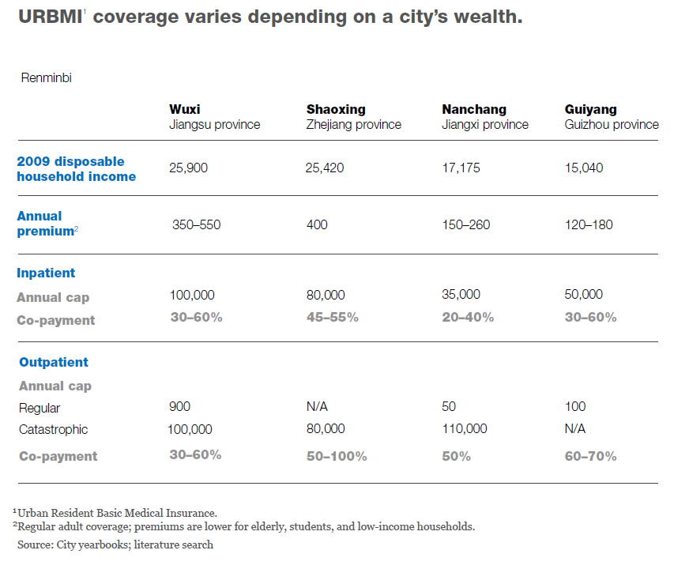

Figure 1. URBMI Coverage Range (23)

The fundamental challenge behind these issue is insufficient governmental funding in healthcare industry. It limited the medical resources available and eventually drove up their prices. In addition, social inequity between the wealthy and the unprivileged and between urban areas and rural areas is represented by the distribution of medical resources, making medical resources less accessible and more expensive in some regions. The insufficiency in healthcare resources can also be reflected by the shortage of medical professionals. China has only 1.6 physicians and 1.8 nurses per 1,000 people, compared with the average number of OECD, 3.2 physicians and 8.8 nurses per 1,000 people (24).

Table 14. Number of Professionals per 1,000 People

As a population billionaire, China owns an unprecedented market for health care businesses. However, it did not properly exploit this market and tries to transfer the responsibility to private and foreign facilities. It is an underdeveloped market with risk, especially political risks.

**Technical Analysis**

Following the SARS epidemic in 2008, the Chinese government realized the importance of establishing an effective Health Information Technology (HIT). The nation currently spends about 0.7% ($700 million) of its health budget on HIT, among which 70% is used for hardware, 20% for software, and 10% for service maintenance. There are three main challenges for the nation’s HIT (28). First, its software is primitive. Chinese software providers have little experienced in healthcare application compared with foreign vendors. A sound and reliable system does not exist yet. Second, the nation does not have enough skilled professionals who possess abundant knowledge in IT and healthcare management to build and maintain a HIT system. Third, most hospital leaders tend to resist to implement new major technologies, as they have not experienced such changes (29). However, as the nation’s investments in healthcare increase and its healthcare reform pushes forward, aiming to establish national as well as regional health information network throughout the country, major IT upgrades have been considered in many hospitals (28). Therefore, considering the gap between the supply and demand, IT professionals who have experiences in healthcare application and companies providing relevant services will benefit greatly from the reform.

**Australia**

**Political Analysis**

Similar to other OECD countries, both of the public and private sectors contribute to Australia’s healthcare expenditure. In 2013, private sector accounted for $1,084 out of $ 4,553 million (23.8%) of the nation’s healthcare expenditure (0). Generally, Australia’s healthcare insurance covers all the medical costs despite the long waiting period. However, one can also choose private hospitals, where the public insurance will cover only 75% of the costs. There are also private insurance plans whose coverage varies. The expenditure details can be found in Figure 2.

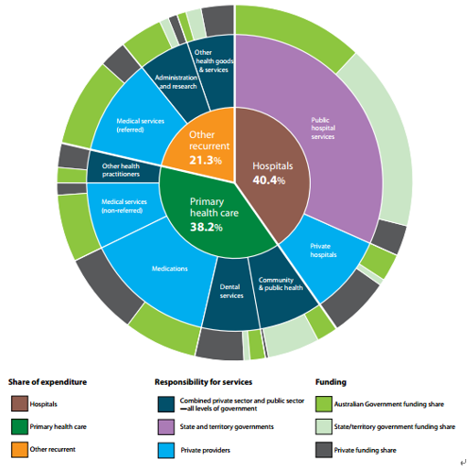

Figure 2. Australia’s Health Services — Funding and Responsibility (30)

Although the quality of Australia’s medical service is trustable, which can be seen from the long life expectancy and other positive figures, the cost of medical services in Australia is high. Therefore, the country is currently undergoing a reform named Australian Health Care Reform Alliance, which aims to achieve a more efficient and accessible healthcare system for the public. However, the progress of the reform remains slow as it has been boycotted by groups of stakeholders, who may lose their income because of some spend-cutting and price-reducing policies in the reform (31).

The complex set of overlapping and fragmented responsibilities of different levels of government also slows down the process of resolving the conflicts and pushing the reform (32). It was so restrained that in 2014 the government even considered to compromise in front of the boycott by imposing a patient copayment for general purpose visitors. If it came true, it would definitely be a great disappointment for Australian citizens. Therefore, it seems that the government is not that steadfast to push forward the reform.

**Economic Analysis**

As we can see from Table 1, the growth rate in healthcare expenditure shares the same trend as that of Japan and is slightly higher in value. In addition, according to Table 10, the GDP growth rate remains the same, meaning that that nation is investing more and more in healthcare expenditure. Considering that the population of Australia is not as aged as that of Japan and there seem no obvious reasons which may cause the difference, the medical spending for Australia is indeed too high.

Australia is also recovering from the recession. As we can see from Table 15, the nation’s GDP per capita is increasing and the disposable income per capita of citizens have also showed a sign of future growth, leaving Australian citizens with a stronger consumption power in the near future if this trend remains (33).

Table 15. GDP and National Disposable Income Changing Percentage (33)

Since Australia government is trying to shrink its overwhelming healthcare expenditure, the growth rate of medical expenditure decreased in past years and the trend is expected to continue (Table 11). Therefore, in general, it is difficult to define how the economic factors together would affect the healthcare industry in Australia.

**Social Analysis**

Australia is also facing a problem that most developed countries have: an aging population. During the five years between 2010 and 2015, the proportion of population aged below 14 decreased from 19.1% to 18.9% and adult population also decreased from 67.4% to 66.2% whereas the number of elderly grew from 13.6% to 14.9% (Table 16).

Table 16. Aging Trend in Australia 2010-2015 (35)

However, the severity of the aging issue is not that urgent in Australia. As we can see from Table 17, unlike other developed countries whose population tends to decrease, the total population of Australia has been increasing in a steady speed in the past decade. The population growth rate is 1.4% in 2015 and the year of 2016 has witnessed the birth of the nation’s 24 millionth citizen (36).

Table 17. Total Population of Australia (in million) (37)

As a result, the aging process of Australia will be much slower than some other nations, as illustrated in Figure 3. The ageing rank of Australia is expected to decrease by 10. All in all, health care businesses should pay attention to this unique trend to make right decisions.

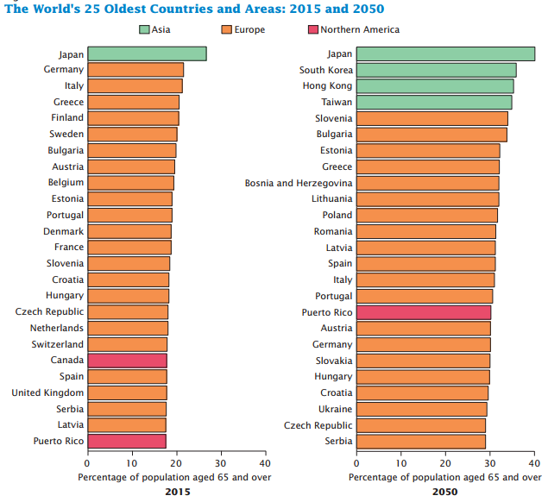

Figure 3. The World's 25 Oldest Countries and Areas: 2015 and 2050 (34)

**Technical Analysis**

National Broadband Network (NBN) is a government-funded project launched in 2007. It aims to replace Australia’s existing network with a new network that comprises of fiber and satellite. In addition, the government will also provide all the network services at a uniform price for users from different regions. The expected total investment is about $50 billion (38). Cisco, one of the world’s largest company providing IT solutions, estimates that the Internet speed will increase by 2.4 fold over the next five years and reach 44.3Mbps by 2020 (39). Considering the widespread usage of information system in healthcare industry, the upgrade of the nation’s network is definitely a good news.

However, Australia may suffer from a shortage in skilled IT professionals in the near future. According to a research done by Greythorn, an IT recruitment firm, the job market in Australia is not very stable. The number of IT workers under 30 years old has decreased from 18% in 2011 to 6% in 2014. In addition, many young adults are actively looking for new opportunities (Figure 4). Many of them prefer to work internationally, as Australian employers usually do not provide great trainings and promotion opportunities. Therefore, health care businesses who intend to enter Australia have to figure out a way to maintain a suitable crew of IT professional to maintain its IT infrastructure.

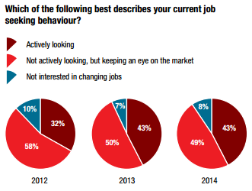

Figure 4. Which of the following best describes your current job seeking behavior? (40)

**3C Analysis**

**Consumer**

We are in an aging world. Those countries which are not facing this issue yet will not get away from it when the baby boomer generations enter their retirement (Figure 5). Therefore, it would be a wise decision to focus on the needs of the elderly and diseases that have greater impacts on them, because this market is sustainable and the demands are not likely to fluctuate.

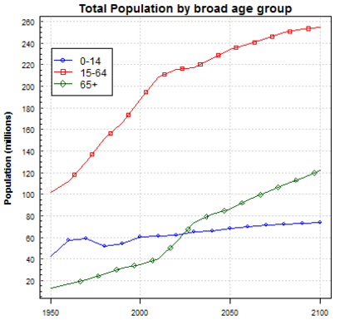 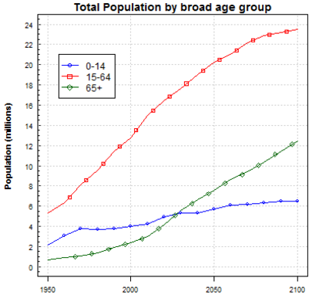

US Australia

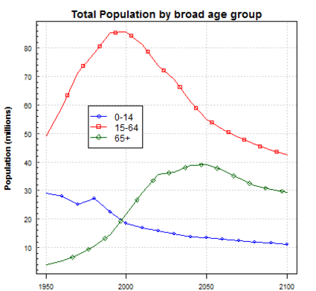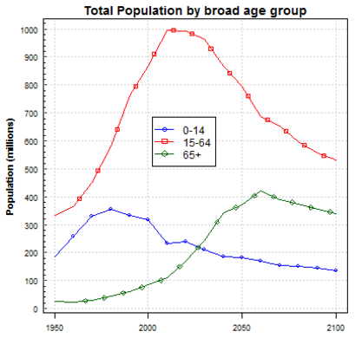

Japan China

Figure 5. World Population Prospects (41)

**Patients**

First, we discuss about the products for individual customers or patients. To start profiting as soon as possible, businesses should initialize their products in countries where there is a sizeable market and customers’ consumption power is strong. Based on healthcare expenditure per capita and total population, the United States and Japan would be two ideal markets. Though Australians have strong consumption power, the market size is not as large as U.S. and Japan. Therefore, it should only be considered when our product does not depend heavily on economies of scale or a large user base. For instance, applications like Uber can hardly achieve greatly in Australia, because there are neither enough drivers nor customers, resulting long waiting period or even absence of service. As for China, though the market size is incredible, the average expenditure in healthcare is too low, which means the actual market is not that large. However, it would be great to promote some low-profit but highly available products or to target at the upper or middle class customers.

Nonetheless, though quality and price are always the key factors for general public, customers from different nations have various consumer behaviors that may affect their decision making. Further analysis is required based on the specifications of the products that need to be promoted. Usually, companies should to start with defining the target groups, based on geographic factors, demographic factors, psychographic factors, and consumer habits, etc. Afterwards, they need to acquire profitable new clients, requiring us to collect consumer data and to constantly refine our marketing strategies. Then businesses also need to retain and renew our clients to survive and thrive. Last but not the least, companies should cultivate lifetime relationship between them and their customers, so the businesses would last for generations. This process applies to any market worldwide.

According to a U.S. research displayed in Figure 6, 76% of people with high health risk believe they are much healthier than they actually are. Therefore, there is a significant chances for products which help people realize their potential health risks. In addition, the same research indicates that health care costs are higher for certain groups. For instance, hospital costs are 24% higher for socially isolated individuals than socially connected (45). Such discoveries would help categorize target patients. The statistics may differ from country to country, but the principle behind them could be a great reference before commencing a thorough survey or research.

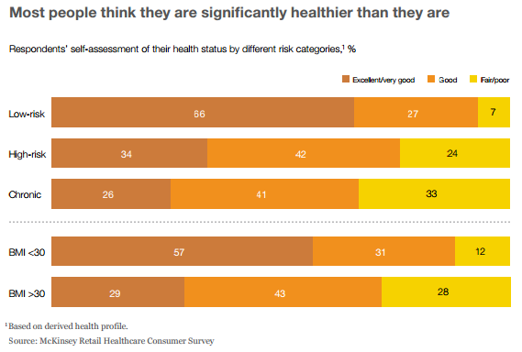

Figure 6. Most People Think They Are Healthier Than They Are (45)

As mentioned above, there are some unique behaviors for customers from different national background that companies should pay attention to. This will help ease the further research and narrow down the most suitable target groups for certain products.

In U.S., one of the most noticeable impact on healthcare industry is the usage of mobile applications. There are already 95 million Americans using mobile phones for health information (46). With the digital environment, people’s health behaviors changed and they know more about their own health conditions, as those technologies enable self-care. Another issue that needs attention is overweight. The average weight of U.S. ranks the third among all countries in the world at 180.62 lb (47). Accordingly, some diseases, such as diabetes, heart disease and high blood pressure issues, are more pervasive in this country. Despite the overweight issue, Americans spend more time on exercises. 62.0% of adults engaged in some activities, and 11.8% of adults retain vigorous training (48). This stimulates the consumption of body-building products and also sport wares.

Japan is the healthiest nation in the world. The proportion of the elderly in total population is also the highest among all countries (Figure 3). Considering the longevity, there is an extraordinary market for elderly care products or services. In Japan, people deeply trust the recommendations of their medical providers who commit to provide genuine suggestions. Therefore, it is important for companies to consult these key opinion leaders’ opinions about their products, to improve the products when necessary, and also to maintain a positive relationship with them (49).

Chinese tend to worry a lot about their health condition and prefer to seek high level medical resources when they think they are in serious troubles (50). As a result, large hospitals in main cities, where doctors are more skillful, are always crowded. It is not surprise to see patients travel thousands of miles to see a famous doctor. Therefore, high-quality medical products have a promising market in China as the citizens’ consumption power keeps raising. On the other hand, Chinese customers are, in most cases, price sensitive. For those minor illness with low health threats, such as cold or usual fever, people tend to resolve them by themselves or utilize inexpensive medicines. Additionally, Chinese consumers generally favor foreign brands (51). Though the fever starts to fade out as the nation develops, it is still a good news for foreign investors.

No noticeable unique behaviors for Australian patients detected yet.

All in all, compared with other industries, medical products are more difficult to promote, as they take pressure from both moral and legal aspects. For example, advertising prescription medicines directly to customers are not permitted in Australia and Japan. Nonetheless, there is always other ways to promote a product. Once the specifications of a product is defined, further researches about consumer behaviors are required to get more market insights to secure a success.

**Hospitals**

Hospitals and clinics are the foundation of a healthcare system and they are ideal wholesale purchasers for medical products. The challenge comes when businesses need to know how hospital administrators make purchase decisions, because healthcare industry is not as transparent as other fields due to privacy reasons and restrictive legislations.

According to a study conducted by Google in 2013, almost all of the 800 U.S. hospital administrators will do researches online to demonstrate product features and identify sales representatives. Afterwards, 81% of hospital administrators directly contact a vendor for more information. In addition, interviewers prefer demo video rather than merely words, as videos show the real world scenarios (42). Though traditional methods, such as peer recommendations and sales representative visits, are still important, digital marketing is playing an increasingly important role in the decision making process. Furthermore, the purchase decisions in hospitals usually take a long time to make, as only 46% of the interviewers typically took six months or less to complete a transaction (Table 18). As a result, the company may not see an incoming cash flow immediately after the debut of the products. Businesses need to give the market time to get familiar with us and then remember us. Though the figures would vary in different regions, the general trend behind this survey may apply to other markets.

Table 18. Length of Typical Purchase Cycle in U.S. Hospitals

Hospitals in U.S. are more transparent than that of other nations. One reason is because the legislation system does not strictly limit the imports of medical devices and everything is stated clearly on the Internet (52). Therefore, on political aspect, products have no overwhelming obstacles to overcome to enter U.S. hospitals. Another reason is because there are too many eyes staring at this market, so the statistics published by various agencies and consulting firms can be found and utilized by everyone. Similarly, this highly competitive market also requests companies to pay more attention to the statistics, resulting more data available out there.

Compared with U.S. hospitals, Japanese hospitals have more rigorous regulations and a less transparent system. However, the government is releasing its control over the nation’s hospital and medical market. For instance, the nation now allows the registration of more Class II and Class III products via third parties (43). Another good news for medical products is that one may get reimbursement from the government. Therefore, it is necessary to know whether your products are qualified for reimbursement and how much you can get. It will directly affects your profits and your competitiveness. Therefore, though the requirement is still high and the regulations strict, once a company enters the Japanese market with sophisticated products, it should benefit greatly from this world’s second-largest medical market.

As for China, though the nation has a huge market for medical products, its domestic medical market is highly competitive and its regulatory environment is complicated. These are two main reasons why many successful foreign companies failed their businesses in Chinese market. A noticeable feature of Chinese medical market is that most of native manufacturers focus only on Class I or basic Class II products. For those Class III products which usually standardized vigorously, the market still rely heavily on imports (53). Therefore, there are demands for high-end products in major hospitals are great. Onerous regulatory procedures seem one of the biggest challenges for foreign businesses. According to the Wall Street Journal, the approvals of new devices could take twice as long in China as it does in U.S and EU (Figure 7). Inconsistent reimbursement is also a consideration compared with the fine policy of Japanese market. The amount may vary across regions and hospitals. The same product could gain $5 to $33, or even none, in different scenarios (53). It becomes the company’s responsibility to figure whether the benefits from China’s enormous market will be offset by various shortages (54).

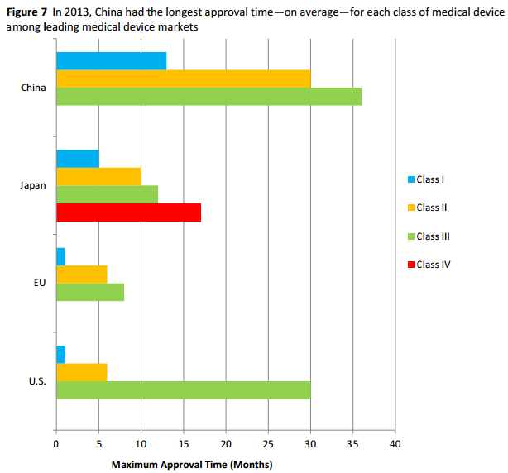

Figure 7. Maximum Approval Time for Medical Devices (Months) (53)

Similar to Japan, the aging Australian population also implies a growth in the nation’s healthcare industry. Recently, China’s Luyu Medical has acquired Australia’s third largest private hospital operator, Health Care, for $668 million. Comments say hospital acquisition at this scale is an unusual opportunity for foreign investors, but the influences of the engagement of a Chinese player on Australia’s hospital system are still unknown (55).

Selling to hospitals is much harder than selling to individual customers, as it is more difficult to reach the sales targets and it is Business-to-Business transactions. Nonetheless, proper online marketing strategies can help a great deal and reduce the necessity for other expenditures.

**Competitor**

Who?

What they offer? And not?

Strategy?

**Company**

Competencies?

Goal?

What resources do we have?

Make or buy?

**References**

0:

[http://stats.oecd.org/index.aspx?DataSetCode=HEALTH_STAT#](http://stats.oecd.org/index.aspx?DataSetCode=HEALTH_STAT)

1:

<http://kff.org/global-health-policy/issue-brief/the-u-s-response-to-ebola-status-of-the-fy2015-emergency-ebola-appropriation/>

2:

<http://www.nytimes.com/2016/05/18/us/zika-senate-vote-emergency-funding.html>

3:

<http://www.usnews.com/news/articles/2015/12/02/rate-of-spending-on-health-care-is-on-its-way-up-again>

4:

<https://www.cms.gov/research-statistics-data-and-systems/statistics-trends-and-reports/nationalhealthexpenddata/downloads/proj2012.pdf>

5

<https://www.cbo.gov/topics/health-care>

<https://www.cms.gov/research-statistics-data-and-systems/statistics-trends-and-reports/nationalhealthexpenddata/downloads/highlights.pdf>

6

<http://www.usnews.com/pubfiles/USNews_Market_Insights_Boomers2015.pdf>

7

<http://bhpr.hrsa.gov/healthworkforce/supplydemand/usworkforce/primarycare/>

8

<http://economix.blogs.nytimes.com/2008/12/05/why-does-us-health-care-cost-so-much-part-iii-an-aging-population-isnt-the-reason/>

9

<http://data.bls.gov/timeseries/LNS14000000>

10

<http://data.worldbank.org/indicator/SH.XPD.OOPC.ZS>

11

<http://www.pwc.com/us/en/technology/publications/assets/pwc-global-software-100.pdf>

12

<http://www.topuniversities.com/university-rankings/university-subject-rankings/2016/medicine#sorting=rank+region=+country=+faculty=+stars=false+search>=

13

<http://www.oecd.org/els/health-systems/Briefing-Note-JAPAN-2014.pdf>

14

<http://www.mckinsey.com/industries/healthcare-systems-and-services/our-insights/improving-japans-health-care-system>

15

<http://www8.cao.go.jp/cstp/tyousakai/innovation/ict/1kai/siryo3-3.pdf#page=3>

16

<http://www5.cao.go.jp/keizai-shimon/kaigi/cabinet/2016/summary_en.pdf>

17

<https://ig.ft.com/sites/numbers/economies/japan>

18

<https://www.jetro.go.jp/ext_images/uk/Invest_in_Japan/Event_Reports/healthcareseminar/index.html/Mr_Anil_Vaidya.pdf>

19

<http://www.seisakukikaku.metro.tokyo.jp/invest_tokyo/english/why-tokyo/industries/medical.html>

20

<https://books.google.co.uk/books?id=gFTXBAAAQBAJ&pg=PT10&lpg=PT10&dq=%22World+Health+Olympics%22+japan&source=bl&ots=A9I9TU5unN&sig=qKiTfEOXtU0BHP-wmSF61EcO5x8&hl=en&sa=X&ved=0ahUKEwiD4OLpxL3NAhWKkpQKHSV_CqIQ6AEIKTAC#v=onepage&q=%22World%20Health%20Olympics%22%20japan&f=false>

21

<http://www.nippon.com/en/features/h00072/>

22

<http://www.ipss.go.jp/s-info/e/ssj2014/006.html>

23

[www.mckinsey.com/~/media/mckinsey/dotcom/client_service/healthcare%20systems%20and%20services/health%20international/hi10_china_healthcare_reform.ashx](http://www.mckinsey.com/~/media/mckinsey/dotcom/client_service/healthcare%20systems%20and%20services/health%20international/hi10_china_healthcare_reform.ashx)

24

<http://www.oecd.org/els/health-systems/Briefing-Note-CHINA-2014.pdf>

25

<http://www.who.int/tdr/publications/documents/health-research-china.pdf>

26

<http://www.telegraph.co.uk/finance/economics/11930766/The-truth-behind-Chinas-manipulated-economic-numbers.html>

27

<http://www.who.int/countryfocus/cooperation_strategy/ccsbrief_chn_en.pdf?ua=1>

28

<http://www.dorenfest.com/doc/chinahitcasestudy.pdf>

29

<http://www.chinabusinessreview.com/chinas-healthcare-reform-how-far-has-it-come/>

30

<http://www.aihw.gov.au/WorkArea/DownloadAsset.aspx?id=60129547593>

31

<http://apo.org.au/resource/health-policy-australia>

32

<http://www.nejm.org/doi/full/10.1056/NEJMp1410737?af=R&rss=currentIssue#t=article>

33

<https://www.theguardian.com/business/grogonomics/2016/jun/16/the-gdp-gap-the-economy-seems-to-be-growing-so-why-isnt-my-bank-balance>

34

<https://www.census.gov/content/dam/Census/library/publications/2016/demo/p95-16-1.pdf>

35

<http://www.abs.gov.au/ausstats/abs@.nsf/0/1CD2B1952AFC5E7ACA257298000F2E76?OpenDocument>

36

<http://www.abs.gov.au/ausstats/abs@.nsf/0/1647509ef7e25faaca2568a900154b63?OpenDocument>

37

<https://www.google.co.jp/publicdata/explore?ds=d5bncppjof8f9_&met_y=sp_pop_totl&idim=country:AUS:CAN&hl=en&dl=en>

38

<http://whirlpool.net.au/wiki/nbn>

39

<http://www.zdnet.com/article/australian-fixed-broadband-speeds-to-average-44-3mbps-by-2020-cisco/>

40

<http://www.greythorn.com.au/media/greythorn/greythorn%20market%20insights%20and%20salary%20guide%202014_2015%20australia%20pay%20rate.pdf>

41

<https://esa.un.org/unpd/wpp/Graphs/DemographicProfiles/>

42

<https://www.thinkwithgoogle.com/articles/how-hospital-administrators-research-online.html>

43

<http://www.pacificbridgemedical.com/ameing-for-asia/medical-device-executives-dont-forget-japan/>

44

<http://heapol.oxfordjournals.org/content/early/2013/04/23/heapol.czt023.full>

45

<http://healthcare.mckinsey.com/sites/default/files/791750_Changing_Patient_Behavior_the_Next_Frontier_in_Healthcare_Value.pdf>

46

<http://www.oliverwyman.com/content/dam/oliver-wyman/global/en/images/insights/health-life-sciences/2014/October/The-Patient-To-Consumer-Revolution.pdf>

47

<http://www.telegraph.co.uk/news/earth/earthnews/9345086/The-worlds-fattest-countries-how-do-you-compare.html>

48

<http://www.cdc.gov/nchs/data/series/sr_10/sr10_230.pdf>

49

<http://www.pacificbridgemedical.com/business-development-services/medical-device-pharmaceutical/medical-market-research/japan/>

50

<http://bmcpublichealth.biomedcentral.com/articles/10.1186/1471-2458-12-1121>

51

<http://www.chinabusinessreview.com/understanding-chinese-consumers/>

52

<http://www.fda.gov/MedicalDevices/DeviceRegulationandGuidance/ImportingandExportingDevices/ucm050126.htm>

53

<https://www.usitc.gov/publications/332/id-036workingpaperusmedicaldevicesfinalss.pdf>

54

<http://pure.au.dk/portal-asb-student/files/76744303/MASTER_THESIS_Bernhardt_Liang_mainbody.pdf>

55

<http://www.wsj.com/articles/chinas-luye-medical-to-buy-australian-private-hospital-operator-1449367162>

**The Best-Kept Secret in Healthcare Marketing Research**

<http://marketstreetresearch.com/images/The%20Best%20Kept%20Secret%20in%20Healthcare%20Marketing%20Research.pdf>

**Summary**

What is the most important reason why customers choose one facility over another?

How to conduct a survey that helps know the real thoughts of customers?

1. Ask customers not what they value, but what they can sacrifice
2. A could be slightly or greatly more important than B, which cannot be reflected
3. Determine attributes to be evaluated based on regional conditions
4. Come up with different configurations and ask customers which one they prefer on a 10 point scale
5. By providing various scenarios for customers, and have them think actively in real-world context
6. Is there a single most important driver? Physicians

It is easy to understand why city residents would want a cleaner river, but this argument is rife with holes and assumptions, and thus, not strong enough to lead to increased funding.

[**http://cmucssa.net/bbs/viewtopic.php?f=3&t=7093**](http://cmucssa.net/bbs/viewtopic.php?f=3&t=7093)

[**http://cmucssa.net/bbs/viewtopic.php?f=3&t=7122**](http://cmucssa.net/bbs/viewtopic.php?f=3&t=7122)

[**http://cmucssa.net/bbs/viewforum.php?f=3**](http://cmucssa.net/bbs/viewforum.php?f=3)

[**http://www.1point3acres.com/bbs/forum.php?mod=viewthread&tid=113843&highlight=%D7%AA%D1%A7**](http://www.1point3acres.com/bbs/forum.php?mod=viewthread&tid=113843&highlight=%D7%AA%D1%A7)

perfunctory 敷衍的

overt 明显的

exacting 严格的

pensive 忧郁的，哀愁的

droll（ness） 幽默的

stoicism n恬淡寡欲

fastidious a挑剔的

ballyhoo nv大肆宣传

quip nv妙语 嘲讽

congenial a意识相投的

disingenuous a虚伪的 不老实的

dilatory a拖拉的

parochialism n狭隘

empiricism n经验主义

tendentious a有偏见的

discursion n漫无目的

subtlety n微妙的

flippancy n轻率

cynicism 玩世不恭 愤世嫉俗 =嘲笑= 尖酸刻薄 犬儒主意

acquiescence n默许

intractability n棘手

intractable a棘手

tractable a易处理的；驯良的

venerable a值得尊敬的

detestation n嫌恶

disdain vn鄙视

justification n理由

sabotage vn妨碍 破坏

discreet a谨慎的

discretion n谨慎，自由判定

treatise n论文

sheer a绝对的 完全的

ubiquity n普遍存在

ubiquitous

rosy a乐观的，美好的

for all 虽然

coagulation n凝结

obviate v避免 消除

accentuate v强调

plasticity n适应性 可塑性

deplete v耗尽

replete v充满

encumber v阻止

compulsory a强制的 义务的

compel v强迫

scrutinize v仔细检查

skirt / circumvent v绕过

distortion n曲解

revelation n揭露 启示

neglect v忽略

inveterate a成习惯的

stigma n污名 耻辱

blemish n瑕疵 污点

endorse v认可 赞同

condemn v谴责 定罪

proprietary a私人所有的 n所有人

didactic a说教

perpetuate a长存的 v保持

*dichotomy n二分法

*paradox n悖论

cosmopolitan a世界性的

intransigent a不妥协的

mercenary a唯利是图的 雇佣的

insular a孤立的 与世隔绝的

capricious a变化莫测的反复无常的

evoke v唤起

relish v喜欢 盼望

attain v达到

insufferable a难以忍受的

whereby adv 凭什么 靠那个

flout vn嘲弄 轻视

impulse nv推动 冲动

albeit conj虽然

subversive a破坏性的 颠覆性的

culpable a有罪的 有错的

palpable a明显的；可感知的

iconoclastic a打破旧习惯的

temperate a温和的 适度的

prompt a立刻的 v提示 促进

sophisticated a复杂的complex 有经验的 （the problem is~）

ascribe v归因于

delegate v委派

compunction n悔恨

consensus n一致，合意

tenable a可维持的 站得住脚的

efficacious a有效的 灵验的

aesthetic a美学的

demise n死亡 终止

intimate a亲密的 精通的 n至交 v暗示 通知

transience n短暂

symmetry n对称性 匀称

evanescent a容易消散的 会凋零的

adduce v举出 引证

trifling a微不足道的

trifle n琐事 v开玩笑 浪费

conspicuous a显而易见的

intrigue v计谋 激起兴趣

intriguing a有趣的 迷人的

deleterious a有毒的 有害的