**CS 640 Programming Assignment 3 Report**

**AI Game ——** **4×4×4 Tic-Tac-Toe**

November 25, 2019

**Teamwork**

|  |  |  |  |
| --- | --- | --- | --- |
| **Team members** | **Kerberos** | **BU ID** | **Works** |
| Ziqi Tan | ziqi1756 | U 88387934 | Design data structure and algorithm.  Coding. |
| Kaijia You | caydenyo | U 44518396 | Coding and software testing.  Write documentations. |
| Tian Ding | dingtian | U 90706530 | Coding.  Adjusting parameters. |

Contents

**1 Assignment Requirements** 3

**2 Insight into 4×4×4 Tic-Tac-Toe Game** 3

**3 Skeleton Code Quick Review** 3

**4 Methodology and Implementation** 4

**4.1 Evaluation Function** 4

**4.2 Change Data Structure** 4

**4.3 Occupy the strongest points as fast as possible** 5

**4.4 Winning move and force move** 5

**4.5 Minimax** 5

**4.6 Alpha-Beta Pruning** 6

**4.7 Progressive Deepening** 6

**4.8 Heuristic Pruning** 6

**5 Algorithm Design** 7

**6 Results and Discussion** 9

**6.1 Battle with randomness AI** 9

**6.2 AI vs. AI with the same settings** 9

**6.3 AI vs. AI with different settings** 10

**6.4 AI behavior analysis** 10

**7 Conclusions** 10

**References** 10

**Appendix** 11

The rest of this report is organized as follows. First, we review the assignment requirements. Second, we provide insight into the 4×4×4 Tic-Tac-Toe Game mostly based on [1]. Third, we go through the skeleton code and discuss our methodology. Finally, we discuss our test result. Our strategy can easily defeat the algorithm with simple defend and attack strategy and perfectly defeat random algorithm. The second player of our AI performs better than the first player.

# **1 Assignment Requirements**

In this assignment, we are required to implement an AI 4x4x4 cubic tic-tac-toe game by using minimax and alpha-beta pruning method which drive our AI make decisions as beneficial as possible. We should try our best to modify our algorithm and beat AI implemented from other teams for extra credits.

# **2 Insight into** **4×4×4 Tic-Tac-Toe Game**

According to [1], the first player in 4×4×4 Tic-Tac-Toe Game can always force a win. Additionally, no draw exists.

# **3 Skeleton Code Quick Review**

**runTicTacToe.java** serves as the game engine. The **run()** method is a critical part. It should be recognized that the decision algorithm (myAIAlgorithm(board, player)) will be called many times in the game.

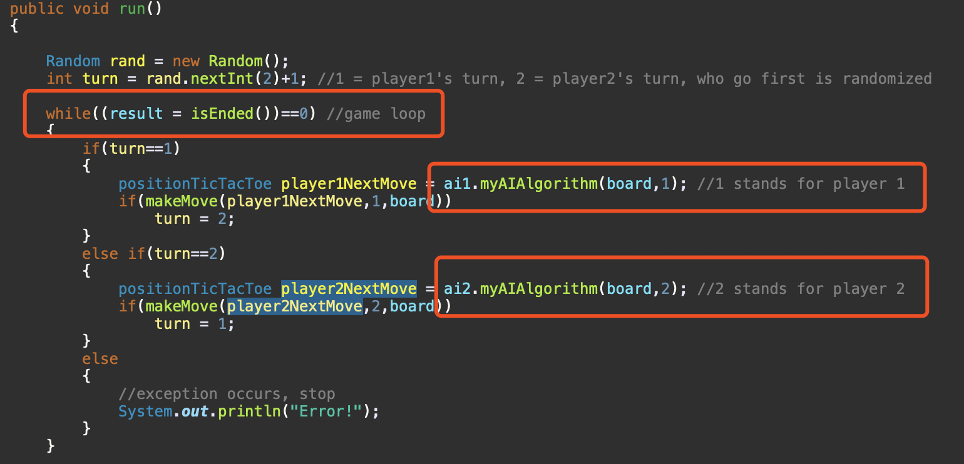

**Data structure of the Tic Tac Toe board**

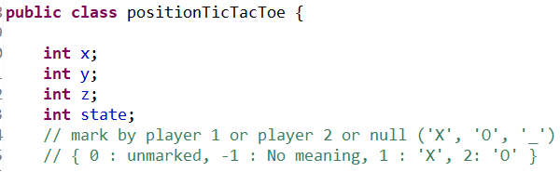

# **4 Methodology and Implementation**

## **4.1 Evaluation Function**

In every board configuration, the player should evaluate his/her current situation, which is a crucial part of a heuristic process for an Artificial Intelligence. We adapt the following strategy [2].

The evaluator has a list of how many 1-in-a-rows, 2-in-a-rows, 3-in-a-rows and 4-in-a-rows each player has. Where the evaluators differ is in what they do with this information, as described below.



It assigns a positive value to every n-in-a-row the player has, and a negative value to every n-in-a-row the opponent has. An n-in-a-row is worth about an order of magnitude more than an (n-1)-in-a-row. The player’s rows are worth more than the opponent’s rows, which means an aggressive attack strategy.



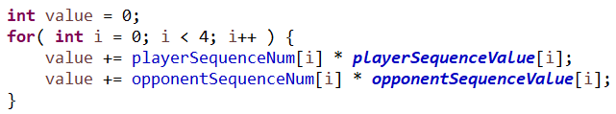

## **4.2 Change Data Structure**



Without deep copy of a list of objects, this board data structure takes much less time and memory.

In the skeleton code, position in the cube is represented by an object that contains x, y, z and status which occupies a lot of memory to store when the scale of the cube becomes larger. What’s more, the for-loop in the makeMove method is terribly time cost and not necessarily. We have already known the exact node that we want to mark after doing minimax and alpha-beta pruning, however, the board is store in a List that means we must iterate the items in the List to get the position we want, which will cost O(n) in the worst case. The efficiency will be obviously better if the board is store in an array, we can mark the position simply by the subscript of the array and it only takes O(1). For this reason, we came up with the version 2 of this design.

## **4.3 Occupy the strongest points as fast as possible**

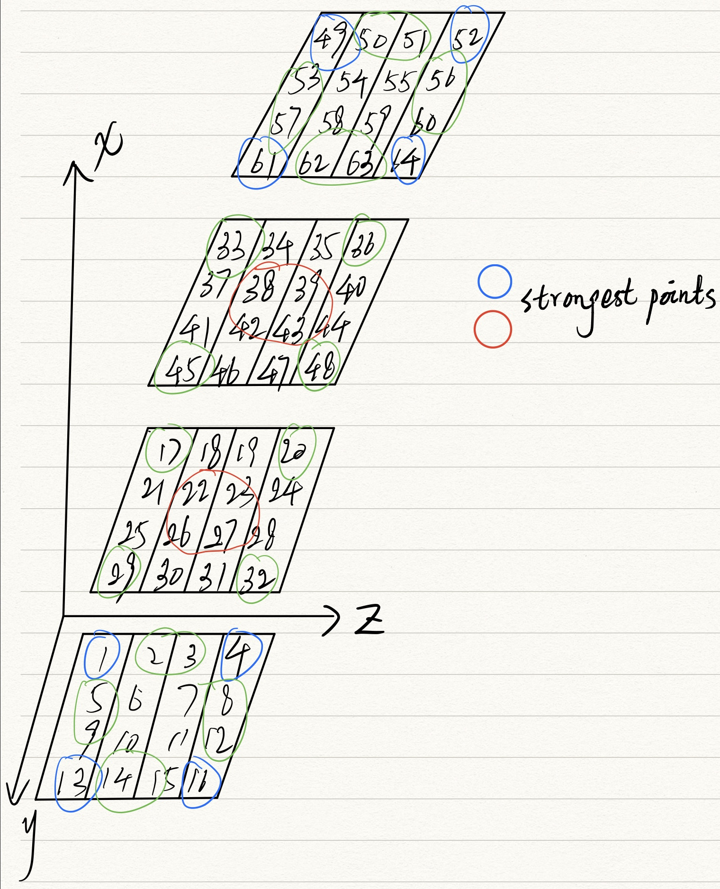

The strongest point is the point that cross by most of the winning lines. The strongest points shown in the picture has 7 wining lines respectively. It is easy to understand that the 8 nodes in the center of the cube give players more winning strategies. Each player will not win in the beginning of the game, so it is important for players to occupy the strongest nodes as fast as possible when the game begins.

## **4.4 Winning move and force move**

As the game begins, the board will be different after players finish their turns. Player will check if 3 nodes of his/her own are filled in the same line, if yes, then player can take a winning move immediately. Otherwise player should check if 3 nodes of opponent are filled in the same line, is yes, then player has no choice but have to stop opponent from winning which is called force move.

## **4.5 Minimax**

If the current chess board is not fit in the situation above then AI should make decisions by minimax and alpha-beta pruning method to maximize the its profit and minimize the opponent’s profit at the same time.

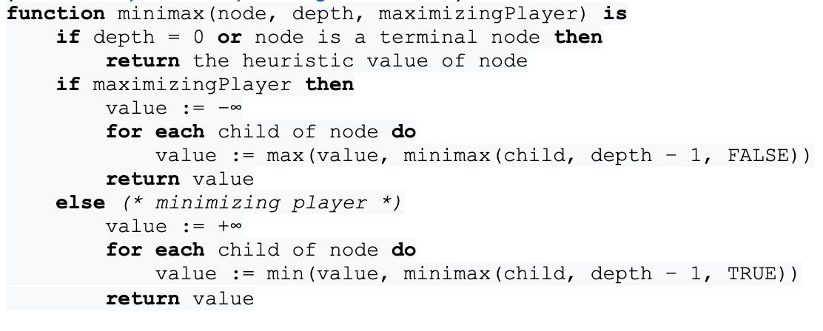

**Pseudocode of minimax**

## **4.6 Alpha-Beta Pruning**

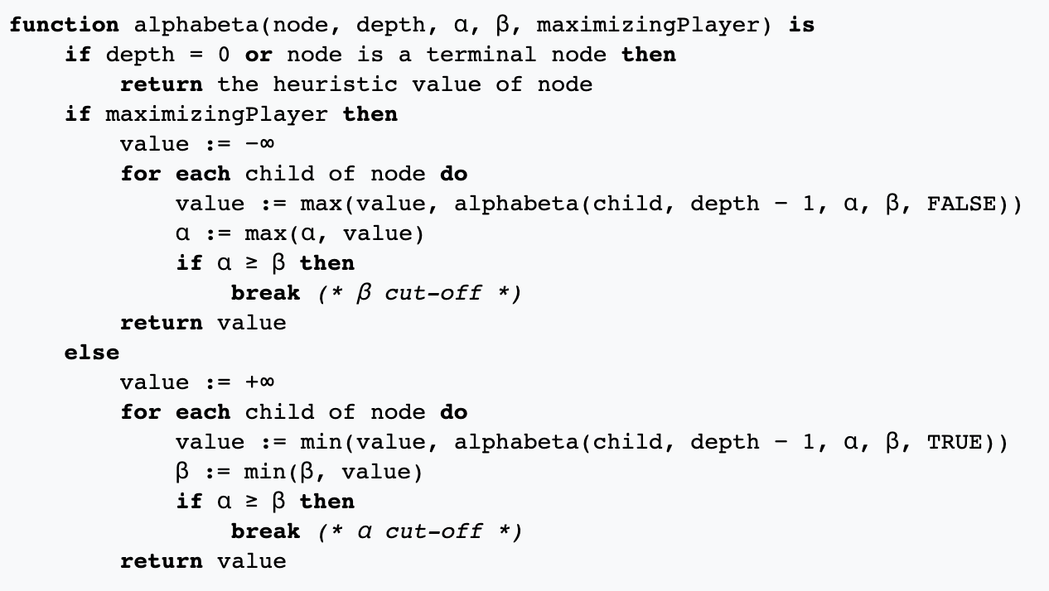

**Pseudocode of alpha-beta pruning**

## **4.7 Progressive Deepening**

Analyze game situation to depth = 1, depth = 2, depth = 3, … until time is up.

## **4.8 Heuristic Pruning**

Define the traverse order. We traverse the strongest points first, which are obviously promising move.

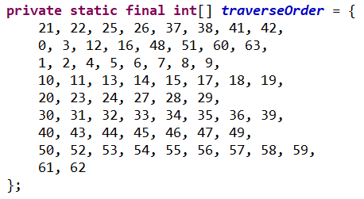

# **5 Algorithm Design**

1. **Pseudocode of myAIAlgorithm**

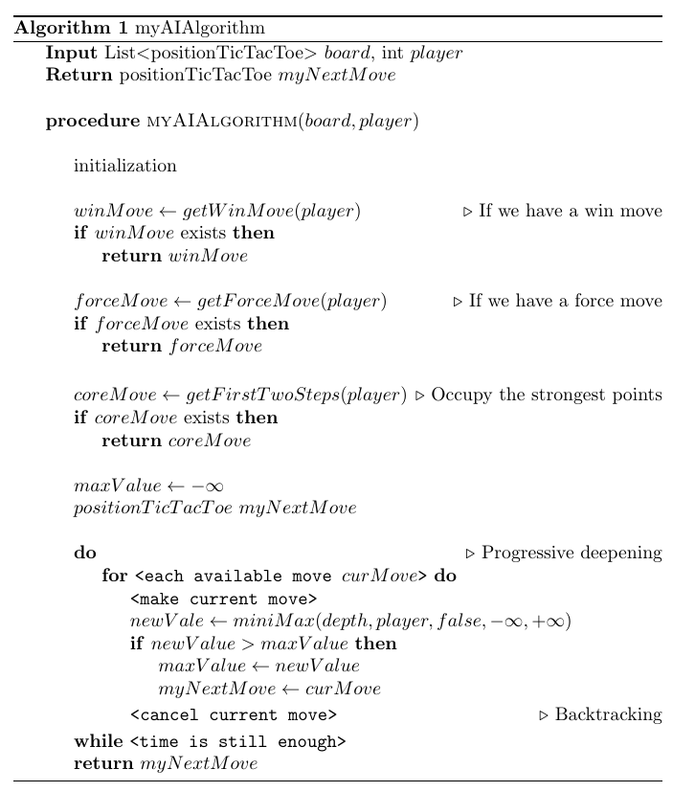

1. **Pseudocode of miniMax**

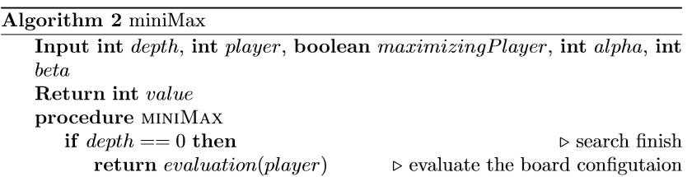

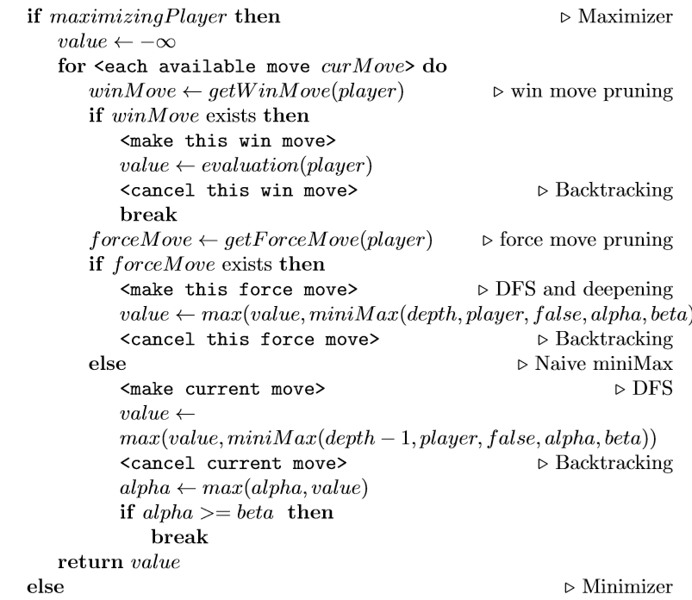

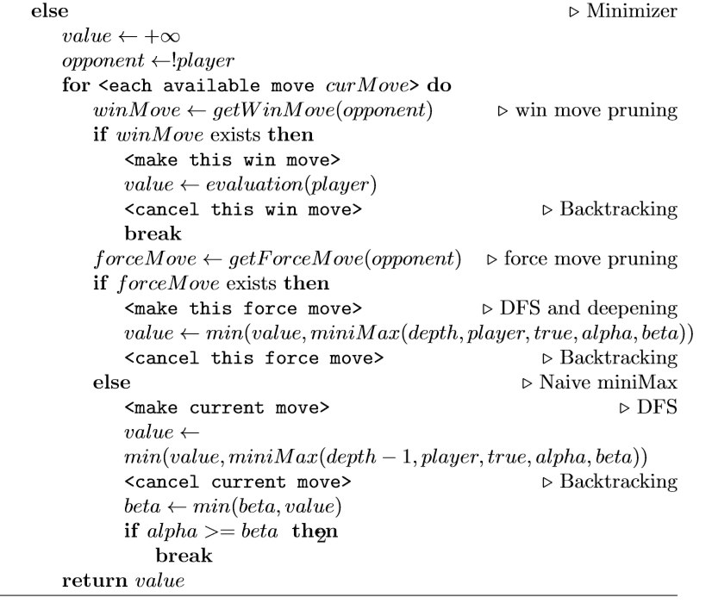

# **6 Results and Discussion**

## **6.1 Battle with randomness AI**

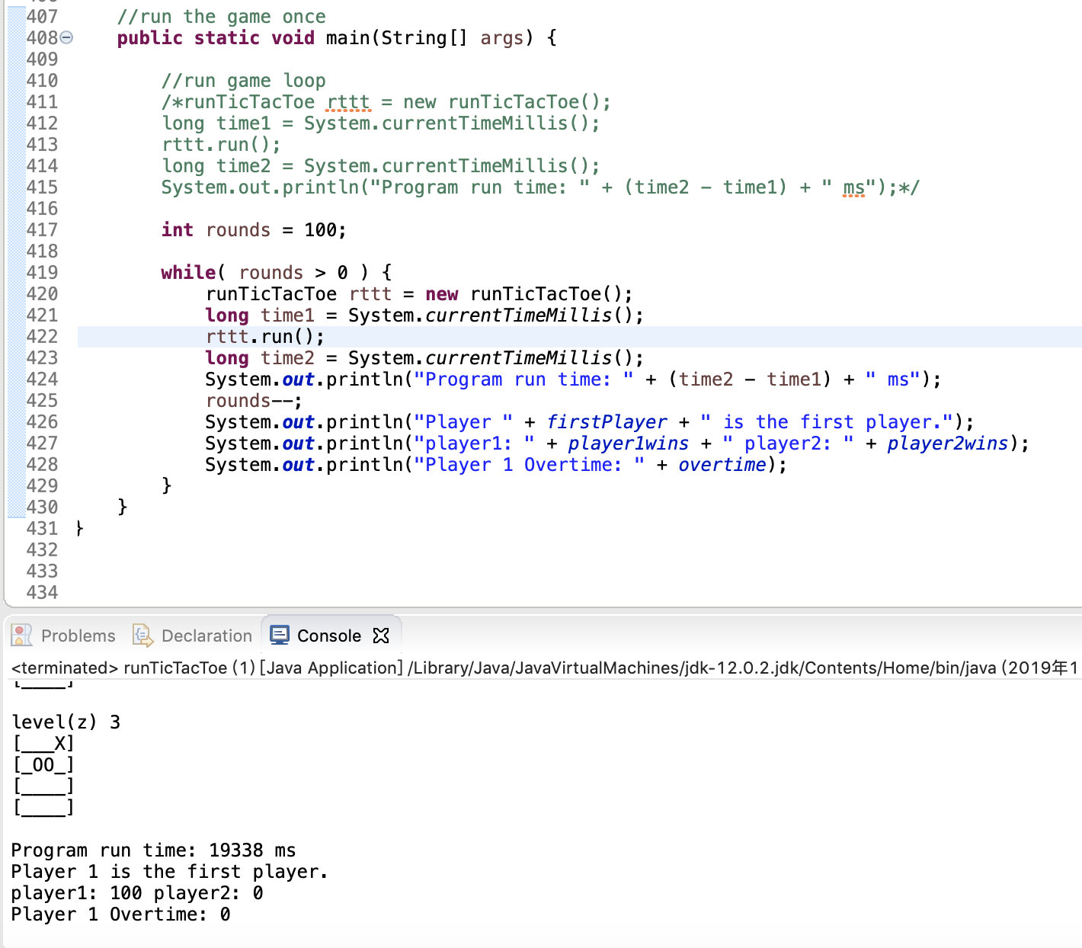

Our AI can completely beat randomness AI. Player 1 is our AI player and player 2 is randomness AI. The first player is chosen randomly.

## **6.2 AI vs. AI with the same settings**

**Battle between final version as a first player and final version as a second player.**



Result: the second player performs much better than the first player. The second players win 68 rounds in 100.

The reason may be that

* the second player has much more time to do progressive deepening as the number of available moves gets less and less.
* Besides, the heuristic value is not always correct.



* Additionally, in the first move of each player, they randomly choose one strongest point in the center of the cubic, which means the first step is extremely important for each player in this game.

## **6.3 AI vs. AI with different settings**

Player 1 settings:



Player 2 settings:



Result:

Player 1 wins 12 rounds in 50, when player 1 is the first player.

Player 1 wins 14 rounds in 50, when player 2 is the first player.

The result shows that the settings of player 2 is much better than those of player 1, because no matter who is the first player, player 2 always wins.

## **6.4 AI behavior analysis**

**See more details in appendix.** In the first two steps, AI occupy the strongest points in the center of the cubic randomly, which makes our AI not totally deterministic. Then, AI will take move according to heuristic value. Before that, AI will find a win move or a force move first. AI will fully make use of 10 seconds to search a better move.

The first player is much worse than the second. We make a possible explanation. The second can search more when the board is getting smaller, which means the second player can search more possible moves to decide which move to take.

The random process in the first two step can have critical influence on the result of the game, which means the first two steps is of significant importance.

# **7 Conclusions**

In this assignment, we develop an AI for 4×4×4 Tic-Tac-Toe Game. We adopt minimax with alpha-beta pruning to make a move decision. Besides, we improve our AI by changing the data structure and using progressive deepening and heuristic pruning. As a result, our AI can look ahead for a least 4 moves and completely defeat the randomness AI. When doing self-battling, the second player using our AI performs better than the first hand player.

# **References**

[1] Patashnik, Oren. "**Qubic: 4 × 4 × 4 Tic-Tac-Toe**." Mathematics Magazine 53, no. 4 (1980): 202-16. doi:10.2307/2689613.

[2] **3D Tic Tac Toe Algorithms** - Rochester CS

<https://www.cs.rochester.edu/u/brown/242/assts/studprojs/ttt10.pdf>

# **Appendix**

AI behaviors.

Both players are our AI. Player 1 is the first player.

Player1' turn:

Evaluation 0

Core move

myNextMove: 2 1 2

Player 1 run time: 0 ms

Player2' turn:

Evaluation -7

Core move

myNextMove: 2 2 1

Player 2 run time: 0 ms

level(z) 0

[____]

[____]

[____]

[____]

level(z) 1

[____]

[____]

[__O_]

[____]

level(z) 2

[____]

[____]

[_X__]

[____]

level(z) 3

[____]

[____]

[____]

[____]

Player1' turn:

Evaluation 0

myNextMove: 0 1 2 Value: 59

Player 1 run time: 8158 ms

Player2' turn:

Evaluation -12

myNextMove: 1 1 2 Value: 34

Player 2 run time: 9802 ms

level(z) 0

[____]

[____]

[____]

[____]

level(z) 1

[____]

[____]

[__O_]

[____]

level(z) 2

[_X__]

[_O__]

[_X__]

[____]

level(z) 3

[____]

[____]

[____]

[____]

Player1' turn:

Evaluation 2

myNextMove: 0 1 0 Value: 134

Player 1 run time: 9803 ms

Player2' turn:

Evaluation -12

myNextMove: 0 0 3 Value: 237

Player 2 run time: 9802 ms

level(z) 0

[_X__]

[____]

[____]

[____]

level(z) 1

[____]

[____]

[__O_]

[____]

level(z) 2

[_X__]

[_O__]

[_X__]

[____]

level(z) 3

[O___]

[____]

[____]

[____]

Player1' turn:

Evaluation -64

Force move.

myNextMove: 3 3 0

Player 1 run time: 0 ms

Player2' turn:

Evaluation 102

myNextMove: 1 1 1 Value: 356

Player 2 run time: 9801 ms

level(z) 0

[_X__]

[____]

[____]

[___X]

level(z) 1

[____]

[_O__]

[__O_]

[____]

level(z) 2

[_X__]

[_O__]

[_X__]

[____]

level(z) 3

[O___]

[____]

[____]

[____]

Player1' turn:

Evaluation -80

myNextMove: 0 0 0 Value: 22

Player 1 run time: 9801 ms

Player2' turn:

Evaluation 112

myNextMove: 0 0 1 Value: 223

Player 2 run time: 8258 ms

level(z) 0

[XX__]

[____]

[____]

[___X]

level(z) 1

[O___]

[_O__]

[__O_]

[____]

level(z) 2

[_X__]

[_O__]

[_X__]

[____]

level(z) 3

[O___]

[____]

[____]

[____]

Player1' turn:

Evaluation -148

Force move.

myNextMove: 3 3 1

Player 1 run time: 0 ms

Player2' turn:

Evaluation 231

myNextMove: 1 1 0 Value: 107

Player 2 run time: 9801 ms

level(z) 0

[XX__]

[_O__]

[____]

[___X]

level(z) 1

[O___]

[_O__]

[__O_]

[___X]

level(z) 2

[_X__]

[_O__]

[_X__]

[____]

level(z) 3

[O___]

[____]

[____]

[____]

Player1' turn:

Evaluation -224

Force move.

myNextMove: 1 1 3

Player 1 run time: 0 ms

Player2' turn:

Evaluation 345

myNextMove: 0 0 2 Value: -17

Player 2 run time: 9801 ms

level(z) 0

[XX__]

[_O__]

[____]

[___X]

level(z) 1

[O___]

[_O__]

[__O_]

[___X]

level(z) 2

[OX__]

[_O__]

[_X__]

[____]

level(z) 3

[O___]

[_X__]

[____]

[____]

Player1' turn:

Evaluation -321

myNextMove: 0 1 3 Value: 100349

Player 1 run time: 9808 ms

Player2' turn:

Evaluation 375

Force move.

myNextMove: 0 1 1

Player 2 run time: 0 ms

level(z) 0

[XX__]

[_O__]

[____]

[___X]

level(z) 1

[OO__]

[_O__]

[__O_]

[___X]

level(z) 2

[OX__]

[_O__]

[_X__]

[____]

level(z) 3

[OX__]

[_X__]

[____]

[____]

Player1' turn:

Evaluation -210

myNextMove: 0 3 0 Value: 100468

Player 1 run time: 9805 ms

Player2' turn:

Evaluation 285

Force move.

myNextMove: 0 2 0

Player 2 run time: 0 ms

level(z) 0

[XXOX]

[_O__]

[____]

[___X]

level(z) 1

[OO__]

[_O__]

[__O_]

[___X]

level(z) 2

[OX__]

[_O__]

[_X__]

[____]

level(z) 3

[OX__]

[_X__]

[____]

[____]

Player1' turn:

myNextMove: 1 3 0 Value: 100574

Player 1 run time: 9806 ms

Player2' turn:

Evaluation 196

Force move.

myNextMove: 2 3 0

Player 2 run time: 0 ms

level(z) 0

[XXOX]

[_O_X]

[___O]

[___X]

level(z) 1

[OO__]

[_O__]

[__O_]

[___X]

level(z) 2

[OX__]

[_O__]

[_X__]

[____]

level(z) 3

[OX__]

[_X__]

[____]

[____]

Player1' turn:

Evaluation 52

myNextMove: 3 0 3 Value: 100698

Player 1 run time: 9803 ms

Player2' turn:

Evaluation 101

Force move.

myNextMove: 1 2 1

Player 2 run time: 0 ms

level(z) 0

[XXOX]

[_O_X]

[___O]

[___X]

level(z) 1

[OO__]

[_OO_]

[__O_]

[___X]

level(z) 2

[OX__]

[_O__]

[_X__]

[____]

level(z) 3

[OX__]

[_X__]

[____]

[X___]

Player1' turn:

Evaluation 160

myNextMove: 2 1 3 Value: 100836

Player 1 run time: 9622 ms

Player2' turn:

Evaluation 51

Force move.

myNextMove: 3 1 3

Player 2 run time: 0 ms

level(z) 0

[XXOX]

[_O_X]

[___O]

[___X]

level(z) 1

[OO__]

[_OO_]

[__O_]

[___X]

level(z) 2

[OX__]

[_O__]

[_X__]

[____]

level(z) 3

[OX__]

[_X__]

[_X__]

[XO__]

Player1' turn:

Evaluation 292

myNextMove: 0 3 3 Value: 101048

Player 1 run time: 9804 ms

Player2' turn:

Evaluation -60

Force move.

myNextMove: 1 2 3

Player 2 run time: 0 ms

level(z) 0

[XXOX]

[_O_X]

[___O]

[___X]

level(z) 1

[OO__]

[_OO_]

[__O_]

[___X]

level(z) 2

[OX__]

[_O__]

[_X__]

[____]

level(z) 3

[OX_X]

[_XO_]

[_X__]

[XO__]

Player1' turn:

Evaluation 453

myNextMove: 1 3 2 Value: 101207

Player 1 run time: 9099 ms

Player2' turn:

Evaluation -144

Force move.

myNextMove: 2 3 1

Player 2 run time: 0 ms

level(z) 0

[XXOX]

[_O_X]

[___O]

[___X]

level(z) 1

[OO__]

[_OO_]

[__OO]

[___X]

level(z) 2

[OX__]

[_O_X]

[_X__]

[____]

level(z) 3

[OX_X]

[_XO_]

[_X__]

[XO__]

Player1' turn:

Evaluation 564

Time out alert!

myNextMove: 2 0 2 Value: 101392

Player 1 run time: 9808 ms

Player2' turn:

Evaluation -215

Force move.

myNextMove: 1 0 1

Player 2 run time: 0 ms

level(z) 0

[XXOX]

[_O_X]

[___O]

[___X]

level(z) 1

[OO__]

[OOO_]

[__OO]

[___X]

level(z) 2

[OX__]

[_O_X]

[XX__]

[____]

level(z) 3

[OX_X]

[_XO_]

[_X__]

[XO__]

Player1' turn:

Evaluation 594

Force move.

myNextMove: 1 3 1

Player 1 run time: 0 ms

Player2' turn:

Evaluation -193

Force move.

myNextMove: 1 3 3

Player 2 run time: 0 ms

level(z) 0

[XXOX]

[_O_X]

[___O]

[___X]

level(z) 1

[OO__]

[OOOX]

[__OO]

[___X]

level(z) 2

[OX__]

[_O_X]

[XX__]

[____]

level(z) 3

[OX_X]

[_XOO]

[_X__]

[XO__]

Player1' turn:

Evaluation 718

myNextMove: 2 1 1 Value: 101495

Player 1 run time: 9804 ms

Player2' turn:

Evaluation -275

Force move.

myNextMove: 2 1 0

Player 2 run time: 0 ms

level(z) 0

[XXOX]

[_O_X]

[_O_O]

[___X]

level(z) 1

[OO__]

[OOOX]

[_XOO]

[___X]

level(z) 2

[OX__]

[_O_X]

[XX__]

[____]

level(z) 3

[OX_X]

[_XOO]

[_X__]

[XO__]

Player1' turn:

Evaluation 845

myNextMove: 1 2 2 Value: 101575

Player 1 run time: 9808 ms

Player2' turn:

Evaluation -357

Force move.

myNextMove: 3 0 0

Player 2 run time: 0 ms

level(z) 0

[XXOX]

[_O_X]

[_O_O]

[O__X]

level(z) 1

[OO__]

[OOOX]

[_XOO]

[___X]

level(z) 2

[OX__]

[_OXX]

[XX__]

[____]

level(z) 3

[OX_X]

[_XOO]

[_X__]

[XO__]

Player1' turn:

Evaluation 969

myNextMove: 3 0 2 Value: 101575

Player 1 run time: 9802 ms

Player2' turn:

Evaluation -433

Force move.

myNextMove: 0 3 2

Player 2 run time: 0 ms

level(z) 0

[XXOX]

[_O_X]

[_O_O]

[O__X]

level(z) 1

[OO__]

[OOOX]

[_XOO]

[___X]

level(z) 2

[OX_O]

[_OXX]

[XX__]

[X___]

level(z) 3

[OX_X]

[_XOO]

[_X__]

[XO__]

Player1' turn:

Evaluation 1101

myNextMove: 3 3 2 Value: 101575

Player 1 run time: 9802 ms

Player2' turn:

Evaluation -525

Force move.

myNextMove: 3 3 3

Player 2 run time: 0 ms

level(z) 0

[XXOX]

[_O_X]

[_O_O]

[O__X]

level(z) 1

[OO__]

[OOOX]

[_XOO]

[___X]

level(z) 2

[OX_O]

[_OXX]

[XX__]

[X__X]

level(z) 3

[OX_X]

[_XOO]

[_X__]

[XO_O]

Player1' turn:

Evaluation 1198

myNextMove: 3 2 2 Value: 101575

Player 1 run time: 9802 ms

Player2' turn:

Evaluation -554

Force move.

myNextMove: 3 1 2

Player 2 run time: 0 ms

level(z) 0

[XXOX]

[_O_X]

[_O_O]

[O__X]

level(z) 1

[OO__]

[OOOX]

[_XOO]

[___X]

level(z) 2

[OX_O]

[_OXX]

[XX__]

[XOXX]

level(z) 3

[OX_X]

[_XOO]

[_X__]

[XO_O]

Player1' turn:

Evaluation 1309

myNextMove: 2 2 2 Value: 101575

Player 1 run time: 9802 ms

Player2' turn:

Evaluation -733

Force move.

myNextMove: 0 2 2

Player 2 run time: 0 ms

level(z) 0

[XXOX]

[_O_X]

[_O_O]

[O__X]

level(z) 1

[OO__]

[OOOX]

[_XOO]

[___X]

level(z) 2

[OXOO]

[_OXX]

[XXX_]

[XOXX]

level(z) 3

[OX_X]

[_XOO]

[_X__]

[XO_O]

Player1' turn:

Evaluation 1474

Win move

myNextMove: 2 3 2

Player 1 run time: 0 ms

(2,0,2)state: 1

(2,1,2)state: 1

(2,2,2)state: 1

(2,3,2)state: 1

Player1 Wins

level(z) 0

[XXOX]

[_O_X]

[_O_O]

[O__X]

level(z) 1

[OO__]

[OOOX]

[_XOO]

[___X]

level(z) 2

[OXOO]

[_OXX]

[XXXX]

[XOXX]

level(z) 3

[OX_X]

[_XOO]

[_X__]

[XO_O]

Program run time: 221420 ms

Player 1 is the first player.