**CS 655 Computer Network -- GENI Mini Project Proposal**

**Password Cracker**

**Collaboration**

Ziqi Tan, Xueyan Xia, Kaijia You, Jingzhou Xue

**System Features**

Design a distributed system (similar to Hadoop), where a user submits the md5 hash of a 5-character password (a-z, A-Z) to the system using a web interface. The web interface with the help of worker nodes cracks the password by a brute force approach. The systems should be scalable, i.e. you can add/remove workers on the fly.

**System Design**

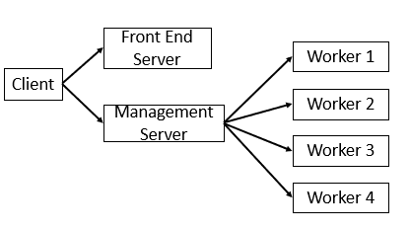

Client side is the browser where the user can setup the md5 and the number of workers to crack the password. The browser sends http request to the frontend server and fetch the GUI and as shown in the figure above, we decouple the frontend and backend service. When the user clicks “crack” in the browser, it will send post request to the management server and simply wait for the response. The management server dispatches jobs to workers via http request. We will hard code the workers directly in the worker machine. When a worker receives a job (http request), it will brute force the password and response to management server. The server will response to client once it gets the correct password.

**Improvement**

The time for the client to wait the result may be much longer if the password is long. The simple post request may not be the appropriate way. We will try web socket as the server push.