**Lab 9 -- Routing**

**Ziqi Tan U 88387934**

**1 My topology**

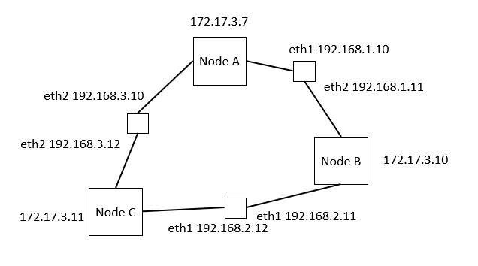

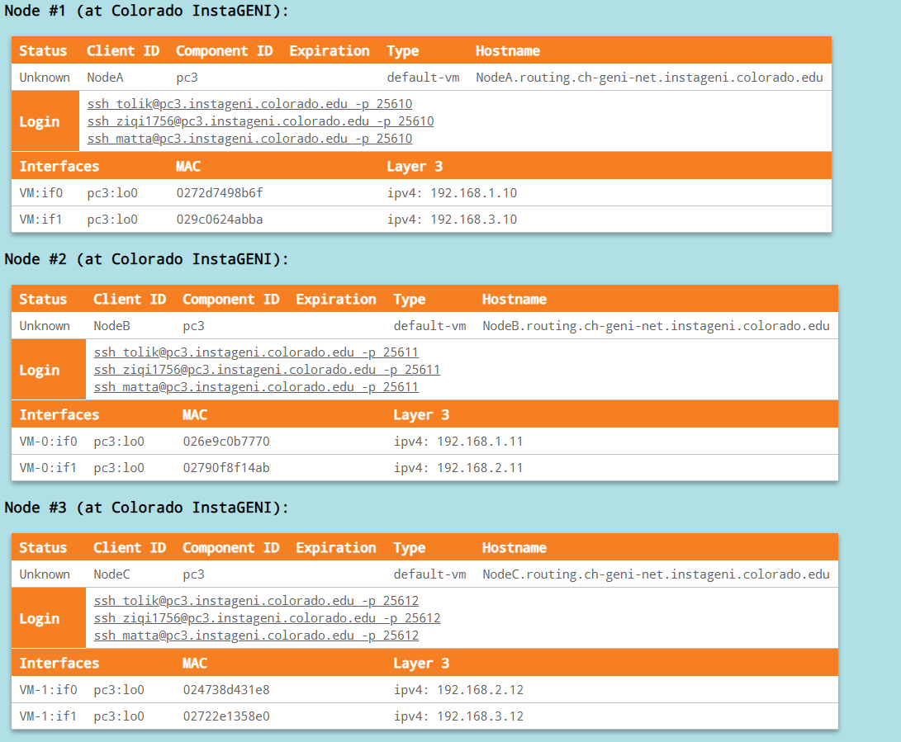

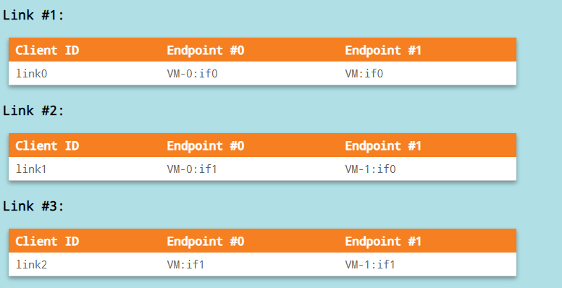

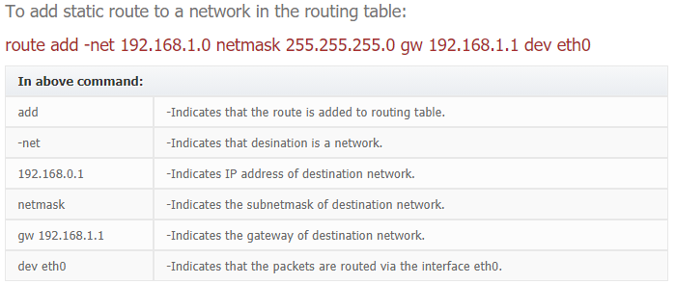

**2 Questions:**

1. **What happens when you traceroute from A to IP address 192.168.2.12 before you setup the static routes? Why?** Include the output of the traceroute in your writeup



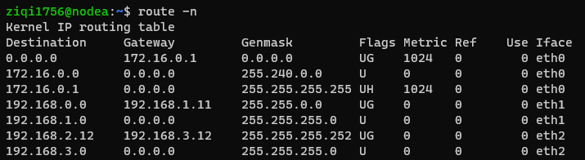

The routing table in Node A shows that if the destination is 192.168.12 then the next hop is 192.168.3.12

Using interface eth2 192.168.3.10. Thus, it takes only one hop to reach the destination.

1. **Setup the routing from A to 192.168.2.12 so that it goes through B. Was it enough to just modify the routing tables? What else did you need to change in order for the traffic to flow? Ensure that you have connectivity by running a ping from A to 192.168.2.12.** In your writeup include all the commands you ran and a screenshot of the routing configuration.

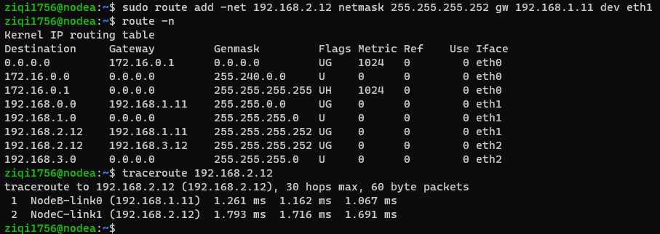

It was enough to just modify the routing tables.

1. **What happens when you traceroute from A to IP address 192.168.2.12 after you setup the static routes?** In your writeup include a screenshot of the traceroute output.

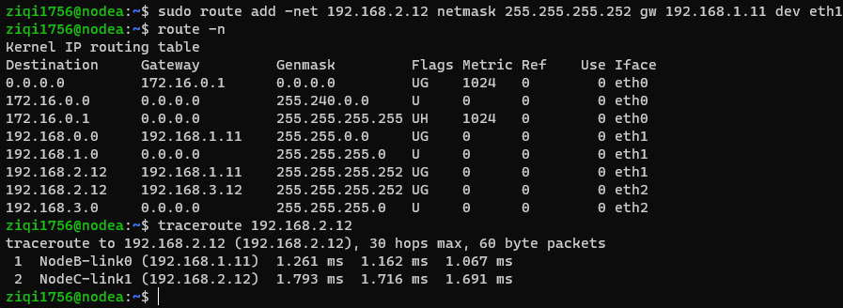

It takes two hops to reach the destination.

**Node B Routing Table**

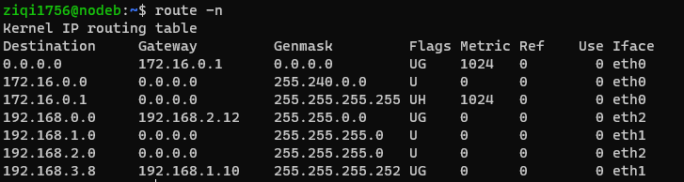

**Node C Routing Table**

