**CS 655 Programming Assignment 2**

**Reliable Transport Protocol**

Collaboration

Xueyan Xia U82450191

Ziqi Tan U88387934

Ziqi Tan:

Implementation

Stop and wait

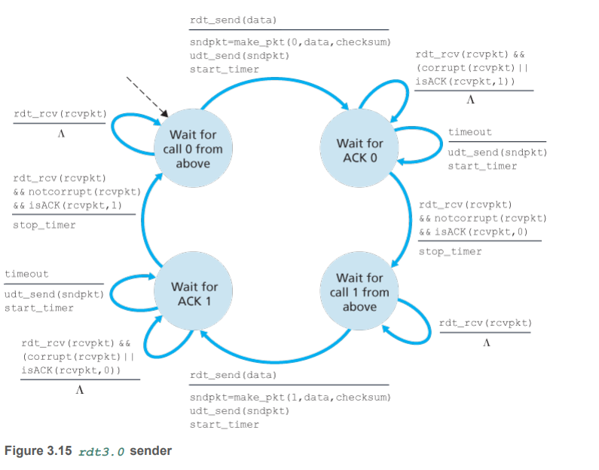

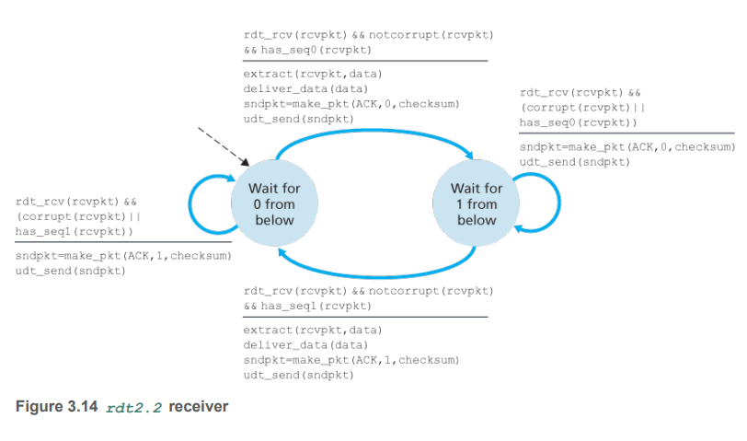

Selective Repeat with cumulative ACKs

Go Back N with SACK option