1. What is a layered communication model? Draw the two (layered) models of the ISO OSI and the TCP/IP protocol suites. Compare the two models. For each model, indicate the main functions provided by each layer.

It is a network model based on network architecture. Each layer is responsible for providing the corresponding services and implement of the reliable protocols.

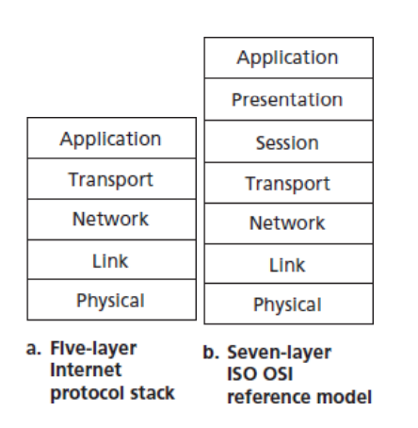

**application**: user interface

**presentation**: code conversion, encryption, compression

**session**: organizes and synchronizes the data exchange

**transport**: multiplexing/demultiplexing, fragmentation/reassembly, end-to-end flow control, congestion control and error control

**network**: addressing and routing data

**link**: link-level flow and error control

**physical:** physical and electrical interfaces (normally 100% hardware)

2. What are two reasons for using layered protocols?

Protocol layering has conceptual and structural advantages. As we have seen, layering provides a structured way to discuss system components. Modularity makes it easier to update system components.

each layer provides its service by (1) performing certain actions within that layer and by (2) using the services of the layer directly below it.

3. In the context of layered network architecture, what is a connection-oriented service and what is a connection-less service? Why do we need both services? Identify the various functions and interfaces needed to provide each service?

Connection-oriented service: Before the client and server can start to send data to each other, they first need to handshake and establish a TCP connection. Usually reliable; delivery is in-order, error- and loss-free, no duplication.

Connection-less: data is sent directly in a best-effort way; data can arrive out-of order, be lost, corrupted, duplicated

Connection-oriented service is the one of the fundaments of reliable data transmitting.

Connection-less service provides finer application-level control over what data is sent, and when with smaller packet header overhead.

4. Explain the difference between FDM (Frequency Division Multiplexing), STDM (Synchronous Time Division Multiplexing), and statistical multiplexing.

**Multiplexing Strategies**

In FDM, signals of different frequencies are combined for concurrent transmission over a shared medium.

Synchronous time division multiplexing assigns a fixed time slot to each connected device, whether the device transmits data or not.

In statistical multiplexing, a communication channel is divided into an arbitrary time slot on demand.

5. A cable TV system has 100 commercial channels; each of them is alternating between programs and advertising. Is this more like TDM (Time Division Multiplexing) or like FDM (Frequency Division Multiplexing)?

FDM

6. Define the terms client and server application programs. Which one of the two is usually more difficult to build? Why?

The server performs a passive open operation, runs on a well-known port number and provides services for clients by sending and receiving messages.

The clients performs an active-open operation, gets assigned an arbitrary unused port number and connects it to a server on a remote machine

Server. Because it needs to implement functions (eg. Multithread) to maintain individual connections to different clients and provide efficiency and reliable service at the same time.

With the help of a diagram, describe the different components and the operation of an electronic mail application.

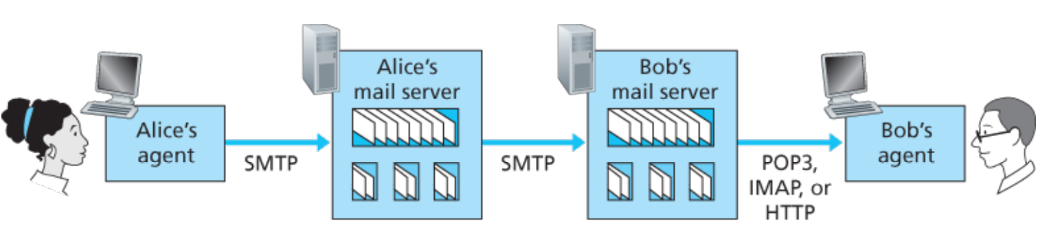

1.Alice invokes her user agent for e-mail, provides Bob’s e-mail address (for example, bob@someschool.edu), composes a message, and instructs the user agent to send the message. (TCP、SMTP)

2. Alice’s user agent sends the message to her mail server, where it is placed in a message queue.

3. Alice’s mail server sees the message in the message queue. It opens a TCP connection to an SMTP server, running on Bob’s mail server.

4. After some initial SMTP handshaking, the SMTP client sends Alice’s message into the TCP connection.

5. At Bob’s mail server, the server side of SMTP receives the message. Bob’s mail server then places the message in Bob’s mailbox.

6. Bob invokes his user agent to read the message at his convenience, which is based on mail access protocol such as POP3 or HTTP protocol.

7. We have seen a number of application-layer protocols. Give examples and explain the difference between (i) stateless and stateful protocols, (ii) push and pull protocols, and (iii) persistent and non-persistent protocols.

(i)

an HTTP server maintains no information about the clients, vice versa

(ii)

Push protocol: The client always pushes the file to the Web server.

pull protocol: someone loads information on a Web server and users pull the information from the server at their convenience

(iii)

Nonpersistent HTTP: At most one object (html file, jpeg image, audio clip file, …) is sent over a TCP connection

Persistent HTTP: Multiple objects can be sent over single TCP connection between client and server

8. Mention at least three techniques to scale client-server application architectures (i.e. reduce their load on the server and/or network for a large number of clients)?

Web caches (proxy server), Conditional GET, Cookies: keeping “state”

9. With the help of a diagram, explain the steps involved in mapping an Internet name into its IP address. Be precise about how each step is accomplished.

Suppose that some application (such as a Web browser or a mail reader) running in a user’s host needs to translate a hostname to an IP address.

The application will invoke the client side of DNS, specifying the hostname that needs to be translated.

DNS in the user’s host then takes over, sending a query message into the network. All DNS query and reply messages are sent within UDP datagrams to port 53.

Firstly, the client would contact its local DNS server, if there is no cache information, the local DNS server forwards the query message to a root DNS server.

The root DNS server takes note of the suffix and returns to the local DNS server a list of IP addresses for TLD servers responsible for the suffix.

The local DNS server then contacts one of TLD servers, which returns the IP address of an authoritative server.

Finally, the local DNS server resends the query message to an authoritative server, which returns the IP address for the hostname.

10. The primary model of network interaction among application programs is known as the client-server model. (a) Define the terms client and server. (b) A client sends a 128-byte request to a server located 100 km away over a 1-Gbps optical fiber, and then waits for a reply to get back. What is the utilization of the link (i.e. percentage of time the link is busy transmitting) during this transaction? Take the speed of light in fiber optics to be 200 km/msec. (c) Consider the situation of part (b) again. Compute the minimum possible response time both for the 1-Gbps link and for a 1-Mbps link. What conclusion can you draw?

(a)

The server performs a passive open operation, runs on a well-known port number and provides services for clients by sending and receiving messages.

The client performs an active-open operation, gets assigned an arbitrary unused port number and connects it to a server on a remote machine

(b)、(c)

Response Time (RTT) = Transmission Delay + 2 * Propagation Delay

Throughput = Data Amount / RTT

Link Utilization = Throughput / capacity

When data rate is too much smaller than link capacity, link utilization would be extremely small. In this case, smaller the capacity, larger the utilization.

11. Suppose a 100-Mbps point-to-point link is being set up between the earth and a new lunar colony. The distance from the moon to the earth is approximately 240,000 miles, and data travels over the link at the speed of light---186,000 miles per second.

(a) Calculate the minimum round-trip time (RTT) for the link.

2 * 240, 000 / 186, 000 = 2.58 s

(b) Using the RTT as the delay, calculate the delay-bandwidth product for the link.

Bandwidth = 100 Mbps

RTT = 2.58s

D * B = 2.58 * 10 8 bit

(c) A camera on the lunar base takes pictures of the earth and saves them in digital format to disk. Suppose Mission Control on earth wishes to download the most current image, which is 25 MB. What is the minimum amount of time that will elapse between the request for the data goes out and the transfer is finished?

RTT + 25 * 8 / 100 = 4.58 s

(d) Suppose each image is transferred as a sequence of packets using the sliding window selective-repeat protocol. Assuming each packet carries 1 KB of data, how many bits do you need for the sequence number? Explain your answer.

Delay * Bandwidth = 2.58 * 10 8 bit

D * B / Packet Size = SWS / 1 KB = 258000

Log2(258000*2) = 19

12. Go-back-n and selective-repeat are two basic approaches to deal with transmission errors.

(a) Compare the two approaches in terms of storage and capacity requirements.

Go-back-n:

It saves receiver buffering by requiring packets to arrive in-order

It would be simpler in buffering and protocol processing at sender and receiver. For example, it could easily detect duplicated and out-of-order packets by always expecting “the next sequence number”.

It consumes more link capacity by retransmitting correctly received packets.

Selective repeat:

The channel would not become filled with unnecessary packets retransmission, better utilization of the capacity.

The sender and receiver windows will not always coincide. Also needs more buffer space in sender and receiver.

(b) With the aid of a packet sequence (timing) diagram, show the operation of go-back-n when a data-packet/ACK-packet/NAK-packet is lost.

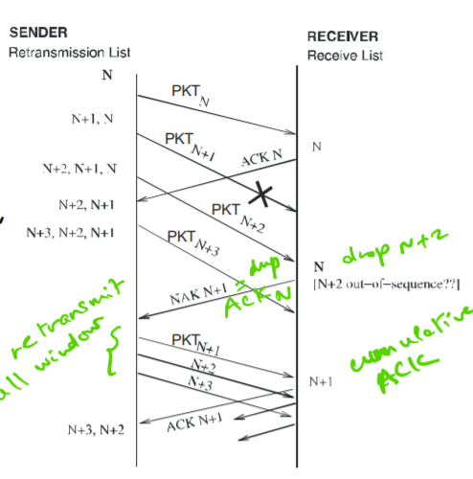

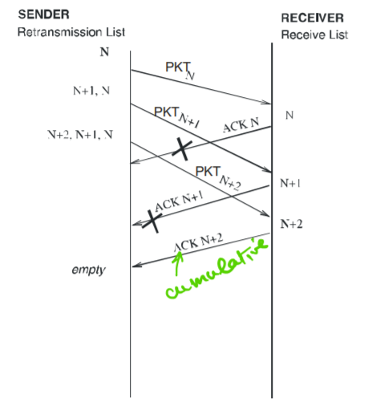

(NAK也是一样的)

13. Consider an ARQ algorithm running over a 20,000-meter point-to-point fiber link.

(a) Compute the propagation delay for this link, assuming that the speed of light is 2*108 meters per second in the fiber.

2 * 104 / 2 * 108 = 0.0001 s

(b) Suggest a suitable timeout value for the ARQ algorithm to use. What is the reason behind your suggestion?

EstimatedRTT = (1−α)⋅EstimatedRTT+α⋅SampleRTT

the new value of EstimatedRTT is a weighted combination of the previous value of EstimatedRTT and the new value for SampleRTT. The recommended value of α is α = 0.125

the SampleRTT values will fluctuate from segment to segment due to congestion in the

routers and to the varying load on the end systems.

(c) Why might it still be possible for the ARQ algorithm to timeout and retransmit a packet, given this timeout value?

the RTT variation, DevRTT , as an estimate of how much SampleRTT typically deviates from EstimatedRTT :

DevRTT=(1−β)⋅DevRTT+β⋅|SampleRTT−EstimatedRTT|

The recommended value of β is 0.25.

14. Consider a satellite link with a one-way propagation time of 0.27 second and a transmission rate of 1 Mbps (106 bps) with packets of 1000 bits each. What is the minimum window size of go-back-n that results in efficiency (utilization) of 100%?

Bandwidth Delay Product = 1 Mbps * (0.27 * 2 + 1000 / 1Mbps) = 541000 bits

SWS = B * D / Packet Size = 541000 / 1000 = 541 + 1

Bits of sequence number = log2(542) = 10

15. Assume a sliding window protocol using selective repeat. With the aid of a packet sequence (timing) diagram, show why the range of sequence numbers {0, 1, … , 2K-1}, where K denotes the size of the sender's window and the receiver's window, is enough for the protocol to work correctly.

The sequence number we need should be at least two times as the send window size, in order to make sure the receiver could distinguish a new packet number from an old one.

16. Suppose you are designing a sliding window protocol for a 1 Mbps point-to-point link to Venus, which has a round-trip propagation delay of 4 seconds. Assuming the size of each packet is 1,000 bytes, how many bits do you need for the sequence number? Explain your answer

Go-Back-n

B * D = 1, 000, 000 * 4 = 4, 000, 000 bits

4s, 4, 000, 000 bits

1 frame of size 1000 bytes

Frame number: 4,000,000 / 1000 * 8 = 500

Bits of sequence number: log 2 (500 + 1) = 9

17. Explain how two application programs interact with TCP in order to communicate in a client/server fashion. Make sure to define the terms client and server, and identify the various operations performed by the client and server. Explain what TCP does as a result of each operation.

TCP performs role in connection establishment and close. Before and after data transmission, we need to do three-way handshake to make sure a connection is established or closed successfully between a client and the server. During this connection, TCP protocols will ensure reliable connection.

1) avoid loss at receiver -> flow control, “ACK” s

2) detect corrupted packets -> checksum

3) detect lost packets -> retransmission timeout ≈ RTT

4) recovery -> Automatic Repeat Request (ARQ)

5) detect duplicates -> sequence number

18. How does TCP identify a connection? Is the information needed for this identification readily available to the TCP software in the received TCP segment? Explain.

IP Address and Port number.

Yes. TCP protocols demultiplex based on this information in TCP segment and send data to

aboded layer.

19. Why does UDP exist? Would it not have been enough to just let user processes send raw IP packets?

20. A reliable transport protocol with window size of 65,535 bytes is used over a 1- Gbps link (109 bps) link that has a 10-msec one-way propagation delay. What is the maximum throughput (data rate) achievable? What is the link utilization (percentage of time the link is busy)?

Bit Rate (throughput): Amount of data that can be transmitted per time unit

Performance: Delay m Time it takes to send message from point A to point B

Total Delay = Processing + Queueing + Transmission + Propagation

Propagation Delay = Distance / SpeedOfLight

transmission = Size / Bit Rate (throughput)

Bandwidth (Bit Rate) x Delay Product (BxD): The bandwidth-delay product of a link is the maximum number of bits that can be in the link.

TCP/IP:

Application layer: The application layer is where **network applications and their application-layer protocols** reside.

Transport layer: The Internet’s transport layer **transports application-layer messages between application endpoints**.

Network layer: The Internet’s network layer is responsible for **moving network-layer packets known as datagrams from one host to another**.

Link layer: The Internet’s network layer **routes a datagram through a series of routers between the source and destination.**

Physical layer: the job of the physical layer is to **move the individual bits within the frame from one node to the next.**

OSI:

Presentation layer: The role of the presentation layer is to provide services that **allow communicating applications to interpret the meaning of data exchanged.** These services include **data compression** and **data encryption** as well as **data description**

Session Layer: The session layer provides for **delimiting and synchronization of data exchange**, including the means to build a checkpointing and recovery scheme.

Switches: intermediate nodes in a network

Routers / gateways: nodes that connect networks

ISP: Internet Service Provider

API: application programming interface

address: byte-string that identifies a node; usually unique

routing: process of determining how to forward messages toward the destination node based on its address

types of addresses: unicast(node-specific), broadcast(all nodes on the network), multicast (some subset of nodes on the network)

Get vs Post:

Get: Input is uploaded in URL field of request line.

Post: Input is uploaded to server in entity body. Web page often includes form input

HEAD: asks server to leave requested object out of response

PUT: uploads file in entity body to path specified in URL field

DELETE: deletes file specified in the URL field

TCP:

Full duplex: point-to-point data transfer

Flow control: keep sender from overrunning receiver

Congestion control: keep sender from overrunning network

Sliding Window: Imposes a limit on the number of outstanding unACKed packets. The size of the send window is chosen to achieve both high link utilization and flow control

Reliable Transmission:

Assume FIFO channel (no out of order),

1) avoid loss at receiver -> flow control, “ACK” s

2) detect corrupted packets -> checksum

3) detect lost packets -> retransmission timeout ≈ RTT

4) recovery -> Automatic Repeat Request (ARQ)

5) detect duplicates -> sequence number