# CS 655 Computer Network -- Lab1 Introduction to Wireshark

Ziqi Tan U 88387934

1. List 3 different protocols that appear in the protocol column in the unfiltered

packet-listing window in step 7 above.

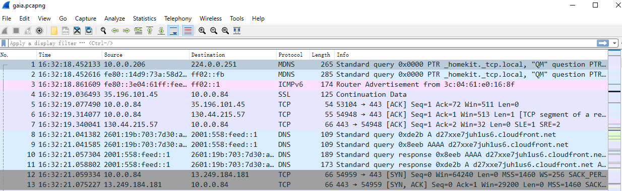

As we can see, MDNS, ICMP, SSL, TCP, DNS and TCP are shown in the screenshot.

1. How long did it take from when the HTTP GET message was sent until the HTTP OK reply was received?

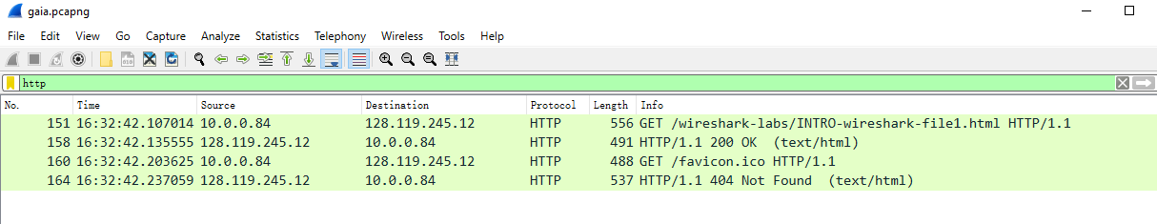

It takes 0.028541 second.

1. What is the Internet address of the gaia.cs.umass.edu? What is the Internet address of your computer?

gaia.cs.umass.edu: 128.119.245.12

My computer: 10.0.0.84

1. Print the two HTTP messages (GET and OK) referred to in question 2 above.

