# **Lab HTTP**

**Ziqi Tan U 88387934**

## **The Basic HTTP GET/response interaction**

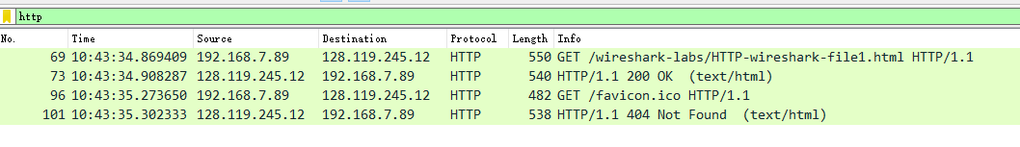

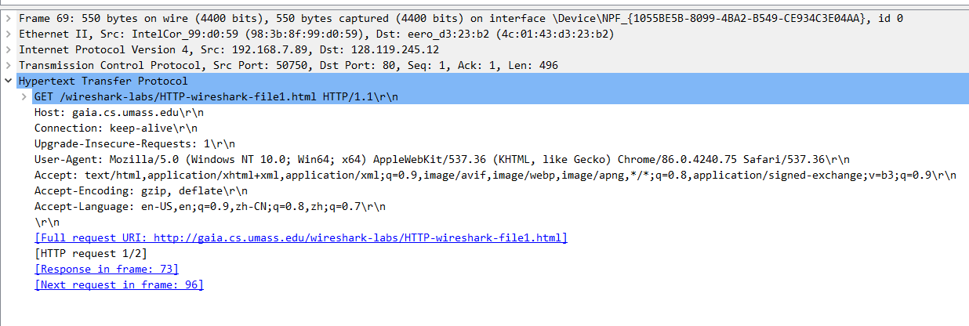

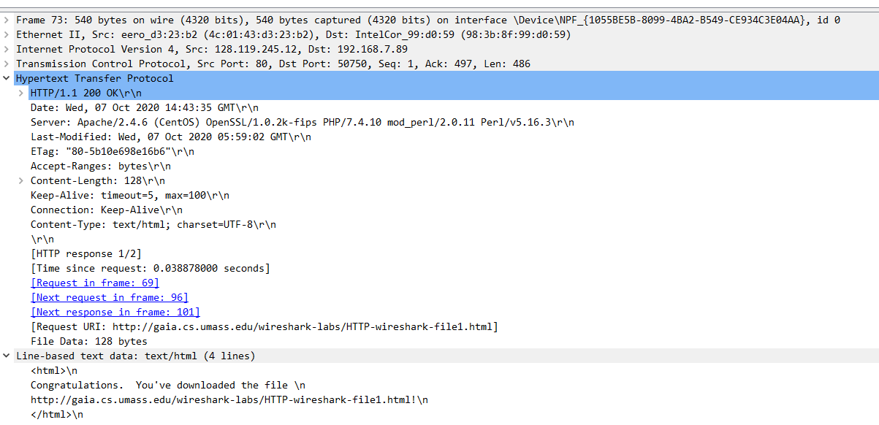

<http://gaia.cs.umass.edu/wireshark-labs/HTTP-wireshark-file1.html>

1. Browser: HTTP 1.1, Server: HTTP 1.1
2. Accepted language: en-US,en;q=0.9,zh-CN;q=0.8,zh;q=0.7

English and Chinese.

This is called a relative quality factor. It specifies what language the user would prefer, on a scale of 0 to 1.

1. IP address of my computer: 192.168.7.89, of the server: 128.119.245.12.
2. Status code returned from the server: 200.
3. Last modified: Wed, 07 Oct 2020 05:59:02 GMT.
4. Content length: 128 bytes.
5. By inspecting the raw data in the packet content window, do you see any headers within the data that are not displayed in the packet-listing window? If so, name one.

For example: keep alive.

## **The HTTP CONDITIONAL GET/response interaction**

http://gaia.cs.umass.edu/wireshark-labs/HTTP-wireshark-file2.html

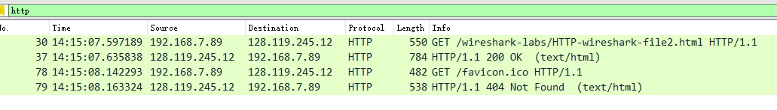

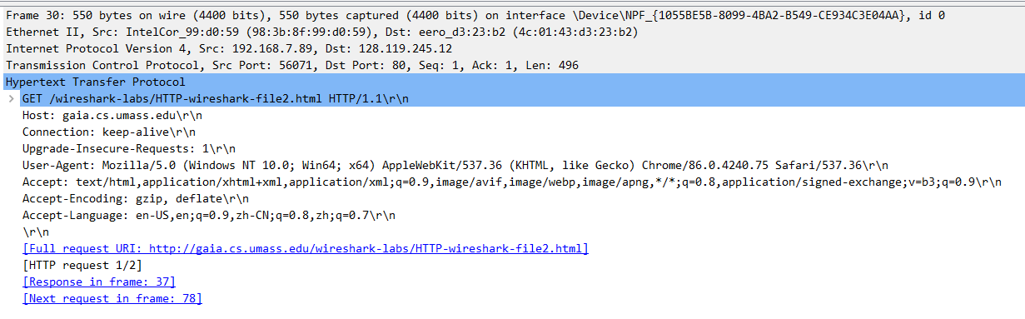

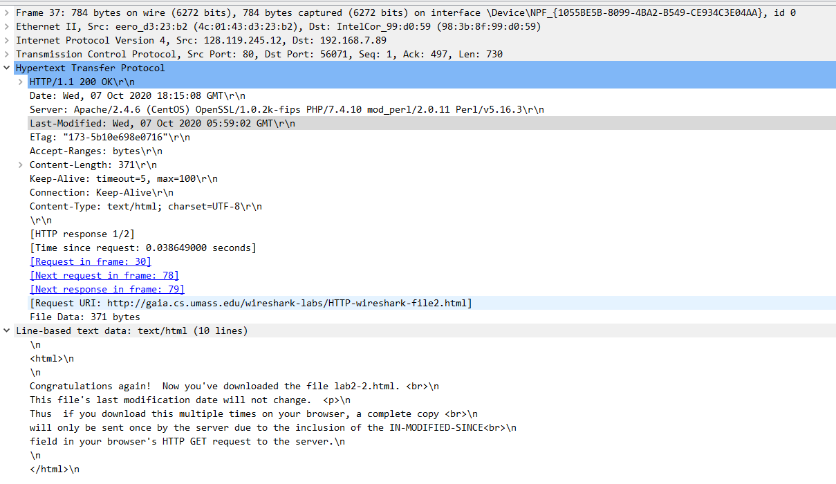



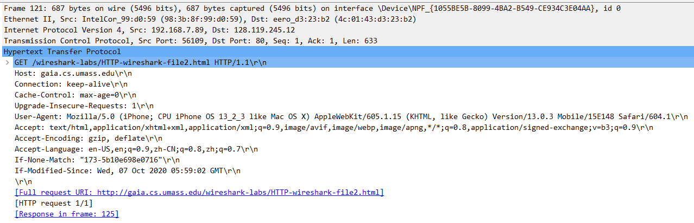

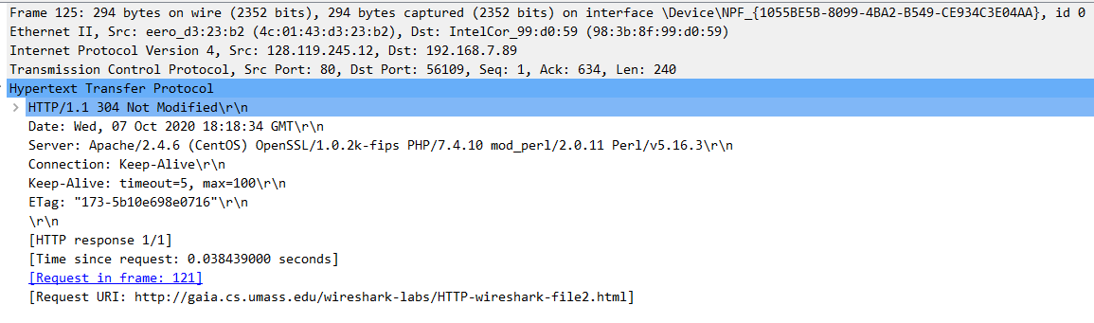

1. No “IF-MODIFIED-SINCE” line in the first http get request.
2. In the first http response, the server explicitly returned the contents of the file. We can see the line-base text data in the packet.
3. If-Modified-Since: Wed, 07 Oct 2020 05:59:02 GMT
4. 304 Not Modified. The server didn’t explicitly return the contents of the file. The server told the browser that the content was not modified and please use the cache content.

## **Retrieving Long Documents**

http://gaia.cs.umass.edu/wireshark-labs/HTTP-wireshark-file3.html



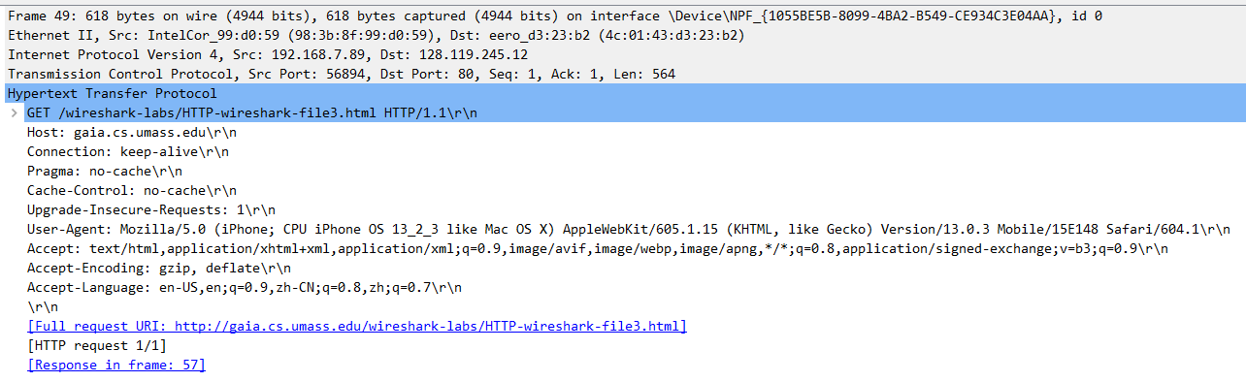

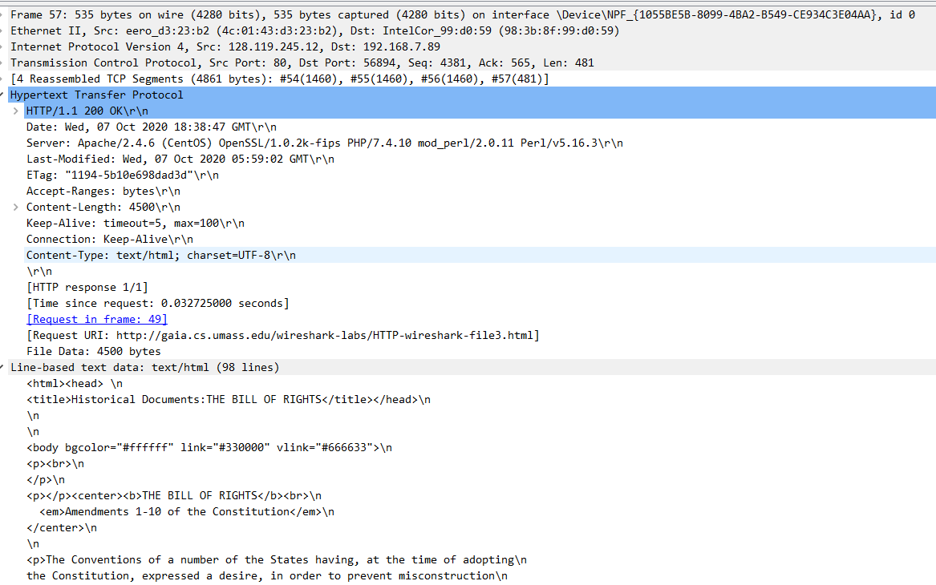

1. Only one http request was sent by my browser. Packet number is 49.
2. Number 57.
3. 200 OK.
4. 4 TCP segments were needed.

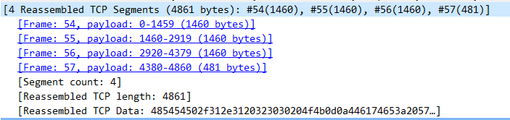

## **HTML Documents with Embedded Objects**

http://gaia.cs.umass.edu/wireshark-labs/HTTP-wireshark-file4.html

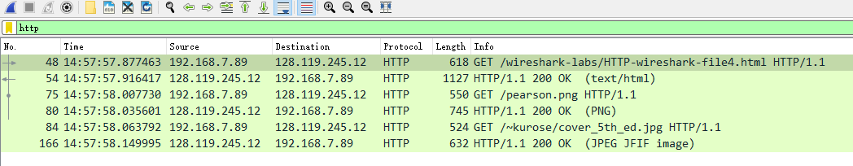

1. The browser sent 3 http request.

They were sent to 192.119.245.12.

1. They were downloaded in serial, but actually they may download in parallel (See the second waterfall image). Let’s see the waterfall in Chrome developer tool. The blue part represents content download. The blue part of these two images didn’t overlap. They may overlap sometimes.

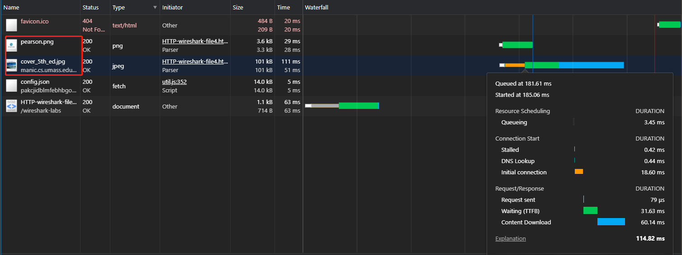

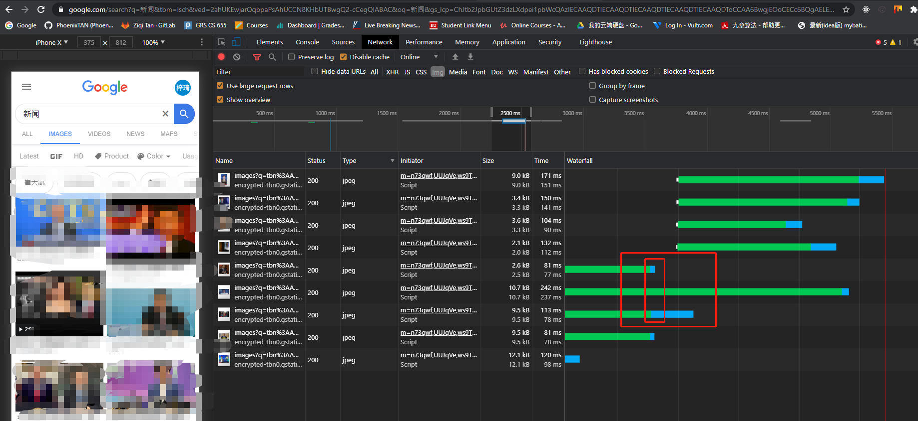

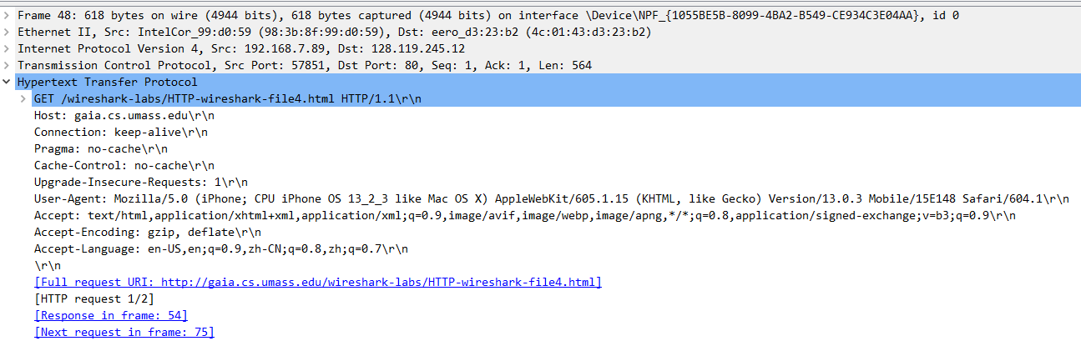

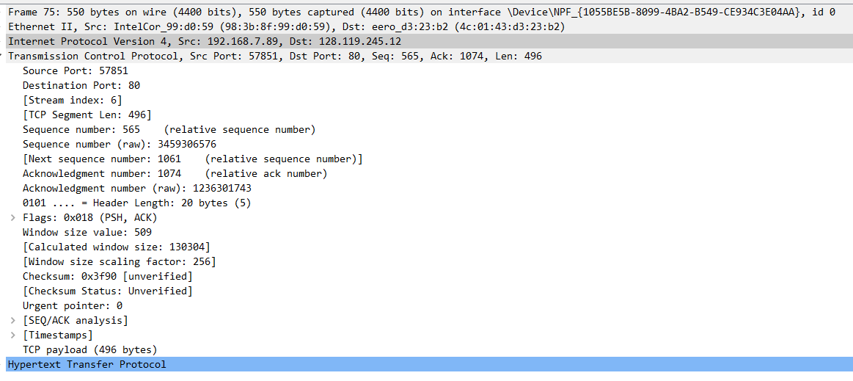

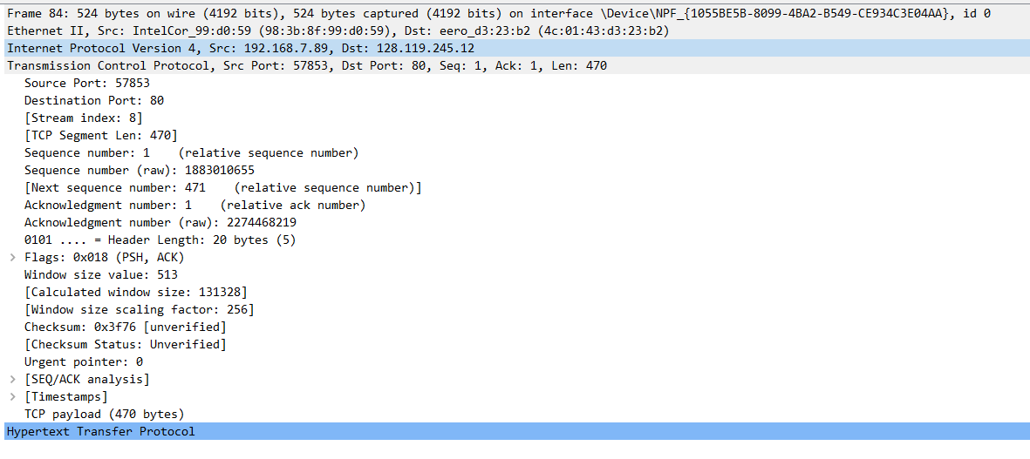

## **HTTP Authentication**

http://gaia.cs.umass.edu/wireshark-labs/protected_pages/HTTP-wireshark-file5.html

The username is “wireshark-students” (without the quotes), and the password is “network” (again, without the quotes).

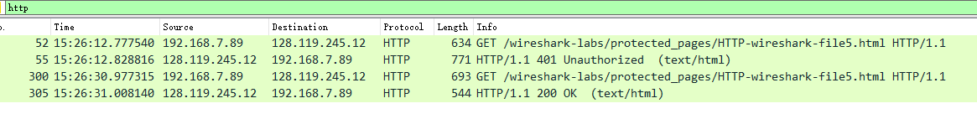

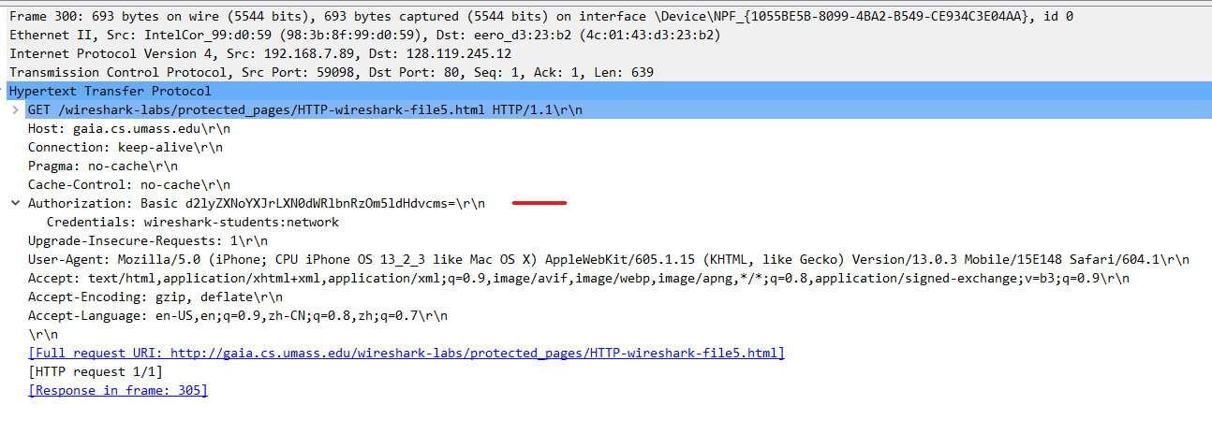

1. Firstly, the server tells us 401 Unauthroized.
2. The second request includes the Authorization field.

Note:

The username (wireshark-students) and password (network) that you entered are encoded in the string of characters (d2lyZXNoYXJrLXN0dWRlbnRzOm5ldHdvcms=) following the “Authorization: Basic” header in the client’s HTTP GET message. While it may appear that your username and password are encrypted, they are simply encoded in a format known as Base64 format. The username and password are not encrypted!