CS 655 Computer network

**Lab 6 —— HTTP Server**

Ziqi Tan

U 88387934

Question 1: What was the output of the above command and why? Provide screenshots.

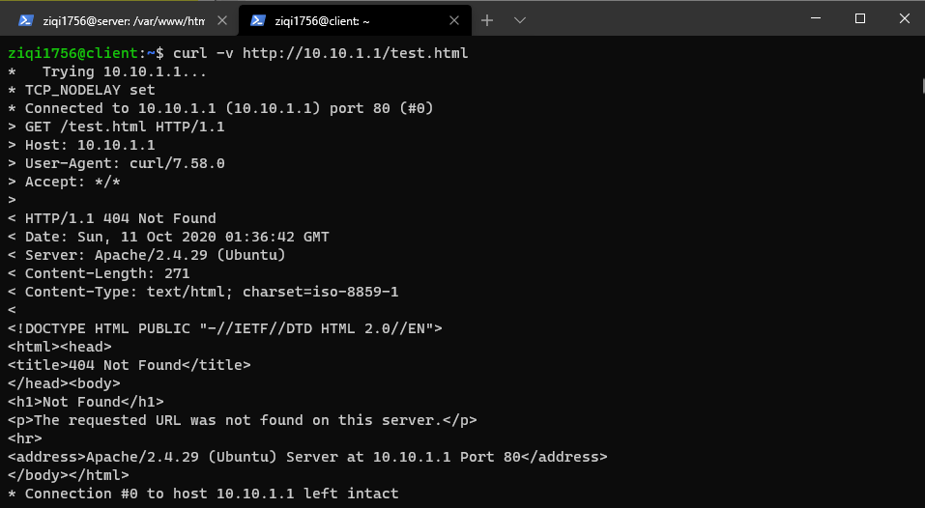

Question 2: What was the output of the above command and why? Provide screenshots.4

**Create my own index.html without correct html format.**

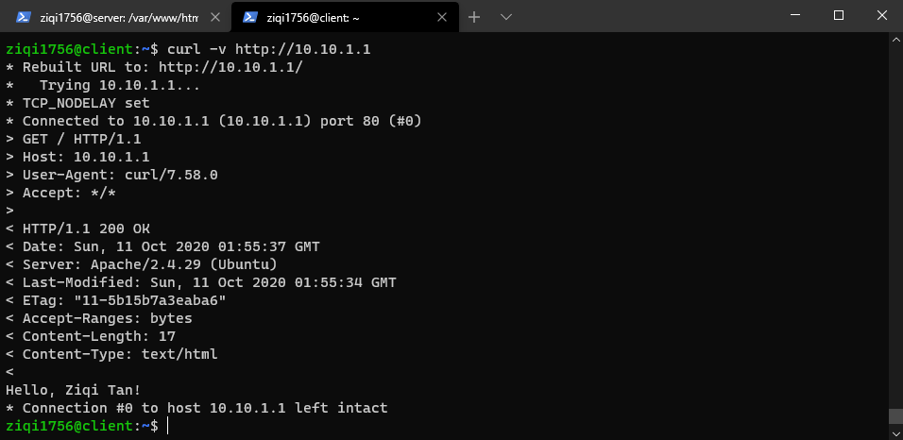

**Create my own index file without .html suffix.**

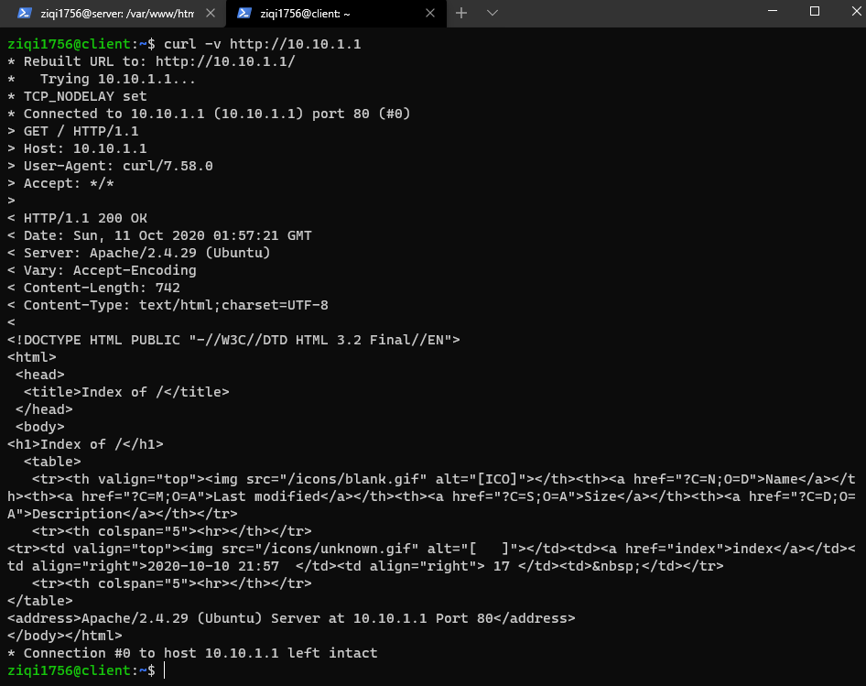

Question 3: Create your own correctly formatted HTML document in place of the message in index.html. Follow the same procedure as above to retrieve this document. Take a screenshot!

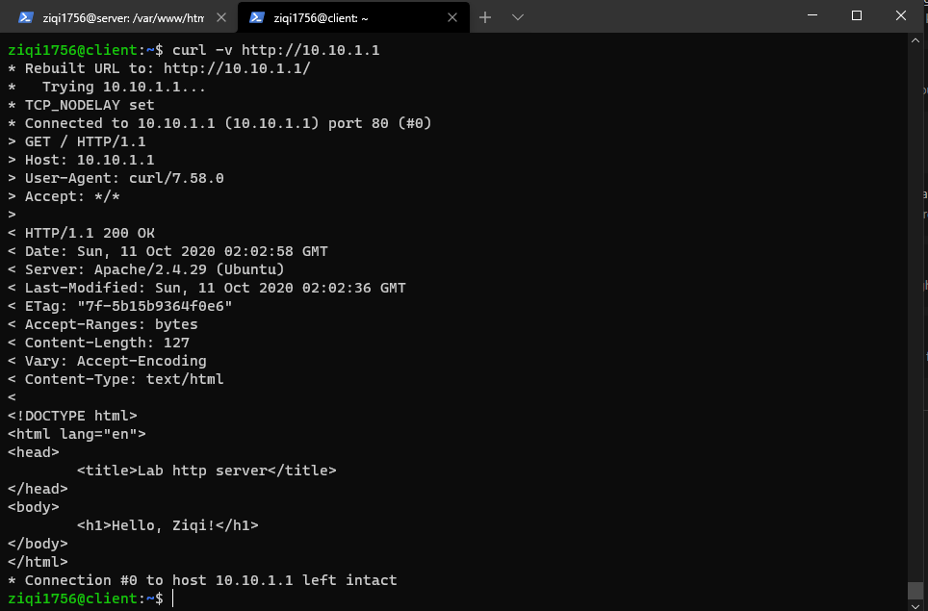

Question 4: You’ve learned that HTTP has many different status codes. By modifying your requests made from the client machine you already observed two of them, explain briefly

what do they mean and explain 2 more status codes by reading up on http.

404: page not found. The page that you want to find in the server does not exist.

200: OK. The page is fetched from the server successfully.

500: server internal error.

401: not authorized. You have not login or the priority to access the page.