**PA #2 – Part I**

**Implementing Selective-Repeat with cumulative ACKs**

**Ziqi Tan U 88387934 ziqi1756@bu.edu**

**Xueyan Xia U 82450191 xueyanx@bu.edu**

# **0 How to run these protocols?**

1. Open folder “src” and find “Project.java”.
2. Turn to the bottom of “Project.java” and uncomment

simulator = **new** SelectiveRepeatSimulator(numOfMessages, loss, corrupt, delay, trace, seed, windowsize, timeout);

1. Run “Project.java”.

If you want to run GBN with SACK, modify the code in “Project.java” as below.

simulator = **new** GBNSimulator(numOfMessages, loss, corrupt, delay, trace, seed, windowsize, timeout);

# **1 Stop & Wait (window = 1)**

## **Case 1: works for no loss and no corruption**

**Input values**

* Number of messages to simulate: 100
* Packet loss probability: 0.0
* Packet corruption probability: 0.0
* Average time between messages from sender’s layer 5: 300
* **Window size: 1**
* Retransmission timeout: 30
* Trace level: 3
* Random seed: 1234

**Part of output in the terminal**

-- * Network Simulator v1.0 * --

Enter number of messages to simulate (> 0): [10] 100

Enter packet loss probability (0.0 for no loss): [0.0] 0

Enter packet corruption probability (0.0 for no corruption): [0.0] 0

Enter average time between messages from sender's layer 5 (> 0.0): [1000] 300

Enter window size (> 0): [8] 1

Enter retransmission timeout (>0.0) [15.0] 30

Enter trace level (>= 0): [0] 3

Enter random seed: [0] 1234

generateNextArrival(): called

generateNextArrival(): time is 0.0

generateNextArrival(): future time for event 1 at entity 0 will be 65.1509140293588

EVENT time: 65.1509140293588 type: 1 entity: 0

generateNextArrival(): called

generateNextArrival(): time is 65.1509140293588

generateNextArrival(): future time for event 1 at entity 0 will be 101.0406811731315

Calling aOutput()...

toLayer3: seqnum: 0 acknum: 0 checksum: 3029525244 payload: aaaaaaaaaaaaaaaaaaaa

toLayer3: scheduling arrival on other side

startTimer: starting timer at 65.1509140293588

EVENT time: 67.37757499923703 type: 2 entity: 1

Calling bInput()...

toLayer3: seqnum: 0 acknum: 0 checksum: 4108050209 payload:

toLayer3: scheduling arrival on other side

EVENT time: 69.2864467299417 type: 2 entity: 0

Calling aInput()...

stopTimer: stopping timer at 69.2864467299417

EVENT time: 101.0406811731315 type: 1 entity: 0

generateNextArrival(): called

generateNextArrival(): time is 101.0406811731315

generateNextArrival(): future time for event 1 at entity 0 will be 124.9732963042085

Calling aOutput()...

toLayer3: seqnum: 1 acknum: 0 checksum: 2281148032 payload: bbbbbbbbbbbbbbbbbbbb

toLayer3: scheduling arrival on other side

startTimer: starting timer at 101.0406811731315

EVENT time: 102.46888637958922 type: 2 entity: 1

Calling bInput()...

toLayer3: seqnum: 0 acknum: 1 checksum: 2212294583 payload:

toLayer3: scheduling arrival on other side

toLayer3: seqnum: 0 acknum: 1 checksum: 2212294583 payload:

toLayer3: scheduling arrival on other side

…

…

Simulator terminated at time 30186.773277993096

**Statistics**

===============STATISTICS=======================

Number of original packets transmitted by A: 100

Number of retransmissions by A: 0

Number of data packets delivered to layer 5 at B: 100

Number of ACK packets sent by B: 150

Number of corrupted packets: 0

Ratio of lost packets: 0.00%

Ratio of corrupted packets: 0.00%

Average RTT: 10.340

Average communication time: 10.340

==================================================

## **Case 2: works for loss and no corruption**

**Input values**

- Number of messages to simulate: 100

- Packet loss probability: 0.1

- Packet corruption probability: 0.0

- Average time between messages from sender’s layer 5: 300

- Window size: 1

- Retransmission timeout: 30

- Trace level: 3

- Random seed: 1234

**Recovery from DATA loss and error detection by bimeout**

EVENT time: 101.0406811731315 type: 1 entity: 0

generateNextArrival(): called

generateNextArrival(): time is 101.0406811731315

generateNextArrival(): future time for event 1 at entity 0 will be 124.9732963042085

Calling aOutput()...

**toLayer3: seqnum: 1 acknum: 0 checksum: 2281148032 payload: bbbbbbbbbbbbbbbbbbbb**

**toLayer3: packet being lost**

startTimer: starting timer at 101.0406811731315

EVENT time: 124.9732963042085 type: 1 entity: 0

generateNextArrival(): called

generateNextArrival(): time is 124.9732963042085

generateNextArrival(): future time for event 1 at entity 0 will be 357.98211615344707

Calling aOutput()...

EVENT time: 131.0406811731315 type: 0 entity: 0

Calling aTimerInterrupt()...

toLayer3: seqnum: 1 acknum: 0 checksum: 2281148032 payload: bbbbbbbbbbbbbbbbbbbb

toLayer3: scheduling arrival on other side

startTimer: starting timer at 131.0406811731315

EVENT time: 132.4688863795892 type: 2 entity: 1

Calling bInput()...

toLayer3: seqnum: 0 acknum: 1 checksum: 2212294583 payload:

toLayer3: scheduling arrival on other side

EVENT time: 134.43626209295937 type: 2 entity: 0

Calling aInput()... Receive ACK=0

**Recovery from ACK loss and error detection by timeout**

EVENT time: 2803.921231727042 type: 2 entity: 1

Calling bInput()...

**toLayer3: seqnum: 0 acknum: 0** checksum: 4108050209 payload:

**toLayer3: packet being lost**

EVENT time: 2830.372325815607 type: 0 entity: 0

**Calling aTimerInterrupt()...**

**toLayer3: seqnum: 0 acknum: 0** checksum: 3924856370 payload: kkkkkkkkkkkkkkkkkkkk

toLayer3: scheduling arrival on other side

startTimer: starting timer at 2830.372325815607

EVENT time: 2839.928464613788 type: 2 entity: 1

Calling bInput()...

**toLayer3: seqnum: 0 acknum: 0** checksum: 4108050209 payload:

toLayer3: scheduling arrival on other side

EVENT time: 2842.5797601245154 type: 2 entity: 0

**Calling aInput()...**

stopTimer: stopping timer at 2842.5797601245154

**Statistics**

===============STATISTICS=======================

Number of original packets transmitted by A: 100

Number of retransmissions by A: 37

Number of data packets delivered to layer 5 at B: 100

Number of ACK packets sent by B: 169

Number of corrupted packets: 0

Number of A corrupted packets: 0

Ratio of lost packets: 12.09%

Ratio of corrupted packets: 0.00%

Average RTT: 11.598

Average communication time: 14.088

==================================================

## **Case 3: works for corruption and no loss**

Input values

- Number of messages to simulate: 100

- Packet loss probability: 0.0

- Packet corruption probability: 0.1

- Average time between messages from sender’s layer 5: 300

- Window size: 1

- Retransmission timeout: 30

- Trace level: 3

- Random seed: 1234

**Recovery from DATA corruption and error detection by timeout**

EVENT time: 101.0406811731315 type: 1 entity: 0

generateNextArrival(): called

generateNextArrival(): time is 101.0406811731315

generateNextArrival(): future time for event 1 at entity 0 will be 124.9732963042085

Calling aOutput()...

**toLayer3: seqnum: 1** acknum: 0 checksum: 2281148032 payload: bbbbbbbbbbbbbbbbbbbb

**toLayer3: packet being corrupted**

toLayer3: scheduling arrival on other side

startTimer: starting timer at 101.0406811731315

EVENT time: 102.46888637958922 type: 2 entity: 1

Calling bInput()...

EVENT time: 124.9732963042085 type: 1 entity: 0

generateNextArrival(): called

generateNextArrival(): time is 124.9732963042085

generateNextArrival(): future time for event 1 at entity 0 will be 357.98211615344707

Calling aOutput()...

EVENT time: 131.0406811731315 type: 0 entity: 0

**Calling aTimerInterrupt()...**

**toLayer3: seqnum: 1** acknum: 0 checksum: 2281148032 payload: bbbbbbbbbbbbbbbbbbbb

toLayer3: scheduling arrival on other side

startTimer: starting timer at 131.0406811731315

EVENT time: 133.00805688650166 type: 2 entity: 1

**Calling bInput()...**

**toLayer3: seqnum: 0 acknum: 1** checksum: 2212294583 payload:

toLayer3: scheduling arrival on other side

EVENT time: 137.68941312906279 type: 2 entity: 0

Calling aInput()...

**Recovery from ACK corruption and error detection by time out**

EVENT time: 6530.350901821955 type: 2 entity: 1

Calling bInput()...

**toLayer3: seqnum: 0** acknum: 1 checksum: 2212294583 payload:

**toLayer3: packet being corrupted**

toLayer3: scheduling arrival on other side

EVENT time: 6534.028077028717 type: 2 entity: 0

Calling aInput()...

EVENT time: 6552.41584521012 type: 0 entity: 0

**Calling aTimerInterrupt()...**

**toLayer3: seqnum: 1** acknum: 0 checksum: 3797934679 payload: zzzzzzzzzzzzzzzzzzzz

toLayer3: scheduling arrival on other side

startTimer: starting timer at 6552.41584521012

EVENT time: 6561.870082705161 type: 2 entity: 1

**Calling bInput()...**

**toLayer3: seqnum: 0 acknum: 1** checksum: 2212294583 payload:

toLayer3: scheduling arrival on other side

EVENT time: 6563.777306436354 type: 2 entity: 0

Calling aInput()...

stopTimer: stopping timer at 6563.777306436354

**Statistics**

===============STATISTICS=======================

Number of original packets transmitted by A: 100

Number of retransmissions by A: 13

Number of data packets delivered to layer 5 at B: 100

Number of ACK packets sent by B: 152

Number of corrupted packets: 26

Number of A corrupted packets: 10

Ratio of lost packets: 1.13%

Ratio of corrupted packets: 3.65%

Average RTT: 12.570

Average communication time: 15.937

==================================================

## **Case 4: works for both loss and corruption**

===============STATISTICS=======================

Number of original packets transmitted by A: 100

Number of retransmissions by A: 110

Number of data packets delivered to layer 5 at B: 100

Number of ACK packets sent by B: 166

Number of corrupted packets: 31

Number of A corrupted packets: 15

Ratio of lost packets: 25.27%

Ratio of corrupted packets: 3.90%

Average RTT: 11.653

Average communication time: 456.632

==================================================

# **2 Selective Repeat with cumulative ACK (window > 1)**

**Case 1: works for no loss and no corruption**

**Input values**

- Number of messages to simulate: 25

- Packet loss probability: 0.0

- Packet corruption probability: 0.0

- Average time between messages from sender’s layer 5: 300

- Window size: 8

- Retransmission timeout: 15

- Trace level: 3

- Random seed: 1234

**Statistics**

===============STATISTICS=======================

Number of original packets transmitted by A: 25

Number of retransmissions by A: 3

Number of data packets delivered to layer 5 at B: 25

Number of ACK packets sent by B: 28

Number of corrupted packets: 0

Number of A corrupted packets: 0

Ratio of lost packets: 5.36%

Ratio of corrupted packets: 0.00%

Average RTT: 9.286

Average communication time: 10.177

==================================================

EXTRA:

===============CUSTOM STATISTICS==================

Total packets transmitted by A: 28

Original packets transmitted by A: 25

Total number of packets accounts for RTT: 24

Number of lost packets: 0

A corrupt: 0

B corrupt: 0

==================================================

**Case 2: identify (on output trace) case where ack is lost/corrupted and a later cumulative ack moves sender window by more than 1**

EVENT time: 2094.6966460158087 type: 2 entity: 1

Calling bInput()...

seqNum is in [rcv_base, rcv_base + N - 1]

SeqNum: 11 baseSeq: 11

Reveive window:

seqnum: 11 acknum: 0 checksum: 2827291660 payload: rrrrrrrrrrrrrrrrrrrr

null

null

null

null

null

null

null

currentBaseSeqNum: 11

Receive window after slide:

null

null

null

null

null

null

null

null

currentBaseSeqNum: 12

toLayer3: seqnum: 0 acknum: 11 checksum: 3596227959 payload:

**toLayer3: packet being corrupted**

**Case 2: ACK corrupted**

toLayer3: scheduling arrival on other side

EVENT time: 2097.896450697348 type: 2 entity: 0

Calling aInput()...

**Case 2: ACK corrupted**

ACK from B is corrupted!

EVENT time: 2115.610522782067 type: 0 entity: 0

Calling aTimerInterrupt()...

toLayer3: seqnum: 10 acknum: 0 checksum: 2615173232 payload: qqqqqqqqqqqqqqqqqqqq

toLayer3: scheduling arrival on other side

startTimer: starting timer at 2115.610522782067

EVENT time: 2120.4380016479995 type: 2 entity: 1

Calling bInput()...

toLayer3: seqnum: 0 acknum: 10 checksum: 2707236321 payload:

toLayer3: packet being lost

EVENT time: 2131.0525833918273 type: 1 entity: 0

generateNextArrival(): called

generateNextArrival(): time is 2131.0525833918273

generateNextArrival(): future time for event 1 at entity 0 will be 2193.069246498001

Calling aOutput()...

seqnum: 10 acknum: 0 checksum: 2615173232 payload: qqqqqqqqqqqqqqqqqqqq

seqnum: 11 acknum: 0 checksum: 2827291660 payload: rrrrrrrrrrrrrrrrrrrr

seqnum: 12 acknum: 0 checksum: 3086035889 payload: ssssssssssssssssssss

toLayer3: seqnum: 12 acknum: 0 checksum: 3086035889 payload: ssssssssssssssssssss

toLayer3: scheduling arrival on other side

EVENT time: 2134.1922360911894 type: 2 entity: 1

Calling bInput()...

seqNum is in [rcv_base, rcv_base + N - 1]

SeqNum: 12 baseSeq: 12

Reveive window:

seqnum: 12 acknum: 0 checksum: 3086035889 payload: ssssssssssssssssssss

null

null

null

null

null

null

null

currentBaseSeqNum: 12

Receive window after slide:

null

null

null

null

null

null

null

null

currentBaseSeqNum: 13

toLayer3: seqnum: 0 acknum: 12 checksum: 1330857165 payload:

toLayer3: scheduling arrival on other side

**Case 2: send next ACK**

EVENT time: 2136.4642170476395 type: 2 entity: 0

Calling aInput()...

seqnum: 10 acknum: 0 checksum: 2615173232 payload: qqqqqqqqqqqqqqqqqqqq

seqnum: 11 acknum: 0 checksum: 2827291660 payload: rrrrrrrrrrrrrrrrrrrr

seqnum: 12 acknum: 0 checksum: 3086035889 payload: ssssssssssssssssssss

**Case 2: Next cumulative ACK and**

**Sender window moves by 2**

**CumulativeACK: 12 baseNum: 10**

stopTimer: stopping timer at 2136.4642170476395

**Case 3 and Case 5 can be traced in the following output trace.**

**Case 3: identify (on output trace) case where when data packet is lost/corrupted, and data is retransmitted after RTO.**

**Case 5: identify (on output trace) case where when data packet is lost/corrupted, and the retransmitted data is delivered and a cumulative ack moves the sender window by more than 1.**

-- * Network Simulator v1.0 * --

Enter number of messages to simulate (> 0): [10] 100

Enter packet loss probability (0.0 for no loss): [0.0] 0.2

Enter packet corruption probability (0.0 for no corruption): [0.0] 0

Enter average time between messages from sender's layer 5 (> 0.0): [1000] 50

Enter window size (> 0): [8]

Enter retransmission timeout (>0.0) [15.0] 30

Enter trace level (>= 0): [0] 0

Enter random seed: [0] 1234

**CumulativeACK: 11 baseNum: 9**

**CumulativeACK: 2 baseNum: 0**

**CumulativeACK: 8 baseNum: 6**

Simulator terminated at time 5031.128879665518

**Statistics**

===============STATISTICS=======================

Number of original packets transmitted by A: 100

Number of retransmissions by A: 65

Number of data packets delivered to layer 5 at B: 100

Number of ACK packets sent by B: 116

Number of corrupted packets: 0

Number of A corrupted packets: 0

Ratio of lost packets: 23.13%

Ratio of corrupted packets: 0.00%

Average RTT: 19.054

Average communication time: 38.811

==================================================

EXTRA:

===============CUSTOM STATISTICS==================

Total packets transmitted by A: 165

Original packets transmitted by A: 100

Total number of packets accounts for RTT: 66

Number of lost packets: 64

A corrupt: 0

B corrupt: 0

==================================================

**Output trace**

EVENT time: 2548.661763359478 type: 1 entity: 0

generateNextArrival(): called

generateNextArrival(): time is 2548.661763359478

generateNextArrival(): future time for event 1 at entity 0 will be 2562.7765739921265

Calling aOutput()...

seqnum: 5 acknum: 0 checksum: 2500758075 payload: bbbbbbbbbbbbbbbbbbbb

seqnum: 6 acknum: 0 checksum: 2323295622 payload: cccccccccccccccccccc

toLayer3: seqnum: 6 acknum: 0 checksum: 2323295622 payload: cccccccccccccccccccc

**Case 3 and Case 5: Data packet lost**

toLayer3: packet being lost

EVENT time: 2550.4565569017614 type: 2 entity: 1

Calling bInput()...

Generate the ACK again.

toLayer3: seqnum: 0 acknum: 5 checksum: 2226203566 payload:

EVENT time: 2562.7765739921265 type: 1 entity: 0

generateNextArrival(): called

generateNextArrival(): time is 2562.7765739921265

generateNextArrival(): future time for event 1 at entity 0 will be 2611.5482039857175

Calling aOutput()...

seqnum: 5 acknum: 0 checksum: 2500758075 payload: bbbbbbbbbbbbbbbbbbbb

seqnum: 6 acknum: 0 checksum: 2323295622 payload: cccccccccccccccccccc

seqnum: 7 acknum: 0 checksum: 4089729731 payload: dddddddddddddddddddd

toLayer3: seqnum: 7 acknum: 0 checksum: 4089729731 payload: dddddddddddddddddddd

toLayer3: scheduling arrival on other side

EVENT time: 2566.1804559465318 type: 2 entity: 1

Calling bInput()...

seqNum is in [rcv_base, rcv_base + N - 1]

SeqNum: 7 baseSeq: 6

Reveive window:

null

seqnum: 7 acknum: 0 checksum: 4089729731 payload: dddddddddddddddddddd

null

null

null

null

null

null

currentBaseSeqNum: 6

EVENT time: 2574.799035615101 type: 0 entity: 0

Calling aTimerInterrupt()...

toLayer3: seqnum: 5 acknum: 0 checksum: 2500758075 payload: bbbbbbbbbbbbbbbbbbbb

toLayer3: scheduling arrival on other side

startTimer: starting timer at 2574.799035615101

EVENT time: 2583.954710531938 type: 2 entity: 1

Calling bInput()...

Generate the ACK again.

toLayer3: seqnum: 0 acknum: 5 checksum: 2226203566 payload:

toLayer3: scheduling arrival on other side

EVENT time: 2586.9139072847684 type: 2 entity: 0

Calling aInput()...

seqnum: 5 acknum: 0 checksum: 2500758075 payload: bbbbbbbbbbbbbbbbbbbb

seqnum: 6 acknum: 0 checksum: 2323295622 payload: cccccccccccccccccccc

seqnum: 7 acknum: 0 checksum: 4089729731 payload: dddddddddddddddddddd

EVENT time: 2604.799035615101 type: 0 entity: 0

Calling aTimerInterrupt()...

toLayer3: seqnum: 6 acknum: 0 checksum: 2323295622 payload: cccccccccccccccccccc

**Case 3: RTO retransmit packet 6**

toLayer3: packet being lost

startTimer: starting timer at 2604.799035615101

EVENT time: 2611.5482039857175 type: 1 entity: 0

generateNextArrival(): called

generateNextArrival(): time is 2611.5482039857175

generateNextArrival(): future time for event 1 at entity 0 will be 2705.88702047792

Calling aOutput()...

seqnum: 6 acknum: 0 checksum: 2323295622 payload: cccccccccccccccccccc

seqnum: 7 acknum: 0 checksum: 4089729731 payload: dddddddddddddddddddd

seqnum: 8 acknum: 0 checksum: 3686496435 payload: eeeeeeeeeeeeeeeeeeee

toLayer3: seqnum: 8 acknum: 0 checksum: 3686496435 payload: eeeeeeeeeeeeeeeeeeee

toLayer3: scheduling arrival on other side

EVENT time: 2620.396801660207 type: 2 entity: 1

Calling bInput()...

seqNum is in [rcv_base, rcv_base + N - 1]

SeqNum: 8 baseSeq: 6

Reveive window:

null

seqnum: 7 acknum: 0 checksum: 4089729731 payload: dddddddddddddddddddd

seqnum: 8 acknum: 0 checksum: 3686496435 payload: eeeeeeeeeeeeeeeeeeee

null

null

null

null

null

currentBaseSeqNum: 6

EVENT time: 2634.799035615101 type: 0 entity: 0

Calling aTimerInterrupt()...

toLayer3: seqnum: 6 acknum: 0 checksum: 2323295622 payload: cccccccccccccccccccc

toLayer3: packet being lost

startTimer: starting timer at 2634.799035615101

EVENT time: 2664.799035615101 type: 0 entity: 0

Calling aTimerInterrupt()...

toLayer3: seqnum: 6 acknum: 0 checksum: 2323295622 payload: cccccccccccccccccccc

toLayer3: scheduling arrival on other side

startTimer: starting timer at 2664.799035615101

EVENT time: 2666.9457686086616 type: 2 entity: 1

Calling bInput()...

seqNum is in [rcv_base, rcv_base + N - 1]

SeqNum: 6 baseSeq: 6

Reveive window:

seqnum: 6 acknum: 0 checksum: 2323295622 payload: cccccccccccccccccccc

seqnum: 7 acknum: 0 checksum: 4089729731 payload: dddddddddddddddddddd

seqnum: 8 acknum: 0 checksum: 3686496435 payload: eeeeeeeeeeeeeeeeeeee

null

null

null

null

null

currentBaseSeqNum: 6

Receive window after slide:

null

null

null

null

null

null

null

null

currentBaseSeqNum: 9

**toLayer3: seqnum: 0 acknum: 8 checksum: 4194326291 payload:**

**Case 5: Receiver sends cumulative ACK**

toLayer3: scheduling arrival on other side

EVENT time: 2673.193273720512 type: 2 entity: 0

Calling aInput()...

seqnum: 6 acknum: 0 checksum: 2323295622 payload: cccccccccccccccccccc

seqnum: 7 acknum: 0 checksum: 4089729731 payload: dddddddddddddddddddd

seqnum: 8 acknum: 0 checksum: 3686496435 payload: eeeeeeeeeeeeeeeeeeee

**Case 5: Sender receives**

**cumulative ACK and**

**moves the window by 2**

**CumulativeACK: 8 baseNum: 6**

**stopTimer: stopping timer at 2673.193273720512**

**Case 4: identify (on output trace) case where when data packet is lost/corrupted, and data is retransmitted after receiving duplicate ack**

EVENT time: 3833.265175328837 type: 1 entity: 0

generateNextArrival(): called

generateNextArrival(): time is 3833.265175328837

generateNextArrival(): future time for event 1 at entity 0 will be 3919.05880916776

Calling aOutput()...

**seqnum: 14 acknum: 0** checksum: 2030448238 payload: aaaaaaaaaaaaaaaaaaaa

toLayer3: seqnum: 14 acknum: 0 checksum: 2030448238 payload: aaaaaaaaaaaaaaaaaaaa

**Case 4: packet 14 is corrupted**

**toLayer3: packet being corrupted**

toLayer3: scheduling arrival on other side

startTimer: starting timer at 3833.265175328837

EVENT time: 3836.0678121280557 type: 2 entity: 1

Calling bInput()...

**bInput sends duplicate ACK because of corruption**

**toLayer3: seqnum: 0 acknum: 13** checksum: 945058907 payload:

**Case 4: send duplicate ACK**

toLayer3: scheduling arrival on other side

EVENT time: 3843.9144260994294 type: 2 entity: 0

Calling aInput()...

seqnum: 14 acknum: 0 checksum: 2030448238 payload: aaaaaaaaaaaaaaaaaaaa

**duplicate ACK: 13**

**toLayer3: seqnum: 14 acknum: 0** checksum: 2030448238 payload: aaaaaaaaaaaaaaaaaaaa

**Case 4: receive duplicate ACK and**

**Retransmit packet 14**

toLayer3: scheduling arrival on other side

startTimer: starting timer at 3843.9144260994294

startTimer: Warning: Attempting to start a timer that is already running

EVENT time: 3853.7952208014162 type: 2 entity: 1

Calling bInput()...

seqNum is in [rcv_base, rcv_base + N - 1]

SeqNum: 14 baseSeq: 14

Reveive window:

seqnum: 14 acknum: 0 checksum: 2030448238 payload: aaaaaaaaaaaaaaaaaaaa

null

null

null

null

null

null

null

currentBaseSeqNum: 14

Receive window after slide:

null

null

null

null

null

null

null

null

currentBaseSeqNum: 15

# **4 Logistics**

## **Overall Design**

Limit sequence number is 2 times the window size.

The sender buffer will buffer everything from layer 5 no matter how fast the message comes. When the sender sends all packets in the sender window, the sender will not send any packet until receive a cumulative ACK to slide the sender window. Thus, in aInput() when we slide the window, we will send the available packets.

A more specific design can be seen in the following finite state machine.

## **Finite State Machine for Selective Repeat with cumulative ACK**

**Sender behaviors:**

1. Event: data received from above.

Action:

1. Buffer it.
2. Check the next available sequence number for the packet. If the sequence number is within the sender’s window, the data is packetized and sent.
3. Start timer.
4. Event: timeout or duplicate ACK.

Action:

1. Retransmit only the next missing (unACK’ed) packet.
2. Restart timer.
3. Event: ACK received.

Action: slide window and transmit the packets that now fall within the window. If the packet corrupts, discard it.

**Receiver behaviors:**

1. Packet with sequence number in [rcv_base, rcv_base+N-1] is correctly received.

If the received packet falls within the receiver’s window, it is buffered.

If this packet has a sequence number equal to the base of the receive window, then this packet, and any previously buffered and consecutively numbered packets are delivered to the upper layer.

The receive window is then moved forward by the number of packets delivered to the upper layer.

1. Packet with sequence number in [rcv_base – N, rcv_base – 1] is correctly received. An ACK must be generated, even though this is a packet that the receiver has previously acknowledged.
2. Otherwise. Ignore the packet.

## **Checksum**

We employ a java library java.util.zip to do the checksum.

1. Concatenate a string S with the following attributes of a packet: sequence number, ack number and payload (actually, other attributes can be corrupted to in the real world, we can just put it together in the string S).
2. Use getBytes() method of Class String to get the bytes of string S.
3. Then use Checksum crc32 = new CRC32() to iteratively update the checksum value.

## **Statistics**

1. **Justification for retransmission timer**

We use a static retransmission timer value and it is determined by our input.

1. **Number of retransmits under no loss and no corruption**

We can refer to the statistics in every case shown above.

**Input values for part 3 to part 8:**

- Number of messages to simulate: 100

- Average time between messages from sender’s layer 5: 300

- Window size: 8

- Retransmission timeout: 30

- Random seed: 1234

1. **Retransmits as function of loss**

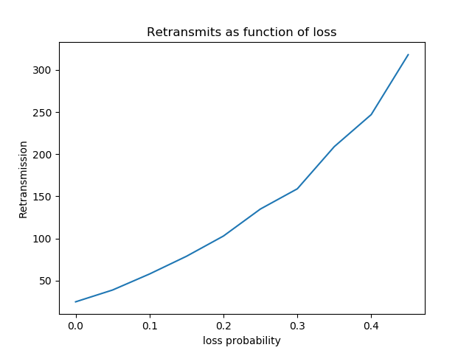

**Figure: Retransmits as function of loss (corruption probability = 0.1)**

1. **Retransmits as function of corruption**

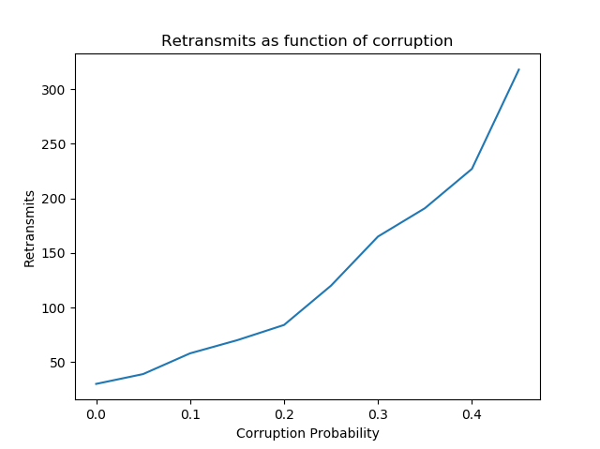

**Figure: Retransmits as function of corruption (loss probability = 0.1)**

1. **Average RTT as function of loss**

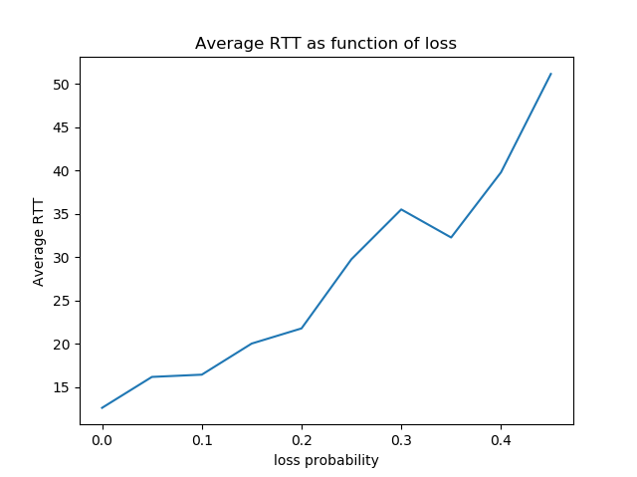

**Figure: Average RTT as function of loss (corruption probability = 0.1)**

1. **Average RTT as function of corruption**

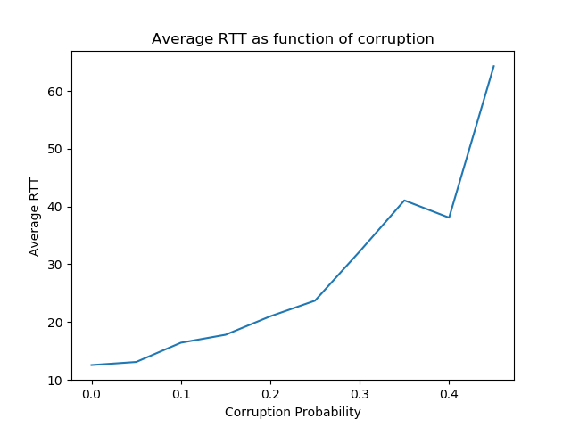

**Figure: Average RTT as function of corruption (loss probability = 0.1)**

1. **Average time to communicate packet vs. loss**

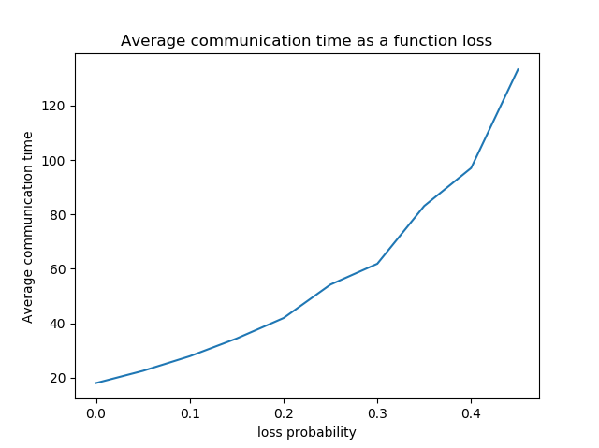

**Figure: Average time to communicate packet vs. loss (Corruption probability = 0.1)**

1. **Average time to communicate packet vs. loss**

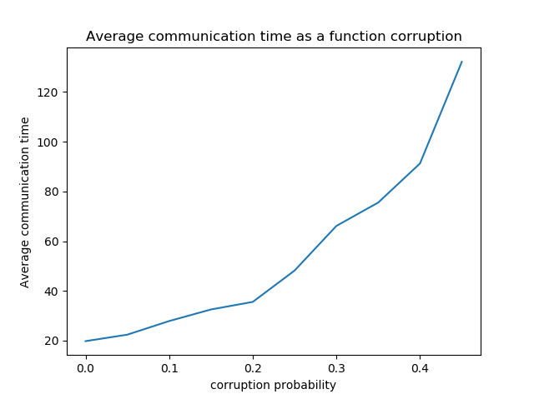

**Figure: Average time to communicate packet vs. corruption (Loss probability = 0.1)**

## **Error Conditions**

This program runs fine. No matter how many messages the sender sends, for example 1000, the receiver will always receive the exact number of messages intact and in order.

It may have some abnormal statistics.

When the layer 5 sends the message too fast to the sender buffer, then the sender has to buffer all the message. If the sender cannot send the packets to layer 3 when aOutput() is called, the packets buffered will never be sent. Thus, many packet are sent by the aTimerInterrupt() when a timeout event happened. This is also a drawback of this simulator. We figure out for a really long time to solve this problem, but it does not work well. That is why the average communication time is abnormal when the average arrival time of a message from layer 5 is very small.