**Using Github on Linux**

 If unable to git add

fatal: Unable to create '/home/phoenix/Desktop/tools/repo/.git/index.lock' : Permission denied

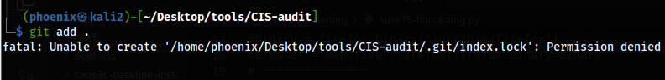

Then chmod ./.git:

**sudo chmod -R 777 ./.git;**

If still cannot git add => Remove repo/.git/index.lock

**sudo rm -rf ./.git/index.lock;**

Should be able to git add now

git add .

git commit -m""

git push -u origin main

// Using HTTPS to Git

sudo git clone gitRepo.git;

// If HTTPS keeps asking for username & password

// Try => generate new SSH key on local Linux => Upload public SSH key to Git

sudo ssh-keygen -t ed25519 -C "phoenixyork166@github.com";

Enter file in which...

/home/phoenix/.ssh/id_ed25519;

// Verify id_ed25519 id_ed25519.pub are generated

ls -la /home/phoenix/.ssh

// Verify both public & private key

**All public & private keys are stored in /home/userName/.ssh**

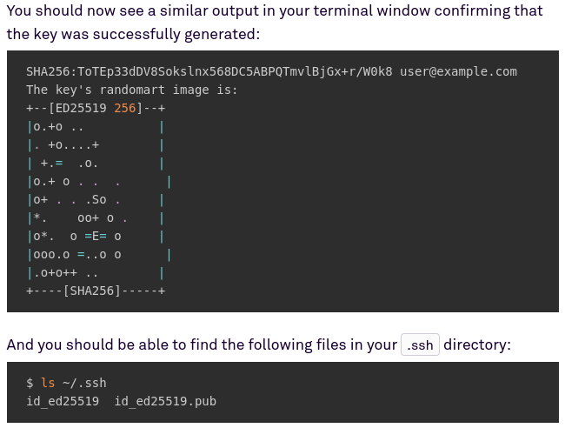

cat ~/.ssh/id_ed25519.pub;



Select WHOLE line => Copy & paste:

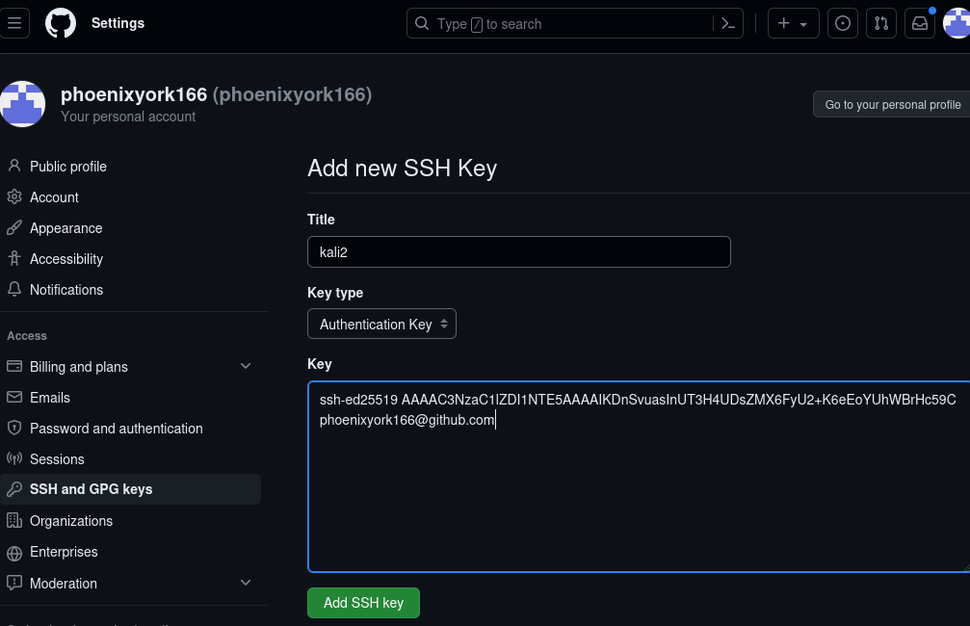

// Try cloning

sudo git clone REPO;

sudo git clone git@github.com:phoenixyork166/bash-01.git;

// After 1st cloning, you'll see

// Daily git operations

sudo git add . ;

sudo git commit -m"";

sudo git push;

// Enter passphrase

ssh-agent /bin/bash;

ssh-add ~/.ssh/id_ed25519;

Now, we should be able to git clone using ssh on GitHub!