Training, Result, References

1. Training

It is critical that the model be validated in real-time to ensure compatibility.
Thus model for the regression job, which is to produce Water Quality index using sensor data, is trained using Machine Learning algorithms such as Multiple Linear regression, Random Forest Regression, Support Vector regressor, Gradient Boosting Regression, Decision Tree Regression, and Deep Learning algorithm ANN (Artificial Neural Network).

A total of five major categories were developed based on the WQI (Water Quality Index) values of the samples: Excellent, Good, Poor, Very Poor, and Unsuitable.
The classification process was conducted using machine learning algorithms, such as Logistic Regression, Random Forest Classification, Support Vector Machines (SVMs), Gradient Boosting Classification and Decision Tree Classification.

Algorithm: Water Quality Prediction and Classification Algorithm
Input: The collected Lake Water Samples
Output: Prediction of Water Quality Index (WQI) and Classification of samples.

1. Collecting the water sample from different identified stations.
2. Feature Engineering: This involved selecting the relevant features that would be used to train the machine learning model.
      - Exploratory data analysis (EDA) is performed, and it reveals that the features are largely unrelated.
      - Boxplot is analysed.
3. Apply the following:
- For Predicting WQI:
  - Mulitple Linear Regression, Accuracy: 48%
  - Random Forest Regression, Accuracy: 97.87%
  - Support Vector regressor, Accuracy: Poor
  - Gradient Boosting Regression, Accuracy: 98%
  - Decision Tree Regression, Accuracy: 91.5%
- For Classification:
  - Logistic Regression, Accuracy: 55%
  - Random Forest Classification: 92%
  - Support Vector Machine, Accuracy: 54%
  - Gradient Boosting Classification, Accuracy: 91%
  - Decision Tree Classification, Accuracy: 87%
Given the foregoing, it is clear that the Enselble learning approach outperformed other commonly used learning methods.

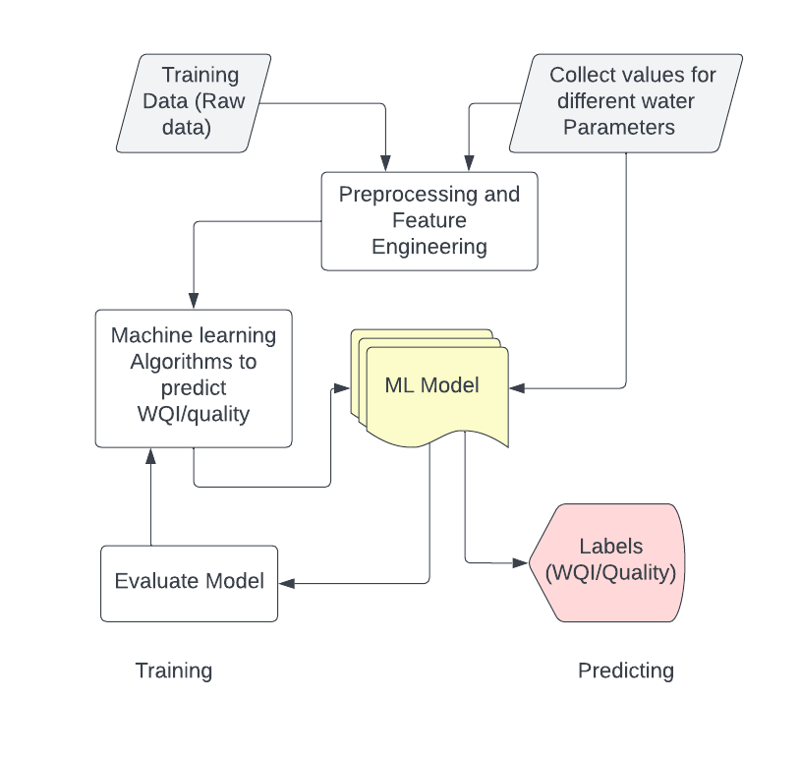

Overall, the main purpose to forecast WQI and categorise water samples were achieved.

2. Result:

Several evaluation metrics, including R2 score, RMSE, and MAE, were used to test the models. The results show that the Random Forest Regression, Deep Learning algorithm ANN, and Random Forest Classifier are the most successful for predicting WQI and for classifying water sample and gives highest R2 scores. The model can now predict the Water Quality Index and can classify water samples with high accuracy.

Using data acquired manually using sensors, the trained model was near enough in learning from the behaviour of data, with an accuracy of 98% in a known environment and up to 96% in an unfamiliar environment.
This showed that the model was able to accurately predict the behaviour of the data in both a known and unfamiliar environment. The model had a high degree of accuracy and was able to learn from the data with minimal human intervention.

In Remote Sensing, Satellite imagery from numerous lakes in Bangalore is used and processed with the help of image Processing and remote sensing technologies to derive Turbidity and Chlorophyll readings in the form of cloud Pixel Percentage.
Remote sensing assisted us in achieving large-scale coverage, which enables us to gather information over a large area in a short span of time, cost-effectiveness as it eliminates the need for expensive on-site visits, timely access to information, repeated observations since it can collect data repeatedly, allowing for the monitoring of changes over time, and non-invasive methodologies, which is essential in sensitive areas such as wildlife habitats, protected areas, and archaeological sites.

3. References:
[1] “Remote Sensing of Water Quality Parameters over Lake by using Sentinel-3 OLCI (Ocean and Land Colour Instrument)” by A. Najah, A. El-Shafie, O. A. Karim & Amr H. El-Shafie, Neural Computing and Applications, October 2018.
[2] “Deep learning-based water quality estimation and anomaly detection using Landsat-8/Sentinel-2 virtual constellation and cloud computing” by Sung EunKim, WonSeo, march 2020.
[3] “A Satellite-based Remote Sensing Technique for Surface Water Quality Estimation” at Yuqiao reservoir by Zhao Ying, Nan Jun, Cui Fu-Yi & Guo Liang - Journal of Zhejiang University-SCIENCE A, April 2019.
[4] “Modelling and Prediction of Water Quality by Using Artificial Intelligence” by Hieda Adriana Nascimento Silva, Antonello Rosato, Rosa Altilio, Massimo Panella, March 2021.
[5] “The Design Of the Remote Water Quality Monitoring System Based on WSM” by RP Bukata, JE Bruton, JH Jerome, March 2021.
[6] “A. Edge artificial intelligence for industrial internet of things applications: An industrial edge intelligence solution.”, Foukalas, F.; Tziouvaras, IEEE Ind. Electron. Mag. 2021, 15, 28–36.
[7] “Intelligent model for predicting water quality” by K Ashwini, JJ Vedha, MD Priya - Int. J. Adv. International Journal of Advance Research, Ideas and Innovations in Technology, 2019 academia.edu

[8] “Application of Aquatic Organisms in Water Quality Monitoring, Environment and Development, Vol. 4, pp. 115, 2018” by Huiting, W., Jingyu, S., & Hongmin.

[9] “Supervision and Management Information System for Rural Drinking Water Project Construction, in Proceedings of the 3rd IEEE International Conference on Intelligent System Design and Engineering Applications, pp. 1372-1375, 2013” by Zhenhua.

[10] “Developing a Model-based Drinking Water Decision Support System Featuring Remote Sensing and Fast Learning Techniques, in Proceedings of the IEEE Systems Journal, Vol. 12, No. 2, pp. 1358-1368, 2018” by Imen, S., Chang, N. B., Yang, Y. J., & Golchubian, A.

[11] “Design of Smart Sensors for Real-time Water Quality Monitoring, IEEE Access, Vol. 4, pp. 3975-3990, 2016” Cloete, N. A., Malekian, R., & Nair L.

