977-302 Digital Engineering Project I
Semester 2/2025

Intelligent Assistant using Image Processing and LLM: A Case Study of Patient Triage System
Project Report

Phokin Wanna 6630613024

Advisor: Aj.Wisarut Chantara

__________________________

Asst.Prof. Dr.Komsan Kanjanasit
Asst.Prof. Kullawat Chaowanawatee

College of Computing
Prince of Songkla University, Phuket Campus
Project Title Intelligent Assistant using Image Processing
and LLM: A Case Study of Patient Triage System

Author Phokin Wanna 6630613024
Major Digital Engineering
Academic Year 2025

Abstract
This project was the development of a contactless patient triage Assistant, that using a multi algorithms with image processing. For this system is designed for helping to reduce overcrowd in emergency department and triage area.
In the system contain of three main processes:
- Vision Module that using Image Processing and algorithms to detect pain gestures and physically anomaly.
- Audio Module to transcribe Thai and English spoken symptoms into text.
- Processing Module to deploy a local large language model to combine a visual and an auditory data for decision making and sent out the feedback.
The expected result of this project was a real time kiosk system. That it can classify patients into ESI levels, detect important physical signs and assist nurses by generating clinical summaries and visual evidence to reducing workload of nurses.
Keywords: Patient triage, Image processing, large language models and Emergency severity index

Acknowledgements
In this project has been completed successfully and mostly would like to thank adviser, Aj.Wisarut Chantara. For his helping direction support during the research and development process.
I would also like to thank my peers in the nursing faculty for providing necessary requirements and insights of the medical triage workflow.

Phokin Wanna
1 May 2026
TABLE OF CONTENTS

Abstract ii
Acknowledgements iii
List of Figures vi
List of Tables vii
List of Abbreviations viii
Chapter 1 Introduction 10
  - Overview 10
  - Objectives 10
  - Scope 11
  - Procedures 11
  - Expected Project Results 12
  - Locations 13
  - Development Tools 13
Chapter 2 Theory Background / Literature Review 14
  - Large Language Models (LLM) 14
  - Medical Triage Standards 15
  - Computer Vision and Pose Estimation 18
    - OpenCV 18
    - MediaPipe Framework and Pose Topology 18
  - Image Preprocessing and Skin Color Analysis 19
    - Image Resizing and Pixel Normalization 19
    - Color Space Conversion (RGB to HSV) 19
    - Histogram Analysis and Otsu's Thresholding 20
  - Automatic Speech Recognition (ASR) 21
  - Related Research 21
Chapter 3 Proposed Solution 23
TABLE OF CONTENTS (CONT.)

  - System Architecture 23
    - Input Module 23
    - Processing Module 23
    - Output Module 24
    - Speech-to-Text (STT) Constraints and Privacy Management 24
  - All System Architecture 25
  - System Design 27
    - User Interaction 27
    - Frontend and Backend Architecture 28
    - Core Processing and Logic 30
  - Project Plan 36
Chapter 4 Results and Conclusion 37

  - System Performance and Experimental Setup 37
    - Hardware Environment 37
    - Physical Environment Setup 37
    - Testing Methodology 39
  - Vision Classification Results 40
    - Gesture Detection and Dynamic Boundary Results 40
    - Skin Color Analysis 45
  - LLM Model ESI Classification Results 48
  - Latency and Computational Performance 51
    - Latency Identification 51
    - Optimization Methodologies 52
    - Post-Optimization Performance Results 52
  - Conclusion 53
  - Future Work 53
References 54

LIST OF FIGURES

Figure 2-1 General Model of LLMs 13
Figure 2-2 LLM Architected 14
Figure 2-3 ESI Triage Algorithm v4 15
Figure 2-4 OpenCV 16
Figure 2-5 MediaPipe 16
Figure 3-1 System Architecture 23
Figure 3-2 All System Architecture 25
Figure 3-3 Patient and Nurse Interface System 28
Figure 3-4 Client-Server Architecture 30
Figure 3-5 Chest Pain Recognition Logic 32
Figure 3-6 Flowchart of Skin Color Analysis using HSV 35
Figure 4-1 Hardware Specifications and Requirements 37
Figure 4-2 Distance from equipment to ground 38
Figure 4-3 Distance from equipment camera to base 39
Figure 4-4 Gesture detection’s logic 40
Figure 4-5 Testing Vision System: Normal posture 41
Figure 4-6 Testing Vision System: Chest pain posture 41
Figure 4-7 Testing Vision System: Head pain posture 42
Figure 4-8 Testing Vision System: Abdomen pain posture 42
Figure 4-9 Testing Vision System: Unnecessary posture - Scratching 43
Figure 4-10 Testing Vision System: Unnecessary posture – Crossed Arms 43
Figure 4-11 Testing Vision System: Unnecessary posture – Thinking (1) 44
Figure 4-12 Testing Vision System: Unnecessary posture – Thinking (2) 44
Figure 4-13 Image segmentation and HSV Calculated 45
Figure 4-14 Testing Vision System: Red face detected 46
Figure 4-15 Testing Vision System: Pale face detected 46
Figure 4-16 Testing skin analysis algorithm with HSV (1) 47
LIST OF FIGURES (CONT.)

Figure 4-17 Testing skin analysis algorithm with HSV (2) 47
Figure 4-18 Testing overall System: Critical emergency (scenario 1) 48
Figure 4-19 Log of scenario 1’s result 49
Figure 4-20 Testing overall System: Urgent Condition (scenario 2) 49
Figure 4-21 Log of scenario 2’s result 50
Figure 4-22 Testing overall System: Non-Urgent (scenario 3) 50
Figure 4-23 Log of scenario 3’s result 51
Figure 4-24 Latency Comparison of 16-bit and 4-bit Model 52
Figure 4-25 Log Optimized Execution Time (16-bit Model) 52
Figure 4-26 Log Optimized Execution Time (4-bit Model) 53

LIST OF TABLES
Table 3-1 Project plan 31
Table 4-1 Breakdown System Latency 48

 | LIST OF ABBREVIATIONS
ESI | Emergency Severity Index
HSV | Hue, Saturation, Value
JSON | JavaScript Object Notation
LLM | Large Language Model
PDPA | Personal Data Protection Act
ROI | Region of Interest
SOAP | Subjective, Objective, Assessment, Plan
STT | Speech-to-Text
TTS | Text-to-Speech
YCrCb | Luminance (Y), Chrominance Red (Cr), Chrominance Blue (Cb)
ASR | Automatic Speech Recognition

Chapter 1 Introduction

This chapter covers the background, objectives, scope, methodologies, expected project outcomes, as well as the location and tools used for system development.

Overview
In some emergency departments, currently face a patient overcrowding and limited nursing staff, that it leading to delays in patient screening. And traditional triage was relied much on verbal communication. That it takes so much time.
This project proposes a Smart Contactless Patient Triage Assistant to solve these problems. The system functions as an automated pre triage kiosk that uses cameras and microphones to assess patients. It integrates computer vision and natural language processing to:
- Detects important pain postures
- Analyze physically signals
- Summarize Thai and English patient context complaints
- Predict the urgency level

Objective
1.2.1 Detects pain gestures and skin color anomaly by using Image Processing.
1.2.2 Classify patient urgency level based on the emergency Severity Index standard.
1.2.3 Assist nurses by provide a triage summaries and visual evidence.

Scope

Input Scope
- Video frame input.
- Speech input in short sentences (sentences that are not too long) and it must contain point context.

In Scope
- Walk-in and Communicable Patients.

Out of Scope
- Patients that lay down on bed.
- Disabled Patient
- Critical emergency (Emergency patients (ESI-1).

System Scope
- Gesture Detection
- Physically analysis detected.
- Use a local LLM for ESI level evaluate.

Output Scope
- Triage result (ESI Level 1-5).
- Clinical summary.
- Patient snapshot evidence.

Procedures
Step 1: Requirement Gathering
- Interview nursing students, to understand triage workflows
Step 2: Vision Module Development
- Using Media Pipe for physically pose evaluation
- Develop the OpenCV algorithms for the skin color analysis
Step 3: Audio & Logic Development
- Implement Whisper for Thai Speech to Text
- Fixing the Llama 3.2’s parameter
Step 4: System Integration
- Combine Vision and Audio modules
Step 5: Testing & Evaluation
- Testing with simulate patient scenarios
- Then evaluate classification accuracy and response time process
Step 6: Deployment
- Provide a Json file that it must contain patient info and ESI level
Step 7: Reporting
- Complete the report and documentation

Expected Project Results
- Classify the patients into ESI levels
- Detect critical visual signs that it can verify patient complaints
- Reduce the time required for patient documentation
- Create a privacy environment triage system

Locations
- College of Computing, Prince of Songkla University, Phuket Campus.

Development Tools
Software
- Programming Language: Python
- AI Frameworks: MediaPipe, Whisper, Ollama (Llama 3.2)
- Code Editor: Visual studio code
- Interface: Streamlit / HTML
Hardware
- PC/Laptop with GPU.
- Webcam and Microphone.

Chapter 2 Theory Background/Literature Review

An overview of the fundamental theoretical and principles that used as the foundation for this project.

Large Language Models (LLM)
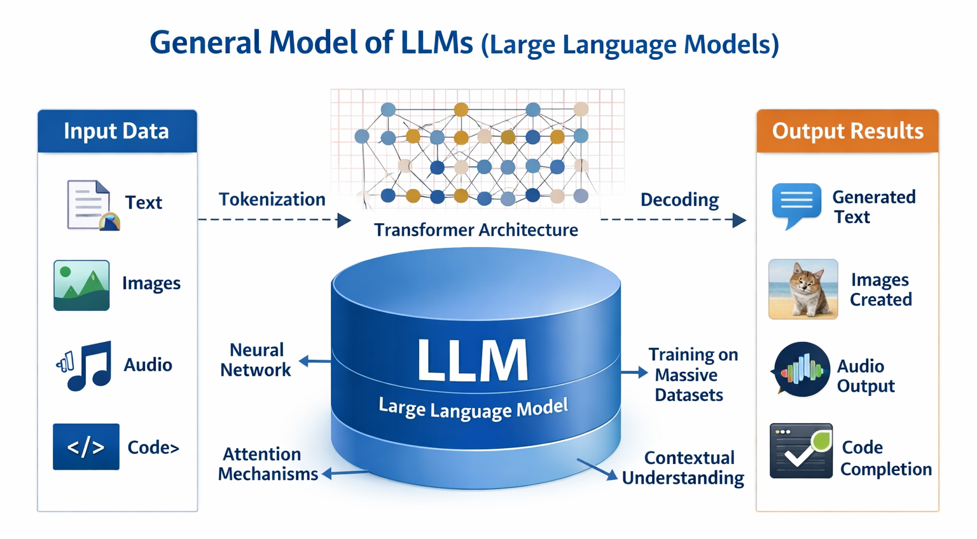

Figure 2-1 General Model of LLMs
A large language model (LLM) [1] is an artificial intelligence (AI) system that designed to understand the process and generate text context.
It was the Mechanism within the transformer architecture. This mechanism allows the model to weigh the relevance of different words in a sentence simultaneously, rather than processing them sequentially. The input text will broke down into numerical pieces that were "tokens”. And The model then apply to understand the semantic relationships between these tokens. Incorporate techniques Grouped Query Attention (GQA) and parameter quantization.

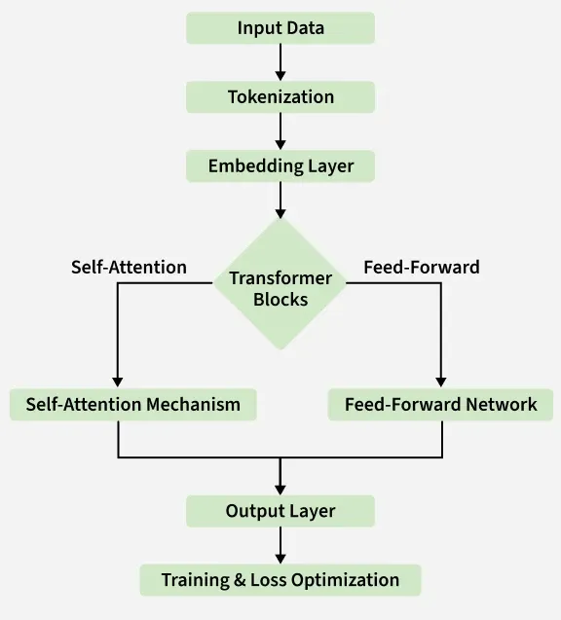

Figure 2-2 LLM Architecher

Emergency Severity Index (ESI) Triage Standard [2]
This project references the Emergency Severity Index (ESI) Version 4, developed by the Agency for Healthcare Research and Quality (AHRQ) in USA. This standard provide as the Core Logic for the Large Language Model to evaluate patient urgency and categorizing them into five levels as follows:
- Level 1 (Resuscitation)
  - Definition: A patient with a life threatening condition, that needs help right away. Without immediate medical treatment, the patient is at high risk of dying.
  - Symptom: Unconscious, have stopped breathing or are gasping for air or are experiencing heart failure or severe shock.
- Level 2 (Emergent)
  - Definition: Is in a high risk situation, experiencing severe pain (between 7 - 10), or showing with acute confusion. Treatment must be start within 10 - 15 minutes.
  - Symptom: Severe chest pain, unilateral weakness, suspected stroke or severe dyspnea.
- Level 3 (Urgent)
  - Definition: Has stable vital signs but requires "two or more evidence" for evaluation and treatment. Treatment should begin within 30-60 minutes.
  - Symptom: Severe abdominal pain and closed fractures requiring X-rays and splinting or high fever with dyspnea, etc.
- Level 4 (Less Urgent)
  - Definition: Has stable vital signs and is expected to require "only one evidence" for evaluation and treatment.
  - Symptom: Minor lacerations, sprained ankle, or suspected urinary tract infection (UTI).
- Level 5 (non urgent)
  - Definition: General patients seeking treatment for minor illnesses. Require no resources beyond a standard physical examination and a medical prescription.
  - Symptom: Common cold, sore throat, minor rashes, prescription refills or routine wound dressing.

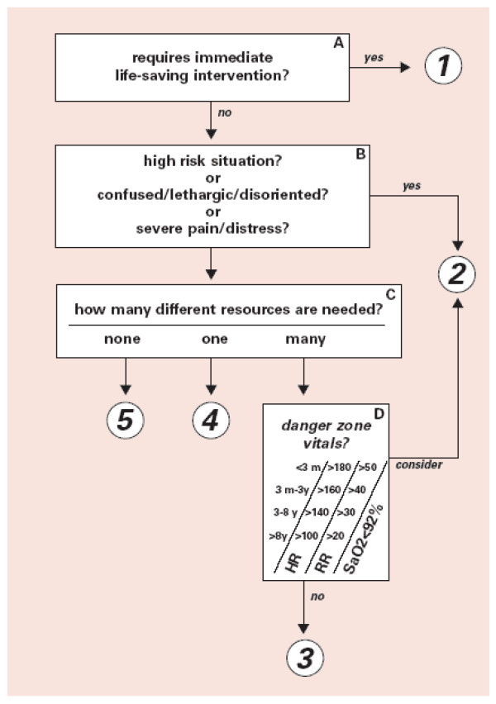

Figure 2-3 ESI Triage Algorithm v4 [3]

Computer Vision and Pose Estimation
Computer vision is a subfield of artificial intelligence that enables computers to derive high-level understanding from digital images or videos.

2.3.1 OpenCV [4]
OpenCV is a highly optimized open source programming library designed specifically for real time computer vision and machine learning applications.
- OpenCV processes images as multi-dimensional matrices. It applies linear algebra and matrix operations to alter these pixels. For instance, it can convert a standard RGB matrix into a different color space such as HSV or apply a mathematical threshold to isolate specific regions of an image for further analysis.



Figure 2-4 OpenCV

2.3.2 MediaPipe Framework and Pose Topology
MediaPipe is an open-source framework developed by Google for building cross-platform, customizable machine learning pipelines for time-series data, such as video streams.
- MediaPipe Pose utilizes a machine learning architecture called BlazePose. The pipeline first uses a detector to locate the human region within the frame, and then a subsequent landmark model predicts the exact (x, y, z) coordinates of the 33 anatomical joints. These spatial coordinates can then be used to calculate anatomical angles and distances using standard Euclidean geometry and trigonometry, allowing for precise human action and gesture recognition.


Figure 2-5 MediaPipe

Image Preprocessing and Skin Color Analysis
Image preprocessing encompasses a series of algorithmic operations applied to raw image data prior to computer vision analysis or machine learning processing .
- Raw images captured by cameras are often inconsistent due to varying resolutions, lighting conditions, and sensor noise. Preprocessing standardizes these images, enhances essential features, and eliminates data such as background shadows

2.4.1 Image Resizing and Pixel Normalization
- Resizing Digital images consist of pixel matrices. Machine learning algorithms require uniform input dimensions. Resizing interpolates the matrix to a fixed dimension.
- Normalization Standard RGB pixel values range from 0 to 255. Normalization mathematically scales these values to a standardized range, typically 0 to 1, by dividing each pixel by 255. This reduces the mathematical variance in the data, which stabilizes gradient descent during neural network processing.
2.4.2 Color Space Conversion (RGB to HSV) [5]
While RGB (Red, Green, Blue) represents raw color intensity, it is highly sensitive to external illumination. Converting the image to the HSV (Hue, Saturation, Value) color space isolates the luminance, Value from the chromaticity HSV.
- First, find the maximum and minimum values among the normalized R, G, and B components:
$C_{max}= max(R,G,B)$ (2-1)
$C_{min}= min(R,G,B)$ (2-2)
$diff=C_{max}-C_{min}$ (2-3)
- Hue (H) Calculation Determines the actual color type.
If $C_{max}=R, then H=60° x ((G-B/diff) mod6)$ (2-4)
If $C_{max}=G, then H=60° x ((B-R/diff) +2)$ (2-5)
If $C_{max}=B, then H=60° x ((R-G/diff) +4)$ (2-6)
- Saturation (S) Calculation: Determines the color intensity.
If $C_{max}=0,then S=0$ (2-7)
If $C_{max}!=0,then S=(diff/C_{max}) x 100$ (2-8)
- Value (V) Calculation: Determines the brightness.
$V=C_{max} x 100$ (2-9)
2.4.3 Histogram Analysis and Otsu's Thresholding [6]
To analyze the distribution of pixels, techniques like Otsu's thresholding are applied. Otsu's thresholding is an automatic image segmentation algorithm that determines the optimal threshold value to separate an image into foreground and background binary black and white by minimizing intra class variance. By evaluating the distribution of pixel intensities such as calculating the percentage of high intensity (white) pixels versus low-intensity (black) pixels the overall brightness and significant color anomalies within a specific region can be quantified.

2.5 Automatic Speech Recognition (ASR)
Automatic Speech Recognition (ASR) [7] is a computational technology that enables the recognition and translation of spoken language into text. Modern ASR systems, such as the Whisper model that use deep learning and Transformer architectures to process audio signals.
- An ASR system takes a raw audio waveform as its input, analyzes the acoustic and linguistic properties of the sound, and generates a corresponding written transcript

2.6 Related Research
2.6.1 " Designing Effective User Interface Experiences for a Self-Service Kiosk to Reduce Emergency Department Crowding " [8]
- Medical kiosks are physical station, that it deployed in hospital waiting areas. The it integrated with biometric sensors
- Systems require patients to physically interaction, with the machine to measure signs and manually input their complaints by a touchscreen
2.6.2 " Contactless Patient Care Using Hospital IoT: CCTV Camera Based Physiological Monitoring in ICU " [9]
- In computer vision have to numerous studies on non-contact patient monitoring systems, in intensive care units (ICUs) and emergency ward
- They are using RGB and thermal cameras to extract physiological signals. And detect pain levels through facial expression analysis and posture estimation algorithms
2.6.3 "Large language models in medicine." [10]
- There is a growing body of research on the application of LLMs in healthcare for clinical note generation and patient interaction
- Modern systems transcribe patient-doctor conversations and generate structured clinical summaries using powerful cloud-based APIs
- Cloud based LLMs give significant data privacy (PDPA/HIPAA) and latency challenges in emergency medical settings. by using a locally deployed. This ensures complete data privacy while simultaneously fusing auditory data with real time visual metadata to make safety critical triage decisions
The proposed Smart Contactless Patient Triage Assistant, makes the limitations of existing solutions. First, unlike traditional kiosks, it is completely contactless, reducing infection risks and physical strain on critical patients. Second, it achieves multimodal combination by cross verifying visual physiological anomalies with verbal symptoms in real time and surpassing single domain AI tools. Finally, by deploying the LLM reasoning module locally on local hardware. The system ensures strict PDPA compliance. That was eliminating the privacy risks associated with cloud based LLM.

Chapter 3 Proposed Solution

This chapter provide the design, architecture and implementation logic of that was proposed on this project.

System Architecture
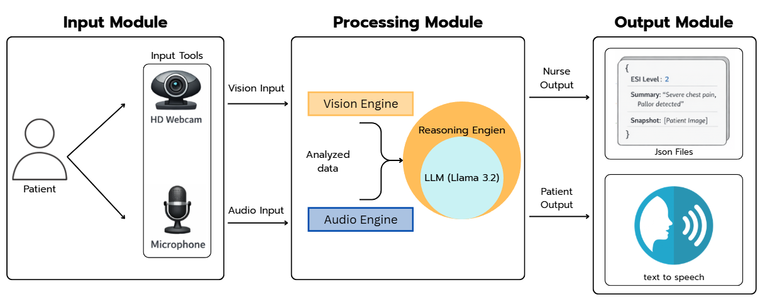

Figure 3-1 System Architecture

Input Module
Input Module will capture patient data, instantly when their arrival at the triage area.
- Visual Input using a webcam to captures the patient, specifically focusing on their upper body posture and facial area
- Audio Input by microphone captures the Patient info and symptom descriptions in the Thai or English language

Processing Module
- Vision module analysis the video input using Media Pipe Pose to detect pain gestures and OpenCV color analysis to identify facial anomaly like pallor or flushing face
- Audio module that use the Whisper model for transcribe the patient spoken Thai or English symptoms into text
- Reasoning module it evaluates both the transcribed both audio and visual data to describe the urgency of the patient's condition

Output Module
- Audio Output using a Text to Speech module. Response asking the follow up questions or instructing the patient to wait. Into Thai or English speech through the kiosk's speaker to guide the patient
- Data Output for the Nurse and the reasoning module formats its will conclusions into a JSON payload that was include:
  - ESI level the predicted emergency level ranging from 1 to 5
  - Summary a context from input of the patient's symptoms
  - Visual evidence snapshot for the nurse to verify more about the case

Speech-to-Text (STT) Constraints and Privacy Management
For noise reduction, will use a directional microphone with voice activity detection. That if ambient noise is too high, STT be bypassed with relying on the vision module. And for PDPA the kiosk operates a one way. TTS provides only basic instructions without provide a sensitive information and all patient information is securely transmitted as a JSON payload.

All System Architecture

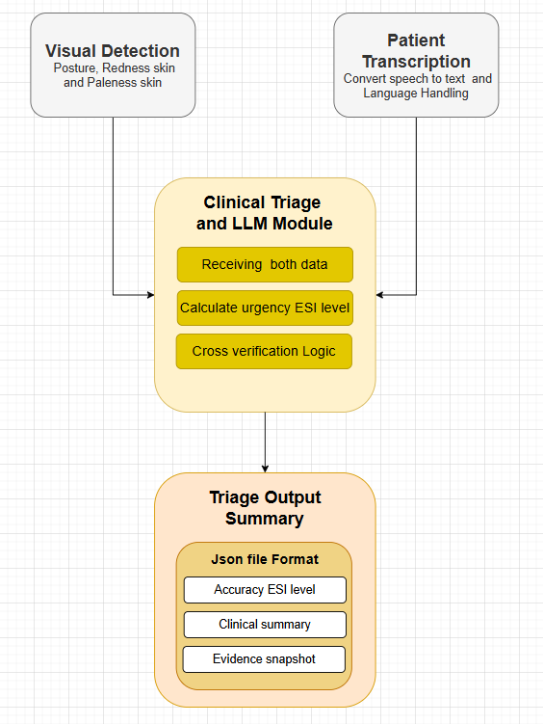
Figure 3-2 All System Architecture

- Step 1 Starting when a patient arrives at the triage area and places in front of it. Then system will require permission from user before they are using this system. Then webcam will captures the patient's physical state. While the microphone will captures their explanation of symptoms in Thai or English
- Step 2 Once the raw data is captured, it is routed to two distinct processing modules to ensure minimal latency
  - In the Vision Module the video frames are processed to extract visual metadata. MediaPipe analyzes the skeletal structure to flag any pain related postures. Then, OpenCV algorithms extract the facial region and compute color histograms in the HSV color spaces to detect physiological distress. A snapshot of the frame is temporarily saved as visual evidence
  - In the Audio Module the audio stream is sent to the Whisper model, then translates the raw Thai or English speech into a structured text
- Step 3 The extracted visual data and the transcribed text are then combined and formatted into a structured prompt. sent into the LLM. Then it will use predefined prompt instructions based on the ESI standard. It cross verifies the data to calculate the final triage severity level
- Step 4 LLM will generates the conclusion output for two users
  - System will sends a JSON file to the nurse's dashboard. That Json payload contain the calculated ESI level and a clinical summary and visual evidence snapshot containing the detected anomaly, if it was detected
  - For the patient system will convert the LLM's response into spoken Thai or English, using a TTS module. It will providing feedback or instructions to the patient through speakers

System Design

User Interaction
- As a patient, it will automatically records their verbal symptoms while observing their posture and skin color. When it processes this data, it will provide feedback or instructions to the patient through a TTS module and shows a text on the screen.
- As a nurse, system will pushes alerts to the nurse's secure web dashboard. Each case report include the calculated ESI level, a clinical summary and visual evidence snapshots. That will allows the nurse to verify the result and make the final clinical decision without leaving their station

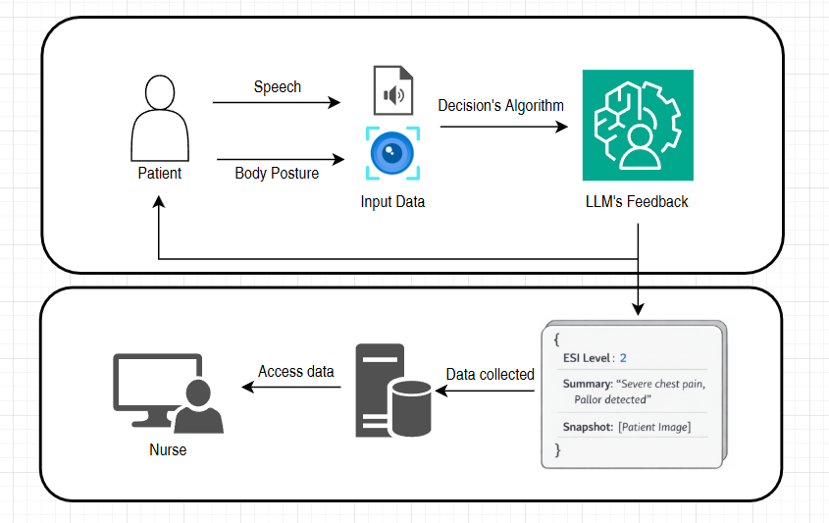

Figure 3-3 Patient and Nurse Interface System

Frontend and Backend Architecture
Frontend Architecture
- The interface acts as the data collection node. It was continuously captures a raw video streams and audio signals. It will only show the raw inputs to the backend and plays the TTS audio that was responses back to the patient.

- This interface was develop using a web framework. It functions as a monitoring dashboard that listens for incoming JSON payloads from the backend. When it receiving data, it will renders the patient's calculated ESI level and a clinical summary and a visual evidence snapshot.
Backend Architecture
- The system was a parallel processing to handle incoming streams.
- The context text base and visual flag data are sent to the LLM model. That it was running in the Ollama processor. Cause this model can processes the multiple prompt to deduce the triage level.

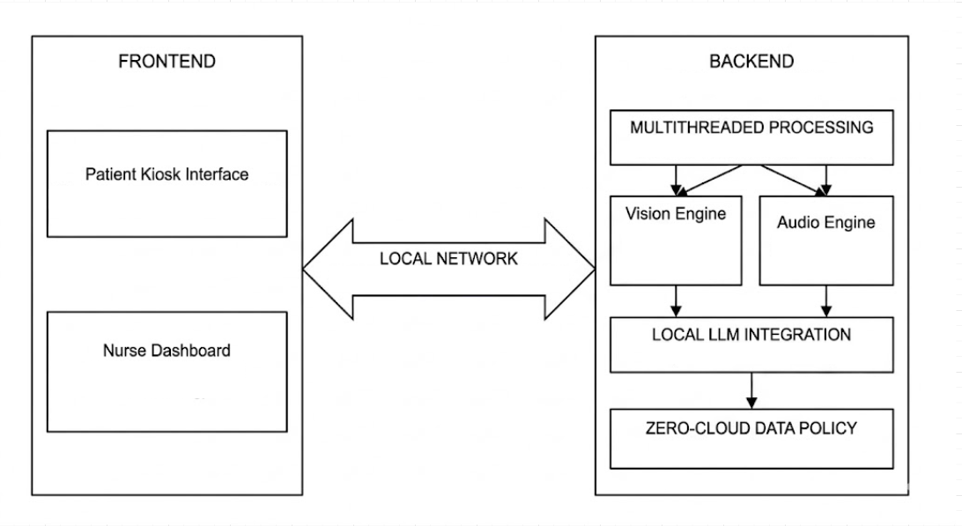

Figure 3-4 Client-Server Architecture

Core Processing and Logic
- Geometric Logic for Pose Recognition
- To define that a patient has a pain posture, system evaluates on geometric calculation by tracking on important point on body and face to check with another point on body, to define patient’s posture
- First, the system calculates the Chest Center coordinate $P_{c}$ by finding the midpoint between the Left Shoulder $P_{ls}$ and Right Shoulder $P_{rs}$
$x_{c}=\frac{x_{ls}+x_{rs}}{2}$ (3-1)
$y_{c}=\frac{y_{ls}+y_{rs}}{2}$ (3-2)
- Then use Euclidean Distance [11] (D) between the active Wrist $P_{w}$ and the Chest Center or $P_{c}$ can be calculated by Euclidean Formula
$D = \sqrt{({x_{w}-x_{c})}^{2}+(y_{w}-y_{c})^{2}}$ (3-3)
- Then the system will calculates the angle ($θ$) at the Elbow joint $P_{e}$ using the coordinates of the Shoulder $P_{s}$, Elbow $P_{e}$, and Wrist $P_{w}$. Using the inverse tangent function (atan2) [12]
$Radians =\arctan\left(y_{w}-y_{e},x_{w}-x_{e}\right)-\arctan\left(y_{s}-y_{e},x_{s}-x_{e}\right)$ (3-4)
$θ=|Radians x \frac{180}{π}|$ (3-5)

If $θ$ > $180°$, then $θ$ = $360°$ -$θ$
A normal resting arm has an angle near $160°$ - $180°$. A folded arm clutching the chest typically forms an acute angle. If $30°≤θ≤120°$. So, condition B is met

Temporal Verification
- Frame Rate (fps) = 30
- Required Duration (t) = 2 seconds
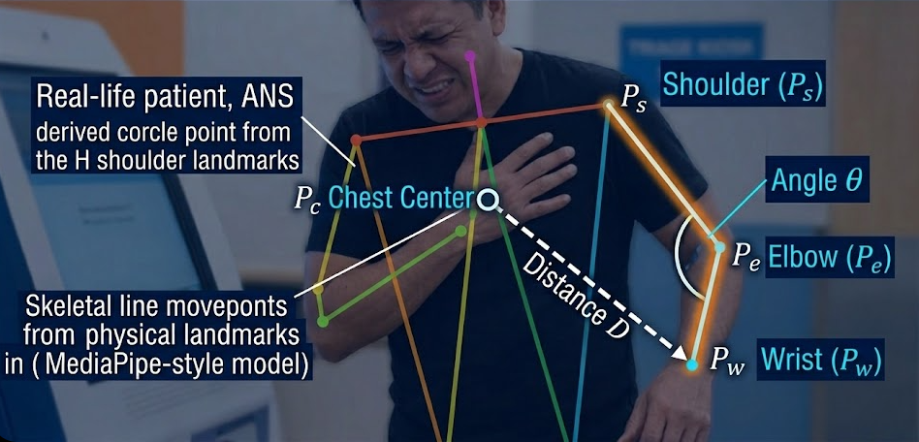
- Required Consecutive Frames (F) = $Fps x t=60$ frames.
Figure 3-5 Chest Pain Recognition Logic

- Physically Sign Analysis with HSV Color Space
To check how urgent a patient in some case, must have to look at their facial skin color. This project focus on Pallor or Flushing skin face. Then system must uses the following steps:
Region of Interest (ROI) Extraction
- To filter noise from non-skin features such as, eyes or lips. System will use facial landmarks to isolate the calculated area space. That centroid of the ROI is calculated based on three reference points is the eye, nose and ear
$Cheek_{X}=\frac{Eye_{x}+Nose_{x}+Ear_{x}}{3} x Imagewidth$ (3-6)
$Cheek_{y}=\frac{Eye_{y}+Nose_{y}+Ear_{y}}{3} x Imageheight$ (3-7)

When the center point is defined, the system will generates a bounding box to crop the skin surface for calculating.
Color Space Transform
Input frames from the webcam were BGR (Blue, Green, Red) format. And because of BGR is highly sensitive to with lighting changes. It can be fixing by the system converts the ROI to the HSV value, by:
- Hue (H) is a wavelength or the actual color
- Saturation (S) was the intensity of the color
- Value (V) was the brightness

Baseline Calibration and Configuration
Since everyone has different skin tones. A single threshold doesn't work for every case. Therefore, system will use the first 3 seconds to learn the patient's natural look. It will calculates their average hue and saturation, to create a standard baseline for more accurate tracking
$Baseline_{S}=\frac{1}{n} \sum_{i=1}^{n}{S_{i}}$ (3-8)
$Baseline_{H}=\frac{1}{n} \sum_{i=1}^{n}{H_{i}}$ (3-9)

Classification Logic
Then the system will compares the current frame's values of CurrentS and CurrentH. Against the baseline logic:
- Pallor is a decrease in blood flow, that mean resulting in reduced color saturation. Then the system will trigger an alert if the saturation drop exceeds a threshold
$Baseline_{S}-Current_{S}>Threshold_{pallor}$ (3-10)
- Flushing was define by increased blood flow, that it leading to higher saturation and a shift in Hue toward the red spectrum
$|Baseline_{H}-Current_{H}|>Threshold_{hueShift}$ (3-11)
and
${Current}_{S}>{Baseline}_{S}+Threshold_{Flush}$ (3-12)

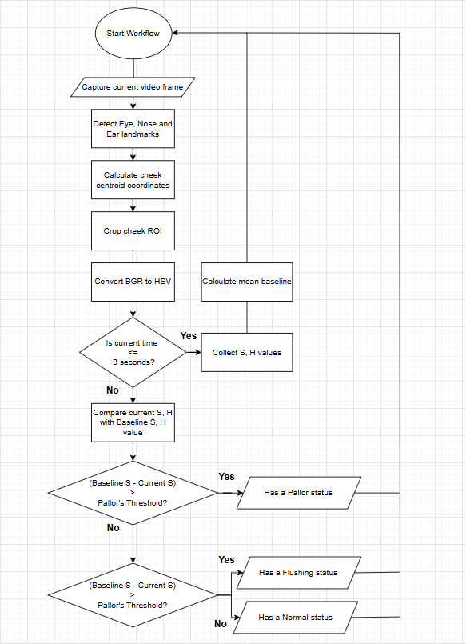
Figure 3-6 Flowchart of Skin Color Analysis using HSV

Project Plan

Table 3-1 Project plan

TASK | 2026
TASK | January |  |  |  | February |  |  |  | March |  |  |  | April |  |  |  | May
TASK | 1 | 2 | 3 | 4 | 1 | 2 | 3 | 4 | 1 | 2 | 3 | 4 | 1 | 2 | 3 | 4 | 1 | 2 | 3 | 4
Research topics and Theory
Preparing the Data
Component System testing
Evaluating the System
Testing Prediction of ESI
Develop and Deploy in Website
Document and Report

Chapter 4 Results and Conclusion

In this chapter will present the results of the Project system analysis, including Vision analysis patient performance, LLM system for ESI classification, and the conclusion with future work.

System Performance and Experimental Setup
The architecture relies on real-time analyzing that rather than static weights, the experimental setup and parameters are important to ensuring result accuracy:

Hardware Environment
To comply with the Personal Data Protection Act (PDPA), the system operates using Local Processing with the following specifications:
- Graphics Processing Unit with 8GB VRAM
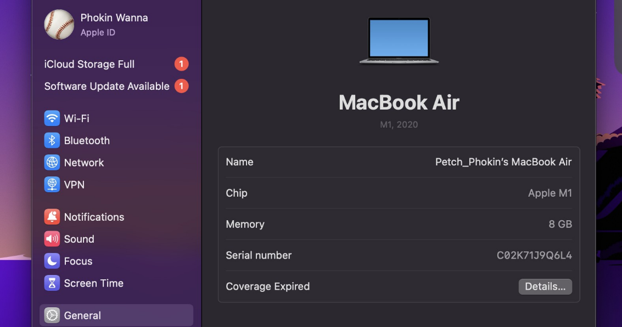
- 1080p resolution webcam and Microphone, on device
Figure 4-1 Hardware Specifications and Requirements

Physical Environment Setup
To create the conditions of a triage nursing kiosk. The following control variables were providing:
- The patient stands at 1.0 - 1.5 meters from the camera and device up from floor at least 1.0 meter.
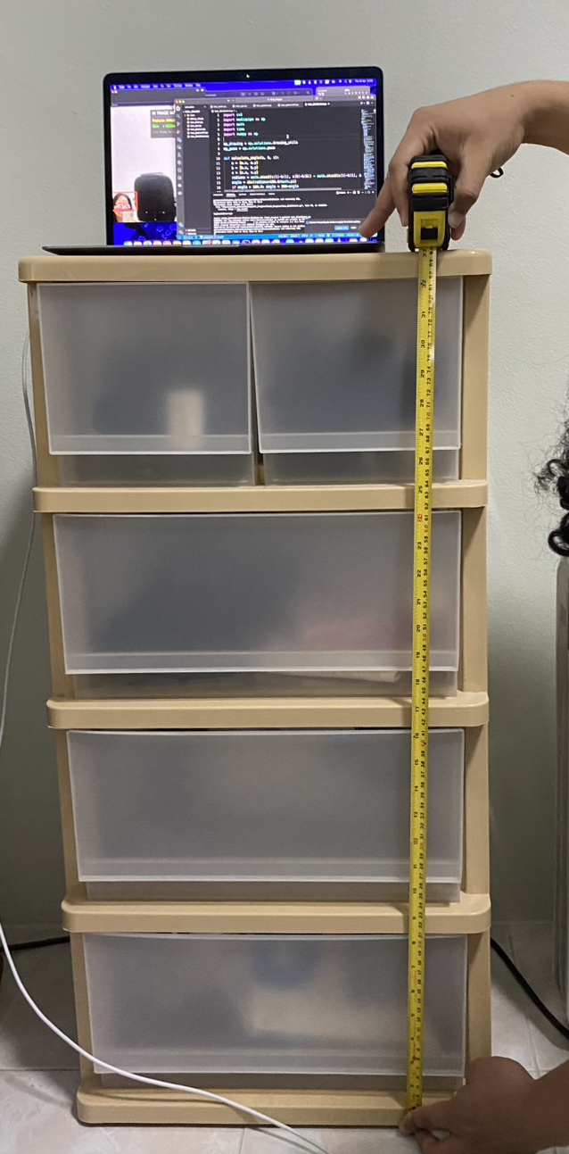
- Background noise must be closing environment to get the efficiency of the Speech to Text system.
Figure 4-2 Distance from equipment to ground
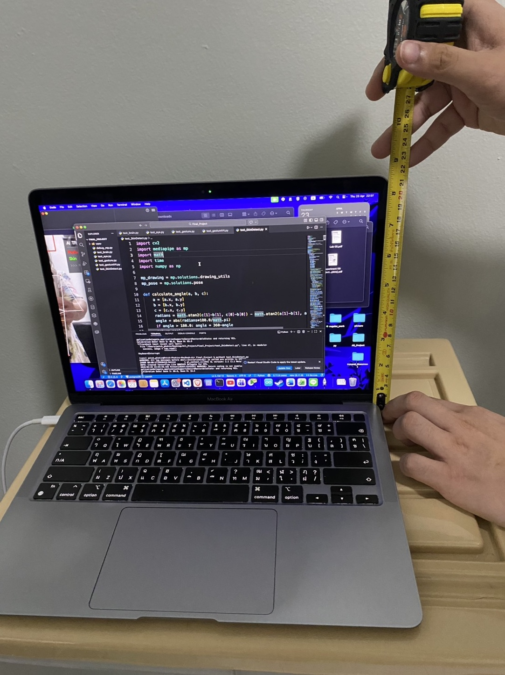
Figure 4-3 Distance from equipment camera to base

Testing Methodology
- System Calibration First 3 seconds of each session are used to make personalized baselines for skin tone and body proportions.
- A total dataset simulated scenarios were tested, divided into target pain gestures and distracting poses to measure error handling performance.

Vision Classification Results
This section evaluates the Vision Module, the system primary contactless for extracting physical data.

Gesture Detection and Dynamic Boundary Results
Based on the experiments. The main three target area such as Head, Chest and Abdomen provide high efficiency
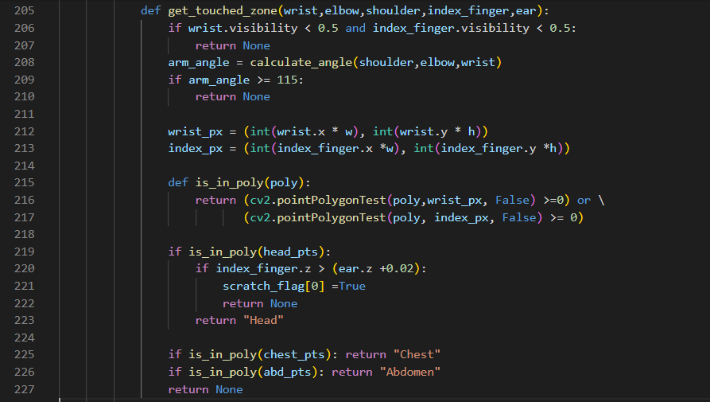
- The system uses the ‘CV’ function to determine whether the coordinates of the wrist or index.
Figure 4-4 Gesture detection’s logic
If contact is up to 2.0 seconds it will change from the 'Analyzing' to 'Anomaly Detected'. Prevents false detection caused by regular body movements.

- Setting the Chest Ratio to ‘0.55’ of the upper body length. It allows system to clearly define between chest pain and abdominal pain. Even when the patient turns sideways or bends over.

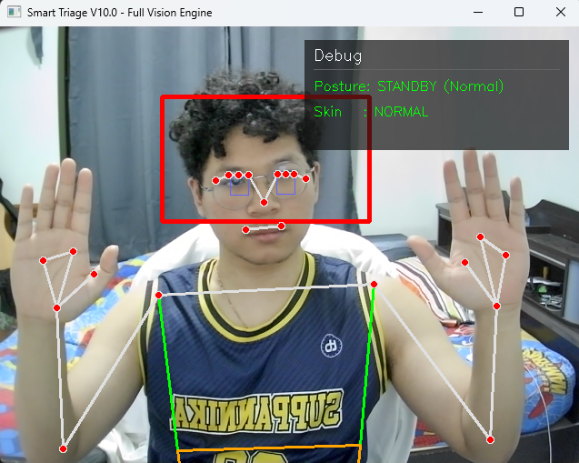
Figure 4-5 Testing Vision System: Normal posture

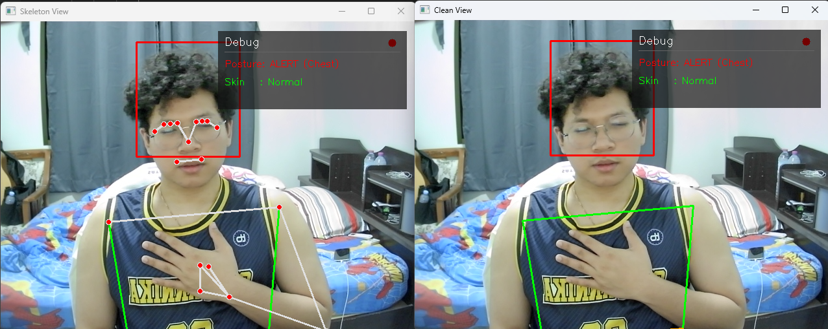
Figure 4-6 Testing Vision System: Chest pain posture

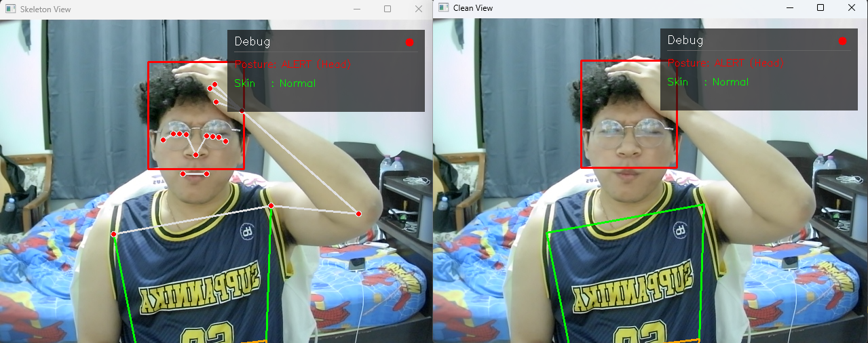
Figure 4-7 Testing Vision System: Head pain posture

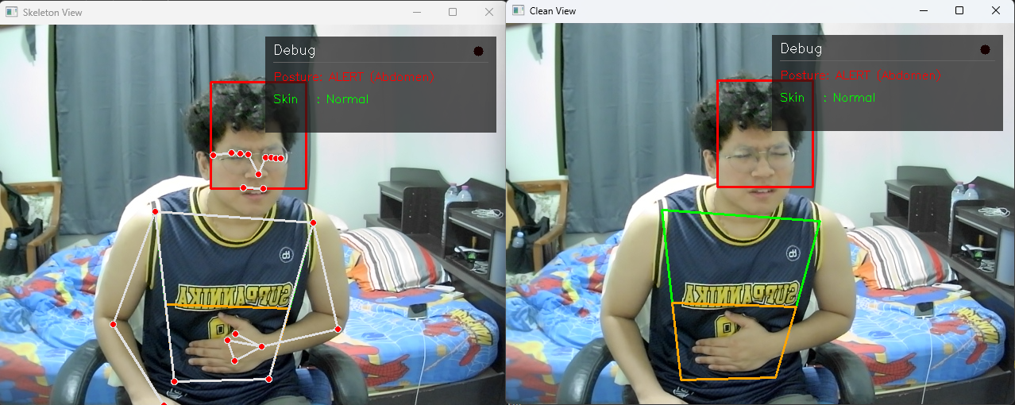
Figure 4-8 Testing Vision System: Abdomen pain posture

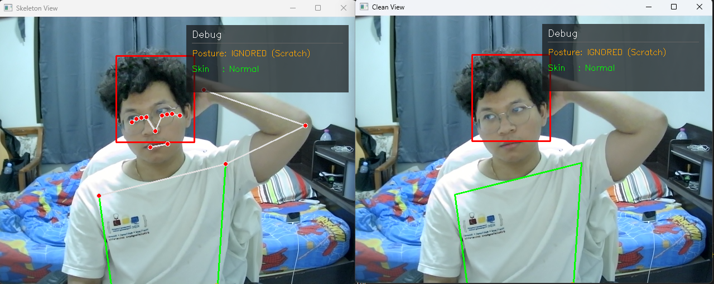
Figure 4-9 Testing Vision System: Unnecessary posture - Scratching
- Analyzes Z axis depth to locate the hand relative to the head. If the hand is deeper than the ear alignment, it classified as scratching rather than a headache symptom.

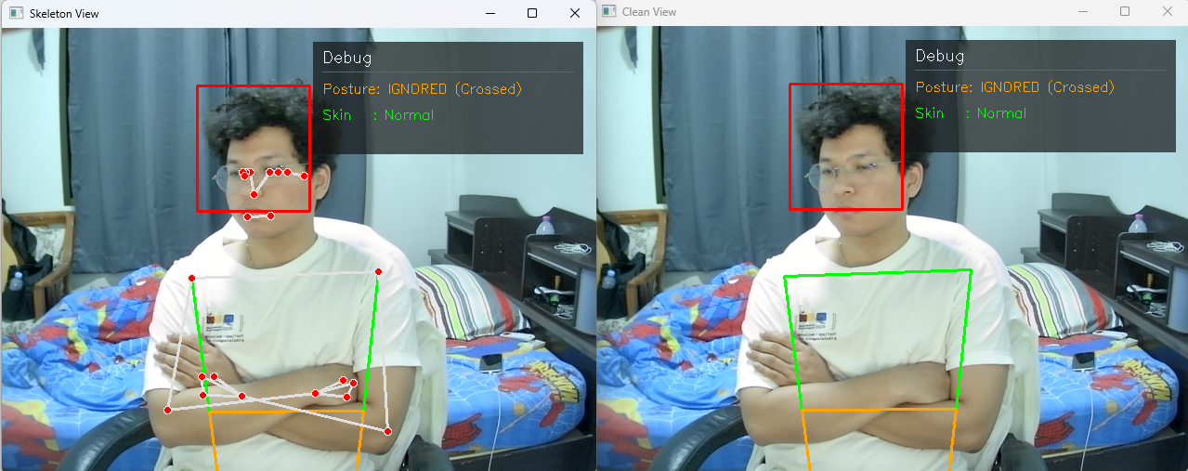
Figure 4-10 Testing Vision System: Unnecessary posture – Crossed Arms
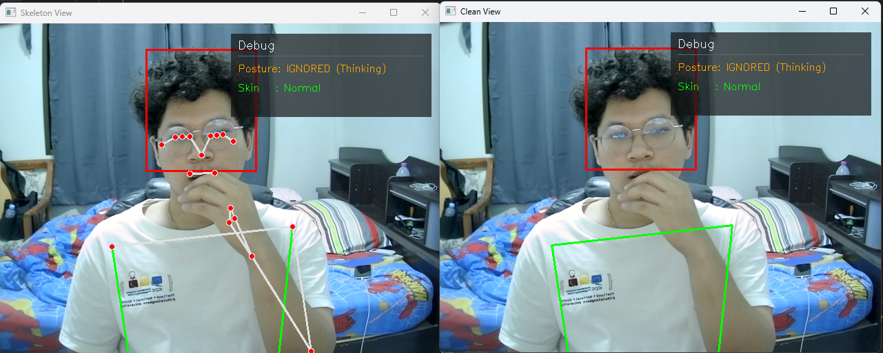
- System detects a Line Segment Intersection between the arms. And triggers if an intersection exists and the elbow angle is 60 - 115°.
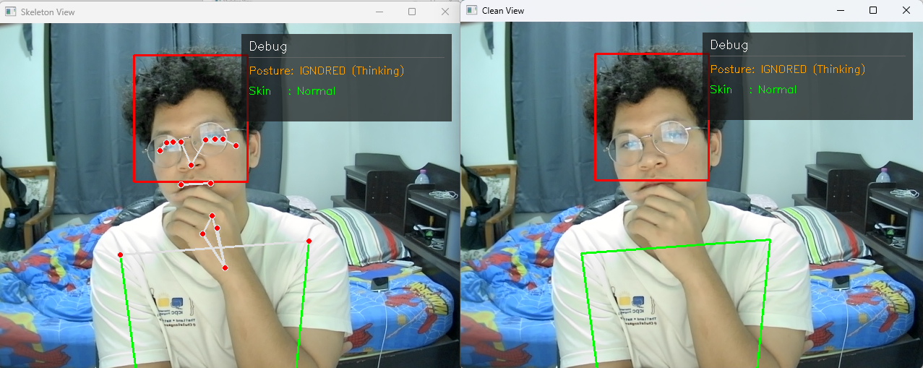
Figure 4-12 Testing Vision System: Unnecessary posture – Thinking (1)
Figure 4-12 Testing Vision System: Unnecessary posture – Thinking (2)
- Calculates the wrist to mouth distance. If it is within 30% of the shoulder width, the action is classified as a normal posture and the alert is suppressed.
Based on the results above. The system can disguise between normal postures and specific gestures. These specific gestures are separate into two groups. Those that affect the system (such as holding the head or stomach from pain) and those that do not (such as scratching the head, which the system might mistake for a headache if not filtered out).
And the results show that the system achieved an accuracy of 72% (from a dataset of 60 tests). Which is in acceptable level. However, more gestures must be added in the future to cover all possible movements and further improve the system's overall accuracy.

Skin Color Analysis
Primary focusing on detect pale skin and Flushing or red skin. This system suitable for face skin change detected, before and while the patient using this system.
- System extracts the ROI by using image segmentation and transforms it from BGR to HSV.
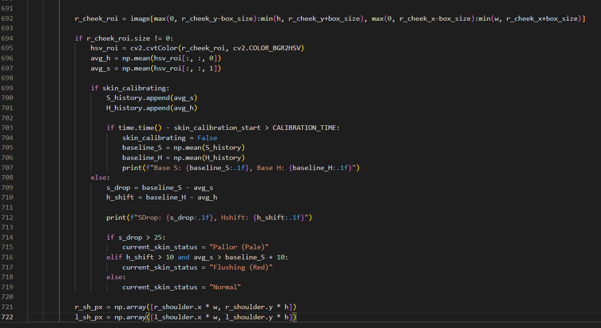
Figure 4-13 Image segmentation and HSV Calculated

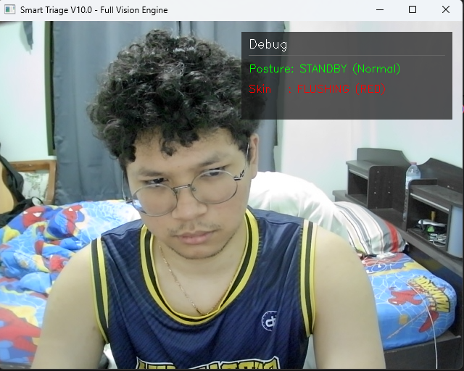
- When simulating a pallor condition. The system accurately detects a drop in saturation and shifted hue value, that will trigger a "Pallor" or “Red Face” flag.

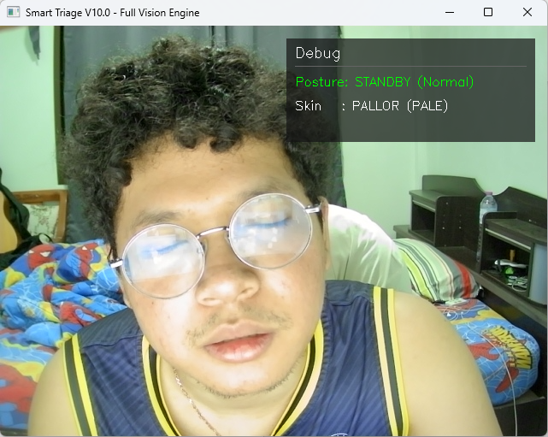
Figure 4-14 Testing Vision System: Red face detected
Figure 4-15 Testing Vision System: Pale face detected
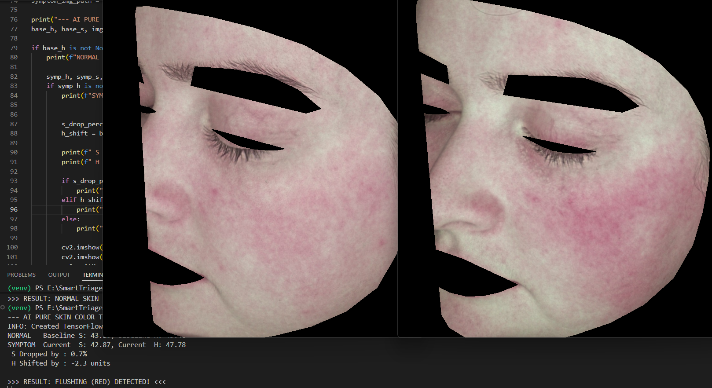
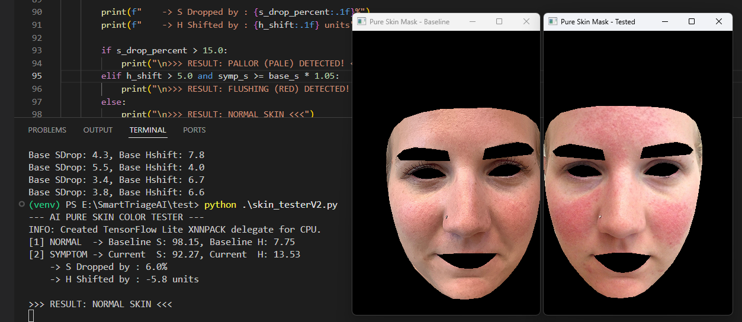
Figure 4-16 Testing skin analysis algorithm with HSV (1)
Figure 4-17 Testing skin analysis algorithm with HSV (2)

Based on the images shown above. The system ability to detect face skin color is generally satisfactory but still has errors. The system currently predicts the correct results about 56% (based on a dataset of 70 tests).
The main reason for this result is likely the color model being used (HSV). It cannot separate the light value from the actual color shades
during calculation.
As a result, the system's color calculations can become distorted because they are easily interrupted with by external lighting (as Figure 4 -15. Light reflex user face that it from monitor. But user do not really have a pale skin. So, that make it provide that result).

LLM Model ESI Classification Results
This section was evaluating the Reasoning Module. By combine Visual Flags from the Vision Module and Audio Transcripts from the Speech to Text module and LLM will classifies patient urgency based on ESI standards.
To provide the results, Conducted Scenario Testing across three cases (critical to non urgent) must generating outputs in JSON format.

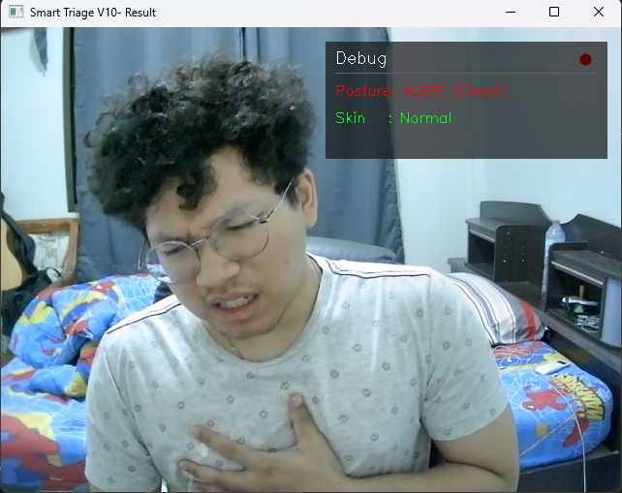
Scenario 1: Critical Emergency (ESI Level 1 - 2)
Figure 4-18 Testing overall System: Critical emergency (scenario 1)
- A patient arrives with exhibiting severe respiratory distress.
- Chest Pain Hold with Any kind of Skin
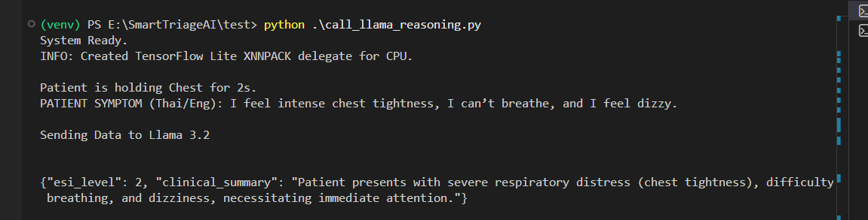
- Context: "I feel intense chest tightness, I can’t breathe, and I feel dizzy."
Figure 4-19 Log of scenario 1’s result
System successfully detects verbal symptoms with Chest Hold signs. It correctly provides ESI Level 2. And system following the rule as specified in the System Prompt to remain within medical safety guidelines.
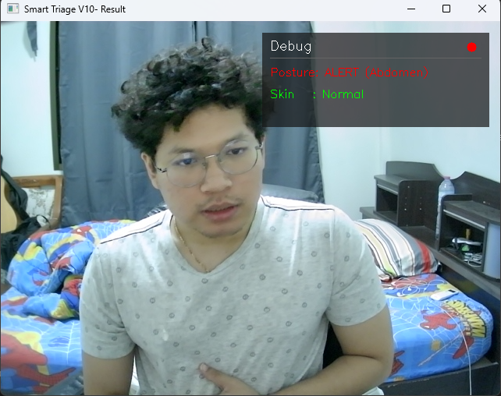
Scenario 2: Urgent Condition Requiring Resources (ESI Level 3)
Figure 4-20 Testing overall System: Urgent Condition (scenario 2)
- A patient presents with persistent abdominal pain.
- Abdominal Pain Hold with Normal Skin
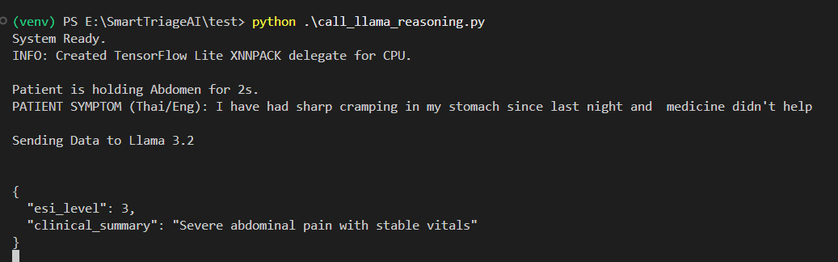
- Context: " I've had sharp cramping in my stomach since last night and medicine didn't help."
Figure 4-20 Log of scenario 2’s result
Although the reported, the Vision Module detected no signs of shock or pallor. The LLM evaluated the patient as stable, That leading to a classification of ESI Level 3.
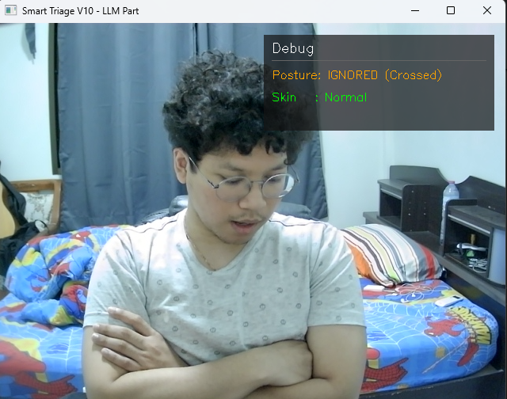
Scenario 3: Non-Urgent (ESI Level 5)
Figure 4-21 Testing overall System: Non-Urgent (scenario 3)
- A patient reports minor symptoms and a non pain related gesture.
- Crossed Arms Hold (Ignored) with Normal Skin
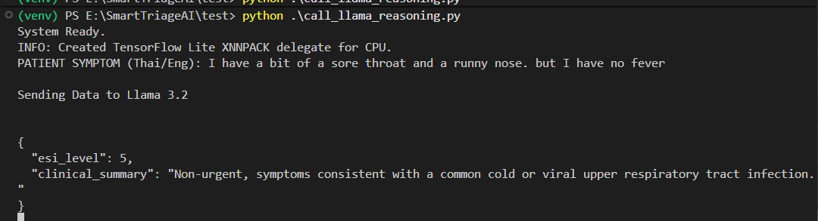
- Context: " I have a bit of a sore throat and a runny nose, but I have no fever."
Figure 4-22 Log of scenario 3’s result
System can detect the ‘Ignored’ status from the Vision Module, the LLM correctly provide the lack of acute physical distress (No emergency) and assigned Level 5, that is mean no evidence needed.
Testing shows that Llama model 3.2 is highly effective at identifying the relation between visual and audio contexts. And found that primary challenge in this module is Inference Latency.

Latency and Computational Performance

Latency Identification
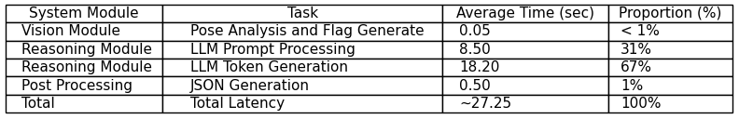
It showed a total delay of 20.4 to 31.8 seconds from receiving input to showing the result. That is mean it must analyze each part of the process to find exactly problems.
Table 4-1 Breakdown System Latency
- Table shows that the ‘Reasoning Module’ is the main cause of the delay. Taking 98% of the processing time. Running the model at full quality used too much VRAM

Optimization Methodologies
- The model weights were changed from Float16-bit to 4-bit Quantization using the Ollama framework. Change the model size from 6GB to 2GB. This change made the system much faster at generating text.
- System parameter was changed from long sentences to a key value format. It reduced the time the LLM spends reading.

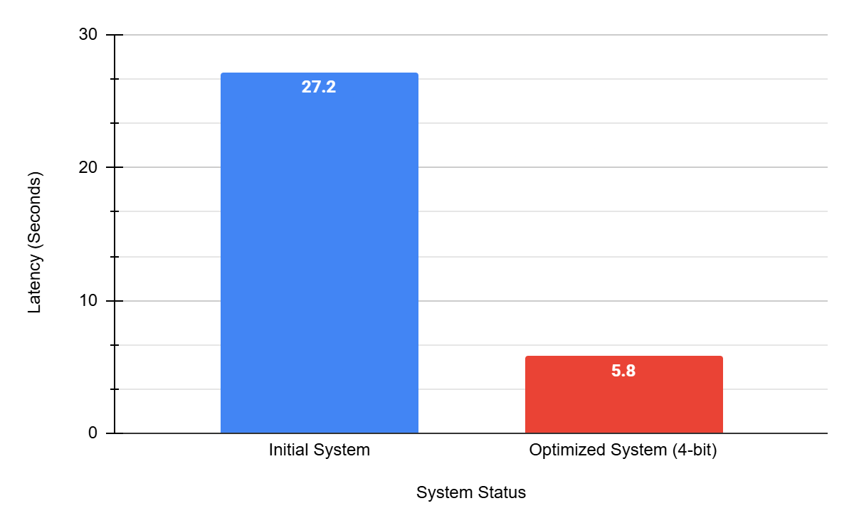
Post-Optimization Performance Results
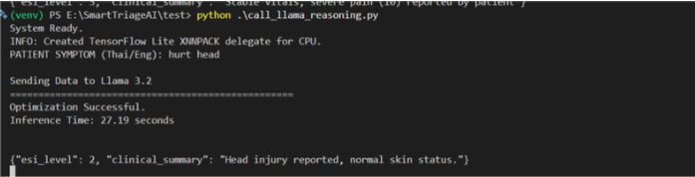
Figure 4-23 Latency Comparison of 16-bit and 4-bit Model
Figure 4-24 Log Optimized Execution Time (16-bit Model)

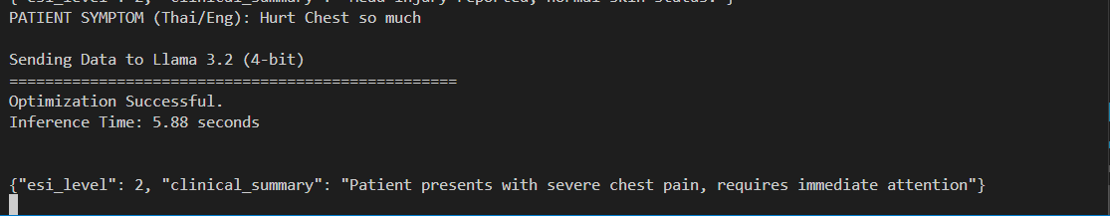
Figure 4-24 Log Optimized Execution Time (4-bit Model)

Results:
- Prefill time reduced from 8.45 seconds to 1.2 seconds.
- Generation time reduced from 18.2 seconds to 4.5 seconds.
- Total latency dropped from an average of 27 seconds to 5 – 7 seconds per case.

Conclusion
The ESI Triage System integrates Multidata by combining necessary pain gestures and skin color analysis using hue, saturation, and value from the Vision Module with patient symptom descriptions.
It shows that adding physical context to the patient's history, helps the system accurately classify urgency and generate a Clinical Summary in JSON format according to medical standards. And after optimization, the processing time is fast enough to meet the actual needs of a hospital triage point in normal environment work filed. However, this project still needs some point to improved more such as accuracy (skin analysis, pain gestures and even triage accuracy) by using ML to train the data for more accuracy. And system must still work on dynamic environment.

Future Work
- Using CIELAB instead of HSV (to improve skin analysis accuracy)
- Deploy web application dashboard
- Integrate data from physical medical devices
- Implement another ML model to train the system algorithms

References

- AWS (Amazon Web Services). "What is a Large Language Model (LLM)?"[Online].Available:https://aws.amazon.com/what-is/large-language-model/ [Accessed: Feb. 27, 2026].
- ResearchGate, Margaret Warton, “Evaluation of the Emergency Severity Index in US Emergency Departments for the Rate of Mistriage” .Available:https://www.researchgate.net/publication/369333241_Evaluation_of_the_Emergency_Severity_Index_in_US_Emergency_Departments_for_the_Rate_of_Mistriage.
- ResearchGate, Ramesh P Aacharya, “Emergency Department Triage: An EthicalAnalysis”.Available:https://www.researchgate.net/publication/51701713_Emergency_Department_Triage_An_Ethical_Analysis.
- OpenCV, "About OpenCV," OpenCV. [Online]. Available: https://opencv.org/about/ [Accessed: Feb. 27, 2026].
- V. Pendela, "RGB vs HSV," Medium, Oct. 20, 2020. Available: https://medium.com/@venkatpendela96/rgb-vs-hsv-52e55e504120
- S. Mallick, "Otsu Thresholding with OpenCV," LearnOpenCV. Available: https://learnopencv.com/otsu-thresholding-with-opencv/
- Radford, A., et al. (OpenAI). "Robust Speech Recognition via Large-Scale Weak Supervision" (Whisper Paper).Available: https://openai.com/research/whisper
- J. R. Silva et al., "Designing Effective User Interface Experiences for a Self-Service Kiosk to Reduce Emergency Department Crowding," 2020 IEEE International Conference on Healthcare Informatics (ICHI), 2020. Available: https://ieeexplore.ieee.org/document/9201858/
- M. S. Khan et al., "Contactless Patient Care Using Hospital IoT: CCTV Camera Based Physiological Monitoring in ICU," IEEE Access, vol. 11, pp. 102292-102305, 2023. Available:https://ieeexplore.ieee.org/document/10229220/
- Thirunavukarasu, A. J., et al. (2023). "Large language models in medicine." Nature Medicine. Available: https://www.nature.com/articles/s41591-023-02448-8

- Risfendra."Contactless Infant Height Measurement for Enhanced Early Detection of Stunting Using Computer Vision Techniques". IEEE Access, 2025. Available: https://ieeexplore.ieee.org/document/10910102/
- H R Nishanth. "StrideSync - AI Enhanced Workout Tracking and Form Validation".IEEE, 2024. Available: https://ieeexplore.ieee.org/document/11035904/

