Project Proposal: Simple Network Scanner with Rust and ICED GUI

# 1. Introduction

Network security is a critical aspect of managing and maintaining IT systems. For this school project, we propose to develop a simple network scanner using the Rust programming language, accompanied by a graphical user interface (GUI) built with the ICED library. The network scanner will enable users to scan open ports on a specified IP address and display the results in a user-friendly interface. This project aims to provide a hands-on demonstration of fundamental network communication concepts through a functional and accessible tool.

# 2. Objective

The primary objective of this project is to create a basic tool that:  
- Scans for open TCP ports on a target IP address.  
- Provides a user-friendly graphical interface using the ICED library.  
- Demonstrates core concepts of network communication and port scanning.

# 3. Project Scope

The scope of the network scanner will include the following key features:  
- Single IP Port Scanning: The tool will allow users to scan a specific IP address for open TCP ports within a given range.  
- ICED-based GUI: The graphical interface will enable users to input an IP address, specify a port range, and view scan results in real-time.  
- Basic Reporting: The results of the scan (open/closed ports) will be displayed within the GUI, providing a clear and concise summary.

# 4. Features & Functionality

## 4.1 Port Scanning

The network scanner will attempt to connect to a specified list of common TCP ports (e.g., ports 1-1024) on a target IP address.  
If a port is open, the scanner will mark it as 'open' in the results; otherwise, it will be listed as 'closed.'

## 4.2 ICED GUI

The user interface, built with the ICED library, will provide the following functionalities:  
- Input fields for entering a target IP address and defining the range of ports to be scanned (e.g., from port 1 to 1024).  
- A start button to initiate the scan.  
- A real-time display of the scan results, showing which ports are open or closed.

## 4.3 Real-Time Scan Updates

The GUI will display scan results in real-time as each port is scanned. The list will update dynamically, showing the status (open/closed) of each port in the specified range.

(Other features would be added depends on project timeline)

# 5. Tools & Technologies

The development of this project will rely on the following technologies:  
- Rust: Rust will be used to implement the core functionality of the network scanner, leveraging its performance and memory safety features.  
- ICED: The ICED library will be utilized to build a minimal and intuitive graphical interface for the application.  
- std::net: Rust’s standard networking library, std::net, will handle the TCP connections required for port scanning. (Other libraries would be added depends on project scope and features)

# Mockup Design

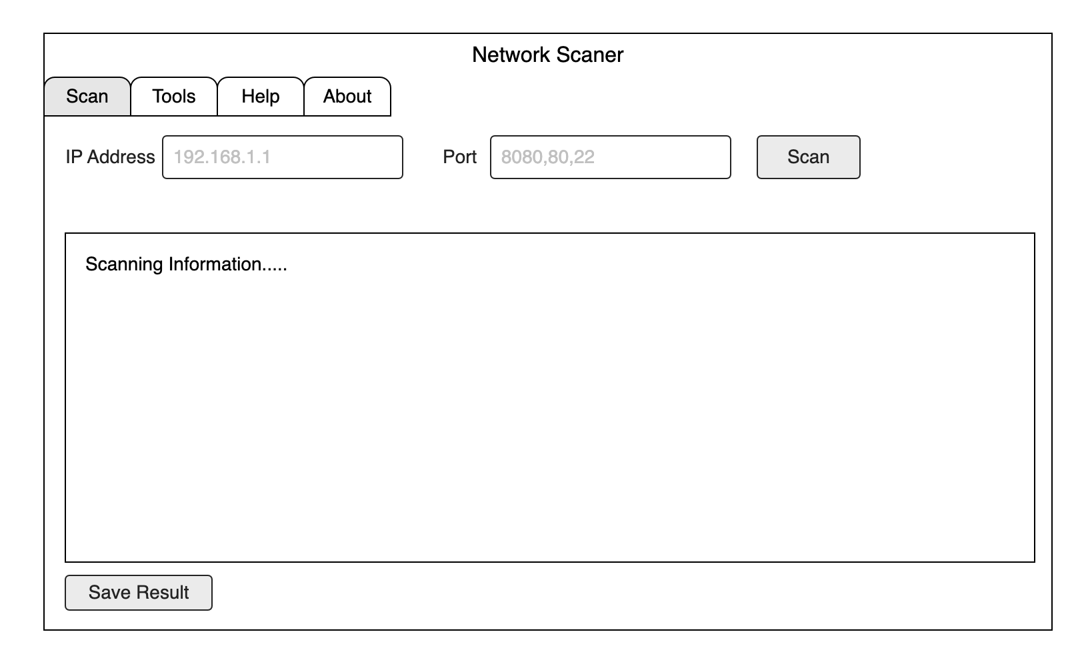

# Team Members

* Phone Myat Pyae Sone (67011642)
* La Min Maung (67011615)