Terac <> Berkeley AI Hackathon
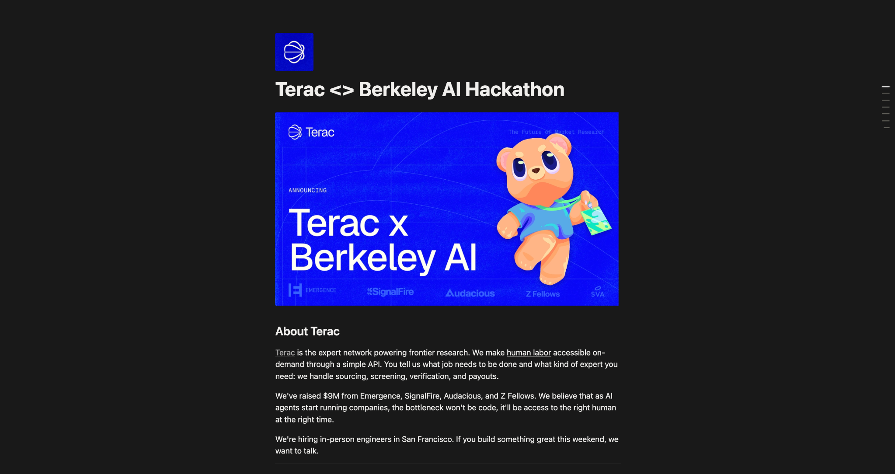

About Terac
Terac is the expert network powering frontier research. We make human labor accessible on-demand through a simple API. You tell us what job needs to be done and what kind of expert you need: we handle sourcing, screening, verification, and payouts.
We've raised $9M from Emergence, SignalFire, Audacious, and Z Fellows. We believe that as AI agents start running companies, the bottleneck won't be code, it'll be access to the right human at the right time.
We're hiring in-person engineers in San Francisco. If you build something great this weekend, we want to talk.

Our Berkeley Hackathon Challenge
Over the past year, we've seen a large trend in teams shipping/training their own AI models as part of their hackathon projects. Traditionally, teams have utilized Kaggle and Hugging Face - but today, we want to raise the bar even higher.
This track is about making a model measurably better with data you collect yourself during the hackathon using Terac.
That means:
- Building an annotation environment. A simple app (a Vercel app works great) where an AI generates tasks or outputs and a human labels, rates, or compares them.
- Calling the Terac API/MCP to bring the annotators. Launch your task on Terac and we'll get real people to annotate it. You focus on the environment, not on recruiting or incentives. That part is on us.
- Fine-tuning and improving your model. Train a model on the data you collected and show a clear improvement over the base model.
Pull that off within 24 hours and you've built something genuinely impressive.

Judging Criteria
Criteria | Weight | What We're Looking For
Model Improvement | 40% | Improvement over the base model, credibly shown (ideally a before/after human eval via Terac)
Annotation Environment | 35% | Task design, creativity, and UX
Use of Human Data | 25% | Smart use of the human data (label quality, and getting signal efficiently within your credit)

Setup/Guidelines
- You'll sign in to Terac as a researcher. Send us a Slack message and we'll give your team credits.
- Each team gets $250 in Terac credit to spend on annotations.
- Annotators are general-population only. No specialist panels (no doctors, lawyers, and so on), which keeps turnaround fast and your credit going further.
- Setup our MCP here.
- View our API here.
- Reference our example projects and guides below!

Prizes
1st place: $1000 cash + Interviews at Terac
2nd place: $500 cash + Interviews at Terac

Project Examples [WIP]
Example 1:
An SVG comparison arena where an LLM generates two SVGs and humans rate which is better
Please contact Moritz Kamke (510)-717-5960 with questions!
(To be updated)

