Article type: Original Research

Recipient-Focused Hallucinations in AI-Generated Professor Outreach Emails: A Pilot Factorial Evaluation of Grounding and Verification
Azhdar Mammadov¹, Abhinav Singh²†, Kanan Gasimov³, and Phong Cao⁴
¹ Department of Electrical and Electronic Engineering, University of Nottingham, Nottingham, United Kingdom ² Department of Computer Science, BITS Pilani, Pilani, Rajasthan, India ³ Independent Researcher, Baku, Azerbaijan ⁴ Department of Computer Science, Worcester Polytechnic Institute, Worcester, Massachusetts, USA
† Corresponding author: Abhinav Singh, laterabhi1@gmail.com
ORCID iDs: A. Mammadov: https://orcid.org/0009-0009-4326-5838 | A. Singh: https://orcid.org/0009-0007-0604-0782 | K. Gasimov: https://orcid.org/0009-0002-2140-4154 | P. Cao: https://orcid.org/0009-0008-1951-1560
Word count: 4798 (abstract 398 + body 4400; excludes tables, figure captions, declarations, and references).

Abstract
Background. LLMs increasingly draft personalized academic outreach, which depends on describing a real professor's research. Unsupported claims about a recipient's topics, methods, or findings misrepresent their scholarly work.
Methods. In an offline pilot, a 2 × 2 design varied whether the writer received a publication evidence packet during drafting and whether a verifier revised the draft afterwards (conditions A–D). We generated 96 emails for 12 professors across three fields, decomposed them into 360 atomic research claims, and labelled each against the professor's evidence packet with an automatic (LLM) evaluator. All primary estimates are pilot estimates from automatic labels, not human-verified measurements. Reliability was assessed against a blinded 36-claim human-labelled subset (10% of claims) and a second automatic evaluator from a third model family.
Results. Under the primary evaluator, the closed-book baseline (A) had a Severe Error Rate (SER) of 0.344 (21/61 claims; exact 95% CI 0.227–0.477). Grounding the writer (B) produced no severe errors in 90 judged claims (0.000, CI 0.000–0.040) and raised Supported Personalization Density (SPD) from 0.65 to 1.71 supported claims per 100 words. Verify-only (C) left 1 severe error in 50 claims (0.020; SPD 1.04); grounded-plus-verified (D) produced none (0/87) at the highest specificity (1.76).
Interpretation and limits. Primary-evaluator agreement with the human annotator was only fair (κ = 0.33, CI 0.16–0.49), entirely below the conventional κ ≥ 0.6 threshold, though one-directional (too lenient in 14 of 16 disagreements, never too strict), making these rates lower bounds. The zeros are evaluator-specific: a second evaluator relabelling the same claims found 10 severe errors in B and 4 in D, closed-book 0.455 — a large reduction under grounding, not elimination. And 17 of the 21 closed-book severe errors came from the four psychology professors; excluding that field, closed-book SER falls to 0.095. What holds under both evaluators, in every field: grounded conditions beat both ungrounded ones, and grounding beats post hoc verification.
Conclusion. Verified publication evidence sharply reduced severe misrepresentation — to zero under the primary evaluator, roughly four-fold under the second — while making emails more specific, and outperformed correcting drafts afterwards. Grounding, not correction alone, is the more promising safeguard; establishing the effect size needs human labelling at scale and a validated judge.
Keywords: Large Language Models; Hallucination; Academic outreach; Grounded generation; Scientific claim verification; Personalized text generation; Factuality evaluation.

1. Introduction
Large Language Models (LLMs) are increasingly used as writing assistants for personalized text, including email and academic writing. Models can adapt writing style from very limited user data, and personalized generation cannot be judged well by generic lexical metrics alone.^{1,2}
Academic outreach is distinctive because personalization is not only about tone. A message to a professor typically demonstrates fit by referring to the recipient's research topics, publications, methods, datasets, findings, or collaborations. That makes it more sensitive than ordinary email polishing: a message may sound specific and respectful while attributing the wrong method, overstating a result, inventing an impact claim, or combining unrelated papers into a misleading description. Unlike ordinary summarization errors, these mistakes target a named individual whose real publications provide an objective ground truth — making them both higher-stakes and unusually well suited to systematic measurement. Prospective students and outreach tools increasingly draft such messages at scale.
Yet little work evaluates such emails by decomposing their descriptions into claim-level units, checking them against publication evidence, and measuring whether safeguards preserve useful specificity rather than merely deleting risky details. This study addresses that gap with a controlled 2 × 2 pilot comparing evidence supplied during drafting against evidence-based post-generation verification.
The primary research question is: how do publication grounding during drafting and evidence-based post-generation verification affect the factual accuracy of research-related claims in AI-generated outreach emails to professors? The secondary objective is to measure the factuality–specificity trade-off — whether safer outputs remain genuinely personalized, or whether safety is achieved by deleting the details that give an email value.
This is a pilot: its contribution is a measurement framework, a reproducible pipeline, and a first effect estimate with explicit uncertainty — not a settled effect size.

2. Related Work and Research Objective

2.1 Personalized text and email generation
Language models can adapt wording, tone, and perceived relevance to a target reader. Panza shows personalized email assistants learn sender-style patterns from small email collections and use retrieval-augmented generation to condition on examples.¹ Organizational bulk-email research shows personalization affects engagement outcomes such as recognition and detailed reading.³ Both evaluate style, relevance, or engagement rather than whether claims about a real recipient are supported. We instead focus on recipient-grounded personalization: the email must describe a professor's actual research accurately, not merely sound tailored.

2.2 Automated personalized-text evaluation
AuPEL argues personalized generation should be evaluated across personalization, quality, and relevance, not by surface metrics alone.² Work on personalization-induced hallucination shows personalization can itself distort factual reasoning, creating tension between being specific and staying correct.⁴ Both motivate measuring whether an email's research claims are evidence-supported, not just whether it sounds personalized.

2.3 Atomic factuality evaluation
FActScore evaluates long-form generation by decomposing text into atomic factual claims and measuring the proportion supported by reliable sources.⁵ This matters here because one fluent sentence may carry a topic, method, dataset, and impact claim at once; judging the email as simply correct or incorrect would hide those differences. We adapt atomic factuality evaluation to research claims in academic outreach.

2.4 Scientific claim verification
SciFact checks scientific claims against paper abstracts, labelling whether evidence supports, refutes, or fails to establish them.⁶ SciFact-Open extends this to an open domain, showing verification hardens as retrieval scale grows and that abstract-only evidence supports only a limited version of some claims.⁷ Hence our evidence policy: packets carry publication metadata and abstracts plus selected passages for focal papers where method-, result-, or scope-sensitive claims need more detail. These benchmarks, however, evaluate prepared claims rather than naturally generated emails, where claims arise inside persuasive text that may overstate novelty or infer collaborations.

2.5 Grounded generation and post-generation correction
RARR checks outputs after generation and minimally revises them to improve attribution while preserving original text.⁸ FLEEK pipelines claim extraction, evidence gathering, judgment, and correction.⁹ SciFix corrects false scientific claims.¹⁰ These motivate our verification arm. On the grounding side, AGREE shows explicit grounding improves generation and citation quality over weaker prompting or post hoc citation,¹¹ and ScholarCopilot shows retrieval-integrated academic writing improves citation quality.¹² Together they suggest evidence during drafting may beat repairing claims afterwards — the comparison our design tests.

2.6 Remaining gap
These strands study separate parts of the problem. Email-personalization work rarely evaluates factual accuracy about a real recipient; scientific verification rarely evaluates naturally generated outreach; grounded generation does not measure whether safeguards preserve professor-specific personalization. The gap is recipient-focused factuality in AI-generated academic outreach.

3. Methods

3.1 Study design
This is an offline pilot; no generated emails were sent. The design is a 2 × 2 factorial with two binary factors: whether the writing model receives an evidence packet during drafting, and whether a separate verifier revises the draft afterwards (Table 1). This isolates both main effects and their interaction. The B-versus-C comparison is central, testing whether evidence is more useful during generation or only during repair.
Table 1. Experimental conditions.
Condition | Writer receives evidence | Post-generation verification | Purpose
A | No | No | Closed-book baseline
B | Yes | No | Effect of grounding during writing
C | No | Yes | Effect of correction after ungrounded writing
D | Yes | Yes | Combined safeguards

3.2 Sampling frame and evidence packets
We sampled 12 professors across computer science/AI, psychology/cognitive science, and biomedicine/public health — four per field — reported under anonymous IDs (CS-01, PSY-01, BIO-01, …). Professors were drawn from OpenAlex¹³ with ORCID identifiers and restricted to mid-visibility researchers, limiting the chance the model already knew them from pretraining.
Each packet contains a faculty-page or lab-profile research summary; eight representative papers with title, abstract, year, authors, venue, DOI, and source link; one or two selected passages for a focal paper; the retrieval date; and provenance notes. Abstracts were reconstructed from OpenAlex and normalized to remove residual markup.
The packet is the agreed evaluation source, not a complete record of a career. A claim can therefore be unsupported relative to the packet without being false in the world, and claims it cannot judge fairly are labelled outside evidence scope rather than forced into the unsupported category. These are provisional pilot packets; full multi-source identity verification is future work.

3.3 Generation and verification
For each professor and condition we generated two independent drafts, giving 12 × 4 × 2 = 96 emails. The writer was OpenAI gpt-4o-mini (temperature 0.7, 220-word limit), using one prompt across all conditions differing only in the presence of the evidence block.
In C and D a separate verifier (Anthropic claude-haiku-4.5, temperature 0) received the draft and the packet under a minimal-edit policy: extract research claims, check them against the packet, preserve supported content, soften overstatements, remove or generalize unsupported or contradicted content. Every deletion and rewrite was logged separately, so the analysis can test whether factuality improved by preserving supported specificity or by erasing risky content. Models were accessed via OpenRouter; every run recorded model, provider, prompt version, seed, and temperature.

3.4 Claim extraction and automatic evaluation
Each email was decomposed into atomic research claims — the smallest independently checkable statements about the professor's research — by a claim extractor (Anthropic claude-3-haiku), with extraction and labelling as separate steps under separate prompts. Each claim was then labelled against the packet by an automatic evaluator (also claude-3-haiku) using the seven labels in Table 2.
Table 2. Claim labels used for annotation.
Label | Meaning | Use in metrics
Supported | The packet directly supports the claim as written | Counts toward supported specificity
Partially supported | Core idea related, but wording broader or less precise than the evidence | Secondary factuality analysis
Overstated | Directionally related but stronger than the evidence permits | Not reported (see §3.6)
Unsupported | No support for a claim the packet should be able to support if justified | Counts as a severe error
Contradicted | The packet directly conflicts with the claim | Counts as a severe error
Outside evidence scope | The packet cannot judge the claim fairly | Excluded from the factual denominator
Subjective/generic | Praise or generic wording with no checkable research fact | Excluded from the factual denominator

The writer (OpenAI) and evaluator (Anthropic) are different families, so the evaluator does not grade its own family's text. This separation does not hold in C and D, where the verifier (claude-haiku-4.5) and evaluator (claude-3-haiku) are both Anthropic models; §5.3 treats this as a limitation. Condition B, which carries the central claim, uses no verifier and is unaffected.

3.5 Reliability assessment
Automatic labels require validation, so we assessed the evaluator two ways.
A human annotator labelled a blinded 36-claim subset (10% of claims) spanning all conditions and fields, working from a name-scrubbed evidence reference and blind to condition and to whether text was an original or verified draft. Human labels are gold. We report raw agreement, Cohen's κ with a 95% interval, the full confusion matrix, and per-condition coverage. Separately, all 360 claims were relabelled by a second automatic evaluator from a third model family (gemini-2.5-flash-lite).
Where a human and an automatic evaluator disagree, the human label governs. The human subset is small and unevenly distributed across conditions; §4.2 reports that distribution explicitly rather than aggregating over it.

3.6 Metrics and statistical analysis
The primary factuality metric is Severe Error Rate (SER) = (unsupported + contradicted) / judged factual claims. The primary specificity metric is Supported Personalization Density (SPD) = supported research-specific claims per 100 words. Secondary measures are the email-level any-severe-error rate and verifier deletion/rewrite frequencies.
We had pre-specified an overstatement rate. We do not report it: neither automatic evaluator ever emitted the overstated label on any of the 360 claims, so the metric is identically zero by construction rather than by finding. The human annotator did use it. We treat this as a defect of the instrument (§4.2) rather than present a structurally empty metric.
Confidence intervals. Claims are nested within emails within professors, so claims are not independent. We report exact (Clopper–Pearson) intervals on pooled claim counts as primary, because they remain well defined when a condition has zero severe errors, alongside a cluster bootstrap resampling whole emails.
The cluster bootstrap is uninformative for a zero-event condition: if no email contains a severe error, every resample returns zero and the interval collapses to [0, 0]. That collapse is an artifact of the resampling procedure, not evidence the underlying rate is zero, and reporting it as a confidence interval would assert unsupportable certainty. For B and D we therefore report the exact upper bound at the claim level and, because clustering places the effective sample size between the claim count and the email count, also at the email level; the true bound lies between them.
A logistic mixed-effects model with professor and email random effects was considered but is not estimable at this sample size, particularly for the zero-event conditions.

3.7 Anonymization, blinding, and reproducibility
Because ungrounded outputs can fabricate claims about real people, no real professor name appears in any released artifact and the name-to-identifier mapping is kept private. Emails, claims, and the annotation sheet are name-stripped, and annotators see neither the condition nor whether a text is original or verified. All code, prompts, emails, labels, and figures are released so the pipeline can be re-run.

4. Results

4.1 Primary pilot estimates
We generated 96 emails across 12 professors, four conditions, and two seeds, yielding 360 atomic claims. The automatic label distribution was 246 supported, 62 outside evidence scope, 21 unsupported, 20 partially supported, 10 subjective/generic, and 1 contradicted — a factual denominator of 288 judged claims and 22 severe errors. All estimates here are automatic pilot labels; §4.2 quantifies how far they can be trusted.
Two details in Table 3 matter for interpretation. First, the email-level denominator is the number of emails carrying at least one judged factual claim, not the number generated: in condition A, 2 of 24 emails produced only outside-scope or subjective/generic claims and are excluded, giving 10/22 rather than a rate over 24. Second, B and D contain no severe errors, so their intervals are upper bounds only.
Table 3. Per-condition factuality and supported personalization (automatic pilot labels). Intervals are exact (Clopper–Pearson) 95% intervals. B and D observed zero severe errors; their intervals are upper bounds and must not be read as demonstrated zeros.
Condition | Emails generated | Emails with ≥1 factual claim | Factual claims | Severe errors | SER | 95% CI | SPD | Emails with ≥1 severe error | 95% CI
A — closed-book | 24 | 22 | 61 | 21 | 0.344 | 0.227–0.477 | 0.65 | 10/22 (0.455) | 0.244–0.678
B — grounded | 24 | 24 | 90 | 0 | 0.000 | 0.000–0.040 | 1.71 | 0/24 (0.000) | 0.000–0.142
C — verify-only | 24 | 24 | 50 | 1 | 0.020 | 0.001–0.106 | 1.04 | 1/24 (0.042) | 0.001–0.211
D — grounded + verified | 24 | 24 | 87 | 0 | 0.000 | 0.000–0.042 | 1.76 | 0/24 (0.000) | 0.000–0.142

The closed-book baseline had a SER of 0.344, with at least one severe error in 10 of 22 judged emails. Grounding (B) produced no severe errors in 90 judged claims under this evaluator — §4.2 shows a second evaluator does not reproduce that zero — and raised SPD from 0.65 to 1.71. Verifying ungrounded drafts (C) left 1 severe error in 50 claims (SPD 1.04). The combined condition (D) also produced none, at the highest specificity (1.76). Figure 1 plots the rates with their intervals; Figure 2 places each condition on the Supported-Specificity Frontier.
The 22 severe errors were 21 in condition A and 1 in condition C; B and D produced none. Factual claims per condition varied (A fewest at 61, B most at 90), reflecting that grounded emails made more, and more specific, checkable statements rather than generic praise — the same effect captured by the rise in SPD.
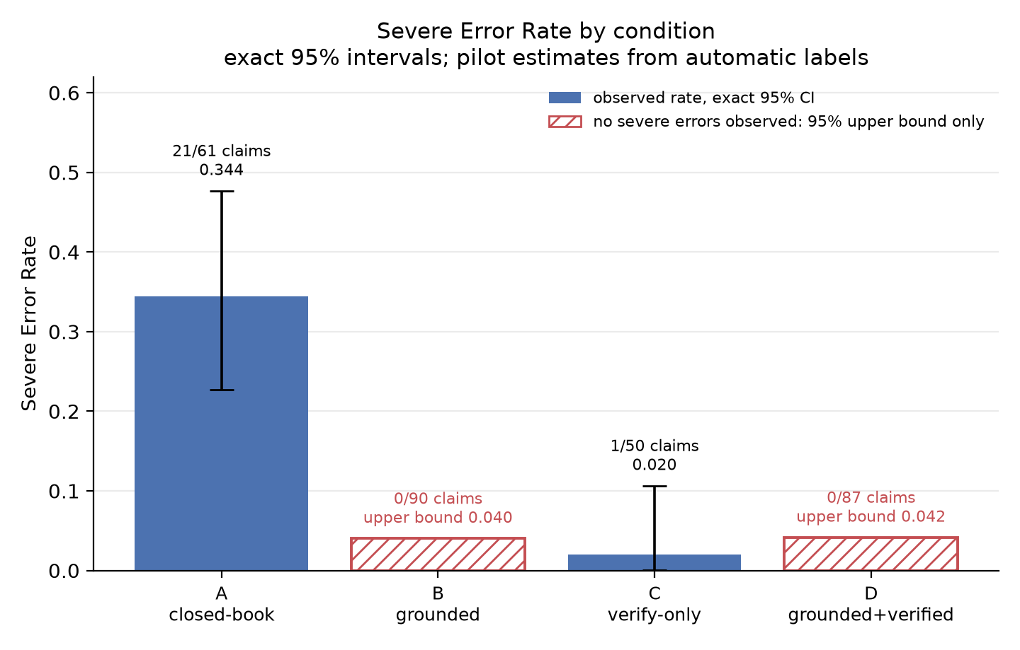
Figure 1. Severe Error Rate by condition, with exact 95% intervals. Solid bars are observed rates (A, C). Hatched bars (B, D) mark conditions where no severe error was observed; the bar height is the 95% upper bound, not a measured rate. All values are pilot estimates from automatic labels.

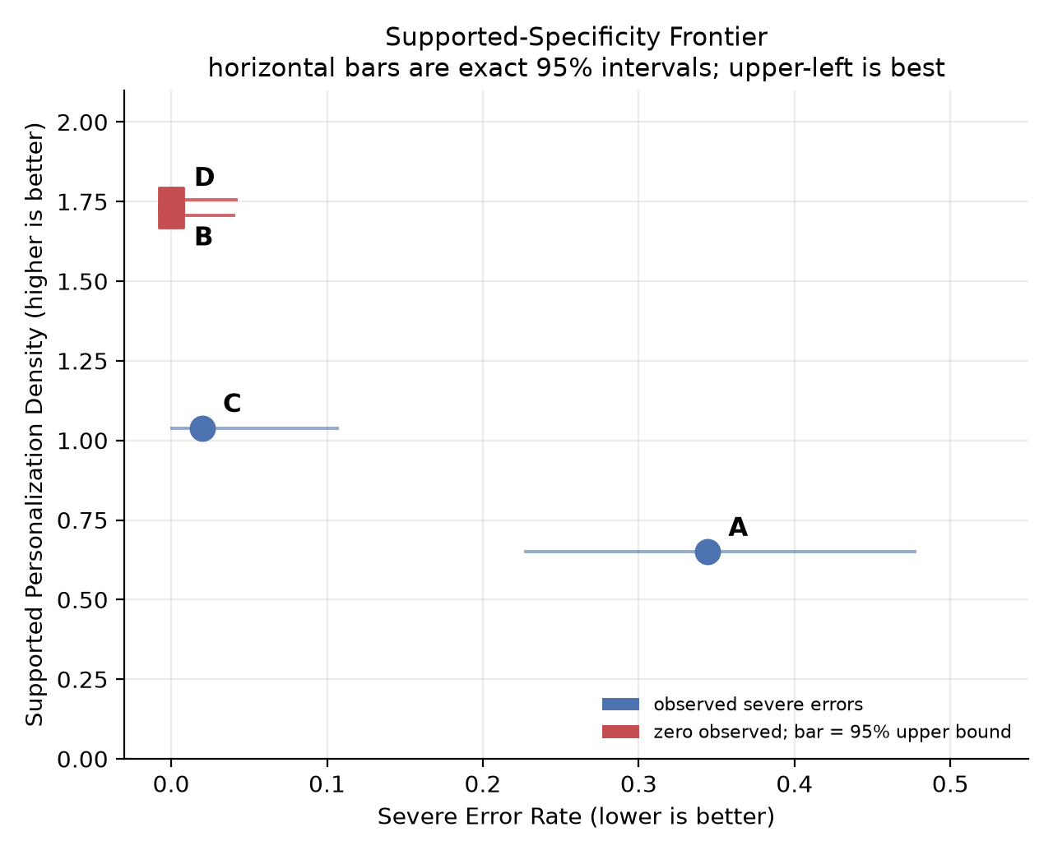
Figure 2. Supported-Specificity Frontier. Each condition is plotted at (x = Severe Error Rate, lower is better; y = Supported Personalization Density, higher is better), with horizontal bars showing exact 95% intervals. A sits at the lower right; B and D at the upper left, where the bar denotes the interval their zero observation is consistent with; C is intermediate.

4.2 Evaluator reliability and the uncertainty it adds
The estimates above come from an LLM judge. This subsection reports how well it tracks human judgment (Table 4), placed here rather than in the Discussion because it bounds every number above.
Table 4. Agreement between annotators. κ intervals are Wald intervals on Cohen's κ.
Comparison | Claims | Raw agreement | Cohen's κ | 95% CI | Interpretation
Primary evaluator (claude-3-haiku) vs human | 36 | 0.556 | 0.33 | 0.16–0.49 | fair
Primary evaluator vs second evaluator (gemini-2.5-flash-lite) | 360 | 0.725 | 0.50 | 0.44–0.57 | moderate
Second evaluator vs human | 36 | 0.694 | 0.54 | 0.35–0.74 | moderate

Four points follow, none reassuring.
First, the primary evaluator's agreement with the human annotator is only fair, and the entire interval (0.16–0.49) lies below the κ ≥ 0.6 threshold conventionally required before a rater is treated as reliable. The primary labels are not a validated instrument.
Second, the second automatic evaluator agreed with the human better than the primary did (κ = 0.54 versus 0.33). The primary estimates are drawn from the weaker of the two automatic raters; re-running the corpus with a stronger judge is a priority.
Third, and most consequentially, the zeros in B and D are specific to the primary evaluator. Running the second evaluator over the same 360 claims does not reproduce them (Table 5).
Table 5. Per-condition Severe Error Rate under each automatic evaluator. Both labelled all 360 claims independently; factual denominators differ because the evaluators assign the excluded categories differently. Intervals are exact 95% intervals.
Evaluator | A (closed-book) | B (grounded) | C (verify-only) | D (grounded + verified)
Primary (claude-3-haiku) | 21/61 = 0.344 (0.227–0.477) | 0/90 = 0.000 (0.000–0.040) | 1/50 = 0.020 (0.001–0.106) | 0/87 = 0.000 (0.000–0.042)
Second (gemini-2.5-flash-lite) | 35/77 = 0.455 (0.341–0.572) | 10/94 = 0.106 (0.052–0.187) | 11/54 = 0.204 (0.106–0.335) | 4/90 = 0.044 (0.012–0.110)

The second evaluator finds 10 severe errors in condition B and 4 in D, where the primary found none. What survives across both evaluators is the structure of the result, not the zero: the closed-book baseline is worst under both; both grounded conditions beat both ungrounded ones under both; and B < C, the study's key comparison, holds under both (0.000 vs 0.020; 0.106 vs 0.204). What does not survive is the claim that grounding eliminated severe errors, and the B-versus-D ordering (the second evaluator ranks D best, the primary B). We therefore treat the grounding effect as a large reduction in severe misrepresentation whose magnitude is judge-dependent — roughly four-fold on the second evaluator's labels — rather than as elimination. This is the strongest reason not to read the zeros in Table 3 as a property of the emails.
Fourth, the human/machine disagreement has a specific and consequential structure (Table 6).
Table 6. Human (rows) × primary automatic evaluator (columns), 36 claims.
Human label ↓ | contradicted | outside scope | overstated | partially supp. | subj./generic | supported | unsupported | Total
contradicted | 0 | 1 | 0 | 0 | 0 | 0 | 0 | 1
outside evidence scope | 0 | 3 | 0 | 0 | 0 | 0 | 0 | 3
overstated | 0 | 0 | 0 | 0 | 0 | 1 | 0 | 1
partially supported | 0 | 0 | 0 | 1 | 0 | 1 | 0 | 2
subjective/generic | 0 | 0 | 0 | 0 | 0 | 6 | 0 | 6
supported | 0 | 0 | 0 | 1 | 0 | 16 | 0 | 17
unsupported | 0 | 6 | 0 | 0 | 0 | 0 | 0 | 6
Total | 0 | 10 | 0 | 2 | 0 | 24 | 0 | 36

Of the 16 disagreements, the evaluator was too lenient in 14, too strict in 0, and orthogonally different in 2. The disagreement is genuinely one-directional here, which is why the automatic rates are lower bounds. But the mechanism is more damaging than simple leniency:
- The judge does not mislabel severe claims as supported; it moves them out of the denominator. Seven claims the human called unsupported (6) or contradicted (1) were labelled outside evidence scope, a category excluded from the SER denominator. The judge therefore biases the denominator, not only the numerator, so SER is not simply an attenuated version of the true rate.
- SPD is also inflated. Six claims the human called subjective/generic were labelled supported. Of the 24 claims the judge called supported, only 16 were human-supported: precision 0.67 (95% CI 0.47–0.83). The SPD numerator is inflated by roughly a third; applying that factor uniformly gives approximate human-adjusted densities of 0.43 (A), 1.14 (B), 0.69 (C), and 1.17 (D) — ordering preserved, absolute values not.
- The *overstated* label was never emitted by either automatic evaluator on any of the 360 claims, though the human annotator used it, making one pre-specified secondary metric unmeasurable with this instrument (§3.6).
Human-labelled coverage is also thin and unevenly spread, limiting what the subset can confirm (Table 7).
Table 7. Human-labelled subset coverage and human-labelled SER per condition. Intervals are exact 95% intervals.
Condition | Human claims | Judged factual | Severe | Emails | Human SER | 95% CI
A | 16 | 11 | 7 | 6 | 0.636 | 0.308–0.891
B | 10 | 10 | 0 | 4 | 0.000 | 0.000–0.308
C | 7 | 3 | 0 | 3 | 0.000 | 0.000–0.708
D | 3 | 3 | 0 | 1 | 0.000 | 0.000–0.708

On the human-labelled subset the closed-book SER is 0.636 (7/11), well above the automatic 0.344, consistent with the leniency above. But C and D rest on three human-labelled factual claims each — D's from a single email — and their human intervals extend to 0.71. The human subset confirms the closed-book baseline is bad and is consistent with grounding being better; it does not confirm the per-condition estimates for B, C, or D, and we do not claim it does.

4.3 The closed-book effect is concentrated in one field
Pooling across fields conceals heterogeneity that bears directly on how far the headline number generalizes (Table 8).
Table 8. Severe Error Rate by field and condition (automatic labels).
Field | A (closed-book) | B (grounded) | C (verify-only) | D (grounded + verified)
Psychology | 17/19 = 0.89 | 0/30 = 0.00 | 0/15 = 0.00 | 0/31 = 0.00
Computer science | 3/23 = 0.13 | 0/33 = 0.00 | 1/20 = 0.05 | 0/26 = 0.00
Biomedicine | 1/19 = 0.05 | 0/27 = 0.00 | 0/15 = 0.00 | 0/30 = 0.00

The pooled closed-book rate of 0.344 is not a homogeneous effect. The four psychology professors account for 17 of the 21 closed-book severe errors (81%). Two professors alone account for 11 of the 21, and 5 of the 12 professors produced no severe errors at all even closed-book. Excluding psychology, the closed-book SER falls to 0.095 (4/42, 95% CI 0.027–0.226); excluding computer science it is 0.474, and excluding biomedicine 0.476.
Figure 3 shows the per-field rates against the pooled estimate. Every field did contain at least one unsupported or fabricated closed-book claim, and no field produced any severe error under grounding, so the direction of the effect is consistent. Its magnitude, however, is dominated by one field of four professors and should not be read as a general closed-book hallucination rate for academic outreach.
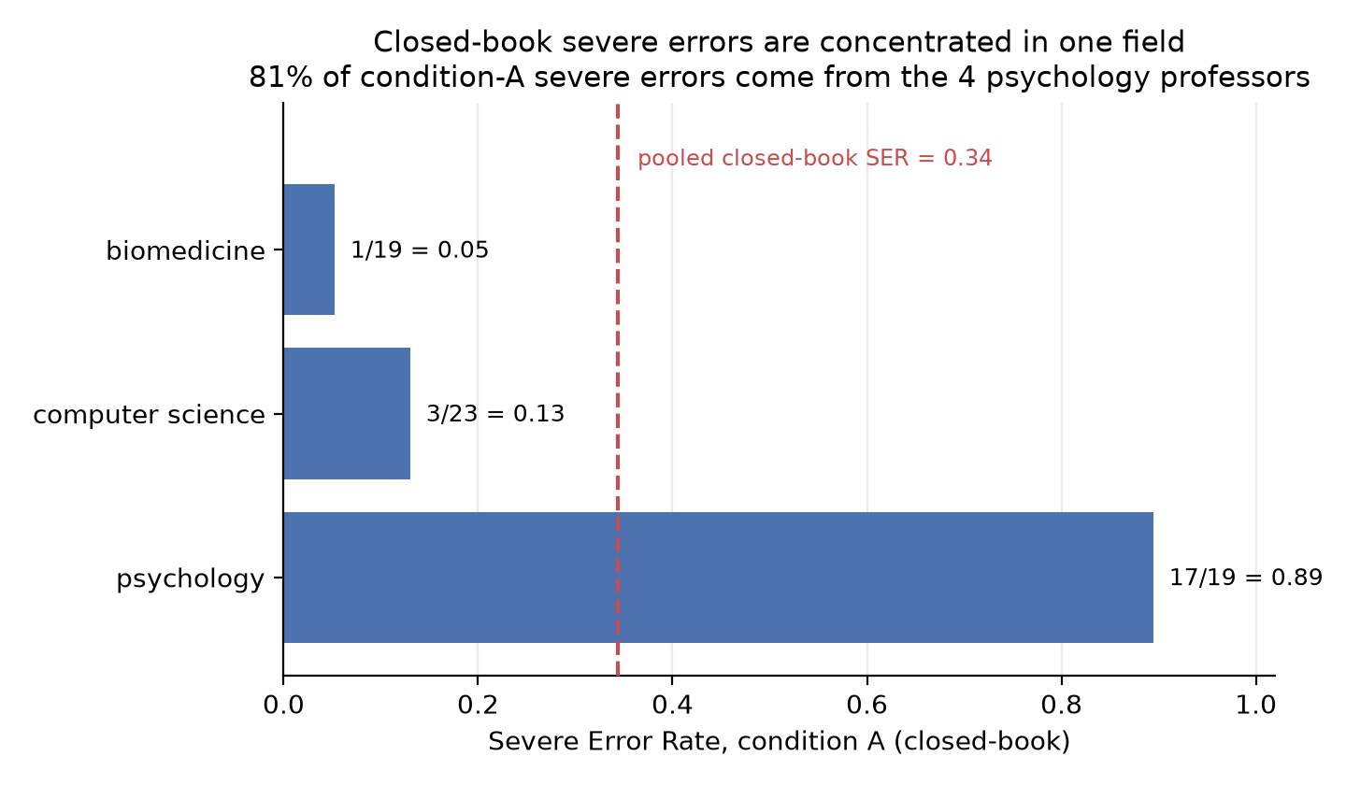
Figure 3. Closed-book (condition A) Severe Error Rate by field, against the pooled rate of 0.34. The pooled estimate is driven by the psychology subsample; the other two fields fall well below it.

4.4 Verifier edit behaviour
The verifier's edit log distinguishes factuality achieved by preserving supported content from factuality achieved by deletion (Table 9).
Table 9. Verifier edit decisions. Intervals are exact 95% intervals.
Condition | Edit decisions | Delete | Soften/rewrite | Keep | Deletion rate | 95% CI
C — verify-only | 49 | 27 | 14 | 8 | 0.551 | 0.402–0.693
D — grounded + verified | 56 | 14 | 14 | 28 | 0.250 | 0.144–0.384

The verifier deleted 55.1% of edit decisions when repairing ungrounded drafts but only 25.0% when the draft was already grounded — unlikely to be chance (Fisher's exact test, p = 0.0025). Correspondingly it kept 28 of 56 decisions in D but only 8 of 49 in C.

5. Discussion

5.1 Principal findings
Grounding at write time (B) cut severe errors sharply while raising supported specificity: factuality and usefulness moved together rather than trading off. Absent evidence, a capable model readily produced plausible but unsupported research descriptions for a real professor — 0.344 under the primary evaluator, 0.455 under the second, 0.636 on the human subset. Supplying the professor's real publications beforehand reduced that to zero under the primary evaluator and 0.106 under the second, while making emails more specific, not less.
Three boundaries apply. First, zero observed errors in 90 claims is not a demonstrated zero: the data are consistent with a true rate up to roughly 4% at the claim level and 14% at the email level. Grounding reduced misrepresentation below this instrument's detection threshold at this sample size; it is not shown to eliminate it, and a deployment claim of "no misrepresentation" would not be supported. Second, that zero belongs to the primary evaluator, not to the emails (§4.2). The defensible form of the central finding is that grounding produced a large reduction in severe misrepresentation while increasing specificity, with the reduction's size judge-dependent and its floor not established. Third, the baseline problem is concentrated in one of three fields (§4.3), so the improvement's size is far less well established than its direction.

5.2 Grounding versus correction
The key comparison, B versus C, favours grounding on both axes (B: SER 0.000, upper bound 0.040, SPD 1.71; C: 0.020, SPD 1.04). The mechanism is visible in the verifier's edits: the deletion rate when repairing an ungrounded draft was more than double that when the draft was already grounded (0.551 versus 0.250, p = 0.0025). A verifier fixing an ungrounded draft achieves factuality partly by removing risky but specific content, lowering specificity; when the draft was grounded, it finds less to delete and specificity survives. This answers the secondary question: the factuality–specificity trade-off is real for correction-after, and grounding largely avoids it.
This is the one part of the result that does not depend on which judge is believed. On the primary evaluator the factuality comparison is thin, resting on a single severe error in C, so the ranking would rest mainly on the specificity gap and the deletion mechanism. The second evaluator separates the conditions far more clearly — 0.106 for B against 0.204 for C, on 94 and 54 judged claims — and also ranks both grounded conditions above verify-only. Grounding beats post hoc repair under both evaluators, on both axes, and in every field. Of the study's claims, this is the best supported.
This extends grounded-generation findings that evidence during drafting beats post hoc citation¹¹ into a recipient-focused outreach setting with an explicit specificity measure, and operationalizes the personalization-induced-hallucination concern⁴ concretely.

5.3 Threats to validity
The primary instrument is not validated. Agreement with the human annotator was fair at best (κ = 0.33, 95% CI 0.16–0.49), which is why we report pilot estimates. Disagreement was one-directional in the validated subset (lenient in 14 of 16, strict in none), which is why the rates are lower bounds. But two structural defects mean the bias is not a simple downward scaling: severe claims were reclassified into a category excluded from the denominator (7 of 36 claims), and generic praise was counted as supported (6 of 36), inflating SPD by about a third. The second evaluator agreed with the human better than the primary did, indicating a poor choice of primary judge rather than an unavoidable limitation.
The headline zeros are judge-dependent. The most serious constraint is that the study's most quotable number does not replicate across instruments (§4.2, Table 5). Absolute rates here should be treated as instrument-relative throughout, and only the between-condition comparisons — which agree across both evaluators — as findings about the emails.
Verifier and evaluator share a model family. Writer (OpenAI) and evaluator (Anthropic) are deliberately different families, but in C and D the verifier (claude-haiku-4.5) and evaluator (claude-3-haiku) are both Anthropic. The near-zero rates in C and D may partly reflect family agreement between the model that edited the text and the one that graded it. Condition B, which carries the central claim, uses no verifier and is unexposed; the second evaluator, from a third family, still ranks both grounded conditions above both ungrounded ones, and its higher rate for C (0.204) than for either grounded condition is consistent with post hoc repair being genuinely weaker rather than with a family artifact alone. Still, C and D should be treated as more fragile than B.
Effect concentrated in one field. As reported in §4.3, 81% of closed-book severe errors came from four psychology professors and five of twelve professors produced none. The pooled baseline is not a general rate.
Zero-event conditions. Under the primary evaluator two of four conditions contain no events, so the design has little power to distinguish B from D. That D offers no factuality gain over B is a null result at this sample size, not evidence of equivalence — and the second evaluator ranks D slightly ahead of B, a further reason to treat that ordering as undetermined.

5.4 Practical implications
For anyone deploying LLMs to draft academic or professional outreach, retrieval grounding is the more promising default of the two safeguards: it was the only intervention that reduced misrepresentation on every measure we applied while simultaneously improving usefulness. Post-hoc verification remains valuable as a second line of defence — it reduced errors substantially on ungrounded drafts — but alone it trades away specificity, and under both evaluators it underperformed grounding.
Two cautions follow. This favours grounding in system design but is not grounds for advertising a factuality guarantee: a deployed assistant should expect residual misrepresentation even when grounded, at a rate this study bounds only loosely (below roughly 4% on the primary evaluator's labels, near 11% on the second's). And our experience cautions about evaluation practice as much as generation: had we relied on a single automatic judge, as many pipelines do, we would have reported elimination of an error mode a second judge still detects. Teams evaluating factuality should run at least two independent judges before believing a zero.

5.5 Limitations and future work
Human validation covers 36 of 360 claims (10%), with only three judged factual claims each in C and D, so per-condition human estimates are unavailable. Scaling human annotation is the highest-value next step; we would prioritise a stratified expansion — every claim the automatic evaluator flagged severe, plus roughly 30 per condition — yielding per-condition human rates with usable intervals at tractable cost. We used a single writer model. Evidence packets are provisional and rest on abstracts plus abstract excerpts, so a claim true only in full text counts against the model, again making SER conservative. The sample is small (12 professors, English only) and mid-visibility by construction, so results may not transfer to very famous researchers a model may have memorised. Future work should scale human labelling, adopt a stronger and validated automatic judge drawn from a family distinct from both writer and verifier, add cross-model writers, incorporate full-text evidence, and broaden field and language coverage.

6. Conclusion
In an offline pilot benchmark of AI-generated professor outreach emails, giving the writer verified publication evidence sharply reduced severe misrepresentation of professors' research while making the emails more specific, and it outperformed post-generation verification on both counts. Grounding, rather than correction alone, is the more promising safeguard for recipient-focused academic outreach.
The direction of this effect is robust: it holds in all three sampled fields and under both independent automatic evaluators, and the comparison that motivated the study favours grounding under both. Its magnitude is not established. The primary labels come from an evaluator with only fair human agreement (κ = 0.33); the zeros it reports for the grounded conditions are not reproduced by a second evaluator, which finds a residual rate near 0.11; and the closed-book severity defining the size of the improvement is concentrated in one of three sampled fields. Human labelling at scale, a validated automatic judge from a family distinct from both writer and verifier, and a larger professor sample are the immediate next steps.

Declarations
Abbreviations. LLM — large language model; SER — Severe Error Rate; SPD — Supported Personalization Density; RAG — retrieval-augmented generation; CI — confidence interval; κ — Cohen's kappa.
Funding. This research did not receive any specific grant from funding agencies in the public, commercial, or not-for-profit sectors.
Conflicts of Interest. The authors declare no competing financial interests or personal relationships that could have influenced this work.
Ethics Statement. Ethics approval was not required: the study used only publicly available scholarly metadata (OpenAlex) and involved no human participants, private identifiable data, or animal subjects. No emails were sent to any individual. Professors are referred to by anonymized IDs; because ungrounded outputs can contain fabricated claims about real researchers, the real-name mapping is withheld.¹³
Data Availability. Code, prompts, run configurations, the name-scrubbed atomic claims with all three sets of labels (primary evaluator, second evaluator, human), the claim-to-condition map, figures, and the complete revision statistics (analysis/revision/, including de-identified per-run word counts and verifier actions) are available at https://github.com/PhongCT1105/Hack-Research. Every table in this paper can be regenerated from those files by scripts/compute_revision_stats.py.
The generated email texts themselves are withheld, together with the professor identity map. Closed-book drafts address real researchers by name and contain fabricated claims about their work, so releasing them would both de-anonymize the sample and propagate misrepresentations of identifiable people — the harm this study exists to measure. We will share the email corpus with the editors or reviewers on request for verification.
AI Use Statement. The authors used Anthropic Claude (via Claude Code) and OpenAI Codex to help implement and test the evaluation pipeline and to assist in preparing this revision. All AI-generated code and text were reviewed, edited, and verified by the authors, who take full responsibility for the accuracy and integrity of the manuscript. No citation, datum, method, or result was generated without author verification; every statistic was regenerated from the released data by the scripts named in §4, and every reference was checked against the arXiv record. LLMs were also the object of study: the writer (OpenAI gpt-4o-mini), verifier (Anthropic claude-haiku-4.5), claim-extractor and primary evaluator (Anthropic claude-3-haiku), and second evaluator (Google gemini-2.5-flash-lite) are named in the Methods.
Author Contributions. Abhinav Singh — generation/verification pipeline, evaluation infrastructure, analysis. Phong Cao — dataset and evidence packets. Kanan Gasimov — annotation framework and human validation. Azhdar Mammadov — related work and manuscript. All authors reviewed the final manuscript.
Acknowledgements. We thank the NSRI Summer Research Hackathon 2026 organizers and the Technology & AI track sponsors, ColdMatch and Quanticle, whose focus on AI-assisted academic outreach and research insight motivated this study's problem setting. The sponsors provided no funding for, and had no role in, the design, execution, analysis, or reporting of this work.

References
1. Nicolicioiu A, Iofinova E, Jovanovic A, Kurtic E, Nikdan M, Panferov A, et al. Panza: design and analysis of a fully-local personalized text writing assistant. arXiv:2407.10994. 2024. 2. Wang Y, Jiang J, Zhang M, Li C, Liang Y, Mei Q, et al. Automated evaluation of personalized text generation using large language models. arXiv:2310.11593. 2023. 3. Kong R, Zhang C, Sun R, Chhabra V, Nadimpalli T, Konstan JA. Multi-objective personalization in multi-stakeholder organizational bulk e-mail: a field experiment. arXiv:2302.11156. 2023. 4. Sun Z, Zhan Y, Shen C, Yu W, Zhang X, He M, et al. When personalization misleads: understanding and mitigating hallucinations in personalized LLMs. arXiv:2601.11000. 2026. 5. Min S, Krishna K, Lyu X, Lewis M, Yih W, Koh PW, et al. FActScore: fine-grained atomic evaluation of factual precision in long form text generation. arXiv:2305.14251. 2023. 6. Wadden D, Lin S, Lo K, Wang LL, van Zuylen M, Cohan A, et al. Fact or fiction: verifying scientific claims. arXiv:2004.14974. 2020. 7. Wadden D, Lo K, Kuehl B, Cohan A, Beltagy I, Wang LL, et al. SciFact-Open: towards open-domain scientific claim verification. arXiv:2210.13777. 2022. 8. Gao L, Dai Z, Pasupat P, Chen A, Chaganty AT, Fan Y, et al. RARR: researching and revising what language models say, using language models. arXiv:2210.08726. 2022. 9. Fatahi Bayat F, Qian K, Han B, Sang Y, Belyi A, Khorshidi S, et al. FLEEK: factual error detection and correction with evidence retrieved from external knowledge. arXiv:2310.17119. 2023. 10. Ashok D, Kulkarni A, Pham H, Póczos B. SciFix: outperforming GPT3 on scientific factual error correction. arXiv:2305.14707. 2023. 11. Ye X, Sun R, Arik SÖ, Pfister T. Effective large language model adaptation for improved grounding and citation generation (AGREE). arXiv:2311.09533. 2023. 12. Wang Y, Ma X, Nie P, Zeng H, Lyu Z, Zhang Y, et al. ScholarCopilot: training large language models for academic writing with accurate citations. arXiv:2504.00824. 2025. 13. Priem J, Piwowar H, Orr R. OpenAlex: a fully-open index of scholarly works, authors, venues, institutions, and concepts. arXiv:2205.01833. 2022.

Supplementary Material
Supplementary File 1 — reproducibility appendix: prompt versions (writer, verifier, extractor), run configuration, run-manifest description, and the annotation rubric.
Supplementary File 2 — revision statistics: analysis/revision/report.md and the nine CSV files regenerated by scripts/compute_revision_stats.py, containing every interval, confusion-matrix cell, per-professor count, and agreement statistic reported above, plus run_metadata.csv (de-identified per-run word counts and verifier actions), which is what allows the tables to be reproduced without the withheld email texts.
Both are available in the repository named under Data Availability.

