ARCHITECTURE

Version 2.0

**Bảng ghi nhận thay đổi tài liệu**

|  |  |  |  |
| --- | --- | --- | --- |
| **Ngày** | **Phiên bản** | **Mô tả** | **Người thay đổi** |
| 08/03/2024 | 1.0 | Logical view, process view, development view, deloyment view | Tâm |
| 16/06/2024 | 2.0 | Cập nhật Logical view, process view, development view, deloyment view | Duy, Nghĩa, Tâm, Đăng |
|  |  |  |  |

Mục lục

Logical View 3

Process view của nghe nhạc 4

Developer view 5

Deloyment view 5

# Logical View

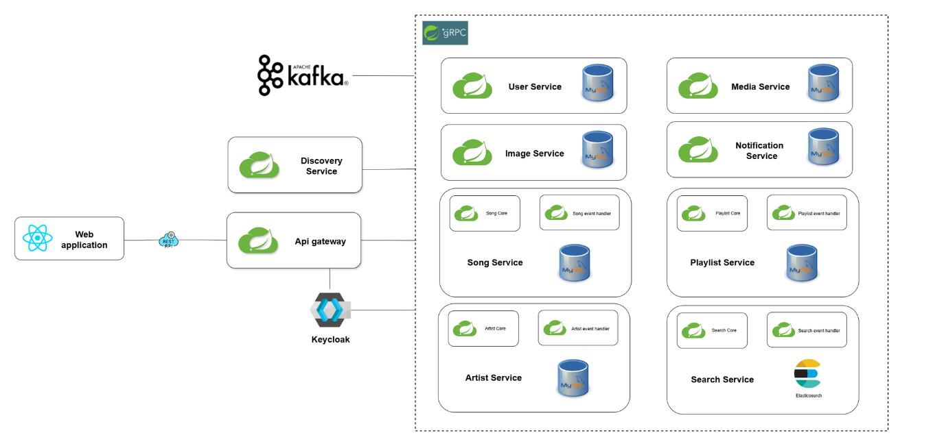

# Process view

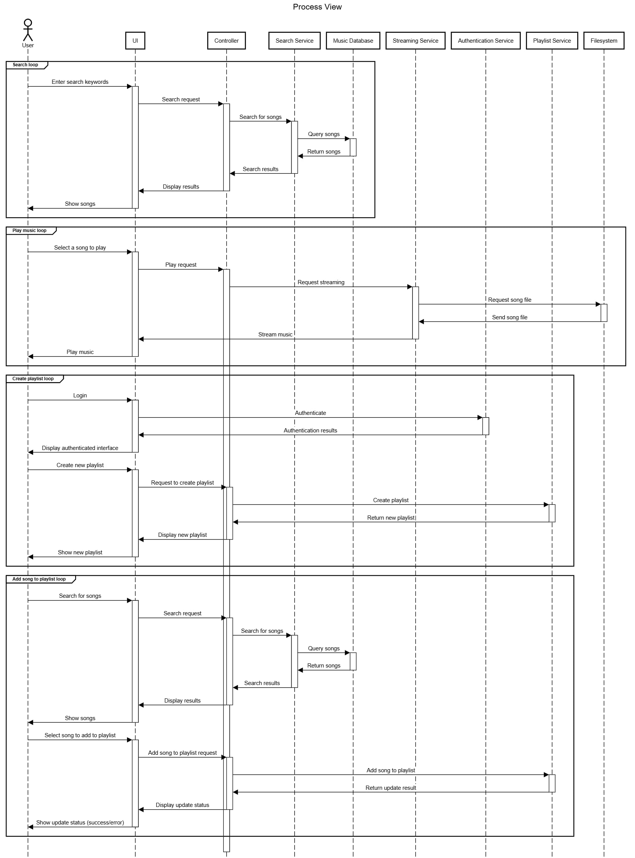

# Developer view

FE phần người dùng:

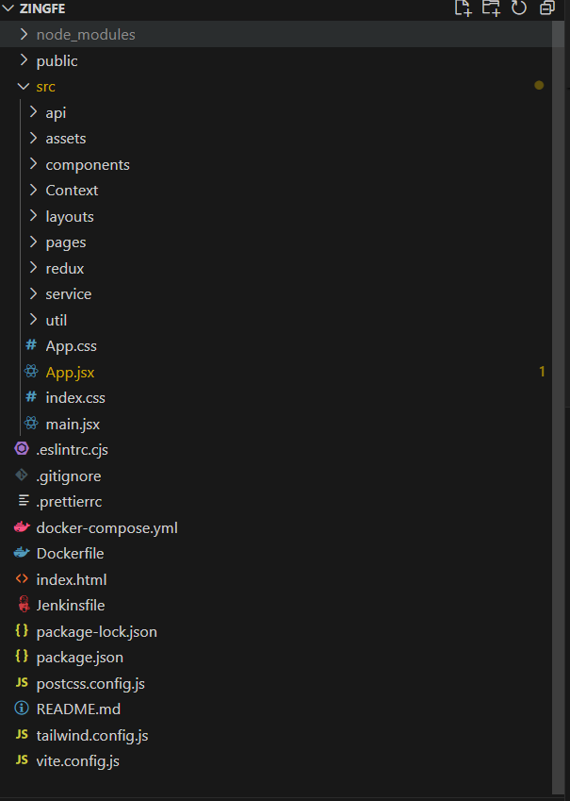

FE phần admin:

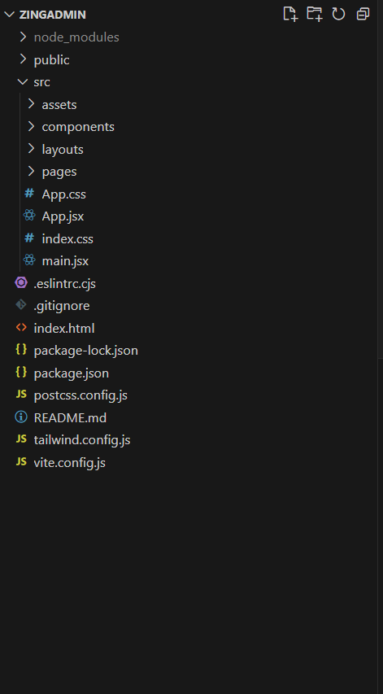

Tổng quát BE:

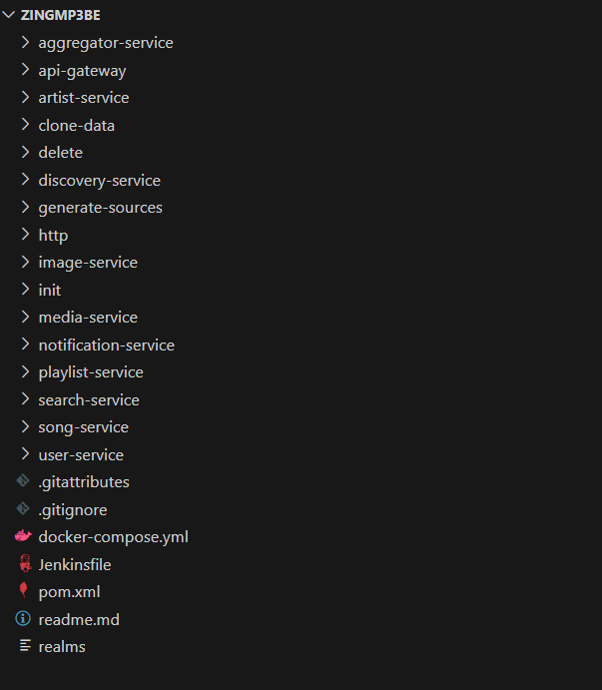

Aggregator-service

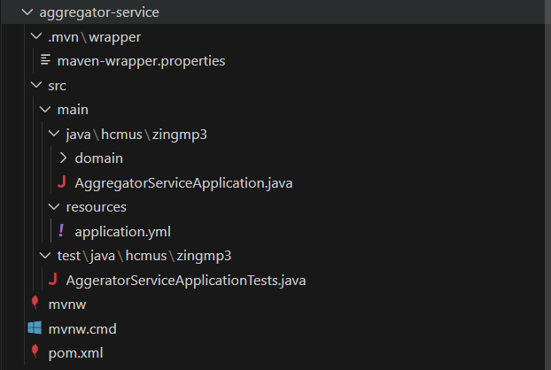

Api-gateway

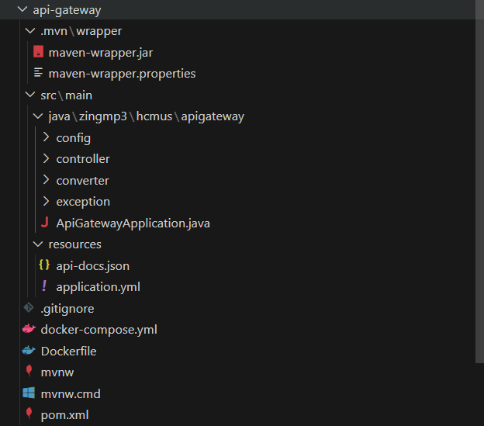

Tổng quan artist service:

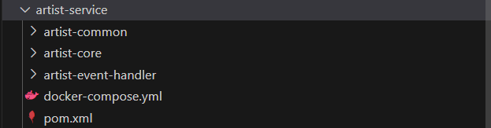

Chi tiết artist common:

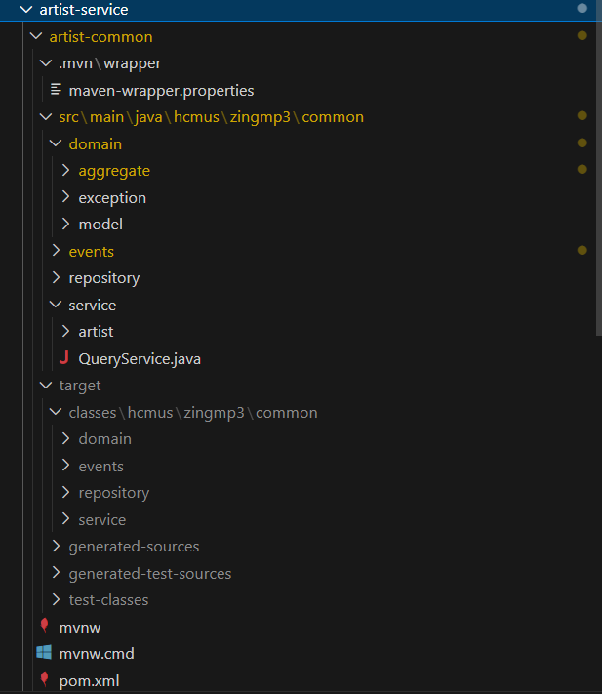

Chi tiết artist core:

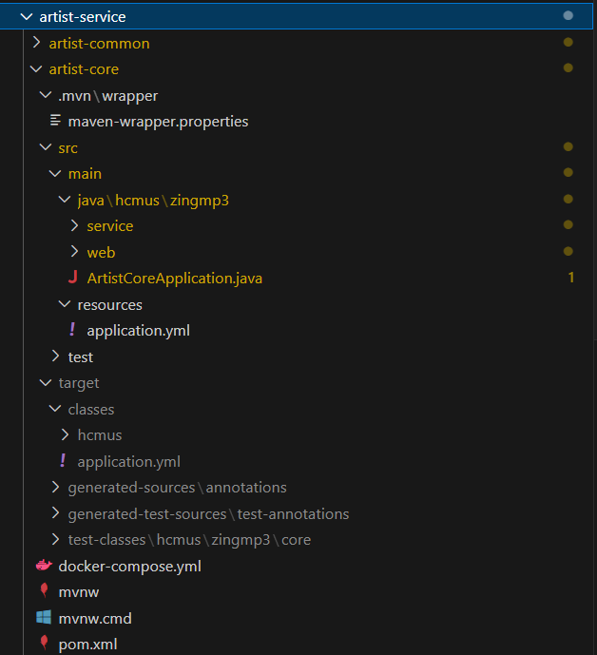

Chi tiết artist handler:

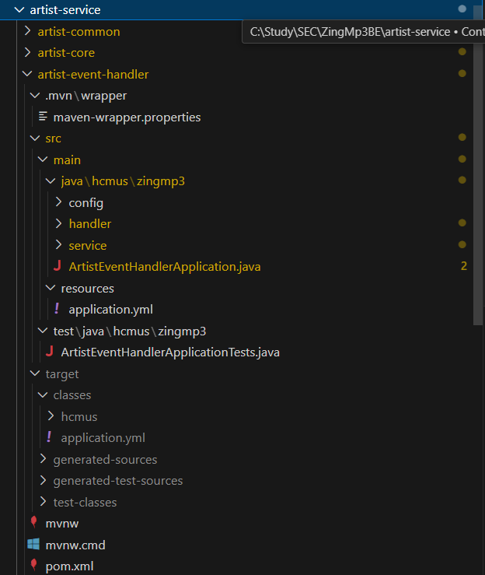

Clone data:

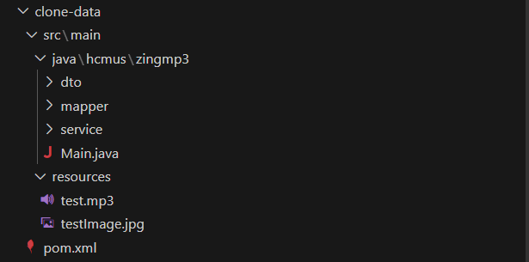

Tổng quan delete:

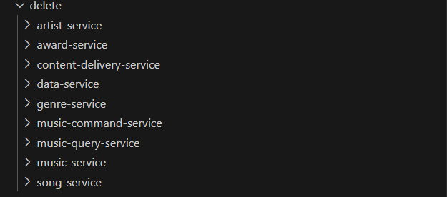

Delete artist service:

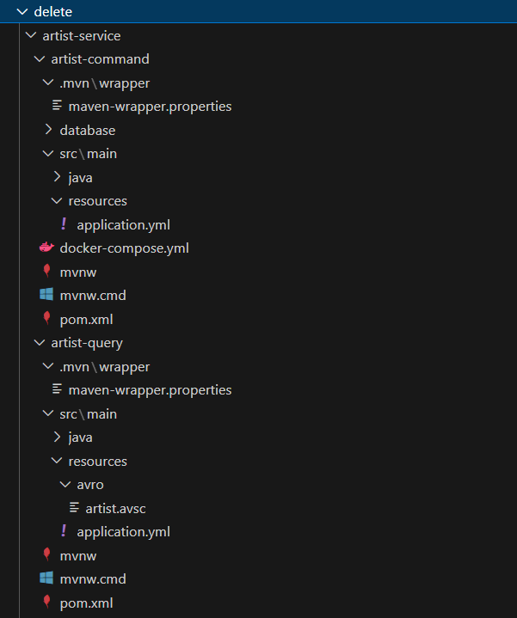

Delete award service:

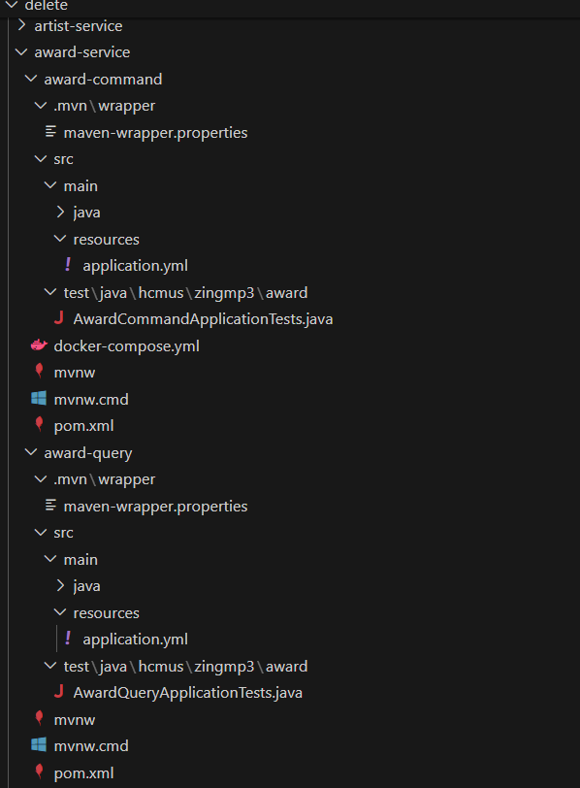

Delete content-delivery-service

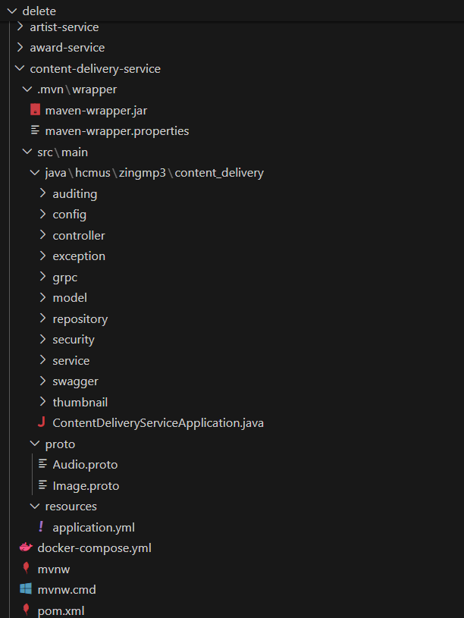

Delete data service:

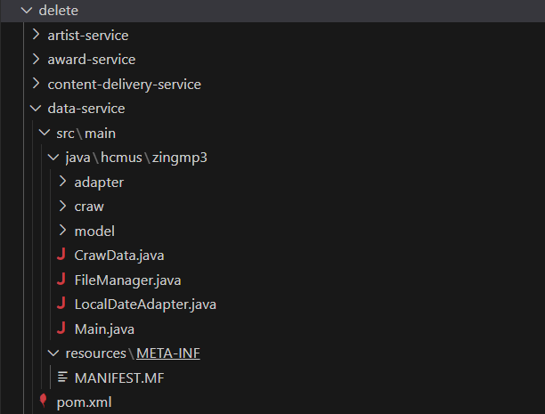

Delete genre-service:

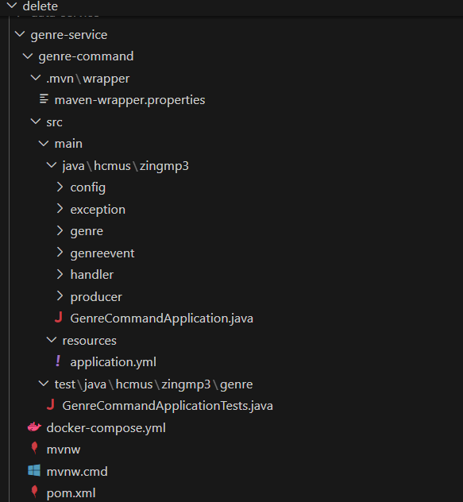

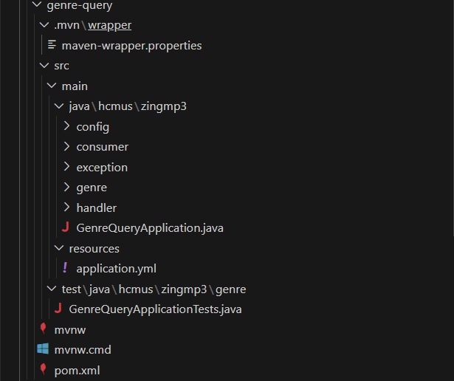

Delete music command service:

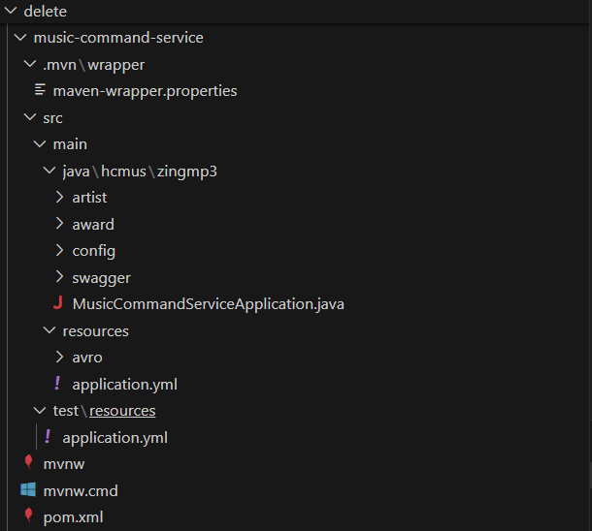

Delete music-query service:

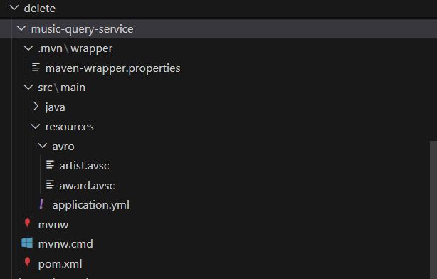

Delete music service:

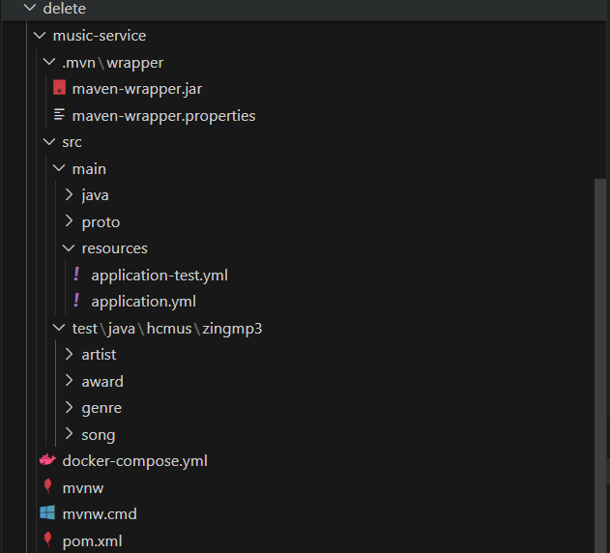

Delete Song service:

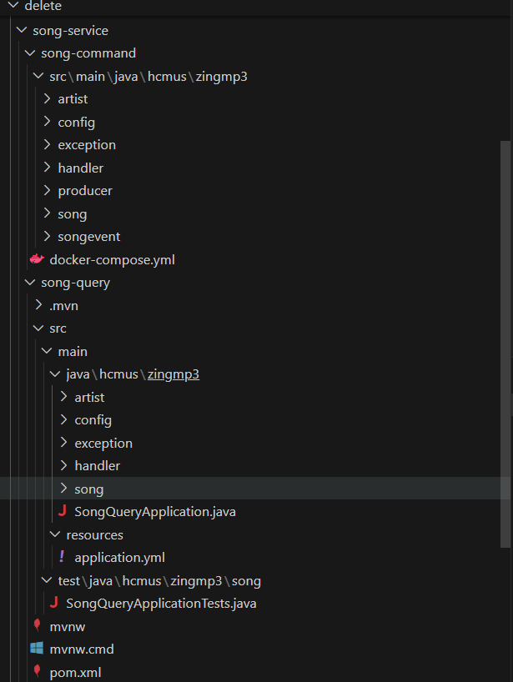

Discovery service:

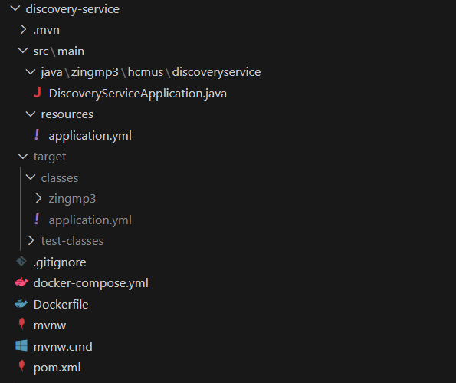

Generate-source:

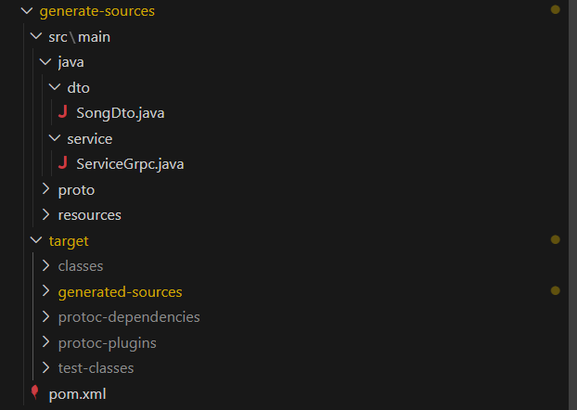

http:



Image service:

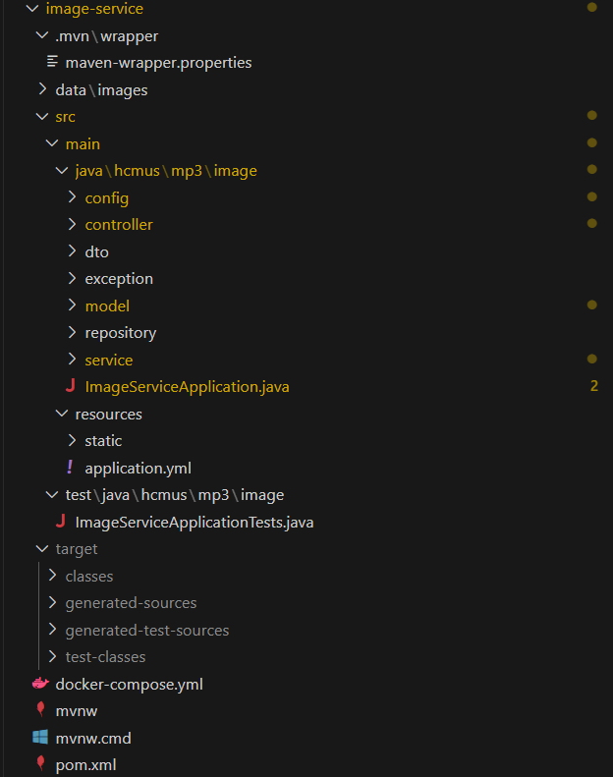

Init:

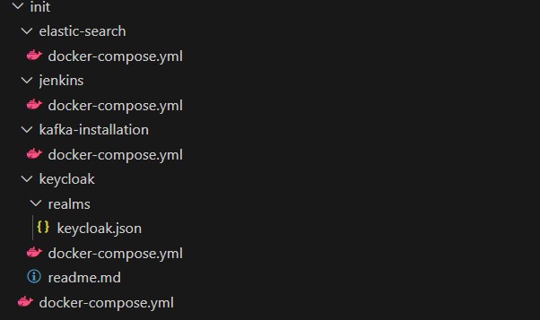

Media service:

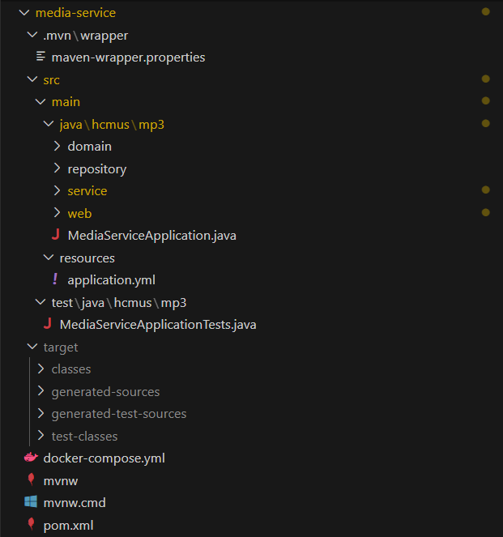

Notification service:

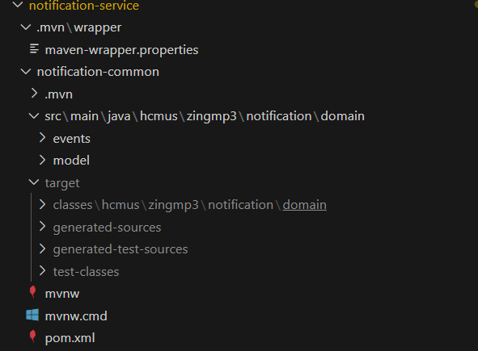

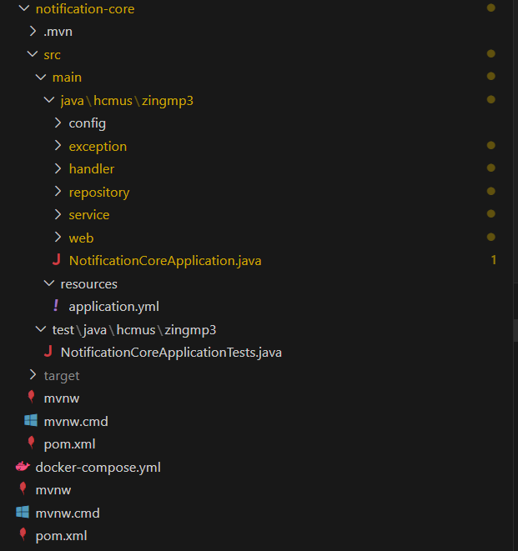

Playlist-service:

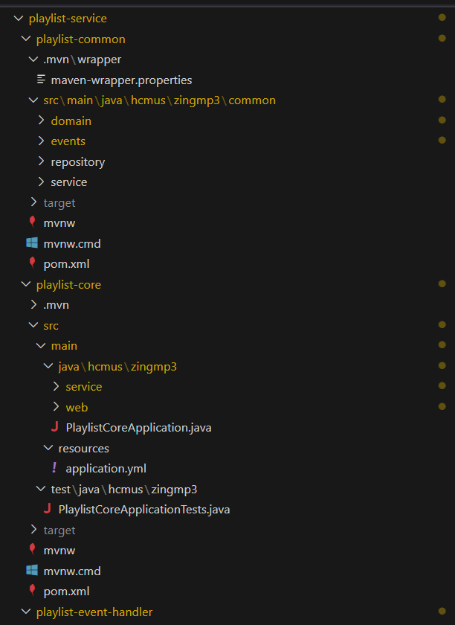

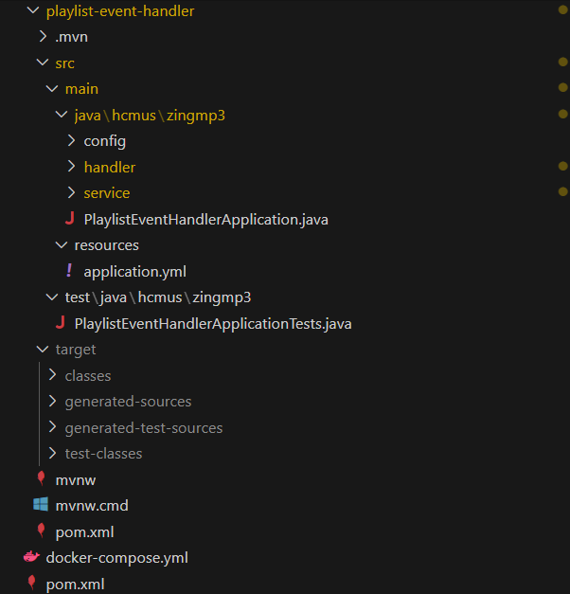

Search-service:

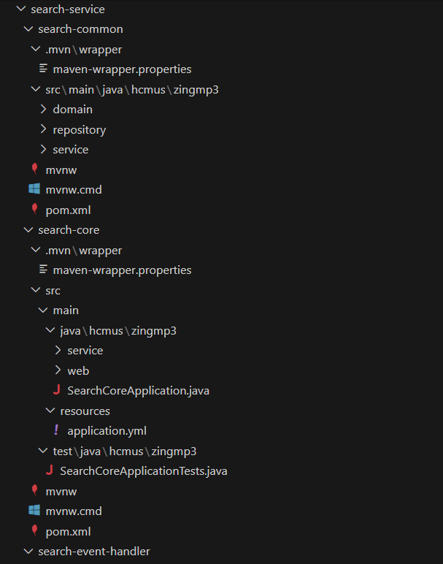

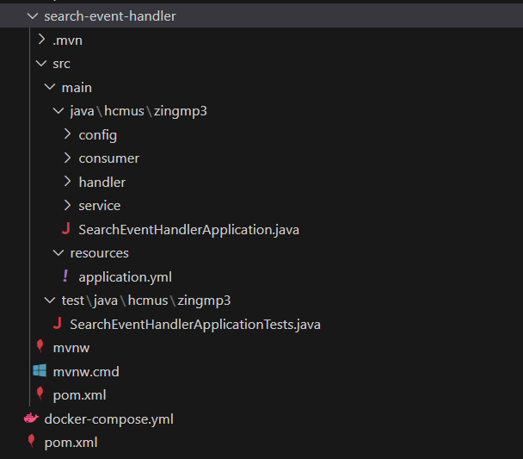

Song-service:

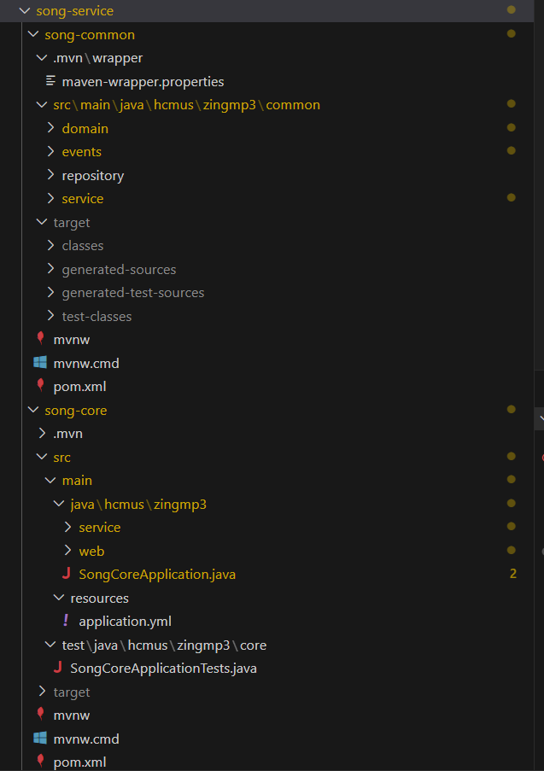

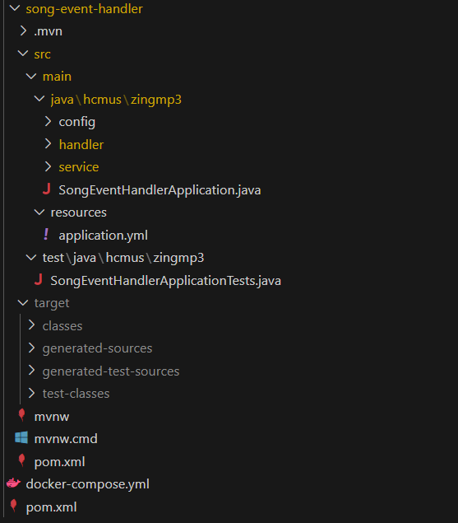

User-service:

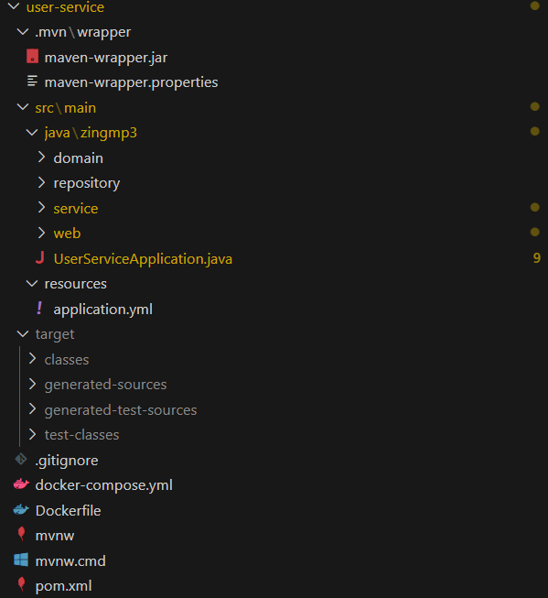

# 

# Deloyment View

