How to check a variable’s type?

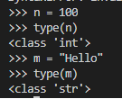If you are not sure what class a value falls into, Python has a function called type which can tell you.

In what cases, you will get ***SyntaxError*** from the compiler telling you that some of your variables have **invalid names**? Can you give 3 different examples of **invalid names**?

