1. What is Boolean? Write down 3 different expression that results a Boolean type (i.e. 5 == 6)

A Boolean value is either true or false.

x == y # Produce True if ... x is equal to y

x != y # ... x is not equal to y

x > y # ... x is greater than y

x < y # ... x is less than y

x >= y # ... x is greater than or equal to y

x <= y # ... x is less than or equal to y

1. 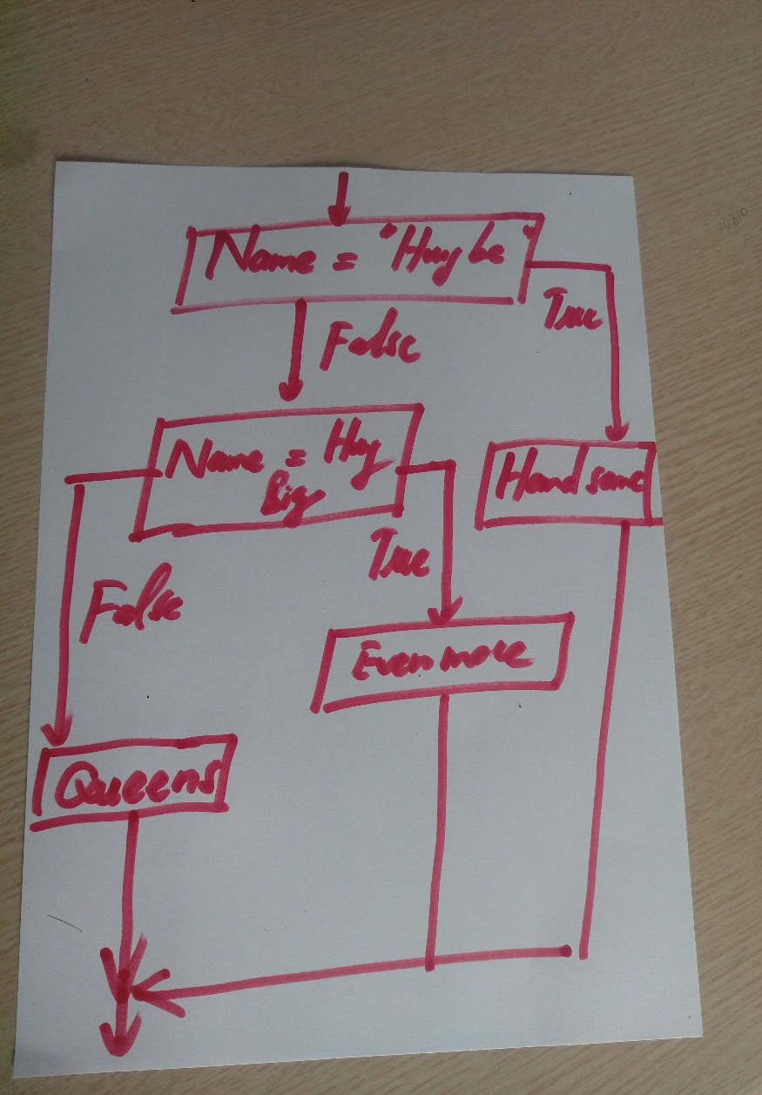What is a flow chart? Draw flow chart for the following code snippet: (you can draw on a paper, take a picture of it
2. What is nested conditionals? Write a piece of code that uses nested conditionals

One conditional can also be nested within another.

