### #bug26

### #bug25: http://localhost:8080/blog.html

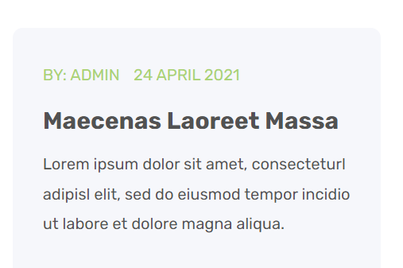

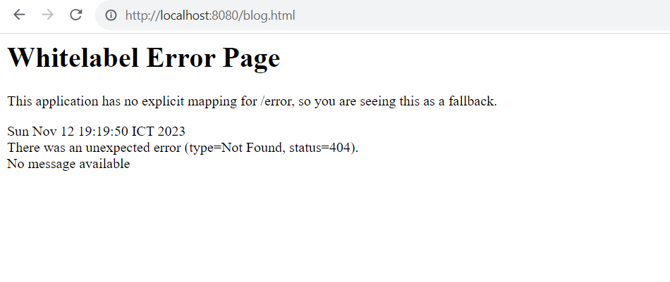

### #bug24http://localhost:8080/blog.html

### 

### #bug23http://localhost:8080/auth/forgot-password

### #bug22http://localhost:8080/single-product-variable.html

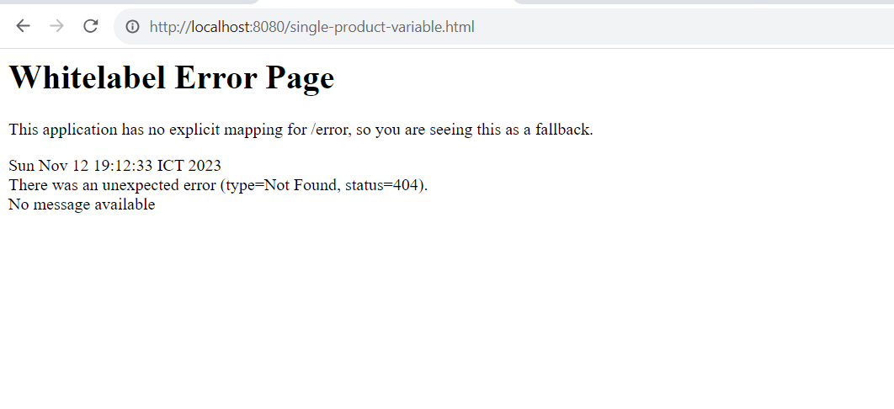

### #bug21http://localhost:8080/hotel/detail/%7Ba.id%7D

### 

### #bug20:chuyển trang ttp://localhost:8080/shop.html

### 

### #bug19:chuyển trang <http://localhost:8080/hotel/lpage=null>

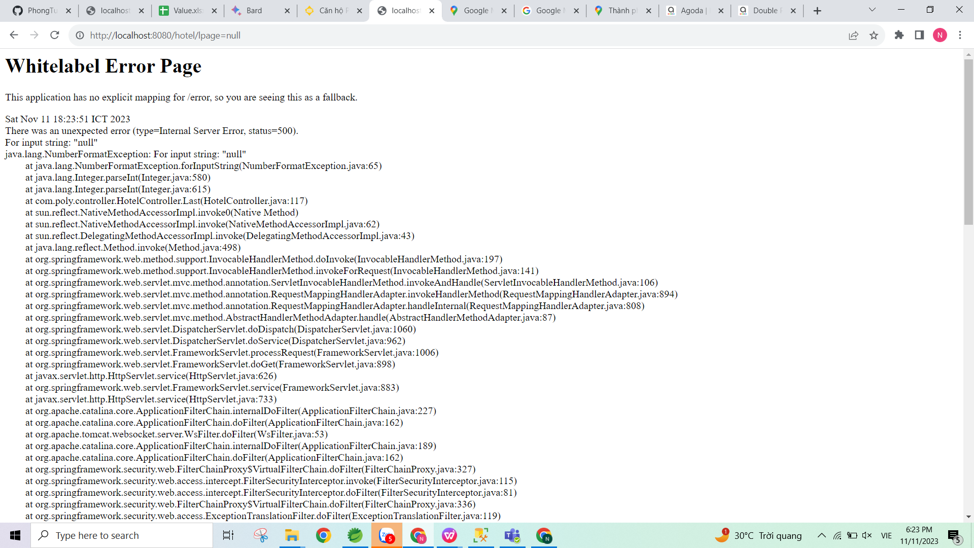

### #bug18: chuyển trang <http://localhost:8080/single-product-variable.html>

### #bug17: chuyển trang <http://localhost:8080/index.html>

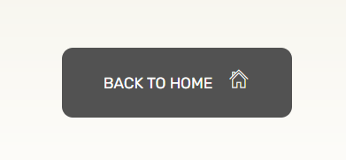

### 

### #Bug17: chuyển trang <http://localhost:8080/place/hotel/22>

### #Bug16: chuyeenr trag <http://localhost:8080/blog.html>

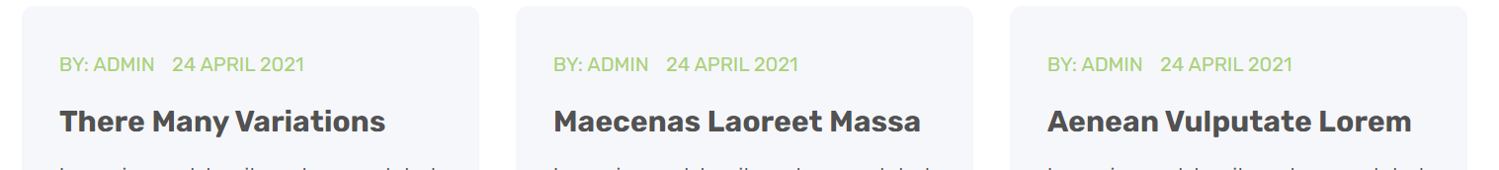

### 

### #Bug15: chuyển trang <http://localhost:8080/index.html>

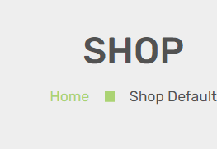

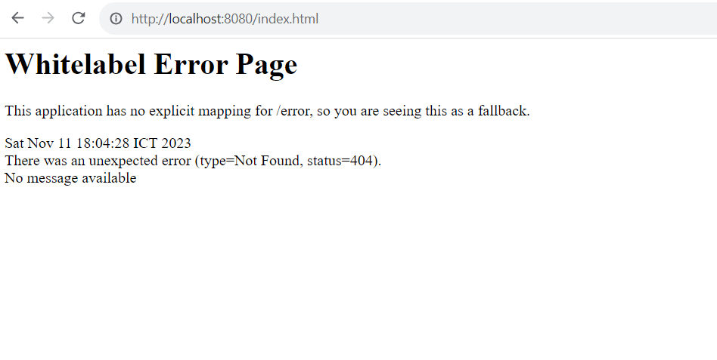

### #Bug14: chuyển trang http://localhost:8080/index.html



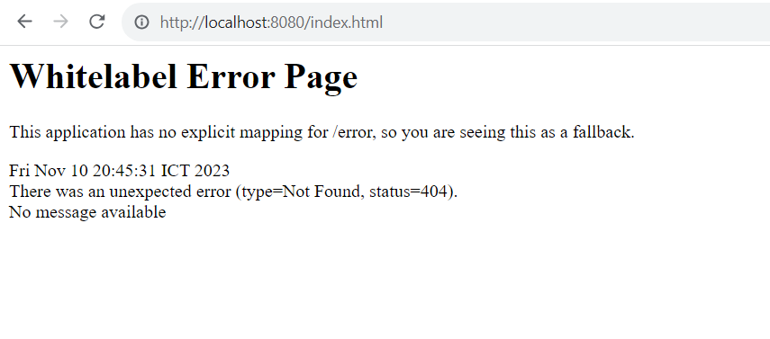

### #Bug13:chuyển trang <http://localhost:8080/login-register.html>

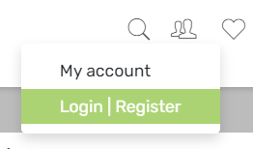

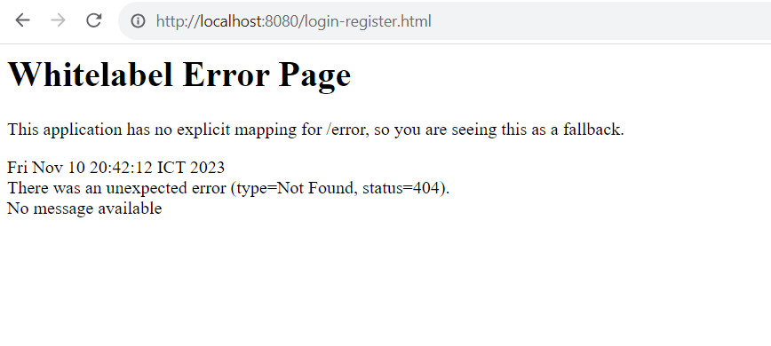

### #Bug12: chuyển trang <http://localhost:8080/shop.html> lỗi all trang shop

### 

### #Bug11:chuyển trang <http://localhost:8080/cart.html>



### 

### #Bug10:chuyển trang <http://localhost:8080/wishlist.html>



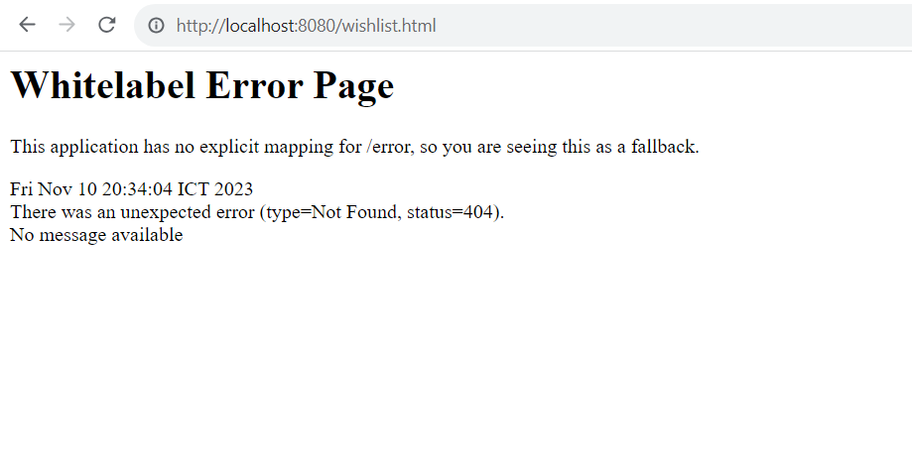

### #Bug9:chuyển tranghttp://localhost:8080/shop.html

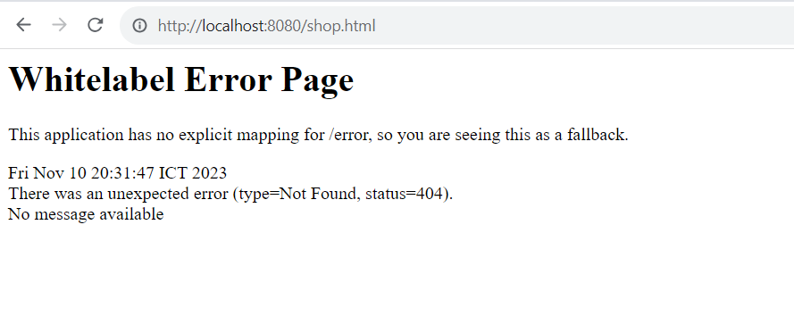

### #Bug8:chuyển trang <http://localhost:8080/single-product-variable.html> lỗi all như hình

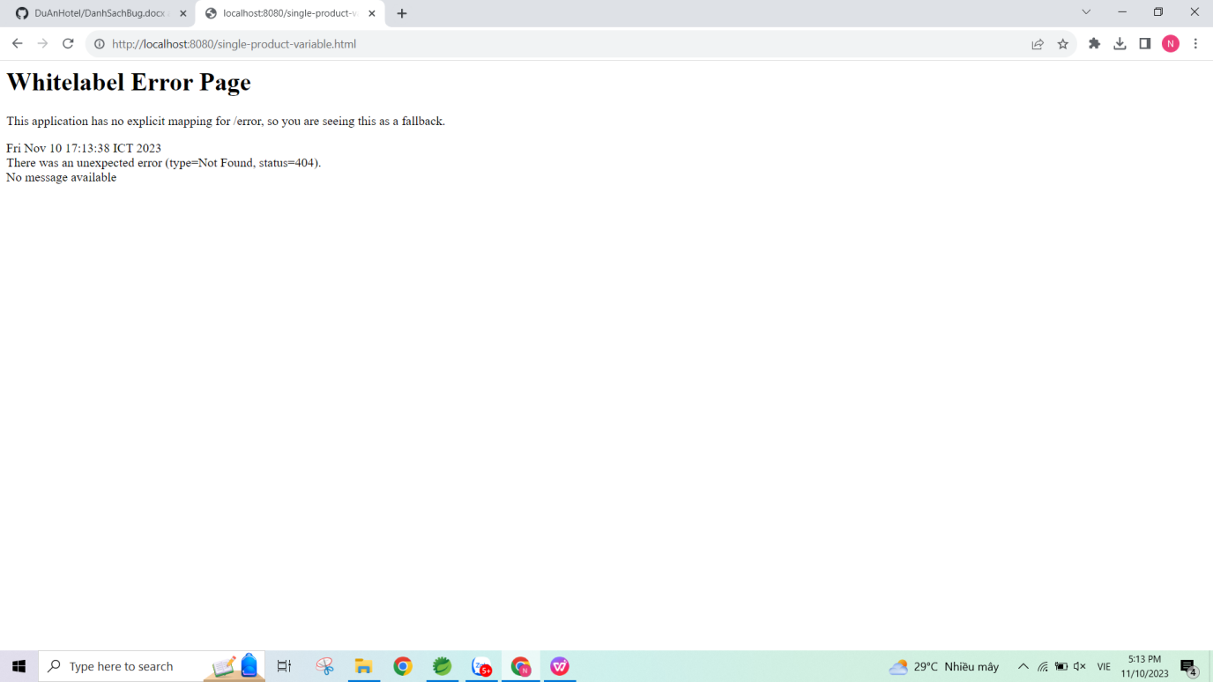

#Bug7: chuyển trang <http://localhost:8080/wishlist.html> trái tim lỗi

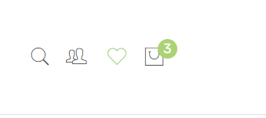

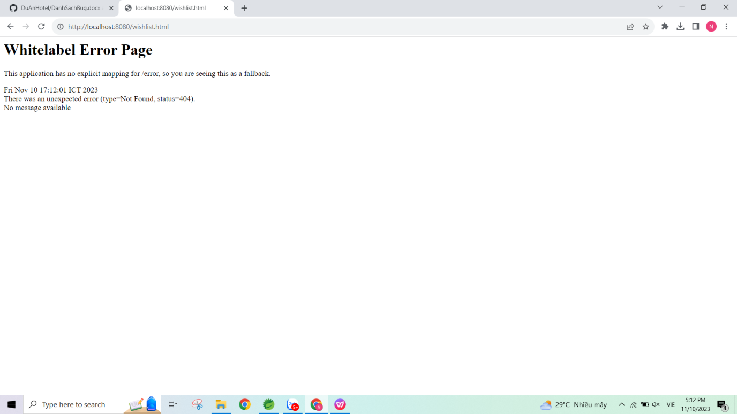

#Bug6:chuyển trang <http://localhost:8080/auth/forgot-password> 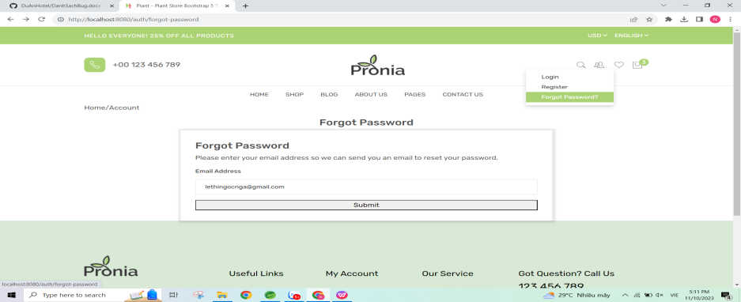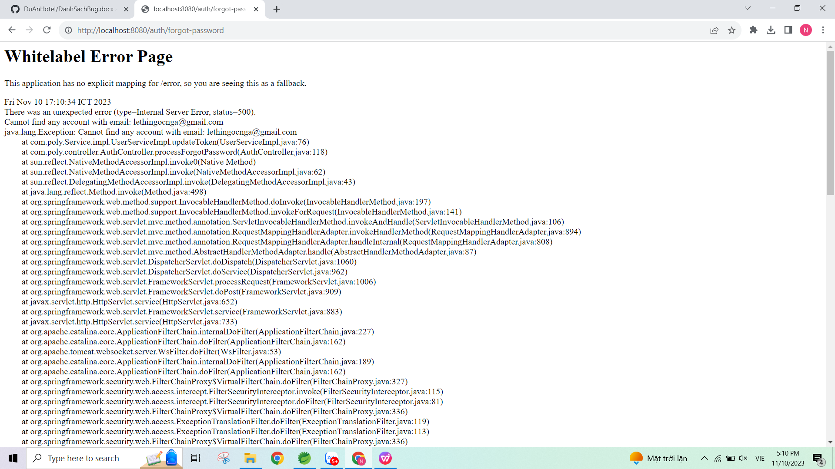

### #Bug5:chuyển trang <http://localhost:8080/blog-listview.html> Blog list view, blog detal lỗi

### #Bug4:chuyển trang <http://localhost:8080/my-account.html> **tất cả thanh như hình lỗi hết ạ** T

### #Bug3: chuyển trang [http://localhost:880/index.html](http://localhost:8080/index.html)

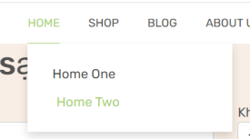

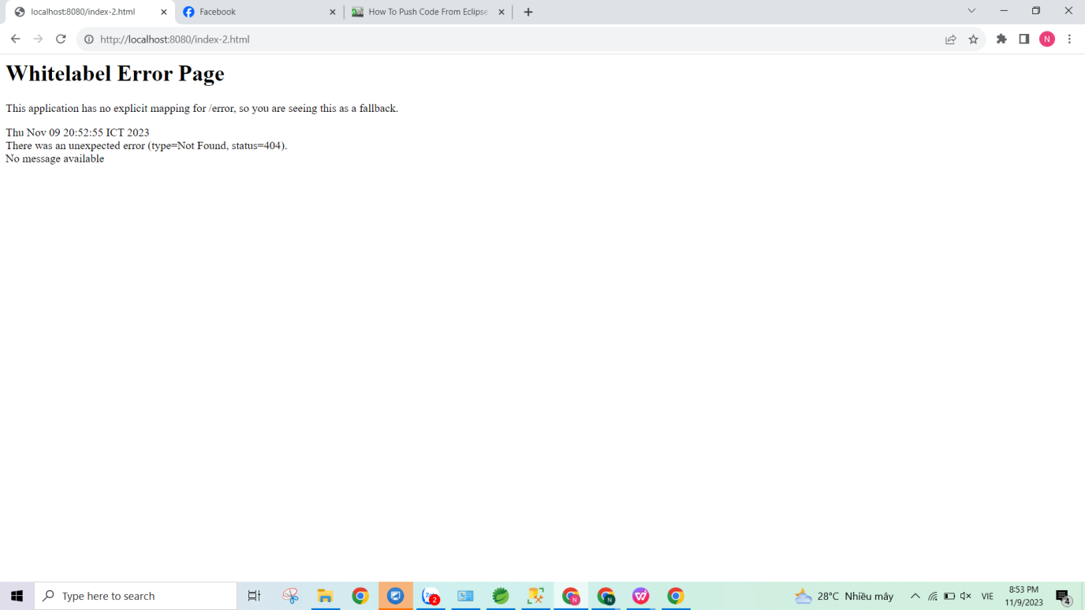

### #Bug2: Chuyển trang <http://localhost:8080/about> false

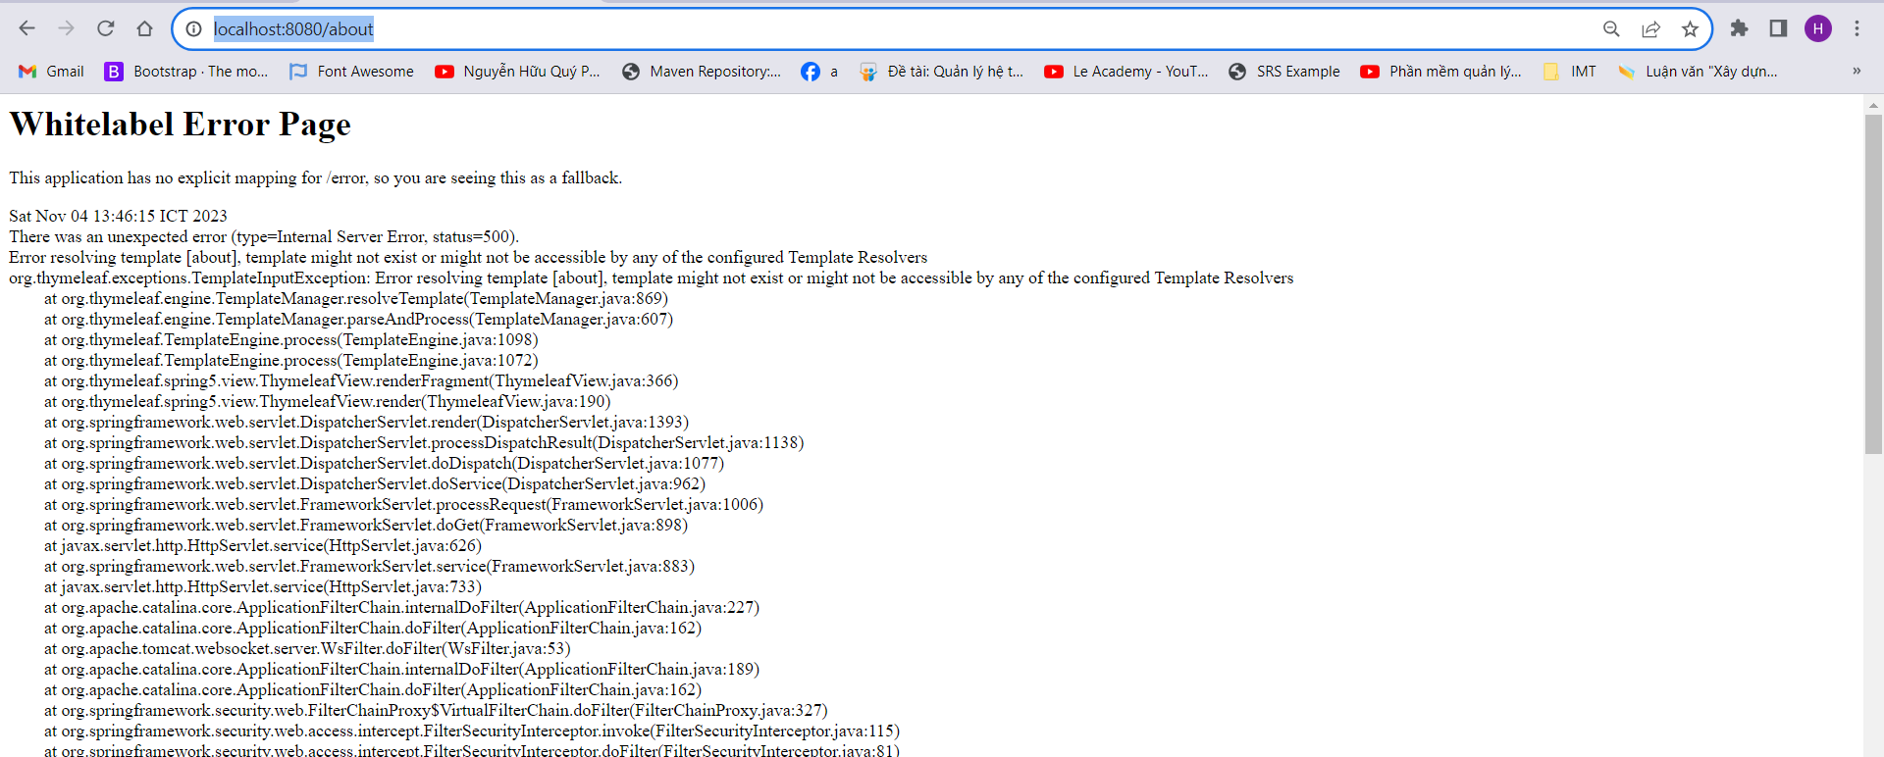

### Done #Bug1: Chuyển trang <http://localhost:8080/shop> false

