Now write SQL for the following and the test the queries:

5. The make and model of the cars which cost below $15,000.00.

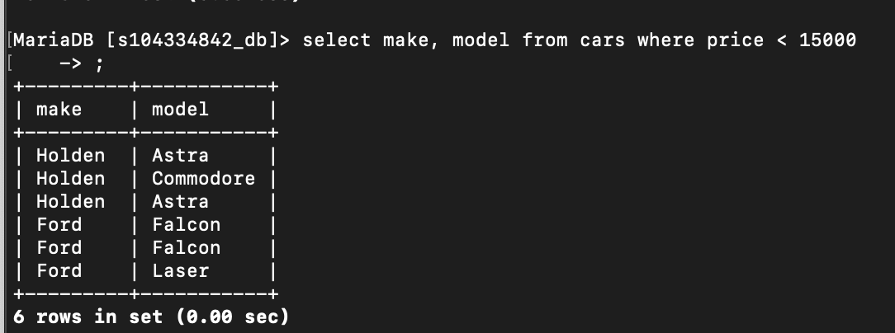

6. Average price of FORD cars.

**7. Cars manufactured in 2010 or later and costing $15,000 or more.**

