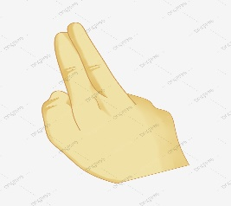

**Send Control Signals**

**Create event**

**Hand Gesture**

**Get Hand Movement**

**Module Bluetooth**

**IMAGE PROCESS**

**CAMERA**

**Car or  
Other devices**