1 install node

npm init

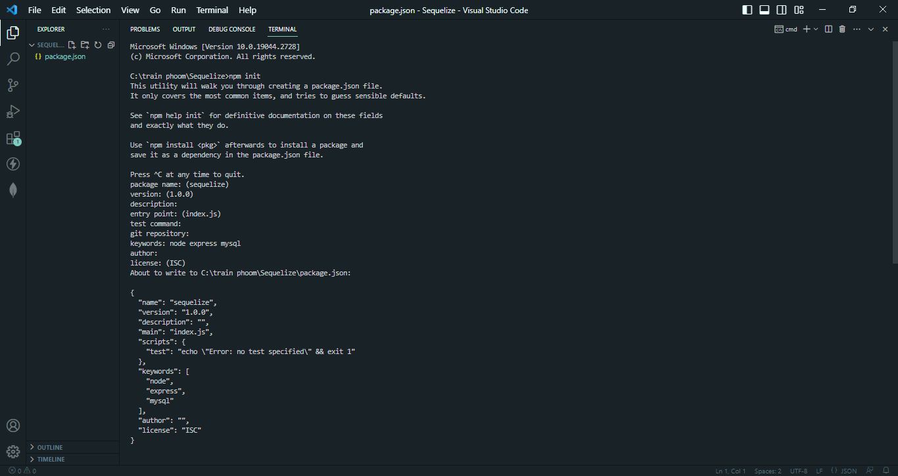

2 npm i –save express sequelize cors mysql2

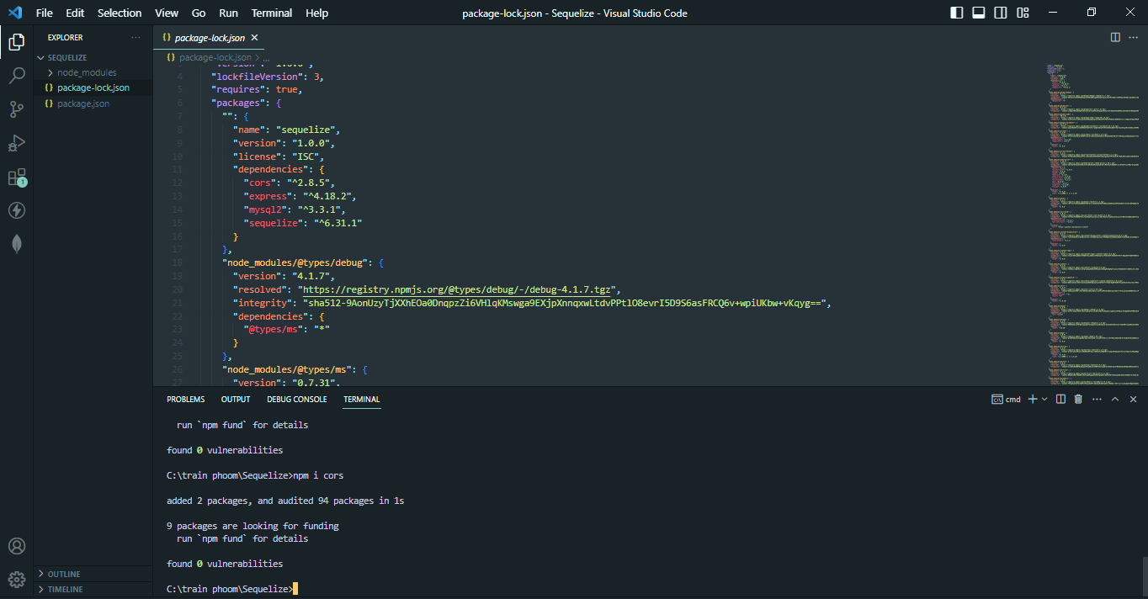

3 create folder config controllers models and file server.js

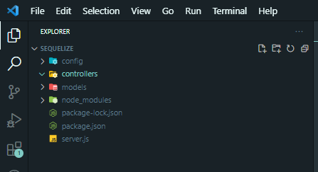

4 create file server.js

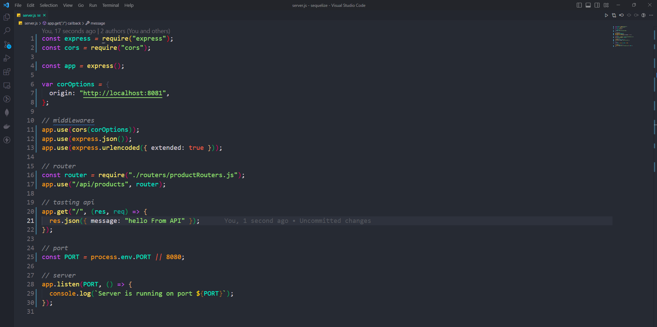

5 create file dbConfig.js in folder config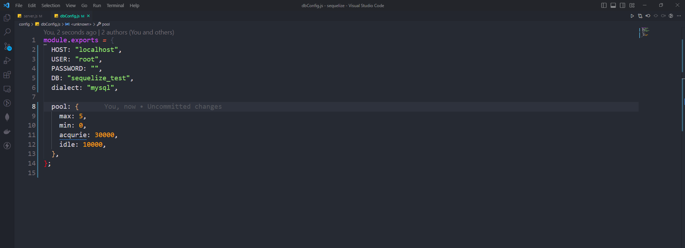–

6 create file index.js in folder models

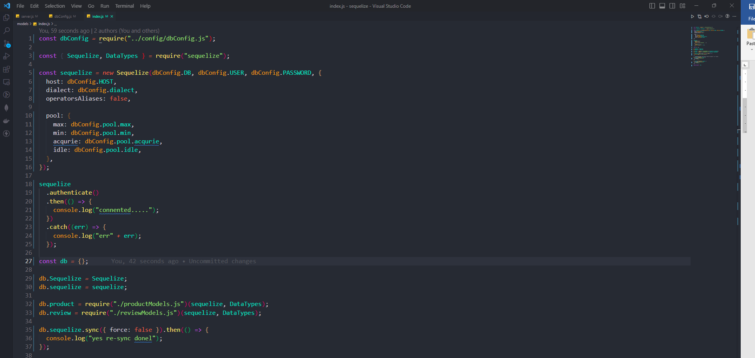

7 create file product and review in folder models

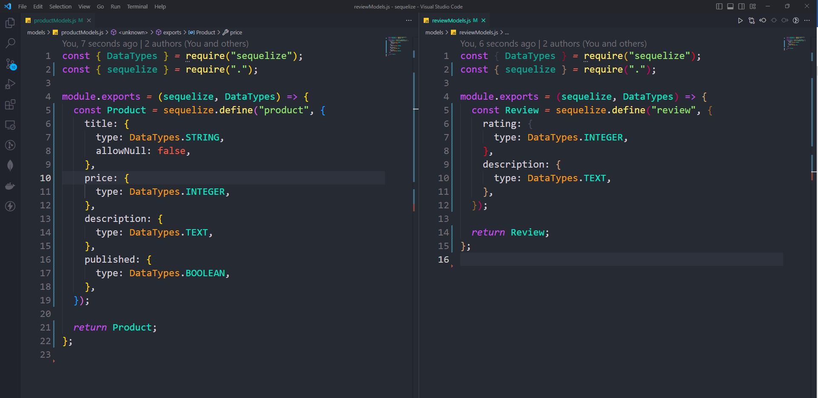

8 create productcontrollers.js

8.1 create product

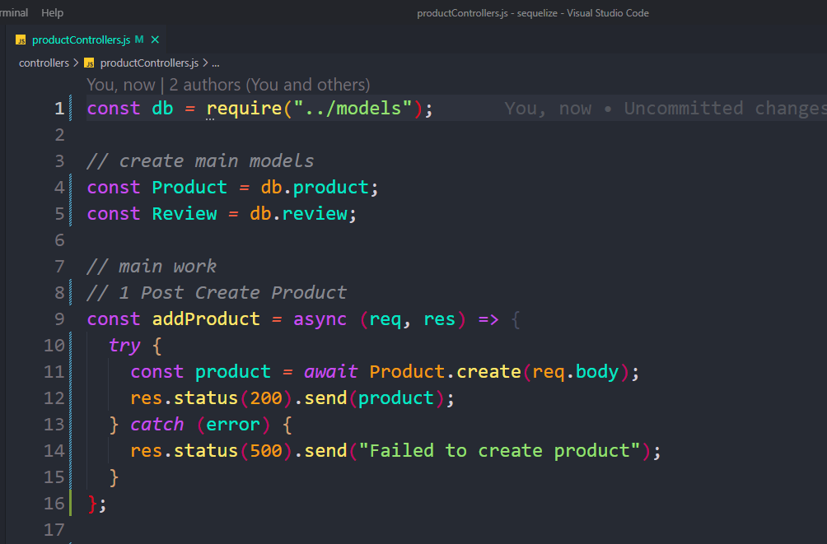

8.2 get all product

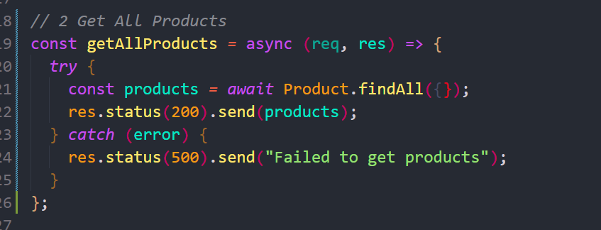

8.3 get single product

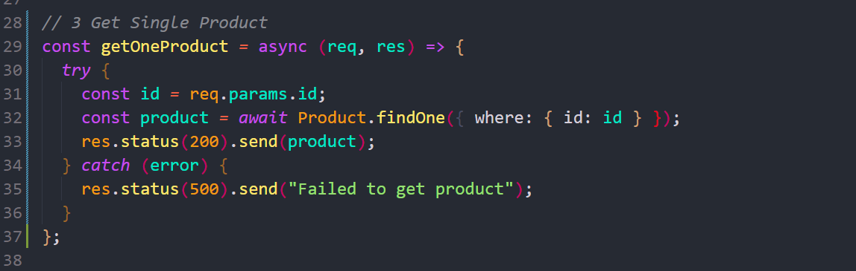

8.4 update Product

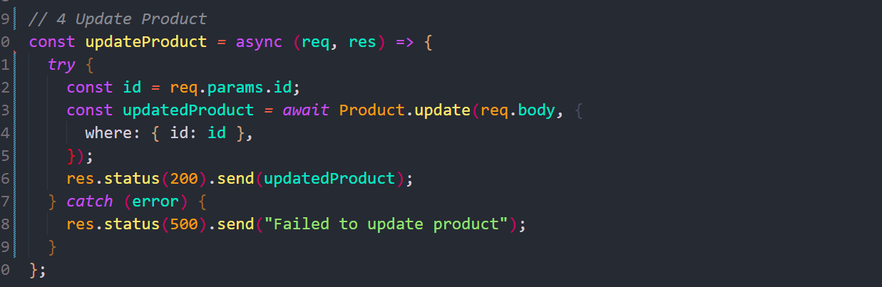

8.5 delete product

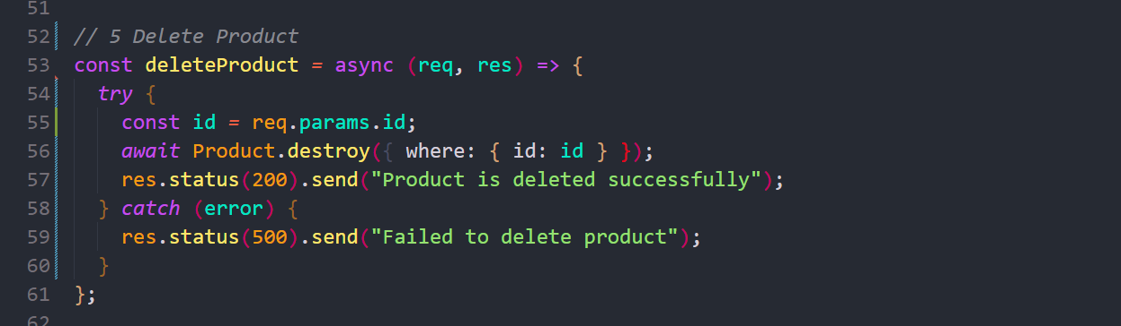

8.6 *published product*

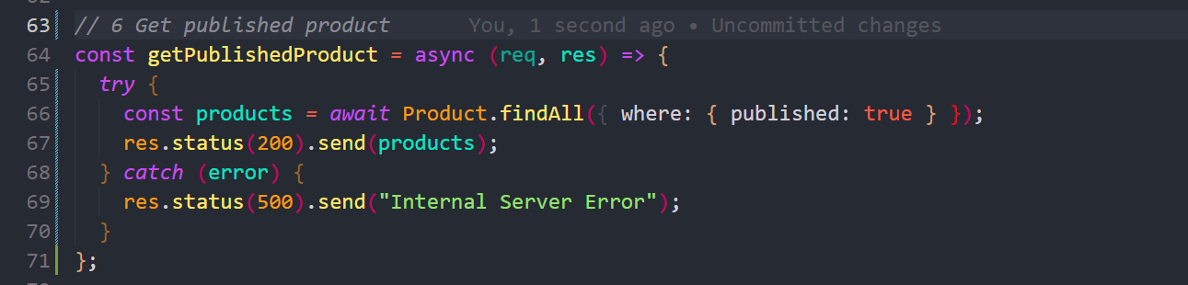

9 create folder Routers and create file productRouters and create router in file productRouters.js

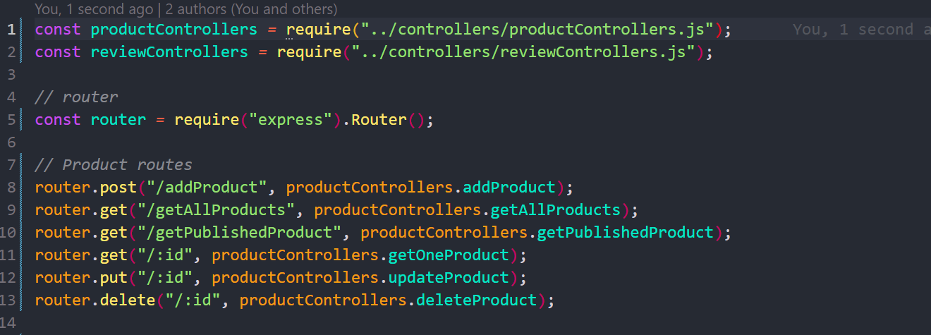

10 create router in file server.js

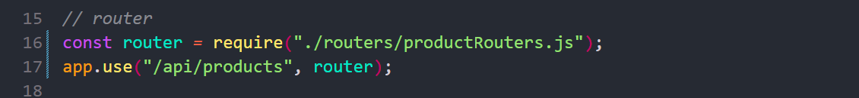

11 create file review in folder controllers

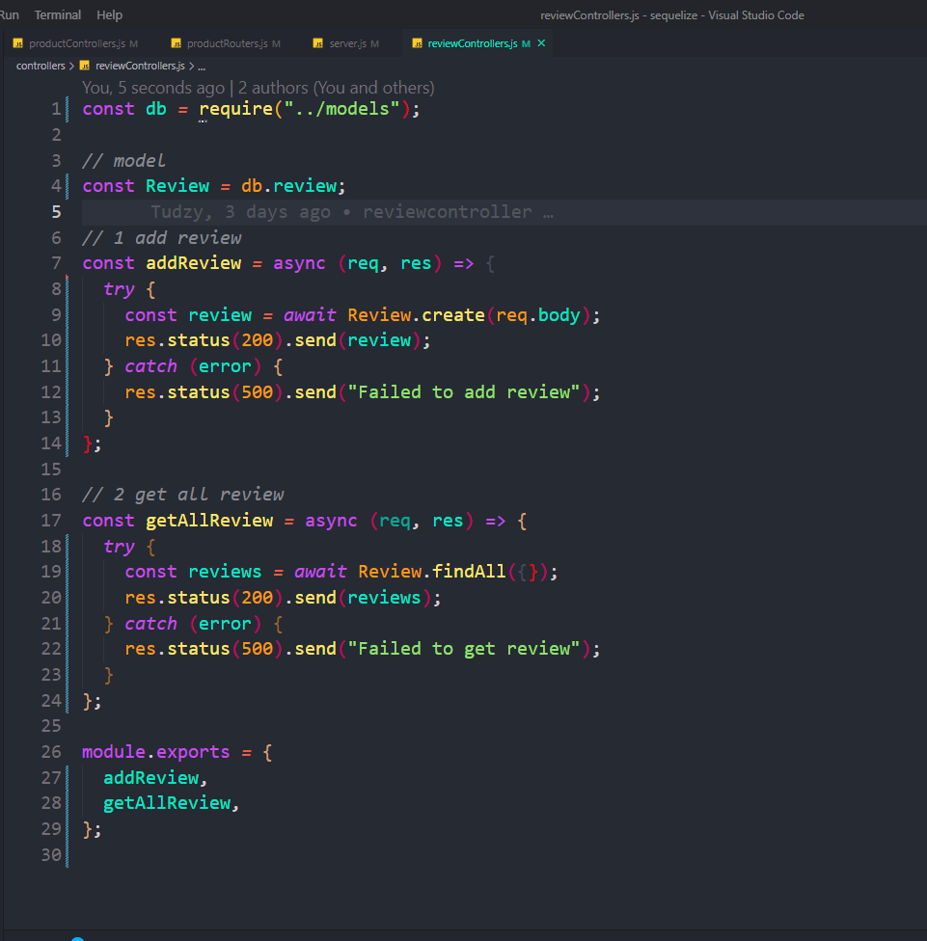

12 add reviewcontrollers.js in productRouter

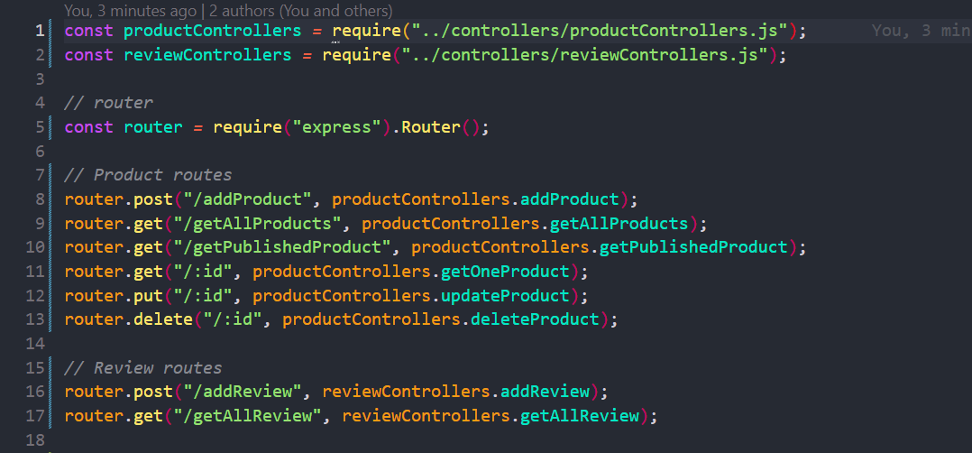

13 edit index.js in models

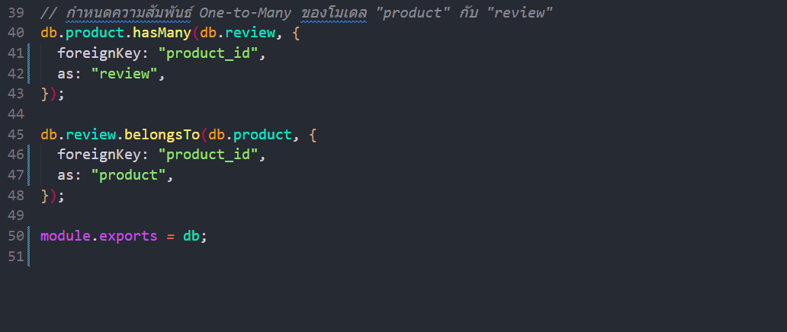

14 connect one to many

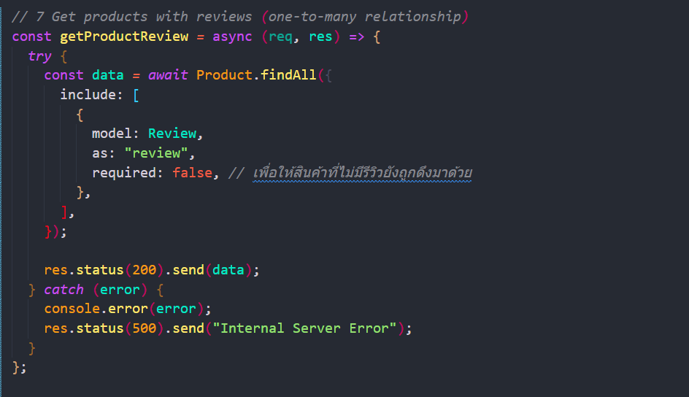

**15 create getProductReview in productRouter.js**

