|  |
| --- |
| **How to create a winning skateboarding game**  Market Insights and Player Data  **Vivek Pillai**  **Internship Assignment ~ MB Softech Consultants** 2/28/2023 |
|  |

Introduction:

Skateboarding games have been a popular genre in the video game industry for decades, offering players the chance to experience the thrill and excitement of skateboarding from the comfort of their own home. With the recent resurgence of interest in skateboarding culture, fueled in part by the popularity of social media platforms such as TikTok and Instagram, the market for skateboarding games has seen a renewed surge of interest.

As a game data analyst, it is our task to conduct a detailed analysis of the skateboarding games market, including the competition, sales records, available markets, and player behavior insights. In this report, we will provide a comprehensive overview of the skateboarding games market across different platforms, including PC, Xbox, PlayStation, Android, and iOS.

This report is divided into several sections, with each section providing detailed information on a specific aspect of the skateboarding games market. In the first section, we will provide an overview of the skateboarding games market, including the number of games available on each platform and the direct competition that we will be facing. In the subsequent sections, we will delve deeper into player behavior insights, sales records, available markets, and other relevant topics.

Our goal is to provide actionable insights and recommendations that will help our team to develop a successful skateboarding game that appeals to a wide audience and stands out in a crowded market.

Market Analysis

The skateboarding games market has seen significant growth in recent years, with the rise of skate culture and the popularity of extreme sports among gamers. According to a report by **Statista**, Revenue in the Video Games segment is projected to reach US$365.60bn in 2023, with **mobile games** accounting for the largest segment with market volume of US$315.90bn in 2023. The skateboarding games market is a subset of the larger video games market, with a variety of games available on different platforms.

* Number of Skateboarding Games

There are currently several skateboarding games available on each platform, including PC, Xbox, PlayStation, Android, and iOS. Some of the most popular skateboarding games include Tony Hawk's Pro Skater 1+2, Skate XL, and Skater XL. In total, there are over 66 skateboarding games available on various platforms according to **Wikipedia**, with new games being released every year.

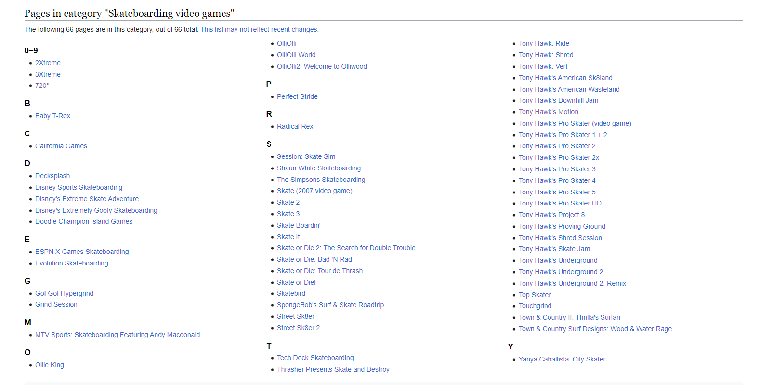

* Direct Competition

The skateboarding games market is highly competitive, with several well-established players competing for market share. The direct competition that our project will be facing includes games like Tony Hawk's Pro Skater 1+2, Skate XL, and Skater XL, which have established fan bases and loyal players. These games offer a range of features, including **realistic physics, customizable avatars, and online multiplayer modes**. Our project will need to offer unique features and gameplay to stand out in this crowded market.

Overall, the skateboarding games market presents a significant opportunity for growth and innovation, but also poses significant challenges for new entrants. It will be important for our project to differentiate itself from the competition and offer a compelling value proposition to players. By conducting further **market research** and **analyzing player behavior data**, we can identify areas of opportunity and develop a winning strategy for our skateboarding game.

**Sales Record**

Sales records for most popular Skateboard games (All Platforms):

**Tony Hawk's Pro Skater 1 + 2**: Tony Hawk’s Pro Skater 1 + 2 has become the fastest-selling game in the franchise, selling **1 million copies in the first two weeks.** In the United Kingdom, the game was the biggest launch for the franchise since 2003's Tony Hawk's Underground and was the second biggest launch in the franchise overall.

**Skate 3:** Skate 3 is the third installment in the Skate series and the sequel to 2009's Skate 2, developed by EA Black Box and published by Electronic Arts. It was released worldwide in May 2010 for PlayStation 3 and Xbox 360 with a total sale of **2.71 million on xbox and 2.03 million on ps3.**

**Session- Skate Sim: Session:** Skate Sim is developed by Montreal independent developer Crea-ture Studios for Microsoft Windows, Nintendo Switch, PlayStation 4, PlayStation 5, Xbox One and Xbox Series X/S. According to steam.db, VG Insights and SteamSpy Session: Skater Sim has estimated to have a sold of **300-513K copies**.

|  |  |
| --- | --- |
| **Game** | **Total Sales** |
| True Skate | 5 Mn (Mobile Downloads) |
| Tony Hawk’s Pro Skater 1+ 2 | 1Mn in 10 days |
| Skate (2007) | 0.71Mn (xbox) + 0.38Mn (ps3) |
| Skate 3 | 2.71Mn (xbox) + 2.03Mn (ps3) |
| Session: Skate Sim | 0.3Mn-0.51Mn |
| OlliOlli World | 60K on Steam |
| Skate 2 | 1Mn (xbox) + 0.83Mn (ps3) |
| Shaun White Skateboarding | 0.20Mn (ps3) + 0.16Mn (xbox) + 0.18Mn (Wii) + 0.03Mn (Pc) |
| Skateboard Party 3 | 5 Mn (Mobile Downloads) |

**Awards and Recognition**

* Tony Hawk’s Pro Skater 1+2

|  |  |  |  |
| --- | --- | --- | --- |
| **Award** | **Year** | **Category** | **Result** |
| Gamescom Awards | 2020 | Best Sports Game | **WON** |
| Golden Joystick Awards | 2020 | Best Multiplayer Game | Nominated |
| Xbox Game of the Year | Nominated |
| The Game Awards | 2020 | Best Sports/Racing Game | **WON** |
| D.I.C.E Awards | 2021 | Sports Game of the Year | **WON** |
| NAVGTR Awards | 2021 | Outstanding Game, Classic Revival | Nominated |
| SXSW Gaming Awards | 2021 | Excellence in Audio Design | Nominated |
| The Dreamies | 2021 | Refreshing Revive | Nominated |

* **Rating**

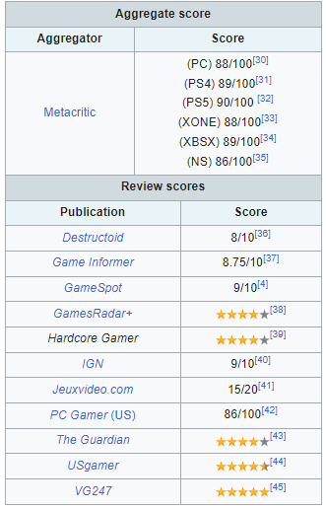

* Skate (2007)

|  |  |  |  |
| --- | --- | --- | --- |
| **Award** | **Year** | **Category** | **Result** |
| BAFTA Game Awards | 2007 | Artistic Achievement | Nominee |
| Best Use of Audio |

* **Rating**

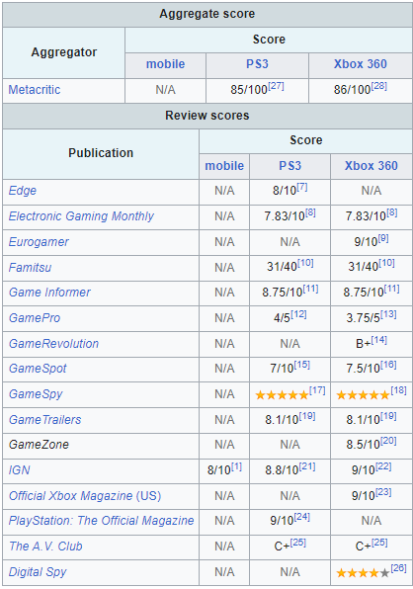

* Skate 3

***NO AWARDS***

* **Rating**

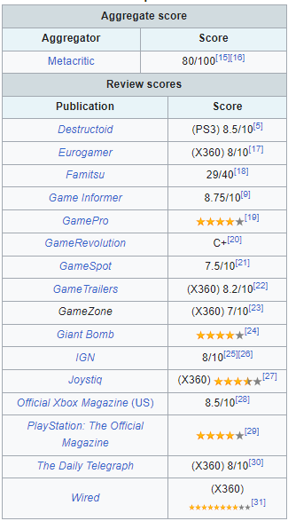

* Session: Skate Sim

|  |  |  |  |
| --- | --- | --- | --- |
| **Award** | **Year** | **Category** | **Result** |
| Steam Awards | 2022 | Best Game You Suck At | Nominee |

* **Rating**

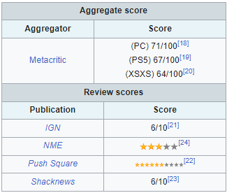

* **OlliOlli World**

|  |  |  |  |
| --- | --- | --- | --- |
| **Award** | **Year** | **Category** | **Result** |
| Golden Joystick Awards | 2022 | Best Audio | Nominated |
| The Game Awards | 2022 | Best Sport/Racing Game | Nominated |
| 26th Annual D.I.C.E Awards | 2023 | Sports Game of the Year | **WON** |
| 23rd Game Developers Choice Awards | 2023 | Social Impact Award | Pending |
| Best Visual Art | Honorable Mention |

* **Rating**

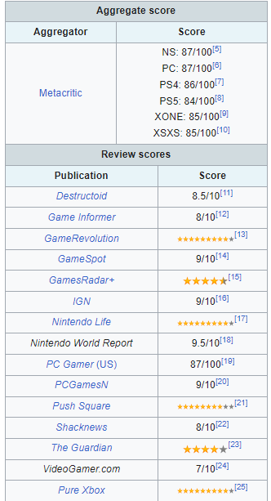

* **Skate 2**

|  |  |  |  |
| --- | --- | --- | --- |
| **Award** | **Year** | **Category** | **Result** |
| D.I.C.E Awards | 2010 | Outstanding Achievement in Sound Design | Nominated |
| Outstanding Achievement in Soundtrack | Nominated |
| Canadian Videogame Awards | 2010 | Best Audio | Nominated |
| Best Technology | Nominated |

* **Rating**

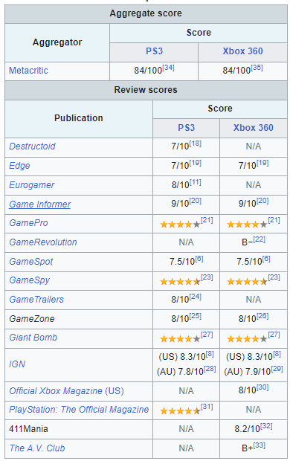

* Shaun White Skateboarding

***NO AWARDS***

* **Rating**

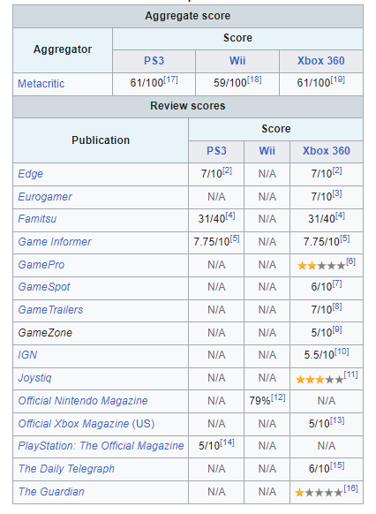

* **Skater XL**

***NO AWARDS***

* **Rating**

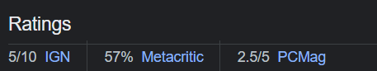

**Player Behavior Analysis**

**Average session duration**:

|  |  |  |  |
| --- | --- | --- | --- |
| Game | Average Player Count (Week) | Average Twitch Views (Week) | Average Play Time (Total) |
| Session: Skate Sim | 373 | 22 | 15h |
| OlliOlli World | 64 | 23 | 0.7h |
| Skater XL | 458 | 96 | 31h |
| Tony Hawk’s Pro Skater 1 + 2 | -- | -- | 12h |

**Popularity Score:**

|  |  |  |
| --- | --- | --- |
| **Game** | **Popularity Score (/100)** | **📈+/-** |
| Session: Skate Sim | 5 | -- |
| Tony Hawk’s Pro Skater 1+ 2 | 7 | +0.2 (Week) |
| Skate (2007) | 5 | +0.1 (Week) |
| Skate 3 | 9 | +0.2 (Week) |
| Skater XL | 7 | -- |
| Skater 2 | 5 | -- |
| OlliOlli World | 5 | +0.3 (Week) |

*(Data from PlayerTracker.net)*

**Strategies and Suggestions**

1. **Focus on creating a strong user experience:** The gameplay and controls should be intuitive and easy to learn, while also being challenging and engaging.
2. **Provide regular updates and new content:** Keep the game fresh and exciting by adding new levels, tricks, and features on a regular basis. This will help to retain existing players and attract new ones.
3. **Incorporate social features:** Encourage players to share their progress, scores, and achievements on social media platforms. This will help to create a sense of community around the game and increase its visibility.
4. **Offer in-game rewards and incentives:** Provide players with a sense of progression and achievement by offering rewards such as new gear, customizations, or access to exclusive content.
5. **Analyze player feedback and behavior:** Pay attention to player feedback and behavior data to identify areas where the game can be improved or optimized. Use this information to guide future updates and enhancements.
6. **Optimize for mobile devices:** Ensure that the game is optimized for mobile devices, with a responsive design and efficient use of resources to minimize load times and improve performance.
7. **Leverage emerging technologies:** Consider incorporating emerging technologies such as augmented reality or virtual reality to enhance the gameplay experience and attract new players.
8. **Partner with influencers and content creators:** Partner with popular influencers and content creators in the skateboarding community to promote the game and reach a wider audience.
9. **Beta releases:** Consider releasing a beta version of the game to a small group of players to gather feedback and make improvements before the official launch. This can help identify and fix any bugs or issues, as well as get early feedback from players.
10. **In-game purchases:** Implement a variety of in-game purchases that players can make to enhance their experience. This can include cosmetic items like skins and costumes, as well as additional levels or game modes that can be purchased. It's important to balance the in-game purchases so that they don't feel too intrusive or mandatory, but still provide value to players.
11. **Esports integration:** Consider integrating the game into esports competitions and events. This can help build a community of dedicated players and increase the game's visibility and popularity. It's important to design the game with esports in mind, with a focus on balance and fairness for competitive play.
12. **Social media presence:** Build a strong social media presence for the game, with regular updates and engagement with the community. This can help build excitement and anticipation for the game, as well as provide a platform for feedback and communication with players.
13. **Player progression and rewards:** Implement a system of player progression and rewards to encourage players to keep playing and improving. This can include achievements, leaderboards, and unlocking new content as players progress.
14. **Regular updates and bug fixes:** Commit to regular updates and bug fixes to keep the game fresh and address any issues that arise. This can help keep players engaged and satisfied with the game over the long term.

By implementing these strategies and suggestions, the skateboarding game project can have a better chance of success in the market and provide an enjoyable and engaging experience for players.

**Data Visualization:**

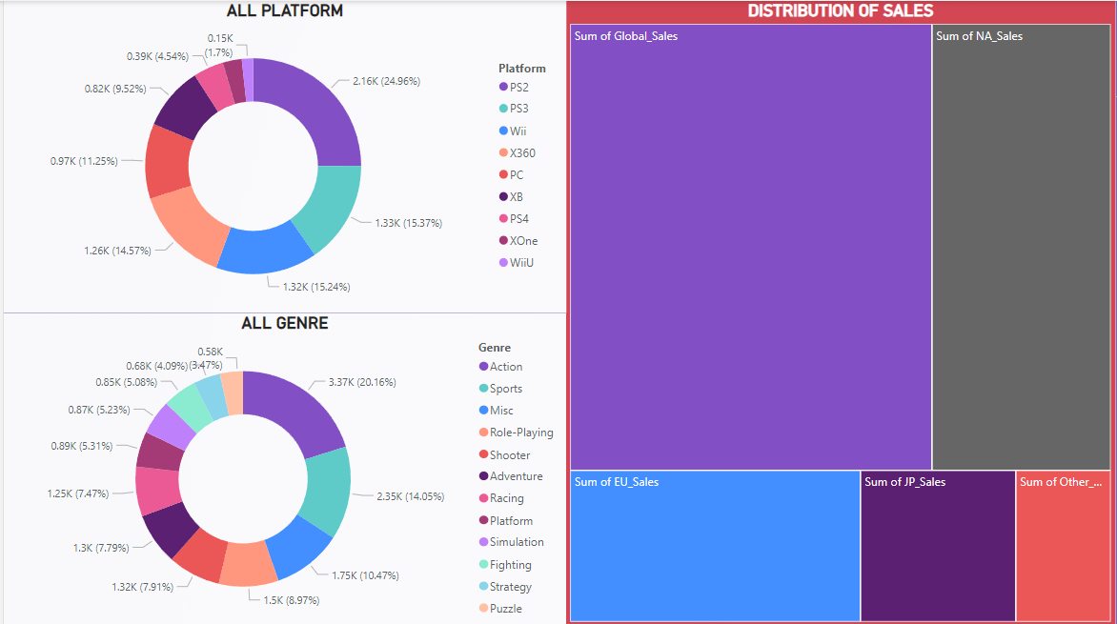

**Conclusion**

In conclusion, after conducting a detailed analysis of the skateboarding game market, it is evident that there is a significant demand for such games across multiple platforms. There are several direct competitors in the market, such as Tony Hawk's Pro Skater 1+2 and Skate XL, who have recorded substantial sales figures. However, our game can differentiate itself by implementing unique gameplay mechanics and focusing on the mobile platform, where there is immense market potential.

Moreover, community engagement can play a crucial role in the success of our game. By participating in online forums and social media groups, we can gain valuable feedback from players and make necessary improvements to the game. Additionally, the implementation of in-game purchases can generate a substantial revenue stream, as several players are willing to spend money on virtual items and upgrades.

The player behavior analysis has revealed valuable insights, such as the most popular tricks performed by players and their average session duration. These findings can be utilized to enhance the gameplay experience and increase player engagement.

Overall, by implementing the suggested strategies and utilizing the data-driven approach, our game can potentially achieve substantial success in the skateboarding game market.