Exercise 5: Simple GUI Application

# Instruction

1. Open Eclipse and then “new > java project”. Your Eclipse Java Project will be named as: 2110215_Exercise5_2019_{ID}_{FIRSTNAME}.
   * Example: “2110215_Exercise5_2019_6130123421_John”.
2. Do not forget to import JavaFX SDK library to your project module path.
3. Implement the program as per instruction in this document.
4. After finishing the program, **call a TA to check the result**.
5. Create a UML Diagram using “ObjectAid” and put the result image (UML.png) in your project folder.
6. Export your project into a runnable jar file called “Exercise5_2019_{ID}”.
   * Example: “Exercise5_2019_6130123421.jar”.

Exercise 5: Simple GUI Application

# Problem Statement

The objective of this exercise is to implement the simple GUI application as shown in Figure 1 below using JavaFX platform. You must create a GUI using a coding approach learned in the class.

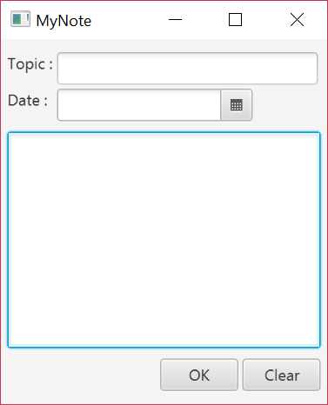

Figure 1: The expected resulting GUI application.

There are three sections in the application: the top section, the middle section, and the bottom section. The top section contains two Labels, a TextField, and a DatePicker. The middle section contains a single TextArea. The bottom section contains two buttons: OK button and Clear button.

# GUI Specifications

## General

1. The window has the title as **“MyNote”**.
2. The size of the window (excluding the frame, i.e. title bar, window border) is of size 270 × 300.
3. The padding size of the window is 10 vertically and 5 horizontally.
4. The vertical spacing between each section has the size of 8.

## Top Section

The top section contains two rows.

1. The first row contains a Label with the text **“Topic : ”**. The Label is aligned to the left side of the window and is followed by a TextField with the width of 200.
2. The second row contains a Label with the text **“Date : ”** on the left. The Label is aligned to the left side of the window and is followed by a DatePicker with the width of 150.
3. A vertical spacing between the two rows has the size of 3.

## Middle Section

The middle section contains a single TextArea, which its horizontal size should fill up the space of the window.

## Bottom Section

The bottom section contains two buttons.

1. The text of the button on the left is **“OK”**.
2. The text of the button on the right is **“Clear”.**
3. Each button has a width of 60.
4. Both buttons are aligned to the right side of the window.
5. The horizontal spacing between the buttons has the size of 3.

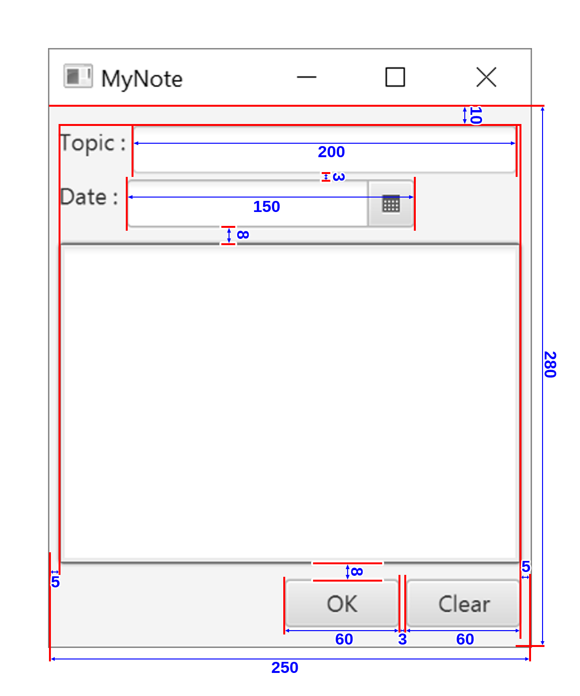

**300**

**270**

Figure 2: GUI’s layout specification

# Event Handling Specifications

## Button “Ok”

When this button is clicked, notify the user using Alert with AlertType of “INFORMATION” and show detail in this format

Topic : {TOPIC_FROM_TEXTFIELD}

Date : {DATE_FROM_DATEPICKER}

Description : {DESCRIPTION_FROM_TEXTAREA}

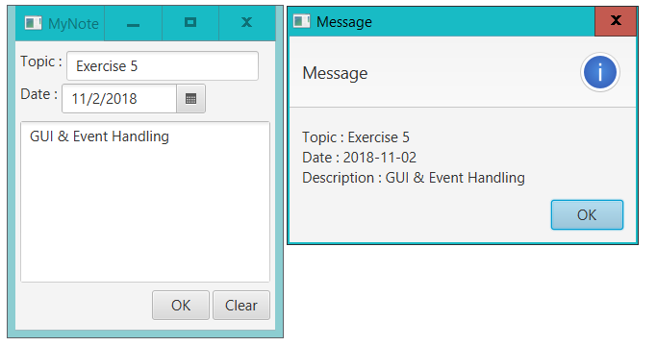

Figure 3: Alert example when OK button is clicked

## Button “Clear”

When this button is clicked, the data in topic TextField and date of DatePicker in top section along with description TextArea in the middle section will be cleared.

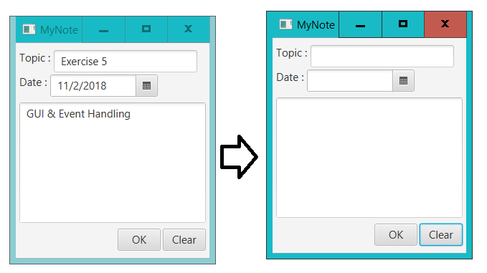

Figure 4: GUI when Clear button is clicked