PhotoManager PM

User Manual
and
Installation Guide

Version 1.2.4-0 (November 2010)

Copyright © 2004 – 2010 Dietrich Hentschel <dihent@freenet.de>
Table of Contents
1Introduction 4
1.1Motivation 4
1.2A Typical Workflow 4
1.3Delete, Move and Copy your Pictures 5
2Program Start 6
2.1The First Program Start 6
2.2All Further Program Starts 8
3The Graphical User Interface 9
3.1The Thumbnails Windows 10
3.1.1Zooming 10
3.1.2Remove a Thumbnail 10
3.1.3Thumbnails surrounded with a black dashed line 11
3.1.4Thumbnails surrounded with a red line 11
3.1.5The Text under the Thumbnails 11
3.2The Menu Bar 12
3.2.1Menu “File“ 12
3.2.2Menu “Search” 12
3.2.3Menu “Delete“ 13
3.2.4Menu “Extras“ 13
3.2.5Menu “PM-Info“ 14
3.3Preview Window 15
3.4Subwindows 15
3.5Status Bar 17
4The Photo Album 18
4.1“Open” picture collection 19
4.2Closed Picture Collection (B and X Sequences) 21
4.2.1Create a Sequence in Subwindow “Sequence” 21
4.2.2Insert the Sequence in Subwindow “Search” into photo album 21
5Slide Show 22
5.1Text under the Picture 22
6Insert Search Keys 24
6.1Insert Search Keys in Subwindow “Picture” 24
6.1.1Change the Creation Date 24
6.1.2Manage Indices 25
6.2Insert Search Keys in Subwindow “Group” 26
7Manage Base and Extended Sequences 27
7.1.1 Create new Sequences 27
7.1.2Modify Sequences 28
7.1.3Delete a Sequence 28
8Modifying Pictures 30
8.1.1Modify internally 30
8.1.1.1Cut 30
8.1.1.2Rotate and Mirror a Picture 31
8.1.2Modify with an External Picture Modification Program 32
9Import or Export Pictures 34
9.1Import 34
9.1.1Import Internally 34
9.1.2Import Externally 35
9.2Export 36
9.2.1Export without Deletion 37
9.2.2Delete Pictures Irrevocable 38
10Print 39
11Display the EXIF information 40
12Appendix A: Installation 41
12.1Start Options 41
12.2Linux 43
12.2.1Linux: Direct Camera Import (autostart) 43
12.3Windows 44
12.3.1Windows: Direct Camera Import (autostart) 44
12.4OS Independent Installation 45
13Appendix B: License and Author 46

Introduction

Motivation
Do you know it: First, you have a few dozen pictures on the PC, then you get more and more and suddenly you have about a thousand? Still you have the overview and can find all the pictures at request.
But slowly the overview was gone. This is besides the many advantages one of the disadvantage of the digital photography. There are more and more pictures and no one want to delete any picture. Perhaps you need just the deleted one.
This program will help you. It was built from 2003 until today and it's not complete, but quite useful. It is open source, you can use it free of charge and it is created in the Java programming language. You can use it on many computer platforms, on Linux, Windows, Mac, and all systems with a Java runtime environment.
You can do with the program nearly all conventional exercises that any photo manager can do. You can import, sort, and make picture collections; the pictures can be rotated, mirrored and exported. It can call an external picture modification program and PhotoManager manage all your modified versions of your pictures.
Above all, the program doesn't modify, move, or copy the original picture files. All changes are stored in auxiliary data. If you don't like the program you can start the “uninstall” function and delete all the auxiliary data. Then the pictures are as they were before the first program start: untouched and unchanged. Try out the program; you can only willfully destroy your picture collection.

A Typical Workflow
Here is a typical workflow, how you can manage your pictures with the program. It is only a suggestion, but it has been proven.
So you could use the program:

- Import the pictures from your camera: connect it to the PC and the program starts automatically and import all pictures
- You can see all just imported pictures in the preview window
- You can immediately delete any picture you don't like
- Create one or more picture collections
- Insert the newly created collections into your photo album

This is done quickly. You shall do it with all just exposed pictures.
After then you can do more, depending of time and “appetite”:
- make search keys for some or all pictures
- rotate, cut and modify them with an external picture modification program
- make more picture collections and show them with the slide show
- make paper copies, export pictures, and send them via email to friends
- Classify, sort ....

This is a recursive process.

Delete, Move and Copy your Pictures
The program normally doesn't delete, move, or copy any picture file.
There are some exceptions:
- You can delete consciously original picture files in the subwindow “Export”.
- You copy original picture files to a save place on your hard disk before you modify them with an external picture modifying program.

Program Start
Before using Photo Manager (PM), you must install the program on your computer (see Annex to this document).
Depending on the installation and operating system you start PM by pressing the icon on your desktop or by selecting PM in the menu of all the installed programs. Ask in doubt your supervisor for the PC or those who installed the program.
If you start the program on your computer for first time, it prompts for the Top Level Picture Directory TLPD. This is the directory for all pictures managed by PM. For every picture in or under the TLPD the program creates a thumbnail and some auxiliary data (meta data). The program neither copies, moves, nor deletes the original picture files.

The First Program Start
After you start the program for first time, PM ask you for the language. Select the desired language and click "Continue" (Later you can change the selected language in menu → Extra → Language/Sprache).

Then PM prompt for the Top Level Picture Directory TLPD.
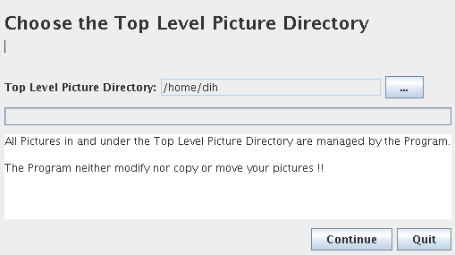

Change the TLPD or press the button (...) to choose the directory with the file chooser. Press button “continue” and PM display the number of the found pictures in or under the TLPD.

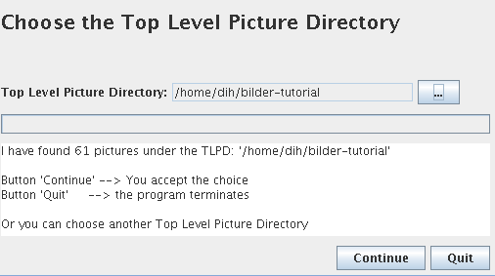

Once you have pressed the "Continue" button, the Graphical User Interface GUI is loaded and you will see another dialog with the number of found pictures (with the GUI in the background).
Press again button “continue” and PM check for duplicate pictures to import. Then the result will be displayed:
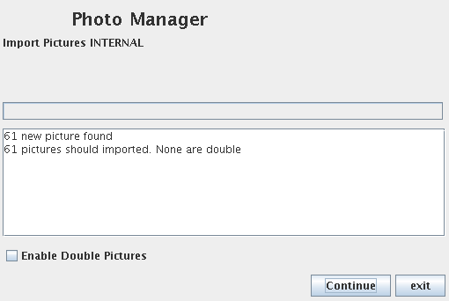

If PM found duplicate pictures, you must decide whether to import them. Select the button "import duplicate pictures" if you want (you can later browse your picture collection for duplicate pictures and delete them if necessary).
After you click the "Continue" button PM will generate a thumbnail of each picture. It takes a while, about ½ to 1 second per picture.
After all pictures are imported they will be displayed at the left side window, the preview window.
Note:
If the program no pictures founds after selecting the Top Level Picture directory TLPD, you should continue anyway. Later you can import all the pictures you want to manage by the program.

All Further Program Starts
For all other program starts no Top Level Picture Directory TLPD will be prompted. PM always check for unknown pictures in and under the TLPD. If new pictures are found the program ask you to import them.
If the program is running you can at any time import new pictures: Copy them into or under the TLPD or connect your camera to your PC.

The Graphical User Interface
After successful program start you see the Graphical User Interface GUI of PM. IT always look like this:
On the left side you see always the “Preview Window” and on the right side one of the 8 “Working Windows”.

On Top: The Menu Bar
Tabs to select another Subwindow

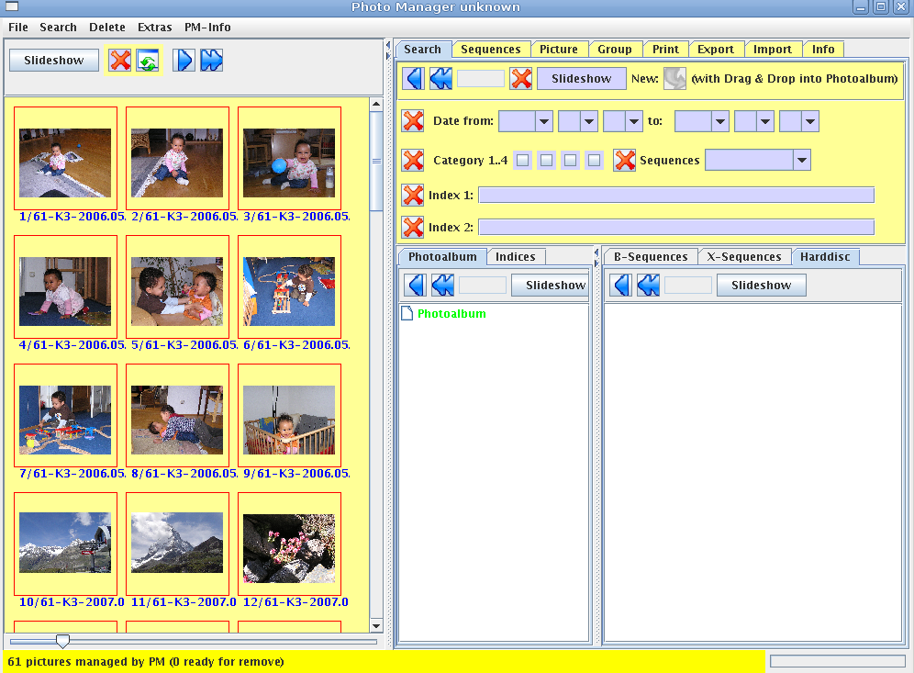

Right side the
Subwindows
Left side the Preview Window

Below the Status line
A Divider between the Preview Window and the Subwindow

- On the top is the Menu Bar
- on the left is the Preview Window
- on the right side are the various Subwindows. They can be reached with the tabs on top. There are eight different subwindows. After program start the subwindow “Search” will be displayed
- on the bottom is the Status Bar

The Thumbnails Windows
There are several windows to display thumbnails: The Preview Window on the left side and on the right side the Subwindows “Sequences”, “Group”, “Print”, and “Export”. All the thumbnails in the windows have the same behavior.

Zooming
Below every window with thumbnails there is a slider to zoom continuous the thumbnails.

Remove a Thumbnail
You can remove a thumbnail from the window. This can be undone.

This thumbnail is deleted
from the window
Remove all white squares

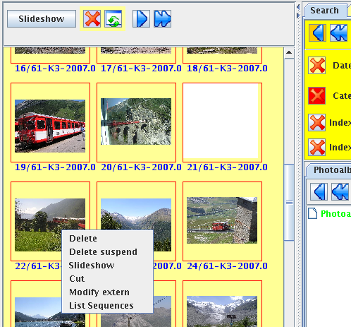

Select the thumbnail and get the context menu with the right mouse button

The thumbnails will be only removed from the window, not from your hard disc.
- Remove the Thumbnail:
Select the thumbnail with the left mouse button. Then get with the right mouse button the context menu and select “Delete”. A white square is displayed.
- Suspend the deletion:
Select the white square. Then get with the right mouse button the context menu and select “Delete Suspend”.

- Remove all white squares from the window:
Press the button on top the window.

Thumbnails surrounded with a black dashed line
If there are in the left side preview window thumbnails surrounded with a black dashed line, the same thumbnails are displayed on the right side.

Thumbnails surrounded with a red line
Thumbnails surrounded with a thin red dashed line:
This pictures belongs not to a base sequence.
Thumbnails surrounded with a thick red dashed line:
Only in the subwindow “Sequences” (a base sequence).
This picture belongs to another base sequence than the selected sequence.

The Text under the Thumbnails
Under every thumbnail is some information, for instance:

X3/28-K3-2007.04.27
X Optional: The picture was modified with an external picture modification program
3/28 The third of 28 thumbnails
K3 The picture category 1 to 4
2007.04.27 Creation date of the picture (from the EXIF information)

The Menu Bar

Menu “File“

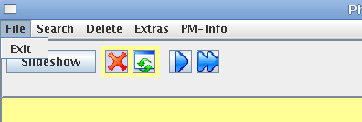

Menu “Search”
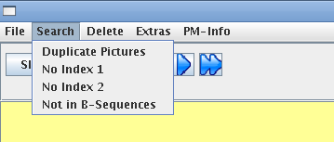

- Duplicate Pictures:
Find all duplicate pictures.
- No Index 1:
Search all pictures have no Indices 1.
- No Index 2:
Search all pictures have no Indices 2.
- Not in B-Sequences:
Search all pictures not in base sequences.

Menu “Delete“
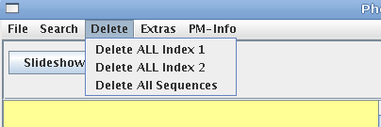

- Delete ALL Index 1:
Delete irrevocable all Indices 1.
- Delete ALL Index 2:
Delete irrevocable all Indices 2.
- Delete ALL Sequences:
Delete irrevocable all base and extended sequences.

Menu “Extras“
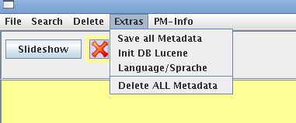

- Save all Metadata:
Save all modified metadata.
- Init DB Lucene:
Create a damaged Lucene DataBase.
- Language/Sprache:
- Delete ALL Metadata (Uninstall):
Delete irrevocable ALL the metadata.

Menu “PM-Info“

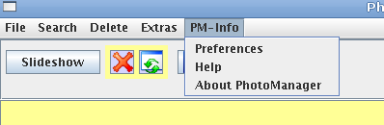

- Preferences:
information over the program, version, pathes ...
- Help:
Online Help (not yet available).
- About PhotoManager:
Version and the author.

Preview Window
In this window, pictures are displayed as thumbnails.
With the single right arrow you can copy all thumbnails into a subwindow on the right side. With the double right arrow you append the thumbnails into a subwindow on the right side.
Pictures with surrounded black dashed line are also displayed in the right side subwindow. Pictures with surrounded red line are not in a base sequence.

Copy all thumbnails to the right subwindow
Append all thumbnails to the right subwindow
Refresh all thumbnails (after deletion)
Delete all thumbnails

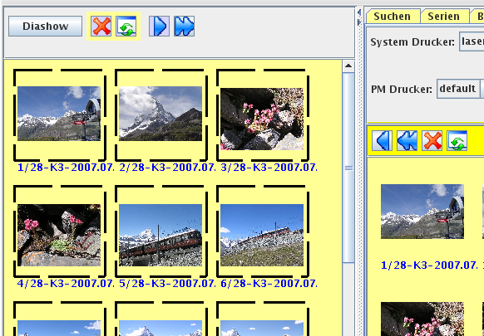

Subwindows
There are eight subwindows on the right side of the main window. You can change the subwindow with tabs on top. If you start the program always the subwindow “Search” is displayed.
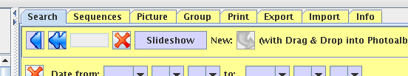

The subwindows “Sequences”, “Group”, “Print”, and “Export” are windows with thumbnails.
You can copy or append all thumbnails to the right side preview window.

Append all pictures to the right side preview window
Refresh after deleted some pictures
Copy all pictures to the right side preview window

Delete all thumbnails

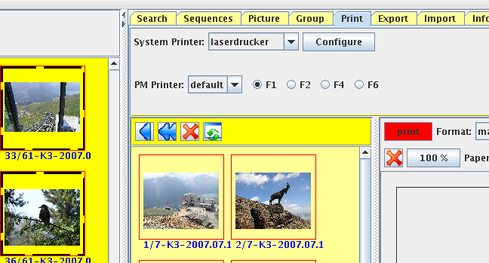

Status Bar
On bottom there are the status bar.
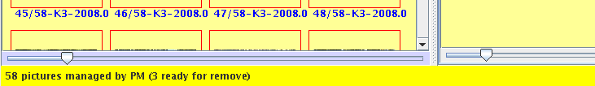

Number of pictures managed by the program
Number of pictures removed irrevocable from the hard disk

The pictures removed from your hard disk are removed irrevocable when exit the program.

The Photo Album
The most important is the photo album. It contained picture collections.
The photo album is structured as a tree with nodes and leaves. The nodes are areas (such as Holiday, Italy, 1990), the branches are collections of pictures (for example, Toscana, Grandchildren).
Before a collection of pictures will be inserted into the photo album, it must be structured, which means you need branches of nodes. You install a node by selecting another node and click on right mouse button. On the context menu you click on “Insert node” and type into the field the name of the new node.
You see on the screen shot an example of nodes. The nodes can be moved using drag and drop and can be removed by context menu.

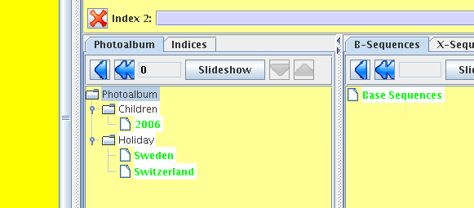

Thereafter, you must create the picture collections.
There are two types of picture collections:

- “Open” picture collections:
You create them here in the subwindow “Search” by searching some pictures and insert them as picture collections by dragging from the drag & drop button on top of the “Search” subwindow into the photo album.
- “Closed” picture collections (Sequences):
You create them in the subwindow “Sequences” and insert them into the photo album by drag & drop them from the right base and extended sequence trees into the photo album.

“Open” picture collection
An “Open” picture collection is a number of arbitrary pictures. Such a collection is connected to some search keys. If you import new pictures with same search keys, the pictures are added implicitly to the collection.
The great advantage of an "open picture collection" is, you can create them with some search keys and insert them into the photo album. This is a very quick procedure.
In the upper part of the subwindow “Search” you search pictures with search keys like:

- Picture creation date:
That is the date from the EXIF picture information.
- Category:
Every picture is allocated with a category 1, 2, 3, or 4. The meaning must be determined by the user. A possible assignment (just a suggestion) is:
Category 1: The very best pictures.
Category 2: Not quite so good, but still acceptable.
Category 3: Not so good to demonstrate by slide show.
Category 4: Pictures to delete from the hard disk (Deletion candidates). You finally delete them in the subwindow “Export”
Newly imported pictures get always the category 3.
You change the category in the subwindows “Picture”, “Group”, or by selecting a thumbnails and press key tabs 1, 2, 3, or 4.
- Indices:
You can assign each picture to any number of indices. There are index 1 and index 2. When searching, they are always linked with AND. Indices between index 1 or 2 are linked with OR.
New pictures are without indices. You insert the indices in the subwindows “Picture” and “Group”.

Drag&Drop Button for dragging the pictures found by search keys into the photo album

25 pictures are found

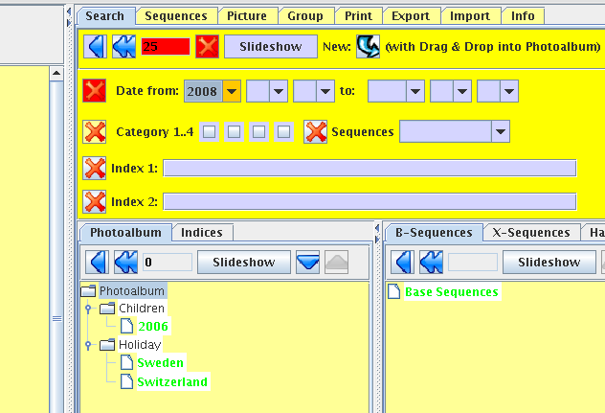
You see in screen shot that by search key “Date from” 2008 (selected by the combo box) 25 pictures are found. If you select the drag&drop button on top of the window by the left hand mouse button and drag the mouse into the photo album, you create an entry in the photo album.

Advantage of the Open Picture Collection:
You can create and insert collections into the photo album without much effort. Every picture has a creation date and you can make open collections without create indices or sequences. Search some pictures by creation date and put them into the photo album.

Disadvantage of the Open Picture Collection:
You can't sort the pictures within an open picture collection. They are always sorted by creation date. If you import new pictures with same search keys, the pictures are added implicitly to the collection.

Closed Picture Collection (B and X Sequences)
You create a closed picture collection in the subwindow “Sequences”. You search some pictures in the subwindow “Search”, move them into the preview window to the left, change to the subwindow “Sequence” and choose some or all for a sequence. Then you create the sequence.
The collection is called “closed” due to not add someone implicitly by importing new pictures. You can sort the pictures within the sequence.

Create a Sequence in Subwindow “Sequence”

Insert the Sequence in Subwindow “Search” into photo album

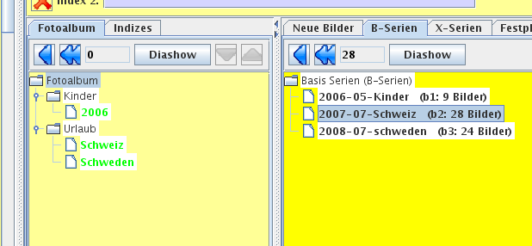

You can change the name in the photo album by clicking the right mouse button and select the appropriate entry.
You can insert a sequence multiple into the photo album.

Slide Show
You can show a picture collection with the slide show.
You call a slide show by pressing the button “Slide Show” in the preview window, the subwindow “Search”, or by selecting a thumbnail and the context menu (select the thumbnail and press the right mouse button to get the context menu and select the “Slide show” entry).
You can view the pictures:
- Manually (press Function key F2)
You get next picture by pressing the right arrow tab key and
previous picture by pressing the left arrow tab key
- Automatically (press Function key F3):
Automatically the next picture after 4 seconds. You can change the time by pressing the “+” or “-” key tab.
- Random (press Function key F4):
Search next picture at random.

Terminate the slide show by pressing the Escape – Key (“Esc” on the top left side of your keyboard).

Text under the Picture

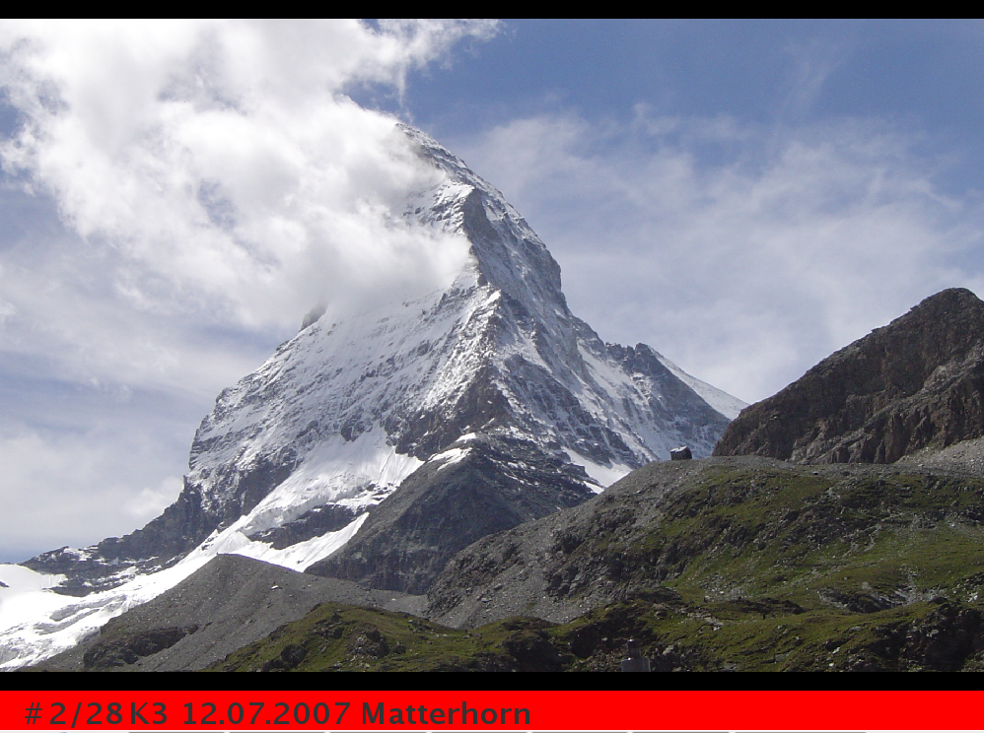

Under every picture you see the text:

- #: The picture was cutting
- X: The picture was modified by an external modification program
- 2/28: The second picture of 28 pictures

You can change the following items in configuration file:

- K<Category>
- <Creation date>
- <Remarks>
(you manage the remarks in subwindow “Picture”)

Insert Search Keys
Every picture can be associated by one or more search keys. In subwindow “Search” you can search pictures by the search keys.
If you import the pictures the search key “creation date” is taken from the EXIF picture information. You can change the creation date in subwindow “Picture” and “Group”.
You can insert all the search keys in the subwindow “Picture” and “Group”.

Insert Search Keys in Subwindow “Picture”
You manage the search keys for a single picture in the subwindow “Picture”.
The search keys to manage are:

- Creation date
- Indices 1
- Indices 2
- Remarks
- Category
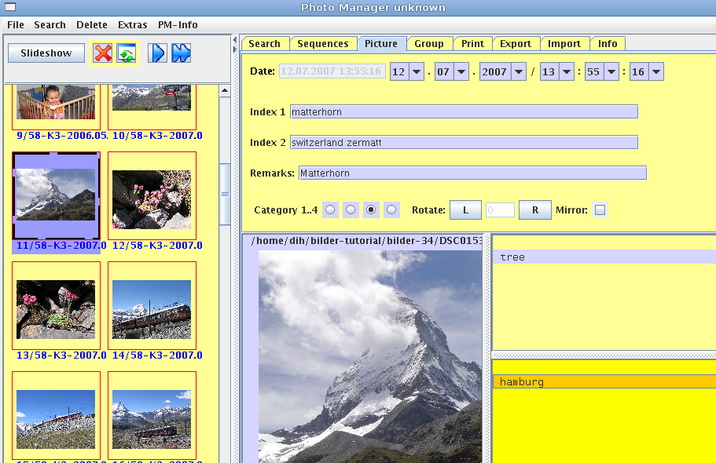

You can rotate (left or right) and mirror the picture. These attributes are not search keys.

Change the Creation Date
You can change the creation date. The original creation date is saved and will always be displayed in red color besides the changed date.

Manage Indices
There are two fields for indices: Index 1 and Index 2. They are connected with AND.
Every index can have as many entries as you like. All entries in on index are connected among themselves with OR.
If you set index 1 to “tree birch” and index 2 to “hamburg”, then you find the picture as followed:

 | Index 1 | Index 2
found | birch tree stone
found | tree | hamburg
not found | tree | munich
found |  | hamburg munich
found | birch AND tree
found | b*
not found |  | Hamburg AND munich
not found | birch AND (tree AND stone)

Insert Search Keys in Subwindow “Group”
In the subwindow “Group” you manage search keys for multiple pictures. This feature allows you with less time and effort manage multiple pictures together.
Search all pictures that shall get the same indices and move them into the display of subwindow “Group”. Then type the indices into index 1 and index 2 and if you want a category and press button “Group them”. All pictures get the same indices and desired category.
Further you can change the creation date of all the selected pictures. Type the date and time (minutes and seconds). After you press “Group them” the program change the creation date of all pictures continuously in seconds. You can use this feature if for example you cannot find the creation date in EXIF information.

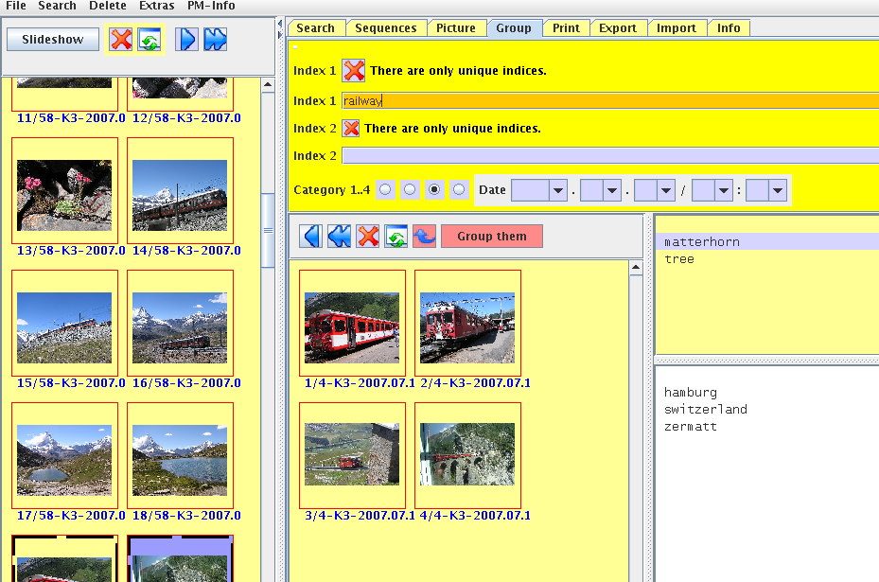

In the screen shot you see 4 pictures selected. All shall get the index 1 “railway” (Don't forget to press the button “Group them”).

Manage Base and Extended Sequences
Base and extended Sequences are closed sequences. They are managed in the subwindow “Sequences”.
A sequence is a collection of pictures, for instance pictures of a journey, a music event, or pictures of the renovation of the living room. A sequence should not comprise too many or too few pictures. About 30 to 200 is a good choice, but not mandatory. Hence pictures in a closed sequence are a continuous queue of some photos, you can sort them and you can add as many as you like at every time.
There are B and X sequences.
B-sequences are base sequences. Each picture may be assigned only to one base sequence. Thus, no base sequence “overlap” with another. After you imported new pictures you should create one or more base sequences of them. This will ensure that no pictures are lost. You can check for pictures not in base sequences: menu “Search” → not in B-Sequences.
X-sequences are eXtended sequences. Each picture may be assigned to one or more extended sequences. Otherwise, there is no difference between an extended or a base sequence. For example you can put all pictures of special flowers or all pictures of sailing yachts into an extended sequence. Of course this can be achieved with an open sequence too, but you can't sort them.
Base and extended sequences are managed by hierarchical ordered trees. They are displayed in the subwindows “Sequences” and “Search”. They are not identical with the photo album.
If want to insert a sequence into the photo album, change into the subwindow “Search”. There you can per drag&drop insert sequences from the base or extended sequence tree into the photo album.

Create new Sequences
Search and move or copy some pictures into the preview window on the left side of the main window. This can be exactly the pictures for the new sequence or a superset.
Change to the subwindow “Sequences” and choose the window of the desired sequence type: base or extended.
Copy all the pictures for the new sequence into the subwindow. You can do it with the right arrow button on top the preview window, with the return key, or double click with the left mouse button. All the pictures in the subwindow are pictures for the new sequence.
If you want create a new base sequence and there are pictures already in another base sequence they are surrounded with a thick red line. On top of the thumbnail you see the respective base sequence number. If you create the sequence you get a warning. If you ignore the warning all pictures from the other sequences moves to the new created sequence.
You can sort the pictures by drag&drop the thumbnails. If you have all pictures together for the new sequence, insert it per drag&drop into the sequence tree.

Drag&Drop Button for dragging a new sequence into the sequence tree at the desired place

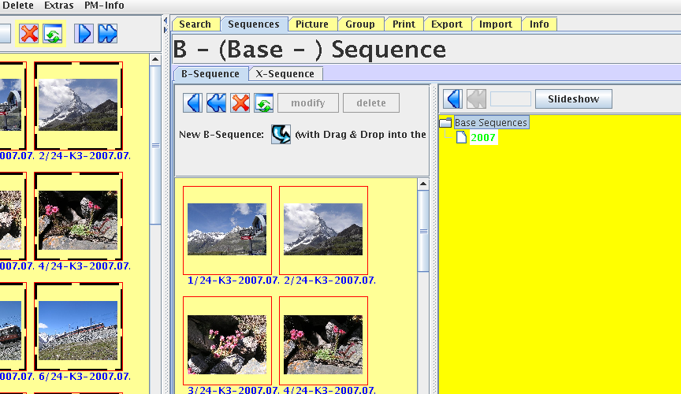

Before you insert the sequence into the tree it is recommended to structure the tree.

Modify Sequences
In the subwindow “Sequences” you can modify base and extended sequences. Search the respective sequence in the sequence tree, double click it with the left mouse button and you see all thumbnails of the sequence in the subwindow.
You can delete pictures in the sequence by select the thumbnail with the left mouse button and press the right mouse button to get the context menu. Select then the entry delete. The picture to delete shall be displayed white.
You can add some picture to the sequence. Search the desired pictures and move them into the preview window on the left of the main window. Then double click them with the left mouse button or press the return key.
You can sort the pictures of a sequence by drag&drop the thumbnails in the subwindow.
After modification press button “modify”. Don't forget it.

Delete a Sequence
Get the sequence to delete in subwindow “Sequence” and press button “Delete”.

Modifying Pictures
You can modify pictures internally and with an external picture modification program.

Modify internally
If you modify the picture internally neither move, copy, or delete the original picture file. All modification information are stored in the metadata. The internally modifications are cut, rotate and mirror.

Cut
The cut window is a modal dialog window. You call it by selecting a thumbnail with the right mouse button and the get with the left mouse button the context menu. Select the entry cut. You see the following dialog window:
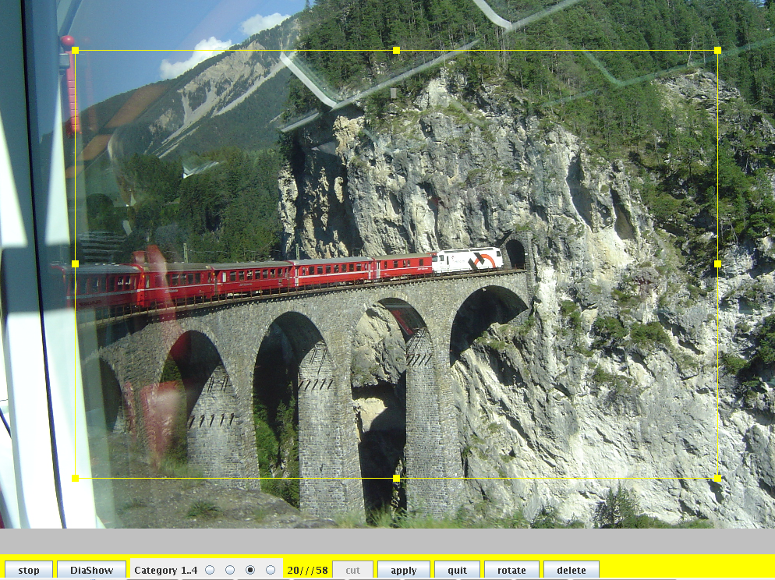
Press button “cut”. You see a yellow square with control handles. By dragging and dropping the control handle on an edge, you can change the square.

- Button “cut”:
The yellow square are displayed. By drag&drop you can change the square.
If you change the ratio, the square line prints as dashed line.
- Button “apply”:
All the control handle disappear and the new cutout area are stored in the metadata.
- Button “quit”:
The changes will be canceled.
- Button “rotate”:
Rotate the square.
- Button “delete“:
Delete the square. The picture will not be cutting.

Furthermore you can change the category.
Button “stop” terminate the modal dialog. Button “Slide Show” calls the slide show. If you have cut a picture the thumbnails is marked with a hash sign.

Rotate and Mirror a Picture
You can rotate 90, 180, and 270 degrees the picture.
Select a thumbnail and press key “l” (rotate left) or key “r” (rotate right) or key “s” (mirror the picture). You can also rotate and mirror the picture in the slide show (key “l”, “r”, and “s”). Furthermore in the subwindow “Picture” (Button “L”, “R”, and “S”).

Modify with an External Picture Modification Program
You can call an external modification program to modify the pictures. You must not terminate PhotoManager, after modification you can continue to manage your pictures.
Select a thumbnail with the left mouse button and press the right mouse button to get the context menu. Select the entry “modify ex tern” to show the modal modification dialog.
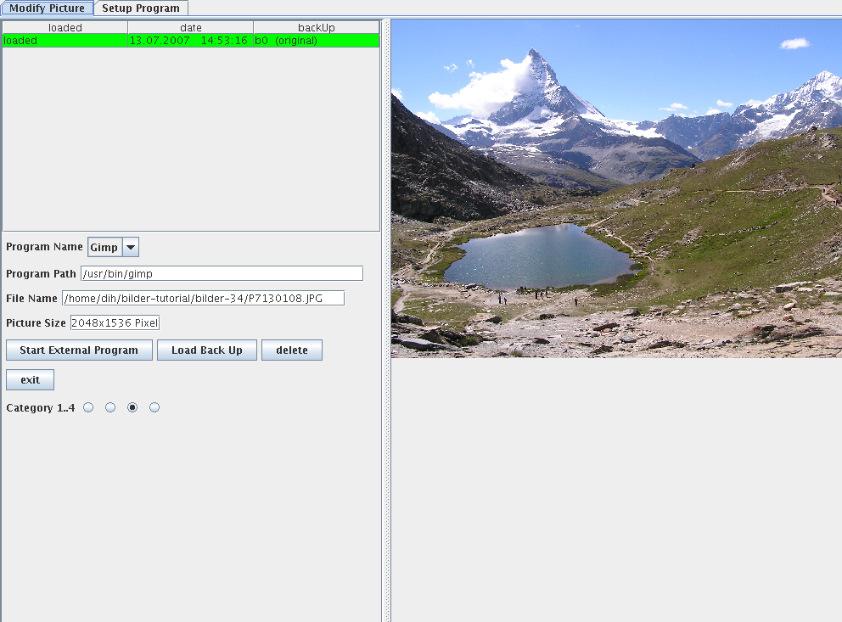

Before you call the external program you must configure it. Press the tab “Setup Program”. There you can choose one or more programs and go back to tab “Modify Picture”.
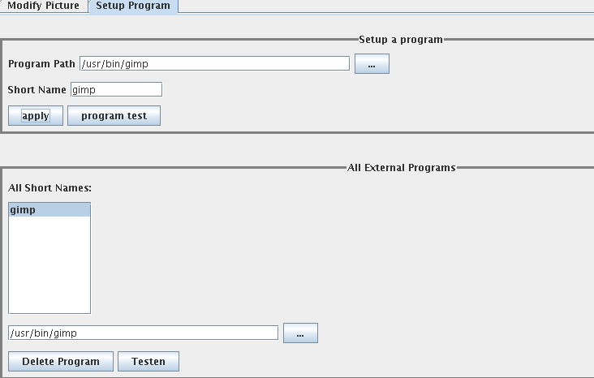

Press button “Start External Program”. PM calls the program and you can modify the picture as you like. If you have modified the picture save it under the same name. Do not save it under another name. That is very important due PM manage all versions of the modified picture files.
A list of all modified picture files is shown. The first line is always the original picture file. You can delete every modified file but not the original picture.
Press button “Exit” to save all modified files and terminate the modal dialog. Under the thumbnail of a modified picture there are shown a “X”. That is the sign for a modification.

Import or Export Pictures

Import
You can import pictures “internal” and “external”. If the picture files are in or under the top level picture directory it is an internal import, otherwise an external import.

Import Internally
All unknown picture files in or under the top lever picture directory shall be imported when:
- The program starts or
- you press the button “Import Internal” in subwindow “Import”.

The program checks for duplicate pictures. Are some found you can decide to import them.

Button to import internally

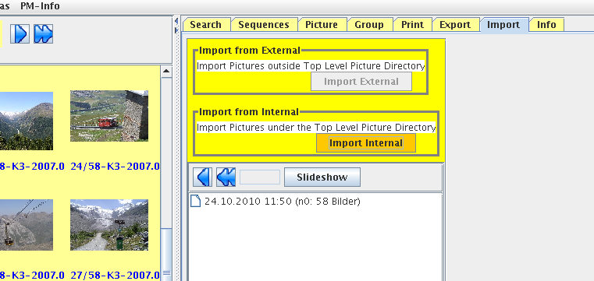

Import Externally
All picture files outside the top level picture directory TLPD shall be imported when you:
- start the program with auto start option
- start the program with option -i
- press button “Import external” in subwindow “Import”.
The program checks for duplicate pictures and eliminate them for import. The program don't delete the pictures outside the TLPD and import them into the directory <year>/<year>_<month>. If not present the program create this directory.

Autostart: If you connect your camera to the USB port, the program starts automatically supposed the program is installed for autostart. See “Installation Guide”.
If you connect your camera to the PC, it doesn't matter the program is running or not. If the program is running the button “Import external” in the subwindow “Import” shall be enabled. Press it and you start the import. If the program is not running, it starts automatically and you can import the pictures.
Program start with option -i: If you start the program with option -i followed by the directory name of the pictures to import, and/or one or more file names of pictures to import, the program starts and import the pictures.
Press button “import external”: If the button in the subwindow “Import” is enabled, you can press it and import the pictures.

Export
You can export pictures:
- Unmodified:
Optionally with all the meta data.
- Modified:
Optionally with all the meta data.
- Delete irrevocable pictures

Move or copy all the pictures you want to export into the subwindow “Export”. You can sort them with drag&drop the thumbnails.
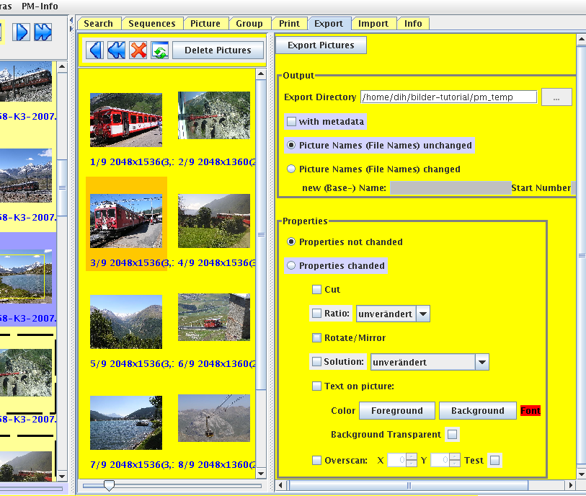

Export without Deletion
You start the export by pressing the button “Export Pictures”. All pictures and when required the meta data are written into the directory:
<TLPD>/pm_temp/PhotoManager/pm_<yyyymmdd>_<hhmmss>
All pictures are written into this directory as a flat file system (even if they are originally in subdirectories). Non-ambiguous filenames are made ambiguous.
If you have modified pictures with an external picture modification program, the modified pictures are exported.
Before you start the export you shall made some configurations:

Area “Output”:

- Export Directory:
You can't change the output directory. It is planned for future. The export directory are always:
<TLPD>/pm_temp/PhotoManager/pm_<yyyymmdd>_<hhmmss>
- Check Box “With Meta Data”:
If selected, the pictures to export are exported with all the associated meta data. You can select this check box only if you export the pictures unmodified.
- Radio Button “Picture Names (File Names) Unchanged”:
All pictures are exported with the original file name.
- Radio Button “Picture Names (File Names) Changed”:
All filenames obtains the base name followed by a consecutive number. Before starting the export you can sort the thumbnails with drag&drop.

Area Properties:

- Radio Button: Properties not Changed:
All pictures to export leaves unmodified if modified internally.
- Radio Button: Properties Changed:
If pictures are modified internally, they shall be exported with this modifications.

Radio Button “Properties Changed” :

- Check Box “Cut”:
If selected and a picture is cut, only the cut area will be exported.
- Check Box “Ratio“:
Not yet realized.
- Check Box “Rotate/Mirror“:
If selected all rotated and mirrored pictures will be exported rotated and mirrored.
- Check Box “Resolution“:
All pictures will be changed to the selected resolution.
- Check Box “Text on Picture“:
All pictures will be exported with text on the bottom.
Default text: Category, creation date and sequence name.
- Check Box “over scan“:
With x and y you set a border on every side. “x” in pixel set the left the right side border, “y” in pixel set the top and bottom side border.

Delete Pictures Irrevocable
Press button “Delete Pictures” on top of the thumbnails to delete irrevocable the pictures in the subwindow “Export” inclusive all the meta data.

Print
In Subwindow “Print” you can make a hard copy of 1, 2, 4, or 6 pictures.

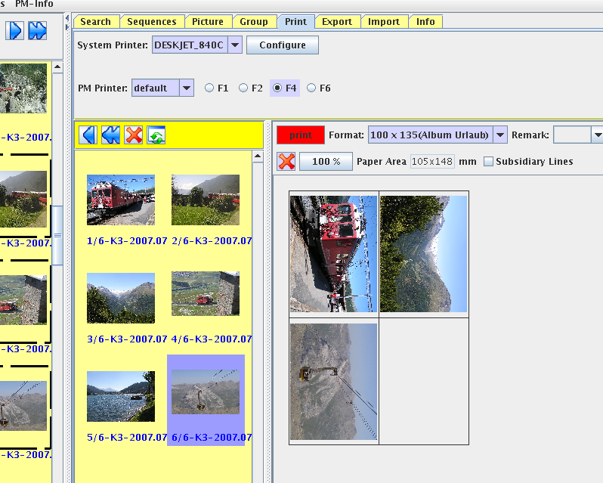

Display the EXIF information

In subwindow “Info” all EXIF information are shown.

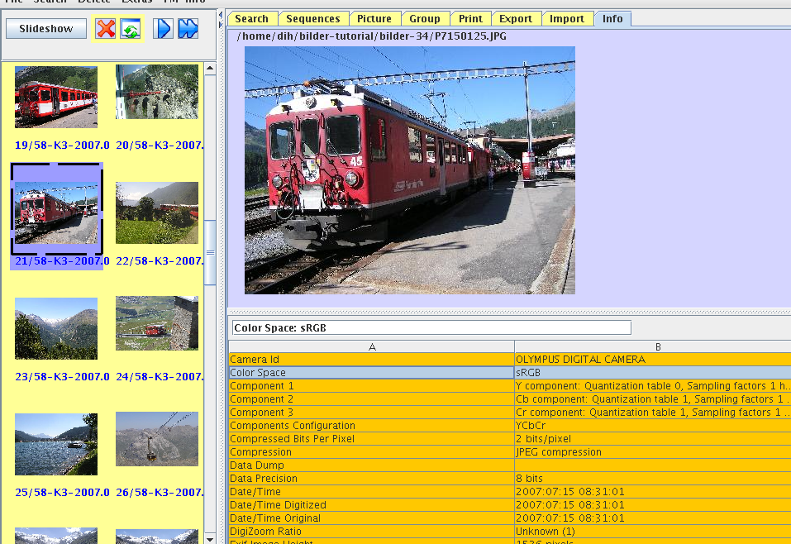

Appendix A: Installation
The program is written in Java. You can run it on all OS with a Java runtime environment version 5 and higher from sun or openJDK.
You can download the program from SourceForge:

http://sourceforge.net/projects/photo-man/

There are installation packages for Windows, Linux, Mac OS X, and a package for an OS independent installation.

Start Options

Syntax:
name [-b <tlpd>] [-e <configfile>] [-i <importdirectory>] [files ...]

Parameter:
name
Program name, dependent of operating system an installation
-b <tlpd>
Optional: Top Level Picture Directory (TLPD).
If not stated, the program search a configuration file.
Either a configuration file is stated with option -e or
it is found as <home-directory>/.photo-manager/pm_einstellungen.xml.
If there is in the configuration file not the name of TLPD or the configuration file is not found, it will be prompted at program start.
-e <configfile>
Optional: Configuration file.
If not stated, the program search a configuration file at
<home-directory>/.photo-manager/pm_einstellungen.xml.
If not found, the program creates the configuration file and store it at
<home-directory>/.photo-manager/pm_einstellungen.xml.
If in the configuration file no TLPD name found, the program prompt the TLPD.
-i <importdirectory>
Optional: Directory name for pictures to import externally.
files ...
Optional: One or more filenames or directory names for pictures to import externally.

You can start the program only “once at a time”. If you try to start it once more, it will be terminate with a warning.
There are an exception: You can start it once more with option -i or/and import-filenames. The program search the first started program-instance and transfer the filenames and terminate. The first started program-instance enabled the button “External import” in subwindow “Import”.

Linux
Precondition:
You must use a debian or debian like distribution.
Java runtime environment version 5 or higher or openJDK.
The debian package photo-manager<version>.deb
Download it from sourceforge:
http://sourceforge.net/projects/photo-man/

Installation:
dpkg install photo-manager_1.2.0-1.deb
(perhaps another program version)

Program start:
Commandline: photo-man

Linux: Direct Camera Import (autostart)
You must install the autostart with the command
/usr/local/bin/photo-man -i %m

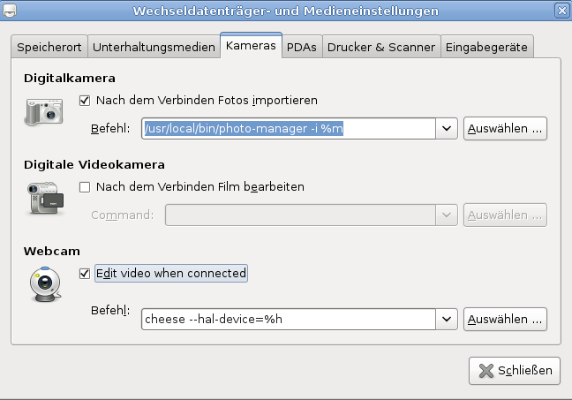

Windows

Precondition:
Java runtime environment version 5 or higher.
The set-up file photo-manager-setup<version>.exe
Download it from sourceforge:
http://sourceforge.net/projects/photo-man/

Installation:
Start the “exe” file and follow the instruction. There will be installed a program icon and the user manual.
Constraint: Don't change the installation target directory (C:\Program\PhotoManager)

Windows: Direct Camera Import (autostart)

The program path: C:\Program\PhotoManager\pm
The arguments: % L

OS Independent Installation

Precondition:
Java runtime environment version 5 or higher or openJDK.
You need the zip file: photo-manager<version>.zip
Download it from SourceForge:
http://sourceforge.net/projects/photo-man/

Installation:
Unpack the zip file. There are a REAME file and all jar files you need.

Program Start:
java -XX:+UseConcMarkSweepGC -Xms500M -Xmx800M -jar pm.jar [start parameter]

Change Xms and Xmx accordingly your main memory. Half the memory is a good coice.

Appendix B: License and Author

This program is open source under the GNU General Public License as published by the Free Software Foundation.

You reach the author: <dihent@freenet.de>

