**Decoding VR Gaming by Lens of The Natya Shastra**

In 1970 Katz propounded a theory called uses and gratification theory. It became the most popular and powerful media theory till day about media consumption. Katz proposed that unlike conventional thought media audiences are not passive at all. In fact they actively select and consume media for specific uses and gratification. These were classified into 5 categories:

1. to be informed\educated.

2. Self identification with the characters of media content.

3. Entertainment

4. Social Interaction.

5. Escapism

To add utility in media content, content producers use various forms of art more specifically performing art. According to Marshall McLuhan all art is a cage designed to trap the mind. This thought can be specifically linked with eastern philosophies where in various technique and methods were devised and used to capture mind and bring about awareness an end to the psychosomatic miseries of life. The result is experience of relaxation and peace. This thought brings into picture the most ancient text \ manuscript on performing arts i.e. "Natya shashtra".

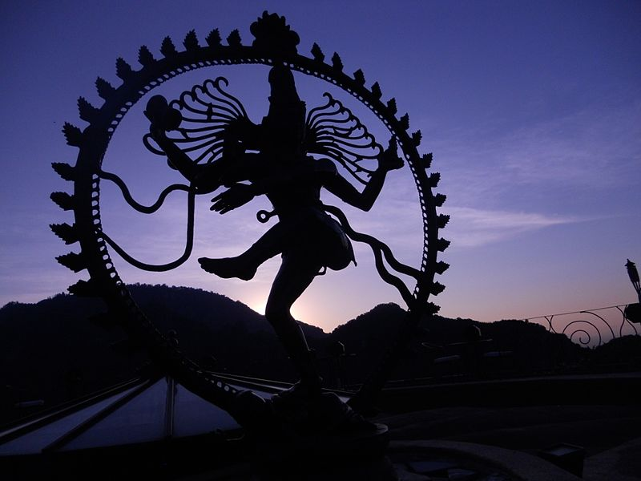

The legend says that in ancient days soon after civilization began to establish, daily activities of facing various situations that evoke feeling of love, hatred, anger, lust, compassion, laughter, disgust, horror, heroism and wonder were reduced, as human beings started to construct civilization. Prior to this each human had to face adverse situation like fight animals and climate to survive, now when advancement of agriculture and civilization was at aid no such situations arises. It led to boredom. To escape miseries of boredom people prayed Lord Brahma. He decided to teach bharata the secrets of performing arts and then bharata created an instructional manual for the same called natya shastra. In creation of Natya Brahma advised bharata to use 8 rasas of life namely shringaram(attractivenes), hasyam(humour), raudram(rage), karunyum(comapssion), bibhatsam(disgust), Bahyanakam(horror), veeram(heroism), abhutam(amazement). In this formulation 9’th rasa, shanti ras was excluded. Reason for this exclusion was that shanti or the peace lies within the audience. All the miseries are created by human mind by associating meanings, expectations, cravings and aversion to the experiences of five senses so it can be said that natya or performing art is a cage designed using 8 rasas. The intension is to engage mind and escape the reality by immersing senses into constructed reality. This technique has been used since in various forms of arts from dance, to theatre, to cinema, to computer gaming and now virtual reality gaming. The cage is becoming thicker and experience is becoming intense by each technological advancement. Virtuix omni is one of such advancement.

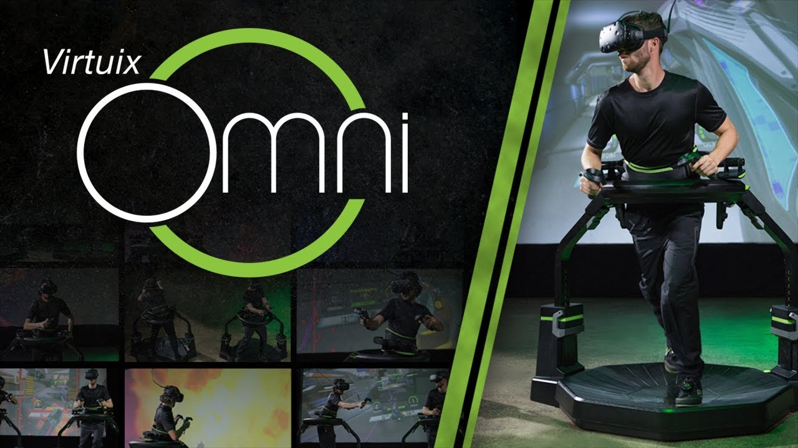

Till the day two senses eyes and ears were immersed in this constructed realities. Vision was restricted to the computer screens and the audience became more of a couch potato, which has numerous demerits. However, virtuix omni expands this restricted vision to 360 and uses surround sound technology enhancing the effect. But the most remarkable difference is involvement of entire body by use of omnidirectional treadmill simulator which immerses the audience into constructed reality completely by enabling locomotion. In future probably more senses will be engaged and the experience of shanti rasa will be intensified.