Computational methods
Spin–orbit coupling (SOC) was included in all the band structure and parity calculations utilized for the topological study. The parity eigenvalues of the SOC spinor wavefunctions were calculated through irvsp [1]. All structures except β-H-2Be exhibit both inversion and time-reversal symmetry. For these structures, the $Z_{2}$ topological index was calculated based on the parities of the occupied Kramers pairs at the time-reversal-invariant momenta (TRIM) according to the Fu–Kane criterion [2]. The parity product at a TRIM $Λ_{i}$ is given by

$$δ_{i}=\prod_{m=1}^{N}{ξ_{2m}}\left(Λ_{i}\right)$$

where $ξ_{2m}\left(Λ_{i}\right)$ = ±1 is the parity eigenvalue of either state in the m-th occupied Kramers pair, and N is the number of occupied Kramers pairs.

The topological index is then derived from:

$${\left(-1\right)}^{ν}=\prod_{i}{δ_{i}}$$

Here, $ν$ = 1 implies nontrivial band topology, while $ν$ = 0 implies trivial band topology.

The structure β-H-2Be lacks an inversion center; therefore, its $ν$ was calculated through the evolution of Wannier charge centers (Wilson loop) [3]. The Wilson loops were calculated using WannierTools [4] based on Wannier function models generated through Wannier90 [5]. For square-trilayer (ST) beryllene, α-2HBe and β-2H-2Be, the Wilson loop calculation is consistent with the parity calculation.

The Quantum ESPRESSO (QE) calculations [6,7] were performed on the structures relaxed with the PBE functional. We used ONCV pseudopotentials [8] where Be 1s states were considered to be valence states, with plane-wave cutoffs of 80 and 640 Ry for wavefunctions and charge density, respectively, and Marzari–Vanderbilt smearing of 0.02 Ry [9]. We also used a two-dimensional Coulomb cutoff [10], along with a vacuum of about 15 Å or larger. The k-point grids were 56 × 56, 52 × 52, 46 × 46 and 57 × 52 for ST-beryllene, α-2HBe, β-2H-2Be and β-H-2Be, respectively. In order to study the band topology of these structures, we recalculated the parities at the TRIM with fully relativistic projector-augmented-wave pseudopotentials [11] (90 and 720 Ry) with spin–orbit interaction and computed Wilson loops as explained above.

Phonons of ST-beryllene, β-2H-2Be and β-H-2Be were computed using density-functional perturbation theory (DFPT) [12] on a 12 × 12 q-point mesh, and electron–phonon coupling was calculated using EPW [13,14]. Electronic states and phonon perturbations were Wannier-interpolated from coarse 24 × 24 k-point and 12 × 12 q-point meshes to 80 × 80 fine meshes, and the convergence was checked using 40 × 40 fine meshes. Electronic and phonon smearings were set to 0.15 eV and 0.5 meV, respectively, and the Matsubara-frequency cutoff was 1.2 eV. The electron–phonon coupling constant $λ$ and the logarithmic average phonon frequency $ω_{log}$ were extracted from the isotropic Eliashberg spectral function $α^{2}F(ω)$. The superconducting critical temperature $T_{c}$ was calculated in two ways. First, the Allen–Dynes formula [15,16] in the McMillan form was used with the Coulomb pseudopotential $μ^{*}$ varying from 0.10 to 0.16. Second, the isotropic Migdal–Eliashberg equations on the imaginary axis [17–19] were solved with $μ^{*}$ = 0.13, and the isotropic $T_{c}$ was found by fitting the temperature dependence of the gap at the first Matsubara frequency. For β-2H-2Be and β-H-2Be, the anisotropic Eliashberg equations [20] were also solved for each temperature using up to 6000 iterations. Close to $T_{c}$, the convergence was very slow; therefore, the gap was monitored throughout the iterations. A temperature was considered below $T_{c}$ if the extrapolated gap converged to a nonzero value for all fitted ranges, and above $T_{c}$ if the gap exponentially decreased with increasing number of iterations. Finally, $T_{c}$ was estimated from the extrapolation of the limiting gaps below $T_{c}$ and the decay rates above $T_{c}$.

Parity analysis and topological classification
The parity eigenvalues with SOC and the associated parity products are listed in Table 1. The α- and β-beryllene structures have three M points that are symmetry-equivalent, resulting in the reduction of the Fu–Kane product to ${\left(-1\right)}^{ν}=δ_{Γ}{δ_{M}}^{3}=δ_{Γ}δ_{M}$. In the case of ST-beryllene, the $Z_{2}$ index is derived from ${\left(-1\right)}^{ν}=δ_{Γ}δ_{M}{δ_{X}}^{2}=δ_{Γ}δ_{M}$, where ${δ_{X}}^{2}$ is the product over the two equivalent X points.

Table 1. Parity eigenvalues at the TRIM, parity products, $Z_{2}$ indices $ν$ and topological classification of α-, β- and ST-beryllene, as well as the hydrogenated beryllenes. β-H-2Be is not centrosymmetric, and hence its $ν$ value is calculated by means of the Wilson loop.
Structure | Γ | M | Product | $$ν$$ | Classification
α-beryllene | +, + | +, − | −1 | 1 | Nontrivial
β-beryllene | +, −, +, − | −, +, +, − | +1 | 0 | Trivial
ST-beryllene | −, +, +, +, −, + | −, +, +, −, −, + | −1 | 1 | Nontrivial
α-2HBe | +, +, − | +, −, + | +1 | 0 | Trivial
β-2H-2Be | +, −, +, −, + | −, +, +, −, + | +1 | 0 | Trivial
β-H-2Be | — | — | — | 0 | Trivial

For α- and ST-beryllene, the parity products at Γ and M have opposite signs, leading to ${\left(-1\right)}^{ν}$ = −1 and ν = 1, as already shown for α-beryllene [21]. For β-beryllene, both parity products are positive, leading to ν = 0. As all three structures are metallic, α- and ST-beryllene are nontrivial $Z_{2}$ topological metals but not topological insulators, whereas β-beryllene is a trivial metal. All the hydrogenated beryllenes listed in the bottom part of Table 1 have ν = 0. This result comes from the parity products for α-2HBe and β-2H-2Be and the Wilson loop for β-H-2Be, which does not have inversion symmetry. Hydrogenation thus removes the nontrivial $Z_{2}$ topology of α-beryllene: α-2HBe becomes an insulator with a PBE band gap of about 4.9 eV, whereas β-2H-2Be and β-H-2Be are trivial metals.

In ST-beryllene, the Wannier charge centers switch partners once along the Wilson loop. The lowest 12 spinor bands are separated from the rest of the bands by a direct gap in the whole Brillouin zone, with a minimum gap of 1.2–1.3 meV at M, ensuring that $ν$ = 1 is well defined. For the PBE structures used in the QE calculations (Table 2), the QE parity values (for the centrosymmetric structures) and the QE Wilson loops give the same $ν$ for all four structures.

Table 2. Structures optimized with PBE in QE: cell content, lattice constants $a_{1}$ and $a_{2}$, inter-axial angle γ, layer thickness and electronic character.
Structure | Cell content | $a_{1}$ (Å) | $a_{2}$ (Å) | γ (°) | Thickness (Å) | Electronic character
ST-beryllene | Be₃ | 2.18 | 2.18 | 90.00 | 3.04 | Metal
α-2HBe | BeH₂ | 2.32 | 2.32 | 120.00 | 1.74 | Insulator
β-2H-2Be | Be₂H₂ | 2.62 | 2.62 | 46.88 | 3.79 | Metal
β-H-2Be | Be₂H | 2.11 | 2.32 | 117.01 | 2.85 | Metal

Electron–phonon coupling and superconductivity
The main superconducting characteristics are listed in Table 3 and presented in Figure 1. For ST-beryllene, the analysis gives λ = 0.46, Allen–Dynes $T_{c}$ = 2.0 K and isotropic Eliashberg $T_{c}$ = 3.7 K. This means that ST-beryllene is predicted to be a weak-coupling superconductor with a $T_{c}$ of a few kelvin. The electron–phonon coupling constant λ in the case of β-2H-2Be is 1.40, and the Allen–Dynes superconducting critical temperature is $T_{c}$ = 21.9 K for $μ^{*}$ = 0.13. The solution of the isotropic Eliashberg equations gives a larger $T_{c}$ of 28.3 K, with $2Δ_{0}/k_{B}T_{c}$ = 4.28, which is above the BCS value of 3.53 [22] (Figure 1c). Therefore, β-2H-2Be is predicted to be a strong-coupling superconductor with the highest $T_{c}$ among all cases examined. In the case of the anisotropic solution, the superconducting gap of β-2H-2Be approaches a finite value at 29–31 K, while at 32 K and above, it exponentially tends to zero (Figure 1d). Thus, the anisotropic critical temperature $T_{c}$ falls into the range from 31 to 32 K and is estimated to be 31.7 K. For β-H-2Be, from the Allen–Dynes equation, we obtain $T_{c}$ = 8.1 K for $μ^{*}$ = 0.13. On the other hand, the isotropic Eliashberg equations give a higher $T_{c}$ of 11.6 K, with $2Δ_{0}/k_{B}T_{c}$ = 3.64 (Figure 1a). In the anisotropic solution, the superconducting gap approaches a finite value at 14.0 and 14.1 K (about 0.39–0.40 and 0.25–0.28 meV, respectively), while at 14.5 K the gap exponentially tends to zero (Figure 1b). At 14.2 K, the temperature closest to $T_{c}$, the gap does not reach a plateau and does not exponentially decay during approximately 5000 iterations. As a consequence, $T_{c}$ in the anisotropic case lies between 14.1 and 14.5 K and can be estimated to be 14.2 K. Therefore, the gap anisotropy increases $T_{c}$ by about 2.5–2.9 K compared to the isotropic one.

Table 3. Electron–phonon coupling constant λ; logarithmic average phonon frequency $ω_{log}$; Allen–Dynes $T_{c}$ (McMillan form) for $μ^{*}$ = 0.10/0.13/0.16; isotropic Eliashberg $T_{c}$ with the fitted gap amplitude $Δ_{0}$ and gap ratio; and anisotropic Eliashberg $T_{c}$. All numbers are calculated on 80 × 80 fine meshes, and $μ^{*}$ = 0.13 is used for the Eliashberg calculations.
Structure | λ | $ω_{log}$ (meV) | $T_{c}^{AD}$ (K) | $T_{c}^{iso}$ (K) | $Δ_{0}$ (meV) | $$2Δ_{0}/k_{B}T_{c}$$ | $T_{c}^{aniso}$ (K)
ST-beryllene | 0.46 | 36.0 | 3.7/2.0/0.9 | 3.7 | 0.57 | 3.58 | —
β-2H-2Be | 1.40 | 19.5 | 24.2/21.9/19.6 | 28.3 | 5.23 | 4.28 | ≈31.7
β-H-2Be | 0.61 | 40.7 | 11.4/8.1/5.4 | 11.6 | 1.83 | 3.64 | ≈14.2

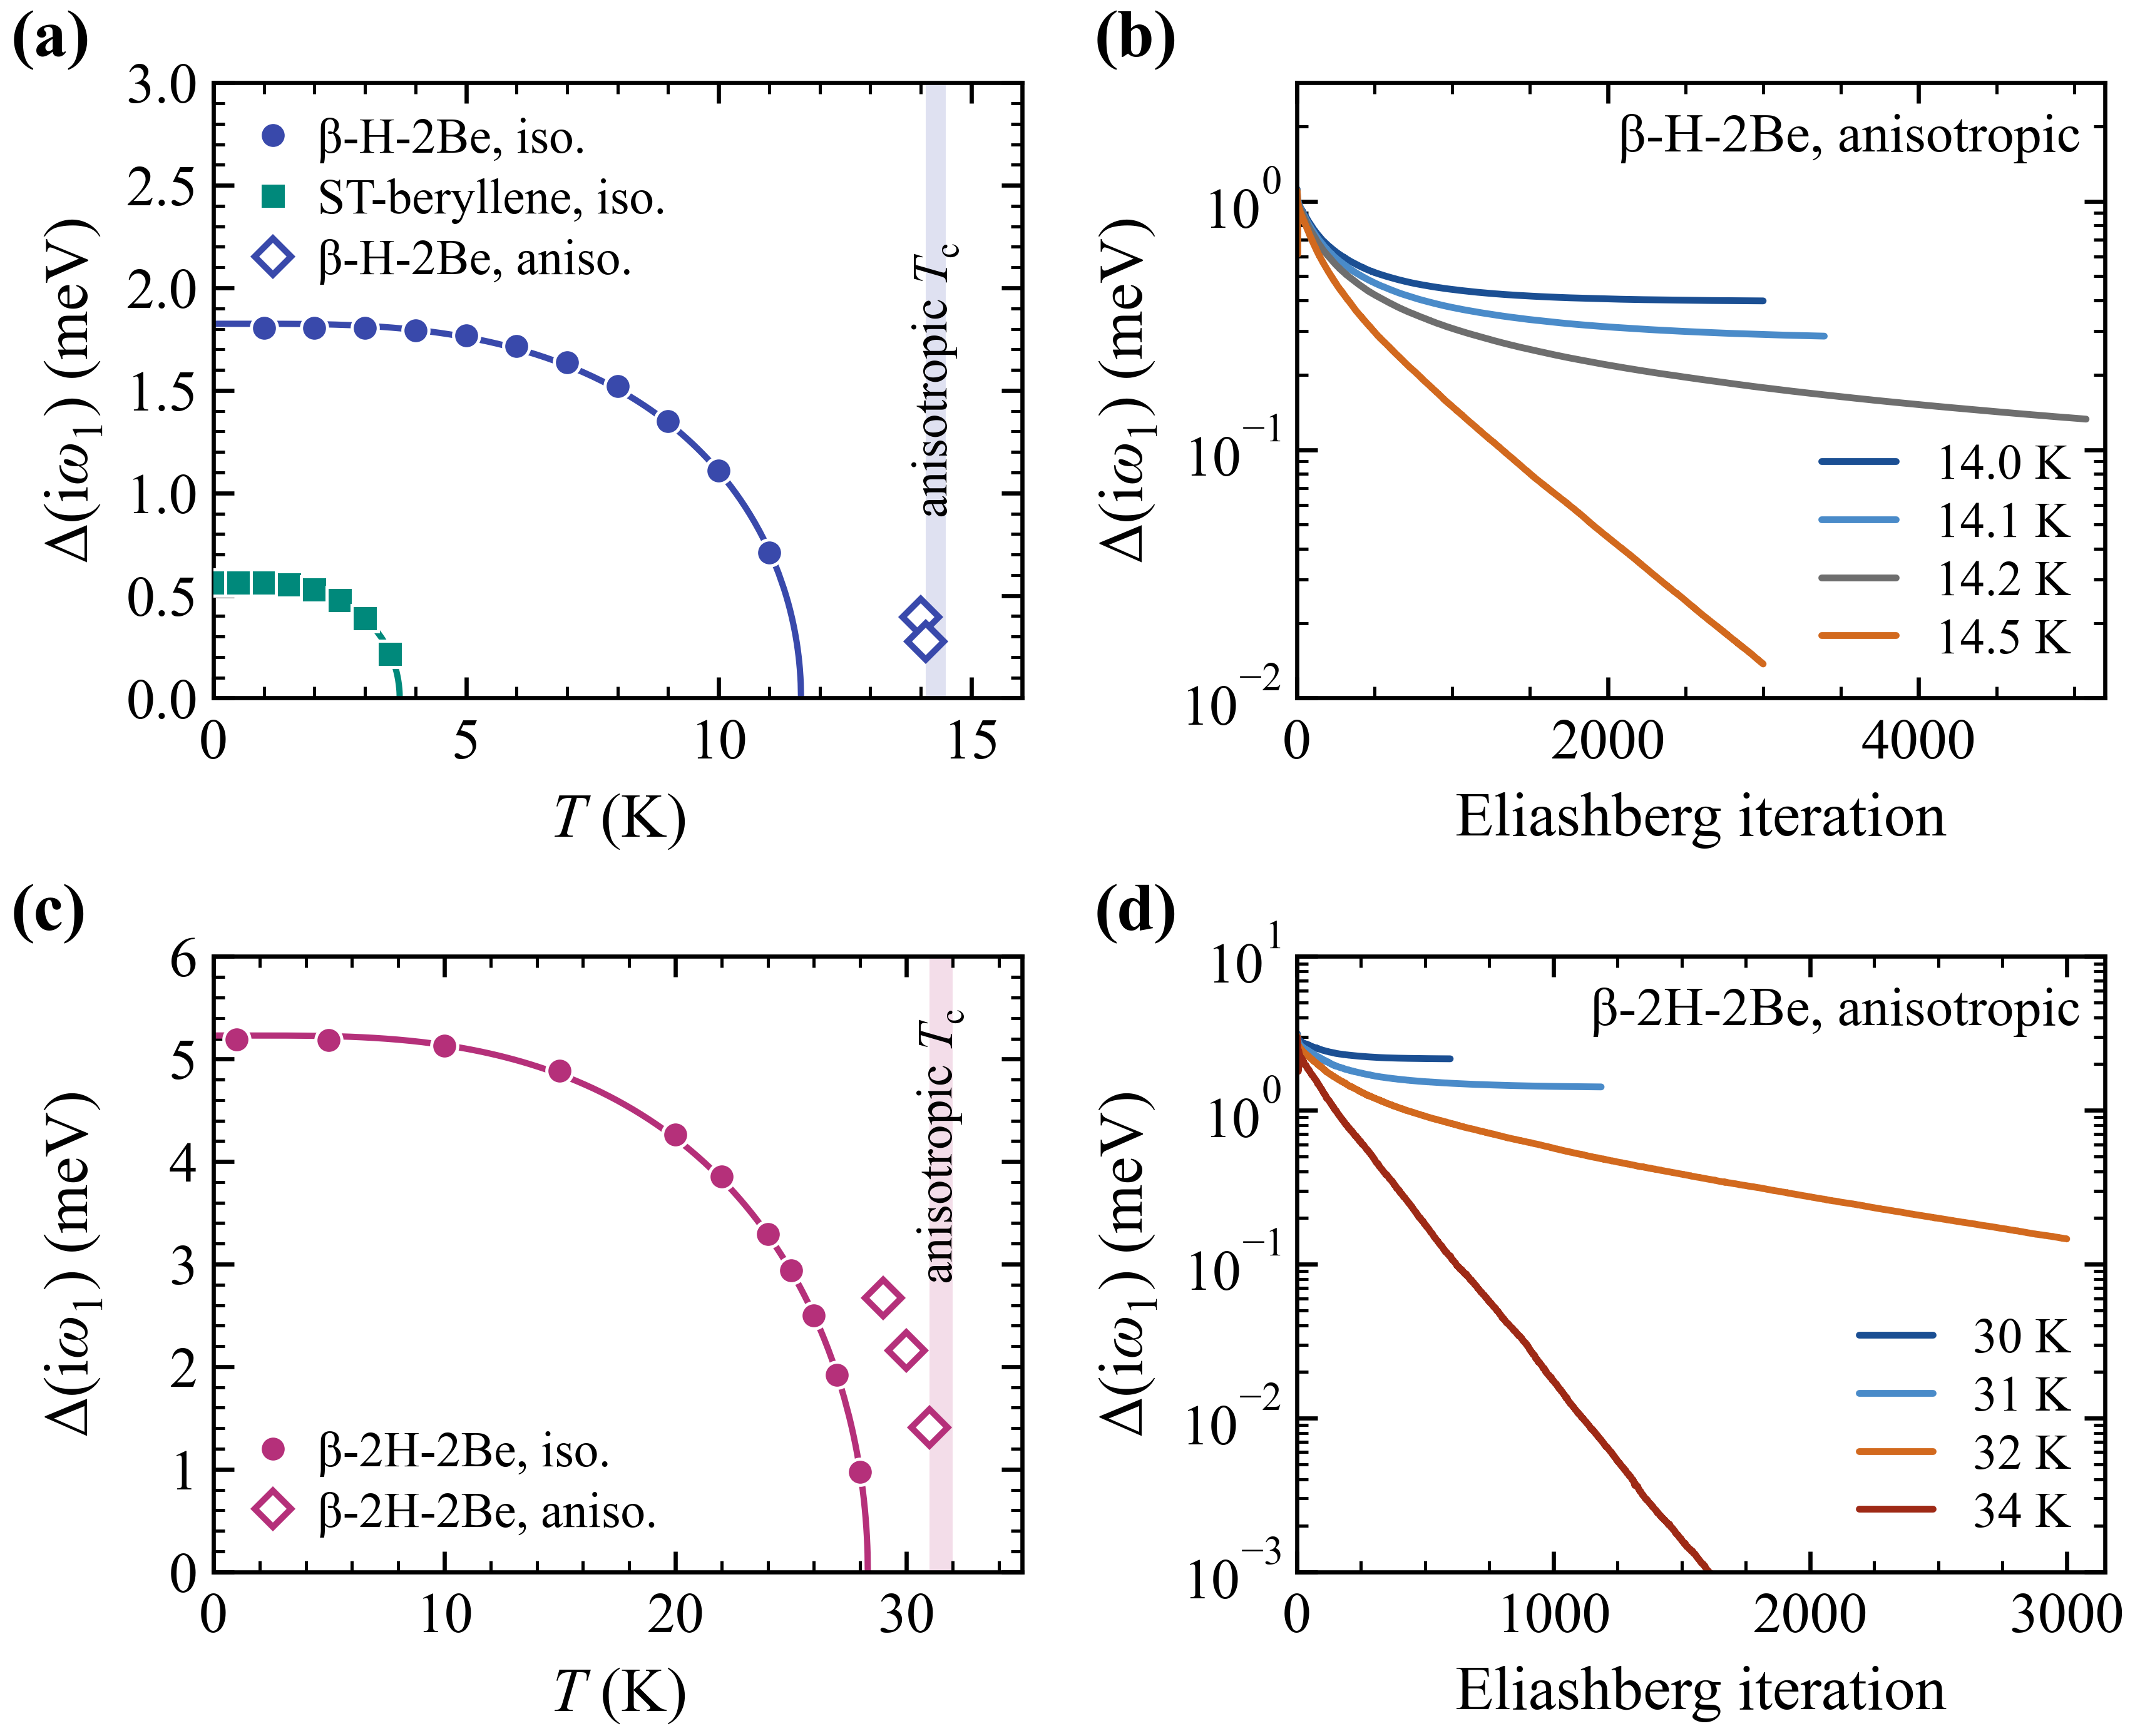
Figure 1. Superconducting gap. (a) Gap at the first Matsubara frequency, $Δ(iω_{1})$, as a function of temperature with $ω_{1}=πk_{B}T$. Circles and squares represent isotropic Eliashberg solutions, while lines correspond to fits with $Δ_{0}\tanh{[1.74{(T_{c}/T-1)}^{1/2}]}$. (b) Fermi-surface-averaged $Δ(iω_{1})$ of β-H-2Be in the anisotropic Eliashberg iterations. (c) and (d) are analogous to (a) and (b), respectively, for β-2H-2Be.

References
[1] J. Gao, Q. Wu, C. Persson, and Z. Wang, Irvsp: To Obtain Irreducible Representations of Electronic States in the VASP, Comput. Phys. Commun. 261, 107760 (2021).
[2] L. Fu and C. L. Kane, Topological Insulators with Inversion Symmetry, Phys. Rev. B 76, 45302 (2007).
[3] R. Yu, X. L. Qi, A. Bernevig, Z. Fang, and X. Dai, Equivalent Expression of Z₂ Topological Invariant for Band Insulators Using the Non-Abelian Berry Connection, Phys. Rev. B 84, 75119 (2011).
[4] Q. Wu, S. Zhang, H.-F. Song, M. Troyer, and A. A. Soluyanov, WannierTools: An Open-Source Software Package for Novel Topological Materials, Comput. Phys. Commun. 224, 405 (2018).
[5] G. Pizzi, V. Vitale, R. Arita, S. Blügel, F. Freimuth, G. Géranton, M. Gibertini, D. Gresch, C. Johnson, T. Koretsune, et al., Wannier90 as a Community Code: New Features and Applications, J. Phys.: Condens. Matter 32, 165902 (2020).
[6] P. Giannozzi, O. Andreussi, T. Brumme, O. Bunau, M. Buongiorno Nardelli, M. Calandra, R. Car, C. Cavazzoni, D. Ceresoli, M. Cococcioni, et al., Advanced Capabilities for Materials Modelling with Quantum ESPRESSO, J. Phys.: Condens. Matter 29, 465901 (2017).
[7] P. Giannozzi, S. Baroni, N. Bonini, M. Calandra, R. Car, C. Cavazzoni, D. Ceresoli, G. L. Chiarotti, M. Cococcioni, I. Dabo, et al., QUANTUM ESPRESSO: A Modular and Open-Source Software Project for Quantum Simulations of Materials, J. Phys.: Condens. Matter 21, 395502 (2009).
[8] D. R. Hamann, Optimized Norm-Conserving Vanderbilt Pseudopotentials, Phys. Rev. B 88, 85117 (2013).
[9] N. Marzari, D. Vanderbilt, A. De Vita, and M. C. Payne, Thermal Contraction and Disordering of the Al(110) Surface, Phys. Rev. Lett. 82, 3296 (1999).
[10] T. Sohier, M. Calandra, and F. Mauri, Density Functional Perturbation Theory for Gated Two-Dimensional Heterostructures: Theoretical Developments and Application to Flexural Phonons in Graphene, Phys. Rev. B 96, 75448 (2017).
[11] A. Dal Corso, Pseudopotentials Periodic Table: From H to Pu, Comput. Mater. Sci. 95, 337 (2014).
[12] S. Baroni, S. de Gironcoli, A. Dal Corso, and P. Giannozzi, Phonons and Related Crystal Properties from Density-Functional Perturbation Theory, Rev. Mod. Phys. 73, 515 (2001).
[13] H. Lee, S. Poncé, K. Bushick, S. Hajinazar, J. Lafuente-Bartolome, J. Leveillee, C. Lian, J.-M. Lihm, F. Macheda, H. Mori, et al., Electron–Phonon Physics from First Principles Using the EPW Code, Npj Comput. Mater. 9, 156 (2023).
[14] F. Giustino, M. L. Cohen, and S. G. Louie, Electron-Phonon Interaction Using Wannier Functions, Phys. Rev. B 76, 165108 (2007).
[15] P. B. Allen and R. C. Dynes, Transition Temperature of Strong-Coupled Superconductors Reanalyzed, Phys. Rev. B 12, 905 (1975).
[16] W. L. McMillan, Transition Temperature of Strong-Coupled Superconductors, Phys. Rev. 167, 331 (1968).
[17] F. Giustino, Electron-Phonon Interactions from First Principles, Rev. Mod. Phys. 89, 15003 (2017).
[18] G. Eliashberg, Interactions Between Electrons and Lattice Vibrations in a Superconductor, Sov. Phys. JETP 11, 696 (1960).
[19] A. Migdal, Interaction Between Electrons and Lattice Vibrations in a Normal Metal, Sov, Phys, JETP 7, 996 (1958).
[20] E. R. Margine and F. Giustino, Anisotropic Migdal-Eliashberg Theory Using Wannier Functions, Phys. Rev. B 87, 24505 (2013).
[21] J. Li, M. Guo, J. Si, L. Shi, X. Shi, J.-J. Ma, Q. Zhang, D. J. Singh, P.-F. Liu, and B.-T. Wang, Coexistence of Superconductivity and Topological Aspects in Beryllenes, Mater. Today Phys. 38, 101257 (2023).
[22] J. Bardeen, L. N. Cooper, and J. R. Schrieffer, Theory of Superconductivity, Phys. Rev. 108, 1175 (1957).

