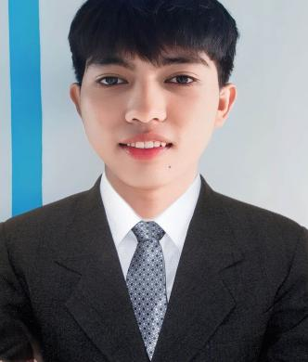Mark Angelo Villanueva Rosales

Tara St. Brg. Pating Masbate City

Philippines

(63+) 9639131975

[markr9353@gmail.com](mailto:markr9353@gmail.com)

|  |  |  |  |  |
| --- | --- | --- | --- | --- |
| **JOB OBJECTIVE** | | | | |
|  | To secure a challenging and rewarding position in a dynamic organization where I can utilize my skills and experience to make a positive impact. | | | |
|  | | | | |
| **Work Experience** | | | | |
|  | Social Media Manager |
|  | Content Creator |
|  | Image & Video Editor |
|  | Actual Merchant |
|  |  |
| **SKILLS** | | | | |
| - | Proficient in video editing software, including Adobe Premiere Pro, PhotoShop, Photopea, Canva, Davinci Resolve, Alight motion and Capcut. | | | |
| - | Proficient in HTML, CSS and JavaScript and VScode programming tool. | | | |
| - | Strong understanding of social media advertising, including campaign creation, targeting, and optimization. | | | |
|  | | | | |
| **EDUCATIONAL BACKGROUND** | | | | |
| - | **Bachelor of Science in Computer Science** | Philippine Women’s College of Davao, April 2019 - Present | | |
| - | **Relevant coursework** | Database Systems, Web Development, Application Development. | | |
| **Languages & Dialects** | | | | |
|  | **English** |  | | |
|  | **Filipino** |  | | |
|  | **Masbateño** |  | | |
|  | **Cebuano/Bisaya** |  | | |
| **CHARACTER REFERENCES** | | | | |
| Name | |  | Designation | Contact Number |
| 1. **Jynellmotilla@gmail.com** | | | Executive VA - Ecom | **09667443288** |
| 1. **Jillian Rose Rosales Ortiz** | | | Virtual Assistant | **09224247947** |