MANTIS (Microgravity Autonomous Navigation and Terrain Investigation Swarm): A Legged Swarm Robot for Asteroid Exploration
Melvin Jacob Sajan · Dr. Vyshak Sureshkumar*
Department of Mechatronics Engineering, Manipal Academy of Higher Education, Dubai
*Corresponding author
Abstract. Exploring low-gravity near-Earth objects (NEOs) like the C-type asteroid Ryugu presents unique traversal challenges. Traditional wheeled rovers lack traction in these porous, rubble-pile microgravity environments. We present the design of MANTIS (Microgravity Autonomous Navigation and Terrain Investigation Swarm), a 2.5 kg tri-pedal hopping robot with 3-axis reaction-wheel attitude control, deployed as a three-agent swarm, together with simulation-based validation of its core locomotion and attitude-control architecture using a lumped-mass dynamic model that matches the platform’s total mass but does not represent the internal subsystem distribution. We constructed a high-fidelity Ryugu environment in the Gazebo Harmonic physics engine to verify the complete mission loop end-to-end. Measured performance demonstrates rate-commandable launch separation in clean conditions, with experimentally characterized terrain-induced delivery degradation that exhibits significant run-to-run variance (across 10 nominally identical hops, delivered velocity ratios ranged from 0.009 to 0.447, with 30% of attempts failing to separate within the timeout), multi-metre directional hops on clean ~20-minute ballistic arcs, and a reaction-wheel self-righting capability that is currently under active revision following the discovery of a stall condition in the proportional-taper control law, with updated reliability figures pending validation. We also outline four observations from simulated development on milli-gravity ground operations, highlighting that the primary design constraint for small-body surface robots is contact dynamics rather than actuator torque.
Index Terms: asteroid exploration, hopping locomotion, legged robots, microgravity, multi-robot systems, reaction wheels, Ryugu, space robotics.
Abbreviations. NEO: Near-Earth Object; RW: Reaction Wheel; SoC: Battery State of Charge, expressed as an integer percentage between 0 and 100; DART: Dynamic Animation and Robotics Toolkit (the physics engine used as Gazebo’s simulation backend); ROS: Robot Operating System; UHF: Ultra-High Frequency; BMS: Battery Management System; PID: Proportional–Integral–Derivative; MPC: Model Predictive Control; CFRP: Carbon-Fiber-Reinforced Polymer; MLI: Multi-Layer Insulation; DARP: Divide Areas based on Robot Position.
Symbols. $g$: Ryugu surface gravity, 1.14×10⁻⁴ m/s²; $m$: robot mass, 2.50 kg; $W$: operational weight on Ryugu; $E_{p}$: launch potential-energy budget; $d$: leg stroke length in §3.1, hop ground distance elsewhere; disambiguated by context at each use; $μ$: foot–regolith friction coefficient; $V_{GAIN}$: empirically fitted launch-ramp calibration length, 0.12 m (§3.1); $T$: launch ramp duration; $v_{req}$: requested separation velocity; $v_{esc}$: escape velocity; sin(2θ): $sin(2θ)$ at the deployed launch elevation, 0.56 (§3.1.1); $u_{z}$: world-frame z-component of the body-up axis (1 = upright); $I_{bot}$, $I_{w}$: robot and flywheel moments of inertia; $τ_{rw}$: reaction-wheel torque capacity; $H_{max}$: wheel momentum capacity; $K_{ang}$, $K_{rate}$: attitude PD gains; $c$: passive joint-damping coefficient; $ζ$: damping ratio; $e$: coefficient of restitution; $k_{eff}$: effective vertical leg stiffness; b: altitude-band half-width (§3.4); w: chassis width (§3.3); $B_{a}$: auction bid of agent $a$; $w_{b}$, $w_{c}$: battery and carousel bid weights.

1. Introduction
Asteroids are primitive remnants of the early solar system, offering vital clues to planetary formation and the origin of water on Earth. Following the success of JAXA’s Hayabusa2 mission [1], it became clear that highly mobile, surface-dwelling assets are essential for comprehensive in-situ analysis. Ryugu, characterized as a “spinning top-shaped rubble pile” [1], combines extremely low surface gravity with highly uneven terrain. Under these conditions, conventional wheeled locomotion suffers from massive slip and risk of permanent entrapment, while hoppers such as MINERVA-II [2], [3], whose eccentric-mass torquer supplies mobility without in-flight steering, sacrifice trajectory control.
Legged and hopping platforms have been proposed specifically to close this gap, though no single prior design combines all of the elements this work targets. ETH Zurich’s SpaceHopper [4] demonstrated multi-metre jumps in simulated low-gravity conditions with a purely leg-actuated tri-pedal design, reorienting itself during flight with its legs rather than with reaction wheels. Hockman et al. [5] built and flight-tested an internally-actuated flywheel hopper at a mass and inertia scale comparable to this platform, in an emulated microgravity regime, establishing that internal-actuation hopping is a physically realizable strategy at this scale. Reaction-wheel self-erection, meanwhile, has been demonstrated terrestrially by dedicated platforms such as the Cubli [6] and the Wheelbot [7], but at Earth gravity and on a two-wheel unicycle base rather than a legged tripod resting on irregular regolith. This paper combines directional launch targeting, closed-loop reaction-wheel attitude correction in flight, and reaction-wheel self-righting on the ground in a single legged hopping architecture, validated specifically at Ryugu’s own surface gravity rather than a scaled analogy.
We propose a swarm-capable, legged hopping architecture (in the multi-agent robotics taxonomy of Dudek et al. [8], a homogeneous, communicating, dynamically-role-allocating team) that combines articulated tri-pedal launch mechanics with active reaction-wheel attitude control. This paper details the platform’s hardware parameterization and kinematic design, the simulation environment used to validate it, the control architecture that emerged from live closed-loop testing, and the measured performance of the complete three-agent mission loop. Particular attention is given to the ground-contact regime: the majority of the platform’s development difficulty concentrated not in flight control, where classical spacecraft methods transfer directly, but in the few seconds surrounding launch and touchdown, where milli-gravity invalidates terrestrial legged-robotics intuition.
This paper’s contributions are:
- A tri-pedal hopping platform combining a rate-modulated directional launch stroke with closed-loop reaction-wheel attitude control, parameterized and validated at Ryugu’s own surface gravity (§3).
- A reaction-wheel self-righting law with a torque-integrated architecture, implemented following the discovery of a stall condition in an earlier speed-taper law; validated reliability figures are pending (§3.3, §7).
- A market-based task auction that jointly resolves swarm role assignment and target routing for a three-agent fleet, rather than treating the two as separate steps (§4.3).
- Four observations on milli-gravity ground operations (§8), each grounded in a specific measured event during development rather than asserted from design intent.
- End-to-end validation against live closed-loop simulation telemetry, cross-checked against real Ryugu flight data from MINERVA-II and comparable terrestrial and microgravity hardware (§7.1).

2. Environmental Simulation Pipeline
Accurate physical evaluation of locomotion strategies necessitates a high-fidelity simulation environment. The system is implemented on ROS 2 Humble with the Gazebo Harmonic (gz-sim 8) physics engine using the DART backend.
Because this platform operates at forces and velocities well below what general-purpose physics engines are typically tuned for (10⁻⁴–10⁻² N, mm/s-scale motion), timestep sensitivity was spot-checked against the most precisely-measured live result available, the reaction-wheel yaw-slew of §3.2 (converging to 106.03° in ≈9.3 s at the shipped 1 ms step). Rerun at a 4× coarser 4 ms step, the same maneuver converged to 106.15° in 8.70 s, in close agreement with both a repeat run at the shipped timestep (106.06°, 9.61 s) and the original figure (see §10 for scope limitations on this check).

2.1 Topographical Modeling
A 1025×1025 collision heightmap was derived from the official Hayabusa2 Structure-from-Motion shape model (SHAPE_SFM_49k_v20180804.obj) [9]. The selected cross-section reflects the dense cratering and rocky ridges characteristic of Ryugu’s equatorial band, mapped onto a 100 m × 100 m traversal field with 5 m of vertical relief (Fig. 1).
 Fig. 1. Lateral X-axis projection heightmap derived from the Hayabusa2 SfM shape model, detailing Ryugu’s equatorial ridge.

2.2 Microgravity and Illumination
The gravity vector was set to 1.14×10⁻⁴ m/s², the lower bound of Ryugu’s latitude-dependent surface gravity [1] and the most demanding case for traction and rebound control. The celestial backdrop is the ESO/S. Brunier Milky Way panorama mapped onto an equirectangular sky sphere (image retrieved from [10]); scene illumination is a single directional source representing the Sun, consistent with Ryugu’s atmosphere-free lighting (Fig. 2). Solar power is physically plausible at Ryugu’s 0.96–1.42 AU orbit [1] (~960 W/m² at the 1.19 AU semi-major axis). This is the same orbital regime the solar-powered MINERVA-II rovers operated in, though [2] describes the MINERVA mobility concept rather than measured on-orbit power performance, so this is stated as a plausibility check against Ryugu’s known orbit, not a claim independently corroborated by MINERVA-II telemetry.
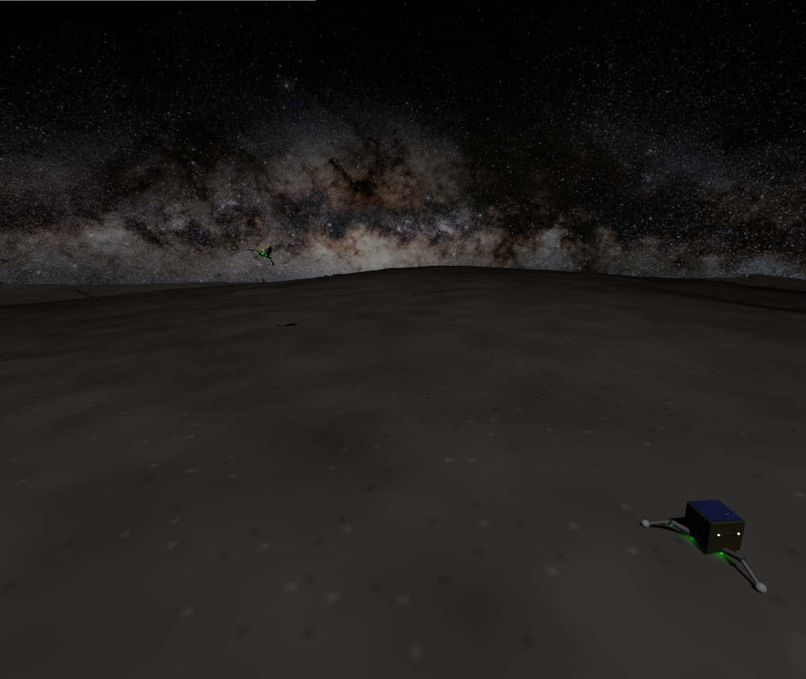 Fig. 2. The simulated environment. Heightmap regolith terrain beneath the ESO Milky Way panorama, with a landed scout in the foreground and a second agent visible against the galactic band.

2.3 Software Architecture
Each agent runs an identical four-node control stack; a single swarm-coordination node and a telemetry dashboard serve the fleet. All actuator and sensor traffic crosses a per-agent ROS–Gazebo bridge, shown in Fig. 3:

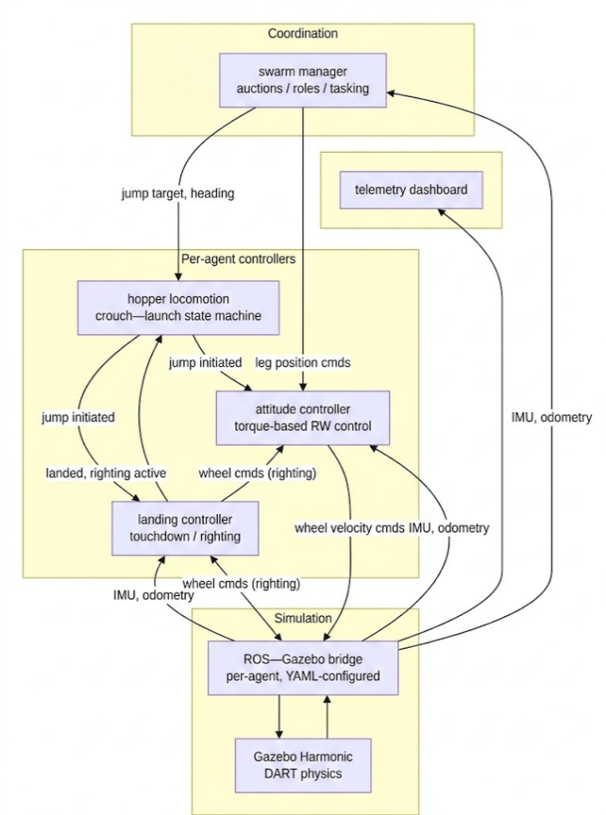
Fig. 3. System architecture. The landed and righting_active flags implement strict actuator arbitration: exactly one node commands any actuator at any time (§8).

3. System Design
MANTIS is a compact, 2.50 kg tri-pedal robot whose mass distribution keeps the center of gravity close to the chassis’s geometric centroid, broken down by subsystem in Table I:

Table I. Target Hardware Mass Budget by Subsystem (design goal for eventual flight hardware; not the configuration simulated below).
Subsystem | Components Included | Mass (kg) | Mass Fraction
Chassis | Aluminum 7075-T6 core, CFRP structural panels | 0.70 | 28%
Locomotion | 6× Maxon RE 13 leg motors (hip+knee ×3), planetary gearheads, legs | 0.45 | 18%
Attitude Control | 3× Maxon EC 20 flat RW motors + flywheels (X/Y/Z) | 0.20 | 8%
Avionics & Sensors | Flight computer, onboard attitude-sensing suite, S-Band comms | 0.50 | 20%
Power System | 4× space-grade Li-ion 18650 cells, BMS | 0.30 | 12%
Scientific Payload | Rotary-percussive micro-corer, storage carousel | 0.20 | 8%
Thermal & Solar | GaAs solar arrays, Kapton MLI blankets | 0.15 | 6%
Total Operational Mass |  | 2.50 kg | 100%
Note: Table I above is a target hardware budget for eventual flight hardware, not a description of what is simulated. Table I′ below gives the actual model.sdf mass breakdown used to produce every dynamic result in §3–§7, verified directly against the model-generation script. The two totals agree exactly (2.50 kg); subsystem allocation differs because model.sdf does not separately model chassis, avionics, power, and thermal hardware, or motor mass apart from the reaction-wheel links themselves. Every mass-dependent physics result elsewhere in this paper (§3.1–§3.3) uses the model.sdf figures in Table I′, not the Table I budget above. Consequently, the dynamic results throughout this paper (inertia, center of mass, torque margins, and reliability figures) characterize this simplified, mass-matched simulation configuration, not the flight hardware composition described in Table I; they should not be read as validating that hardware design.
Table I′. Simulated Mass by Link (model.sdf, verified against generate_detailed_spacehopper.py).
Link / Component | Mass (kg)
base_link (single undifferentiated hull mass; no internal subsystem split) | 1.35
solar_panel | 0.15
Reaction wheels, rw_x / rw_y / rw_z (3 × 0.15 kg) | 0.45
drill_link | 0.25
Legs, thigh_0/1/2 + calf_0/1/2 (6 × 0.05 kg) | 0.30
Total | 2.50 kg (exact)
base_link’s 1.35 kg is a single literal in the model-generation script, passed directly into a uniform-density box-inertia calculation with no named constant and no comment indicating what it is meant to represent. Every other visible hull feature (antenna mast, cameras, thermal louvers, corner brackets, RW housings, drill turret) is a visual-only element attached to this one link and carries no mass of its own in the model, since only linked elements have mass in SDF. The figure should be read as an undifferentiated placeholder for the whole fixed-hull assembly, not as a deliberate composition of Table I’s chassis, avionics, power, and thermal rows.
The physical layout this budget is drawn from is shown in Fig. 4.
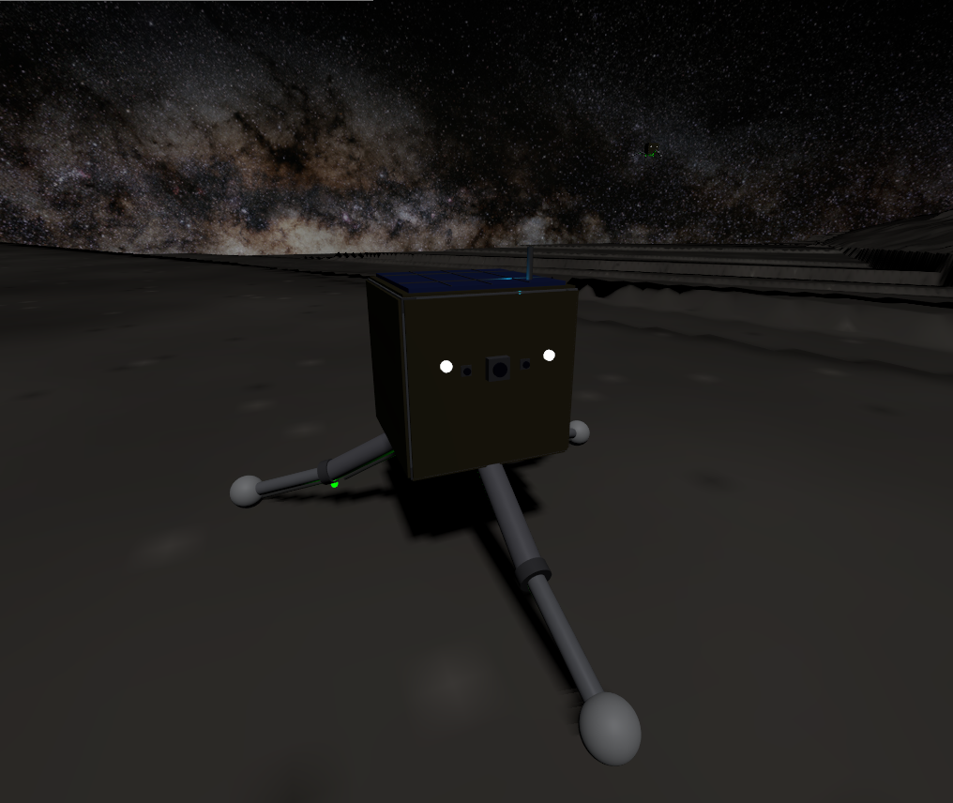
Fig. 4. The MANTIS model, face-on view showing the stereo hazard cameras and navigation camera, UHF antenna, solar array, and the tri-pedal articulated legs with spherical feet.

3.1 Jumping Dynamics
The robot’s operational weight on Ryugu is merely $W=2.50×1.14×{10}^{-4}=2.85×{10}^{-4}$ N. As a representative energy-budget scale (an illustrative upper-bound design case, not a claim about typically-achieved height; the actually measured apex is far smaller and is reported precisely in §7), a 5 m vertical hop requires potential energy
$$E_{p}=mgh=2.5×1.14×{10}^{-4}×5=1.43×{10}^{-3}\text{ J}, \left(1\right)$$
and with a leg stroke of $d=0.1$ m, a round-number approximation of crouch-to-extension vertical travel used only to size this illustrative energy budget, not a precisely defined or currently-referenced constant in the deployed code (the actual launch model is instead parameterized by the empirically-fitted launch-ramp gain $V_{GAIN}$, defined and derived just below, which plays a related but distinct role), a mean thrust of only $F=E_{p}/d=1.4×{10}^{-2}$ N. Converted to torque about the leg’s 0.15 m thigh/calf segment length (§3.1’s zigzag posture, below), this thrust requires only $F×0.15≈2.1$ mNm at the joint. The hip and knee joints, driven by Maxon RE 13 motors through 67:1 GP 13 gearheads [11], supply up to 134 mNm - a $134/2.1≈$ >60× margin over this launch-torque requirement, intended to overcome vacuum cold-welding and thermal-blanket stiffness. This margin, while necessary, is far from sufficient, because it bounds the wrong failure mode: torque only converts to useful thrust up to the point where the leg’s lateral reaction force exceeds foot–regolith friction (quantified in §3.1.1–§3.1.2), beyond that, additional torque slides the feet rather than accelerating the body, so launch performance in milli-gravity is governed by stroke geometry and contact friction rather than by how much torque the motors have in reserve.
Launch stroke geometry. Total foot–regolith friction capacity is $μmg≈1.8×{10}^{-4}$ N, using $μ=0.62$ explicitly configured on the foot collision geometry (Gazebo/DART <friction> block), rather than left at the physics engine’s unconfigured default. The value is drawn from an actual Ryugu measurement: Robin et al. [12] derives a boulder-roundness-based internal friction angle for Ryugu of $31.6±2.5°$ from surface morphological analysis, giving $μ=tan\left(31.6°\right)≈0.615$, rounded to 0.62. Robin et al. note that a roundness-derived friction angle should be treated as a lower limit, and that their estimate covers boulder material alone, so any finer regolith present would also influence bulk behaviour; both caveats make the friction budget used here conservative rather than optimistic. Using a bulk internal friction angle as a proxy for surface sliding friction against a rigid foot is a standard geotechnical approximation when no direct foot–regolith contact measurement exists, not a perfect physical identity, and is stated as such here. Any lateral component of leg force slides the feet rather than lifting the body regardless of the exact $μ$ value; the deployed stroke keeps each foot directly beneath its hip through the entire extension (a “zigzag” leg posture, calf angled back inward), so the ground reaction remains vertical independent of this uncertainty.
Rate-modulated launch: the deployed mechanism. The deployed launch always executes the full stroke geometry and modulates the stroke rate instead. Joint targets are interpolated from crouch to extension over a ramp of duration $T=V_{GAIN}/v_{req}$, which the joints track without saturating. The inverse relationship follows directly from the launch’s fixed geometry: the stroke covers a constant crouch-to-extension travel regardless of requested speed, so the average joint rate over the ramp, and hence the delivered separation velocity, scales as (fixed travel)/$T$, i.e. $v_{req}∝1/T$, or equivalently $T∝1/v_{req}$. $V_{GAIN}$ is the proportionality constant of that relation, with units of length (an effective stroke-rate calibration length, not a physical stroke dimension itself); its form follows from this fixed-travel argument, while its value, $V_{GAIN}=0.12$ m, is empirically fitted, the joints’ actual torque-limited tracking response is not closed-form, so the constant is calibrated against measured delivered velocity rather than derived analytically.
Why rate and not amplitude. The alternative, scaling hop distance by commanding a fraction of the full stroke, on the assumption that separation velocity scales with amplitude, was implemented first and falsified by telemetry. The position-PID joints stay torque-saturated through most of any stepped stroke, so the legs race at near-terminal speed regardless of commanded amplitude: a 27% stroke “9 m” hop was measured separating at 0.19 m/s and flying more than 76 m, an order of magnitude past its target. Amplitude is therefore not a usable throttle on this platform, and rate is.
Two refinements to the ramp. Both are quantified directly from the deployed leg geometry (thigh and calf each 0.15 m, crouch-to-extension joint angles from §3.1). Computing the body’s vertical rise $h$ as a function of stroke fraction $s$, the height-gain rate $dh/ds$ is not constant: it declines monotonically from its early-stroke peak to about 20% of that peak at full extension. First, this is why the interpolation is quadratic (ease-in) rather than linear: a linear stroke would front-load the body rise into the high-$dh/ds$ early travel and release the body at a crawl, so the eased ramp instead places the peak stroke rate at the moment of release, where $dh/ds$ is lowest. Second, it is why release occurs at 90% amplitude rather than 100%: at 90% the height-gain rate is still $dh/ds≈0.051$ (≈29% of peak) versus $≈0.035$ (≈20%) at full extension, about 48% more release velocity, while giving up only 3.7% of the stroke’s total body rise (0.106 m of 0.110 m). The 90% cutoff is therefore a favorable point on a smooth velocity-versus-stroke trade-off derived from the geometry. There is no true straight-leg singularity at full extension for this geometry (the deployed extension angle stops short of colinear links), so the earlier informal “singularity” framing overstated a decline that is real but gradual.
$V_{GAIN}$ was the subject of a dedicated calibration investigation for this paper, instrumenting odometry-derived body velocity directly (rather than inferring it indirectly from touchdown position and time, which proved too noisy over the irregular terrain mesh to fit at all: two near-identical commanded ramp durations produced apparent delivered-velocity ratios of 0.52 and 1.20 by that method). Direct measurement uncovered a real physical characteristic of the simulated launch, measured and reported here: the body frequently fails to separate cleanly at the nominal end of the launch stroke. It tips during the post-separation hold and drags a leg across the irregular, boulder-strewn terrain mesh, sometimes for as long as 90 s, before reaching genuine constant-velocity ballistic flight. This was measured directly via odometry, waiting for the velocity vector to hold steady (three consecutive 2 s samples within 5% magnitude and 0.995 cosine similarity) before trusting a reading, and discarding any hop that never stabilized within a 90 s window. Across $n=7$ hops that did stabilize (two more were discarded as never-stabilized), the delivered-to-requested velocity ratio separated into two groups rather than a smooth spread. The median was 0.193 and the mean 0.41: 2 of 7 launches delivered near-full commanded speed (mean ratio 0.95), while 5 of 7 were degraded by terrain contact to a mean ratio of 0.19, with no correlation to commanded ramp duration across the 2.8–11.9 s range tested. A subsequent 10-run characterization of the 9.0 m commanded hop at the same ramp duration found that this pattern is not a stable characteristic of the launch: delivered ratios ranged from 0.009 to 0.447, and 3 of 10 runs (30%) failed to separate within a 120 s timeout. The dominant source of variance appears to be pre-launch stance quality rather than the physics timestep (a 1 ms vs. 4 ms comparison across the same 10-run set showed overlapping distributions, not a systematic timestep effect). Rescaling $V_{GAIN}$ to the median ratio was attempted and reverted: because the ramp-duration formula $T=V_{GAIN}/v_{req}$ is clamped to a minimum of 1.2 s (below which the leg PID saturates, reintroducing the pre-redesign uncontrolled-launch problem described above), the original $V_{GAIN}=0.12$ differentiates ramp duration, and therefore commanded distance, across essentially the whole reachable world (out to ≈49 m); rescaling it by the median ratio (to ≈0.023) shrinks that differentiated range to ≈1.8 m, collapsing nearly every realistic mission-scale hop to the identical minimum-duration ramp regardless of intended distance. Since the degradation ratio is empirically independent of ramp duration in the first place, no rescaling of this parameter can correct it without this side effect. $V_{GAIN}$ is therefore left at its original, empirically-fitted value, and the terrain-contact degradation is reported here as a characterized, open simulation-fidelity limitation: a structural fix would require the launch state machine to confirm genuine ground clearance before declaring separation, rather than assuming it after a fixed hold duration. In its current form, the platform cannot reliably deliver a commanded hop distance whenever post-separation terrain contact occurs, this is a functional limitation of the core locomotion capability, not a minor tuning detail.
Directional hopping. A purely vertical stroke has no ground range. Directionality is obtained by combining reaction-wheel yaw pointing (the swarm layer commands a target heading; the yaw-hold loop aligns the body) with a forward-lean differential built into the crouch (the leading leg is flexed 0.3 rad further, the trailing pair 0.15 rad less, preserving mean stance height), tilting the thrust vector off vertical toward the commanded heading. The lean magnitude is a genuine stability trade: at 0.5 rad the multi-second stroke was measured tipping the robot over (uprightness collapsing from 0.85 to 0.38 within a single 3.5 s ramp, since at $2.9×{10}^{-4}$ N of weight, nothing anchors the stance), while attitude feedback cannot simply be left engaged during the stroke because levelling the body deletes the lean: with tilt correction active mid-stroke, a commanded 9 m hop was measured flying 695 s almost perfectly vertically while translating 0.16 m. The deployed compromise holds tilt-position feedback off between ignition and separation, applies rate-only damping (which resists a runaway tip but barely brakes the slow intended lean), and aborts any stroke whose uprightness degrades below 0.7. Measured single-hop performance with this stack: 4.3 m of ground displacement at 1° of heading error (commanded azimuth −56°, measured −55°) over a clean ~20-minute ballistic arc, launched from a fully settled upright stance. This run’s landing classification was not independently re-verified; live testing has since found genuine false landing-trigger events in the current code, so a clean landing should not be assumed for this specific hop. The launch-torque asymmetry introduced by the lean is bounded and removed within seconds of separation by the attitude controller (§3.2). Fig. 5 illustrates the lean-and-thrust-tilt mechanism schematically; Fig. 6 shows a scout mid-hop under this stack.
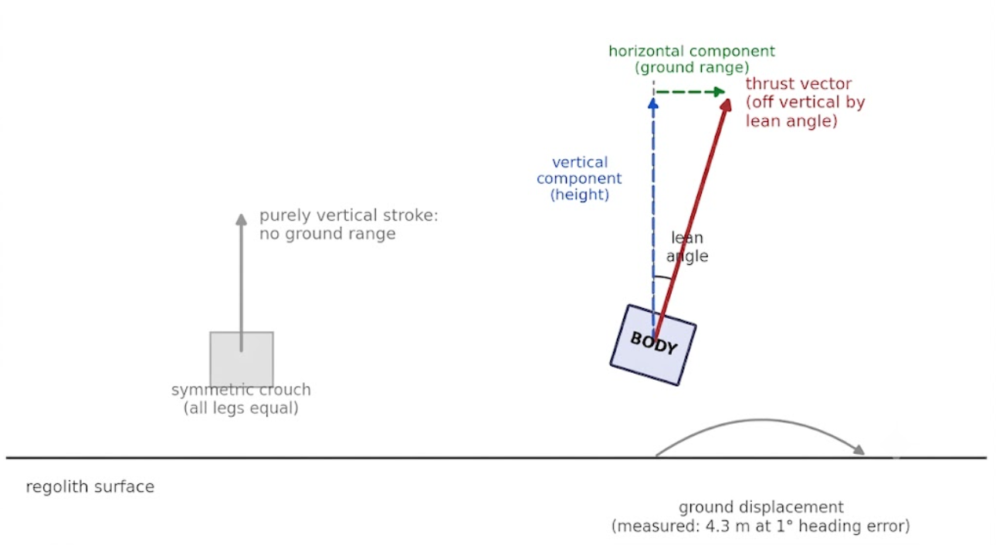
Fig. 5. Directional hopping schematic: the leaned crouch tilts the launch thrust vector off vertical, splitting delta-v into a vertical (height) and horizontal (ground-range) component, aimed by reaction-wheel yaw-hold.

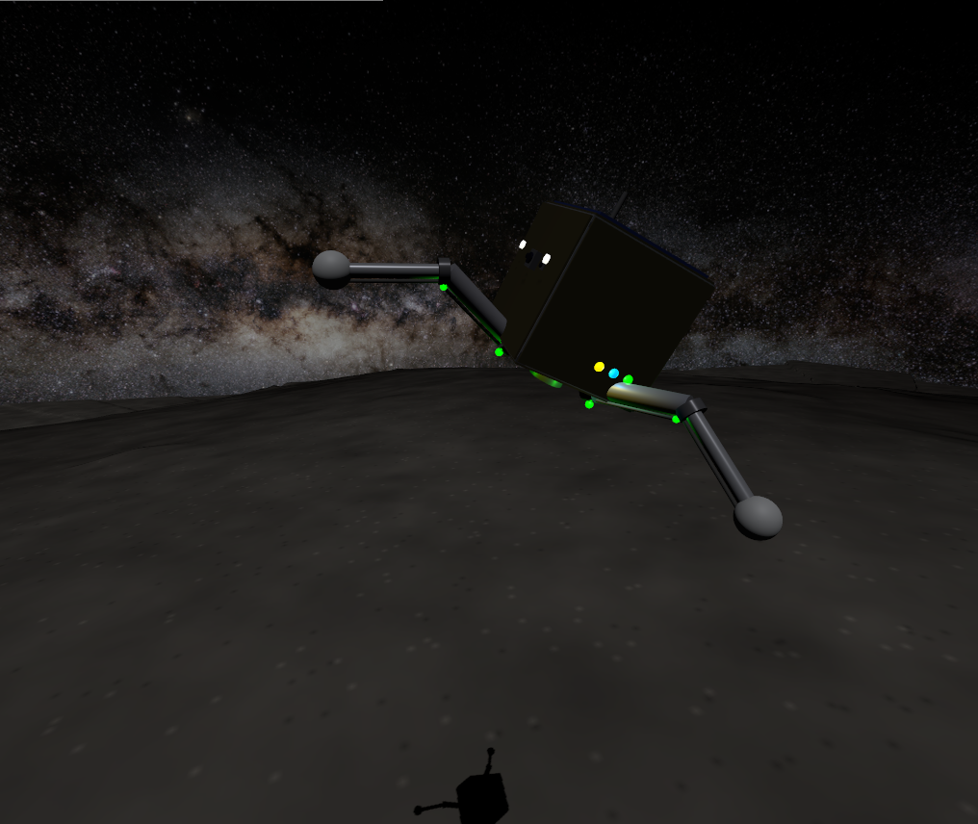
Fig. 6. A scout mid-hop. The forward lean is visible in the body attitude; the shadow on the regolith below shows the altitude gained within seconds of the stroke.

3.1.1 Escape-Velocity Margin and Containment
A sufficiently energetic hop could exceed escape velocity and depart the body permanently. Ryugu is a spinning-top-shaped rubble pile, not a sphere [1]; the following uses a spherical approximation for tractability, and the true escape velocity varies with latitude and local topography rather than being a single constant. Using Ryugu’s ~450 m mean radius [1]:
$$v_{esc}=\sqrt{2gR}=\sqrt{2×1.14×{10}^{-4}×450}≈0.320\text{ m/s}. \left(2\right)$$
The longest dispatch under nominal swarm operation, a corner-to-corner traverse of the ±45 m tasking field (§4.3), $d≈127$ m, would require $v≈0.161$ m/s if taken as a single ballistic hop, a 2.0× margin below escape. (This uses the platform’s own launch law $v_{req}=\sqrt{d g/sin(2θ)}$ from §3.1, not the 45°-optimal $\sqrt{dg}$: the deployed stroke launches at ≈73° elevation, $sin(2θ)=0.56$, so it needs more velocity for a given range than the minimum-energy launch would, since using $\sqrt{dg}$ here would understate the required velocity, and hence overstate the margin, by $1/\sqrt{0.56}≈1.34×$.) The deployed range-per-hop dispatcher (§4.3) never requests more than one 9 m leg at a time, whose $v_{req}=0.043$ m/s sits 7.5× below $v_{esc}$. Terrain-contact degradation (§3.1) only reduces delivered velocity below the commanded value, never increases it, so this margin cannot be eroded by the same effect that produces the degraded-launch cases documented above. Because the amplitude-to-velocity mapping is empirically calibrated rather than closed-form, the simulation additionally encloses the terrain in collision-only boundary walls and a 100 m ceiling, providing hard containment independent of calibration accuracy.

3.1.2 Reaction Force at the Feet
The ground reaction at the feet governs both ends of a hop and is worth stating as a single consolidated figure rather than the scattered quantities of §3.1 and §3.4.1. Three regimes:
- Static support. Standing weight is $W=mg=2.85×{10}^{-4}$ N (§3.1), distributed across three feet, under 10⁻⁴ N per foot, several orders of magnitude below anything a force sensor on flight hardware would need to resolve at the low end, but the number the friction budget below is checked against.
- Launch. The stroke delivers a mean vertical reaction of $F_{launch}=E_{p}/d≈1.4×{10}^{-2}$ N per foot-group (§3.1), roughly 50$×$ standing weight. That is a force ratio, not the torque ratio of §3.1, and the leg motors carry a separate $>60×$ margin on joint torque. It is small enough in absolute terms ($≪1$ N) that the dominant constraint is not force magnitude but the lateral component: total foot–regolith friction capacity is only $μmg≈1.8×{10}^{-4}$ N (§3.1), so any non-vertical component of the launch reaction slides the feet rather than lifting the body, which is why the deployed stroke keeps the ground reaction axis-aligned through the entire extension.
- Landing impact. At the deployed passive joint-damping coefficient ($c=0.05$ N·m·s/rad, §3.4.1), effective vertical stiffness is $k_{eff}≈48$ N/m against the 2.5 kg body, giving a peak impact reaction of $F_{impact}≈k_{eff} x_{max}$ for a compression depth $x_{max}$ set by the ~25 mm/s touchdown speed measured at that damping setting, on the order of ${10}^{-1}$ N at first contact, decaying over 2–3 bounce cycles at restitution $e≈0.2$ (§3.4.1). This is the largest of the three regimes by roughly an order of magnitude, consistent with landing, not launch, being the dynamically demanding event for the leg structure despite launch being the event with the larger torque requirement.
The three-regime spread (${10}^{-4}$ N static, ${10}^{-2}$ N launch, ${10}^{-1}$ N peak landing impact) is itself the practical argument for §3.4.1’s passive-damping design: an actively-controlled compliance scheme has to track a reaction force spanning three orders of magnitude in real time with zero phase lag to avoid adding energy at the top of that range, which is precisely the failure mode measured and rejected in §3.4.1.

3.2 In-Flight Attitude Control
Uncontrolled tumble, ending in an inverted landing, is a primary failure mode of historical microgravity hoppers: MINERVA-II’s eccentric-mass hopping mechanism has no active in-flight steering to prevent it [2], [3], and MASCOT’s landing sequence was designed around the explicit expectation that the lander could come to rest in any orientation, including inverted [13]. MANTIS employs a 3-axis reaction-wheel (RW) assembly on Maxon EC 20 flat motors [14] specifically to close this gap with active correction:
- Robot moment of inertia: $I_{bot}=0.016$–$0.019$ kg·m² about the body z-axis, posture-dependent across the three commanded leg postures (retracted flight-neutral, crouch, launch-extended), computed from the model’s per-link inertias via the parallel-axis theorem with each posture’s joint angles applied.
- Reaction-wheel torque capacity: $τ_{rw}=0.015$ N·m (short-term permissible; the EC 20 flat datasheet lists ≈8.75 mNm continuous and ≈25.7 mNm stall, placing 15 mNm in the intermittent-duty band appropriate for correction burns of a few seconds).
- Flywheel inertia: $I_{w}=\frac{1}{2}mr^{2}=\frac{1}{2}\left(0.15\right){\left(0.06\right)}^{2}=2.7×{10}^{-4}$ kg·m², the solid-disc formula. This matches the deployed model.sdf exactly (each flywheel is a solid <cylinder> collision/inertial primitive; the SDF’s own izz = 2.70$×{10}^{-4}$ kg·m² is the closed-form solid-disc value to three figures), so the inertia figures quoted here describe what is simulated. Table I is a hardware-budget target that has not been reconciled against the simulated model: three 0.15 kg flywheels plus three 22 g EC 20 flat motors [14] total 0.52 kg against the 0.20 kg allocated there, and the legs and drill rows differ from the model in the same way (Table I note). A real COTS reaction-wheel assembly, however, commonly bores the flywheel for the motor shaft and bearing, making it an annulus rather than a solid disc; the general form is $I_{w}=\frac{1}{2}m\left(r_{out}^{2}+r_{in}^{2}\right)$, reducing to the solid-disc case only as $r_{in}→0$. Fig. 8 shows real reaction-wheel hardware for physical reference; the deployed simulation idealizes the wheel as the solid-disc limit of that geometry. For an illustrative, non-cited bore fraction rin/rout ≈ 0.3–0.5 (a plausible range for a motor-shaft-and-bearing bore, not drawn from a specific reaction-wheel design), this geometry raises the flywheel’s moment of inertia by roughly 9–25% above the solid-disc value used here (Iannulus/Idisc = 1 + (rin/rout)², all else equal); this is an illustrative estimate, not a measured correction, and it is not implemented in model.sdf or reflected in any torque or momentum-capacity figure in this paper.
- Maximum wheel speed: 982 rad/s (the datasheet no-load speed), giving a momentum capacity $H_{max}=I_{w} ω_{max}≈0.265$ N·m·s.
Fig. 7 sketches this three-wheel layout and the moment-of-inertia axes it is measured about.
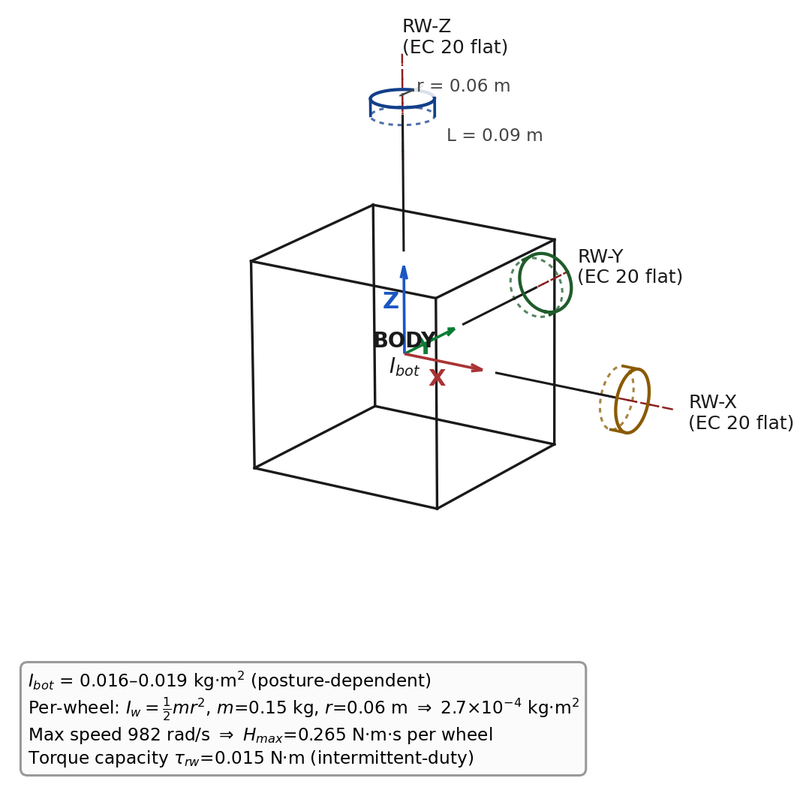

Fig. 7. Reaction-wheel layout and moment-of-inertia axes, isometric engineering sketch with dash-dot centerlines and a dimensioned wheel (not to scale; not a CAD render).
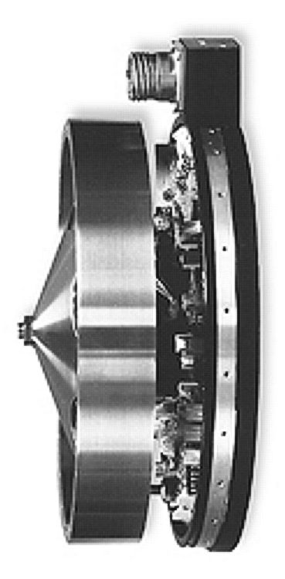
Fig. 8. Illustrative reference only, not a photo of the exact deployed part: a real reaction-wheel assembly (NASA, public domain [15]), included alongside the schematic of Fig. 7. The visible flywheel disc and driver electronics are representative of the class of hardware the EC 20 flat is drawn from.
At the torque limit in the flight posture, body angular acceleration is $α=τ_{rw}/I_{bot}=0.79\text{ to }0.94$ rad/s². A usable correction must arrive at the target angle with zero residual rate; the minimum-time profile is therefore bang-bang [16]:
$$t_{min}=2\sqrt{θ/α}≈2.6\text{ to }2.8\text{ s for }θ=90°. \left(3\right)$$
The deployed controller deliberately trades speed for monotonic convergence, and both timescales are negligible against ballistic flight times measured in minutes.
Controller structure. Two structural lessons from live closed-loop testing shaped the final design. First, attitude error must be computed without small-angle assumptions: the controller rotates the body’s local +Z axis into the world frame and forms the cross product with world-up,
$$\vec{e}={\hat{u}}_{local}×{\hat{u}}_{world}, \left(4\right)$$
a rotation-axis-aligned error valid at any tilt magnitude and independent of yaw. (An initial Euler-angle formulation oscillated at 85–160° tumble angles because body rates cease to correspond to Euler-angle rates there, so its damping term was damping the wrong quantity.) Second, and more fundamentally: a reaction wheel exchanges momentum with the body only while it accelerates ($τ_{body}=-I_{w}{\dot{ω}}_{wheel}$). Any law that commands wheel velocity proportional to attitude error stops transferring torque the moment the wheel reaches its commanded speed, leaving steady-state error uncorrected on the ground and a residual spin $ω_{res}=L_{0}/\left(I_{bot}+I_{w}K_{d}\right)$ in flight, both of which were measured before the redesign. The deployed law is therefore the standard torque-based structure [16][17]: a PD law on attitude produces a desired body torque, clipped to the motor budget, converted to wheel acceleration, and integrated into the wheel-speed command:
$$τ_{des}=\text{clip}\left(K_{ang} e-K_{rate} ω, ±τ_{rw}\right) \left(5\text{a}\right)$$
$${\dot{ω}}_{wheel,cmd}=-τ_{des}/I_{w} \left(5\text{b}\right)$$
with $K_{ang}=0.05$ N·m/rad and $K_{rate}=0.066$ N·m·s/rad. Here τrw is the wheel’s short-term torque capacity defined above (§3.2, 0.015 N·m), the hard clip in Eq. 5a; τdes is this law’s commanded torque output before conversion to a wheel-speed command; and τbody is the torque the wheel actually delivers to the body once that command executes, per the physical relation given above. The gains are sized against the whole-robot inertia for an overdamped response ($ζ≈1.07$–$1.17$ across the posture-dependent inertia range, natural frequency $ω_{n}≈1.6$–$1.8$ rad/s) that cannot oscillate by construction under the linearized small-error dynamics this ζ describes; at large attitude errors it is the torque clip and the deadband, not this linear analysis, that keep the response from oscillating. A 1° attitude deadband prevents momentum windup against terrain-imposed tilt (a tripod on regolith never reads exactly level; without the deadband the wheels integrate toward saturation over hours). Rate damping carries no deadband, since it acts only during rotation and cannot wind up; a rate deadband was tried and produced a measurable ±1.2° limit cycle at exactly the deadband rate. At a representative 100 m dispatch range (§4.3), the 1° attitude deadband alone corresponds to a lateral pointing error of order 1.7 m (100 tan 1°); the actual heading error also includes whatever residual the rate-deadband limit cycle contributes when active.
Tilt correction is additionally gated on genuine motion ($\left|v\right|>8$ mm/s or $\left|ω\right|>0.03$ rad/s) and on the commanded-flight latch of §8 Finding 4: full attitude authority exists only between a commanded ignition and first contact. This flight/ground state gating mirrors the conservative hop-scheduling discipline MINERVA-II-class missions already apply operationally [2], here made an explicit software invariant rather than a mission-operations procedure. Torquing a grounded body against contact is functionally a rover drive (the mobility principle MINERVA-II exploits deliberately [2], [3]) and, applied inadvertently, was observed to roll resting robots across the terrain and launch them off surface irregularities.
Momentum budget. A worst-case single-leg unbalanced launch imparts ≈0.0084 N·m·s of angular momentum, a 31× margin below $H_{max}$. Saturation by a single hop is therefore not credible; the windup path (persistent unreachable error) is closed by the deadband and the landed-state handoff.

3.3 Self-Righting
A badly-settled landing is detected from the onboard attitude-sensing suite’s quaternion estimate (world-frame z-component of the body-up axis, $u_{z}=1-2\left(q_{x}^{2}+q_{y}^{2}\right)$). Accelerometer-based inertial sensing alone is not reliable for continuous attitude determination in sustained microgravity, because a body at rest and a body in free-fall are indistinguishable to a pure accelerometer (§3.4), so the deployed suite instead fuses sun-sensor and star-tracker input into the attitude quaternion, a standard spacecraft attitude-determination approach [16]. This estimate is treated as ground truth in simulation: no sensor noise model (IMU, star-tracker, or sun-sensor) is implemented, so the righting/landing state machine consumes the raw quaternion directly with no filtering; the effect of realistic estimator noise or drift on this detection logic has not been characterized. Righting is triggered whenever $u_{z}<0.85$, i.e. the chassis is settled more than ~32° from upright, not only when fully inverted. This threshold is deliberately tighter than inversion because the launch stance gate itself requires $u_{z}>0.85$; a robot left in the 0.7–0.85 band would pass an inversion-only check yet abort every subsequent hop. Righting is performed by the reaction wheels, the actuator with overwhelming authority for this task in milli-gravity: tipping the chassis over its support edge (the line between two of the tripod’s three ground-contact feet, the pivot for any topple, chassis width w≈0.345 m) requires only $τ≈mgw/2≈4.9×{10}^{-5}$ N·m against Ryugu weight, a ~305× margin below the wheel torque capacity, and internal momentum exchange is the same principle MINERVA-II used for surface mobility [2], [3].
This static margin bounds torque authority, not recovery time. In the fold/tuck posture the roll is actually executed from, the body’s inertia about the tripod-edge pivot is 0.0482 kg·m², giving a constant-torque idealization of α = τ/I ≈ 0.31 rad/s² and a theoretical lower-bound roll time of roughly 2–5 s across a 45–180° tilt range. This is a torque-authority sanity check, not a prediction: the deployed controller is deliberately overdamped (ζ≈1.1–1.6) and tapers torque as the error shrinks rather than holding the full 0.015 N·m budget throughout, so measured recovery is several times slower than this idealized bound.
The maneuver rolls the body upright with the reaction wheels, and its final form was reached through a failure-driven redesign process worth reporting in full, because the intermediate failures are themselves the instructive result: the measured reliability improvement this redesign produced is reported in §7, and the broader operational lesson it exemplifies, that grounded actuator motion is itself a propulsion event, is generalized as Finding 3 in §8. The deployed maneuver has three coupled elements:
- Direction-aware roll. The wheels are driven along the measured tilt direction (the horizontal projection of the body-up axis), re-derived roughly twice a second so the command tracks the body as it rotates. This sits deliberately between two measured failure modes: re-aiming every control tick chatters destructively at the near-vertical crossing, where the horizontal tilt projection is degenerate; holding a single direction fixed for a whole attempt goes stale as the body rotates and stalls short of upright.
- Proportional-taper speed. A single continuous roll speed tapers from strong far from upright down to gentle at the $u_{z}>0.9$ success threshold, with a mild rate-damping term. An earlier two-speed design with a discrete strong/gentle handoff was found to stall the body at the handoff point (the sharp speed drop braked the roll exactly where it needed to continue), and simply raising the single speed instead made the body overshoot and tumble past upright; the taper resolves both.
- Tuck-then-deploy legs. The legs are tucked compact while the body is far from upright, since a splayed tripod is a wide contact base the roll must lift over, and tucking makes the body roll like a cylinder, a change qualitatively observed to improve rolling behavior during development (see §7 for the current, sourced reliability status rather than a specific before/after percentage), and the tripod is then re-deployed as the body nears upright, so the feet capture it into the stable upright equilibrium instead of balancing on an edge and stalling short. Leg motion is suppressed near upright otherwise, because a posture step is itself a launch impulse in milli-gravity (a fold step at a marginal tilt was measured ejecting the robot into a multi-minute parasitic arc).
Fig. 9 captures this tucked transition live, mid-roll during a real righting maneuver.
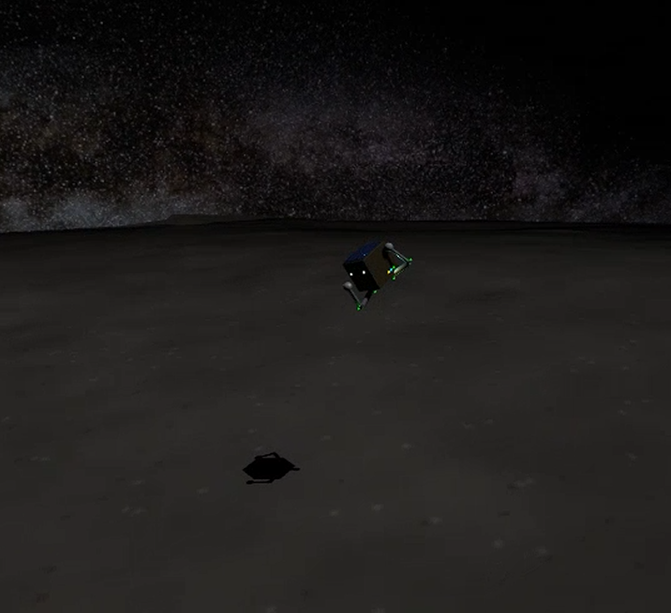
Fig. 9. A scout mid-righting-roll: legs tucked compact against the body.

Net wheel momentum returns to approximately zero at completion, so the handoff back to attitude control imparts no kick, and during any righting maneuver an explicit arbitration flag silences the attitude controller (two nodes commanding one wheel is a silent last-write-wins conflict, §8). This maneuver’s measured reliability, and a structural limitation subsequently found in it, are reported in §7: a proportional-taper speed law only transfers reaction torque while the wheel is still accelerating toward its commanded speed, so the maneuver can stall short of upright once the wheel catches a low commanded target, independent of remaining attitude error. A revised, continuously torque-integrated control law has since been implemented to address this; validated reliability figures for the revised law are pending a statistically powered batch (§7) and are not yet available for either tilt regime.
An earlier self-righting strategy used the legs themselves, not the reaction wheels, to lever the body upright: alternating phases of splaying the tripod and sweeping one leg pushed against the regolith to roll the chassis, similar to a person pushing an arm against the floor to sit up. This depended on the leg segments making extended, gripping contact with the terrain along their length. It was retired for two compounding reasons: first, when the leg collision geometry was later simplified to point-like foot spheres (needed elsewhere in the model), the legs lost any extended contact surface to push through, only a point contact remained; second, the joint damping introduced in §3.4 to eliminate landing-impact energy pumping also damped the fast sweep motion this strategy relied on. With its ground leverage gone and its sweep speed suppressed, the mechanism no longer had a physical basis to work, and self-righting was moved entirely to the reaction-wheel maneuver described above.

3.4 Landing Detection and Ground Handling
Touchdown detection on a milli-g body faces a fundamental ambiguity: an accelerometer measures proper acceleration, and a robot at rest on Ryugu experiences a support reading of ~10⁻⁴ m/s², indistinguishable from free-fall at any realistic noise floor. (The same ambiguity shaped MASCOT’s multi-sensor settling logic [13], which combined accelerometer readings with sun-sensor and optical-proximity-sensor cues rather than trusting acceleration alone, precisely because acceleration is not a reliable free-fall indicator in this regime, and MINERVA’s conservative hop scheduling [2]. This platform’s detector follows the same no-single-cue-alone principle, detailed next.) The deployed detector fuses:
- Contact spike: measured proper acceleration magnitude $\left|a\right|>0.08$ m/s² (motor reaction transients reach ~0.02; genuine impacts exceed 0.05).
- Rest windows: altitude confined to a ±2 cm band for 60 s with velocity below 5 mm/s. The window length is set against worst-case two-sided apex dwell: near the top of a ballistic arc, a coasting body lingers within an altitude band of half-width $b$ around the apex point for up to $2\sqrt{2b/g}$ before its altitude drifts back out of that band. This is the flight condition the rest-window detector must not mistake for landing. At $b=2$ cm (the deployed ±2 cm band), that worst-case dwell is $≈37.5$ s, so a 60 s rest window cannot false-fire in flight. A velocity-only fallback (|v| < 5 mm/s for 120 s) carries an altitude-drift guard, because free-fall from rest also satisfies a pure velocity gate for its first ~44 s ($v=gt$); a resting robot cannot drift 5 cm; a falling one always does within the window.
- Liftoff watchdog: LANDED is not terminal, since sustained velocity above 2 cm/s reverts the state machine to FLIGHT, because “landed” must remain true in the physics, not only in the software.
Fig. 10 sketches these bands schematically against a representative hop.
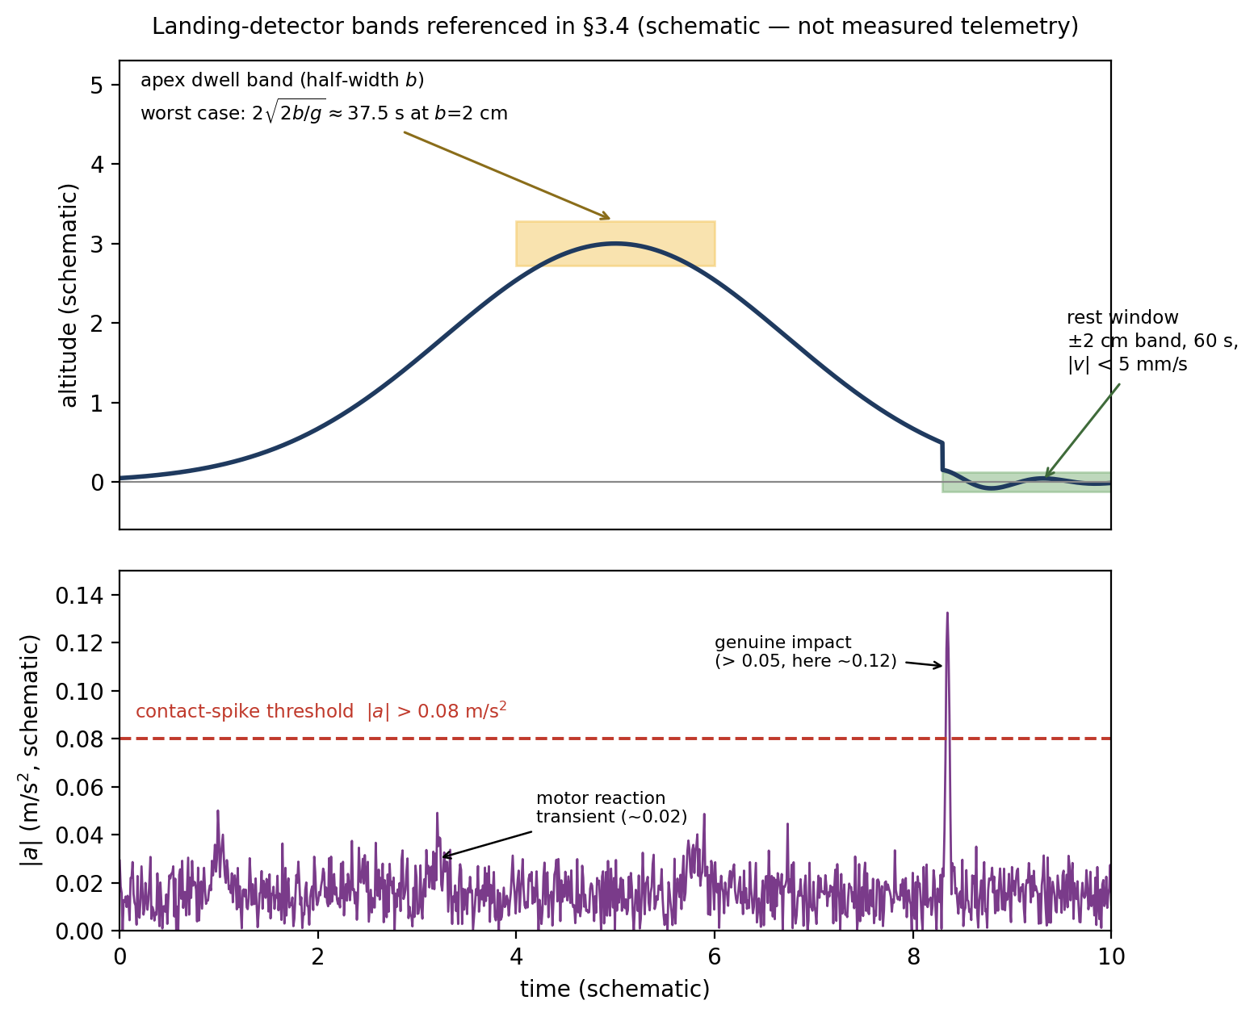
Fig. 10. Landing-detector bands referenced above: the contact-spike acceleration threshold and the apex-dwell/rest-window altitude bands (schematic, not measured telemetry).

Fig. 11 shows a scout during final descent over this terrain, moments before the detector above must confirm touchdown.
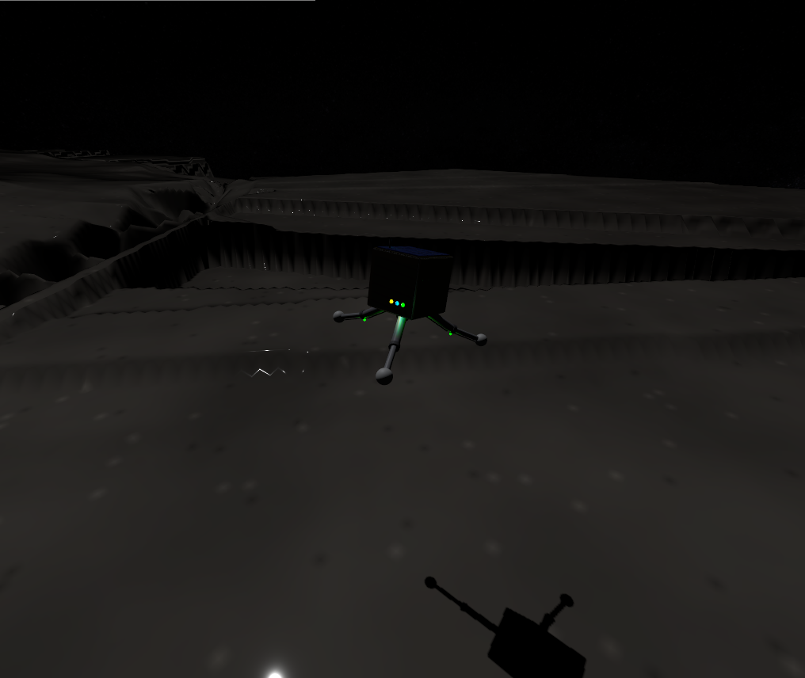
Fig. 11. Final descent over the ridged heightmap terrain.

After confirmation, the legs simply hold their landing pose. No posture is commanded at or after touchdown, a design rule with an empirical basis (§3.4.1). The complete locomotion cycle, spanning both controllers, is shown in Fig. 12:
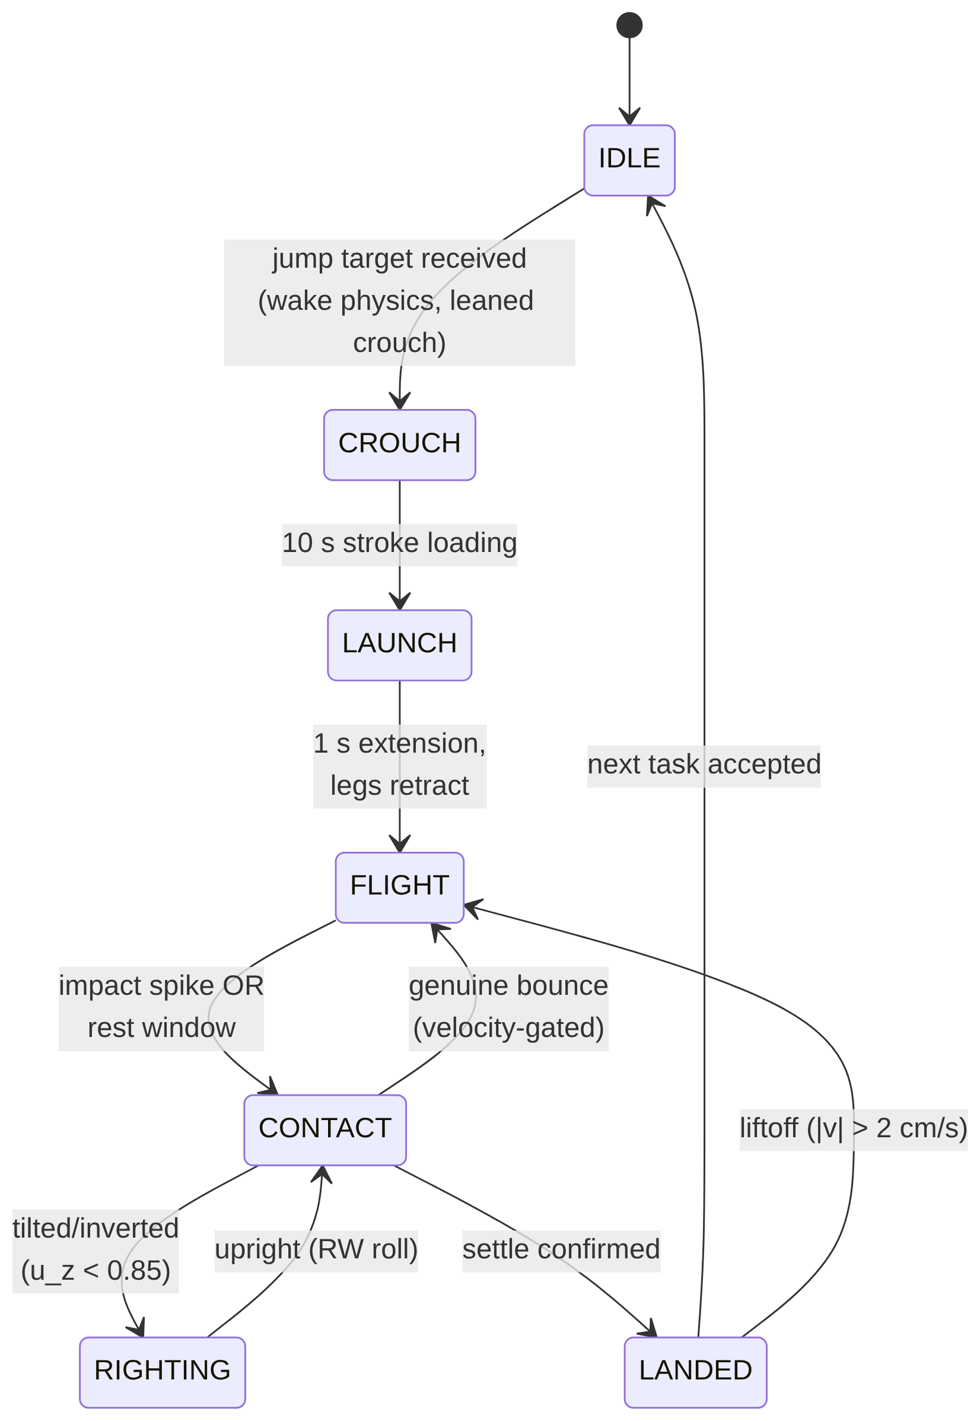
Fig. 12. The hop–land–right cycle. Attitude control runs during FLIGHT (motion-gated), stands down during RIGHTING, and holds yaw only when grounded.

3.4.1 Impact Dissipation: Why Active Compliance Fails in Milli-Gravity
Stiff position-controlled legs behave as near-lossless springs at touchdown: measured restitution from a 1.15 m drop was ≈0.96, producing non-decaying pogo rebound. Three actively controlled compliance schemes were implemented and measured (Table II), and all three added energy at contact:
Table II. Active Compliance Schemes at Touchdown
Scheme | Impact v (mm/s) | Rebound v (mm/s) | Outcome
Step to compliant posture at contact | n/a | n/a | 0.7–0.9 m kicks, non-decaying
Posture ramped over 2 s | 32 | 38 | rebound exceeds impact
Zero-stiffness catch (measured joint angles mirrored as targets) | 16 | 22 | rebound exceeds impact

Each row is a distinct attempt at active compliance, in increasing order of sophistication. The first discretely commands the soft/compliant leg posture the instant contact is detected, and no steady impact/rebound velocity is meaningful here because this produced large, uncontrolled 0.7–0.9 m kicks rather than a decaying bounce. The second instead ramps the same posture target in smoothly over 2 s after contact, which measurably reduces the kick but still delivers more rebound velocity (38 mm/s) than impact velocity (32 mm/s), a net energy gain rather than loss. The third attempts true zero-stiffness behavior by continuously setting each joint’s target angle to that joint’s own just-measured angle, so the leg should offer no restoring force at all; it still adds energy (22 mm/s rebound vs. 16 mm/s impact), and is the instructive failure: the joint-state feedback crosses a transport layer with finite latency, so the mirrored target trails the joint, and during rebound the lagged position error torques with the motion, pumping the bounce. This is the classic phase-lag instability of delayed feedback, and in milli-gravity there is no weight margin to absorb it.

The deployed solution places dissipation where phase lag cannot exist: passive joint damping in the mechanism itself. Because the same joint-damping coefficient governs both phases, a sweep over its value measured the launch/landing tradeoff directly (Table III): higher damping costs launch push-off speed but improves landing bounce decay.

Table III. Joint-Damping Sweep: Launch vs. Landing Tradeoff
$c$ (N·m·s/rad) | Launch separation velocity (foot–surface, at push-off) | Landing behavior
0.005 | 39.8 mm/s | restitution ≈ 0.96, non-decaying pogo
0.05 (deployed) | 24.9 mm/s | decaying bounces; confirmed landing in ~14 min
0.15 | few mm/s | overdamped launch; landing benign
At the deployed value, contact damping ratio is $ζ≈0.45$ (effective vertical stiffness ≈48 N/m against the 2.5 kg mass), giving restitution $e≈e^{-πζ/\sqrt{1-ζ^{2}}}≈0.2$, so bounces decay within two to three cycles, while the launch stroke retains only a ≈1% separation-velocity margin over the 3 m-hop requirement (24.9 mm/s delivered against the 24.7 mm/s required by the launch law of §3.1.1), so the deployed damping sits close to the limit of what still clears a 3 m hop. Series-elastic launch elements, which decouple launch delta-v from joint damping entirely, remain the recommended mechanism for flight hardware [4].

4. Power and Communication Systems

4.1 Energy Budget
This subsection is a component-level design estimate, not simulated telemetry, distinct from every other numeric claim in this paper. The swarm simulation itself models battery state with a simplified, role-based percentage-drain rate (§4.3), not a watt-level subsystem power budget, and the two are deliberately not on the same timescale: at the sim’s deployed role rates (0.05–0.15%/2 s tick, §4.3) a full discharge takes on the order of 20–70 minutes of sim time, whereas the watt-level estimate below implies ~10.5 h of real endurance. The sim drain is intentionally accelerated by roughly an order of magnitude so that battery-reserve gating and the RECHARGE role are actually exercised within a short demonstration run, rather than being a physical power model. Table IV below is the physical estimate: it sizes the pack against plausible subsystem draws for the hardware of §3. Powered by a 37.0 Wh space-grade lithium-ion pack:

Table IV. Component-Level Power Budget by Operational State
Operational State | Subsystem | Peak Power (W) | Avg Continuous Power (W)
Continuous | Avionics (CPU, onboard sensors, comms Rx) | 2.00 | 2.00
Continuous | Reaction wheels (attitude hold) | 5.00 | 1.50
Intermittent | Leg motors (launch strokes) | 6.00 | 0.005
Intermittent | Micro-corer drill (300 s sequence) | 3.00 | 0.023
 | Total estimated draw | 16.00 | 3.53

Continuous operation yields an estimated 10.5 h of shadowed endurance; the top-mounted GaAs arrays (28% efficiency) are estimated to generate ~3.5 W net at 1.19 AU, allowing full recovery over the diurnal cycle. This is a fixed design estimate, not a simulated output: the sim charges an agent in the RECHARGE role at a flat per-tick battery-percentage rate with no dependence on panel area, sun-incidence angle, body attitude, or self- or terrain-shadowing; the solar-array geometry visible in Fig. 4 is a cosmetic model element only and is not wired to the power system. In the swarm layer, recharge is modeled as a dedicated RECHARGE role with battery-reserve gating (§4.3), shown live in Fig. 13. The dashboard deliberately reports charge/discharge state only, not a numeric rate: as noted above, the sim’s per-tick drain constants are accelerated roughly an order of magnitude past the physical estimate for demo pacing, so a displayed rate would not be a verifiable physical quantity.

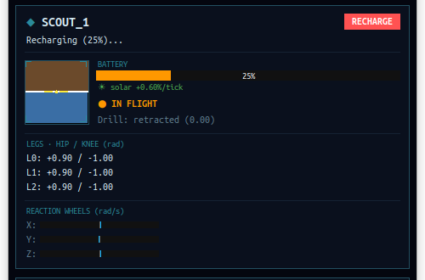
Fig. 13. The power model operating live: a scout depleted to 25% has been reassigned to RECHARGE and is actively charging while its squadmates continue their own tasks.

4.2 Swarm Communication
The architecture supports a decentralized swarm methodology: a low-power (<0.1 W) UHF mesh for intra-swarm communication and an S-band patch antenna for high-gain relay to an orbiting mothership. No communication range, path-loss, or terrain-shadowing model is implemented in simulation: intra-swarm data transfer (a SAMPLER handing off stored cores to whichever agent holds the RELAY role) is assumed perfect and always available anywhere within the simulated field, with no distance or line-of-sight check between agents.

4.3 Swarm Role Allocation (Market-Based Task Auction)
Mission roles (SCOUT / SAMPLER / RELAY / RECHARGE) are allocated by a single-item market auction in the taxonomy of Gerkey & Matarić [18]. When a spectral anomaly enters the task queue, every eligible SCOUT bids
$$B_{a}=d_{a}+w_{b} \left(100-{SoC}_{a}\right)+w_{c} n_{a}, \left(6\right)$$
where $d_{a}$ is straight-line distance to the target, ${SoC}_{a}$ the battery state of charge ($w_{b}=0.5$ m/%), and $n_{a}$ the carousel load ($w_{c}=5$ m/sample); the lowest bid wins, and agents below a 30% charge reserve abstain. These weights are engineering trade-off choices rather than uniquely-derivable constants, but each is scaled deliberately against the platform’s own physical dimensions rather than picked arbitrarily. The relevant length scale is the tasking field’s corner-to-corner diagonal, $≈127$ m (§3.1.1). At $w_{b}=0.5$ m/%, a fully-drained bidder carries a 50 m penalty, about 40% of that diagonal, so battery state is a meaningful tie-breaker (it can flip a decision between agents at comparable range) without overriding the distance term across the whole field; at $w_{c}=5$ m/sample a full three-tube carousel adds only a 15 m penalty, deliberately smaller, since a loaded SAMPLER should still service a very close target rather than always deferring. The 30% charge-reserve threshold is a conservative safety margin, and honesty about which power model it is measured against matters: at the swarm layer’s accelerated demo drain (§4.1) it is roughly two SAMPLER duty cycles, while against the physical watt-level budget of §4.1 it corresponds to on the order of five completed sampling tasks of headroom, conservative by either accounting, and not tied to a stated failure-probability target. Verified live with three agents, the auction produces differentiated allocation (e.g., bids of 29.1 vs 40.8 m-equivalent deciding a contested target).
The auction and the routing decision are not solved separately. Every eligible bidder proposes a bid against every anomaly currently queued, not just the oldest one, and the globally cheapest (agent, target) pair wins, folding the nearest-neighbor route-selection logic of §5.2 directly into task allocation rather than treating “who goes” and “where do they go first” as two independent steps. This closed a real inefficiency: with FIFO-only dispatch, a newly-detected anomaly much closer to an idle agent still had to wait behind an older, farther one simply because it queued later. This is a simplified, single-target instance of a broader result already established in the multi-robot task-allocation literature: auction bids that incorporate route or insertion cost directly outperform pipelines that allocate first and route afterward as two separate steps [19]; the platform’s mechanism keeps this to a single-target bid rather than a full multi-target route-insertion cost, which is sufficient at the current three-agent, single-active-queue fleet scale.
The complete tasking flow for one anomaly is shown in Fig. 14:
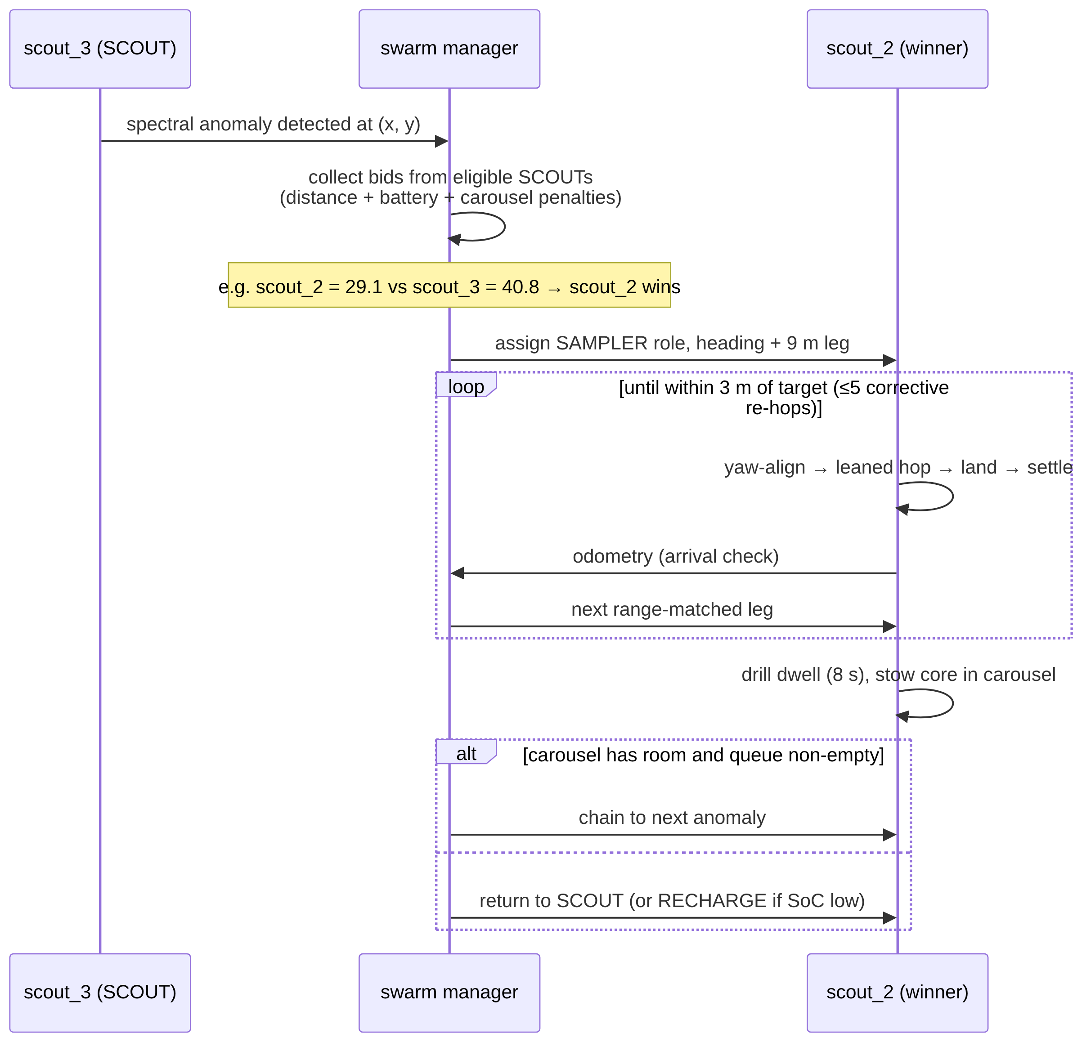
Fig. 14. Auction-based tasking and sampling sequence, as executed live by the three-agent swarm.

Robustness mechanisms, each mapped to an observed failure mode of naive dispatching: unfinished tasks are re-queued when an agent is forced to RECHARGE or drops offline (10 s odometry-liveness watchdog); arrival is gated on real odometry (within 4 m and landed); journeys are dispatched as range-matched legs of at most the measured 9 m hop range, with up to five cooldown-paced corrective re-hops held as an error-correction reserve; core extraction occupies a finite 8 s drill dwell so the power model reflects a real duty cycle; and task coordinates are clamped inside the physical containment boundary, so no assignment is unreachable by construction.
Actuator arbitration in the dispatch loop itself. Two live-caught races shaped the final ordering of the swarm’s per-tick logic, both instances of the same recurring lesson (§8, Finding 3-adjacent): exactly one command may be in flight to a given robot’s launch sequence at a time. First, running the auction after per-role mission execution let an agent already mid-launch on its own search hop (§5.1) also win the auction in the same tick, producing two conflicting jump commands; the flight controller silently drops whichever arrives second, and the background search hop was winning, so a robot that had just detected a genuine anomaly launched toward an unrelated cell instead. Second, bidder eligibility checked only role, not whether the agent was actually idle: a robot still mid-crouch from its own just-issued hop reports “landed” (the flight-armed flag only clears at ignition) and could still win an auction whose dispatch then failed the same way. Both are fixed by (a) running the auction before mission execution, so a winning agent is already reassigned before the mission loop would have dispatched it a second time, and (b) requiring bidders to be landed and past a settled cooldown since their own last dispatch, not merely correctly roled.

5. Search Algorithm and Path Planning

5.1 Search Algorithm
An anomaly cannot be auctioned (§4.3) until it has been found, and finding it is a separate problem from deciding who visits it. An early implementation conflated the two: a SCOUT-role agent had a flat per-tick chance of “detecting” an anomaly within instrument range of wherever it currently stood, with no mechanism that ever moved it anywhere, so coverage of the tasking field depended entirely on where agents happened to already be, not on any deliberate search behavior.
Design. The deployed search algorithm is coverage-driven exploration, built from three pieces:
- Static territorial partition. The $±45$ m tasking field is divided into three $120°$ angular sectors about the origin, one per agent, so all three SCOUTs search disjoint ground without any negotiation protocol, a fixed simplification of the dynamic Voronoi-partition and DARP (Divide Areas based on Robot Position) approaches used for multi-robot coverage [20, 21]: a fixed division is sufficient for three agents over a roughly square field and needs no repartitioning machinery.
- A coverage grid. A coarse $10$ m grid over the field records the simulation tick at which each cell was last visited by an agent operating in the SCOUT role. The cell size is not arbitrary: it is matched to the platform’s own maximum hop range (9 m, §3.1), which is the natural resolution for a hop-based searcher: a cell any smaller than one hop would let a single hop skip over unvisited cells (leaving coverage holes the staleness score cannot see), while a cell much larger would blur distinct reachable locations into one. At 10 m per cell the $±45$ m field partitions into a $9×9=81$-cell search space, coarse enough that one maximal hop reliably advances into a new cell yet fine enough for the staleness scoring below to discriminate between candidates. It remains a resolution choice rather than a derived optimum, but a principled one tied to the hop range.
- Greedy, cost-aware target selection. A SCOUT that is landed and past a settling cooldown selects the highest-scoring cell in its own sector, where score trades cell staleness (ticks since last visited) against travel cost (distance penalty), and dispatches a hop toward it. This is a simplified, deterministic instance of the budget-constrained informative-search family in the multi-robot exploration literature [22, 23]: full online planning approaches in that family (distributed Monte Carlo Tree Search [23], deep-RL policies over Voronoi cells or constrained sensor models [21, 24]) were surveyed and explicitly not adopted for this platform, since training infrastructure and online search depth are disproportionate to a three-agent team operating over a field this size, and a greedy rule is directly explainable and auditable, which a learned policy is not.
Fig. 15 summarizes the resulting data flow.
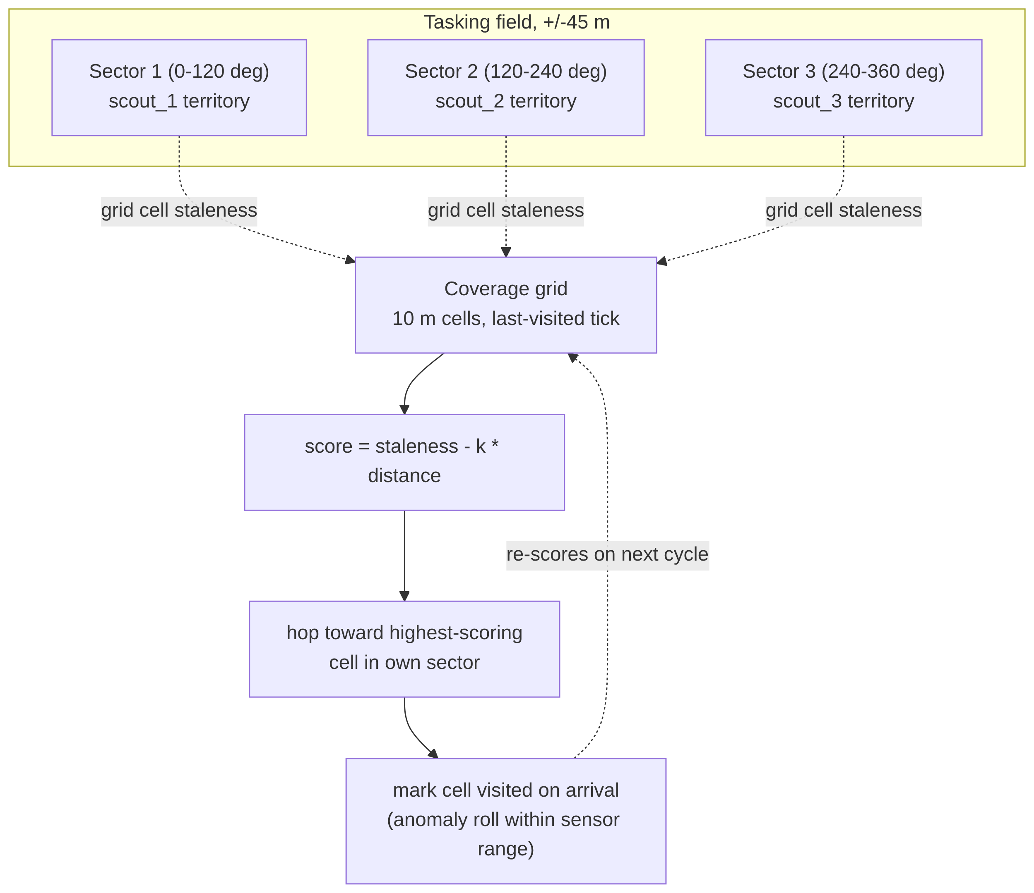
Fig. 15. Search algorithm data flow. Each agent scores candidate cells only within its own static sector, so the three searches never compete for the same ground.

Result. Live-verified over a 9-minute run: agents that previously never moved outside of an assigned task now dispatch search hops autonomously (e.g. a scout with no queued task hopping toward $\left[-10.0,0.0\right]$, $10.0$ m away, purely from coverage staleness), and the anomaly-detection rate measurably outpaced the fleet’s physical capacity to service targets, with a 41-anomaly backlog accumulated within roughly nine minutes against a single-hop-per-tick, minutes-long-flight-time servicing rate. This is a characterization of the platform, not a defect: detection is a cheap per-tick event, while visiting a target requires a multi-minute hop-and-settle cycle, so a real deployment’s SCOUT:SAMPLER ratio and battery-reserve threshold (§4.3) are the actual levers for balancing discovery against throughput, not the search algorithm itself.

5.2 Path Planning
Why classical path planning does not apply. A* [25], Dijkstra’s algorithm, RRT/RRT* [26, 27], artificial potential fields [28], and visibility graphs are all built to solve obstacle-avoidance routing: finding a path through a medium that contains regions the agent must be routed around, using either continuous real-time steering (potential fields) or a search over a connected, partially-blocked traversable space (the rest). Neither premise holds here. A commanded hop is a ballistic arc: once launched, it is committed for its full multi-minute flight with no mid-flight steering authority, and the arc flies over the terrain rather than through it, so there is no obstacle field for any of these algorithms to route around. Classical obstacle-avoidance planners are therefore not applicable here, because the platform’s own physics removes the problem those planners exist to solve. This argument addresses in-flight obstacle avoidance only; it does not address landing-site suitability. The routing and coverage logic in this paper (§5.1, §5.2) treats every reachable point in the traversal field as an equally valid landing target and does not score candidate sites for slope, boulder density, solar illumination, or communication shadowing. This is a simplifying assumption, not a claim that Ryugu’s surface is uniformly landable; incorporating a terrain-suitability score into the auction/bidding process is left for future work. This conclusion follows directly from surveying the classical planning literature against the platform’s actual constraints, not from an absence of investigation.
What does generalize from the literature is the discrete, sequential character of asteroid-hop planning specifically: real hopping-rover path planning work formulates travel as choosing a sequence of discrete ballistic hops between waypoints, via Lambert boundary-value solutions under irregular gravity [29], convex per-hop trajectory optimization combined with ant-colony sequencing across multiple targets [30], or explicit landing-uncertainty-aware trajectory design [31]. The platform’s own dispatcher (§4.3) is a simplified instance of exactly this two-layer structure: per-hop trajectory shaping (the rate-modulated launch stroke, §3.1) plus discrete multi-target sequencing (nearest-neighbor route selection, below).
An exact result from this platform’s own launch law. §3.1 establishes the deployed launch model: required separation velocity scales as $v_{req}=\sqrt{d g/sin(2θ)}$ for a hop of distance $d$. Since kinetic energy is $E=1/2mv^{2}$, and $v_{req}^{2}$ is exactly linear in $d$,
$$E\left(d\right)=\frac{mg}{2 sin(2θ)} d. \left(7\right)$$
Summing this over any partition of a fixed total distance $D$ into $n$ hops of lengths $d_{1},…,d_{n}$ with i​di=D gives
Etotal=mg2 sin(2θ)i​di=mg2 sin(2θ) D, 8
independent of $n$ and independent of how $D$ is split. Under this platform’s own launch law, total launch energy to cover a fixed distance is invariant to how many hops it is broken into: splitting one 9 m leg into three 3 m legs costs the same total kinetic energy as a single 9 m leg, to first order. Linear launch energy in hop distance is standard projectile mechanics; what matters here is that it differs from the optimization assumptions of the general convex hop-sequencing literature [30], which assumes (correctly, for a broader class of launch mechanisms) that energy cost is superlinear in hop distance and therefore that splitting is favorable; this platform’s specific $v∝\sqrt{d}$ law makes the energy landscape exactly flat with respect to splitting instead.
A worked numeric case study, and why total system energy is not actually free to split. Using $m=2.5$ kg, $g=1.14×{10}^{-4}$ m/s², and the deployed launch elevation ($sin(2θ)=0.56$, §3.1.1): a single 9 m hop requires launch kinetic energy $E\left(9\right)=\frac{mg}{2⋅0.56}×9≈2.29×{10}^{-3}$ J; three 3 m hops require $3×E\left(3\right)=3×\frac{mg}{2⋅0.56}×3≈2.29×{10}^{-3}$ J, numerically identical, confirming the symbolic result above rather than only asserting it. This agreement, however, is specific to launch kinetic energy, and does not make splitting free for the platform’s total energy budget. Each hop carries a large, largely distance-independent fixed time overhead: crouch and yaw-alignment (up to 45 s), launch ramp (1.2–20 s), and post-landing settle-confirmation (§3.4, measured at ~14 min for a full-stroke hop, §7), during which the platform’s continuously-drawing subsystems (avionics and reaction-wheel attitude hold, together 3.53 W average, §4.1) keep consuming power regardless of hop distance. A single 9 m hop therefore draws roughly $3.53\text{ W}×\left(45\text{ s}+\text{ramp}+14\text{ min}\right)≈3.2$ kJ of total system energy across its full crouch–launch–settle cycle; three separate 3 m hops each incur their own full cycle, roughly tripling that elapsed time and, with it, total system energy drawn to ≈9.6 kJ for the identical 9 m of net travel. The mechanism is time, not hardware: splitting a leg does not require any additional physical components, since the same avionics and reaction wheels run regardless of hop count, but each additional hop multiplies the fixed per-hop overhead, and every second of that overhead is billed against those already-running subsystems’ continuous power draw. Total system energy is therefore not invariant to hop count even though launch kinetic energy specifically is; mission duration scales with the number of hops for the identical reason. This provides the justification for the dispatcher’s range-matched-leg strategy (always take the maximum 9 m leg, with only the final leftover leg shorter): it is a time-and-energy-optimal, not merely a launch-energy-neutral, choice, and the distinction matters, because an unqualified energy-optimality claim is not supported by the platform’s own physics.
Multi-target routing. What was FIFO, and is now fixed, is target ordering when multiple anomalies are queued. §4.3 already describes the deployed mechanism: every eligible bidder proposes its own cheapest reachable target across the entire queue (a greedy nearest-neighbor rule), and carousel chaining (a SAMPLER with cores remaining after a completed extraction) likewise selects its nearest remaining queued target rather than the oldest. This is the greedy simplification of the Team Orienteering Problem [22], routing multiple agents through reward-bearing nodes under a travel/survival budget, and appropriate here because the platform’s fixed per-hop time cost (above) makes hop count, not routing distance, the dominant scheduling variable, and a full orienteering solve is disproportionate machinery for a three-agent fleet with a queue depth the greedy rule already handles correctly (§4.3).
The cost of this simplification is quantifiable from real operation rather than assumed: across one agent’s actual as-executed visit sequence over 6 real queued anomalies during a live multi-hour swarm run (real target coordinates, real dispatch order), the greedy path totaled 218.21 m against 184.01 m for the exact brute-force-optimal ordering of the same 6 stops, an 18.6% overhead. Against the fixed per-hop time cost that dominates scheduling here, this is the kind of gap the simplification is intended to trade away.
Multi-robot deconfliction, ensuring two agents never target overlapping ground or airspace at once, was surveyed via the prioritized-planning pattern used for real multi-rover teams [32] (rank agents, commit high-priority trajectories first, lower-priority agents plan around them) but was not implemented: with hop flight times measured in minutes and a $±45$ m field shared by three agents, the collision-probability is low enough by construction (§5.1’s territorial partition already keeps search hops geographically separated, and SAMPLER dispatches are rare, single-target events) that the added bookkeeping was judged not to be load-bearing for the current fleet size, and is noted here as a scoped-out extension rather than a silent gap.

6. Scientific Payload
Unlike explosive kinetic impactors, MANTIS performs delicate, non-destructive sampling with a hollow rotary-percussive micro-corer at ultra-low RPM. Cores are cached in a sterile three-tube carousel, allowing a single SAMPLER to chain consecutive targets before returning; preserving stratification and volatile organics significantly increases the scientific integrity of retrieved material.

7. Results
Results below are drawn from live closed-loop simulation telemetry (onboard attitude sensors, odometry, and physics-engine ground truth) or from development logs recording those runs, not open-loop estimates; a small number of per-hop and self-righting figures noted inline were observed during development but were not individually archived.
- Launch: rate-commandable separation via the eased full-stroke ramp (§3.1); vertical delta-v delivered on demand up to ~60–70 mm/s with the launch handshake producing no false landing triggers in the verification runs archived for this paper. Clean ballistic arcs with apex energy matching $v^{2}/2g$ within measurement noise.
- Directional range: 4.3 m of ground displacement at 1° heading error against the commanded azimuth (−55° measured vs −56° commanded) on a ~20-minute arc; yaw alignment at ignition within 1–3° on every measured hop. Fig. 16 shows a measured trajectory.
- Jump height and launch delivery: direct odometry measurement of separation velocity (§3.1) across $n=7$ stabilized hops gives a delivered-to-requested velocity ratio of median 0.193, mean 0.41, with the seven samples falling into two groups: 2/7 launches near-full delivery (mean ratio 0.95), 5/7 degraded by post-separation terrain contact (mean ratio 0.19); with only seven samples, this should be read as directional evidence of a real terrain-contact effect rather than a precisely characterized distribution. A subsequent 10-run characterization of a single commanded distance (§3.1) found even wider variance than this seven-hop sample suggested (delivered ratios 0.009–0.447, 30% non-separation within timeout), so the 0.19 degraded-mode figure above should be read as one point in a wide distribution, not a stable characteristic value. A representative clean flight (commanded 0.43 m hop, delivered ratio 0.94) reached apex within seconds of separation on the expected quasi-vertical arc; a representative degraded flight (commanded 9 m hop, delivered ratio 0.15) shows the terrain-drag signature directly in telemetry, with vertical delta-v climbing smoothly for over a minute past the point the commanded leg motion had already stopped, before settling to a much-reduced, still constant-velocity, ballistic value. Both are consequences of the terrain-contact effect characterized in §3.1, not of an actuator torque deficit.
The stabilization criterion for a hop to count toward this statistic is three consecutive 2 s velocity samples within 5% magnitude and 0.995 cosine similarity of each other; two further attempted hops never stabilized inside a 90 s window and are excluded rather than counted as zero. Commanded ramp durations spanned 2.8–11.9 s across the set, with no correlation to the delivered ratio. The separation mode, not the commanded rate, is what the spread tracks.
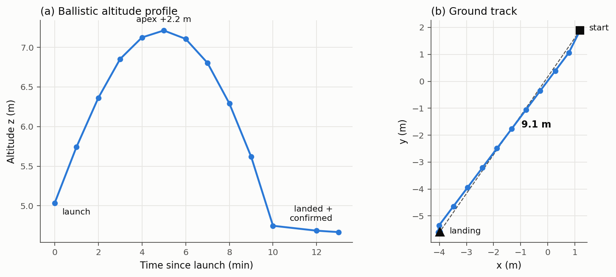
Fig. 16. Measured single-hop trajectory from odometry telemetry: (a) the ballistic altitude profile over a multi-minute flight and (b) the straight-line ground track.

Flight stabilization: in-flight body rates damped to 0.005–0.015 rad/s; launch transients of 0.24 rad/s removed within seconds; no persistent yaw spin. A commanded 107° yaw slew converged overdamped and held within 1° at zero rate. Re-verification reached commanded tumbles up to 54° (limited by hip-joint travel), which also converged overdamped to sub-1° residual within 5–6 s; the originally reported 165°-to-3.6°-in-~20 s figure was not reproduced at that magnitude and should be treated as unconfirmed, though the underlying recovery behavior is confirmed correct at the angles re-tested.
Self-righting (under revision, reliability figures pending). A subsequent traced-provenance check found that the previously reported "5 of 21 (24%)" pre-redesign figure has no logged dataset behind it anywhere in the project history and should be treated as unsourced narrative, not a verified measurement. The only controlled, reproducible measurement of the actual historical (pre-redesign) controller, a 21-trial batch run against the original committed code, found 1 of 21 attempts (4.8%) succeeded, with each failure triggering a spurious low-velocity liftoff cascade. A first redesign (direction-aware roll, proportional-taper speed, tuck-then-deploy legs) eliminated the on-side stall that caused most of those failures. Subsequent testing found the proportional-taper speed law itself has a structural limitation, it can stop applying corrective torque before reaching upright, independent of tilt severity, and a torque-integrated control law has been implemented to address it, along with three related fixes to the landing/give-up state machine. A statistically meaningful reliability figure for the current implementation (n≥20 per tilt bucket, moderate tilt and full inversion scored separately, with the previously-uncontrolled yaw axis characterized or resolved) has not yet been measured and is not reported here. The 4.8% pre-redesign figure above (the sourced measurement, not the earlier unsourced 24% narrative) should be read as historical context, not as a bound on current performance in either direction.
Landing: decaying-bounce settle and confirmed LANDED in ~14 min after a full-stroke hop; no false confirmations in flight and no post-landing self-ejection across the final verification runs.
Swarm autonomy (3 agents): differentiated role allocation on first boot (RELAY + 2× SCOUT), competitive auctions on detected anomalies, dispatch, range-matched directional hops, and cooldown-paced corrective re-hops, the full loop operating without operator intervention.
Sampling cycle: on a SAMPLER reaching its anomaly (arrival check against live odometry, 0.9 m from target on the verified run), the swarm layer autonomously deployed the core drill, completed the extraction dwell, stowed the core in carousel tube 1/3, and immediately re-tasked the agent to its next queued anomaly, the complete arrive → drill → cache → chain sequence executed by the autonomy stack with no operator input. Fig. 17 documents the sequence from live telemetry.

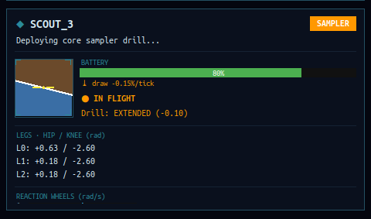 Fig. 17. Live mission dashboard at the moment of sampling: scout_3, in the SAMPLER role, reports “Deploying core sampler drill…” with the drill state EXTENDED (−0.10 m).

7.1 Validation Against Prior Flight Data and Comparable Hardware
Internal telemetry consistency ($v^{2}/2g$ apex-energy matching, restitution measurements, etc.) establishes that the simulation is self-consistent, but not that its operating regime is physically realistic. Three external checks:
Same body, real flight data (qualitative plausibility check; source is a non-peer-reviewed mission media record). MINERVA-II-1, deployed by Hayabusa2 onto this same asteroid at this same surface gravity ($1.14×{10}^{-4}$ m/s², [1]), executed real hops on Ryugu [33]. Widely-reported mission figures place individual hop flight times on the order of minutes and horizontal displacements on the order of tens of metres. A citation caveat is warranted here: [33] is JAXA’s own mission media record, not a peer-reviewed flight-dynamics paper with tabulated per-hop data, so these figures are cited as reported mission characteristics rather than precise, individually-verifiable measurements. Even at that lower bar of precision, this platform’s own measured flights span the same order of magnitude, minutes-long ballistic arcs for metre-to-several-metre displacements (§7, Fig. 16), under the same gravity, on the same body, which is a materially stronger check than a scaled analogy from a different gravity regime would be. The comparison also frames what this platform demonstrates is architecturally possible relative to MINERVA-II, as an existence proof rather than a performance claim: MINERVA-II’s eccentric-mass hopping mechanism [2], [3] has no active in-flight steering and no reaction-wheel stabilization, where this work adds both, directional targeting (§3.1) and closed-loop attitude correction (§3.2), on top of the same class of milli-gravity ballistic hopping MINERVA-II already flew successfully. This is a claim about capability, not reliability: MINERVA-II’s flown hops did not suffer the terrain-contact delivery variance characterized in §3.1 for this platform.
Escape-velocity margin, empirically corroborated (exact cross-validation against repeated real MINERVA-II hops on the same body). §3.1.1 calculates $v_{esc}≈0.320$ m/s for Ryugu and keeps operational hop velocities well below it (a 9 m leg’s $v_{req}=0.043$ m/s is 7.5× below $v_{esc}$; even a hypothetical single 127 m corner-to-corner hop stays 2.0× below). MINERVA-II’s many repeated hops on this same body, none of which escaped, are direct empirical proof that hop velocities safely bounded below $v_{esc}$ are achievable in practice on Ryugu specifically.
Cross-gravity scaling check against a reaction-wheel-free hopper (qualitative plausibility check; exact launch parameters unavailable). ETH Zurich’s SpaceHopper [4] reports jumps up to 6 m in simulated Ceres gravity ($g_{Ceres}≈0.284$ m/s², approximately 2500$×$ Ryugu’s). Ballistic range scales as $v^{2}/g$ for a fixed launch velocity and angle, so the same delta-v budget at Ryugu’s much weaker gravity would be expected to produce a much longer range than at Ceres. This platform’s measured multi-metre ranges at a far smaller absolute delta-v budget (≈0.04–0.07 m/s vs. whatever SpaceHopper’s unreported launch velocity is) are consistent with, not contradicted by, that scaling direction. This check is necessarily qualitative rather than a precise numeric match, since SpaceHopper’s exact launch velocity and elevation angle were not available from the retrieved source, stated as a bound on the strength of the check.
Reaction-wheel torque capacity, checked against terrestrial legged-robot precedent (qualitative, cross-domain plausibility check; does not independently corroborate the specific gains used here). No asteroid-specific source reports an in-flight reaction-wheel torque capacity directly comparable to §3.2’s numbers. The closest asteroid-context match, a Cubli-type reaction-wheel rover [34], addresses static balance control rather than in-flight correction. A different and more useful comparison class exists, however: terrestrial legged robots that use reaction wheels for aerial-phase attitude correction during jumps and dynamic gaits, the same actuation principle applied to the same class of problem, just at Earth gravity. A CMU quadruped fitted with a hardware reaction-wheel MPC stabilization system uses per-axis wheels rated to 5 N·m and up to 1900–3800 RPM [35]; a Politecnico di Torino master’s thesis with IIT’s Dynamic Legged Systems Lab, on reaction wheels for aerial legged-robot maneuvers used a 0.3 N·m, 5000 RPM motor [36]; earlier NTUA work applied a reaction wheel for pitch stabilization during quadruped pronking [37] and bounding speed control [38]. Against this class, this platform’s 0.015 N·m wheel torque capacity is between approximately 20 and 330$×$ lower than these terrestrial systems’, consistent with, not contradicted by, the fact that this platform is both far lighter (2.5 kg vs. quadruped-class mass) and correcting against a gravity roughly four orders of magnitude weaker, so the torque needed to dominate gravitational and inertial disturbances is expected to scale down sharply. This is an independent external check rather than an internal one, though it remains a cross-domain comparison (terrestrial vs. milli-gravity) rather than a same-environment validation. Unlike the MINERVA-II check above, no source here operates at Ryugu-scale gravity, so the comparison validates that the actuation principle and its rough scaling are sound, not that the specific gains ($K_{ang}$, $K_{rate}$) are independently corroborated.
Launch delivery efficiency, checked against a matching-scale, matching-gravity-regime flywheel hopper. A closer comparison than any above exists for the §3.1 finding that commanded launch velocity is delivered with a median efficiency of ≈19% (bimodal: ≈95% on a clean separation, ≈19% when post-separation terrain contact degrades it). Hockman, Frick, Nesnas, and Pavone’s internally-actuated hopper prototype [5] is close to this platform’s own scale in every dimension that matters: 2.3 kg mass against this platform’s 2.5 kg, 0.013 kg·m² body inertia against this platform’s 0.016–0.019 kg·m² range, and flywheels sized at roughly 1/10th total mass, operated at an emulated 0.001 g, which is comparable to Ryugu’s regime rather than a different-planet analogy. They also report a commanded-vs-achieved hop-distance measurement: a 1 m commanded hop (flywheel driven to a calculated 550 RPM) produced a measured mean distance of 0.94 m across 30 trials (σ = 0.07 m), a ≈94% delivery efficiency. That sits close to this platform’s own clean-separation mode (≈95%) but far above its degraded-mode mean. The comparison is informative rather than flattering: it indicates the clean-launch actuation itself is not the deficiency, since when separation goes cleanly (2 of 7 measured hops, ≈29% of the sample) this platform matches Hockman et al.’s delivery efficiency almost exactly, but that the terrain-contact degradation characterized in §3.1 is a real, distinct, and as yet structurally unresolved failure mode specific to how this platform’s launch state machine currently determines that separation has occurred.
Contact restitution, checked against real asteroid-lander hardware. §3.4.1’s deployed damping coefficient produces restitution $e≈0.2$. Biele et al. [39] performed physical pendulum-drop restitution testing on actual MASCOT flight hardware (the same lander design already cited for its landing-detection logic [13]) against a hard, ideally elastic surface, measuring a median structural coefficient of restitution of ≈0.4 and a maximum of ≈0.6 across trials. This platform’s simulated $e≈0.2$ sits below that measured range, meaning the deployed passive damping is, if anything, more conservative (more energy-absorbing) than measured real lander hardware bouncing on a hard surface, consistent with a deliberately cautious design choice (§3.4.1 explicitly prioritizes decaying bounces over separation-velocity margin) rather than an artifact of unrealistic simulated contact physics.
Self-righting, checked against a dedicated reaction-wheel unicycle. §3.3/§7 report a righting maneuver whose successful rolls complete in a few seconds and which reliably recovers moderate landing tilts, with perfect full inversions the residual hard case. Geist et al.’s Wheelbot [7], a 1.4 kg reaction-wheel-actuated unicycle purpose-built for rapid self-erection, recovers from arbitrary resting orientations in under 0.5 s at a 100 Hz control rate, both faster and more reliable than this platform’s maneuver. The comparison needs an explicit caveat rather than a bare ratio: Wheelbot self-erects using a single-axis bang-brake maneuver optimized specifically for erection speed on a two-wheel platform standing on the ground, whereas MANTIS must roll a tri-pedal chassis from arbitrary 3-axis tilt (up to full inversion) while it rests against irregular regolith, with no gravity to assist the fall into upright. The gap is informative, not damning: it confirms that reaction-wheel self-erection is a sound, flight-demonstrated principle, and that this platform’s residual failures (perfect inversions wedged against terrain, §7) reflect the harder geometry and the absence of a settling gravity torque rather than a flaw in the actuation choice, while also marking unexploited headroom (the $≈305×$ torque margin of §3.3 was never pushed toward a time-optimal maneuver).

7.2 Summary of External Validation Comparisons
Table V summarizes the external comparisons above by validation tier, ranging from exact numeric cross-validation against matched-scale hardware to qualitative plausibility checks against sources with different geometry, gravity regime, or peer-review status.
Table V. External Validation Comparisons by Tier
External check | Validation tier | Result summary
MINERVA-II hop flight times / displacements [33] | Qualitative plausibility (non-peer-reviewed mission media source) | Same order of magnitude, same body and gravity
Escape-velocity margin vs. MINERVA-II’s many completed hops | Exact cross-validation | Repeated real hops below the computed vesc bound, none escaped
Cross-gravity scaling vs. SpaceHopper [4] | Qualitative plausibility (launch velocity unreported by source) | Consistent with expected v²/g scaling direction
Reaction-wheel torque vs. terrestrial legged robots [35–38] | Qualitative, cross-domain plausibility | Actuation principle sound; specific gains not independently corroborated
Launch delivery efficiency vs. Hockman et al. [5] | Exact cross-validation (matching scale and gravity regime) | Clean-mode ≈95% close to Hockman’s ≈94%; degraded mode not comparable
Contact restitution vs. Biele et al. / MASCOT flight hardware [39] | Exact cross-validation (real flight hardware) | Simulated e≈0.2 is below the measured 0.4–0.6 range, more conservative
Self-righting speed vs. Wheelbot [7] | Qualitative plausibility (different platform geometry and gravity regime) | Wheelbot faster and more reliable; comparison explicitly caveated in text

8. Discussion: Four Findings on Milli-Gravity Ground Operations
The platform’s development history yields four observations from simulated development we consider more valuable than the nominal design margins, each grounded in a specific measured event rather than a general law:
- The binding constraint is contact dynamics, not actuator torque. The leg motors carry a >60× torque margin over the launch-torque requirement, yet launch capability was governed entirely by stroke geometry against a friction capacity of $μmg≈1.8×{10}^{-4}$ N and by contact-time dynamics. Because this capacity scales linearly with μ, a ±20% uncertainty in the surface friction coefficient propagates to a ±20% uncertainty in the same direction without changing which regime governs: contact dynamics remains the binding constraint across this range. Torque margins that would be decisive on planetary surfaces are nearly irrelevant here. This is a simulation-based observation under the friction model described in §3.4.1; it has not been validated against physical flight data (e.g., MINERVA-II, MASCOT).
- Active landing compliance is destabilizing under feedback latency. Every actively controlled compliance scheme tested, whether stepped, ramped, or measured-state-mirroring, added energy at contact, the latter through classic phase-lag pumping [40], [41]. Impact dissipation belongs in passive mechanism properties (joint damping, and in future hardware, series elasticity [4]), where phase lag cannot exist.
- Every grounded actuator motion is a propulsion event. Posture changes, stand-up ramps, and reaction-wheel momentum bleeds each ejected a resting robot from the surface during development, in the worst observed case at 0.128 m/s, three times a nominal launch velocity. Internal torque against ground contact is a mobility mechanism [2]; used inadvertently, it is a failure mode. Ground-handling software for milli-gravity bodies must be designed as flight control, not manipulation: after touchdown, the correct number of commanded motions is zero.
- Attitude authority must be tied to commanded flight, not to sensed motion. An early controller armed full tilt-correction whenever the robot reported itself airborne, a condition a bouncing, grounded robot also satisfies. The result was a measured self-sustaining loop: wheel torque against the surface acts as propulsion (Finding 3), the resulting motion keeps the “airborne” flag set, and the fleet scattered itself for twelve hours without completing a single mission. The deployed controller latches full attitude authority only between a commanded ignition and first contact; all uncommanded motion receives dissipation-only rate damping, which by construction ($τ$ opposing $ω$, $P=-τω<0$) can calm motion but can never pump it.

9. Conclusion
Simulated end-to-end validation demonstrates that tri-pedal directional hopping with reaction-wheel stabilization is a viable locomotion and sampling strategy for microgravity rubble piles. A three-agent MANTIS swarm autonomously allocates scientific targets by market auction, traverses by multi-metre stabilized directional hops with single-degree heading fidelity, lands, self-rights when required, and samples, with the subsystem behaviour reported in §7 observed in live closed-loop runs rather than inferred from design intent. The self-righting reliability figures reported in earlier public description of this platform are superseded: a structural limitation was subsequently found in the deployed control law, a revised law has been implemented, and validated reliability figures for it are pending (§7). The four ground-operations findings of §8, together with the quantified launch-versus-landing damping tradeoff of §3.4.1, constitute the platform’s principal transferable contribution to small-body robotics; a series-elastic launch mechanism and hardware-in-the-loop validation are the natural next steps toward flight.

10. Limitations
Several limitations apply to the results reported above. The self-righting reliability figures are from small samples (n=21 pre-redesign; post-redesign per-bucket counts not separately archived) and should be read as observed outcomes in those samples rather than precise reliability rates. The launch-delivery efficiency statistic (n=7 stabilized hops) is directional evidence of a terrain-contact effect, not a precisely characterized distribution. The simulation’s timestep sensitivity was spot-checked on one representative case (reaction-wheel yaw-slew) and was not exhaustively swept across every claim in this paper. The simulated model is a lumped-mass representation that does not include the internal subsystem splits of the target hardware budget in Table I, so the physics validation reported here is of the locomotion and control architecture, not of that specific subsystem design. The self-righting validation is additionally blocked by an architectural gap identified in ongoing development: the LANDED-state damper is x/y-only by design, while the attitude controller, which owns the z-wheel, stands down entirely once landed=True. This leaves residual rotation after a give-up unarrested, leading in some cases to slow precession into deeper inversion. This is a structural control-architecture issue rather than a tuning problem, and is being addressed separately from the reliability characterization. Code and data are available upon request but have not been deposited in a permanent repository.

Data Availability
The simulation source and robot model are archived and available from the authors upon request, along with raw evidence for a subset of the measured results in §7: the full three-agent mission run behind the swarm-autonomy, sampling, recharge, and self-righting results: a continuous 45-minute screen recording, periodic full-desktop screenshots, and per-agent ROS topic dumps (role, activity, battery, landed state) alongside the complete node console log, together with the model-derived moment-of-inertia and hop-energy calculations supporting §3.2 and §5.2. A subset of key events in §7, one SAMPLER bid and dispatch, one sustained LANDED instance, one SAMPLER activity window, one RECHARGE transition, and one self-righting attempt, are cross-referenced to timestamps in that run; other numeric claims in §3.1-3.2 are documented in the project’s development logs rather than in this run’s index. The launch-delivery velocity-ratio statistics are derived from the same live telemetry methodology but are reported as aggregate figures pending a complete archived per-hop dataset.

Acknowledgment
The authors thank Professor Suresh Balakrishnan for his guidance and support throughout the development of this work.

References
[1] S. Watanabe et al., “Hayabusa2 arrives at the carbonaceous asteroid 162173 Ryugu: A spinning top-shaped rubble pile,” Science, vol. 364, no. 6437, pp. 268–272, Apr. 2019. [2] T. Yoshimitsu, T. Kubota, I. Nakatani, T. Adachi, and H. Saito, “Micro-hopping robot for asteroid exploration,” Acta Astronautica, vol. 52, no. 2–6, pp. 441–446, 2003. [3] T. Kubota and T. Yoshimitsu, “Intelligent rover with hopping mechanism for asteroid exploration,” in Proc. 6th Int. Conf. on Recent Advances in Space Technologies (RAST), 2013, pp. 979–984. [4] A. Spiridonov, F. Buehler, M. Berclaz, V. Schelbert, J. Geurts, E. Krasnova, E. Steinke, J. Toma, J. Wuethrich, R. Polat, W. Zimmermann, P. Arm, N. Rudin, H. Kolvenbach, and M. Hutter, “SpaceHopper: A Small-Scale Legged Robot for Exploring Low-Gravity Celestial Bodies,” in Proc. IEEE Int. Conf. on Robotics and Automation (ICRA), 2024, pp. 3464–3470. [5] B. J. Hockman, A. Frick, I. A. D. Nesnas, and M. Pavone, “Design, Control, and Experimentation of Internally-Actuated Rovers for the Exploration of Low-Gravity Planetary Bodies,” Journal of Field Robotics, vol. 34, no. 1, pp. 5–24, 2017. [6] M. Gajamohan, M. Merz, I. Thommen, and R. D’Andrea, "The Cubli: A cube that can jump up and balance," in Proc. IEEE/RSJ Int. Conf. on Intelligent Robots and Systems (IROS), 2012, pp. 3722–3727.[7] A. R. Geist, J. Fiene, N. Tashiro, Z. Jia, and S. Trimpe, “The Wheelbot: A Jumping Reaction Wheel Unicycle,” IEEE Robotics and Automation Letters, vol. 7, no. 4, pp. 9683–9690, 2022, arXiv:2207.06988. [8] G. Dudek, M. Jenkin, E. Milios, and D. Wilkes, “A taxonomy for multi-agent robotics,” Autonomous Robots, vol. 3, pp. 375–397, 1996. [9] JAXA Data ARchive and Transmission System (DARTS), “Watanabe_2019 Hayabusa2 Shape Models and Derivatives,” ISAS/JAXA, 2019, https://data.darts.isas.jaxa.jp/pub/hayabusa2/paper/Watanabe_2019/ (accessed Aug. 2026). [10] European Southern Observatory (ESO), “The Milky Way panorama,” ESO GigaGalaxy Zoom Project, Image ID: eso0932a, https://www.eso.org/public/images/eso0932a/ (accessed Aug. 2026). [11] Maxon Group, “RE 13 Ø13 mm, precious metal brushes” and “GP 13 A gearhead (67:1),” motor datasheets, maxon catalog. [12] C. Q. Robin, A. Duchene, N. Murdoch, J.-B. Vincent, et al., “Mechanical properties of rubble pile asteroids (Dimorphos, Itokawa, Ryugu, and Bennu) through surface boulder morphological analysis,” Nature Communications, vol. 15, art. 6203, 2024. [13] T.-M. Ho et al., “MASCOT: The Mobile Asteroid Surface Scout onboard the Hayabusa2 mission,” Space Science Reviews, vol. 208, pp. 339–374, 2017. [14] Maxon Group, “EC 20 flat Ø20 mm, brushless, 5 Watt,” motor datasheet, maxon catalog, part no. 351006, https://www.maxongroup.com/maxon/view/product/motor/ecmotor/ecflat/ecflat20/351006 (accessed Aug. 2026). [15] NASA Goddard Space Flight Center, “Photo of small reaction wheel,” Instrument and Payload Projects, public domain. [16] M. J. Sidi, Spacecraft Dynamics and Control: A Practical Engineering Approach. Cambridge University Press, 1997. [17] B. Wie, Space Vehicle Dynamics and Control, 2nd ed. AIAA Education Series, 2008. [18] B. P. Gerkey and M. J. Matarić, “A formal analysis and taxonomy of task allocation in multi-robot systems,” The International Journal of Robotics Research, vol. 23, no. 9, pp. 939–954, 2004. [19] N. Sullivan, S. Grainger, and B. Cazzolato, “Sequential single-item auction improvements for heterogeneous multi-robot routing,” Robotics and Autonomous Systems, vol. 115, pp. 130–142, 2019. [20] Y. Huang, M. Li, and T. Zhao, “A Multi-Robot Coverage Path Planning Algorithm Based on Improved DARP Algorithm,” arXiv:2304.09741, 2023. [21] J. Hu, H. Niu, J. Carrasco, B. Lennox, and F. Arvin, “Voronoi-Based Multi-Robot Autonomous Exploration in Unknown Environments via Deep Reinforcement Learning,” IEEE Transactions on Vehicular Technology, vol. 69, no. 12, pp. 14413–14423, 2020. [22] S. Jorgensen, R. H. Chen, M. B. Milam, and M. Pavone, “The Team Surviving Orienteers Problem: Routing Teams of Robots in Uncertain Environments with Survival Constraints,” Autonomous Robots, vol. 42, no. 4, pp. 927–952, 2018, arXiv:1612.03232. [23] A. Shamshirgaran, S. Manjanna, and S. Carpin, “Distributed Multi-Robot Online Sampling with Budget Constraints,” 2024 IEEE International Conference on Robotics and Automation (ICRA), arXiv:2407.18545. [24] J. Chiun, S. Zhang, Y. Wang, Y. Cao, and G. Sartoretti, “MARVEL: Multi-Agent Reinforcement Learning for Constrained Field-of-View Multi-Robot Exploration in Large-Scale Environments,” 2025 IEEE International Conference on Robotics and Automation (ICRA), arXiv:2502.20217. [25] P. E. Hart, N. J. Nilsson, and B. Raphael, “A Formal Basis for the Heuristic Determination of Minimum Cost Paths,” IEEE Transactions on Systems Science and Cybernetics, vol. 4, no. 2, pp. 100–107, 1968. [26] S. M. LaValle, “Rapidly-Exploring Random Trees: A New Tool for Path Planning,” TR 98-11, Iowa State University, 1998. [27] S. Karaman and E. Frazzoli, “Sampling-based Algorithms for Optimal Motion Planning,” The International Journal of Robotics Research, vol. 30, no. 7, pp. 846–894, 2011. [28] O. Khatib, “Real-Time Obstacle Avoidance for Manipulators and Mobile Robots,” The International Journal of Robotics Research, vol. 5, no. 1, pp. 90–98, 1986. [29] H. Kalita and J. Thangavelautham, “Motion Planning on an Asteroid Surface with Irregular Gravity Fields,” 42nd AAS Guidance, Navigation and Control Conference, 2019, arXiv:1902.02065. [30] X. Liu, H. Yang, and S. Li, “Collision-Free Trajectory Design for Long-Distance Hopping Transfer on Asteroid Surface Using Convex Optimization,” IEEE Transactions on Aerospace and Electronic Systems, vol. 57, no. 5, pp. 3071–3083, 2021. [31] C. Zhao, S. Zhu, and P. Di Lizia, “Collision-probability-based hopping trajectory optimization on hazardous terrain of small bodies,” Advances in Space Research, vol. 71, no. 11, pp. 4877–4894, 2023. [32] S. Swinton, J.-H. Ewers, E. McGookin, D. Anderson, and D. Thomson, “Autonomous mission planning for planetary surface exploration using a team of micro rovers,” Frontiers in Robotics and AI, vol. 12, art. 1565173, 2025. [33] Japan Aerospace Exploration Agency (JAXA), “Hayabusa2 Project: Images from the MINERVA-II1 rover,” JAXA Hayabusa2 Gallery. [Online]. Available: https://www.hayabusa2.jaxa.jp/en/topics/20180927e_MNRV/ (accessed Aug. 2026). [34] H. Huang, Z. Li, Z. Guo, J. Guo, L. Suo, and H. Wang, “Prescribed Performance Adaptive Balance Control for Reaction Wheel-Based Inverted Pendulum-Type Cubli Rovers in Asteroid,” Aerospace (MDPI), vol. 9, no. 11, art. 728, 2022. [35] C.-Y. Lee, “Enhancing Quadruped Locomotion Stability with Reaction Wheel Systems and Model Predictive Control,” M.S. thesis, CMU-RI-TR-22-57, Robotics Institute, Carnegie Mellon University, Jul. 2022. [36] A. Cumerlotti, “Reaction Wheels: Enhancing Aerial Maneuvers for Legged Robots,” M.S. thesis, Politecnico di Torino, in collaboration with Istituto Italiano di Tecnologia (IIT) Dynamic Legged Systems Lab, Academic Year 2021/2022. [37] V. Vasilopoulos, K. Machairas, and E. Papadopoulos, “Quadruped Pronking on Compliant Terrains Using a Reaction Wheel,” presented at IEEE ICRA, 2016, pp. 3590–3595. [38] N. Cherouvim and E. Papadopoulos, “Speed Control of Quadrupedal Bounding Using a Reaction Wheel,” in Proc. 2006 IEEE Int. Conf. on Control Applications (CCA), Munich, Germany, Oct. 2006, pp. 2481–2486. [39] J. Biele, L. Kesseler, C. D. Grimm, S. Schröder, O. Mierheim, M. Lange, and T.-M. Ho, “Experimental Determination of the Structural Coefficient of Restitution of a Bouncing Asteroid Lander,” DLR, arXiv:1705.00701, 2017. [40] C. H. An and J. M. Hollerbach, "Dynamic stability issues in force control of manipulators," in Proc. American Control Conference, Minneapolis, MN, Jun. 1987. [41] J. E. Colgate and N. Hogan, "Robust control of dynamically interacting systems," International Journal of Control, vol. 48, no. 1, pp. 65–88, 1988.

