ASSIGNMENT 4

DeBoris Leonard

2010-09-25

# Markdown Basics

## Favorite Foods

1. Asian
2. Sandwiches
3. BBQ

## Images

image: 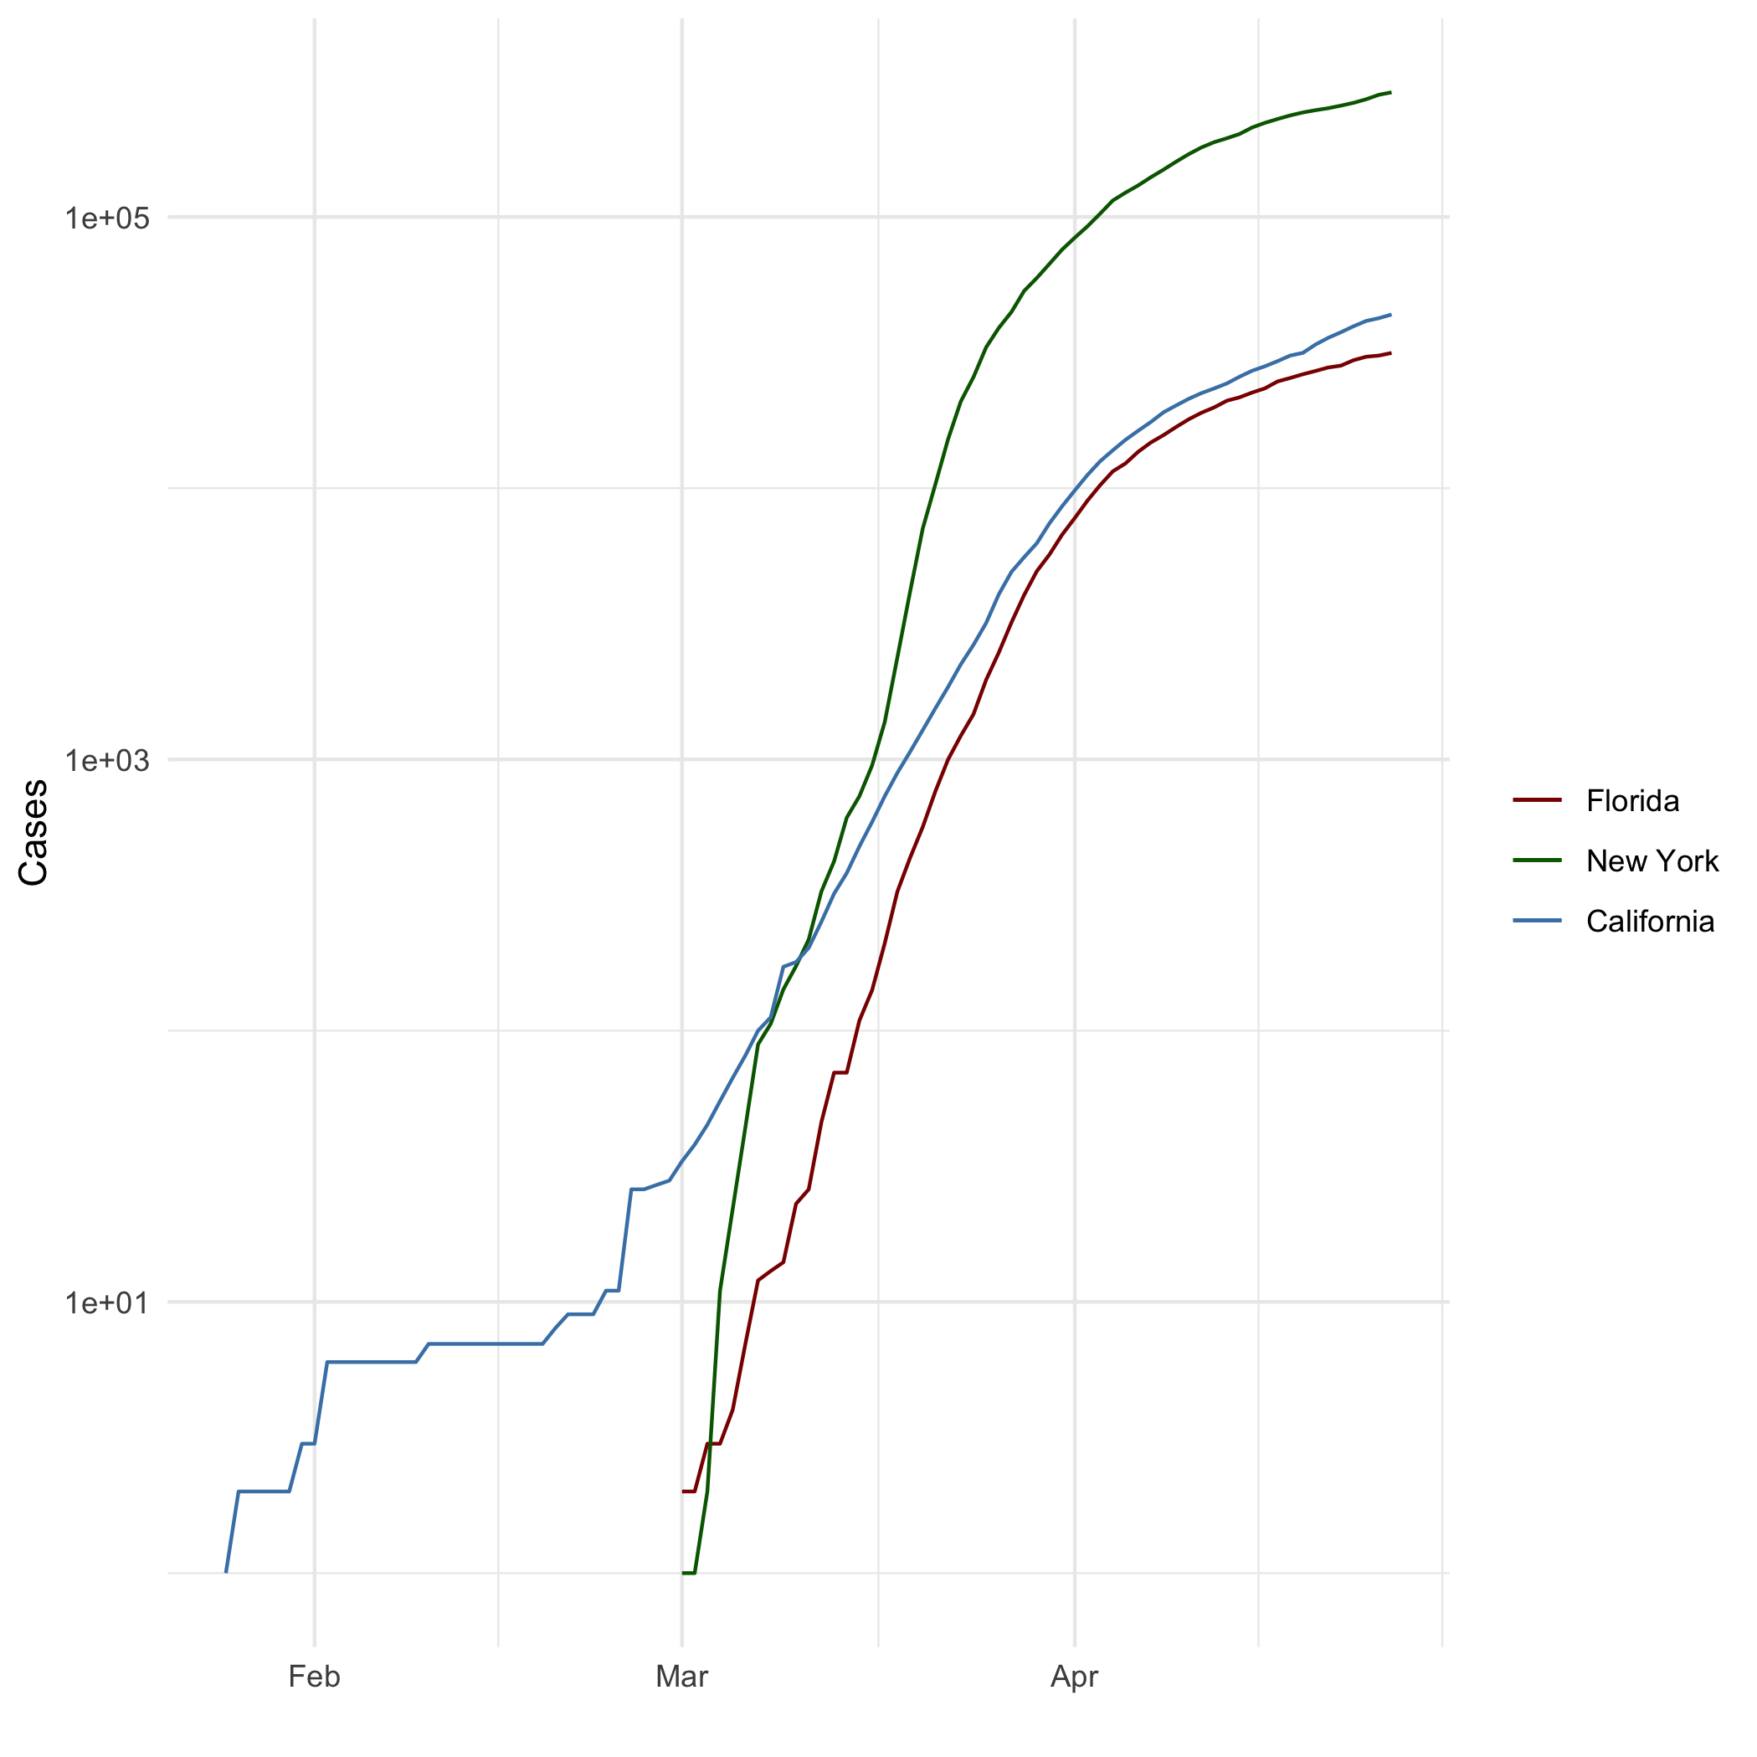

## Add a Quote

“Daaaaaaang! - Joseph Dirte [1]”

## Add an Equation

$$X=10*3^{2}$$

## Add a Footnote

## Add Citations

* R for Everyone @book [lander2014r]
* Discovering Statistics Using R @book [field2012discovering]

# Inline Code

## NY Times COVID-19 Data

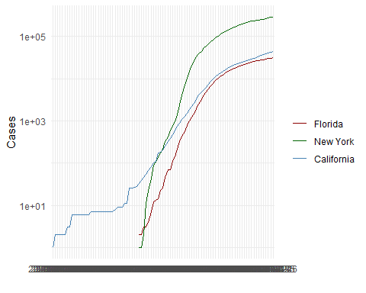

## R4DS Height vs Earnings

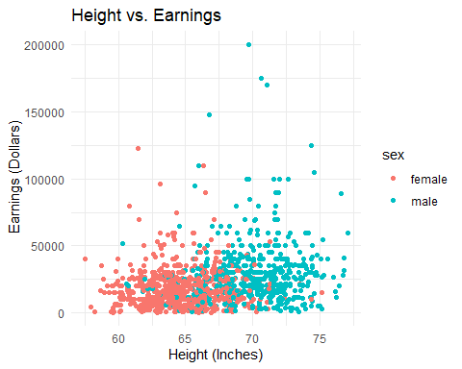

# Tables

## Knitr Table with Kable

One Ring to Rule Them All

|  |  |  |  |  |
| --- | --- | --- | --- | --- |
| name | race | in_fellowship | ring_bearer | age |
| Aragon | Men | TRUE | FALSE | 88 |
| Bilbo | Hobbit | FALSE | TRUE | 129 |
| Frodo | Hobbit | TRUE | TRUE | 51 |
| Galadriel | Elf | FALSE | FALSE | 7000 |
| Sam | Hobbit | TRUE | TRUE | 36 |
| Gandalf | Maia | TRUE | TRUE | 2019 |

## Pandoc Table

##   
##   
## +-----------+--------+---------------+-------------+------+  
## | name | race | in_fellowship | ring_bearer | age |  
## +===========+========+===============+=============+======+  
## | Aragon | Men | TRUE | FALSE | 88 |  
## +-----------+--------+---------------+-------------+------+  
## | Bilbo | Hobbit | FALSE | TRUE | 129 |  
## +-----------+--------+---------------+-------------+------+  
## | Frodo | Hobbit | TRUE | TRUE | 51 |  
## +-----------+--------+---------------+-------------+------+  
## | Galadriel | Elf | FALSE | FALSE | 7000 |  
## +-----------+--------+---------------+-------------+------+  
## | Sam | Hobbit | TRUE | TRUE | 36 |  
## +-----------+--------+---------------+-------------+------+  
## | Gandalf | Maia | TRUE | TRUE | 2019 |  
## +-----------+--------+---------------+-------------+------+  
## | Legolas | Elf | TRUE | FALSE | 2931 |  
## +-----------+--------+---------------+-------------+------+  
## | Sauron | Maia | FALSE | TRUE | 7052 |  
## +-----------+--------+---------------+-------------+------+  
## | Gollum | Hobbit | FALSE | TRUE | 589 |  
## +-----------+--------+---------------+-------------+------+  
##   
## Table: One Ring to Rule Them All

# References

1. Joe Dirt was film from 2001