**Build Ecommerce clothing shop website**

**Name: Huynh Minh Thong**

**Supervisor: Ho Hai Van**

**Initial Contextual Report**

**COMP1682 Final Year Project**

**Programme Title, e.g. BSc Computer Science or BSc Computing**

**Due date:**

**Word count:**

**Abstract**

This is where you succinctly describe your project, the context of and interest in your project, your approach to your project and your progress to date using somewhere between 60 and 120 words. This is much easier to write after you have written the rest of this report.

# Table of Contents

1 Table of Contents 2

2 Introduction 3

2.1 Background 3

2.2 Aims and objectives 3

2.3 Approach 3

3 Literature Review 3

3.1 Approach to literature searching 3

3.2 Identifying the problem 3

3.3 Another Section 3

3.4 Yet Another Section 3

3.5 Conclusions 4

4 Product Research

4.1 Review/Comparison

5 Legal, Social, Ethical and Professional Issues and Considerations 4

*6* *Requirements 4*

6.1 Analysis of requirements 4

6.2 Requirements elicitation 4

6.3 Functional requirements 4

6.4 Non-functional requirements 4

*7* *Design 5*

*8 Prototype 5*

8.1 Review of technology 5

9 Bibliography 5

10 Appendices 5

***\*optional chapters***

# Introduction

## Background

In recent years, the growing speed of websites has helped commercial industries become more convenient in areas almost facing difficulties during the COVID-19 pandemic in 2020. This time, I will develop an ecommerce website. This is a website development project that sells clothing products to a clothing shop. Because during the quarantine period, old customers could not go to the shop to buy products, so we were asked to make a website so that their customers could access the website at any time and have view their products, and checkout for products easily. This is a very interesting project, its special feature is to assist customers who have a need to buy things during a pandemic and are socially isolated in a short time, so this project is very meaningful because it ensures the safety of both customers and sellers during the COVID-19 period. Therefore, we can spend a lot of effort to make this product well.

## Aims and objectives

### Aims

The goal is to develop this product for commercial purposes for an organization wishing to sell at any time, and the customer can buy easily, quickly without having to waste time going directly to the store.

### Objectives

For the above purposes, we have the following Objectives which are essential to be completed in this project. Firstly, we need to transform the commerce platform, from an offline selling business, will switch to an e-commerce platform. As the first thing in a business transition, we will learn about it. E-commerce is one of the most convenient commerce platforms today. Therefore, we need to understand the key elements of this plaform. Atfer this, we will have a report on ecommerce platform. Secondly, we have to create an e-commerce website that has all the elements to help business owners continue running their business during times of a severe pandemic. Website is a place where customers can buy from us anywhere and anytime. So, an ecommerce website must have the following minimum elements: product management setup, product classification by page, sales and promotion functionality, online payment support, product analysis and comparison, and the production is a website with all the functions mentioned above. Thirdly, the important thing when you have a production is user feedback. Therefore, we will collect feedback data from customers after using a brand new e-commerce service of clothing shop online. Since this is our first time adopting the ecommerce platform, we will need customer feedback after we experience and use our products after it is released. Gathering user feedback is one of the essentials of a systems development process. We will have a question form about our website. We will use qualitative and quantitative methods to collect user feedback. Finally, after we collected the data, we will base it on to analysis customer feedback results to prepare errors in the system's maintenance process. We will use analytical tools to obtain analytical models according to customer responses, so that we realize our products need to be engraved for what and what we was good at. As a result, we will continue to promote our strengths and improve our shortcomings in the near future.

## Approach

We will use HTML, CSS, JavaScript to make the interface of our website, here are the three basic things to create a complete interface for the website. To operate the website, we will not stop at the interface, but also need the backend to do the tasks that require the calculation and actions of the website. For example, if we work on a clothing website, the backend will do things like adding products to the shopping cart, checkout, payment, so on. And the backend, we will use Node.js to develop an e-commerce website. So, this is an extremely simple approach for us and for those who are just starting out with e-commerce websites.

## Justification of the suitability of a Methodology or a Framework followed.

We choose with the reason, Node.js uses Google's V8 JavaScript engine to execute code, and an oversized percentage of the bottom modules are written in JavaScript. Node.js contains an integrated library to permit applications to act as an online server without software like Apache HTTP Server or IIS. NPM may be a pre-installed package manager for the Node.js server platform. It is accustomed install Node.js programs from the NPM registry. The package manager allows the community to publish and share open source Node.js libraries and simplify library installation, updating, and not installing. Ultimately, our choice is the logical choice in the construction and operation of this project. (About | Node.js, 2021)

# Literature Review

## Approach to literature searching

After a few weeks of research and research on the e-commerce market, we have read through 3 books and also the 3 most popular methods of making e-commerce websites at the moment. Firstly, WordPress for dummies by Sabin-Wilson author, this book is for those who want to build a website quickly, with few technical parts, detailed WordPress manuals. Secondly, we were introduced to the lack of ASP.NET Core 2.0 MVC & Razor pages for beginners from our mentor. This book talks a lot about technical aspects, so having to master the C # programming language is an advantage to build a website on this framework. Finally, this is a technical book on Node.js, Web development with MongoDB and Nodejs by Satheesh author, which will detail how to use Nodejs libraries such as express, handlebar, others.

## Identifying the problem

### WordPress:

Talking about Wordpress, this is an open source software written in PHP and MySQL direction system. Content management software (CMS) that you just can use to make websites. Put simply, it is a tool that helps you create your own website, blog or news. And this is often one in all the most effective CMS, you will value more highly to use to form your own website. WordPress was developed to serve the final user. No must have an excessive amount of knowledge about programming or advanced website. Because the operations in WordPress are very simple. Intuitive administration interface, helping you to know the management structure of a WordPress website during a short time. But WordPress is additionally powerful and versatile enough to cater to people who are tech savvy. Or run a business website. WordPress is a method for those who want to create a simple, fast website with many available templates, this is an affordable choice because it is cheap for small businesses and business households. Easily design in the form of drag and drop, not completely by code design with simple methods. On the contrary, this is an inexpensive option so the server will be shared with other websites, and with the sharing of resources, the slower the running speed. (Sabin-Wilson, n.d.)

### ASP.NET Core:

As for ASP.NET Core, it could be a cloud-optimized and source-code web framework for developing web applications that run on multiple platforms like Windows, Linux, and Mac. Currently, it includes the MVC framework that mixes the features of MVC and Web API into one web framework. ASP.NET Core applications can run on the .NET Core or on the complete .NET Framework. It is been designed to produce an optimal framework for applications to deploy to the cloud or run on-premises. This is composed of modular with minimal components so you keep flexibility within the construction of your solutions. you'll be able to develop and run cross-platform applications from ASP.NET Core on Windows, Mac, and Linux. The convenience of ASP.NET Core is that it can be run on any different platform, integrating building web UIs and web APIs, having the latest cilent-site frameworks, optimized HTTP requests, open source, large community. Dependency injection is built in to configure system based on real cloud environment. With so many attractive advantages, to operate a website with ASP.NET is quite high cost, not suitable for small businesses. (Fagerberg, n.d.)

### Node.js:

The last one is Node.js, it is a platform built on Chrome's JavaScript runtime for easily building fast and scalable network applications. Node.js uses an event-driven, non-blocking Input /Output model that creates it lightweight and efficient, perfect for data-intensive real-time applications that encounter distributed devices.Node.js is an open source, cross-platform runtime environment for developing server-side and networking applications. Node.js applications are written in JavaScript, and may be run within the Node.js runtime on OS X, Microsoft Windows, and Linux. Node.js also provides an expensive library of varied JavaScript modules which simplifies the event of web applications using Node.js to an excellent extent. Node.js having lightweight REST / JSON APIs is what makes NodeJS shine. With event-driven mechanism, non-blocking Input / Output and model combined with Javascript is a great choice for Web services made of JSON. Regular web sites send HTTP requests and receive responses (Data Flow). Assuming that you will need to handle an extremely large data stream, NodeJS will build Proxies to partition the data streams to ensure maximum operation for other data streams. This is very important for all languages. NodeJS is no exception. Web platform with 5 main browser providers: Mozilla, Google, Apple, Microsoft, Opera. With Google's V8 JavaScript Engine and Event-drivent non-blocking Input / Output, you can load hundreds of thousands of connections at once. But the server configuration for NodeJS is very modest (saving 4 times the typical investment, performance is doubled). Since Nodejs is a new framework, it is impossible to compare it with old frameworks. In addition, Nodejs is quite resource intensive because it handles CPU resource applications. (Satheesh, D'Mello and Krol, n.d.)

## Conclusions

To summarize, we can all see that each of the 3 has different strengths, but each one is created for different needs, if you want to build a website quickly and cheaply, you can use WordPress as an optimal choice, and if you are a commercial business with high revenue, you will choose ASP.NET Core to be the solid foundation for your website. And Node.js, this is a framework that supports APIs very quickly and conveniently, for website builders with knowledge of JavaScript. Therefore, we are on a project to build an e-commerce website with the aim of learning new knowledge and applying it into the product itself so Node.js is a reasonable choice. Not only easy to use, good performance, but also a very good framework for the time being.

# Product Research

## Comparing of similar products or platforms against a set criterion for Usability purpose.

Speaking of Node.js, JavaScript is a language to write interfaces for websites, but after Nodejs appeared, JavaScript was used to write the backend. This greatly increases the speed of development and productivity of both teams, and companies will spend less on hardware as it can handle the same load with less horsepower. Here are 3 popular web applications written in Nodejs:

PayPal was co-founded by famous businessman Elon Musk. It provides online payment solutions to its users, and it's a payment method that stands out on the large e-commerce platform. The service has quite 227 million users and quite 7.6 billion payment transactions. With a growing number of subscribers, PayPal is trying to find an answer to produce a more robust service in terms of performance to their users. Switching to Nodejs ends up in great results. Compared to their previous Java application, the Nodejs application was built almost twice as fast with fewer people. it's written with 33% less lines of code and built with 40% less files. 200ms faster page load time and 35% less average reaction time.

Netflix is one in all the most important streaming services within the world. There is home to over 5500 titles that are streamed 100 million per day to about 120 million users in 190 countries. Alex Liu, a Nodejs developer on the Netflix web team, says that using JavaScript on the server side could be a natural extension of their work environment. They see huge benefits in developer productivity. Since moving Netflix from Java to Nodejs, they have experienced significant improvements in commission performance, boot times are reduced from 40 minutes to 1 minute. Their development team can use lots of open-source modules that the Node community has got to offer.

LinkedIn is that the largest business-oriented social media platform. This is over 530 million members. Currently, it occupies the 31st position within the Alexa Internet's Global Ranking. The LinkedIn development team turned to Nodejs for a few parts of its back-end system, which resulted in ever higher application performance. On the server side, our entire mobile software stack is made entirely in Node. One reason is that the scale and also the second is that Node shows us huge performance.

# Legal, Social, Ethical and Professional Issues and Considerations

Legally, ThongShop will use Nodejs to make an e-commerce website for business. The references in this project are all available on the Internet and free of charge. This project is owned by us and the University of Greenwich. Social issues on this site, we sell clothing products to people aged 20 to over 40, so our images and content will not contain sensitive content, and affect the fine Traditions and customs of Vietnam. This project is very important to us because this is one where we put our whole heart into it, so we don't do unethical things. After the project is completed, to have a certain professionalism, we will not disclose any information related to this project to a third party without any consent from the manager. by Greenwich. Learn, learn, research new things to update this project, respect both the positive and negative comments to get a variety of perspectives on our project, then consider provide solutions to fix problems that have occurred. (Shivani, 2021)

# Requirements

At the end of 2020, a clothing store called ThongShop in Ho Chi Minh city complied with the government's regulations to temporarily close to social isolation. As a result, the store had to be closed, and if it were to close, the owner would suffer a heavy economic loss in maintaining the store. Therefore, the owner has learned about e-commerce website, and they asked us to build an e-commerce website so that they can continue to do business during the pandemic. The request from the customer is that they can create a product on their website, upload a picture of the product, can edit the product and delete the product. On the user side, as a buyer, they have to add products to their shopping cart, and pay online safely.

## Analysis of requirements

In this project, we have a scenario form the customer. They asked us to build an e-commerce website about selling clothes online. Because during the pandemic, they could not continue to trade offline, for that reason they wanted to build an online platform in the form of e-commerce to continue their business. Website construction with the following detailed requirements:

* Online Shop must has Admin to oversee all process in this website.
* The admin must manage all product in website everytime, everywhere like create a new product, edit product, delete product.
* Admin must also be able to track customers such as managing existing orders and products that have been sold.
* User may not need to login to view the product.
* User can search to find the products they are looking for.
* User must be added product to cart.
* User can remove the item from cart.
* User can adjust the quantity of products in the cart.
* User must login to be able to pay.
* Make sure the payment is really safe for customers.
* The web interface should be easy on the eyes for the customer to have a good mood when shopping.

## Comparison of systems

For some projects there may be similar existing systems. This would be a good place to identify these, compare them and elicit requirements from them.

## Requirements elicitation

Perhaps you have conducted some actual research with questionnaires and interviews and such like (having obtained research ethics clearance of course). This would be a good place to discuss this.

## Functional requirements

### Login/Logout

* Login: This function is almost mandatory to make a website, because it will help website owners manage it more easily. The authorization in this website will have 2 users and admin.
* Logout: After purchasing or managing the store, the user or admin can log out to ensure the security of the account.

### CRUD Product

* Create Product: Admin will add products to the website so that it can be sold to users, adding this product will include product name, description, price, image, others.
* Update Product: After adding the product, if after a while the product may increase the price or decrease the price, the update function will allow the admin to edit the product directly on the website.
* Delete Product: Admin can delete the product on the website, if the product is no longer in business purpose, it will be removed by the delete function.

### CRUD Order

* Create Order: When the user adds the product to the cart and proceeds to the payment step, after confirming the successful payment, then the order will be successfully created.
* Edit Order: About the order editing function is for admin when the customer's order has price or product problem, then admin will edit the customer's order to fix the bad situation.
* Delete Order: order deletion function, when the user has an order problem after payment, the user will not be able to cancel their order, but the customer can report to the admin about their order problem and then admin will delete their order.

## Non-functional requirements

Clear statement of non-functional requirements. It may be an idea here to refer back to your earlier LSEPi section as compliance is likely to (and should) be an important aspect here.

# Design

## Use case.

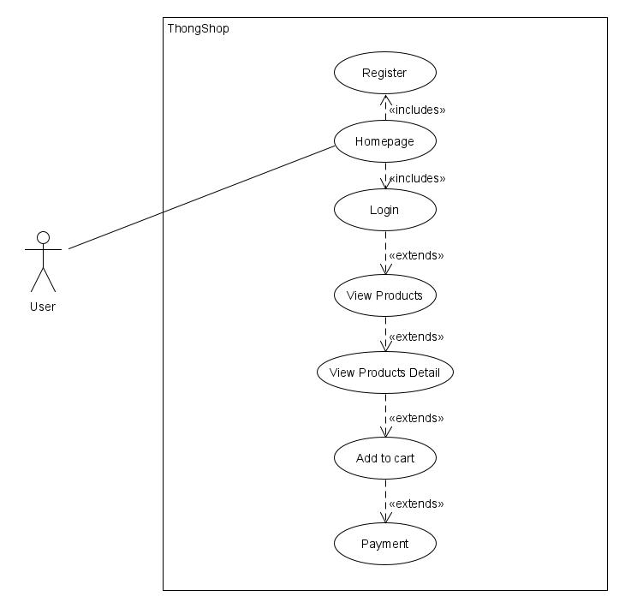

Figure 7.1.1. User Use-case diagram.

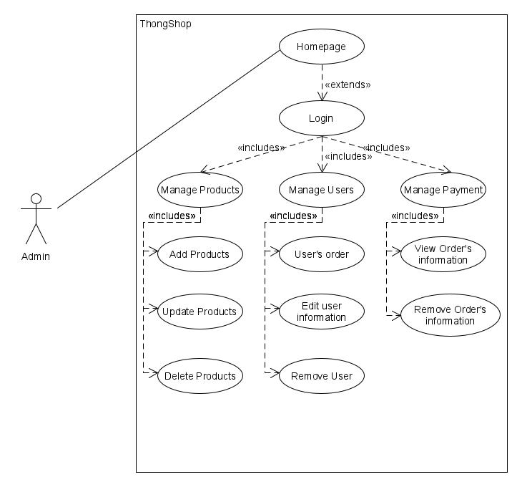

Figure 7.1.2. Admin Use-case diagram.

## State chart.

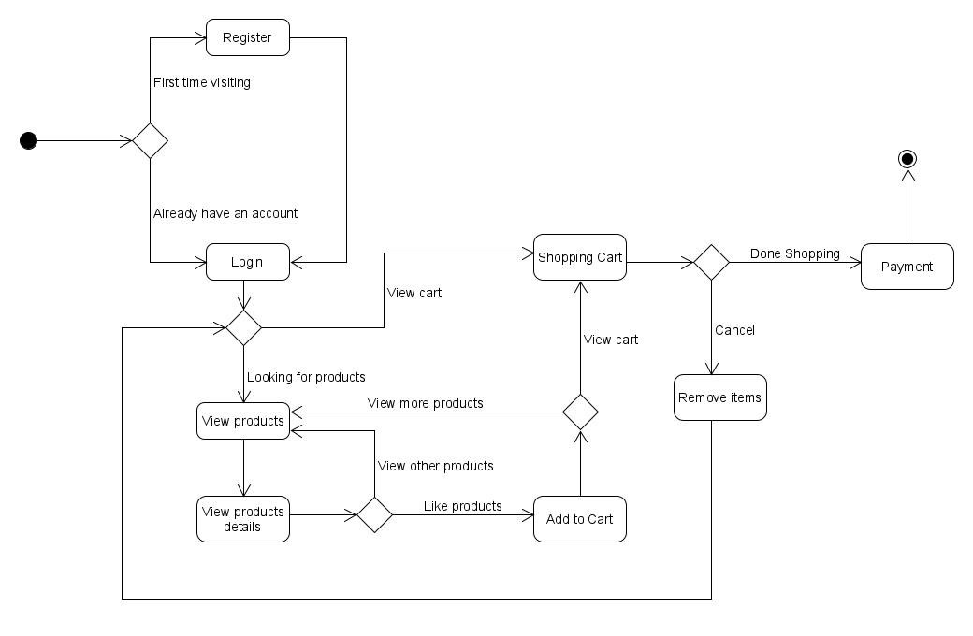

Figure 7.2. State diagram.

## Activity.

## 

Figure 7.3.1. User Activity Diagram.

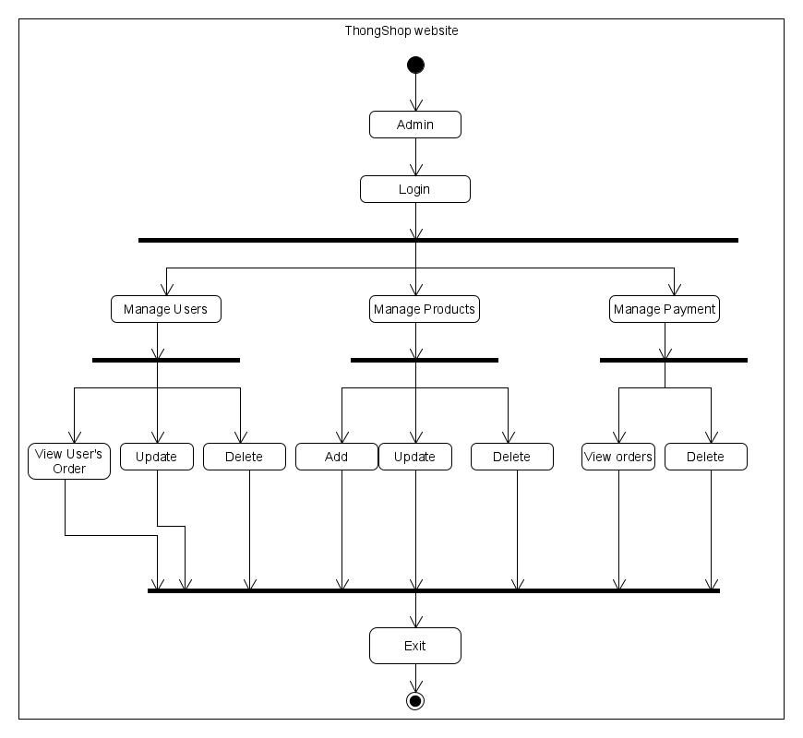

Figure 7.3.2. Admin Activity Diagram.

# Prototype

Describe your approach to creating your first (and second and third) prototype(s).

## Review of technology

If you need to review technologies this is perhaps the place to do it. Perhaps you need a data base, in which case state what database engines have you considered, which have you decided to use and for what reason. Perhaps you need an app, in which case you could, for example, state which development frameworks are available, compare and contrast all, select 3 for detailed comparison, choose one and state why you have made this choice.

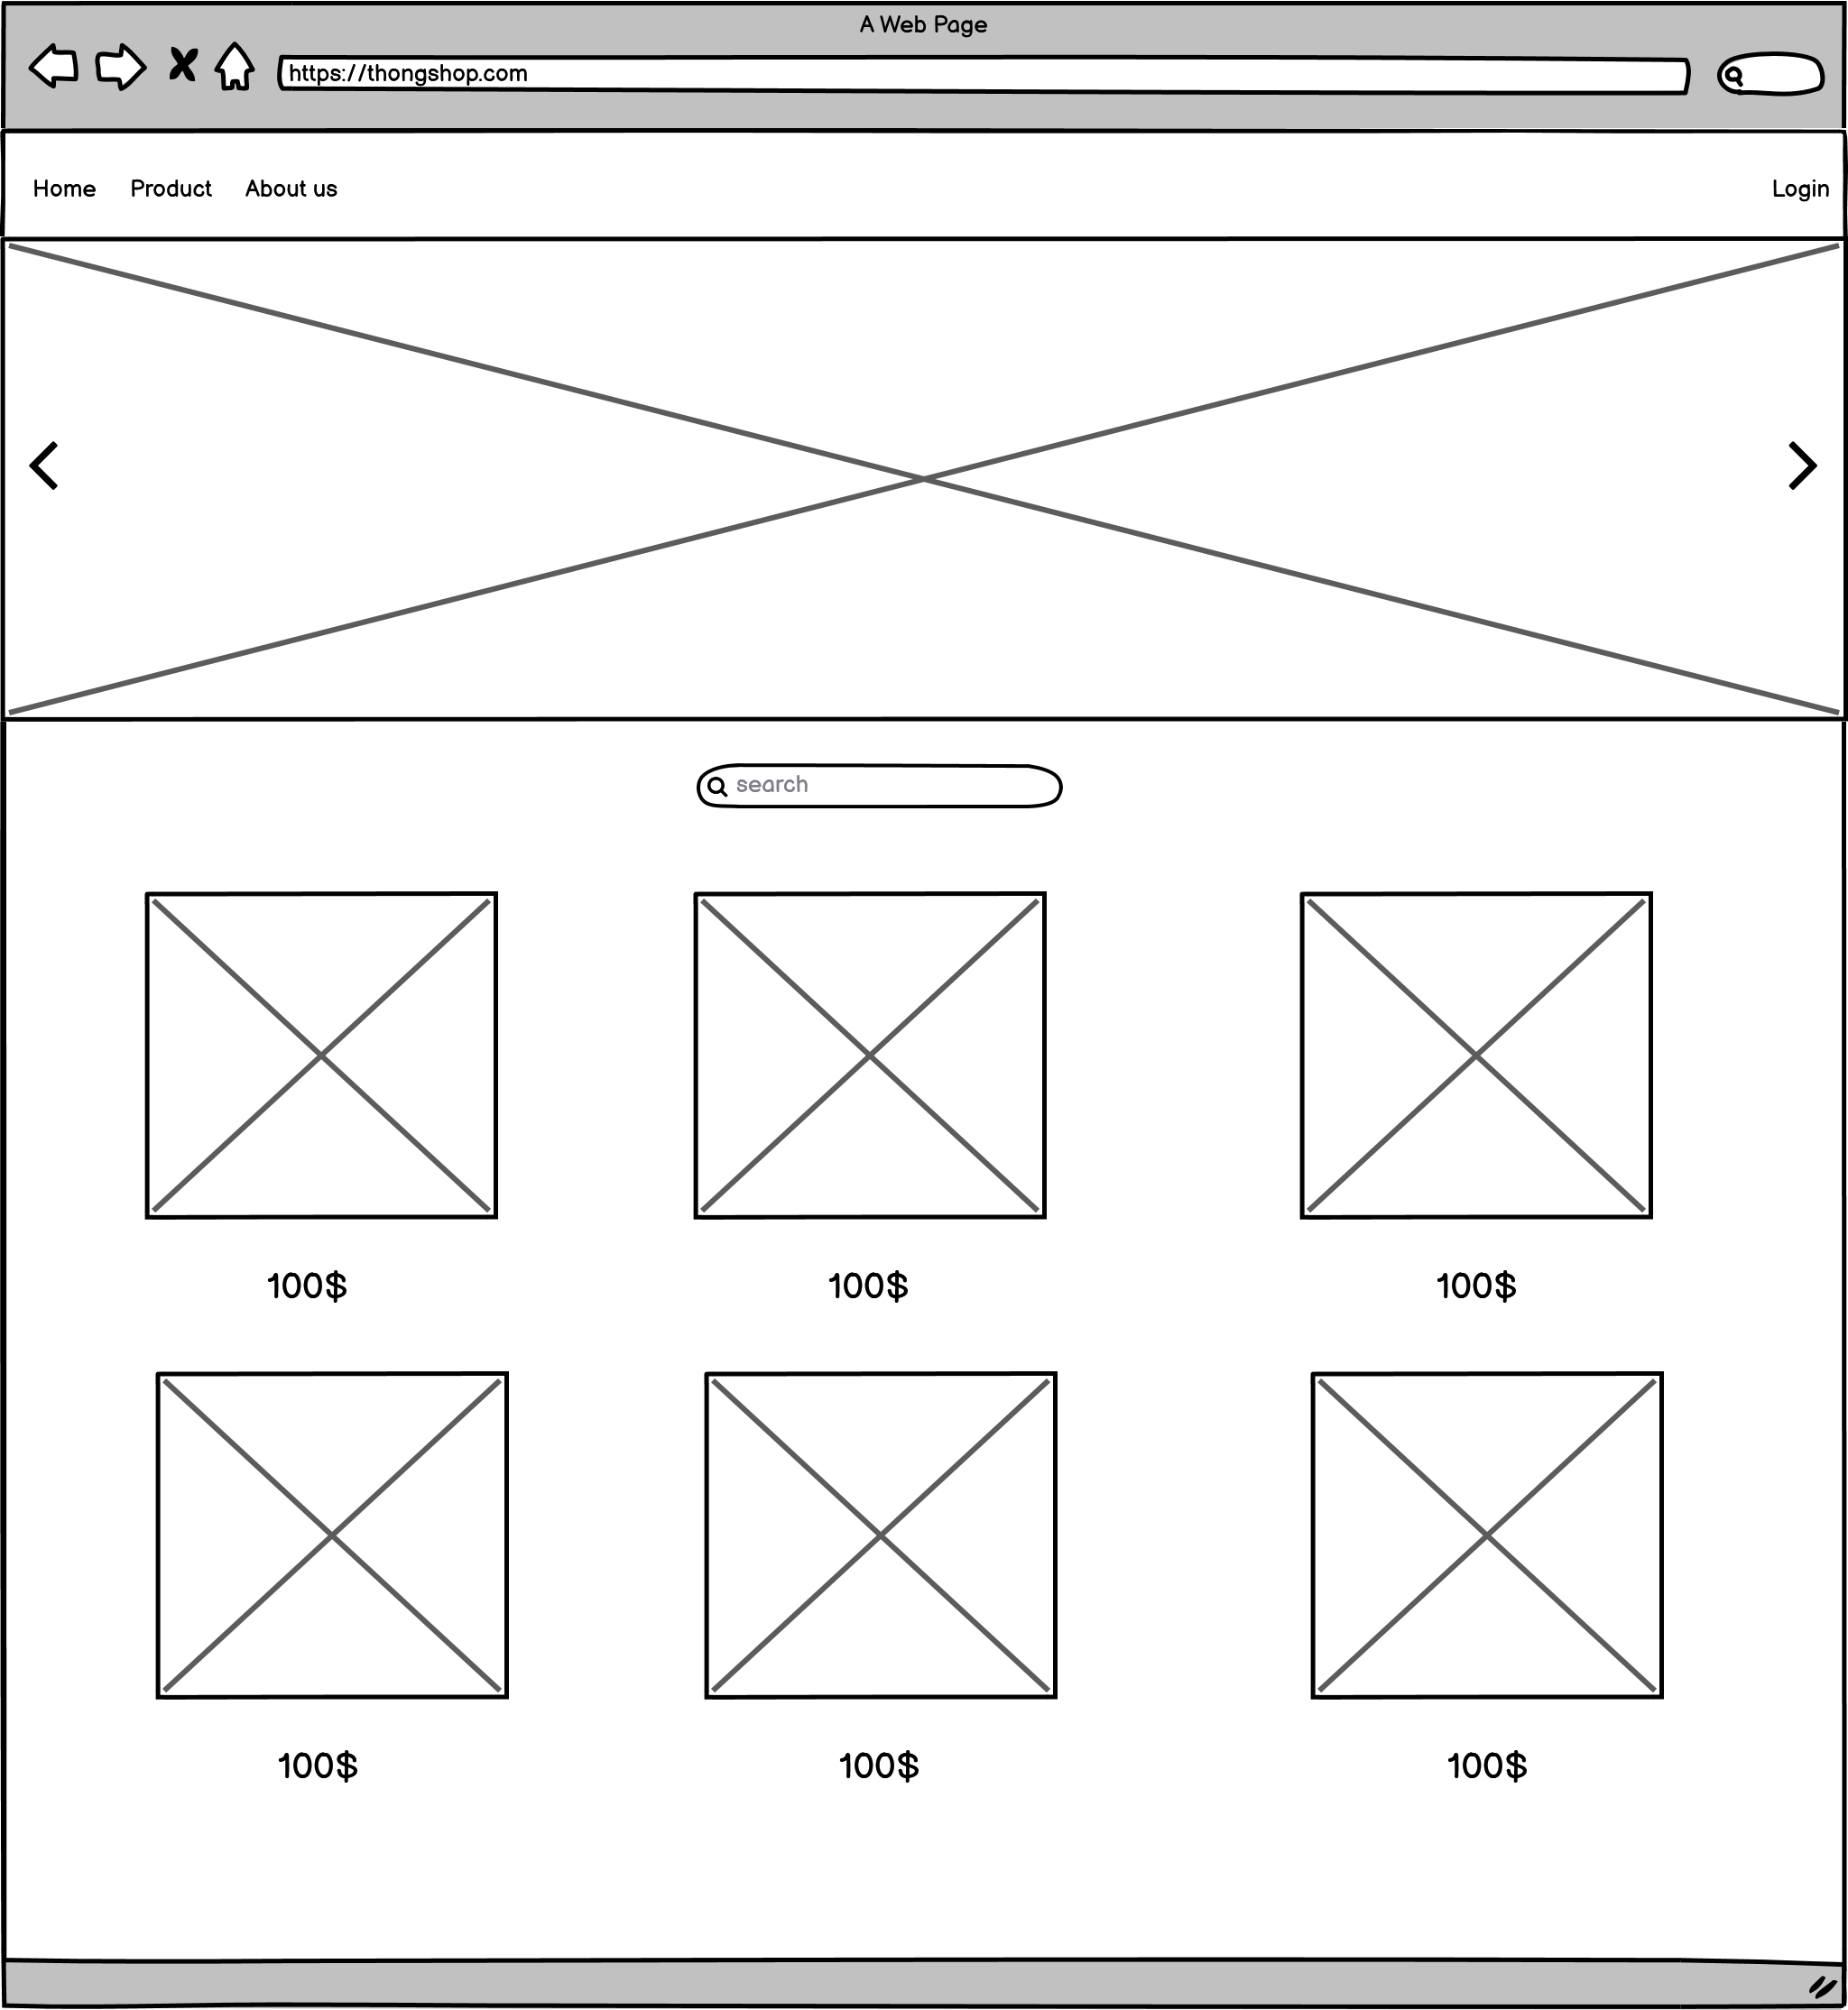

# Reflection

conclusions

Wrap the whole thing up with some conclusions. A reflective approach is increasingly popular but many students struggle with introducing a critical personal perspective (Day, 2013).

# Bibliography

1. Fagerberg, J., n.d. *ASP.NET core 2.0 MVC & Razor pages for beginners*.
2. Sabin-Wilson, L. and Mullenweg, M., n.d. *WordPress for dummies*.
3. Satheesh, M., D'Mello, B. and Krol, J., n.d. *Web development with MongoDB and NodeJS*.
4. Node.js. 2021. *About | Node.js*. [online] Available at: <https://nodejs.org/en/about/> [Accessed 17 March 2021].
5. Shivani, H., 2021. *Available online at: www.ijarcsse.com A Study of Ethical and Social Issues in E-Commerce*. [online] Citeseerx.ist.psu.edu. Available at: <http://citeseerx.ist.psu.edu/viewdoc/summary?doi=10.1.1.473.6654> [Accessed 19 March 2021].