1. Tapping on pickup and drop-off textboxes should take the customers to the screen below. Copy the address from the start-up screen. Frequently used locations should be retrieved from previous bookings. (We will provide the endpoint)

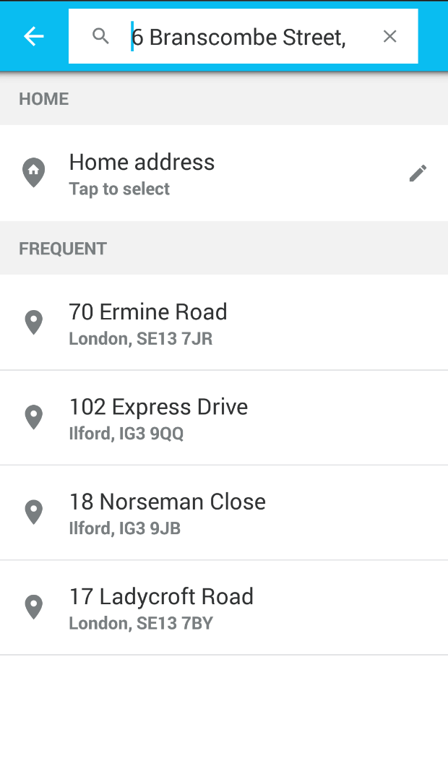

Home address is a real address we take from customer gps, isn’t it?

1. Payment method

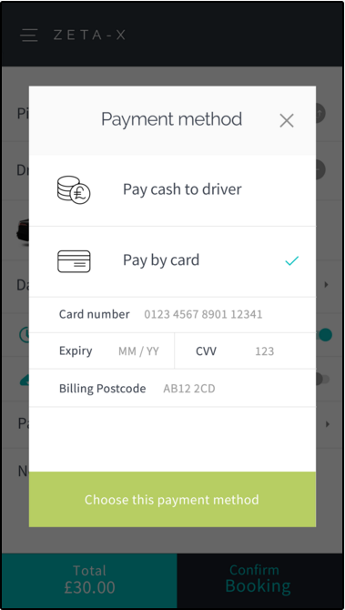

If pay by card is selected then you need to make web service call to the following endpoint first when confirming the booking. For cash payments go to step 13.

BaseURL + ElectronicPayment (POST)

Parameter(JSON):

{

"nonce": null,

"CustID": 0,

"Amount": 0.0

}

Or send the parameters individually (All required)

Returns:

{

"code": 0,

"message": null,

"Auth_Code": null

}

Please explain more about this screeen! What are these field (card number, expiry, cvv, billing postcode) use for?

1. If the return code is 1 then make another call to the booking endpoint

BaseURL + SaveBooking (POST)

Parameter(JSON):

{

"Outcode": null,

"RtnOutcode": null,

"custid": 0,

"pick": null,

"doff": null,

"via": null,

"routedistance": 0.0,

"rtnroutedistance": null,

"vehType": null,

"vehTypeID": 0,

"travelTime": 0.0,

"rtntraveltime": null,

"totalfare": 0.0,

"returnfare": null,

"fare": 0.0,

"note": null,

"pkLat": 0.0,

"pkLong": 0.0,

"rjType": null,

"bookingdate": "0001-01-01T00:00:00",

"paq": 0,

"bags": 0,

"doLat": 0.0,

"doLong": 0.0,

"viaLat": null,

"viaLong": null,

"childseat": false,

"petfriendly": false,

"executive": false,

"returndate": null,

"InServiceArea": false,

}

Or send the parameters individually (All required)

Returns:

{

"code": 0,

"message": null,

"Auth_Code": null

}

If return code is 1 then take them to the screen below.

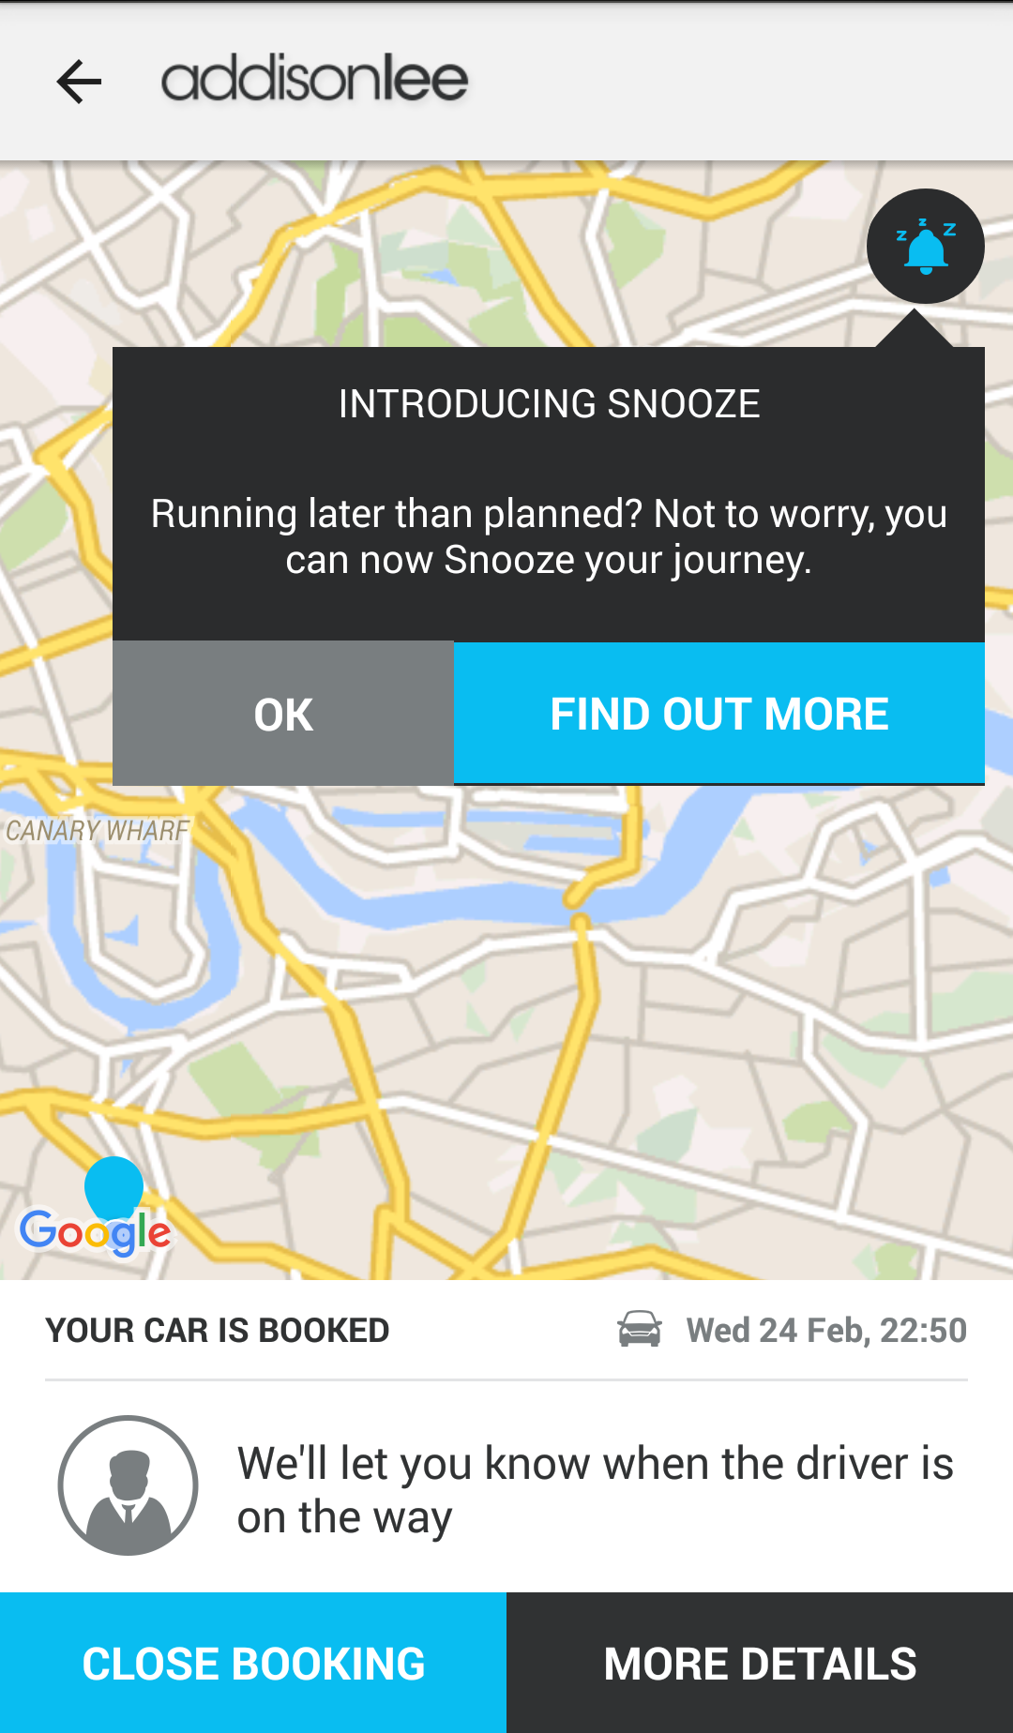

We will only have one button on the bottom of the screen ‘Booking Summary’ and we do not have snooze feature.

SaveBooking not work! I still get the response {"code":0,"message":"Customer Id is required","bref":null}. Please help me out!

Booking Summary

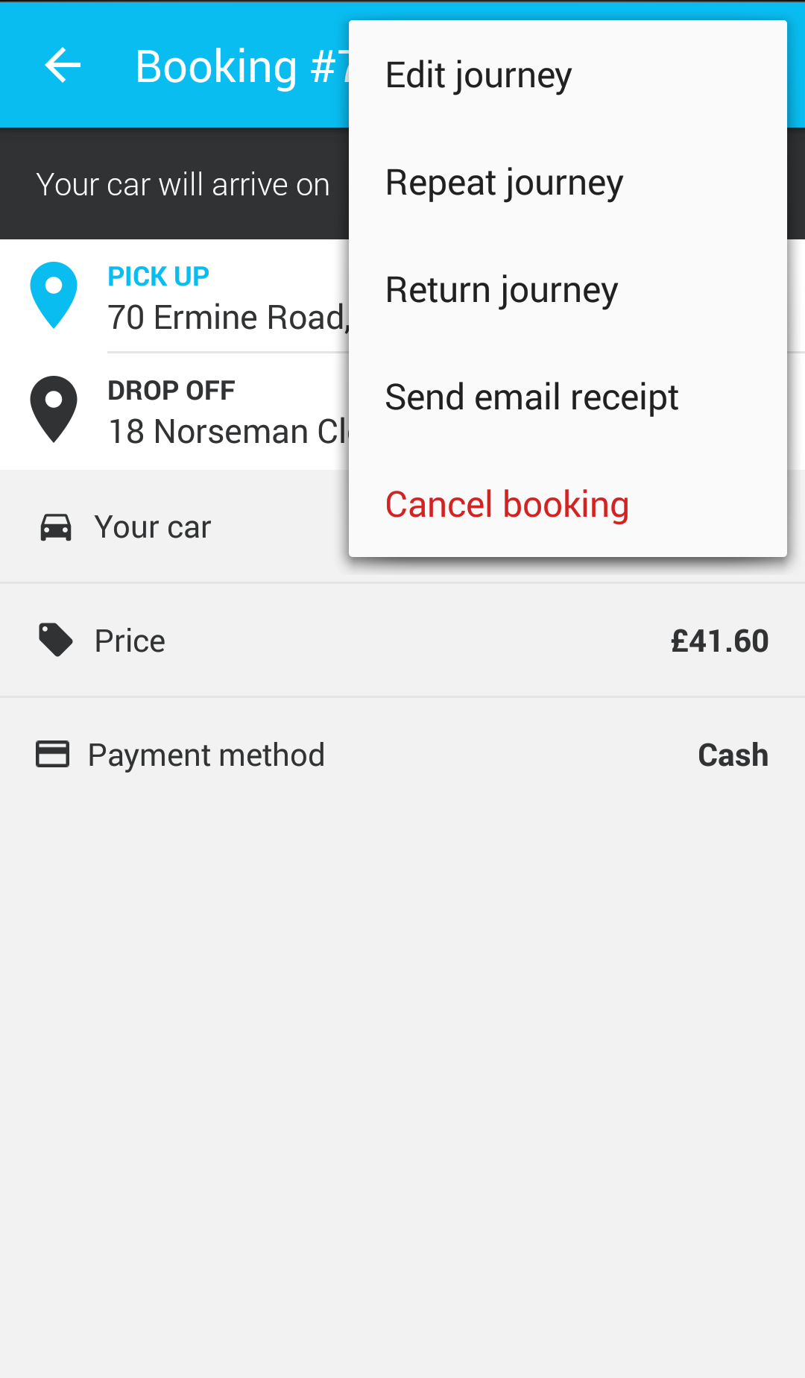

Please use this menu instead of the one on previous page.

Booking Summary ENDPOINT

BaseURL+ CurrentBookings (GET)

Parameter: JSON Object

{

"CustID": 0,

"DeviceID": null

}

Or send the parameters individually (All required)

Returns

{

"jlist": [],

"message": null,

"code": 0

}

{

"JobPartID": null,

"Status": null,

"Contact": null,

"PickupAddress": null,

"DropoffAddress": null,

"TotalFare": null,

"Notes": null,

"PickupDateTime": null,

"ViaLocations": null,

"FlightNumber": null,

"ExpFlightArrival": null,

"ChildSeat": null,

"Passengers": null,

"Suitcases": null,

"MeetAndGreet": null,

"PaymentMethod": null,

"JourneyType": null,

"VehicleType": null

}

Code: 1 success, 0 error

Please support the controller/URL to handle all of these option (Edit journey, cancel booking…..).