1. Tapping on pickup and drop-off textboxes should take the customers to the screen below. Copy the address from the start-up screen. Frequently used locations should be retrieved from previous bookings. (We will provide the endpoint)

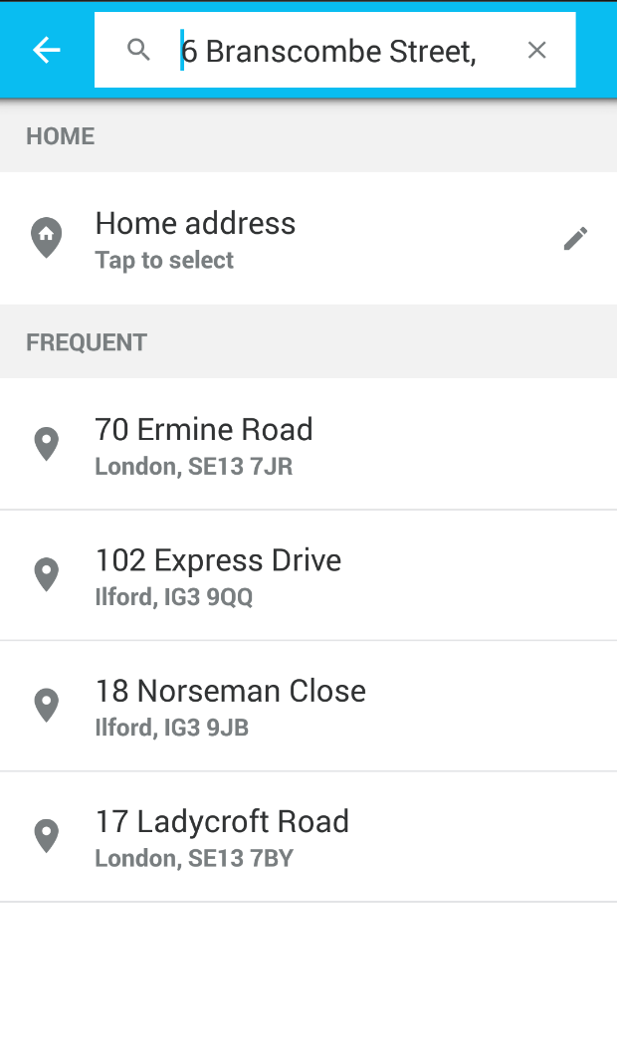

Home address is a real address we take from customer gps, isn’t it?

*No. The user can add/edit their own home address. See the screenshots below.*

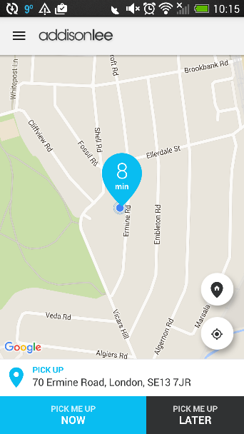

*Pic: 1*

*When they tap the ‘Home’ icon, if the ‘Home Address’ is already set then copy the ‘Home Address’ in Dropoff textbox. If it is not set then take them to the Home Address ‘Setup’ page like*

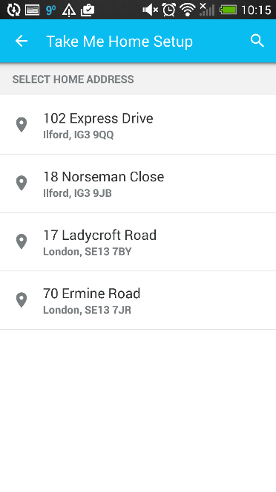

*Pic: 2*

*They should be able to add/edit ‘Home Address’ from profile and ‘search address’ pages too. See below.*

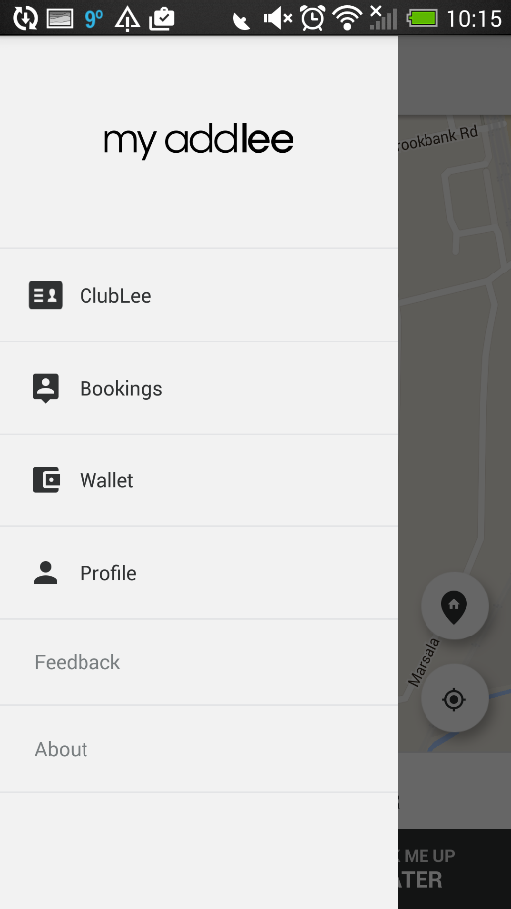

*Pic: 3*

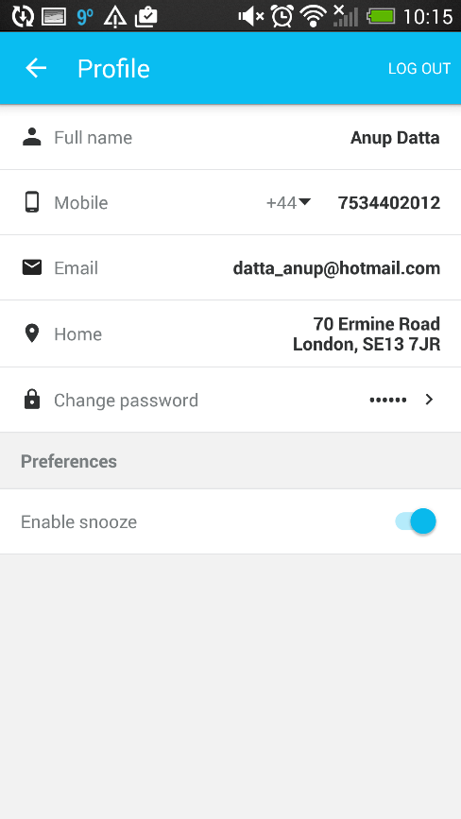

*Pic: 4*

*If they tap onto ‘Home Address’ then take them to edit/setup page (pic 2)*

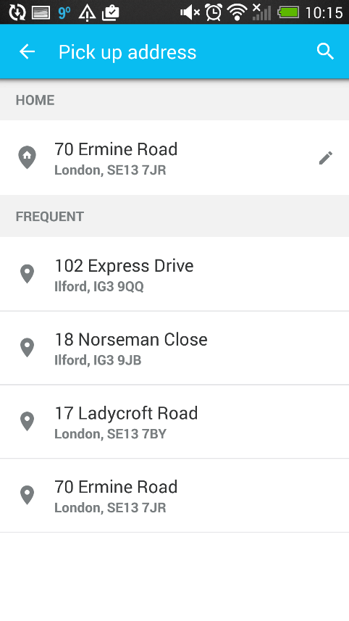

*Pic: 5*

*Provide them an option to edit ‘Home address’ from search address page too*

1. Payment method

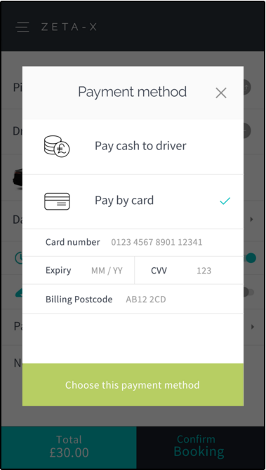

If pay by card is selected then you need to make web service call to the following endpoint first when confirming the booking. For cash payments go to step 13.

BaseURL + ElectronicPayment (POST)

Parameter(JSON):

{

"nonce": null,

"CustID": 0,

"Amount": 0.0

}

Or send the parameters individually (All required)

Returns:

{

"code": 0,

"message": null,

"Auth_Code": null

}

Please explain more about this screeen! What are these field (card number, expiry, cvv, billing postcode) use for?

*I will explain you the payment processing in details separately*

1. If the return code is 1 then make another call to the booking endpoint

BaseURL + SaveBooking (POST)

Parameter(JSON):

{

"Outcode": null,

"RtnOutcode": null,

"custid": 0,

"pick": null,

"doff": null,

"via": null,

"routedistance": 0.0,

"rtnroutedistance": null,

"vehType": null,

"vehTypeID": 0,

"travelTime": 0.0,

"rtntraveltime": null,

"totalfare": 0.0,

"returnfare": null,

"fare": 0.0,

"note": null,

"pkLat": 0.0,

"pkLong": 0.0,

"rjType": null,

"bookingdate": "0001-01-01T00:00:00",

"paq": 0,

"bags": 0,

"doLat": 0.0,

"doLong": 0.0,

"viaLat": null,

"viaLong": null,

"childseat": false,

"petfriendly": false,

"executive": false,

"returndate": null,

"InServiceArea": false,

}

Or send the parameters individually (All required)

Returns:

{

"code": 0,

"message": null,

"Auth_Code": null

}

If return code is 1 then take them to the screen below.

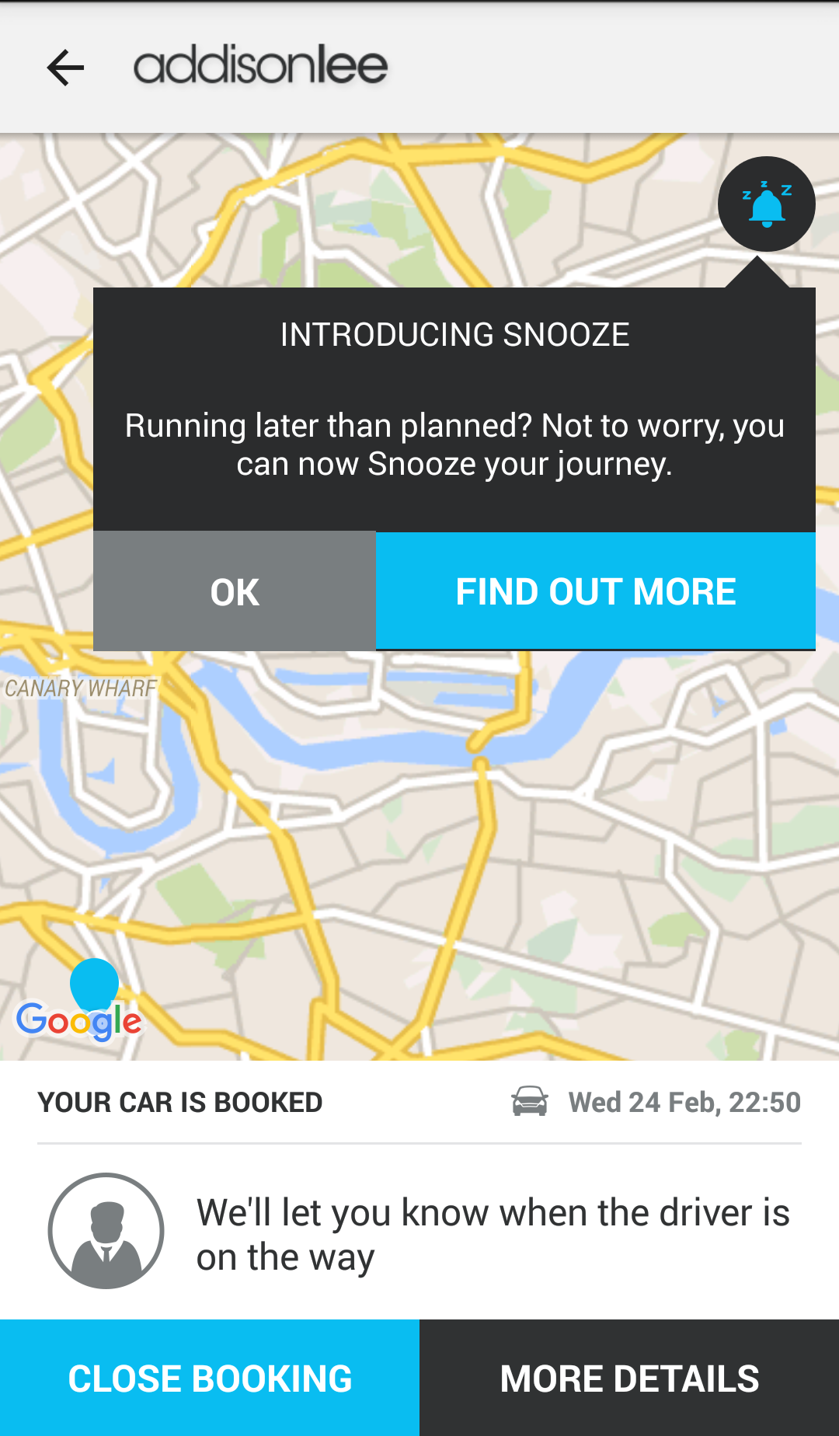

We will only have one button on the bottom of the screen ‘Booking Summary’ and we do not have snooze feature.

SaveBooking not work! I still get the response {"code":0,"message":"Customer Id is required","bref":null}. Please help me out!

*Send me you JSON string. I will tell you what is wrong*

Booking Summary

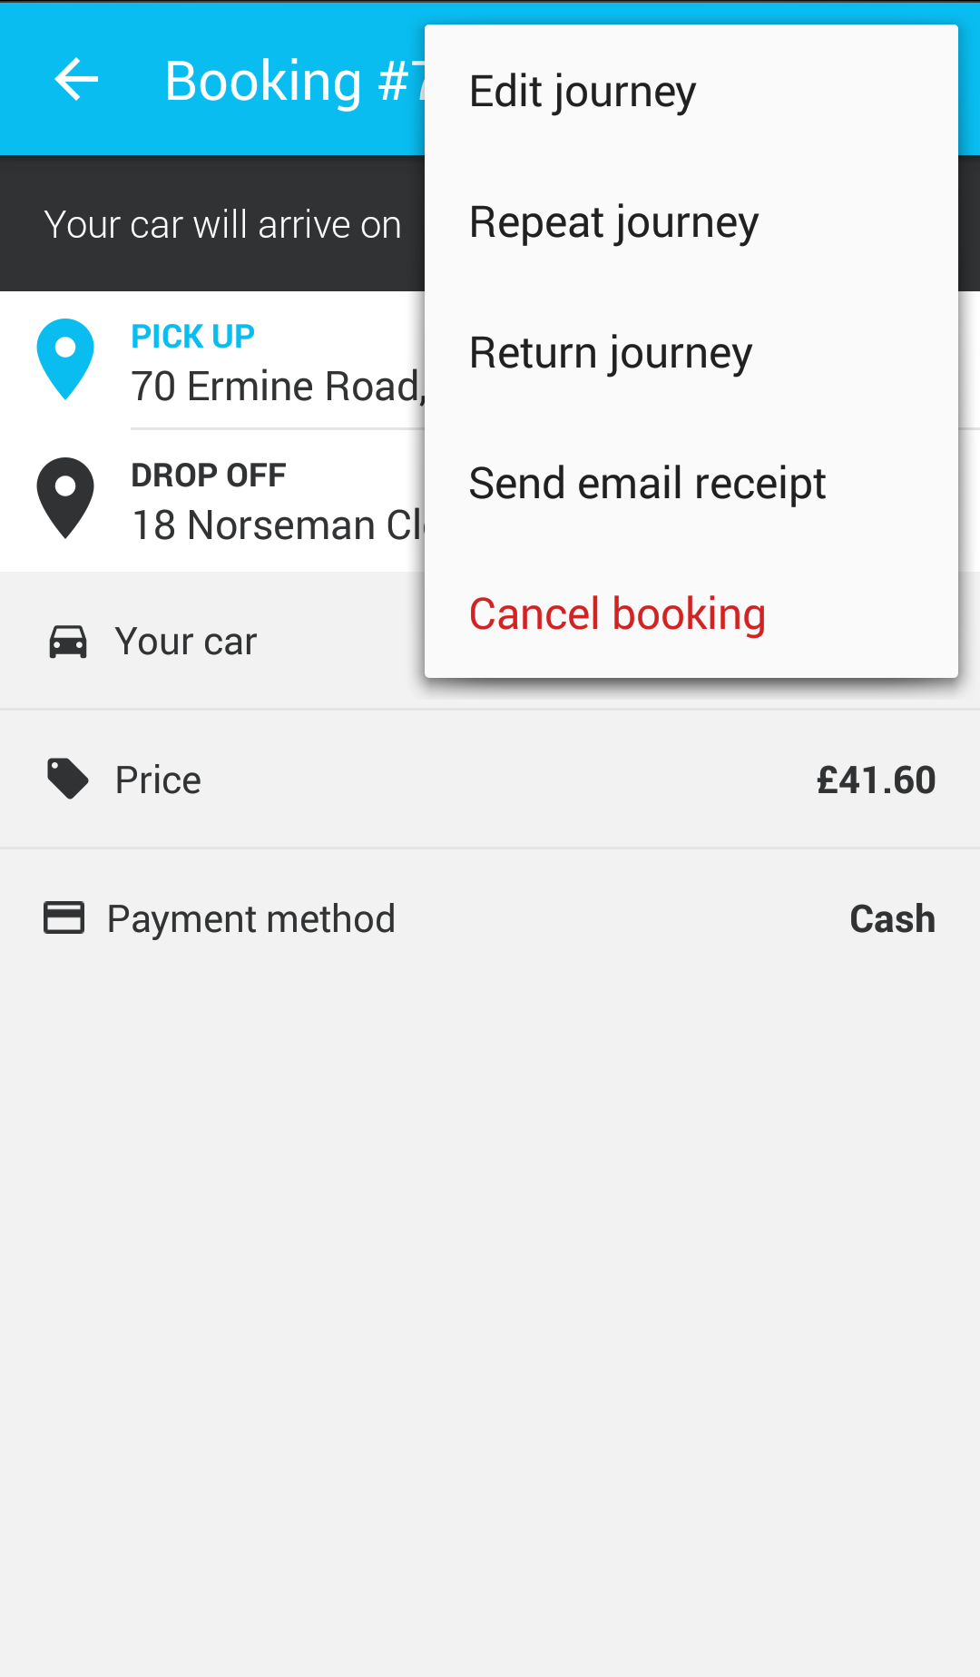

Please use this menu instead of the one on previous page.

Booking Summary ENDPOINT

BaseURL+ CurrentBookings (GET)

Parameter: JSON Object

{

"CustID": 0,

"DeviceID": null

}

Or send the parameters individually (All required)

Returns

{

"jlist": [],

"message": null,

"code": 0

}

{

"JobPartID": null,

"Status": null,

"Contact": null,

"PickupAddress": null,

"DropoffAddress": null,

"TotalFare": null,

"Notes": null,

"PickupDateTime": null,

"ViaLocations": null,

"FlightNumber": null,

"ExpFlightArrival": null,

"ChildSeat": null,

"Passengers": null,

"Suitcases": null,

"MeetAndGreet": null,

"PaymentMethod": null,

"JourneyType": null,

"VehicleType": null

}

Code: 1 success, 0 error

Please support the controller/URL to handle all of these option (Edit journey, cancel booking…..).

*Please remove the ‘Edit’ option. The customer can only cancel the journey. There is an endpoint for cancellation already.*

*POST CancelBooking Param BookingRef*

*Repeat journey: All the parameters will be the same as previous booking. Only ask the customer to confirm the pickup time as it may change. Once customer has selected the ‘new date time’ call SaveBooking with all parameters from booking object. It’s like copying previous booking only the time will change.*

*Return Journey: Same as repeat, but the pickup and dropoff will be swapped.*