Main Screen

1. Map needs to be draggable (please check Addison lee) and marker needs to be always in centre. As the customer drags the map, if the distance between old and new marker position is >=20m then request ‘nearest driver’ again. The webservice returns driver’s driving distance from the pickup location in minutes. The time needs to be displayed inside the marker as per design. However if you are unable to add custom marker then display it in a textbox for now. When you request ‘nearest driver’ you need to reverse geocode the new location again at the same time and display the new pickup address in the pickup textbox.
2. The pickup and dropoff address textbox both need two taps before the keypad opens up. Please check the issue.
3. Limit the frequently used address to maximum 5. Can you divide the autocomplete dropdown into three sections like below:

-Home Address (1)

-Nearby Addresses (5) – Check the previous documentation for endpoint

-Frequently Used Addresses (5)

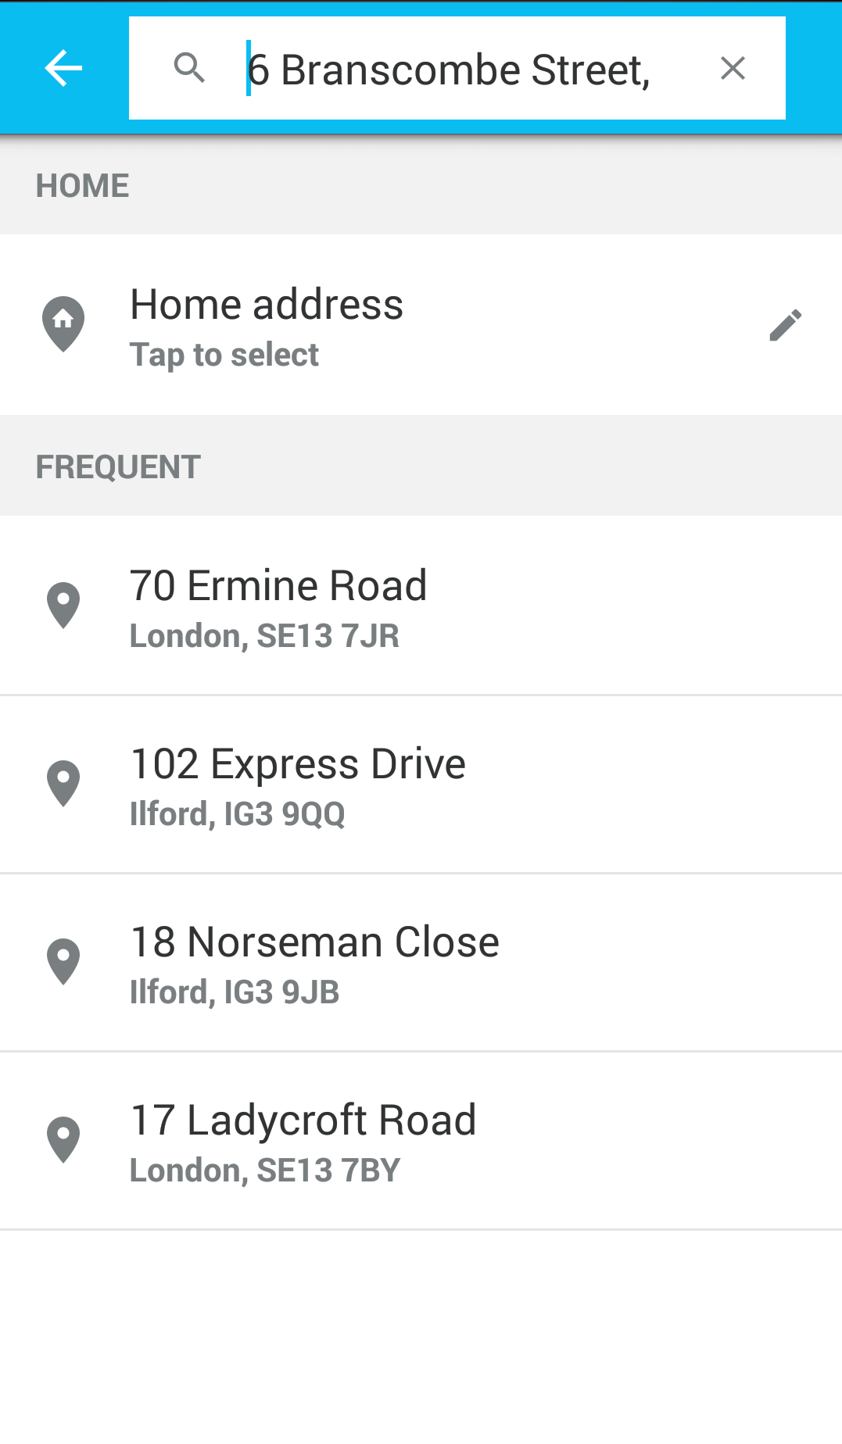

1. The quotation seems to be always $30. As soon as both addresses are available quotation needs to requested and displayed. The quotation needs to be invalidated as soon as any of the address changes.

Booking screen

1. If the customer clicks the ‘+’ button next to the dropoff address then a new textbox needs to be appended below it. It will be called ‘via address’.
2. With any address/datetime changes the quotation needs to be recalled.
3. On ‘confirm booking’ button click the app crashes. Please check the log for more information.
4. Don’t worry about the payment section now. Let’s assume all are ‘cash’ booking.

Navigation Drawer

1. This menu needs to be on top of the textboxes on the bottom of the page.
2. ‘Current bookings’, ‘Booking History’ and ‘Profile’ needs to be kept hidden until the customer logs in.
3. If there are no bookings/history then the customer needs to be prompted and brought back to the main screen.

Let’s do these. Then we will look into more.