REPORT 10 FUNCTIONS

1 . Home screen

On load retrieve the current location and get the full address using reverse geocode. Use this address as pickup location.

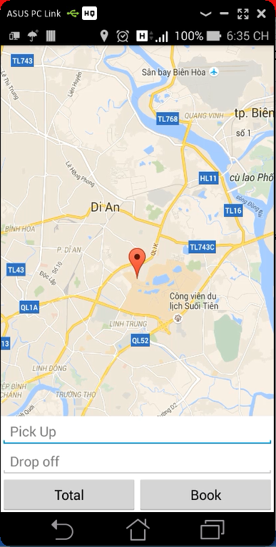

2 . Pick up and drop off

Tapping on pickup and drop-off textboxes should take the customers to the screen below :

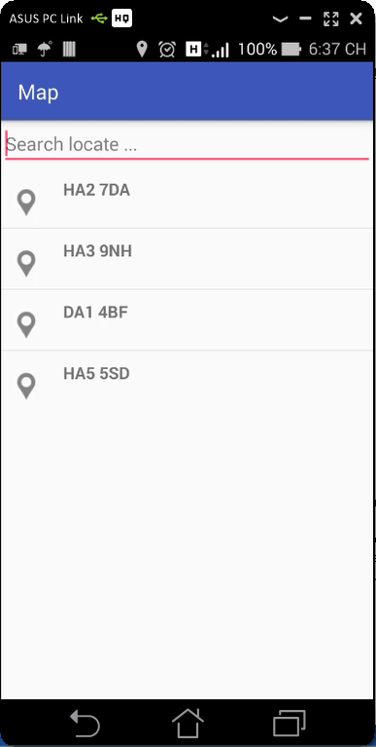

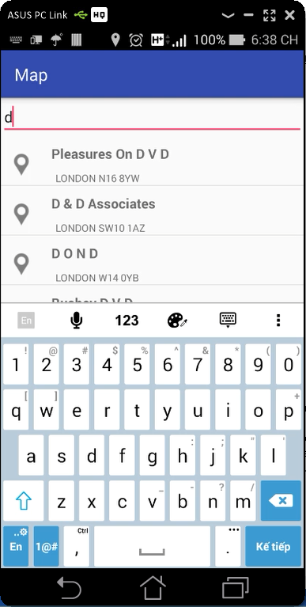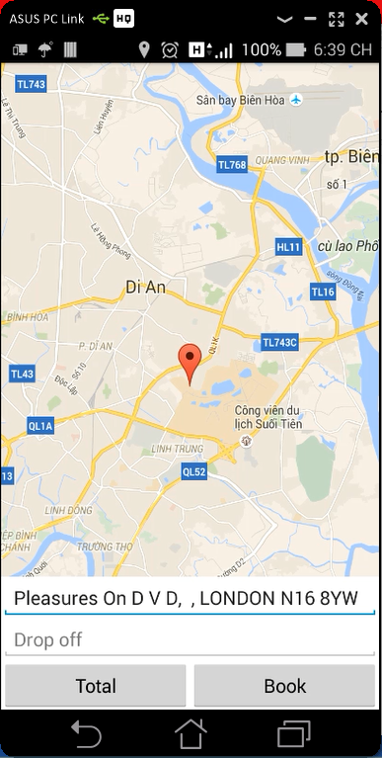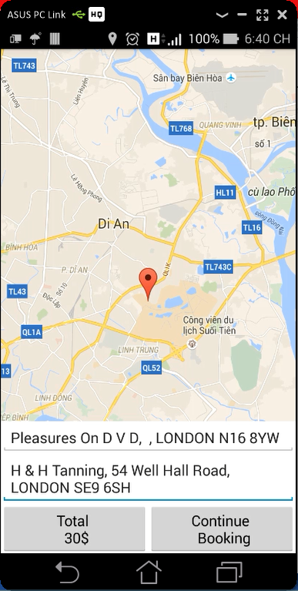

3 . Call method Quotation()

I got some issues here! I’ll send you later.

**private void** postQuotation(Address pickUpAddress, Address dropOffAddress) {  
  
 String url = WebServiceTaskManager.***URL*** + **"Quotation"**;  
  
 WebServiceTaskManager wst = **new** WebServiceTaskManager(WebServiceTaskManager.***POST_TASK***, **this**, **""**) {  
  
 @Override  
 **public void** handleResponse(String response) {  
 Log.*e*(**"response"**, response, **null**);  
 }  
 };  
  
 RetrieveQuote quotation = **new** RetrieveQuote();  
 quotation.setCustid(0);  
 quotation.setPickLat(pickUpAddress.getLatitude());  
 quotation.setPickLong(pickUpAddress.getLongitude());  
 quotation.setDoffLat(dropOffAddress.getLatitude());  
 quotation.setDoffLong(dropOffAddress.getLongitude());  
 **if**(**dateBook** != **null**) {  
 quotation.setBookingdate(**dateBook**.toLocaleString());  
 }**else** {  
 quotation.setBookingdate(**"0001-01-01T00:00:00"**);  
 }  
 quotation.setPaq(0);  
 quotation.setBags(0);  
 quotation.setNote(**note**.getText().toString());  
 quotation.setChildseat(**isChildSeat**);  
 quotation.setPetfriendly(**isPet**);  
  
 String json = **new** JSONSerializer().exclude(**"*.class"**).serialize(  
 quotation);  
 Log.*e*(**"json"**, json, **null**);  
 wst.addNameValuePair(**""**, json);  
  
 wst.execute(**new** String[]{url});  
  
}

4 . On continue

The design not good but I’ll fix it soon.

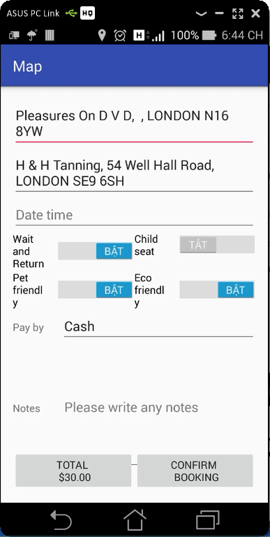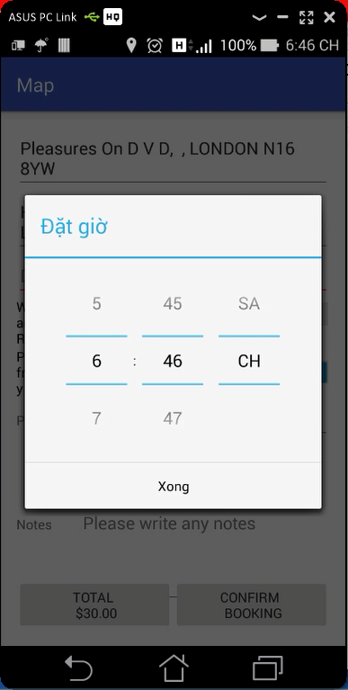

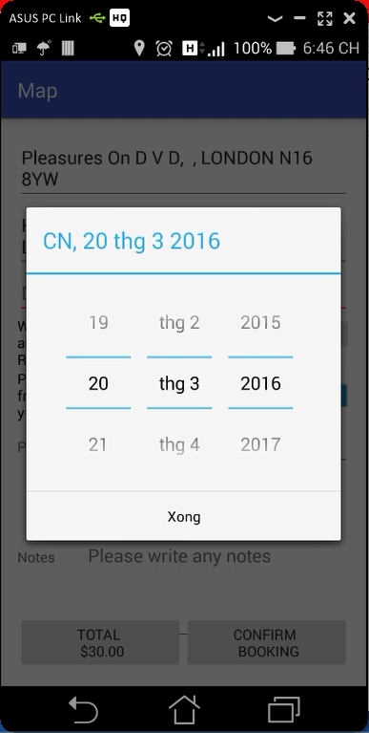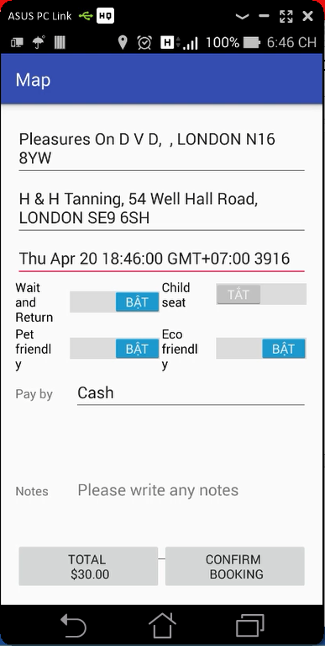

5 . Login

My github : https://github.com/PhuQuy/Atravesar/tree/master/Map

